Appendix A

Robot design

A.1 Manual Robot

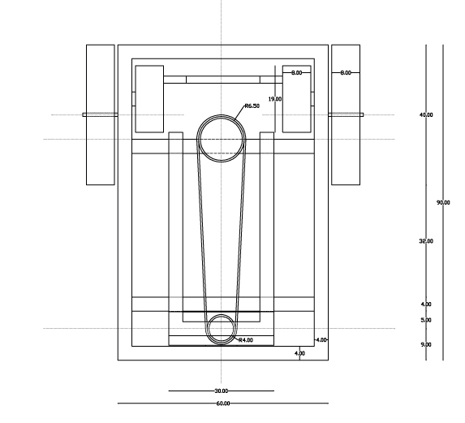
A.1.1 plan view
Figure A.1. Plan view of manual robot

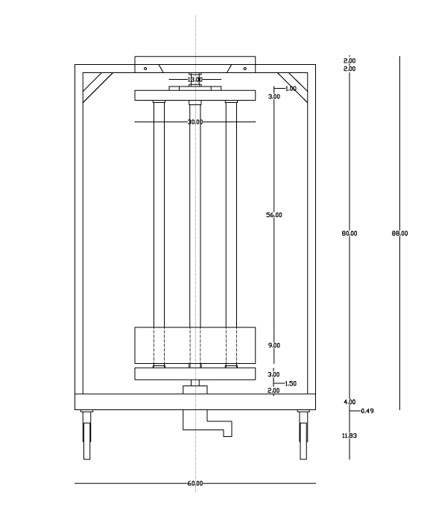
A.1.2 Elevation view

Figure A.2. Elevation view of manual robot

A.1.3 Side view

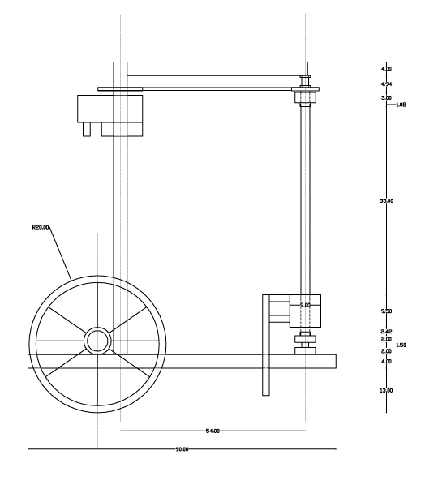

Figure A.3. Side view of manual robot

A.1.4 Three dimension view

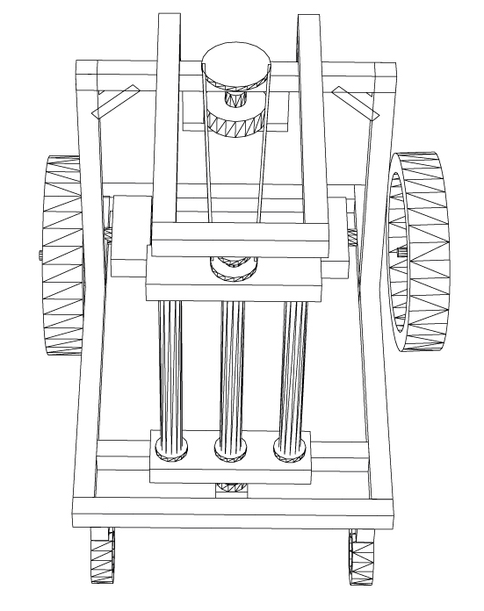
Shoot no.1
Figure A.4. Three dimension view of manual robot shoot no.1

Shoot no.2
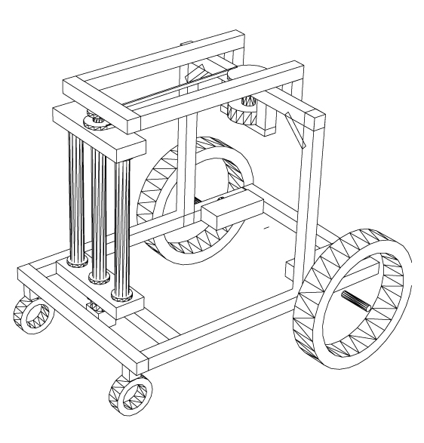
Figure A.5. Three dimension view of manual robot shoot no.2

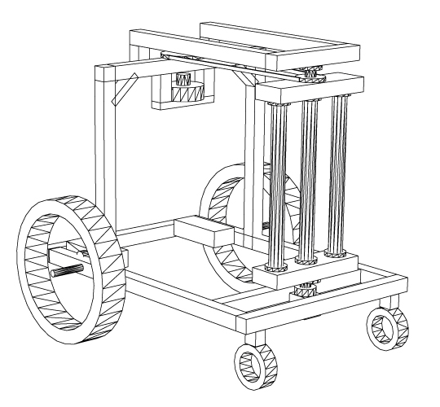
Shoot no.3

Figure A.6. Three dimension view of manual robot shoot no.3

A.2 Automatic robot no.1

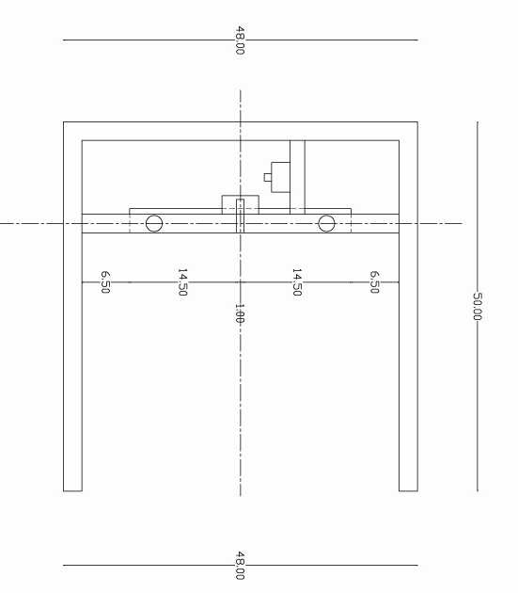
A.2.1 plan view

Figure A.7. Plan view of automatic robot no.1

A.2.2 Elevation view

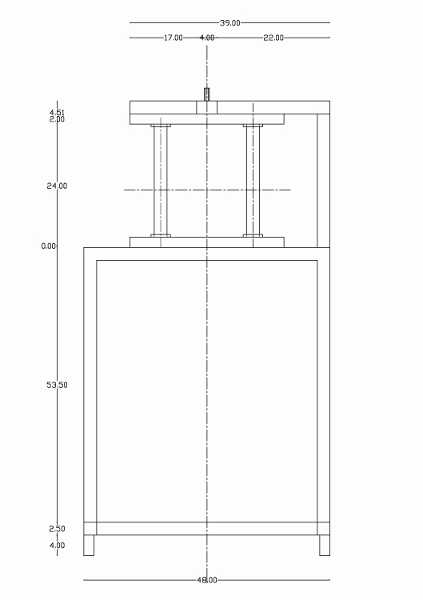

Figure A.8. Elevation view of automatic robot no.1

A.2.3 side view

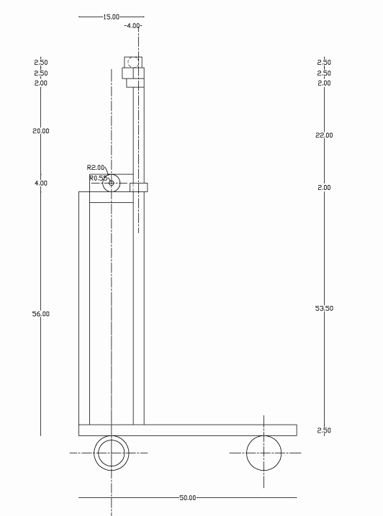

Figure A.8. Side view of automatic robot no.1

A.2.4 three dimension view

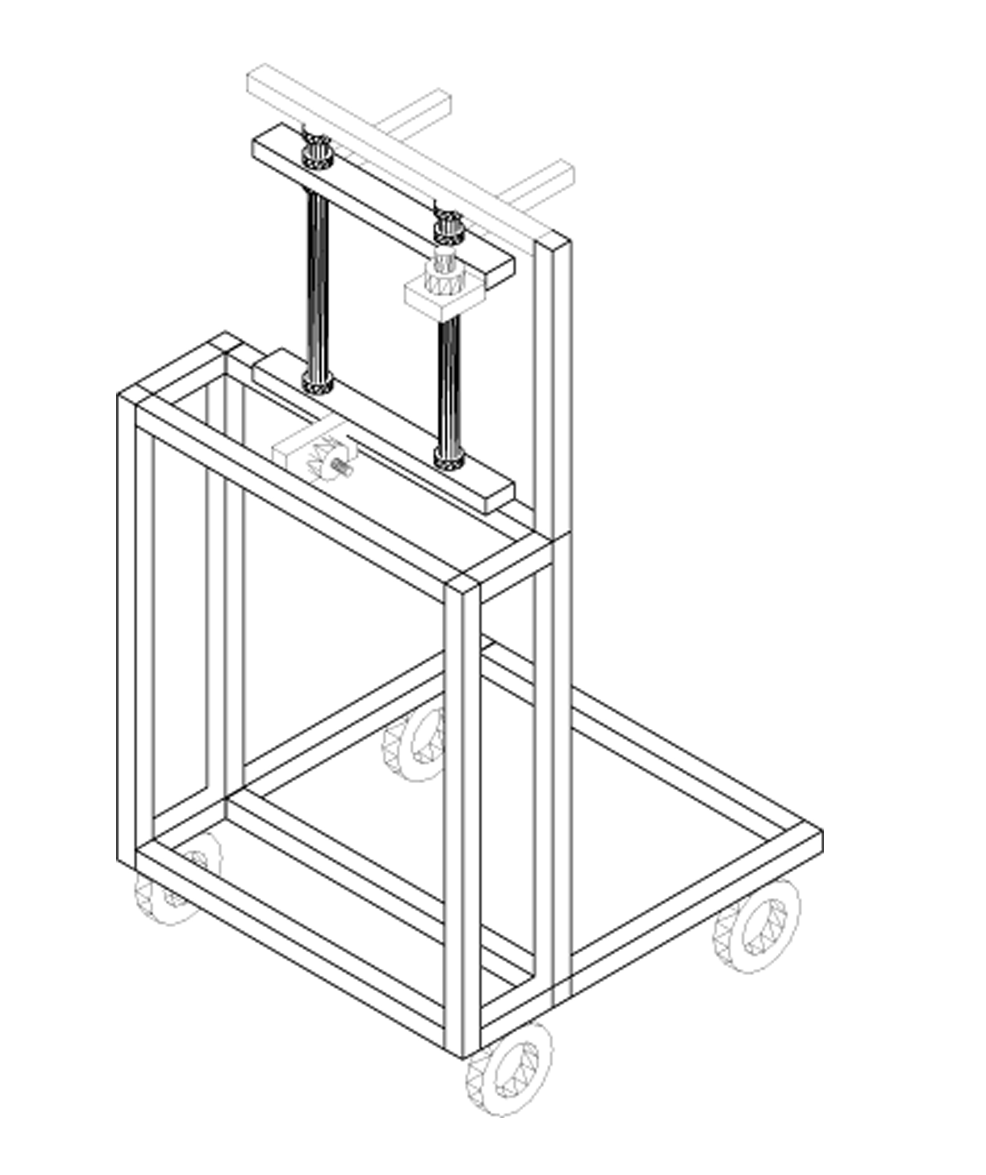

Figure A.9. Three dimension view of automatic robot no.1

