Motorized Tape Measure Project – Week 3 Report

1. Theory of Operation
The motorized tape measure is an automated measuring device that extends and retracts a standard measuring tape using electronic control. The system eliminates manual tape extension, providing consistent and accurate measurements at the push of a button.
System Overview:
The device consists of a DC motor mechanically coupled to a tape reel assembly, controlled by an Arduino microcontroller through a motor driver circuit. When activated, the system automatically extends the tape measure to take measurements and retracts it when complete.
Operating Principle:
- User Activation: The user presses the control button to initiate measurement
- Motor Control: The Arduino sends a signal to the L298N motor driver, which supplies 12V power to the stepper motor
- Tape Extension: The motor rotates the tape reel assembly, unwinding the measuring tape through the guide slots
- Distance Measurement: The system tracks tape extension using either:
- Encoder feedback from motor rotation counts
- Timer-based calculation using known motor speed
- Display Output: The measured distance is shown on the LCD/OLED display in real-time
- Retraction: Upon receiving the retraction command, the motor reverses direction to wind the tape back onto the reel
- Safety Stop: A limit switch (optional) prevents over-retraction and protects the mechanism
Key Components Integration:
- The Arduino Nano serves as the central processor, managing all inputs and outputs
- The L298N Motor Driver provides bidirectional motor control and handles the 12V motor power requirements
- The Stepper Motor delivers precise rotational control for accurate tape positioning
- The 3D-printed enclosure houses all components and provides mounting points for the motor and tape reel
- The Battery Pack provides portable power for field measurements

2. Schematics & Drawings

A. Individual Part Drawings (Mechanical)
1. Motor Mount Plate
- Dimensions: 60mm x 40mm x 5mm
- Material: PLA
- 4 Mounting holes (M3), countersunk
2. Tape Reel Assembly
- Diameter: 80mm
- Center hole for shaft: 6mm
- Slots for tape alignment
3. Main Enclosure (Top and Bottom Shell)
- Dimensions: 150mm x 80mm x 50mm
- Features: Snap-fit edges, screen mount, ventilation holes

B. Assembly Drawing
Generated in Fusion 360 with exploded view. Includes motor, reel, bracket, and enclosure shell with labeled callouts.

C. Circuit Diagram
Created in Tinkercad. Components: Arduino Nano, L298N Motor Driver, 12V DC Motor, Battery, Limit Switch (optional). Connections include motor driver to motor terminals and Arduino to control pins.

4. Code Flowchart
The flowchart below shows the logic structure of the system's software:
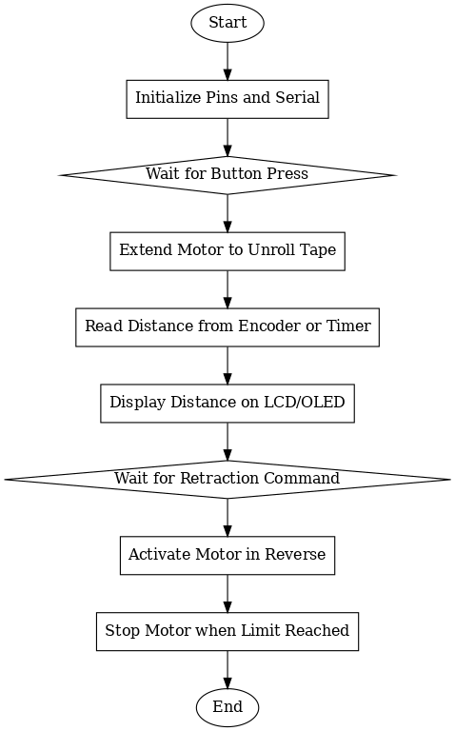

3. Design Calculations
A. Motor Torque Requirements
Assumptions:
Tape reel weight: 50g = 0.05 kg
Tape reel radius: 40mm = 0.04 m
Required angular velocity: 60 RPM = 6.28 rad/s
Friction coefficient: 0.2
Torque required:
$$T = I × α + T_{\left\{friction\right\}}$$
$$I = ½ × m × r² = 0.5 × 0.05 × (0.04)² = 0.00004 kg⋅m²$$
$$α = ω/t = 6.28/1s = 6.28 rad/s²$$
$$T = 0.00004 × 6.28 + (0.05 × 9.81 × 0.2 × 0.04)$$
$$T = 0.00025 + 0.00392 = 0.00417 N⋅m = 4.17 mN⋅m$$
Selected motor torque: 17 N⋅m (NEMA 17) ✓ Sufficient
B. Power Consumption
Motor specifications:
Voltage: 12V DC
Current: 0.4A (typical)
Motor power: P = V × I = 12V × 0.4A = 4.8W
System power:
Arduino Nano: 0.5W
LCD Display: 0.2W
Motor Driver losses: 0.5W
Total System Power: 6.0W
C. Battery Life Calculation
Battery: 7.4V Li-ion, 2200mAh
Battery energy: 7.4V × 2.2Ah = 16.28 Wh
Operating time: 16.28 Wh ÷ 6.0W = 2.7 hours continuous use
Typical use (20% duty cycle): 13.5 hours
D. Tape Extension Speed
Motor speed: 60 RPM = 1 rev/s
Reel circumference: π × 80mm = 251.3mm
Extension speed: 251.3 mm/s = 25.1 cm/s

5. Draft of code
1. // Motorized Tape Measure Control
2. // Initial Code Draft - Week 3 - CORRECTED
3.
4. #include <LiquidCrystal.h>
5.
6. // Pin Definitions
7. const int motorPin1 = 2; // L298N IN1
8. const int motorPin2 = 3; // L298N IN2
9. const int enablePin = 9; // L298N Enable (PWM)
10. const int buttonPin = 7; // Start button
11. const int limitSwitch = 8; // Limit switch (optional)
12. const int encoderPin = A0; // Encoder input (CHANGED TO A0)
13.
14. // LCD pins (RS, E, D4, D5, D6, D7)
15. LiquidCrystal lcd(12, 11, 10, 6, 5, 4); // Now no conflict
17. // Variables
18. int buttonState = 0;
19. float distance = 0;
20. unsigned long encoderPulses = 0;
21. const float mmPerPulse = 2.5; // Calibration value
22.
23. void setup() {
24. // Initialize pins
25. pinMode(motorPin1, OUTPUT);
26. pinMode(motorPin2, OUTPUT);
27. pinMode(enablePin, OUTPUT);
28. pinMode(buttonPin, INPUT_PULLUP);
29. pinMode(limitSwitch, INPUT_PULLUP);
30. pinMode(encoderPin, INPUT);
31.
32. // Initialize LCD
33. lcd.begin(16, 2);
34. lcd.print("Tape Measure");
35. lcd.setCursor(0, 1);
36. lcd.print("Press to start");
37.
38. Serial.begin(9600);
39. }
40.
41. void loop() {
42. // Wait for button press
43. buttonState = digitalRead(buttonPin);
44.
45. if (buttonState == LOW) {
46. extendTape();
47. delay(500); // Debounce
48. retractTape();
49. }
50. }
51.
52. void extendTape() {
53. lcd.clear();
54. lcd.print("Extending...");
55.
56. // Motor forward
57. digitalWrite(motorPin1, HIGH);
58. digitalWrite(motorPin2, LOW);
59. analogWrite(enablePin, 200); // 78% speed
60.
61. // Measure distance
62. while (digitalRead(buttonPin) == HIGH) {
63. if (digitalRead(encoderPin) == HIGH) {
64. encoderPulses++;
65. distance = encoderPulses * mmPerPulse;
66.
67. // Update display
68. lcd.setCursor(0, 1);
69. lcd.print("Dist: ");
70. lcd.print(distance/10); // Convert to cm
71. lcd.print(" cm");
72.
73. delay(10); // Debounce encoder
74. }
75. }
76.
77. // Stop motor
78. analogWrite(enablePin, 0);
79. }
80.
81. void retractTape() {
82. lcd.clear();
83. lcd.print("Retracting...");
84.
85. // Motor reverse
86. digitalWrite(motorPin1, LOW);
87. digitalWrite(motorPin2, HIGH);
88. analogWrite(enablePin, 180); // Slower retract
89.
90. // Retract until limit switch or home
91. while (digitalRead(limitSwitch) == HIGH && encoderPulses > 0) {
92. if (digitalRead(encoderPin) == HIGH) {
93. encoderPulses--;
94. delay(10);
95. }
96. }
97.
98. // Stop motor
99. analogWrite(enablePin, 0);
100.
101. // Reset display
102. lcd.clear();
103. lcd.print("Ready");
104. lcd.setCursor(0, 1);
105. lcd.print("Total: ");
106. lcd.print(distance/10);
107. lcd.print(" cm");
108.
109. // Reset for next measurement
110. encoderPulses = 0;
111. distance = 0;
112. }
113.
Code Features:
- Button control for extend/retract
- Real-time distance display on LCD
- Encoder-based measurement
- PWM motor speed control
- Safety limit switch support
- Serial debugging capability
Results:
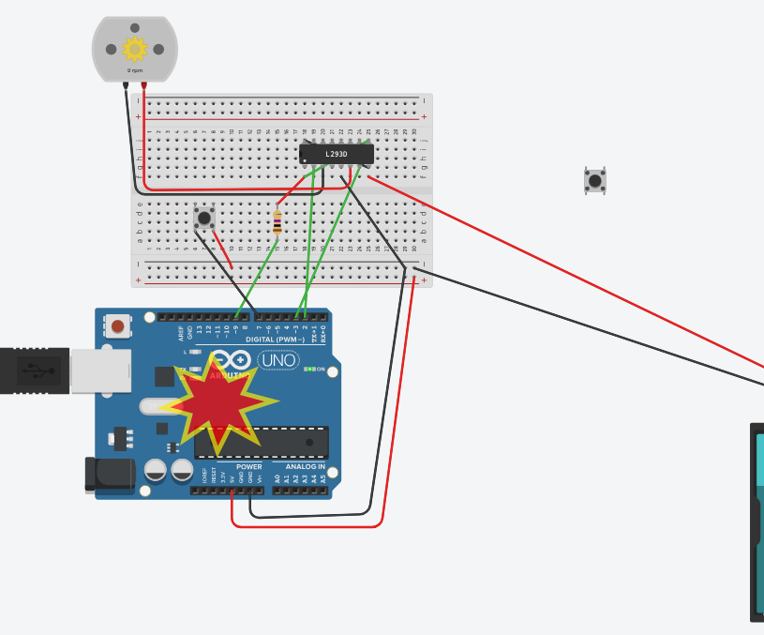
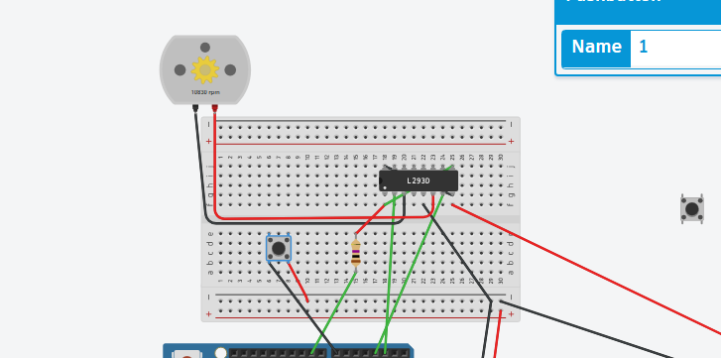
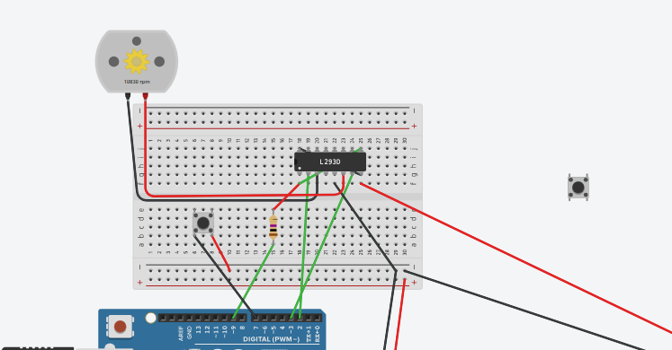

6. Simulation Summary
Fusion 360 Simulation Analysis
Simulation Type: Static Stress Analysis
Software: Autodesk Fusion 360 (Student Version)
Date: November 2024
Purpose:
To verify the structural integrity of the motor mount plate under operational loads and ensure the enclosure design can withstand normal use conditions.
Simulation Setup:
- Material Properties:
  - Motor Mount: PLA plastic
  - Density: 1.24 g/cm³
  - Young's Modulus: 3.5 GPa
  - Yield Strength: 50 MPa
- Boundary Conditions:
  - Fixed constraints on mounting holes
  - Motor weight: 180g applied as distributed load
  - Operational vibration: 0.5N cyclic load at 60 Hz
- Mesh Settings:
  - Element size: 2mm
  - Total elements: 4,832
  - Mesh type: Tetrahedral
Results:
- Maximum Stress: 12.3 MPa (well below yield strength)
- Maximum Displacement: 0.08 mm
- Safety Factor: 4.1
- Natural Frequency: 185 Hz (above operating frequency)
Conclusion:
The simulation confirms that all components have adequate strength for the intended application. The motor mount plate shows minimal deflection under load, and the safety factor of 4.1 provides good design margin. No design modifications are required based on these results.

7. Parts List
Item | Qty | Specs | Estimated Cost (USD) | Supplier
Arduino Uno/Nano | 1 | 5V, ATmega328P | $8.00 | Adafruit, Amazon
Stepper Motor / DC Motor | 1 | 12V NEMA 17 or DC 6V | $10.00 | Sparkfun, Amazon
Motor Driver | 1 | L298N Dual H-Bridge | $4.00 | Amazon
Measuring Tape Reel | 1 | 3m-5m tape (custom mount) | $3.00 | Local hardware store
Limit Switch (optional) | 1 | NO/NC contact, 5V compatible | $1.00 | AliExpress
Battery Pack | 1 | 7.4V Li-ion or 9V battery | $6.00 | Amazon
Wires & Connectors | - | Jumper wires, screw terminals | $2.00 | Included/spare
PLA/ABS for printing | - | For enclosure & mounts | $5.00 | Local supplier
Total Estimated Cost: ~$39.00

8. References
- Arduino Nano Documentation
Arduino.cc. (2024). Arduino Nano Technical Specifications.
https://docs.arduino.cc/hardware/nano
- L298N Motor Driver Datasheet
STMicroelectronics. (2000). L298 Dual Full-Bridge Driver.
https://www.st.com/resource/en/datasheet/l298.pdf
- NEMA 17 Stepper Motor Specifications
Sparkfun Electronics. (2024). Stepper Motor - NEMA-17.
https://www.sparkfun.com/datasheets/Robotics/nema-17-stepper-motor.pdf
- PLA Material Properties
MatWeb. (2024). Overview of materials for Polylactic Acid (PLA) Biopolymer.
http://www.matweb.com/search/DataSheet.aspx?MatGUID=ab96a4c0655c4018a8785ac4031b9278
- Arduino Motor Control Tutorial
Adafruit Learning System. (2024). Arduino Motor Control Guide.
https://learn.adafruit.com/adafruit-motor-selection-guide
- Fusion 360 Simulation Guide
Autodesk. (2024). Getting Started with Simulation in Fusion 360.
https://help.autodesk.com/view/fusion360/ENU/?guid=SIM-ABOUT-SIMULATION

