**Less commands:**

**less filename -** show the contents page wise.

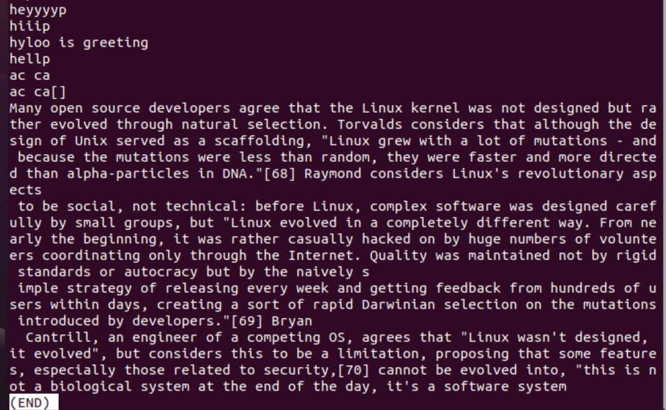

**less -p 'word' filename** - it will show us all the word as highlighted one in the data pages.

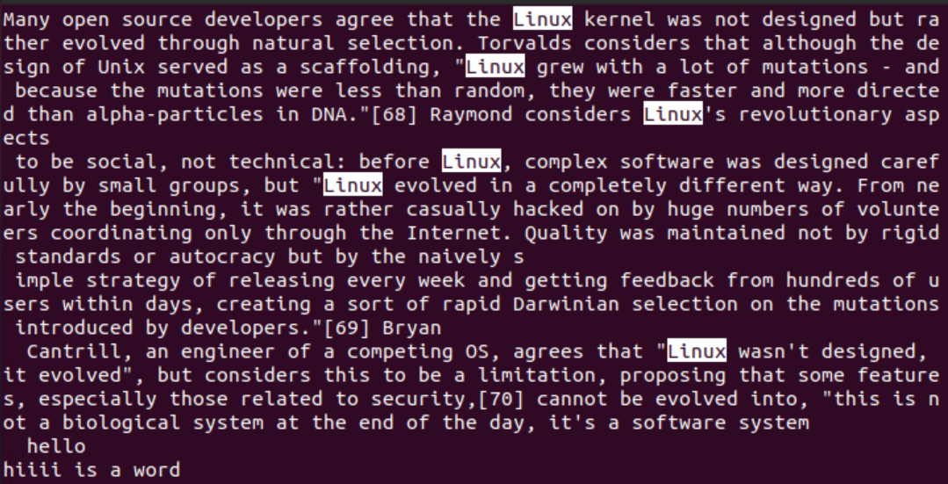

**less -N filename** - it will show the contents with its line number.

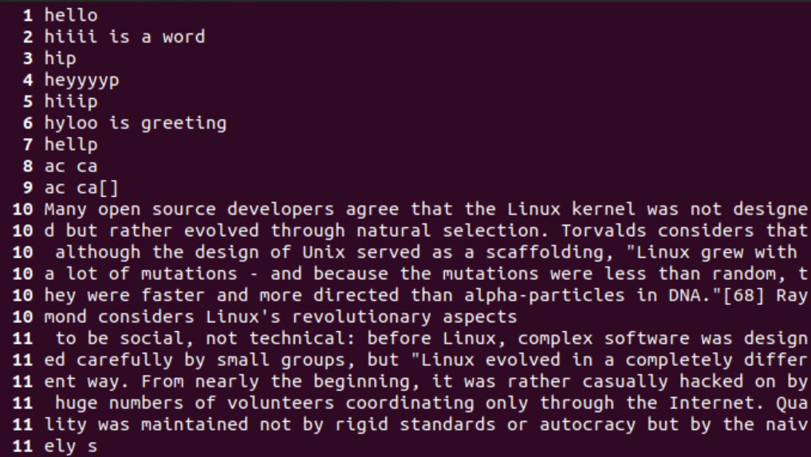

**Vim editor:**

:w filename - to save a file.





:q! - to close without saving.

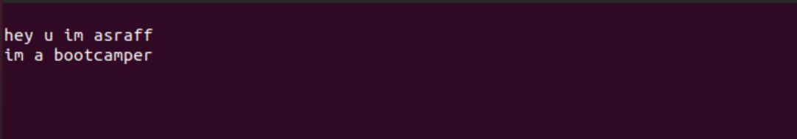



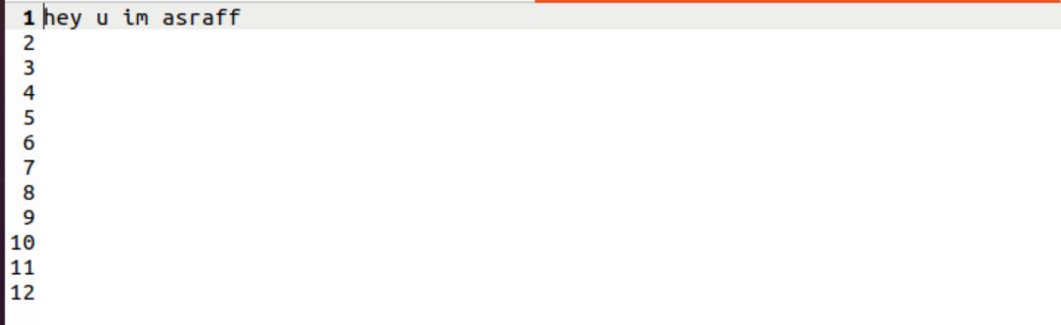

**:r filename** - to enter data of other a file.

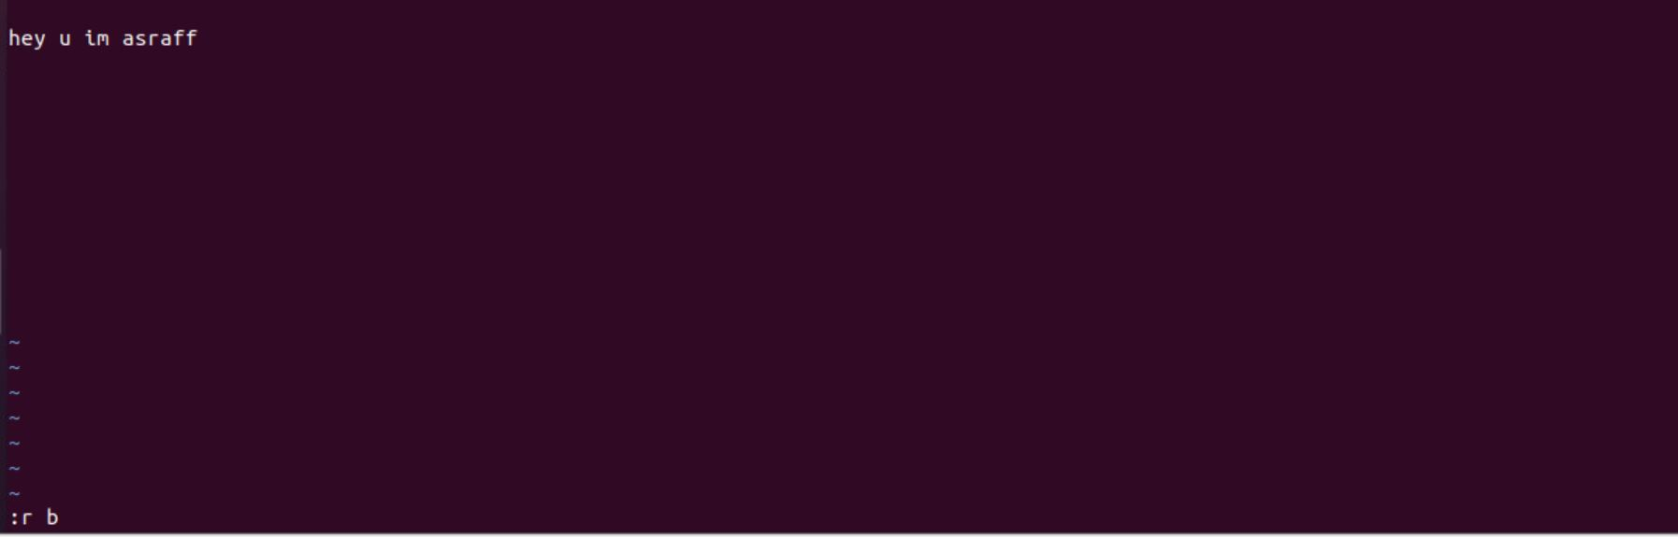

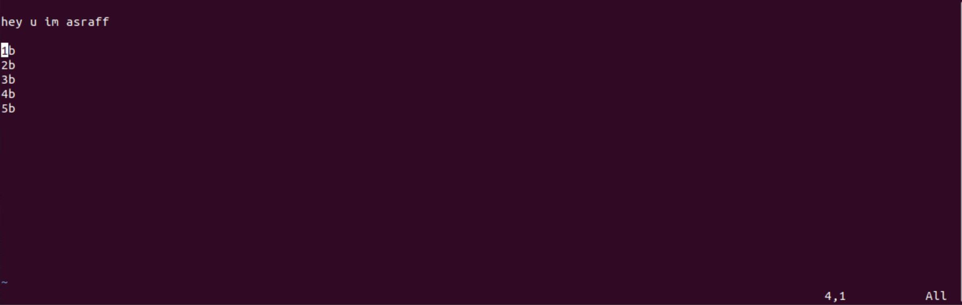

ESC — Terminate insert mode

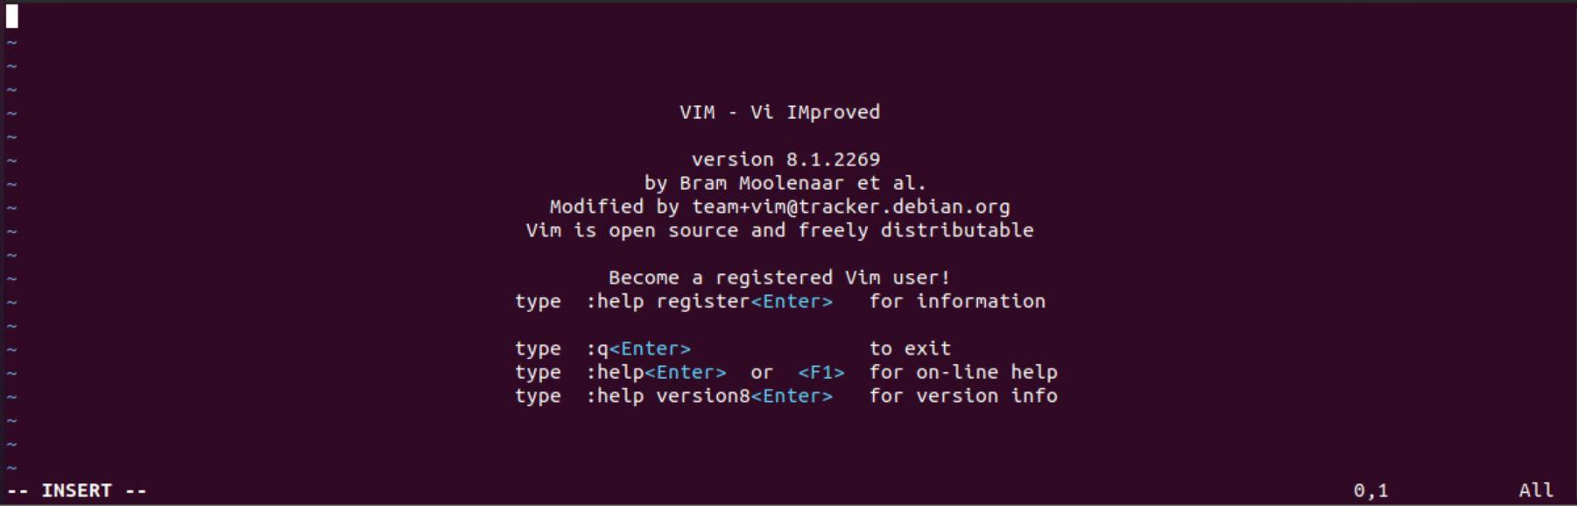

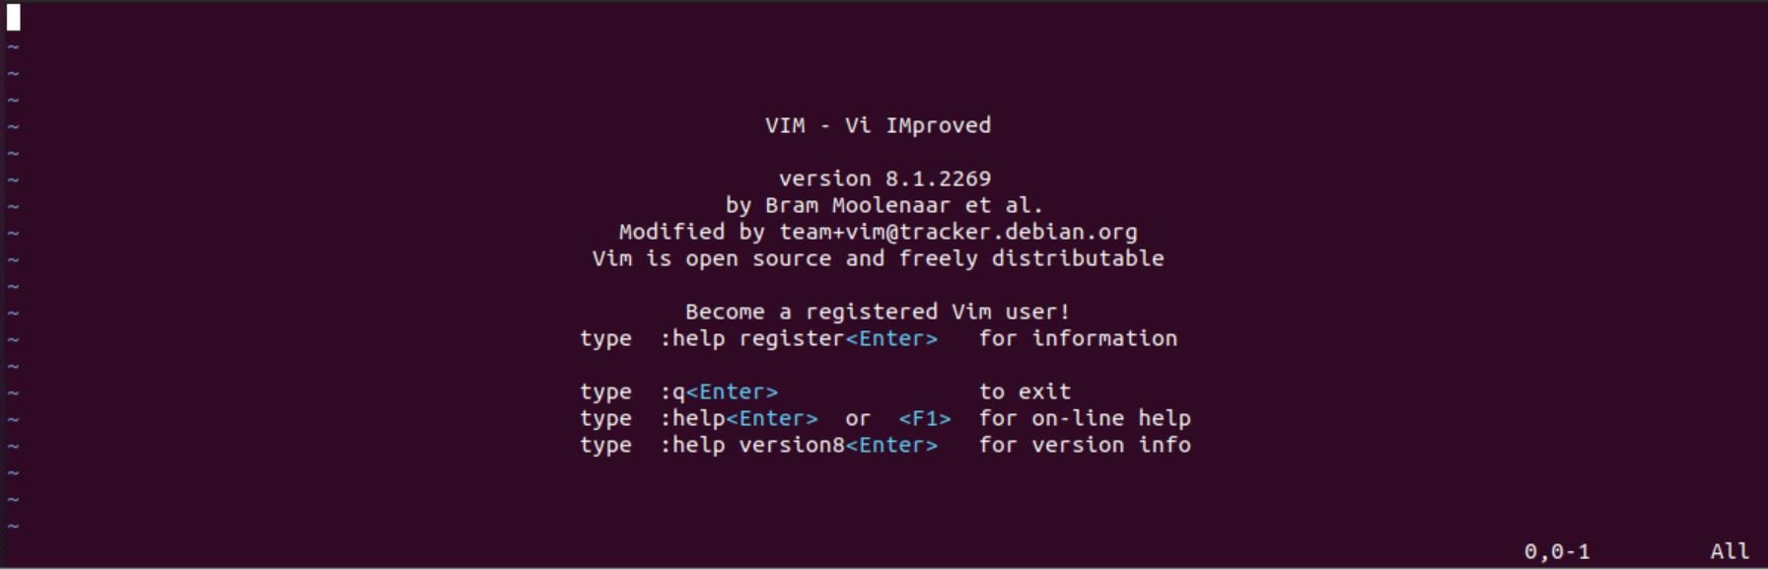

**U** — Undo last change

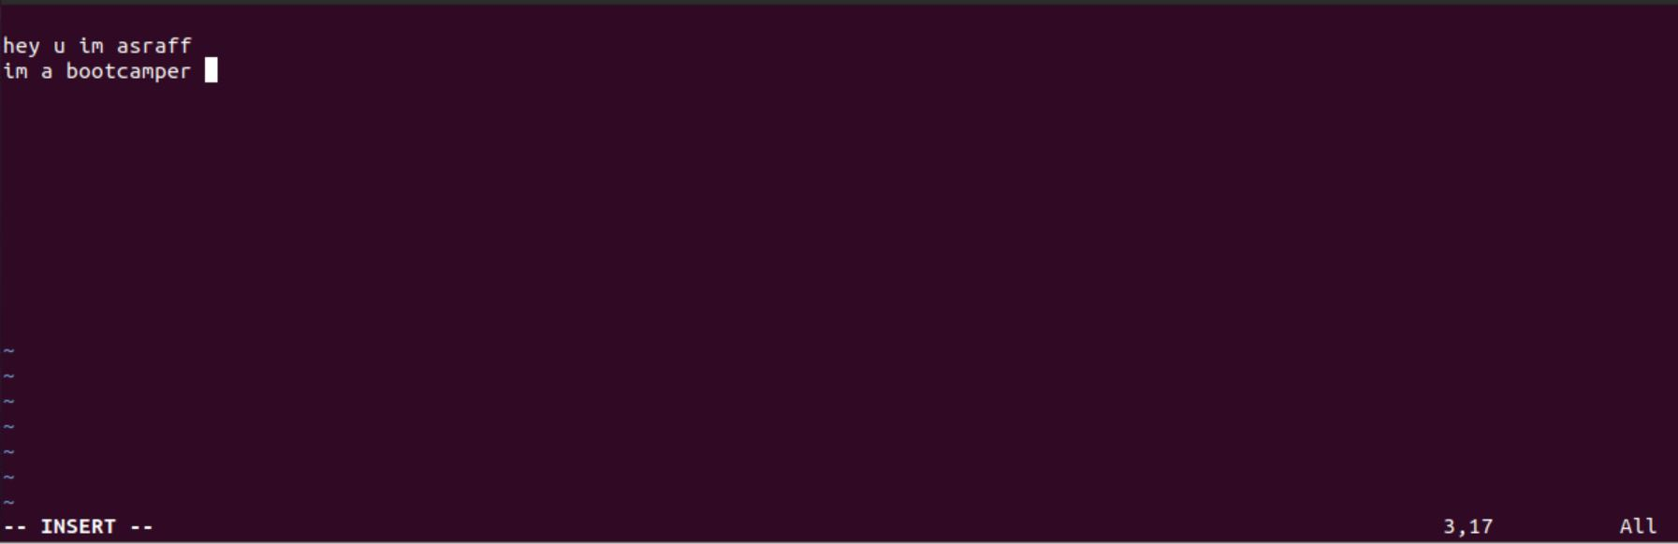

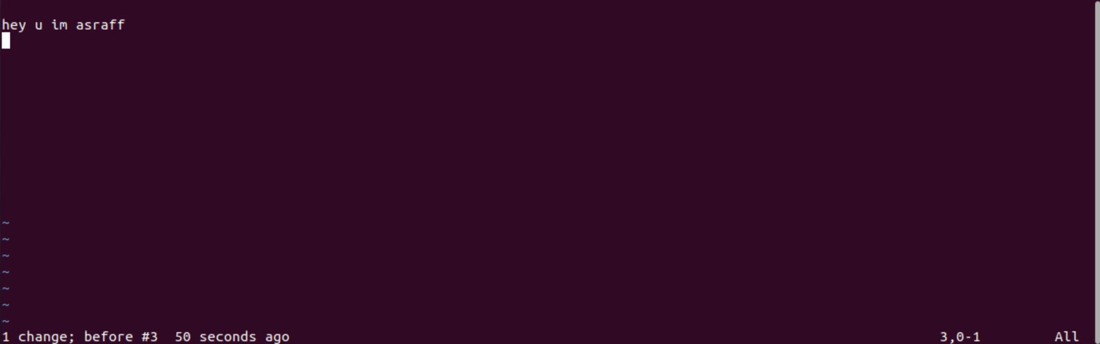

**D** — Delete contents of line after the cursor.





**x —** Delete character at cursor

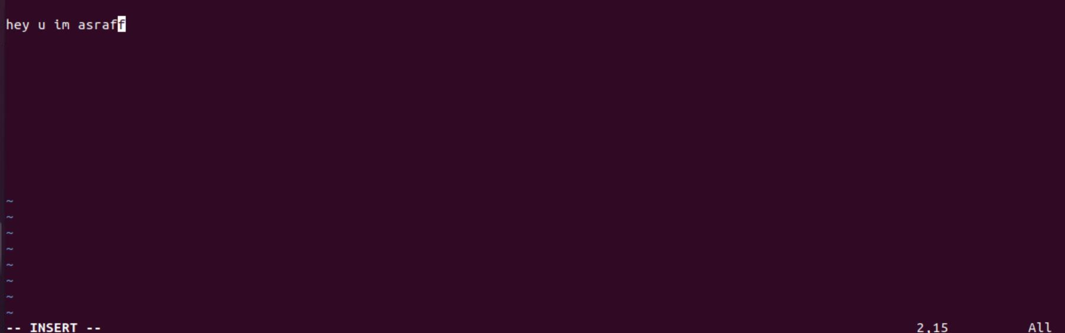

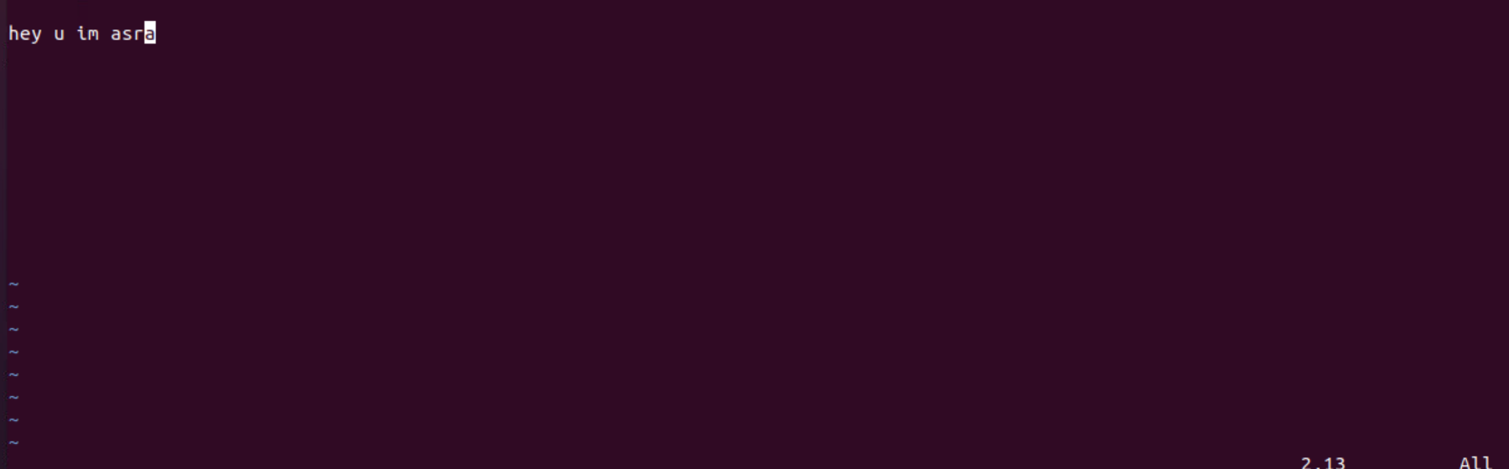

**tail filename:**

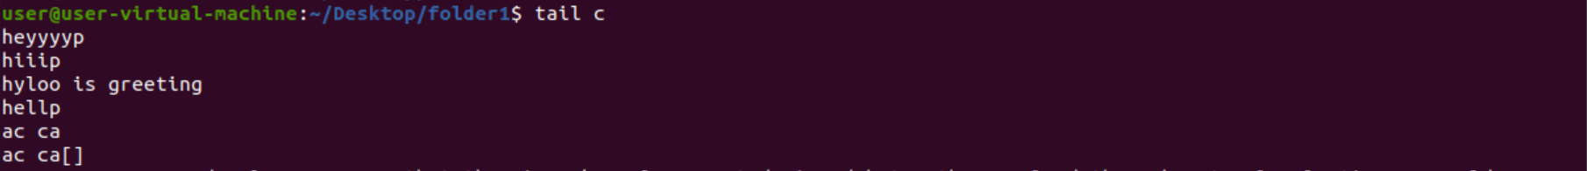

**head filename:**

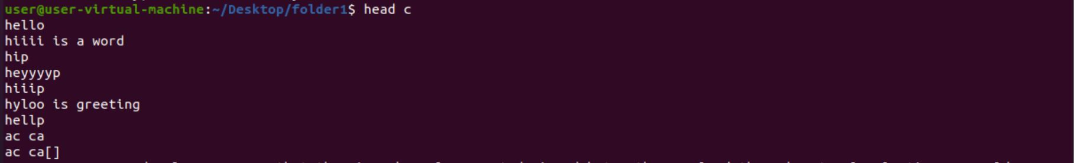

**find filename:**

