**1) creating a file in a terminal**

- touch filename.sh is the command to create a new file.

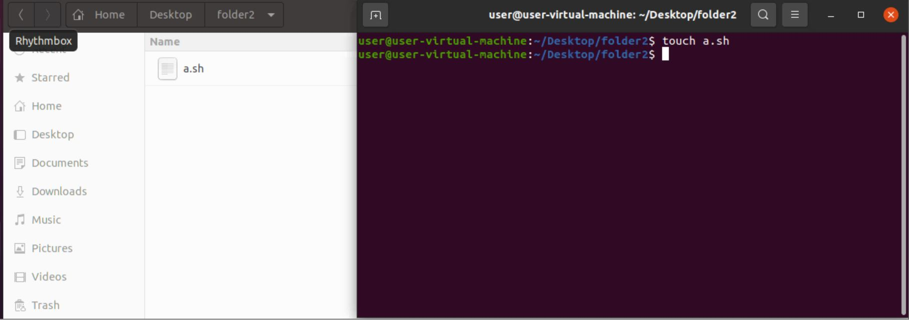

**2) edit the file using vim ,gedit editor**

- vim filename.sh inside the editor create a content and save it by :w filename.sh

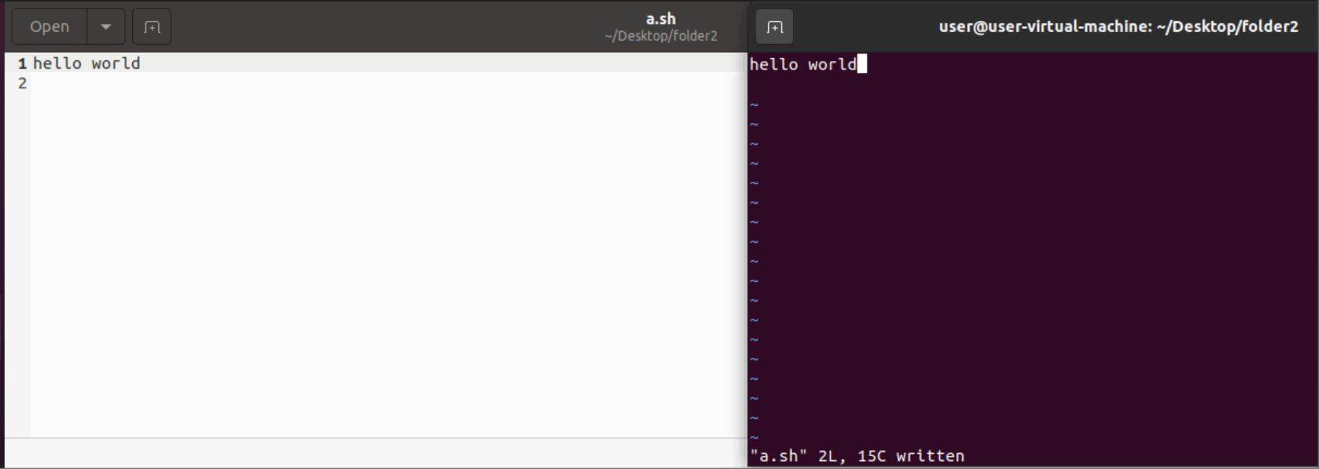

**3) execute the shell file**

-./filename.sh is used to run the shell file.

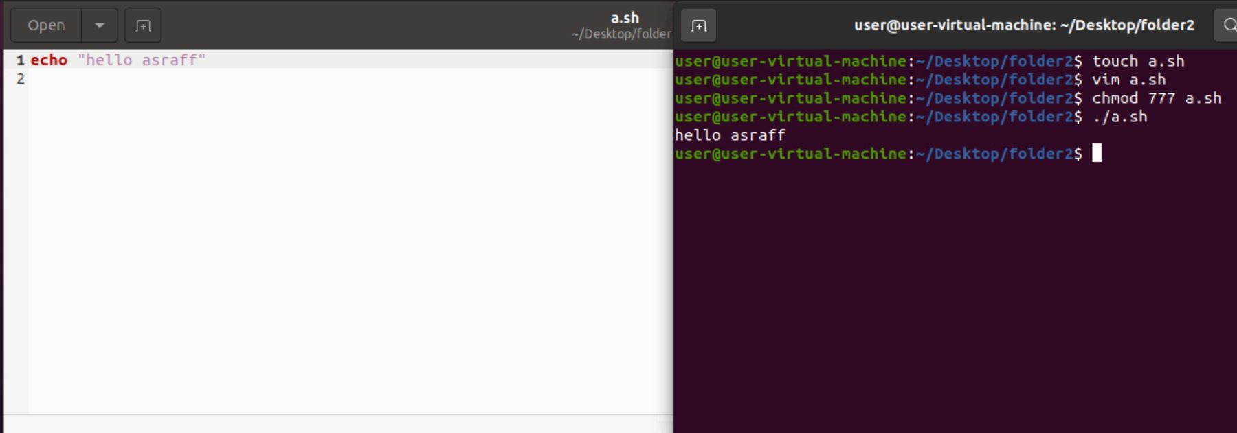

**4)creating a directory using shell script**

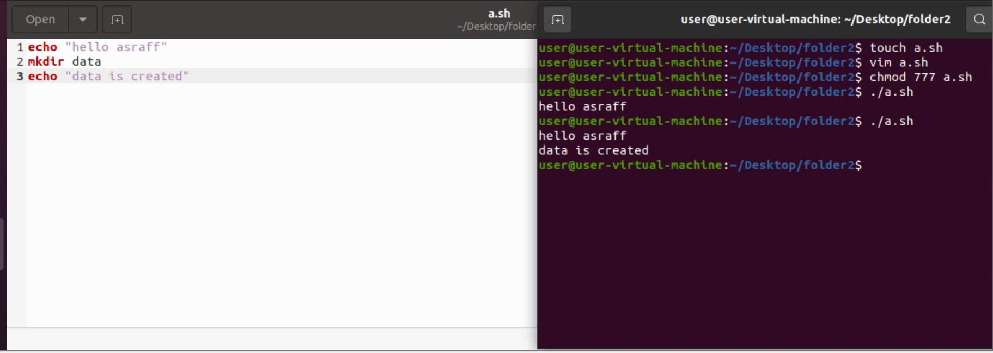

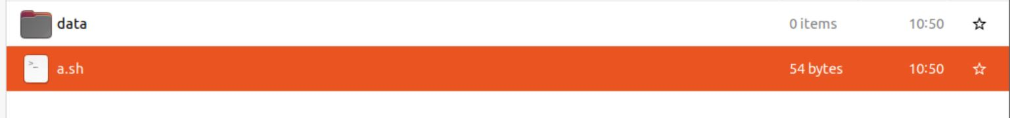

**5) creating a text file in terminal using shell script code:**

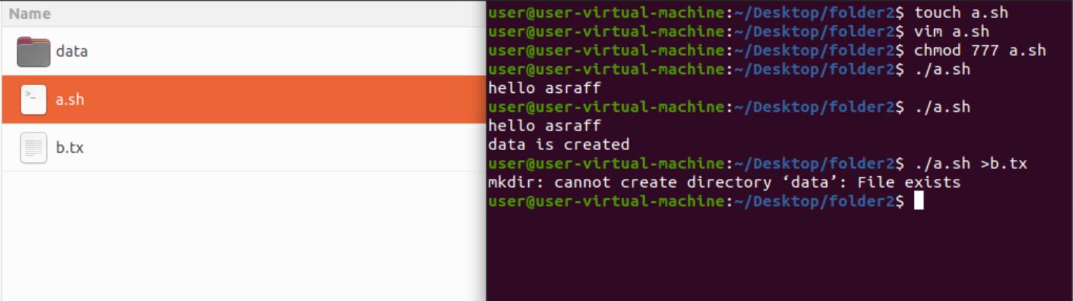

6) **creating a text file using shell script code in the script page:**

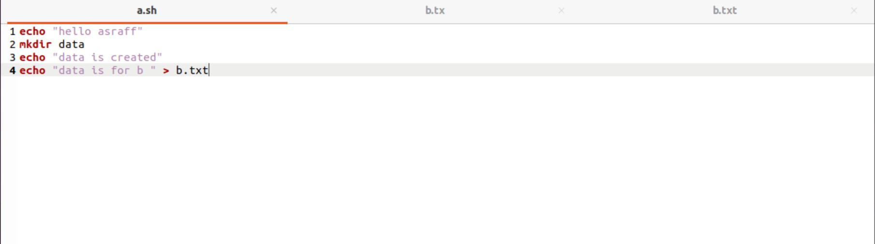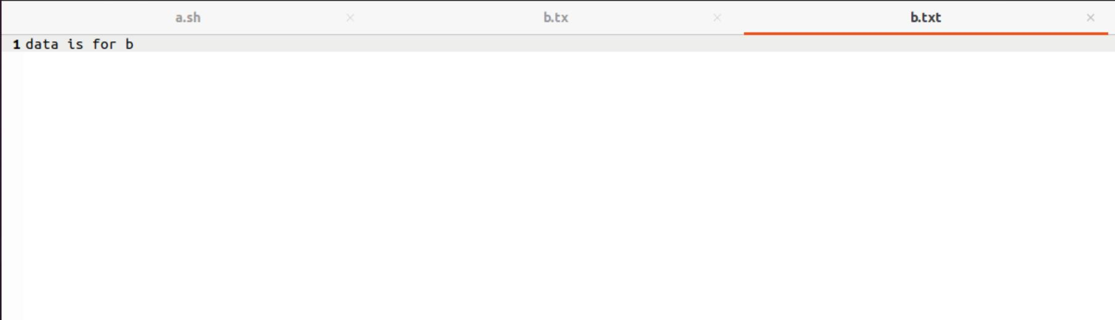

**7) reflecting multiple lines on other text file**

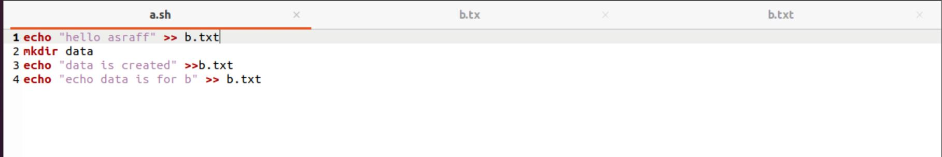

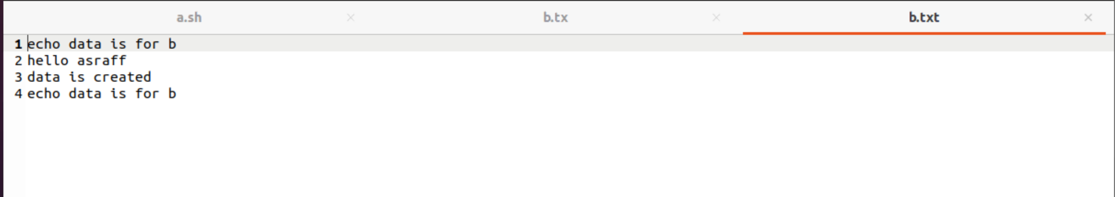

**8)COMMENTS**

- # is used for SINGLE line comment purpose.

-<<COMMENTS ....... COMMENTS is used for MULTIPLE line purpose

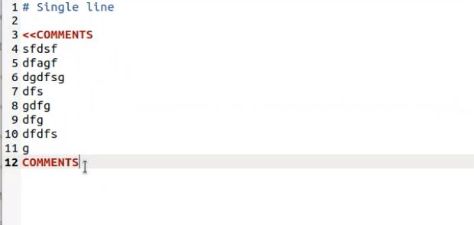

**9)VARIABLE :**

-Variable declaration and execution

-NO SPACE BETWEEN THE VARIABLE NAME AND THE VARIABLE

variable name=variable

echo $name

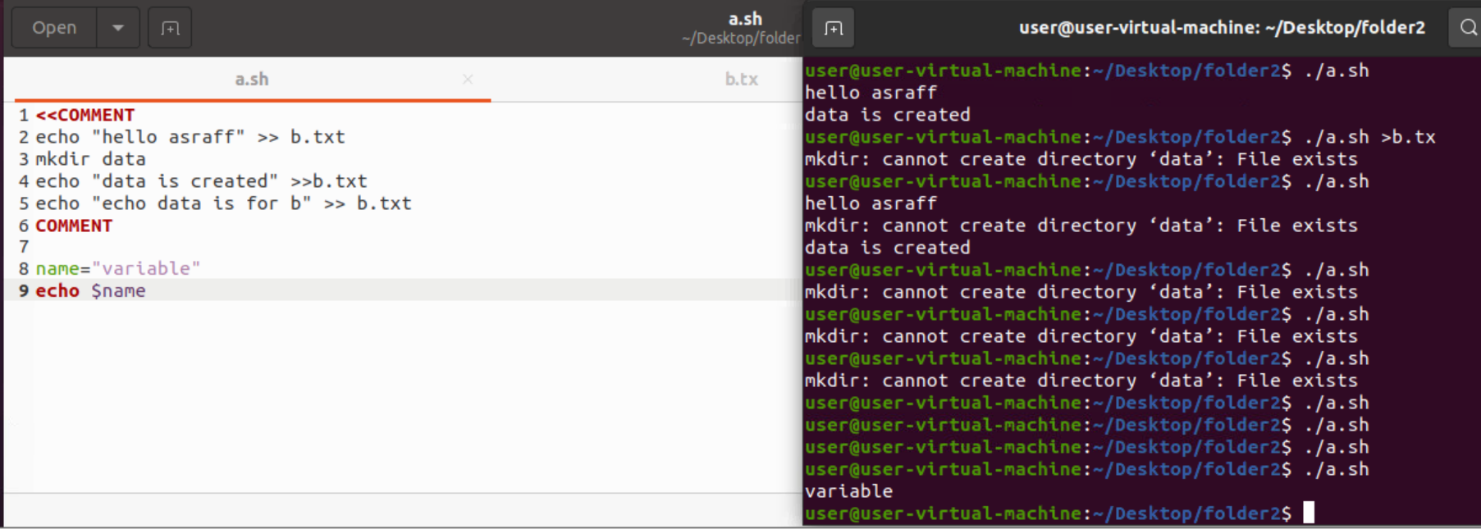

**10) SHELL PROGRAMS:**

**10.1 )diagonal of the rectangle**

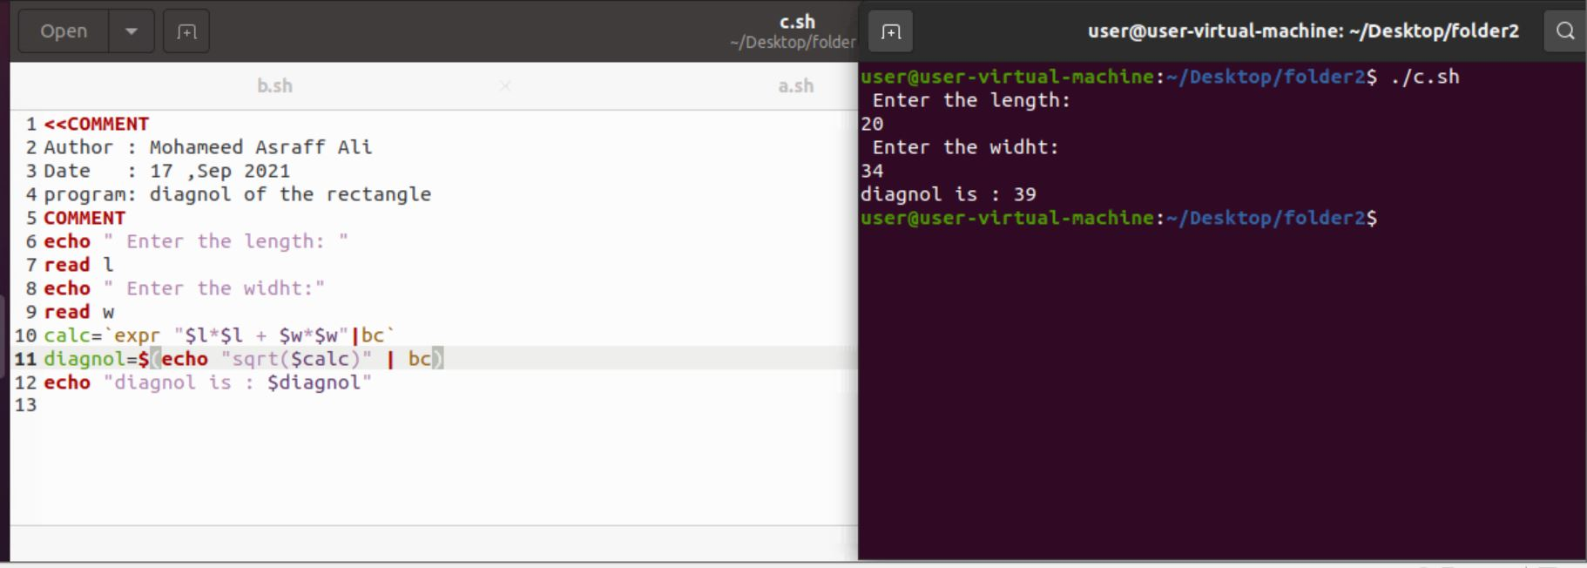

**10.2) simple interest**

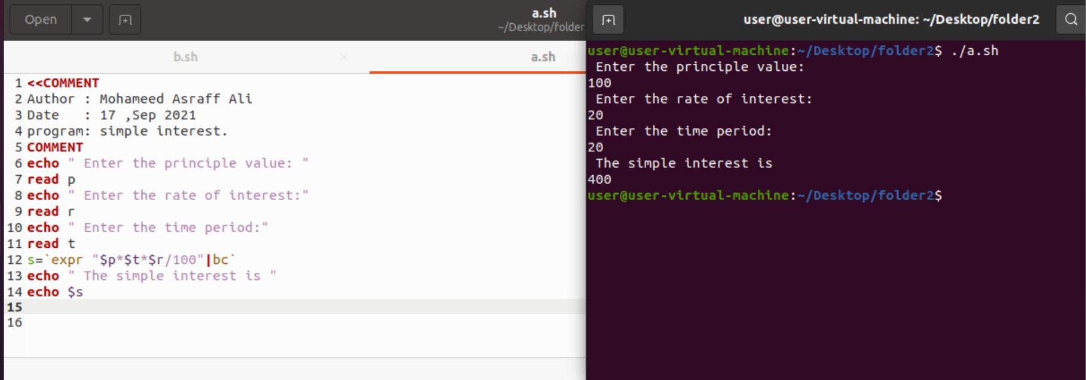

**10.3) circumference of the circle**

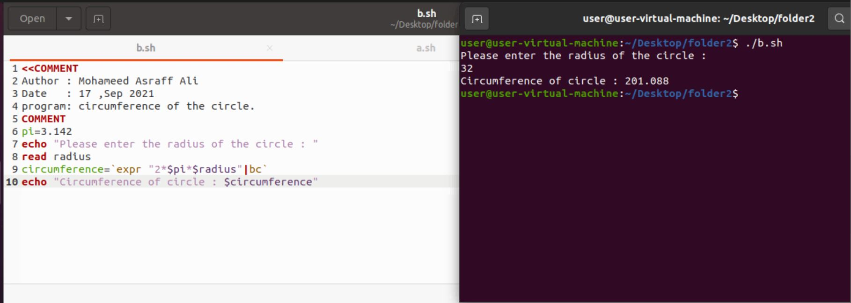

**10.4)printing nth line**

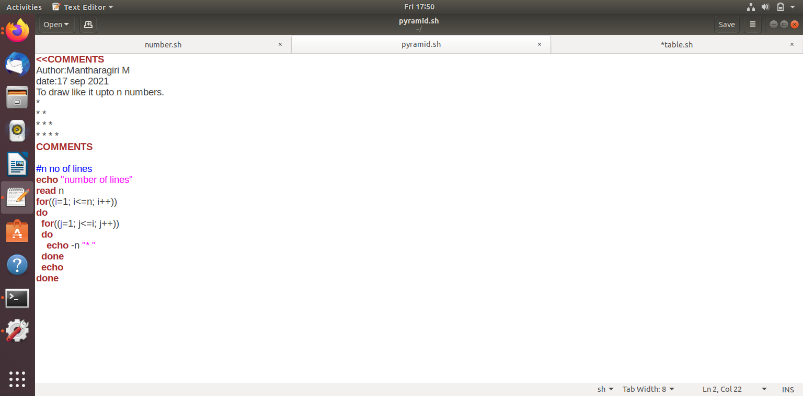

**10.5)printing nth number**

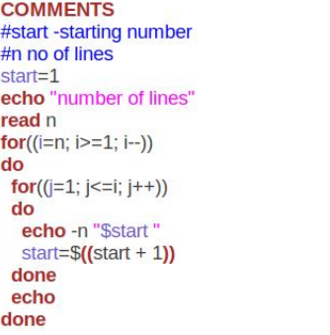

**10.6)printing multiplication table**

