Initiation à la statistique avec R, code et compléments chapitre 3

Frédéric Bertrand et Myriam Maumy-Bertrand

11 décembre 2018

#Chapitre 3  
#page 95  
library(BioStatR)  
Mesures

## masse taille espece  
## 1 28.6 19.1 glycine blanche  
## 2 20.6 14.8 glycine blanche  
## 3 29.2 19.7 glycine blanche  
## 4 32.0 21.1 glycine blanche  
## 5 24.5 19.4 glycine blanche  
## 6 29.0 19.5 glycine blanche  
## 7 28.9 18.9 glycine blanche  
## 8 18.2 14.6 glycine blanche  
## 9 7.9 10.2 glycine blanche  
## 10 15.5 14.6 glycine blanche  
## 11 22.6 16.4 glycine blanche  
## 12 35.5 21.1 glycine blanche  
## 13 32.5 20.7 glycine blanche  
## 14 28.7 18.7 glycine blanche  
## 15 26.0 17.6 glycine blanche  
## 16 13.5 13.2 glycine blanche  
## 17 16.4 14.0 glycine blanche  
## 18 12.5 12.0 glycine blanche  
## 19 26.2 18.3 glycine blanche  
## 20 22.6 17.8 glycine blanche  
## 21 9.7 10.7 glycine blanche  
## 22 21.8 16.5 glycine blanche  
## 23 17.2 14.5 glycine blanche  
## 24 25.2 17.5 glycine blanche  
## 25 12.0 12.2 glycine blanche  
## 26 6.3 8.6 glycine blanche  
## 27 7.0 9.1 glycine blanche  
## 28 20.4 17.0 glycine blanche  
## 29 18.0 15.3 glycine blanche  
## 30 21.1 15.8 glycine blanche  
## 31 18.2 15.9 glycine blanche  
## 32 15.2 12.2 glycine blanche  
## 33 19.8 16.1 glycine blanche  
## 34 21.4 16.0 glycine blanche  
## 35 15.0 13.8 glycine blanche  
## 36 16.4 14.4 glycine blanche  
## 37 17.3 14.2 glycine blanche  
## 38 16.4 15.7 glycine blanche  
## 39 13.5 12.6 glycine blanche  
## 40 13.6 12.0 glycine blanche  
## 41 14.6 12.8 glycine blanche  
## 42 16.9 15.3 glycine blanche  
## 43 11.7 12.4 glycine blanche  
## 44 14.0 14.5 glycine blanche  
## 45 14.6 12.3 glycine blanche  
## 46 10.3 11.8 glycine blanche  
## 47 11.3 12.6 glycine blanche  
## 48 10.7 11.3 glycine blanche  
## 49 10.9 12.5 glycine blanche  
## 50 20.0 16.1 glycine blanche  
## 51 21.5 16.2 glycine blanche  
## 52 12.0 11.3 glycine blanche  
## 53 6.1 8.6 glycine blanche  
## 54 5.4 8.2 glycine blanche  
## 55 40.0 24.5 glycine violette  
## 56 49.2 27.0 glycine violette  
## 57 46.0 25.8 glycine violette  
## 58 26.4 18.7 glycine violette  
## 59 42.2 25.2 glycine violette  
## 60 48.4 25.8 glycine violette  
## 61 23.9 19.2 glycine violette  
## 62 31.7 21.4 glycine violette  
## 63 16.8 12.0 glycine violette  
## 64 21.6 14.0 glycine violette  
## 65 24.1 18.5 glycine violette  
## 66 13.5 12.8 glycine violette  
## 67 22.4 13.8 glycine violette  
## 68 26.1 17.3 glycine violette  
## 69 12.9 12.4 glycine violette  
## 70 26.6 20.0 glycine violette  
## 71 29.6 20.5 glycine violette  
## 72 22.4 18.2 glycine violette  
## 73 17.3 13.3 glycine violette  
## 74 16.6 13.5 glycine violette  
## 75 12.8 12.0 glycine violette  
## 76 19.1 14.5 glycine violette  
## 77 12.4 11.6 glycine violette  
## 78 8.8 9.2 glycine violette  
## 79 13.2 15.1 glycine violette  
## 80 15.9 12.2 glycine violette  
## 81 13.3 11.2 glycine violette  
## 82 6.3 8.4 glycine violette  
## 83 12.9 11.5 glycine violette  
## 84 6.2 7.8 glycine violette  
## 85 8.6 9.8 glycine violette  
## 86 14.4 11.6 glycine violette  
## 87 11.5 9.8 glycine violette  
## 88 11.5 11.0 glycine violette  
## 89 12.8 10.6 glycine violette  
## 90 11.7 11.1 glycine violette  
## 91 15.7 14.0 glycine violette  
## 92 12.0 11.4 glycine violette  
## 93 13.4 11.1 glycine violette  
## 94 11.3 10.7 glycine violette  
## 95 6.6 7.9 glycine violette  
## 96 17.8 13.7 glycine violette  
## 97 9.6 10.0 glycine violette  
## 98 14.3 12.8 glycine violette  
## 99 14.0 12.2 glycine violette  
## 100 11.3 11.4 glycine violette  
## 101 10.2 10.2 glycine violette  
## 102 12.2 10.8 glycine violette  
## 103 15.9 13.0 glycine violette  
## 104 11.7 10.3 glycine violette  
## 105 12.4 11.0 glycine violette  
## 106 11.5 11.4 glycine violette  
## 107 10.6 10.5 glycine violette  
## 108 9.4 9.2 glycine violette  
## 109 9.2 9.9 glycine violette  
## 110 6.1 8.4 glycine violette  
## 111 10.9 12.8 bignone  
## 112 6.6 10.5 bignone  
## 113 22.5 18.0 bignone  
## 114 33.7 21.5 bignone  
## 115 20.6 17.8 bignone  
## 116 16.6 16.3 bignone  
## 117 14.2 17.4 bignone  
## 118 13.8 15.7 bignone  
## 119 14.0 17.3 bignone  
## 120 8.7 13.4 bignone  
## 121 14.2 13.9 bignone  
## 122 10.6 14.6 bignone  
## 123 10.9 14.2 bignone  
## 124 3.3 8.9 bignone  
## 125 9.7 13.0 bignone  
## 126 9.3 12.2 bignone  
## 127 17.2 16.5 bignone  
## 128 10.1 14.7 bignone  
## 129 9.0 13.4 bignone  
## 130 7.1 11.6 bignone  
## 131 7.1 12.9 bignone  
## 132 1.5 6.5 bignone  
## 133 4.1 9.5 bignone  
## 134 8.0 11.8 bignone  
## 135 7.4 13.6 bignone  
## 136 7.2 12.9 bignone  
## 137 6.9 11.6 bignone  
## 138 2.9 9.4 bignone  
## 139 2.4 9.5 bignone  
## 140 10.7 14.0 bignone  
## 141 13.8 13.5 bignone  
## 142 10.9 12.1 bignone  
## 143 10.3 11.6 bignone  
## 144 8.8 13.4 bignone  
## 145 9.0 10.9 bignone  
## 146 8.2 12.2 bignone  
## 147 9.6 13.4 bignone  
## 148 9.0 12.5 bignone  
## 149 5.3 10.5 bignone  
## 150 1.5 7.0 bignone  
## 151 6.7 13.2 bignone  
## 152 2.9 9.3 bignone  
## 153 2.9 7.9 bignone  
## 154 3.5 10.3 bignone  
## 155 3.4 7.5 bignone  
## 156 4.9 8.5 bignone  
## 157 4.7 10.1 bignone  
## 158 4.7 8.3 bignone  
## 159 5.2 10.8 bignone  
## 160 2.1 8.3 bignone  
## 161 2.2 7.1 bignone  
## 162 1.4 6.4 bignone  
## 163 2.7 6.5 bignone  
## 164 1.0 4.8 bignone  
## 165 2.5 7.4 bignone  
## 166 5.5 9.3 bignone  
## 167 2.7 8.6 bignone  
## 168 6.7 9.9 bignone  
## 169 7.3 13.9 bignone  
## 170 2.9 8.7 bignone  
## 171 3.8 9.3 bignone  
## 172 7.6 13.7 bignone  
## 173 3.6 8.3 bignone  
## 174 3.0 8.1 bignone  
## 175 5.8 11.2 bignone  
## 176 5.3 12.0 bignone  
## 177 3.2 11.3 bignone  
## 178 4.4 6.7 bignone  
## 179 3.4 10.6 bignone  
## 180 2.9 8.9 bignone  
## 181 4.9 15.3 laurier rose  
## 182 6.2 15.9 laurier rose  
## 183 4.0 15.0 laurier rose  
## 184 3.3 11.0 laurier rose  
## 185 4.8 15.1 laurier rose  
## 186 5.6 15.6 laurier rose  
## 187 4.5 15.3 laurier rose  
## 188 6.3 18.4 laurier rose  
## 189 4.2 14.0 laurier rose  
## 190 3.9 12.6 laurier rose  
## 191 5.8 16.8 laurier rose  
## 192 4.7 13.6 laurier rose  
## 193 6.0 15.1 laurier rose  
## 194 6.5 16.7 laurier rose  
## 195 5.0 15.3 laurier rose  
## 196 5.5 17.1 laurier rose  
## 197 4.7 14.6 laurier rose  
## 198 5.7 15.0 laurier rose  
## 199 3.6 10.4 laurier rose  
## 200 5.4 16.5 laurier rose  
## 201 5.3 16.6 laurier rose  
## 202 5.0 15.9 laurier rose  
## 203 4.5 14.4 laurier rose  
## 204 4.4 16.2 laurier rose  
## 205 4.8 15.2 laurier rose  
## 206 4.5 15.8 laurier rose  
## 207 3.2 11.0 laurier rose  
## 208 4.7 14.1 laurier rose  
## 209 4.0 13.7 laurier rose  
## 210 5.8 15.4 laurier rose  
## 211 5.5 15.3 laurier rose  
## 212 4.4 13.5 laurier rose  
## 213 3.5 12.0 laurier rose  
## 214 4.4 14.7 laurier rose  
## 215 4.3 15.5 laurier rose  
## 216 4.1 12.9 laurier rose  
## 217 5.3 15.0 laurier rose  
## 218 4.7 15.8 laurier rose  
## 219 5.3 13.8 laurier rose  
## 220 4.7 12.8 laurier rose  
## 221 4.9 16.0 laurier rose  
## 222 4.1 12.0 laurier rose  
## 223 4.6 14.3 laurier rose  
## 224 4.8 14.5 laurier rose  
## 225 3.4 11.4 laurier rose  
## 226 3.4 13.3 laurier rose  
## 227 5.8 15.5 laurier rose  
## 228 4.8 15.1 laurier rose  
## 229 3.9 12.8 laurier rose  
## 230 3.4 12.7 laurier rose  
## 231 4.5 15.7 laurier rose  
## 232 3.3 13.2 laurier rose  
## 233 3.3 13.4 laurier rose  
## 234 3.6 13.8 laurier rose  
## 235 3.5 11.2 laurier rose  
## 236 3.8 11.4 laurier rose  
## 237 3.2 11.1 laurier rose  
## 238 3.8 14.4 laurier rose  
## 239 5.3 13.4 laurier rose  
## 240 5.8 14.7 laurier rose  
## 241 4.6 14.9 laurier rose  
## 242 3.2 10.5 laurier rose  
## 243 4.3 14.6 laurier rose  
## 244 2.7 11.3 laurier rose  
## 245 2.6 9.1 laurier rose  
## 246 2.4 9.0 laurier rose  
## 247 2.6 9.4 laurier rose  
## 248 3.2 12.1 laurier rose  
## 249 6.4 16.1 laurier rose  
## 250 3.4 13.2 laurier rose  
## 251 3.4 11.4 laurier rose  
## 252 2.7 11.5 laurier rose

head(Mesures)

## masse taille espece  
## 1 28.6 19.1 glycine blanche  
## 2 20.6 14.8 glycine blanche  
## 3 29.2 19.7 glycine blanche  
## 4 32.0 21.1 glycine blanche  
## 5 24.5 19.4 glycine blanche  
## 6 29.0 19.5 glycine blanche

#page 96  
head(Mesures,10)

## masse taille espece  
## 1 28.6 19.1 glycine blanche  
## 2 20.6 14.8 glycine blanche  
## 3 29.2 19.7 glycine blanche  
## 4 32.0 21.1 glycine blanche  
## 5 24.5 19.4 glycine blanche  
## 6 29.0 19.5 glycine blanche  
## 7 28.9 18.9 glycine blanche  
## 8 18.2 14.6 glycine blanche  
## 9 7.9 10.2 glycine blanche  
## 10 15.5 14.6 glycine blanche

tail(Mesures)

## masse taille espece  
## 247 2.6 9.4 laurier rose  
## 248 3.2 12.1 laurier rose  
## 249 6.4 16.1 laurier rose  
## 250 3.4 13.2 laurier rose  
## 251 3.4 11.4 laurier rose  
## 252 2.7 11.5 laurier rose

#page 97  
str(Mesures)

## 'data.frame': 252 obs. of 3 variables:  
## $ masse : num 28.6 20.6 29.2 32 24.5 29 28.9 18.2 7.9 15.5 ...  
## $ taille: num 19.1 14.8 19.7 21.1 19.4 19.5 18.9 14.6 10.2 14.6 ...  
## $ espece: Factor w/ 4 levels "bignone","glycine blanche",..: 2 2 2 2 2 2 2 2 2 2 ...

class(Mesures$espece)

## [1] "factor"

names(Mesures$espece)

## NULL

names(Mesures)

## [1] "masse" "taille" "espece"

#page 98  
levels(Mesures$espece)

## [1] "bignone" "glycine blanche" "glycine violette"  
## [4] "laurier rose"

?factor  
str(Mesures5)

## 'data.frame': 252 obs. of 5 variables:  
## $ masse : num 28.6 20.6 29.2 32 24.5 29 28.9 18.2 7.9 15.5 ...  
## $ taille : num 19.1 14.8 19.7 21.1 19.4 19.5 18.9 14.6 10.2 14.6 ...  
## $ graines : int 4 3 5 7 4 4 4 2 1 2 ...  
## $ masse_sec: num 9.3 7.7 10.4 11.5 8.4 10.3 10.1 6.3 2.7 5.5 ...  
## $ espece : Factor w/ 4 levels "bignone","glycine blanche",..: 2 2 2 2 2 2 2 2 2 2 ...

Mesures5

## masse taille graines masse_sec espece  
## 1 28.6 19.1 4 9.3 glycine blanche  
## 2 20.6 14.8 3 7.7 glycine blanche  
## 3 29.2 19.7 5 10.4 glycine blanche  
## 4 32.0 21.1 7 11.5 glycine blanche  
## 5 24.5 19.4 4 8.4 glycine blanche  
## 6 29.0 19.5 4 10.3 glycine blanche  
## 7 28.9 18.9 4 10.1 glycine blanche  
## 8 18.2 14.6 2 6.3 glycine blanche  
## 9 7.9 10.2 1 2.7 glycine blanche  
## 10 15.5 14.6 2 5.5 glycine blanche  
## 11 22.6 16.4 2 8.3 glycine blanche  
## 12 35.5 21.1 6 13.1 glycine blanche  
## 13 32.5 20.7 5 11.4 glycine blanche  
## 14 28.7 18.7 5 10.5 glycine blanche  
## 15 26.0 17.6 3 9.5 glycine blanche  
## 16 13.5 13.2 2 4.7 glycine blanche  
## 17 16.4 14.0 2 6.0 glycine blanche  
## 18 12.5 12.0 3 4.3 glycine blanche  
## 19 26.2 18.3 5 9.1 glycine blanche  
## 20 22.6 17.8 2 8.2 glycine blanche  
## 21 9.7 10.7 1 3.3 glycine blanche  
## 22 21.8 16.5 3 7.2 glycine blanche  
## 23 17.2 14.5 3 5.9 glycine blanche  
## 24 25.2 17.5 4 9.1 glycine blanche  
## 25 12.0 12.2 2 4.2 glycine blanche  
## 26 6.3 8.6 1 2.2 glycine blanche  
## 27 7.0 9.1 1 2.5 glycine blanche  
## 28 20.4 17.0 4 7.1 glycine blanche  
## 29 18.0 15.3 3 6.3 glycine blanche  
## 30 21.1 15.8 4 7.3 glycine blanche  
## 31 18.2 15.9 2 5.8 glycine blanche  
## 32 15.2 12.2 3 5.2 glycine blanche  
## 33 19.8 16.1 4 6.6 glycine blanche  
## 34 21.4 16.0 3 7.5 glycine blanche  
## 35 15.0 13.8 1 5.1 glycine blanche  
## 36 16.4 14.4 2 5.3 glycine blanche  
## 37 17.3 14.2 5 5.9 glycine blanche  
## 38 16.4 15.7 2 6.1 glycine blanche  
## 39 13.5 12.6 2 4.8 glycine blanche  
## 40 13.6 12.0 3 4.5 glycine blanche  
## 41 14.6 12.8 4 4.6 glycine blanche  
## 42 16.9 15.3 3 5.9 glycine blanche  
## 43 11.7 12.4 2 4.1 glycine blanche  
## 44 14.0 14.5 2 5.0 glycine blanche  
## 45 14.6 12.3 2 5.3 glycine blanche  
## 46 10.3 11.8 2 3.8 glycine blanche  
## 47 11.3 12.6 2 4.0 glycine blanche  
## 48 10.7 11.3 2 3.9 glycine blanche  
## 49 10.9 12.5 3 3.6 glycine blanche  
## 50 20.0 16.1 4 7.2 glycine blanche  
## 51 21.5 16.2 2 7.7 glycine blanche  
## 52 12.0 11.3 2 4.3 glycine blanche  
## 53 6.1 8.6 1 2.2 glycine blanche  
## 54 5.4 8.2 1 2.1 glycine blanche  
## 55 40.0 24.5 7 17.4 glycine violette  
## 56 49.2 27.0 7 16.2 glycine violette  
## 57 46.0 25.8 5 13.9 glycine violette  
## 58 26.4 18.7 3 8.3 glycine violette  
## 59 42.2 25.2 5 15.5 glycine violette  
## 60 48.4 25.8 4 16.2 glycine violette  
## 61 23.9 19.2 4 8.0 glycine violette  
## 62 31.7 21.4 5 10.9 glycine violette  
## 63 16.8 12.0 4 5.3 glycine violette  
## 64 21.6 14.0 5 7.2 glycine violette  
## 65 24.1 18.5 3 8.1 glycine violette  
## 66 13.5 12.8 3 4.5 glycine violette  
## 67 22.4 13.8 3 7.5 glycine violette  
## 68 26.1 17.3 6 8.8 glycine violette  
## 69 12.9 12.4 3 4.6 glycine violette  
## 70 26.6 20.0 5 8.9 glycine violette  
## 71 29.6 20.5 3 9.7 glycine violette  
## 72 22.4 18.2 3 7.0 glycine violette  
## 73 17.3 13.3 3 5.8 glycine violette  
## 74 16.6 13.5 4 5.6 glycine violette  
## 75 12.8 12.0 2 4.5 glycine violette  
## 76 19.1 14.5 3 6.7 glycine violette  
## 77 12.4 11.6 2 4.3 glycine violette  
## 78 8.8 9.2 2 3.3 glycine violette  
## 79 13.2 15.1 3 4.1 glycine violette  
## 80 15.9 12.2 3 5.3 glycine violette  
## 81 13.3 11.2 2 5.0 glycine violette  
## 82 6.3 8.4 1 2.3 glycine violette  
## 83 12.9 11.5 2 4.5 glycine violette  
## 84 6.2 7.8 1 2.2 glycine violette  
## 85 8.6 9.8 2 3.0 glycine violette  
## 86 14.4 11.6 2 5.1 glycine violette  
## 87 11.5 9.8 2 4.0 glycine violette  
## 88 11.5 11.0 2 3.9 glycine violette  
## 89 12.8 10.6 2 5.0 glycine violette  
## 90 11.7 11.1 2 4.2 glycine violette  
## 91 15.7 14.0 3 6.1 glycine violette  
## 92 12.0 11.4 2 4.3 glycine violette  
## 93 13.4 11.1 2 4.2 glycine violette  
## 94 11.3 10.7 2 3.7 glycine violette  
## 95 6.6 7.9 1 2.5 glycine violette  
## 96 17.8 13.7 4 6.3 glycine violette  
## 97 9.6 10.0 2 3.2 glycine violette  
## 98 14.3 12.8 3 5.3 glycine violette  
## 99 14.0 12.2 2 5.2 glycine violette  
## 100 11.3 11.4 3 4.2 glycine violette  
## 101 10.2 10.2 3 3.8 glycine violette  
## 102 12.2 10.8 3 4.7 glycine violette  
## 103 15.9 13.0 4 5.5 glycine violette  
## 104 11.7 10.3 2 4.5 glycine violette  
## 105 12.4 11.0 2 4.1 glycine violette  
## 106 11.5 11.4 2 4.5 glycine violette  
## 107 10.6 10.5 2 4.0 glycine violette  
## 108 9.4 9.2 2 3.3 glycine violette  
## 109 9.2 9.9 2 3.5 glycine violette  
## 110 6.1 8.4 1 2.5 glycine violette  
## 111 10.9 12.8 NA 3.0 bignone  
## 112 6.6 10.5 NA 1.1 bignone  
## 113 22.5 18.0 NA 3.4 bignone  
## 114 33.7 21.5 NA 6.6 bignone  
## 115 20.6 17.8 NA 3.5 bignone  
## 116 16.6 16.3 NA 4.3 bignone  
## 117 14.2 17.4 NA 2.1 bignone  
## 118 13.8 15.7 NA 2.1 bignone  
## 119 14.0 17.3 NA 2.4 bignone  
## 120 8.7 13.4 NA 2.2 bignone  
## 121 14.2 13.9 NA 3.2 bignone  
## 122 10.6 14.6 NA 1.7 bignone  
## 123 10.9 14.2 NA 1.6 bignone  
## 124 3.3 8.9 NA 0.5 bignone  
## 125 9.7 13.0 NA 1.5 bignone  
## 126 9.3 12.2 NA 1.9 bignone  
## 127 17.2 16.5 NA 2.4 bignone  
## 128 10.1 14.7 NA 2.3 bignone  
## 129 9.0 13.4 NA 2.9 bignone  
## 130 7.1 11.6 NA 1.5 bignone  
## 131 7.1 12.9 NA 1.6 bignone  
## 132 1.5 6.5 NA 0.2 bignone  
## 133 4.1 9.5 NA 1.4 bignone  
## 134 8.0 11.8 NA 2.2 bignone  
## 135 7.4 13.6 NA 1.9 bignone  
## 136 7.2 12.9 NA 1.1 bignone  
## 137 6.9 11.6 NA 1.3 bignone  
## 138 2.9 9.4 NA 0.8 bignone  
## 139 2.4 9.5 NA 1.1 bignone  
## 140 10.7 14.0 NA 2.3 bignone  
## 141 13.8 13.5 NA 3.5 bignone  
## 142 10.9 12.1 NA 1.7 bignone  
## 143 10.3 11.6 NA 2.0 bignone  
## 144 8.8 13.4 NA 1.7 bignone  
## 145 9.0 10.9 NA 2.5 bignone  
## 146 8.2 12.2 NA 1.7 bignone  
## 147 9.6 13.4 NA 1.2 bignone  
## 148 9.0 12.5 NA 1.7 bignone  
## 149 5.3 10.5 NA 0.9 bignone  
## 150 1.5 7.0 NA 0.7 bignone  
## 151 6.7 13.2 NA 1.1 bignone  
## 152 2.9 9.3 NA 0.6 bignone  
## 153 2.9 7.9 NA 1.0 bignone  
## 154 3.5 10.3 NA 1.2 bignone  
## 155 3.4 7.5 NA 1.1 bignone  
## 156 4.9 8.5 NA 1.5 bignone  
## 157 4.7 10.1 NA 1.2 bignone  
## 158 4.7 8.3 NA 1.3 bignone  
## 159 5.2 10.8 NA 0.9 bignone  
## 160 2.1 8.3 NA 0.5 bignone  
## 161 2.2 7.1 NA 0.5 bignone  
## 162 1.4 6.4 NA 0.6 bignone  
## 163 2.7 6.5 NA 0.4 bignone  
## 164 1.0 4.8 NA 0.4 bignone  
## 165 2.5 7.4 NA 0.8 bignone  
## 166 5.5 9.3 NA 0.9 bignone  
## 167 2.7 8.6 NA 0.9 bignone  
## 168 6.7 9.9 NA 2.0 bignone  
## 169 7.3 13.9 NA 1.1 bignone  
## 170 2.9 8.7 NA 1.3 bignone  
## 171 3.8 9.3 NA 1.0 bignone  
## 172 7.6 13.7 NA 2.6 bignone  
## 173 3.6 8.3 NA 1.5 bignone  
## 174 3.0 8.1 NA 1.0 bignone  
## 175 5.8 11.2 NA 2.0 bignone  
## 176 5.3 12.0 NA 1.1 bignone  
## 177 3.2 11.3 NA 1.5 bignone  
## 178 4.4 6.7 NA 1.5 bignone  
## 179 3.4 10.6 NA 1.4 bignone  
## 180 2.9 8.9 NA 0.9 bignone  
## 181 4.9 15.3 NA 1.2 laurier rose  
## 182 6.2 15.9 NA 1.1 laurier rose  
## 183 4.0 15.0 NA 0.7 laurier rose  
## 184 3.3 11.0 NA NA laurier rose  
## 185 4.8 15.1 NA 0.8 laurier rose  
## 186 5.6 15.6 NA 1.0 laurier rose  
## 187 4.5 15.3 NA 0.7 laurier rose  
## 188 6.3 18.4 NA 1.6 laurier rose  
## 189 4.2 14.0 NA 0.8 laurier rose  
## 190 3.9 12.6 NA 1.1 laurier rose  
## 191 5.8 16.8 NA 0.9 laurier rose  
## 192 4.7 13.6 NA 1.0 laurier rose  
## 193 6.0 15.1 NA 1.5 laurier rose  
## 194 6.5 16.7 NA 1.7 laurier rose  
## 195 5.0 15.3 NA 1.0 laurier rose  
## 196 5.5 17.1 NA 1.3 laurier rose  
## 197 4.7 14.6 NA 1.0 laurier rose  
## 198 5.7 15.0 NA 1.5 laurier rose  
## 199 3.6 10.4 NA 1.1 laurier rose  
## 200 5.4 16.5 NA 1.3 laurier rose  
## 201 5.3 16.6 NA 1.1 laurier rose  
## 202 5.0 15.9 NA 1.0 laurier rose  
## 203 4.5 14.4 NA 1.0 laurier rose  
## 204 4.4 16.2 NA 1.1 laurier rose  
## 205 4.8 15.2 NA 0.8 laurier rose  
## 206 4.5 15.8 NA 0.8 laurier rose  
## 207 3.2 11.0 NA 0.6 laurier rose  
## 208 4.7 14.1 NA 0.8 laurier rose  
## 209 4.0 13.7 NA 0.8 laurier rose  
## 210 5.8 15.4 NA 1.5 laurier rose  
## 211 5.5 15.3 NA 1.3 laurier rose  
## 212 4.4 13.5 NA 0.7 laurier rose  
## 213 3.5 12.0 NA 1.1 laurier rose  
## 214 4.4 14.7 NA 0.9 laurier rose  
## 215 4.3 15.5 NA 1.2 laurier rose  
## 216 4.1 12.9 NA 1.5 laurier rose  
## 217 5.3 15.0 NA 1.6 laurier rose  
## 218 4.7 15.8 NA 0.9 laurier rose  
## 219 5.3 13.8 NA NA laurier rose  
## 220 4.7 12.8 NA 1.2 laurier rose  
## 221 4.9 16.0 NA 1.6 laurier rose  
## 222 4.1 12.0 NA 0.6 laurier rose  
## 223 4.6 14.3 NA 0.7 laurier rose  
## 224 4.8 14.5 NA 0.9 laurier rose  
## 225 3.4 11.4 NA 1.1 laurier rose  
## 226 3.4 13.3 NA 0.6 laurier rose  
## 227 5.8 15.5 NA 1.1 laurier rose  
## 228 4.8 15.1 NA 1.0 laurier rose  
## 229 3.9 12.8 NA 0.8 laurier rose  
## 230 3.4 12.7 NA 0.8 laurier rose  
## 231 4.5 15.7 NA 0.9 laurier rose  
## 232 3.3 13.2 NA 0.5 laurier rose  
## 233 3.3 13.4 NA 0.5 laurier rose  
## 234 3.6 13.8 NA 0.6 laurier rose  
## 235 3.5 11.2 NA 0.6 laurier rose  
## 236 3.8 11.4 NA 1.1 laurier rose  
## 237 3.2 11.1 NA 1.0 laurier rose  
## 238 3.8 14.4 NA 0.7 laurier rose  
## 239 5.3 13.4 NA 1.6 laurier rose  
## 240 5.8 14.7 NA 1.7 laurier rose  
## 241 4.6 14.9 NA 0.9 laurier rose  
## 242 3.2 10.5 NA 1.1 laurier rose  
## 243 4.3 14.6 NA 0.8 laurier rose  
## 244 2.7 11.3 NA 0.5 laurier rose  
## 245 2.6 9.1 NA 0.4 laurier rose  
## 246 2.4 9.0 NA NA laurier rose  
## 247 2.6 9.4 NA 0.9 laurier rose  
## 248 3.2 12.1 NA 0.6 laurier rose  
## 249 6.4 16.1 NA 1.8 laurier rose  
## 250 3.4 13.2 NA 1.2 laurier rose  
## 251 3.4 11.4 NA 1.2 laurier rose  
## 252 2.7 11.5 NA 0.7 laurier rose

#page 101  
table_graines<-table(Mesures5$graines)  
table_graines

##   
## 1 2 3 4 5 6 7   
## 11 41 27 16 10 2 3

effcum_graines<-cumsum(table_graines)  
effcum_graines

## 1 2 3 4 5 6 7   
## 11 52 79 95 105 107 110

#page 102  
table(Mesures5$espece)

##   
## bignone glycine blanche glycine violette laurier rose   
## 70 54 56 72

freq_table_graines<-table_graines/sum(table_graines)  
options(digits=3)  
freq_table_graines

##   
## 1 2 3 4 5 6 7   
## 0.1000 0.3727 0.2455 0.1455 0.0909 0.0182 0.0273

freq_table_graines<-prop.table(table(Mesures5$graines))  
freq_table_graines

##   
## 1 2 3 4 5 6 7   
## 0.1000 0.3727 0.2455 0.1455 0.0909 0.0182 0.0273

#page 103  
freqcum_table_graines<-cumsum(table_graines/sum(table_graines))  
freqcum_table_graines

## 1 2 3 4 5 6 7   
## 0.100 0.473 0.718 0.864 0.955 0.973 1.000

freqcum_table_graines<-cumsum(prop.table((table(Mesures5$graines))))  
freqcum_table_graines

## 1 2 3 4 5 6 7   
## 0.100 0.473 0.718 0.864 0.955 0.973 1.000

#page 104  
?hist  
  
#page 105  
minmax<-c(min(Mesures$masse),max(Mesures$masse))  
minmax

## [1] 1.0 49.2

histo<-hist(Mesures$masse)

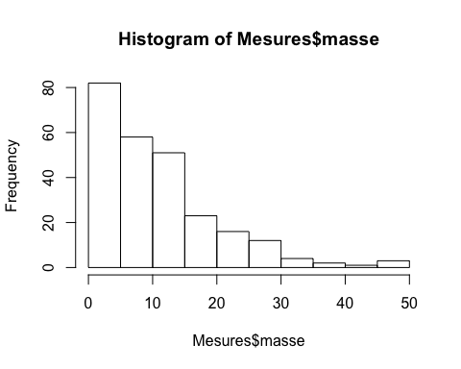

classes<-histo$breaks  
classes

## [1] 0 5 10 15 20 25 30 35 40 45 50

#page 106  
effectifs<-histo$counts  
effectifs

## [1] 82 58 51 23 16 12 4 2 1 3

effectifs<-histo$counts  
cumsum(effectifs)

## [1] 82 140 191 214 230 242 246 248 249 252

frequences<-effectifs/sum(effectifs)  
print(frequences,digits=3)

## [1] 0.32540 0.23016 0.20238 0.09127 0.06349 0.04762 0.01587 0.00794  
## [9] 0.00397 0.01190

sum(frequences)

## [1] 1

#page 107  
print(cumsum(frequences),digits=3)

## [1] 0.325 0.556 0.758 0.849 0.913 0.960 0.976 0.984 0.988 1.000

table(Mesures$espece)

##   
## bignone glycine blanche glycine violette laurier rose   
## 70 54 56 72

plot(taille~masse,data=Mesures)

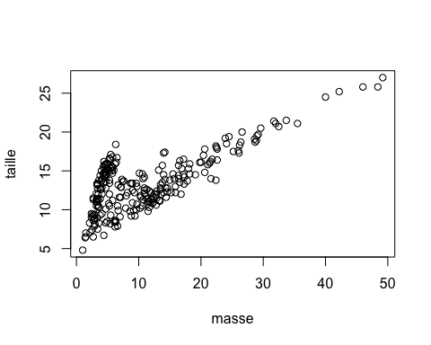

#ggplot est une bibliothèque graphique à connaître  
if(!("ggplot2" %in%  
 rownames(installed.packages()))){install.packages("ggplot2")}  
library(ggplot2)  
#ggplot(Mesures, aes(x = masse)) + geom_histogram()  
#Pas le même calcul de la largeur des classes par défaut. Dans ggplot2, la  
#largeur des classes (binwidth) est égale à l'étendue divisée par 30.  
ggplot(Mesures,aes(x=masse,y=taille))+geom_point()

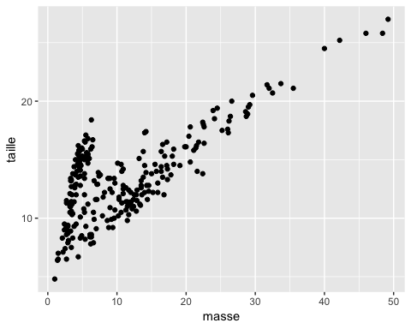

pdf("figure32Bggplot.pdf")  
print(ggplot(Mesures, aes(x = masse,y=taille)) + geom_point())  
dev.off()

## quartz_off_screen   
## 2

#page 109  
args(plot.default)

## function (x, y = NULL, type = "p", xlim = NULL, ylim = NULL,   
## log = "", main = NULL, sub = NULL, xlab = NULL, ylab = NULL,   
## ann = par("ann"), axes = TRUE, frame.plot = axes, panel.first = NULL,   
## panel.last = NULL, asp = NA, ...)   
## NULL

names(par())

## [1] "xlog" "ylog" "adj" "ann" "ask"   
## [6] "bg" "bty" "cex" "cex.axis" "cex.lab"   
## [11] "cex.main" "cex.sub" "cin" "col" "col.axis"   
## [16] "col.lab" "col.main" "col.sub" "cra" "crt"   
## [21] "csi" "cxy" "din" "err" "family"   
## [26] "fg" "fig" "fin" "font" "font.axis"  
## [31] "font.lab" "font.main" "font.sub" "lab" "las"   
## [36] "lend" "lheight" "ljoin" "lmitre" "lty"   
## [41] "lwd" "mai" "mar" "mex" "mfcol"   
## [46] "mfg" "mfrow" "mgp" "mkh" "new"   
## [51] "oma" "omd" "omi" "page" "pch"   
## [56] "pin" "plt" "ps" "pty" "smo"   
## [61] "srt" "tck" "tcl" "usr" "xaxp"   
## [66] "xaxs" "xaxt" "xpd" "yaxp" "yaxs"   
## [71] "yaxt" "ylbias"

#page 110  
plot(taille~masse,pch=19,main="Taille vs. Masse",xlab="Masse",ylab="Taille",data=Mesures)

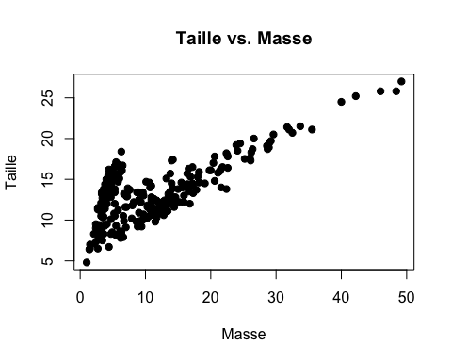

ggplot(Mesures, aes(x = masse,y=taille)) + geom_point(pch=19) + xlab("Masse") +  
 ylab("Taille") + ggtitle("Taille vs. Masse")

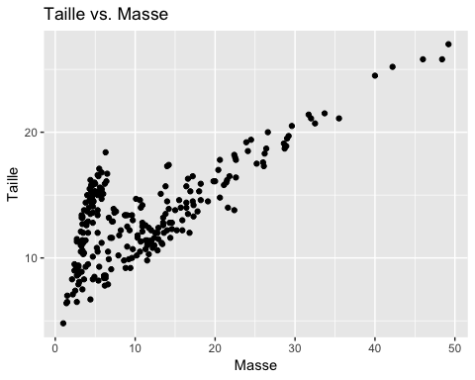

#Autre manière de spécifier le titre et le noms des axes  
ggplot(Mesures, aes(x = masse,y=taille)) + geom_point(pch=19) + labs(title =  
 "Taille vs. Masse", x = "Masse", y = "Taille")



#page 111  
pdf("figure33Bggplot.pdf")  
print(ggplot(Mesures, aes(x = masse,y=taille)) + geom_point(pch=19) +  
 xlab("Masse") + ylab("Taille") + ggtitle("Taille vs. Masse"))  
dev.off()

## quartz_off_screen   
## 2

ggplot(Mesures, aes(x = masse,y=taille)) + geom_point(pch=19) + xlab("Masse") +  
 ylab("Taille") + ggtitle("Taille vs. Masse")+theme(plot.title=element_text(hjust = 0.5))

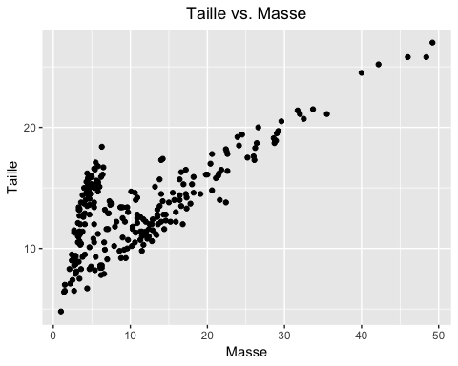

#Titre au centre  
theme_update(plot.title = element_text(hjust = 0.5))  
ggplot(Mesures, aes(x = masse,y=taille)) + geom_point(pch=19) + labs(title =  
 "Taille vs. Masse", x = "Masse", y = "Taille")



#Titre à gauche  
theme_update(plot.title = element_text(hjust = 0))  
ggplot(Mesures, aes(x = masse,y=taille)) + geom_point(pch=19) + labs(title =  
 "Taille vs. Masse", x = "Masse", y = "Taille")



#page 112  
#Titre à droite  
theme_update(plot.title = element_text(hjust = 1))  
ggplot(Mesures, aes(x = masse,y=taille)) + geom_point(pch=19) + labs(title =  
 "Taille vs. Masse", x = "Masse", y = "Taille")

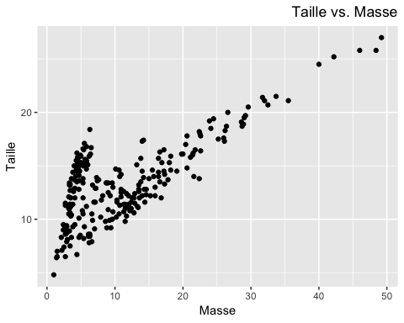

pdf("figure33Cggplot.pdf")  
theme_update(plot.title = element_text(hjust = 0.5))  
print(ggplot(Mesures, aes(x = masse,y=taille)) + geom_point(pch=19) +  
 xlab("Masse") + ylab("Taille") + ggtitle("Taille vs. Masse"))   
dev.off()

## quartz_off_screen   
## 2

#page 113  
pairs(Mesures5)

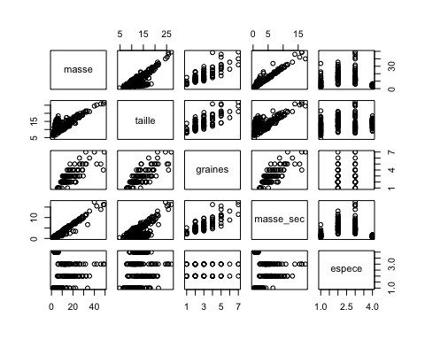

pdf("figure34.pdf")  
pairs(Mesures5)  
dev.off()

## quartz_off_screen   
## 2

pairs(Mesures5,diag.panel=panel.hist)

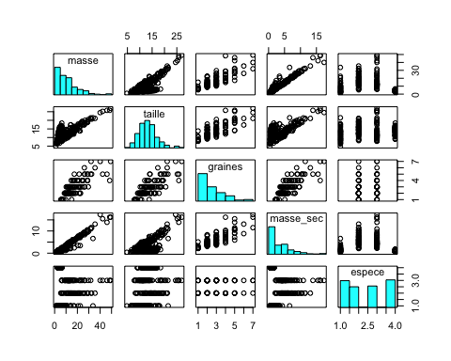

pdf("figure35A.pdf")  
pairs(Mesures5,diag.panel=panel.hist)  
dev.off()

## quartz_off_screen   
## 2

#page 114  
if(!("GGally" %in% rownames(installed.packages()))){install.packages("GGally")}  
library(GGally)  
#Noir et blanc  
ggpairs(Mesures5)

## Warning in (function (data, mapping, alignPercent = 0.6, method =  
## "pearson", : Removed 142 rows containing missing values

## Warning in (function (data, mapping, alignPercent = 0.6, method =  
## "pearson", : Removed 3 rows containing missing values

## Warning in (function (data, mapping, alignPercent = 0.6, method =  
## "pearson", : Removed 142 rows containing missing values

## Warning in (function (data, mapping, alignPercent = 0.6, method =  
## "pearson", : Removed 3 rows containing missing values

## Warning: Removed 142 rows containing missing values (geom_point).  
  
## Warning: Removed 142 rows containing missing values (geom_point).

## Warning: Removed 142 rows containing non-finite values (stat_density).

## Warning in (function (data, mapping, alignPercent = 0.6, method =  
## "pearson", : Removed 142 rows containing missing values

## Warning: Removed 142 rows containing non-finite values (stat_boxplot).

## Warning: Removed 3 rows containing missing values (geom_point).  
  
## Warning: Removed 3 rows containing missing values (geom_point).

## Warning: Removed 142 rows containing missing values (geom_point).

## Warning: Removed 3 rows containing non-finite values (stat_density).

## Warning: Removed 3 rows containing non-finite values (stat_boxplot).

## `stat_bin()` using `bins = 30`. Pick better value with `binwidth`.  
## `stat_bin()` using `bins = 30`. Pick better value with `binwidth`.  
## `stat_bin()` using `bins = 30`. Pick better value with `binwidth`.

## Warning: Removed 142 rows containing non-finite values (stat_bin).

## `stat_bin()` using `bins = 30`. Pick better value with `binwidth`.

## Warning: Removed 3 rows containing non-finite values (stat_bin).

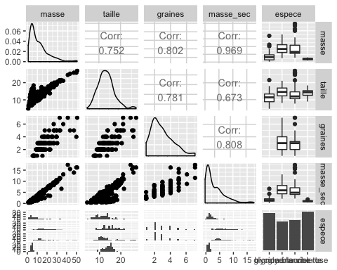

pdf("figure35Bggplot.pdf")  
print(ggpairs(Mesures5))

## Warning in (function (data, mapping, alignPercent = 0.6, method =  
## "pearson", : Removed 142 rows containing missing values

## Warning in (function (data, mapping, alignPercent = 0.6, method =  
## "pearson", : Removed 3 rows containing missing values

## Warning in (function (data, mapping, alignPercent = 0.6, method =  
## "pearson", : Removed 142 rows containing missing values

## Warning in (function (data, mapping, alignPercent = 0.6, method =  
## "pearson", : Removed 3 rows containing missing values

## Warning: Removed 142 rows containing missing values (geom_point).  
  
## Warning: Removed 142 rows containing missing values (geom_point).

## Warning: Removed 142 rows containing non-finite values (stat_density).

## Warning in (function (data, mapping, alignPercent = 0.6, method =  
## "pearson", : Removed 142 rows containing missing values

## Warning: Removed 142 rows containing non-finite values (stat_boxplot).

## Warning: Removed 3 rows containing missing values (geom_point).  
  
## Warning: Removed 3 rows containing missing values (geom_point).

## Warning: Removed 142 rows containing missing values (geom_point).

## Warning: Removed 3 rows containing non-finite values (stat_density).

## Warning: Removed 3 rows containing non-finite values (stat_boxplot).

## `stat_bin()` using `bins = 30`. Pick better value with `binwidth`.  
## `stat_bin()` using `bins = 30`. Pick better value with `binwidth`.  
## `stat_bin()` using `bins = 30`. Pick better value with `binwidth`.

## Warning: Removed 142 rows containing non-finite values (stat_bin).

## `stat_bin()` using `bins = 30`. Pick better value with `binwidth`.

## Warning: Removed 3 rows containing non-finite values (stat_bin).

dev.off()

## quartz_off_screen   
## 2

#Si besoin, créer des abréviations pour les noms des variables  
Mesures5abbr <- Mesures5  
Mesures5abbr$espece <- abbreviate(Mesures5$espece)  
ggpairs(Mesures5abbr, axisLabels='show')

## Warning in (function (data, mapping, alignPercent = 0.6, method =  
## "pearson", : Removed 142 rows containing missing values

## Warning in (function (data, mapping, alignPercent = 0.6, method =  
## "pearson", : Removed 3 rows containing missing values

## Warning in (function (data, mapping, alignPercent = 0.6, method =  
## "pearson", : Removed 142 rows containing missing values

## Warning in (function (data, mapping, alignPercent = 0.6, method =  
## "pearson", : Removed 3 rows containing missing values

## Warning: Removed 142 rows containing missing values (geom_point).  
  
## Warning: Removed 142 rows containing missing values (geom_point).

## Warning: Removed 142 rows containing non-finite values (stat_density).

## Warning in (function (data, mapping, alignPercent = 0.6, method =  
## "pearson", : Removed 142 rows containing missing values

## Warning: Removed 142 rows containing non-finite values (stat_boxplot).

## Warning: Removed 3 rows containing missing values (geom_point).  
  
## Warning: Removed 3 rows containing missing values (geom_point).

## Warning: Removed 142 rows containing missing values (geom_point).

## Warning: Removed 3 rows containing non-finite values (stat_density).

## Warning: Removed 3 rows containing non-finite values (stat_boxplot).

## `stat_bin()` using `bins = 30`. Pick better value with `binwidth`.  
## `stat_bin()` using `bins = 30`. Pick better value with `binwidth`.  
## `stat_bin()` using `bins = 30`. Pick better value with `binwidth`.

## Warning: Removed 142 rows containing non-finite values (stat_bin).

## `stat_bin()` using `bins = 30`. Pick better value with `binwidth`.

## Warning: Removed 3 rows containing non-finite values (stat_bin).

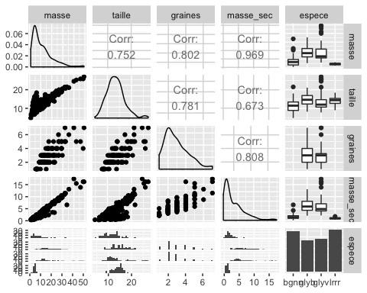

pdf("figure35abbrggplot.pdf")  
print(ggpairs(Mesures5abbr, axisLabels='show'))

## Warning in (function (data, mapping, alignPercent = 0.6, method =  
## "pearson", : Removed 142 rows containing missing values

## Warning in (function (data, mapping, alignPercent = 0.6, method =  
## "pearson", : Removed 3 rows containing missing values

## Warning in (function (data, mapping, alignPercent = 0.6, method =  
## "pearson", : Removed 142 rows containing missing values

## Warning in (function (data, mapping, alignPercent = 0.6, method =  
## "pearson", : Removed 3 rows containing missing values

## Warning: Removed 142 rows containing missing values (geom_point).  
  
## Warning: Removed 142 rows containing missing values (geom_point).

## Warning: Removed 142 rows containing non-finite values (stat_density).

## Warning in (function (data, mapping, alignPercent = 0.6, method =  
## "pearson", : Removed 142 rows containing missing values

## Warning: Removed 142 rows containing non-finite values (stat_boxplot).

## Warning: Removed 3 rows containing missing values (geom_point).  
  
## Warning: Removed 3 rows containing missing values (geom_point).

## Warning: Removed 142 rows containing missing values (geom_point).

## Warning: Removed 3 rows containing non-finite values (stat_density).

## Warning: Removed 3 rows containing non-finite values (stat_boxplot).

## `stat_bin()` using `bins = 30`. Pick better value with `binwidth`.  
## `stat_bin()` using `bins = 30`. Pick better value with `binwidth`.  
## `stat_bin()` using `bins = 30`. Pick better value with `binwidth`.

## Warning: Removed 142 rows containing non-finite values (stat_bin).

## `stat_bin()` using `bins = 30`. Pick better value with `binwidth`.

## Warning: Removed 3 rows containing non-finite values (stat_bin).

dev.off()

## quartz_off_screen   
## 2

#Couleur et groupes  
ggpairs(Mesures5abbr, ggplot2::aes(colour=espece, alpha=0.4), axisLabels='show')

## Warning in (function (data, mapping, alignPercent = 0.6, method =  
## "pearson", : Removed 142 rows containing missing values

## Warning in (function (data, mapping, alignPercent = 0.6, method =  
## "pearson", : Removed 3 rows containing missing values

## Warning in (function (data, mapping, alignPercent = 0.6, method =  
## "pearson", : Removed 142 rows containing missing values

## Warning in (function (data, mapping, alignPercent = 0.6, method =  
## "pearson", : Removed 3 rows containing missing values

## Warning: Removed 142 rows containing missing values (geom_point).  
  
## Warning: Removed 142 rows containing missing values (geom_point).

## Warning: Removed 142 rows containing non-finite values (stat_density).

## Warning in (function (data, mapping, alignPercent = 0.6, method =  
## "pearson", : Removed 142 rows containing missing values

## Warning: Removed 142 rows containing non-finite values (stat_boxplot).

## Warning: Removed 3 rows containing missing values (geom_point).  
  
## Warning: Removed 3 rows containing missing values (geom_point).

## Warning: Removed 142 rows containing missing values (geom_point).

## Warning: Removed 3 rows containing non-finite values (stat_density).

## Warning: Removed 3 rows containing non-finite values (stat_boxplot).

## `stat_bin()` using `bins = 30`. Pick better value with `binwidth`.  
## `stat_bin()` using `bins = 30`. Pick better value with `binwidth`.  
## `stat_bin()` using `bins = 30`. Pick better value with `binwidth`.

## Warning: Removed 142 rows containing non-finite values (stat_bin).

## `stat_bin()` using `bins = 30`. Pick better value with `binwidth`.

## Warning: Removed 3 rows containing non-finite values (stat_bin).

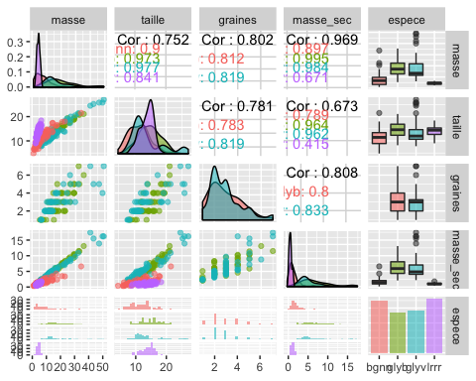

pdf("figure35couleurggplot.pdf")  
print(ggpairs(Mesures5abbr, ggplot2::aes(colour=espece, alpha=0.4),  
 axisLabels='show'))

## Warning in (function (data, mapping, alignPercent = 0.6, method =  
## "pearson", : Removed 142 rows containing missing values

## Warning in (function (data, mapping, alignPercent = 0.6, method =  
## "pearson", : Removed 3 rows containing missing values

## Warning in (function (data, mapping, alignPercent = 0.6, method =  
## "pearson", : Removed 142 rows containing missing values

## Warning in (function (data, mapping, alignPercent = 0.6, method =  
## "pearson", : Removed 3 rows containing missing values

## Warning: Removed 142 rows containing missing values (geom_point).  
  
## Warning: Removed 142 rows containing missing values (geom_point).

## Warning: Removed 142 rows containing non-finite values (stat_density).

## Warning in (function (data, mapping, alignPercent = 0.6, method =  
## "pearson", : Removed 142 rows containing missing values

## Warning: Removed 142 rows containing non-finite values (stat_boxplot).

## Warning: Removed 3 rows containing missing values (geom_point).  
  
## Warning: Removed 3 rows containing missing values (geom_point).

## Warning: Removed 142 rows containing missing values (geom_point).

## Warning: Removed 3 rows containing non-finite values (stat_density).

## Warning: Removed 3 rows containing non-finite values (stat_boxplot).

## `stat_bin()` using `bins = 30`. Pick better value with `binwidth`.  
## `stat_bin()` using `bins = 30`. Pick better value with `binwidth`.  
## `stat_bin()` using `bins = 30`. Pick better value with `binwidth`.

## Warning: Removed 142 rows containing non-finite values (stat_bin).

## `stat_bin()` using `bins = 30`. Pick better value with `binwidth`.

## Warning: Removed 3 rows containing non-finite values (stat_bin).

dev.off()

## quartz_off_screen   
## 2

#En plus  
#Noir et blanc  
Mesuresabbr <- Mesures  
Mesuresabbr$espece <- abbreviate(Mesures$espece)  
ggpairs(Mesuresabbr, diag=list(continuous="bar"), axisLabels='show')

## Warning in check_and_set_ggpairs_defaults("diag", diag, continuous =  
## "densityDiag", : Changing diag$continuous from 'bar' to 'barDiag'

## `stat_bin()` using `bins = 30`. Pick better value with `binwidth`.  
## `stat_bin()` using `bins = 30`. Pick better value with `binwidth`.  
## `stat_bin()` using `bins = 30`. Pick better value with `binwidth`.  
## `stat_bin()` using `bins = 30`. Pick better value with `binwidth`.

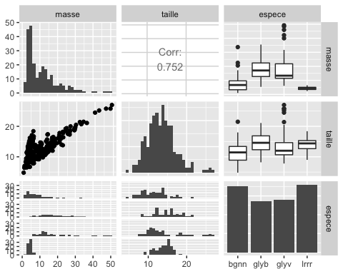

ggpairs(Mesures5abbr, diag=list(continuous="bar"), axisLabels='show')

## Warning in check_and_set_ggpairs_defaults("diag", diag, continuous =  
## "densityDiag", : Changing diag$continuous from 'bar' to 'barDiag'

## `stat_bin()` using `bins = 30`. Pick better value with `binwidth`.

## Warning in (function (data, mapping, alignPercent = 0.6, method =  
## "pearson", : Removed 142 rows containing missing values

## Warning in (function (data, mapping, alignPercent = 0.6, method =  
## "pearson", : Removed 3 rows containing missing values

## `stat_bin()` using `bins = 30`. Pick better value with `binwidth`.

## Warning in (function (data, mapping, alignPercent = 0.6, method =  
## "pearson", : Removed 142 rows containing missing values

## Warning in (function (data, mapping, alignPercent = 0.6, method =  
## "pearson", : Removed 3 rows containing missing values

## Warning: Removed 142 rows containing missing values (geom_point).  
  
## Warning: Removed 142 rows containing missing values (geom_point).

## `stat_bin()` using `bins = 30`. Pick better value with `binwidth`.

## Warning: Removed 142 rows containing non-finite values (stat_bin).

## Warning in (function (data, mapping, alignPercent = 0.6, method =  
## "pearson", : Removed 142 rows containing missing values

## Warning: Removed 142 rows containing non-finite values (stat_boxplot).

## Warning: Removed 3 rows containing missing values (geom_point).  
  
## Warning: Removed 3 rows containing missing values (geom_point).

## Warning: Removed 142 rows containing missing values (geom_point).

## `stat_bin()` using `bins = 30`. Pick better value with `binwidth`.

## Warning: Removed 3 rows containing non-finite values (stat_bin).

## Warning: Removed 3 rows containing non-finite values (stat_boxplot).

## `stat_bin()` using `bins = 30`. Pick better value with `binwidth`.  
## `stat_bin()` using `bins = 30`. Pick better value with `binwidth`.  
## `stat_bin()` using `bins = 30`. Pick better value with `binwidth`.

## Warning: Removed 142 rows containing non-finite values (stat_bin).

## `stat_bin()` using `bins = 30`. Pick better value with `binwidth`.

## Warning: Removed 3 rows containing non-finite values (stat_bin).

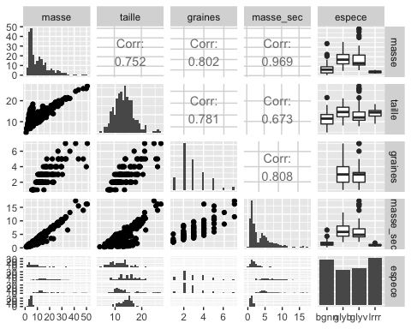

pdf("figure35Mesuresggplot.pdf")  
print(ggpairs(Mesuresabbr, diag=list(continuous="bar"), axisLabels='show'))

## Warning in check_and_set_ggpairs_defaults("diag", diag, continuous =  
## "densityDiag", : Changing diag$continuous from 'bar' to 'barDiag'

## `stat_bin()` using `bins = 30`. Pick better value with `binwidth`.  
## `stat_bin()` using `bins = 30`. Pick better value with `binwidth`.  
## `stat_bin()` using `bins = 30`. Pick better value with `binwidth`.  
## `stat_bin()` using `bins = 30`. Pick better value with `binwidth`.

dev.off()

## quartz_off_screen   
## 2

pdf("figure35Mesures5ggplot.pdf")  
print(ggpairs(Mesures5abbr, diag=list(continuous="bar"), axisLabels='show'))

## Warning in check_and_set_ggpairs_defaults("diag", diag, continuous =  
## "densityDiag", : Changing diag$continuous from 'bar' to 'barDiag'

## `stat_bin()` using `bins = 30`. Pick better value with `binwidth`.

## Warning in (function (data, mapping, alignPercent = 0.6, method =  
## "pearson", : Removed 142 rows containing missing values

## Warning in (function (data, mapping, alignPercent = 0.6, method =  
## "pearson", : Removed 3 rows containing missing values

## `stat_bin()` using `bins = 30`. Pick better value with `binwidth`.

## Warning in (function (data, mapping, alignPercent = 0.6, method =  
## "pearson", : Removed 142 rows containing missing values

## Warning in (function (data, mapping, alignPercent = 0.6, method =  
## "pearson", : Removed 3 rows containing missing values

## Warning: Removed 142 rows containing missing values (geom_point).  
  
## Warning: Removed 142 rows containing missing values (geom_point).

## `stat_bin()` using `bins = 30`. Pick better value with `binwidth`.

## Warning: Removed 142 rows containing non-finite values (stat_bin).

## Warning in (function (data, mapping, alignPercent = 0.6, method =  
## "pearson", : Removed 142 rows containing missing values

## Warning: Removed 142 rows containing non-finite values (stat_boxplot).

## Warning: Removed 3 rows containing missing values (geom_point).  
  
## Warning: Removed 3 rows containing missing values (geom_point).

## Warning: Removed 142 rows containing missing values (geom_point).

## `stat_bin()` using `bins = 30`. Pick better value with `binwidth`.

## Warning: Removed 3 rows containing non-finite values (stat_bin).

## Warning: Removed 3 rows containing non-finite values (stat_boxplot).

## `stat_bin()` using `bins = 30`. Pick better value with `binwidth`.  
## `stat_bin()` using `bins = 30`. Pick better value with `binwidth`.  
## `stat_bin()` using `bins = 30`. Pick better value with `binwidth`.

## Warning: Removed 142 rows containing non-finite values (stat_bin).

## `stat_bin()` using `bins = 30`. Pick better value with `binwidth`.

## Warning: Removed 3 rows containing non-finite values (stat_bin).

dev.off()

## quartz_off_screen   
## 2

#Couleur  
ggpairs(Mesuresabbr, ggplot2::aes(colour=espece, alpha=0.4),  
 diag=list(continuous="bar"), axisLabels='show')

## Warning in check_and_set_ggpairs_defaults("diag", diag, continuous =  
## "densityDiag", : Changing diag$continuous from 'bar' to 'barDiag'

## `stat_bin()` using `bins = 30`. Pick better value with `binwidth`.  
## `stat_bin()` using `bins = 30`. Pick better value with `binwidth`.  
## `stat_bin()` using `bins = 30`. Pick better value with `binwidth`.  
## `stat_bin()` using `bins = 30`. Pick better value with `binwidth`.

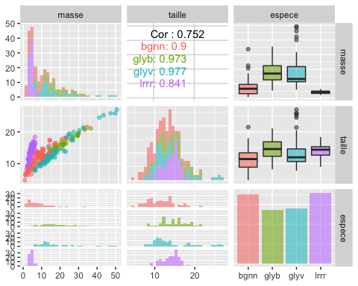

pdf("figure35MesuresCouleurggplot.pdf")  
print(ggpairs(Mesuresabbr, ggplot2::aes(colour=espece, alpha=0.4),  
 diag=list(continuous="bar"), axisLabels='show'))

## Warning in check_and_set_ggpairs_defaults("diag", diag, continuous =  
## "densityDiag", : Changing diag$continuous from 'bar' to 'barDiag'

## `stat_bin()` using `bins = 30`. Pick better value with `binwidth`.  
## `stat_bin()` using `bins = 30`. Pick better value with `binwidth`.  
## `stat_bin()` using `bins = 30`. Pick better value with `binwidth`.  
## `stat_bin()` using `bins = 30`. Pick better value with `binwidth`.

dev.off()

## quartz_off_screen   
## 2

ggpairs(Mesures5abbr, ggplot2::aes(colour=espece, alpha=0.4),  
 diag=list(continuous="bar"), axisLabels='show')

## Warning in check_and_set_ggpairs_defaults("diag", diag, continuous =  
## "densityDiag", : Changing diag$continuous from 'bar' to 'barDiag'

## `stat_bin()` using `bins = 30`. Pick better value with `binwidth`.

## Warning in (function (data, mapping, alignPercent = 0.6, method =  
## "pearson", : Removed 142 rows containing missing values

## Warning in (function (data, mapping, alignPercent = 0.6, method =  
## "pearson", : Removed 3 rows containing missing values

## `stat_bin()` using `bins = 30`. Pick better value with `binwidth`.

## Warning in (function (data, mapping, alignPercent = 0.6, method =  
## "pearson", : Removed 142 rows containing missing values

## Warning in (function (data, mapping, alignPercent = 0.6, method =  
## "pearson", : Removed 3 rows containing missing values

## Warning: Removed 142 rows containing missing values (geom_point).  
  
## Warning: Removed 142 rows containing missing values (geom_point).

## `stat_bin()` using `bins = 30`. Pick better value with `binwidth`.

## Warning: Removed 142 rows containing non-finite values (stat_bin).

## Warning in (function (data, mapping, alignPercent = 0.6, method =  
## "pearson", : Removed 142 rows containing missing values

## Warning: Removed 142 rows containing non-finite values (stat_boxplot).

## Warning: Removed 3 rows containing missing values (geom_point).  
  
## Warning: Removed 3 rows containing missing values (geom_point).

## Warning: Removed 142 rows containing missing values (geom_point).

## `stat_bin()` using `bins = 30`. Pick better value with `binwidth`.

## Warning: Removed 3 rows containing non-finite values (stat_bin).

## Warning: Removed 3 rows containing non-finite values (stat_boxplot).

## `stat_bin()` using `bins = 30`. Pick better value with `binwidth`.  
## `stat_bin()` using `bins = 30`. Pick better value with `binwidth`.  
## `stat_bin()` using `bins = 30`. Pick better value with `binwidth`.

## Warning: Removed 142 rows containing non-finite values (stat_bin).

## `stat_bin()` using `bins = 30`. Pick better value with `binwidth`.

## Warning: Removed 3 rows containing non-finite values (stat_bin).

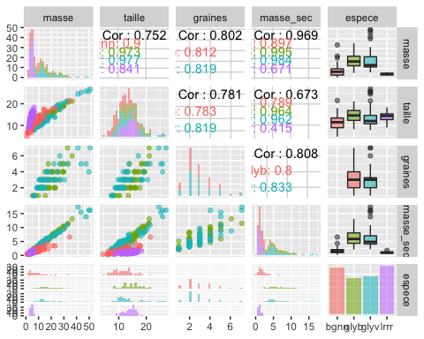

pdf("figure35Mesures5Couleurggplot.pdf")  
print(ggpairs(Mesures5abbr, ggplot2::aes(colour=espece, alpha=0.4),  
 diag=list(continuous="bar"), axisLabels='show'))

## Warning in check_and_set_ggpairs_defaults("diag", diag, continuous =  
## "densityDiag", : Changing diag$continuous from 'bar' to 'barDiag'

## `stat_bin()` using `bins = 30`. Pick better value with `binwidth`.

## Warning in (function (data, mapping, alignPercent = 0.6, method =  
## "pearson", : Removed 142 rows containing missing values

## Warning in (function (data, mapping, alignPercent = 0.6, method =  
## "pearson", : Removed 3 rows containing missing values

## `stat_bin()` using `bins = 30`. Pick better value with `binwidth`.

## Warning in (function (data, mapping, alignPercent = 0.6, method =  
## "pearson", : Removed 142 rows containing missing values

## Warning in (function (data, mapping, alignPercent = 0.6, method =  
## "pearson", : Removed 3 rows containing missing values

## Warning: Removed 142 rows containing missing values (geom_point).  
  
## Warning: Removed 142 rows containing missing values (geom_point).

## `stat_bin()` using `bins = 30`. Pick better value with `binwidth`.

## Warning: Removed 142 rows containing non-finite values (stat_bin).

## Warning in (function (data, mapping, alignPercent = 0.6, method =  
## "pearson", : Removed 142 rows containing missing values

## Warning: Removed 142 rows containing non-finite values (stat_boxplot).

## Warning: Removed 3 rows containing missing values (geom_point).  
  
## Warning: Removed 3 rows containing missing values (geom_point).

## Warning: Removed 142 rows containing missing values (geom_point).

## `stat_bin()` using `bins = 30`. Pick better value with `binwidth`.

## Warning: Removed 3 rows containing non-finite values (stat_bin).

## Warning: Removed 3 rows containing non-finite values (stat_boxplot).

## `stat_bin()` using `bins = 30`. Pick better value with `binwidth`.  
## `stat_bin()` using `bins = 30`. Pick better value with `binwidth`.  
## `stat_bin()` using `bins = 30`. Pick better value with `binwidth`.

## Warning: Removed 142 rows containing non-finite values (stat_bin).

## `stat_bin()` using `bins = 30`. Pick better value with `binwidth`.

## Warning: Removed 3 rows containing non-finite values (stat_bin).

dev.off()

## quartz_off_screen   
## 2

#page 116  
plot(table(Mesures5$graines),type="h",lwd=4,col="red",xlab="Nombre de graines",ylab="Effectif")

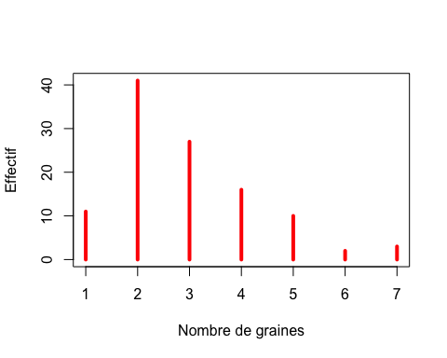

pdf("figure36Aggplot.pdf")  
plot(table(Mesures5$graines),type="h",lwd=4,col="red",xlab="Nombre de graines",ylab="Effectif")  
dev.off()

## quartz_off_screen   
## 2

#page 117  
table(Mesures5$graines)

##   
## 1 2 3 4 5 6 7   
## 11 41 27 16 10 2 3

ggplot(Mesures5, aes(x = graines)) + geom_bar(fill=I("red")) +   
 xlab("Nombre de graines") + ylab("Effectif")

## Warning: Removed 142 rows containing non-finite values (stat_count).

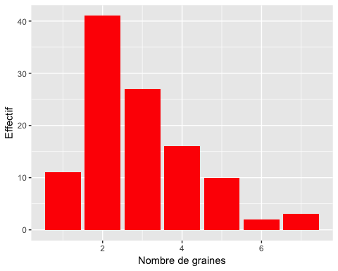

#page 118  
ggplot(Mesures5, aes(x = graines)) + geom_histogram(binwidth=.1,fill=I("red")) +  
 xlab("Nombre de graines") + ylab("Effectif")

## Warning: Removed 142 rows containing non-finite values (stat_bin).

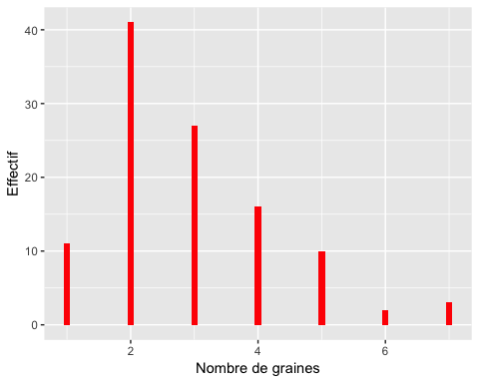

pdf("figure36Bggplot.pdf")  
ggplot(Mesures5, aes(x = graines)) + geom_histogram(binwidth=.1,fill=I("red")) +  
 xlab("Nombre de graines") + ylab("Effectif")

## Warning: Removed 142 rows containing non-finite values (stat_bin).

dev.off()

## quartz_off_screen   
## 2

#page 119  
ggplot(Mesures5, aes(x = graines)) + geom_histogram(binwidth=.1,fill=I("red")) +  
 xlab("Nombre de graines") + ylab("Effectif") + facet_grid(.~espece)

## Warning: Removed 142 rows containing non-finite values (stat_bin).

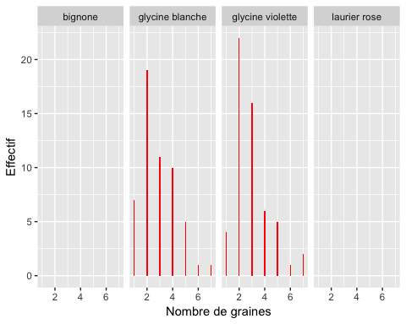

ggplot(Mesures5, aes(x = graines)) + geom_histogram(binwidth=.1,fill=I("red")) +  
 xlab("Nombre de graines") + ylab("Effectif") + facet_grid(espece~.)

## Warning: Removed 142 rows containing non-finite values (stat_bin).

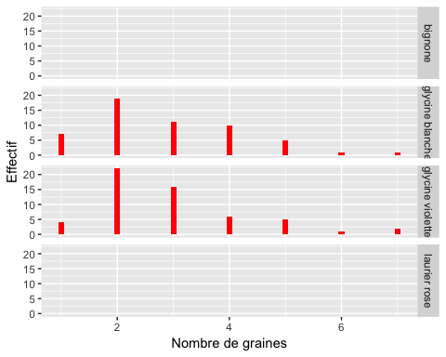

ggplot(Mesures5, aes(x = graines)) + geom_histogram(binwidth=.1,fill=I("red")) +  
 xlab("Nombre de graines") + ylab("Effectif") + facet_wrap(~espece)

## Warning: Removed 142 rows containing non-finite values (stat_bin).

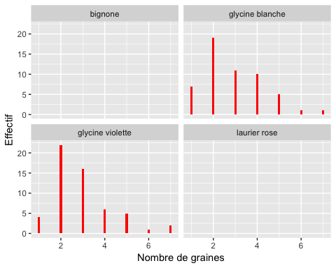

pdf("figure36Cggplot.pdf")  
ggplot(Mesures5, aes(x = graines)) + geom_histogram(binwidth=.1,fill=I("red")) +  
 xlab("Nombre de graines") + ylab("Effectif") + facet_wrap(~espece)

## Warning: Removed 142 rows containing non-finite values (stat_bin).

dev.off()

## quartz_off_screen   
## 2

tapply(Mesures5$graines,Mesures5$espece,table)

## $bignone  
## < table of extent 0 >  
##   
## $`glycine blanche`  
##   
## 1 2 3 4 5 6 7   
## 7 19 11 10 5 1 1   
##   
## $`glycine violette`  
##   
## 1 2 3 4 5 6 7   
## 4 22 16 6 5 1 2   
##   
## $`laurier rose`  
## < table of extent 0 >

#En plus avec ggplot  
data.graines_espece<-as.data.frame(table(Mesures5$graines,Mesures5$espece))  
colnames(data.graines_espece)<-c("nbr.graines","espece","effectif")  
ggplot(data.graines_espece,aes(y=effectif,x=nbr.graines))+geom_bar(stat=  
 "identity")+ facet_grid(espece~.)

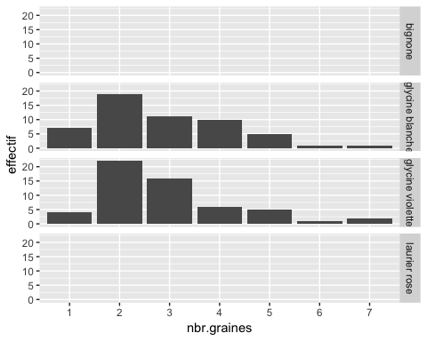

ggplot(data.graines_espece,aes(y=effectif,x=nbr.graines))+geom_bar(stat=  
 "identity")+ facet_grid(~espece)

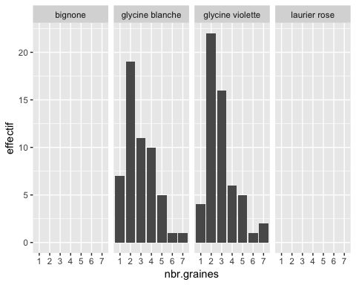

ggplot(data.graines_espece,aes(y=effectif,x=nbr.graines))+geom_bar(stat=  
 "identity")+ facet_wrap(~espece)

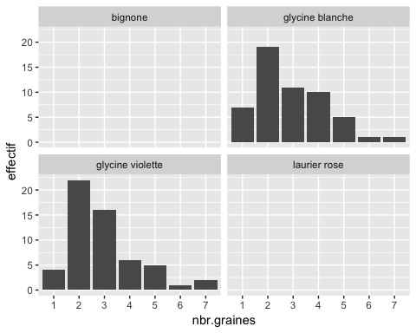

ggplot(data.graines_espece,aes(y=effectif,x=nbr.graines,fill=espece))+geom_bar(  
 stat="identity")+ facet_wrap(~espece)

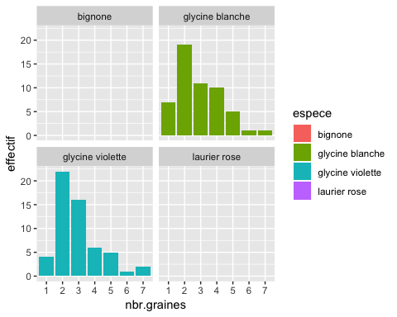

ggplot(data.graines_espece,aes(y=effectif,x=nbr.graines,fill=espece))+geom_bar(  
 stat="identity")+ facet_wrap(~espece) + scale_fill_grey() + theme_bw()

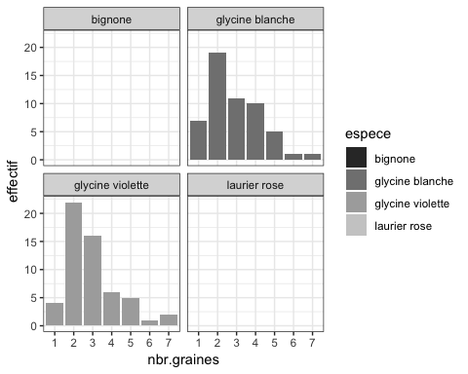

ggplot(data.graines_espece,aes(y=effectif,x=nbr.graines,fill=nbr.graines))+  
 geom_bar(stat="identity")+ facet_wrap(~espece)

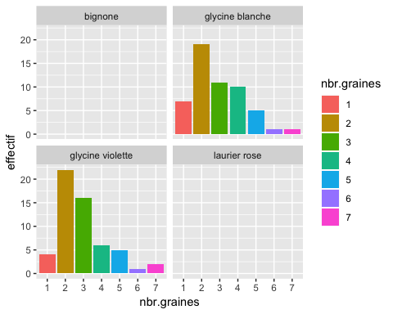

ggplot(data.graines_espece,aes(y=effectif,x=nbr.graines,fill=nbr.graines))+  
 geom_bar(stat="identity")+ facet_wrap(~espece) + scale_fill_grey() + theme_bw()

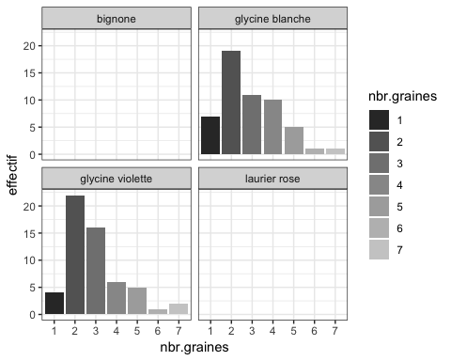

pdf("figure36Dggplot.pdf")  
print(ggplot(data.graines_espece,aes(y=effectif,x=nbr.graines))+geom_bar(stat=  
 "identity")+ facet_grid(espece~.))  
dev.off()

## quartz_off_screen   
## 2

pdf("figure36Eggplot.pdf")  
print(ggplot(data.graines_espece,aes(y=effectif,x=nbr.graines))+geom_bar(stat=  
 "identity")+ facet_grid(~espece))  
dev.off()

## quartz_off_screen   
## 2

pdf("figure36Fggplot.pdf")  
print(ggplot(data.graines_espece,aes(y=effectif,x=nbr.graines))+geom_bar(stat=  
 "identity")+ facet_wrap(~espece))  
dev.off()

## quartz_off_screen   
## 2

pdf("figure36Gggplot.pdf")  
print(ggplot(data.graines_espece,aes(y=effectif,x=nbr.graines,fill=espece))+  
 geom_bar(stat="identity")+ facet_wrap(~espece))  
dev.off()

## quartz_off_screen   
## 2

pdf("figure36Hbwggplot.pdf")  
print(ggplot(data.graines_espece,aes(y=effectif,x=nbr.graines,fill=espece))+  
 geom_bar(stat="identity")+ facet_wrap(~espece) + scale_fill_grey() + theme_bw())  
dev.off()

## quartz_off_screen   
## 2

pdf("figure36Iggplot.pdf")  
print(ggplot(data.graines_espece,aes(y=effectif,x=nbr.graines,fill=nbr.graines))  
 +geom_bar(stat="identity")+ facet_wrap(~espece))  
dev.off()

## quartz_off_screen   
## 2

pdf("figure36Jbwggplot.pdf")  
print(ggplot(data.graines_espece,aes(y=effectif,x=nbr.graines,fill=nbr.graines))  
 +geom_bar(stat="identity")+ facet_wrap(~espece) + scale_fill_grey() +  
 theme_bw())  
dev.off()

## quartz_off_screen   
## 2

#page 120  
if(!("lattice" %in%  
 rownames(installed.packages()))){install.packages("lattice")}  
library("lattice")  
data.graines_espece<-as.data.frame(table(Mesures5$graines,Mesures5$espece))  
colnames(data.graines_espece)<-c("nbr.graines","espece","effectif")  
barchart(effectif~nbr.graines|espece,data=data.graines_espece,layout=c(1,4))

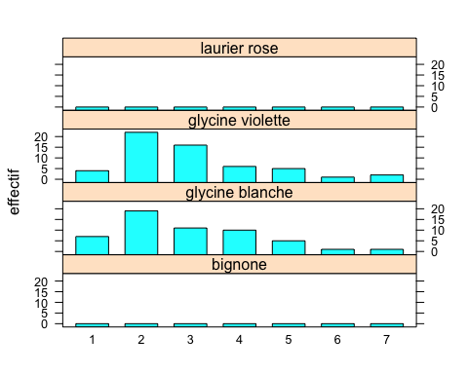

#page 121  
as.data.frame(table(Mesures5$graines,Mesures5$espece))

## Var1 Var2 Freq  
## 1 1 bignone 0  
## 2 2 bignone 0  
## 3 3 bignone 0  
## 4 4 bignone 0  
## 5 5 bignone 0  
## 6 6 bignone 0  
## 7 7 bignone 0  
## 8 1 glycine blanche 7  
## 9 2 glycine blanche 19  
## 10 3 glycine blanche 11  
## 11 4 glycine blanche 10  
## 12 5 glycine blanche 5  
## 13 6 glycine blanche 1  
## 14 7 glycine blanche 1  
## 15 1 glycine violette 4  
## 16 2 glycine violette 22  
## 17 3 glycine violette 16  
## 18 4 glycine violette 6  
## 19 5 glycine violette 5  
## 20 6 glycine violette 1  
## 21 7 glycine violette 2  
## 22 1 laurier rose 0  
## 23 2 laurier rose 0  
## 24 3 laurier rose 0  
## 25 4 laurier rose 0  
## 26 5 laurier rose 0  
## 27 6 laurier rose 0  
## 28 7 laurier rose 0

(table.graines.espece <-  
 table(Mesures5$graines,Mesures5$espece,dnn=c("nbr.graines","espece")))

## espece  
## nbr.graines bignone glycine blanche glycine violette laurier rose  
## 1 0 7 4 0  
## 2 0 19 22 0  
## 3 0 11 16 0  
## 4 0 10 6 0  
## 5 0 5 5 0  
## 6 0 1 1 0  
## 7 0 1 2 0

print(table.graines.espece,zero.print=".")

## espece  
## nbr.graines bignone glycine blanche glycine violette laurier rose  
## 1 . 7 4 .  
## 2 . 19 22 .  
## 3 . 11 16 .  
## 4 . 10 6 .  
## 5 . 5 5 .  
## 6 . 1 1 .  
## 7 . 1 2 .

(data.graines.espece <-  
 as.data.frame(table.graines.espece,responseName="effectif"))

## nbr.graines espece effectif  
## 1 1 bignone 0  
## 2 2 bignone 0  
## 3 3 bignone 0  
## 4 4 bignone 0  
## 5 5 bignone 0  
## 6 6 bignone 0  
## 7 7 bignone 0  
## 8 1 glycine blanche 7  
## 9 2 glycine blanche 19  
## 10 3 glycine blanche 11  
## 11 4 glycine blanche 10  
## 12 5 glycine blanche 5  
## 13 6 glycine blanche 1  
## 14 7 glycine blanche 1  
## 15 1 glycine violette 4  
## 16 2 glycine violette 22  
## 17 3 glycine violette 16  
## 18 4 glycine violette 6  
## 19 5 glycine violette 5  
## 20 6 glycine violette 1  
## 21 7 glycine violette 2  
## 22 1 laurier rose 0  
## 23 2 laurier rose 0  
## 24 3 laurier rose 0  
## 25 4 laurier rose 0  
## 26 5 laurier rose 0  
## 27 6 laurier rose 0  
## 28 7 laurier rose 0

barchart(effectif~nbr.graines|espece,data= data.graines.espece)

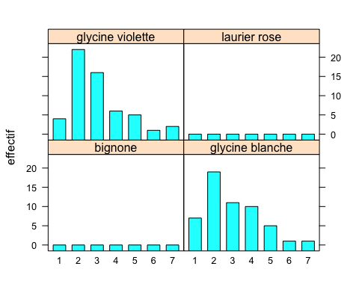

pdf("figure38lattice.pdf")  
barchart(effectif~nbr.graines|espece,data= data.graines.espece)  
dev.off()

## quartz_off_screen   
## 2

#En plus avec ggplot2  
ggplot(data.graines.espece,aes(y=effectif,x=nbr.graines,fill=nbr.graines))+  
 geom_bar(stat="identity")+ facet_wrap(~espece)



pdf("figure38ggplot.pdf")  
print(ggplot(data.graines.espece,aes(y=effectif,x=nbr.graines,fill=nbr.graines))  
 +geom_bar(stat="identity")+ facet_wrap(~espece))  
dev.off()

## quartz_off_screen   
## 2

#page 122  
(table.graines.espece <-  
 table(factor(Mesures5$graines),Mesures5$espece,dnn=c("nbr.graines","espece"),  
 exclude=c("bignone","laurier rose")))

## espece  
## nbr.graines glycine blanche glycine violette  
## 1 7 4  
## 2 19 22  
## 3 11 16  
## 4 10 6  
## 5 5 5  
## 6 1 1  
## 7 1 2  
## <NA> 0 0

#En plus pour supprimer la modalité <NA>  
(table.graines.espece <-  
 table(factor(Mesures5$graines),Mesures5$espece,dnn=c("nbr.graines","espece"),  
 exclude=c("bignone","laurier rose"), useNA="no"))

## espece  
## nbr.graines glycine blanche glycine violette  
## 1 7 4  
## 2 19 22  
## 3 11 16  
## 4 10 6  
## 5 5 5  
## 6 1 1  
## 7 1 2

#page 123  
(data.graines.espece<-as.data.frame(table.graines.espece,responseName="effectif"  
))

## nbr.graines espece effectif  
## 1 1 glycine blanche 7  
## 2 2 glycine blanche 19  
## 3 3 glycine blanche 11  
## 4 4 glycine blanche 10  
## 5 5 glycine blanche 5  
## 6 6 glycine blanche 1  
## 7 7 glycine blanche 1  
## 8 1 glycine violette 4  
## 9 2 glycine violette 22  
## 10 3 glycine violette 16  
## 11 4 glycine violette 6  
## 12 5 glycine violette 5  
## 13 6 glycine violette 1  
## 14 7 glycine violette 2

pdf("figure39lattice.pdf")  
barchart(effectif~nbr.graines|espece,data=data.graines.espece)  
dev.off()

## quartz_off_screen   
## 2

#En plus avec ggplot  
ggplot(data.graines.espece,aes(y=effectif,x=nbr.graines,fill=nbr.graines))+  
 geom_bar(stat="identity")+ facet_grid(~espece)

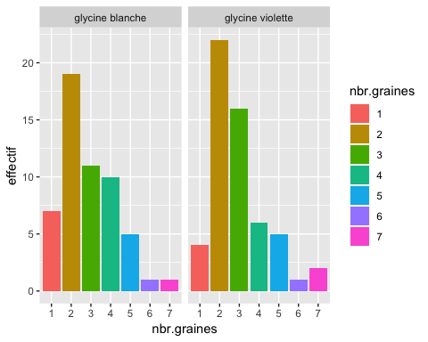

pdf("figure39ggplot.pdf")  
print(ggplot(data.graines.espece,aes(y=effectif,x=nbr.graines,fill=nbr.graines))  
 +geom_bar(stat="identity")+ facet_grid(~espece))  
dev.off()

## quartz_off_screen   
## 2

print(ggplot(data.graines.espece,aes(y=effectif,x=nbr.graines,fill=nbr.graines))  
 +geom_bar(stat="identity")+ facet_grid(~espece) + scale_fill_grey() +  
 theme_bw())

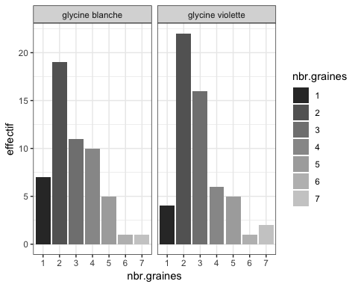

pdf("figure39bwggplot.pdf")  
print(ggplot(data.graines.espece,aes(y=effectif,x=nbr.graines,fill=nbr.graines))  
 +geom_bar(stat="identity")+ facet_grid(~espece) + scale_fill_grey() +  
 theme_bw())  
dev.off()

## quartz_off_screen   
## 2

barchart(effectif~nbr.graines|espece,data=data.graines.espece,layout=c(1,2))

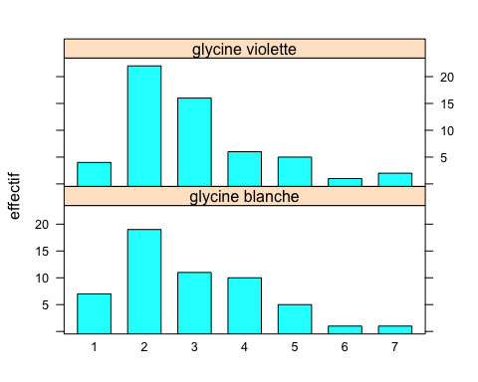

pdf("figure310lattice.pdf")  
barchart(effectif~nbr.graines|espece,data=data.graines.espece,layout=c(1,2))  
dev.off()

## quartz_off_screen   
## 2

#En plus  
ggplot(data.graines.espece,aes(y=effectif,x=nbr.graines,fill=nbr.graines))+  
 geom_bar(stat="identity")+ facet_grid(espece~.)

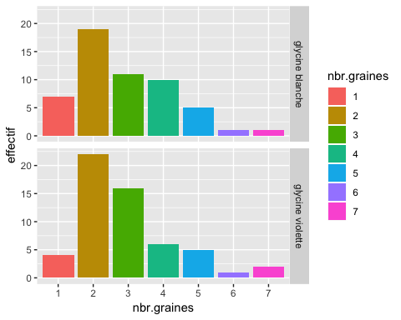

pdf("figure310ggplot.pdf")  
print(ggplot(data.graines.espece,aes(y=effectif,x=nbr.graines,fill=nbr.graines))  
 +geom_bar(stat="identity")+ facet_grid(espece~.))  
dev.off()

## quartz_off_screen   
## 2

print(ggplot(data.graines.espece,aes(y=effectif,x=nbr.graines,fill=nbr.graines))  
 +geom_bar(stat="identity")+ facet_grid(espece~.) + scale_fill_grey() +  
 theme_bw())

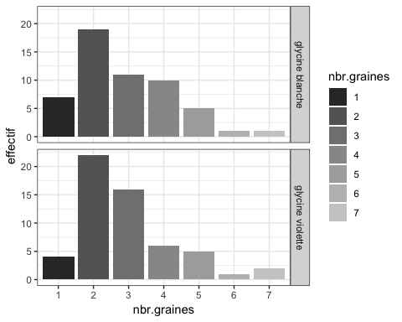

pdf("figure310bwggplot.pdf")  
print(ggplot(data.graines.espece,aes(y=effectif,x=nbr.graines,fill=nbr.graines))  
 +geom_bar(stat="identity")+ facet_grid(espece~.) + scale_fill_grey() +  
 theme_bw())  
dev.off()

## quartz_off_screen   
## 2

#page 125  
xyplot(effectif~nbr.graines|espece,data=data.graines.espece,type="h",lwd=4)

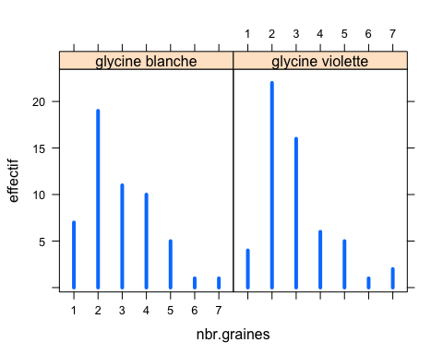

pdf("figure311lattice.pdf")  
xyplot(effectif~nbr.graines|espece,data=data.graines.espece,type="h",lwd=4)  
dev.off()

## quartz_off_screen   
## 2

#En plus ggplot  
ggplot(data.graines.espece, aes(x = nbr.graines)) +  
 geom_linerange(aes(ymin=0,ymax=effectif,group=espece),size=1.2,color=I("blue"))+  
 xlab("Nombre de graines") + ylab("Effectif") + facet_wrap(~espece)

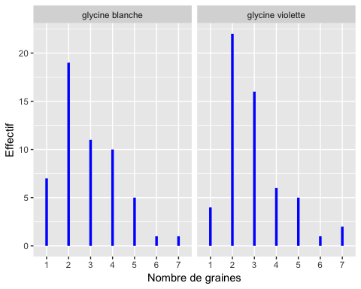

pdf("figure311ggplot.pdf")  
print(ggplot(data.graines.espece, aes(x = nbr.graines)) +  
 geom_linerange(aes(ymin=0,ymax=effectif,group=espece),size=1.2,color=I("blue"))+  
 xlab("Nombre de graines") + ylab("Effectif") + facet_wrap(~espece))  
dev.off()

## quartz_off_screen   
## 2

xyplot(effectif~nbr.graines|espece,data=data.graines.espece,type="h",layout=c(1,2),lwd=4)

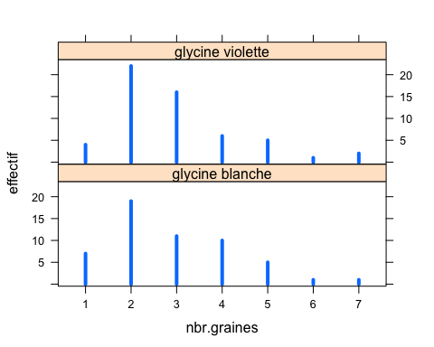

pdf("figure312lattice.pdf")  
xyplot(effectif~nbr.graines|espece,data=data.graines.espece,type="h",layout=c(1,2),lwd=4)  
dev.off()

## quartz_off_screen   
## 2

ggplot(data.graines.espece, aes(x = nbr.graines)) +  
 geom_linerange(aes(ymin=0,ymax=effectif,group=espece),size=1.2,color=I("blue"))+  
 xlab("Nombre de graines") + ylab("Effectif") + facet_grid(espece~.)

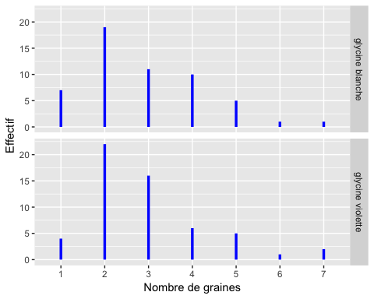

pdf("figure312ggplot.pdf")  
print(ggplot(data.graines.espece, aes(x = nbr.graines)) +  
 geom_linerange(aes(ymin=0,ymax=effectif,group=espece),size=1.2,color=I("blue"))+  
 xlab("Nombre de graines") + ylab("Effectif") + facet_grid(espece~.))  
dev.off()

## quartz_off_screen   
## 2

#page 126  
barplot(table.graines.espece,beside=TRUE,legend=rownames(table.graines.espece))

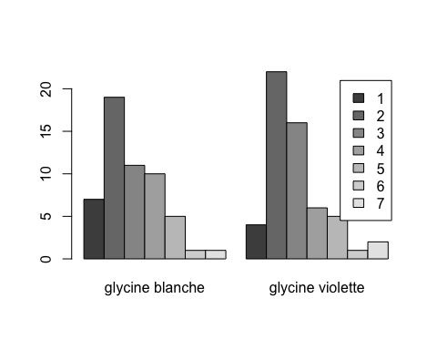

pdf("figure313.pdf")  
barplot(table.graines.espece,beside=TRUE,legend=rownames(table.graines.espece))  
dev.off()

## quartz_off_screen   
## 2

#En plus avec ggplot  
ggplot(data.graines.espece, aes(x = nbr.graines, y= effectif, fill =  
 nbr.graines)) + geom_bar(stat="identity") + xlab("Nombre de graines") +  
 ylab("Effectif") + facet_wrap(~espece) + scale_fill_grey() + theme_bw()

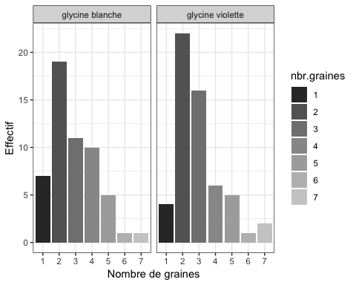

pdf("figure313ggplot.pdf")  
print(ggplot(data.graines.espece, aes(x = nbr.graines, y= effectif, fill =  
 nbr.graines)) + geom_bar(stat="identity") + xlab("Nombre de graines") +  
 ylab("Effectif") + facet_wrap(~espece) + scale_fill_grey() + theme_bw())  
dev.off()

## quartz_off_screen   
## 2

plot(table(Mesures5$graines),lwd=4,col="red",xlab="Nombre de graines",ylab="Effectif")  
lines(table(Mesures5$graines),type="l",lwd=4)

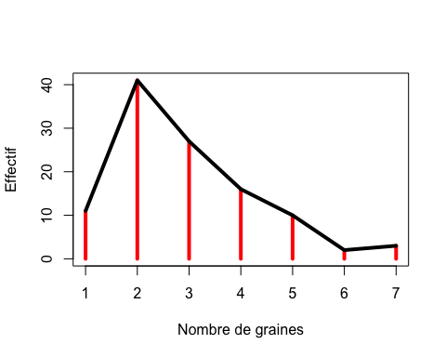

pdf("figure314.pdf")  
plot(table(Mesures5$graines),lwd=4,col="red",xlab="Nombre de graines",ylab="Effectif")  
lines(table(Mesures5$graines),type="l",lwd=4)  
dev.off()

## quartz_off_screen   
## 2

#En plus avec ggplot  
df.table_graines<-as.data.frame(table(Mesures5$graines,dnn="nbr.graines"),  
 responseName="effectif")  
ggplot(df.table_graines, aes(x = nbr.graines)) +  
 geom_linerange(aes(ymin=0,ymax=effectif),size=1.8,color=I("red"))+   
 xlab("Nombre de graines") + ylab("Effectif")

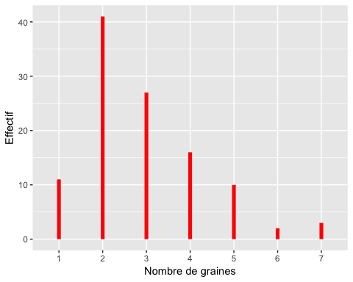

pdf("figure314ggplot.pdf")  
ggplot(df.table_graines, aes(x = nbr.graines)) + geom_linerange(aes(ymin=0,ymax=effectif),  
 size=1.8,color=I("red"))+ xlab("Nombre de graines") + ylab("Effectif")  
dev.off()

## quartz_off_screen   
## 2

ggplot(df.table_graines, aes(x = nbr.graines)) + geom_linerange(aes(ymin=0, ymax=effectif),   
 size=1.2,color=I("red"))+ geom_line(aes(y=effectif,group=""),size=1.2,color=I("black"))+   
 xlab("Nombre de graines") + ylab("Effectif")

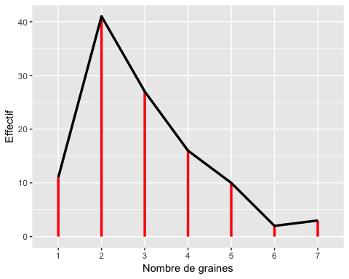

pdf("figure314aggplot.pdf")  
print(ggplot(df.table_graines, aes(x = nbr.graines)) +  
 geom_linerange(aes(ymin=0, ymax=effectif), size=1.2,color=I("red"))+  
 geom_line(aes(y=effectif,group=""), size=1.2,color=I("black"))+   
 xlab("Nombre de graines") + ylab("Effectif"))  
dev.off()

## quartz_off_screen   
## 2

ggplot(df.table_graines, aes(x = nbr.graines))+  
 geom_line(aes(y=effectif,group=""), size=1.2,color=I("black")) +  
 geom_pointrange(aes(ymin=0,ymax=effectif,y=effectif,group=""),  
 size=1.2,color=I("red"))+ xlab("Nombre de graines") + ylab("Effectif")

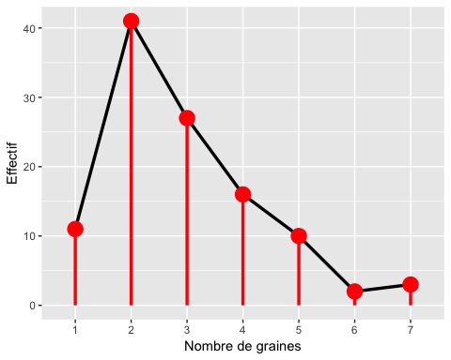

pdf("figure314bggplot.pdf")  
print(ggplot(df.table_graines, aes(x = nbr.graines))+  
 geom_line(aes(y=effectif,group=""), size=1.2,color=I("black")) +  
 geom_pointrange(aes(ymin=0,ymax=effectif,y=effectif,group=""),  
 size=1.2,color=I("red"))+ xlab("Nombre de graines") + ylab("Effectif"))  
dev.off()

## quartz_off_screen   
## 2

ggplot(df.table_graines, aes(x = nbr.graines)) +  
 geom_ribbon(aes(ymin=0,ymax=effectif,group=""),fill=I("red"),alpha=.5)+  
 geom_line(aes(y=effectif,group=""), size=1, color="red")+  
 geom_pointrange(aes(ymin=0,ymax=effectif,y=effectif,group=""), size=1,  
 color="blue")+ xlab("Nombre de graines") + ylab("Effectif") +theme_bw()

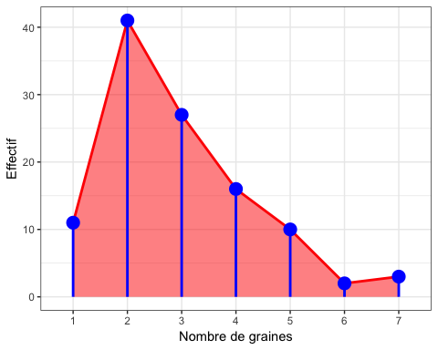

pdf("figure314cggplot.pdf")  
print(ggplot(df.table_graines, aes(x = nbr.graines)) +  
 geom_ribbon(aes(ymin=0,ymax=effectif,group=""),fill=I("red"),alpha=.5)+  
 geom_line(aes(y=effectif,group=""), size=1, color="red")+  
 geom_pointrange(aes(ymin=0,ymax=effectif,y=effectif,group=""), size=1,  
 color="blue")+ xlab("Nombre de graines") + ylab("Effectif") +theme_bw())  
dev.off()

## quartz_off_screen   
## 2

ggplot(df.table_graines, aes(x = nbr.graines)) +  
 geom_ribbon(aes(ymin=0,ymax=effectif,group=""),fill=I("gray80"))+  
 geom_line(aes(y=effectif,group=""), size=1, color=I("gray40")) +  
 geom_pointrange(aes(ymin=0,ymax=effectif,y=effectif,group=""), size=1)+   
 xlab("Nombre de graines") + ylab("Effectif") +theme_bw()

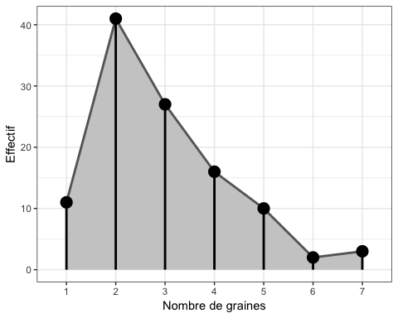

pdf("figure314dggplot.pdf")  
print(ggplot(df.table_graines, aes(x = nbr.graines)) +  
 geom_ribbon(aes(ymin=0,ymax=effectif,group=""),fill=I("gray80"))+  
 geom_line(aes(y=effectif,group=""), size=1, color=I("gray40")) +  
 geom_pointrange(aes(ymin=0,ymax=effectif,y=effectif,group=""), size=1)+   
 xlab("Nombre de graines") + ylab("Effectif") +theme_bw())  
dev.off()

## quartz_off_screen   
## 2

#En plus, ggplot par groupes  
ggplot(data.graines.espece, aes(x = nbr.graines)) +  
 geom_linerange(aes(ymin=0,ymax=effectif,group=espece), size=1.2,color=I("red"))+  
 geom_line(aes(y=effectif,group=espece), size=1.2,color=I("black"))+   
 xlab("Nombre de graines") + ylab("Effectif") + facet_wrap(~espece)

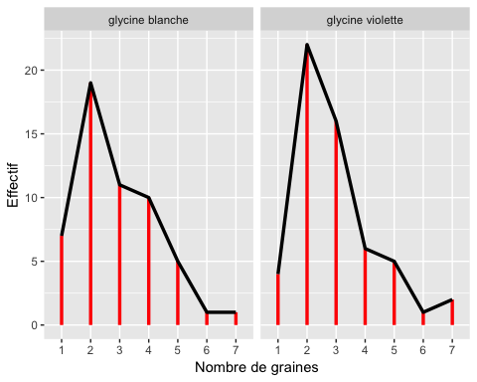

pdf("figure314groupeAggplot.pdf")  
print(ggplot(data.graines.espece, aes(x = nbr.graines)) +  
 geom_linerange(aes(ymin=0,ymax=effectif,group=espece), size=1.2,color=I("red"))+  
 geom_line(aes(y=effectif,group=espece), size=1.2,color=I("black"))+   
 xlab("Nombre de graines") + ylab("Effectif") + facet_wrap(~espece))  
dev.off()

## quartz_off_screen   
## 2

ggplot(data.graines.espece, aes(x = nbr.graines))+  
 geom_line(aes(y=effectif,group=espece), size=1.2,color=I("red")) +  
 geom_pointrange(aes(ymin=0,ymax=effectif,y=effectif,group=espece),  
 size=1.2,color=I("blue"))+ xlab("Nombre de graines") + ylab("Effectif") +  
 facet_wrap(~espece)

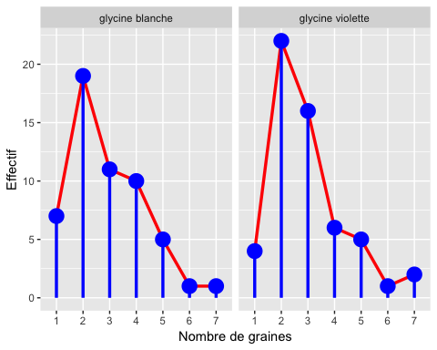

pdf("figure314groupeAggplot.pdf")  
print(ggplot(data.graines.espece, aes(x = nbr.graines))+  
 geom_line(aes(y=effectif,group=espece), size=1.2,color=I("red")) +  
 geom_pointrange(aes(ymin=0,ymax=effectif,y=effectif,group=espece),  
 size=1.2,color=I("blue"))+ xlab("Nombre de graines") + ylab("Effectif") +  
 facet_wrap(~espece))  
dev.off()

## quartz_off_screen   
## 2

ggplot(data.graines.espece, aes(x = nbr.graines)) +  
 geom_ribbon(aes(ymin=0,ymax=effectif,group=espece),fill=I("red"),alpha=.5)+  
 geom_line(aes(y=effectif,group=espece), size=1, color="red")+  
 geom_pointrange(aes(ymin=0,ymax=effectif,y=effectif,group=espece), size=1,  
 color="blue")+ xlab("Nombre de graines") + ylab("Effectif") +  
 facet_wrap(~espece)+theme_bw()

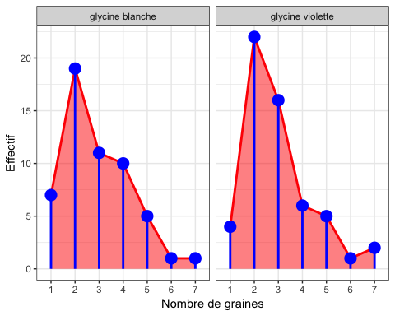

pdf("figure314groupeAggplot.pdf")  
print(ggplot(data.graines.espece, aes(x = nbr.graines)) +  
 geom_ribbon(aes(ymin=0,ymax=effectif,group=espece),fill=I("red"),alpha=.5)+  
 geom_line(aes(y=effectif,group=espece), size=1, color="red")+  
 geom_pointrange(aes(ymin=0,ymax=effectif,y=effectif,group=espece), size=1,  
 color="blue")+ xlab("Nombre de graines") + ylab("Effectif") +  
 facet_wrap(~espece)+theme_bw())  
dev.off()

## quartz_off_screen   
## 2

ggplot(data.graines.espece, aes(x = nbr.graines)) +  
 geom_ribbon(aes(ymin=0,ymax=effectif,group=espece),fill=I("gray80"))+  
 geom_line(aes(y=effectif,group=espece), size=1, color=I("gray40")) +  
 geom_pointrange(aes(ymin=0,ymax=effectif,y=effectif,group=espece), size=1)+   
 xlab("Nombre de graines") + ylab("Effectif") + facet_wrap(~espece)+theme_bw()

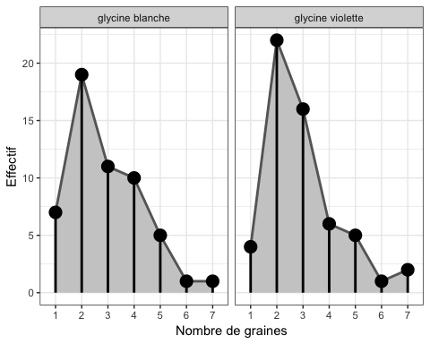

pdf("figure314groupeAggplot.pdf")  
print(ggplot(data.graines.espece, aes(x = nbr.graines)) +  
 geom_ribbon(aes(ymin=0,ymax=effectif,group=espece),fill=I("gray80"))+  
 geom_line(aes(y=effectif,group=espece), size=1, color=I("gray40")) +  
 geom_pointrange(aes(ymin=0,ymax=effectif,y=effectif,group=espece), size=1)+   
 xlab("Nombre de graines") + ylab("Effectif") + facet_wrap(~espece)+theme_bw())  
dev.off()

## quartz_off_screen   
## 2

#page 128  
plot(cumsum(table(Mesures5$graines)),type="h",lwd=4,col="red",xlab="Nombre de graines",  
 ylab="Effectif")  
lines(cumsum(table(Mesures5$graines)),lwd=4)

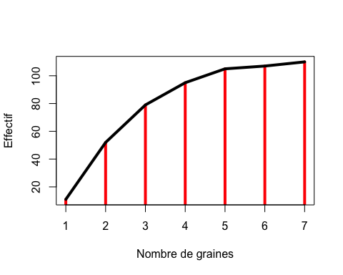

pdf("figure315.pdf")  
plot(cumsum(table(Mesures5$graines)),type="h",lwd=4,col="red",xlab="Nombre de graines",  
 ylab="Effectif")  
lines(cumsum(table(Mesures5$graines)),lwd=4)  
dev.off()

## quartz_off_screen   
## 2

df.cumsum.table_graines<-df.table_graines; df.cumsum.table_graines[,2] <-  
 cumsum(df.table_graines[,2])  
ggplot(df.cumsum.table_graines, aes(x = nbr.graines)) +  
 geom_linerange(aes(ymin=0, ymax=effectif), size=1.2,color=I("red"))+  
 geom_line(aes(y=effectif,group=""), size=1.2,color=I("black"))+   
 xlab("Nombre de graines") + ylab("Effectif")

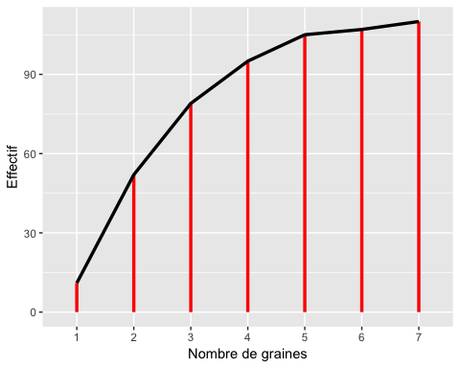

pdf("figure315ggplot.pdf")  
print(ggplot(df.cumsum.table_graines, aes(x = nbr.graines)) +  
 geom_linerange(aes(ymin=0, ymax=effectif), size=1.2,color=I("red"))+  
 geom_line(aes(y=effectif,group=""), size=1.2,color=I("black"))+   
 xlab("Nombre de graines") + ylab("Effectif"))  
dev.off()

## quartz_off_screen   
## 2

ggplot(df.cumsum.table_graines, aes(x = nbr.graines))+  
 geom_line(aes(y=effectif,group=""), size=1.2,color=I("black")) +  
 geom_pointrange(aes(ymin=0,ymax=effectif,y=effectif,group=""),  
 size=1.2,color=I("red"))+ xlab("Nombre de graines") + ylab("Effectif")

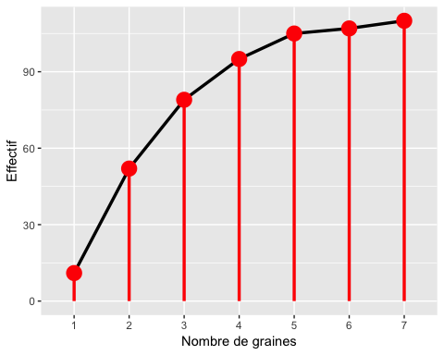

pdf("figure315bggplot.pdf")  
print(ggplot(df.cumsum.table_graines, aes(x = nbr.graines))+  
 geom_line(aes(y=effectif,group=""), size=1.2,color=I("black")) +  
 geom_pointrange(aes(ymin=0,ymax=effectif,y=effectif,group=""),  
 size=1.2,color=I("red"))+ xlab("Nombre de graines") + ylab("Effectif"))  
dev.off()

## quartz_off_screen   
## 2

ggplot(df.cumsum.table_graines, aes(x = nbr.graines)) +  
 geom_ribbon(aes(ymin=0,ymax=effectif,group=""),fill=I("red"),alpha=.5)+  
 geom_line(aes(y=effectif,group=""), size=1, color="red")+  
 geom_pointrange(aes(ymin=0,ymax=effectif,y=effectif,group=""), size=1,  
 color="blue")+ xlab("Nombre de graines") + ylab("Effectif") +theme_bw()

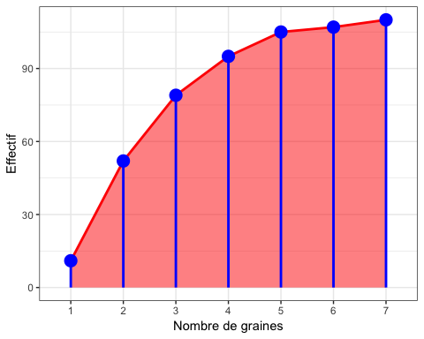

pdf("figure315cggplot.pdf")  
print(ggplot(df.cumsum.table_graines, aes(x = nbr.graines)) +  
 geom_ribbon(aes(ymin=0,ymax=effectif,group=""),fill=I("red"),alpha=.5)+  
 geom_line(aes(y=effectif,group=""), size=1, color="red")+  
 geom_pointrange(aes(ymin=0,ymax=effectif,y=effectif,group=""), size=1,  
 color="blue")+ xlab("Nombre de graines") + ylab("Effectif") +theme_bw())  
dev.off()

## quartz_off_screen   
## 2

ggplot(df.cumsum.table_graines, aes(x = nbr.graines)) +  
 geom_ribbon(aes(ymin=0,ymax=effectif,group=""),fill=I("gray80"))+  
 geom_line(aes(y=effectif,group=""), size=1, color=I("gray40")) +  
 geom_pointrange(aes(ymin=0,ymax=effectif,y=effectif,group=""), size=1)+   
 xlab("Nombre de graines") + ylab("Effectif") +theme_bw()

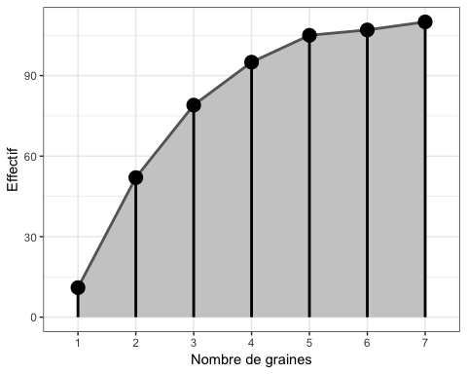

pdf("figure315dggplot.pdf")  
print(ggplot(df.cumsum.table_graines, aes(x = nbr.graines)) +  
 geom_ribbon(aes(ymin=0,ymax=effectif,group=""),fill=I("gray80"))+  
 geom_line(aes(y=effectif,group=""), size=1, color=I("gray40")) +  
 geom_pointrange(aes(ymin=0,ymax=effectif,y=effectif,group=""), size=1)+   
 xlab("Nombre de graines") + ylab("Effectif") +theme_bw())  
dev.off()

## quartz_off_screen   
## 2

#Par groupes  
data.cumsum.graines.espece<-data.graines.espece  
data.cumsum.graines.espece[,3] <- unlist(tapply(data.graines.espece[,3],  
 data.graines.espece[,2],cumsum))  
  
ggplot(data.cumsum.graines.espece, aes(x = nbr.graines)) +  
 geom_linerange(aes(ymin=0,ymax=effectif,group=espece), size=1.2,color=I("red"))+  
 geom_line(aes(y=effectif,group=espece), size=1.2,color=I("black"))+   
 xlab("Nombre de graines") + ylab("Effectif") + facet_wrap(~espece)

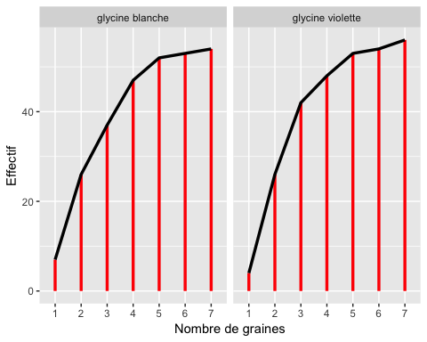

pdf("figure315eggplot.pdf")  
print(ggplot(data.cumsum.graines.espece, aes(x = nbr.graines)) +  
 geom_linerange(aes(ymin=0,ymax=effectif,group=espece), size=1.2,color=I("red"))+  
 geom_line(aes(y=effectif,group=espece), size=1.2,color=I("black"))+   
 xlab("Nombre de graines") + ylab("Effectif") + facet_wrap(~espece))  
dev.off()

## quartz_off_screen   
## 2

ggplot(data.cumsum.graines.espece, aes(x = nbr.graines))+  
 geom_line(aes(y=effectif,group=espece), size=1.2,color=I("red")) +  
 geom_pointrange(aes(ymin=0,ymax=effectif,y=effectif,group=espece),  
 size=1.2,color=I("blue"))+ xlab("Nombre de graines") + ylab("Effectif") +  
 facet_wrap(~espece)

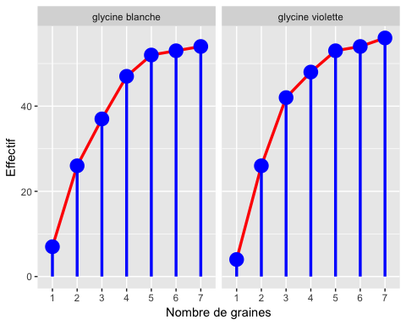

pdf("figure315fggplot.pdf")  
print(ggplot(data.cumsum.graines.espece, aes(x = nbr.graines))+  
 geom_line(aes(y=effectif,group=espece), size=1.2,color=I("red")) +  
 geom_pointrange(aes(ymin=0,ymax=effectif,y=effectif,group=espece),  
 size=1.2,color=I("blue"))+ xlab("Nombre de graines") + ylab("Effectif") +  
 facet_wrap(~espece))  
dev.off()

## quartz_off_screen   
## 2

ggplot(data.cumsum.graines.espece, aes(x = nbr.graines)) +  
 geom_ribbon(aes(ymin=0,ymax=effectif,group=espece),fill=I("red"),alpha=.5)+  
 geom_line(aes(y=effectif,group=espece), size=1, color="red")+  
 geom_pointrange(aes(ymin=0,ymax=effectif,y=effectif,group=espece), size=1,  
 color="blue")+ xlab("Nombre de graines") + ylab("Effectif") +  
 facet_wrap(~espece)+theme_bw()

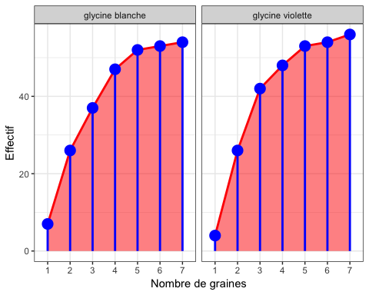

pdf("figure315gggplot.pdf")  
print(ggplot(data.cumsum.graines.espece, aes(x = nbr.graines)) +  
 geom_ribbon(aes(ymin=0,ymax=effectif,group=espece),fill=I("red"),alpha=.5)+  
 geom_line(aes(y=effectif,group=espece), size=1, color="red")+  
 geom_pointrange(aes(ymin=0,ymax=effectif,y=effectif,group=espece), size=1,  
 color="blue")+ xlab("Nombre de graines") + ylab("Effectif") +  
 facet_wrap(~espece)+theme_bw())  
dev.off()

## quartz_off_screen   
## 2

ggplot(data.cumsum.graines.espece, aes(x = nbr.graines)) +  
 geom_ribbon(aes(ymin=0,ymax=effectif,group=espece),fill=I("gray80"))+  
 geom_line(aes(y=effectif,group=espece), size=1, color=I("gray40")) +  
 geom_pointrange(aes(ymin=0,ymax=effectif,y=effectif,group=espece), size=1)+   
 xlab("Nombre de graines") + ylab("Effectif") + facet_wrap(~espece)+theme_bw()

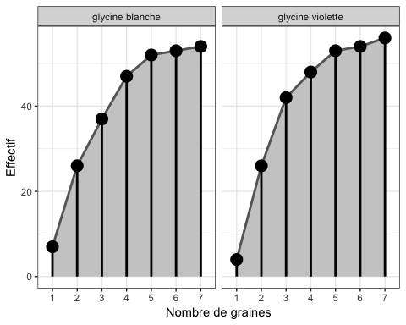

pdf("figure315hggplot.pdf")  
print(ggplot(data.cumsum.graines.espece, aes(x = nbr.graines)) +  
 geom_ribbon(aes(ymin=0,ymax=effectif,group=espece),fill=I("gray80"))+  
 geom_line(aes(y=effectif,group=espece), size=1, color=I("gray40")) +  
 geom_pointrange(aes(ymin=0,ymax=effectif,y=effectif,group=espece), size=1)+   
 xlab("Nombre de graines") + ylab("Effectif") + facet_wrap(~espece)+theme_bw())  
dev.off()

## quartz_off_screen   
## 2

pie.graines<-c(0.1000,0.3727,0.2455,0.1455,0.0909,0.0182,0.0273)  
  
#page 129  
names(pie.graines)<-c("1 graine","2 graines","3 graines","4 graines","5  
 graines","6 graines","7 graines")  
pie(pie.graines,col=c("red","purple","cyan","blue","green","cornsilk","orange"))

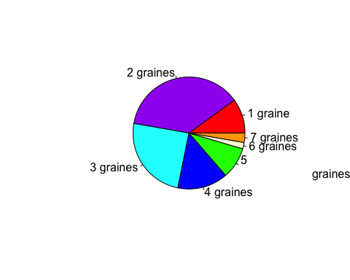

pie(table(Mesures5$graines),labels=c("1 graine",paste(2:7,"  
 graines")),col=rainbow(7))

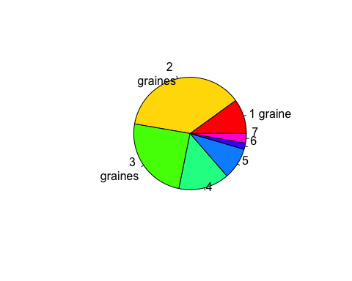

pdf("figure316.pdf")  
pie(table(Mesures5$graines),labels=c("1 graine",paste(2:7,"  
 graines")),col=rainbow(7))  
dev.off()

## quartz_off_screen   
## 2

#ggplot pie is only a polar coord change from geom_bar  
p=ggplot(data.graines.espece, aes(x="", y= effectif, fill = nbr.graines)) +  
 geom_bar(stat="identity",position="fill") + xlab("Nombre de graines") +  
 ylab("Effectif") + facet_wrap(~espece) + scale_fill_grey() + theme_bw()  
p

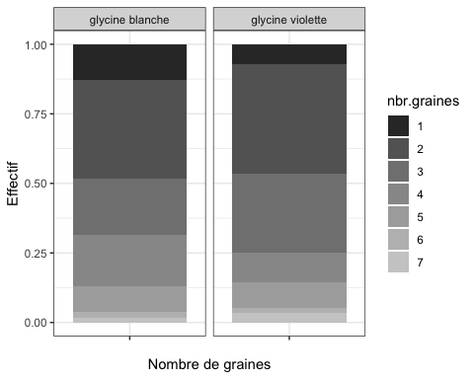

q <- p+coord_polar(theta="y")  
q

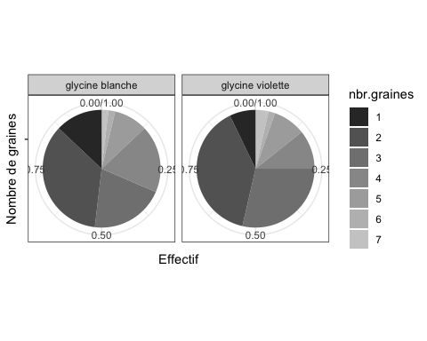

q + scale_fill_hue()

## Scale for 'fill' is already present. Adding another scale for 'fill',  
## which will replace the existing scale.

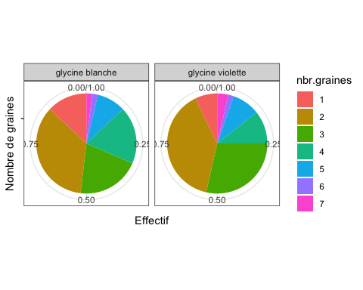

q + scale_fill_brewer()

## Scale for 'fill' is already present. Adding another scale for 'fill',  
## which will replace the existing scale.

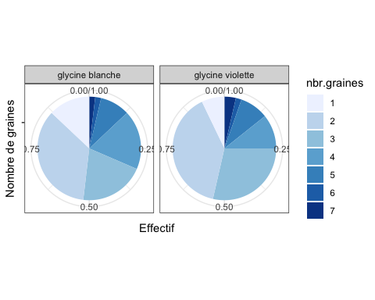

pdf("figure316aggplot.pdf")  
print(q)  
dev.off()

## quartz_off_screen   
## 2

pdf("figure316bggplot.pdf")  
print(q + scale_fill_hue())

## Scale for 'fill' is already present. Adding another scale for 'fill',  
## which will replace the existing scale.

dev.off()

## quartz_off_screen   
## 2

pdf("figure316cggplot.pdf")  
print(q + scale_fill_brewer())

## Scale for 'fill' is already present. Adding another scale for 'fill',  
## which will replace the existing scale.

dev.off()

## quartz_off_screen   
## 2

#page 130  
hist(Mesures$masse)



histo<-hist(Mesures$masse,ylab="Effectif",xlab="Masse",main="Histogramme des  
 masses")

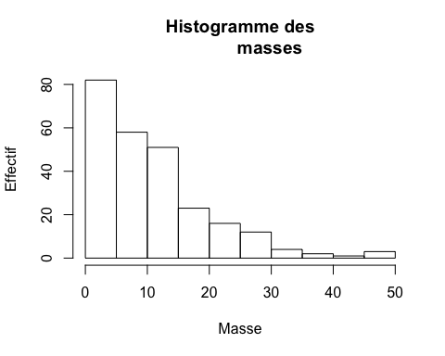

#en plus ggplot  
g=ggplot(Mesures,aes(x=masse))+geom_histogram()  
g

## `stat_bin()` using `bins = 30`. Pick better value with `binwidth`.

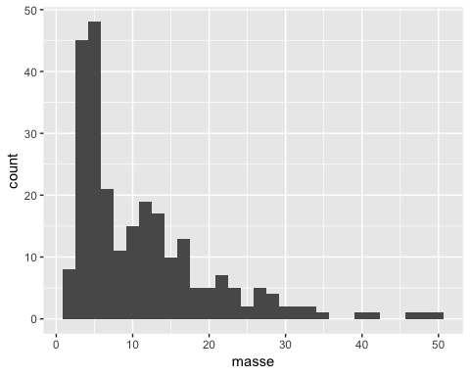

pdf("figure317aggplot.pdf")  
g

## `stat_bin()` using `bins = 30`. Pick better value with `binwidth`.

dev.off()

## quartz_off_screen   
## 2

g1 = g +  
 geom_histogram(binwidth=diff(range(Mesures$masse))/nclass.Sturges(Mesures$masse)  
 ) #Règle de Sturges   
g1

## `stat_bin()` using `bins = 30`. Pick better value with `binwidth`.

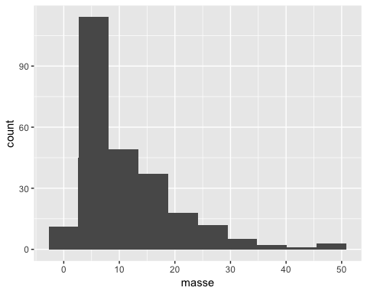

pdf("figure317bggplot.pdf")  
g1

## `stat_bin()` using `bins = 30`. Pick better value with `binwidth`.

dev.off()

## quartz_off_screen   
## 2

ggplot(Mesures,aes(x=masse))+geom_histogram(aes(fill=..count..))+  
 scale_fill_gradient("Count", low = "green", high = "red")

## `stat_bin()` using `bins = 30`. Pick better value with `binwidth`.

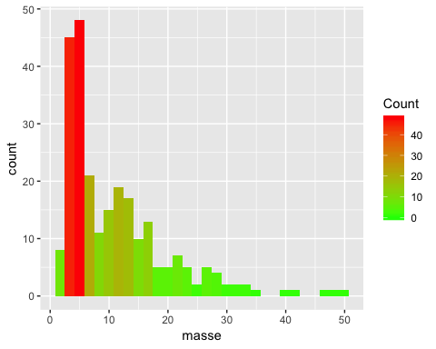

pdf("figure317cggplot.pdf")  
print(ggplot(Mesures,aes(x=masse))+geom_histogram(aes(fill=..count..))+  
 scale_fill_gradient("Count", low = "green", high = "red"))

## `stat_bin()` using `bins = 30`. Pick better value with `binwidth`.

dev.off()

## quartz_off_screen   
## 2

g+geom_histogram(aes(fill=..count..),binwidth=diff(range(Mesures$masse))/  
 nclass.Sturges(Mesures$masse))+scale_fill_gradient("Count",low = "green", high ="red")

## `stat_bin()` using `bins = 30`. Pick better value with `binwidth`.

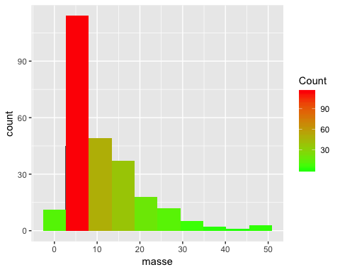

pdf("figure317dggplot.pdf")  
print(g+geom_histogram(aes(fill=..count..),binwidth=diff(range(Mesures$masse))/  
 nclass.Sturges(Mesures$masse))+scale_fill_gradient("Count", low = "green", high = "red"))

## `stat_bin()` using `bins = 30`. Pick better value with `binwidth`.

dev.off()

## quartz_off_screen   
## 2

ggplot(Mesures,aes(x=masse))+geom_histogram(aes(fill=..count..))+  
 scale_fill_gradient("Count", low = "grey80", high = "black")

## `stat_bin()` using `bins = 30`. Pick better value with `binwidth`.

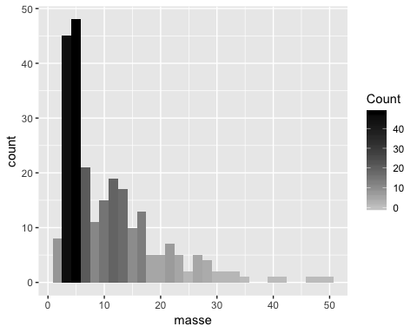

pdf("figure317eggplot.pdf")  
print(ggplot(Mesures,aes(x=masse))+geom_histogram(aes(fill=..count..))+  
 scale_fill_gradient("Count", low = "grey80", high = "black"))

## `stat_bin()` using `bins = 30`. Pick better value with `binwidth`.

dev.off()

## quartz_off_screen   
## 2

g+geom_histogram(aes(fill=..count..),binwidth=diff(range(Mesures$masse))/  
 nclass.Sturges(Mesures$masse))+scale_fill_gradient("Count", low = "grey80", high = "black")

## `stat_bin()` using `bins = 30`. Pick better value with `binwidth`.

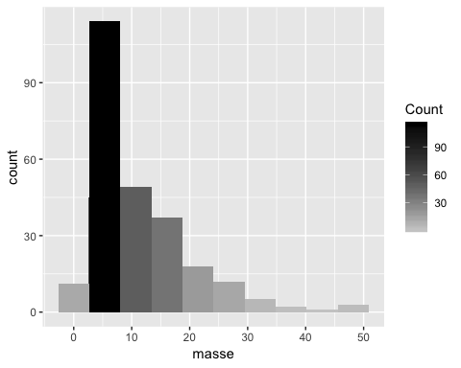

pdf("figure317fggplot.pdf")  
print(g+geom_histogram(aes(fill=..count..),binwidth=diff(range(Mesures$masse))/  
 nclass.Sturges(Mesures$masse))+scale_fill_gradient("Count", low = "grey80", high = "black"))

## `stat_bin()` using `bins = 30`. Pick better value with `binwidth`.

dev.off()

## quartz_off_screen   
## 2

#page 131  
histo<-hist(Mesures$masse)



histo

## $breaks  
## [1] 0 5 10 15 20 25 30 35 40 45 50  
##   
## $counts  
## [1] 82 58 51 23 16 12 4 2 1 3  
##   
## $density  
## [1] 0.065079 0.046032 0.040476 0.018254 0.012698 0.009524 0.003175  
## [8] 0.001587 0.000794 0.002381  
##   
## $mids  
## [1] 2.5 7.5 12.5 17.5 22.5 27.5 32.5 37.5 42.5 47.5  
##   
## $xname  
## [1] "Mesures$masse"  
##   
## $equidist  
## [1] TRUE  
##   
## attr(,"class")  
## [1] "histogram"

#page 133  
library(lattice)  
histogram(~masse|espece,data=Mesures)

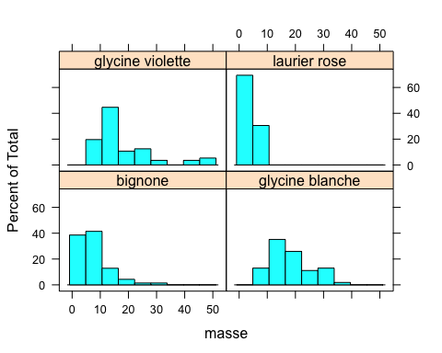

pdf("figure318lattice.pdf")  
histogram(~masse|espece,data=Mesures)  
dev.off()

## quartz_off_screen   
## 2

#en plus  
ggplot(Mesures, aes(x = masse)) +  
 geom_histogram(binwidth=diff(range(Mesures$masse))/nclass.Sturges(Mesures$masse)  
 ) + xlab("Nombre de graines") + ylab("Effectif") + facet_wrap(~espece)

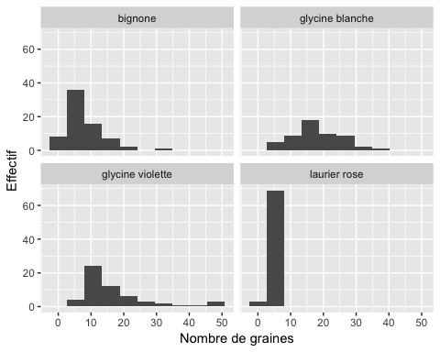

pdf("figure318ggplot.pdf")  
print(ggplot(Mesures, aes(x = masse)) +  
 geom_histogram(binwidth=diff(range(Mesures$masse))/nclass.Sturges(Mesures$masse)  
 ) + xlab("Nombre de graines") + ylab("Effectif") + facet_wrap(~espece))  
dev.off()

## quartz_off_screen   
## 2

ggplot(Mesures, aes(x = masse)) +  
 geom_histogram(aes(fill=..count..),binwidth=diff(range(Mesures$masse))/  
 nclass.Sturges(Mesures$masse)) + xlab("Nombre de graines") + ylab("Effectif") +  
 facet_wrap(~espece) + scale_fill_gradient("Count", low = "green", high = "red")

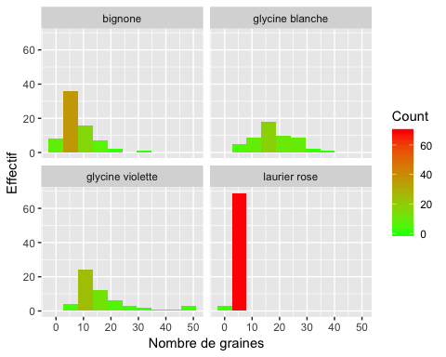

pdf("figure318aggplot.pdf")  
print(ggplot(Mesures, aes(x = masse)) +  
 geom_histogram(aes(fill=..count..),binwidth=diff(range(Mesures$masse))/  
 nclass.Sturges(Mesures$masse)) + xlab("Nombre de graines") + ylab("Effectif") +  
 facet_wrap(~espece) + scale_fill_gradient("Count", low = "green", high = "red"))  
dev.off()

## quartz_off_screen   
## 2

g=ggplot(Mesures, aes(x = masse)) +  
 geom_histogram(aes(fill=..count..),binwidth=diff(range(Mesures$masse))/  
 nclass.Sturges(Mesures$masse)) + xlab("Nombre de graines") + ylab("Effectif") +  
 facet_wrap(~espece)  
g

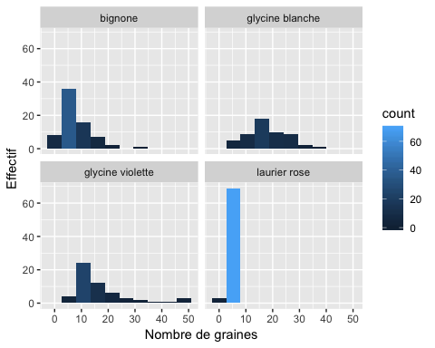

pdf("figure318bggplot.pdf")  
print(g)  
dev.off()

## quartz_off_screen   
## 2

histo<-hist(Mesures$masse,ylab="Effectif",xlab="Masse",main="Polygone des  
 effectifs des masses")  
lines(histo$mids,histo$counts,lwd=2)  
points(histo$mids,histo$counts,cex=1.2,pch=19)

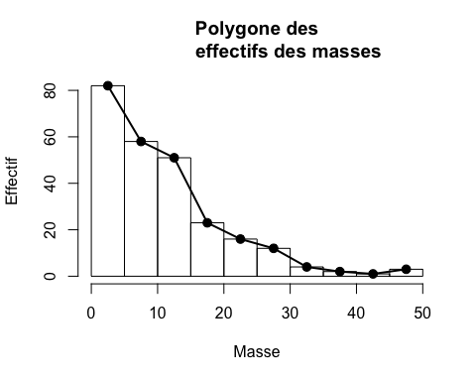

pdf("figure319.pdf")  
histo<-hist(Mesures$masse,ylab="Effectif",xlab="Masse",main="Polygone des  
 effectifs des masses")  
lines(histo$mids,histo$counts,lwd=2)  
points(histo$mids,histo$counts,cex=1.2,pch=19)  
dev.off()

## quartz_off_screen   
## 2

#En plus ggplot  
g=ggplot(Mesures, aes(x = masse)) +  
 geom_histogram(aes(fill=..count..),binwidth=diff(range(Mesures$masse))/  
 nclass.Sturges(Mesures$masse),boundary=0) + xlab("Nombre de graines") + ylab("Effectif")  
g

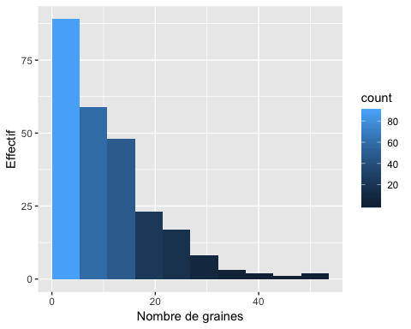

pdf("figure319ggplot.pdf")  
print(g)  
dev.off()

## quartz_off_screen   
## 2

g1=g+geom_line(binwidth=diff(range(Mesures$masse))/nclass.Sturges(Mesures$masse),  
 size=2,alpha=.60,color="blue",stat="bin",boundary=0)  
g1

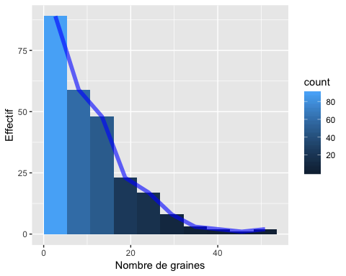

pdf("figure319aggplot.pdf")  
g1  
dev.off()

## quartz_off_screen   
## 2

g+stat_bin(binwidth=diff(range(Mesures$masse))/nclass.Sturges(Mesures$masse),  
 size=2,alpha=.60,color="blue",geom="line",boundary=0)



pdf("figure319bggplot.pdf")  
print(g+stat_bin(binwidth=diff(range(Mesures$masse))/  
 nclass.Sturges(Mesures$masse),size=2,alpha=.60,color="blue",geom="line",boundary=0))  
dev.off()

## quartz_off_screen   
## 2

g1+ scale_fill_gradient(low="white", high="black")

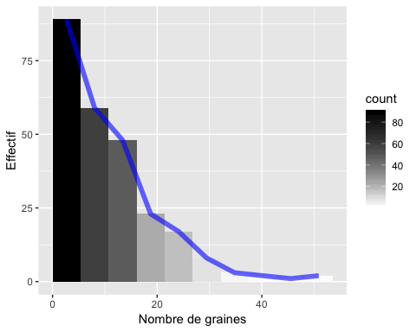

pdf("figure319cggplot.pdf")  
print(g1+ scale_fill_gradient(low="white", high="black"))  
dev.off()

## quartz_off_screen   
## 2

if(!("scales" %in% rownames(installed.packages()))){install.packages("scales")}  
library(scales)  
g1+ scale_fill_gradient2(low=muted("red"), mid="white",  
 high=muted("blue"),midpoint=40)

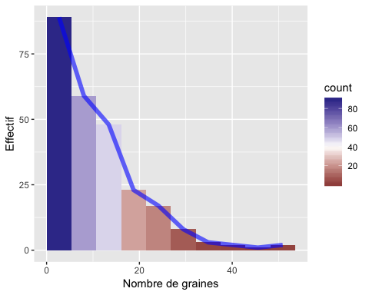

pdf("figure319dggplot.pdf")  
g1+ scale_fill_gradient2(low=muted("red"), mid="white",  
 high=muted("blue"),midpoint=40)  
dev.off()

## quartz_off_screen   
## 2

g1+ scale_fill_gradientn(colours = c("darkred", "orange", "yellow", "white"))

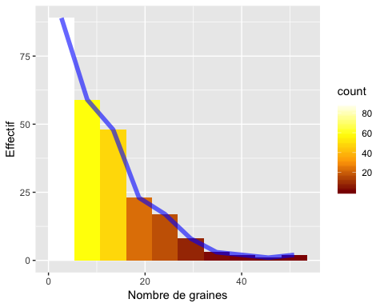

pdf("figure319eggplot.pdf")  
g1+ scale_fill_gradientn(colours = c("darkred", "orange", "yellow", "white"))  
dev.off()

## quartz_off_screen   
## 2

#Par groupe  
g=ggplot(Mesures, aes(x = masse)) +  
 geom_histogram(aes(fill=..count..),binwidth=diff(range(Mesures$masse))/  
 nclass.Sturges(Mesures$masse),boundary=0) + xlab("Nombre de graines") +  
 ylab("Effectif") + facet_wrap(~espece)  
g

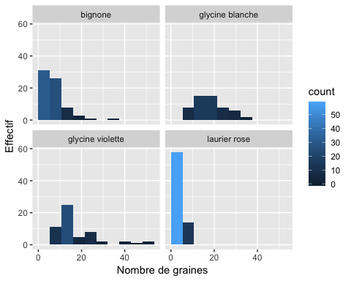

pdf("figure319fggplot.pdf")  
print(g)  
dev.off()

## quartz_off_screen   
## 2

g+geom_freqpoly(aes(fill=..count..),binwidth=diff(range(Mesures$masse))/  
 nclass.Sturges(Mesures$masse),size=2,alpha=.60,color="blue")+  
 scale_fill_gradientn(colours = c("darkred", "orange", "yellow", "white"))

## Warning: Ignoring unknown aesthetics: fill

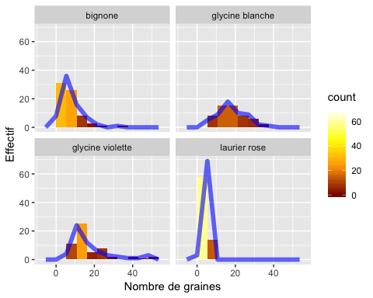

pdf("figure319fggplot.pdf")  
print(g+geom_freqpoly(aes(fill=..count..),binwidth=diff(range(Mesures$masse))/  
 nclass.Sturges(Mesures$masse),size=2,alpha=.60,color="blue")+  
 scale_fill_gradientn(colours = c("darkred", "orange", "yellow", "white")))

## Warning: Ignoring unknown aesthetics: fill

dev.off()

## quartz_off_screen   
## 2

#page 135  
histo<-hist(Mesures$masse,plot=FALSE)  
barplot<-barplot(cumsum(histo$counts),ylab="Effectif",xlab="Masse",main="  
 Polygone des effectifs cumulés des masses")  
lines(barplot,cumsum(histo$counts),lwd=2)  
points(barplot,cumsum(histo$counts),cex=1.2,pch=19)

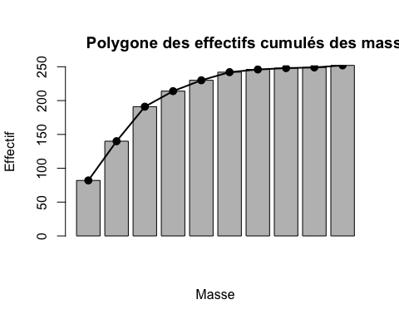

pdf("figure320.pdf")  
barplot<-barplot(cumsum(histo$counts),ylab="Effectif",xlab="Masse",main="  
 Polygone des effectifs cumulés des masses")  
lines(barplot,cumsum(histo$counts),lwd=2)  
points(barplot,cumsum(histo$counts),cex=1.2,pch=19)  
dev.off()

## quartz_off_screen   
## 2

#Effectifs et polygone des fréquences cumulées  
library(qcc)

## Package 'qcc' version 2.7

## Type 'citation("qcc")' for citing this R package in publications.

pareto.chart(table(Mesures5$graines))

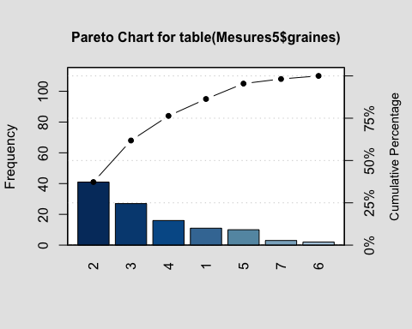

##   
## Pareto chart analysis for table(Mesures5$graines)  
## Frequency Cum.Freq. Percentage Cum.Percent.  
## 2 41.00 41.00 37.27 37.27  
## 3 27.00 68.00 24.55 61.82  
## 4 16.00 84.00 14.55 76.36  
## 1 11.00 95.00 10.00 86.36  
## 5 10.00 105.00 9.09 95.45  
## 7 3.00 108.00 2.73 98.18  
## 6 2.00 110.00 1.82 100.00

pdf("figure320qcc.pdf")  
pareto.chart(table(Mesures5$graines))

##   
## Pareto chart analysis for table(Mesures5$graines)  
## Frequency Cum.Freq. Percentage Cum.Percent.  
## 2 41.00 41.00 37.27 37.27  
## 3 27.00 68.00 24.55 61.82  
## 4 16.00 84.00 14.55 76.36  
## 1 11.00 95.00 10.00 86.36  
## 5 10.00 105.00 9.09 95.45  
## 7 3.00 108.00 2.73 98.18  
## 6 2.00 110.00 1.82 100.00

dev.off()

## quartz_off_screen   
## 2

consmw=diff(range(Mesures$masse))/nclass.Sturges(Mesures$masse)  
consmw

## [1] 5.36

consmw.espece=cbind(espece=names(unlist(lapply(split(Mesures$masse,Mesures$  
 espece),function(xxx) return(diff(range(xxx))/nclass.Sturges(xxx))))),  
 consmw.espece=unlist(lapply(split(Mesures$masse,Mesures$espece),function(xxx)  
 return(diff(range(xxx))/nclass.Sturges(xxx)))))  
consmw.espece

## espece consmw.espece   
## bignone "bignone" "4.0875"   
## glycine blanche "glycine blanche" "4.3"   
## glycine violette "glycine violette" "6.15714285714286"  
## laurier rose "laurier rose" "0.5125"

Mesures.binw<-merge(cbind(Mesures,consmw=diff(range(Mesures$masse))/  
 nclass.Sturges(Mesures$masse)),consmw.espece)  
  
g=ggplot(Mesures.binw, aes(x = masse))   
g +  
 geom_histogram(data=Mesures.binw,aes(y=5.355556*..density..,fill=..density..),  
 binwidth=diff(range(Mesures$masse))/nclass.Sturges(Mesures$masse),boundary =  
 min(Mesures$masse)) + xlab("Masse") + ylab("Fréquence")

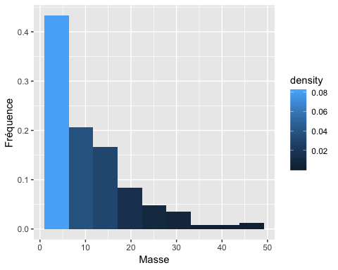

pdf("figure320ggplot.pdf")  
print(g +  
 geom_histogram(data=Mesures.binw,aes(y=5.355556*..density..,fill=..density..),  
 binwidth=diff(range(Mesures$masse))/nclass.Sturges(Mesures$masse),boundary =  
 min(Mesures$masse)) + xlab("Masse") + ylab("Fréquence"))  
dev.off()

## quartz_off_screen   
## 2

g +  
 geom_histogram(data=Mesures.binw,aes(y=5.355556*..count..,fill=..count..),  
 binwidth=diff(range(Mesures$masse))/nclass.Sturges(Mesures$masse),boundary =  
 min(Mesures$masse)) + xlab("Masse") + ylab("Dénombrement")

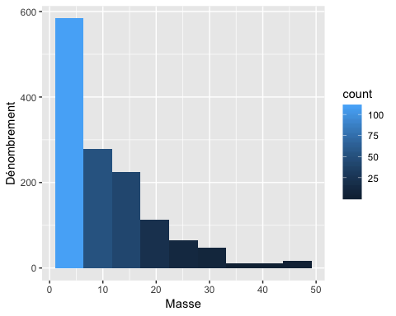

pdf("figure320aggplot.pdf")  
print(g +  
 geom_histogram(data=Mesures.binw,aes(y=5.355556*..count..,fill=..count..),  
 binwidth=diff(range(Mesures$masse))/nclass.Sturges(Mesures$masse),boundary =  
 min(Mesures$masse)) + xlab("Masse") + ylab("Dénombrement"))  
dev.off()

## quartz_off_screen   
## 2

g + stat_ecdf(n=nclass.Sturges(Mesures$masse)+1,direction="vh") +  
 stat_ecdf(n=nclass.Sturges(Mesures$masse)+1,direction="vh",geom="linerange",ymin  
 =0,aes(ymax=..y..))

## Warning: Ignoring unknown parameters: direction

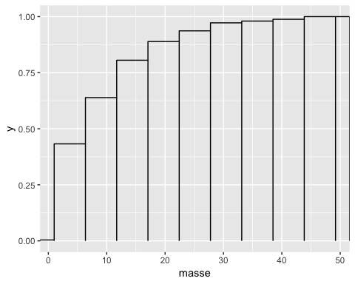

pdf("figure320bggplot.pdf")  
print(g + stat_ecdf(n=nclass.Sturges(Mesures$masse)+1,direction="vh") +  
 stat_ecdf(n=nclass.Sturges(Mesures$masse)+1,direction="vh",geom="linerange",ymin  
 =0,aes(ymax=..y..)))

## Warning: Ignoring unknown parameters: direction

dev.off()

## quartz_off_screen   
## 2

g +  
 geom_histogram(aes(y=5.355556*..density..,fill=..density..),binwidth=diff(range(  
 Mesures$masse))/nclass.Sturges(Mesures$masse),boundary = min(Mesures$masse)) +  
 xlab("Masse") + ylab("Fréquence") +  
 stat_ecdf(n=nclass.Sturges(Mesures$masse)+1,direction="vh") +  
 stat_ecdf(n=nclass.Sturges(Mesures$masse)+1,direction="vh",geom="linerange",ymin  
 =0,aes(ymax=..y..))

## Warning: Ignoring unknown parameters: direction

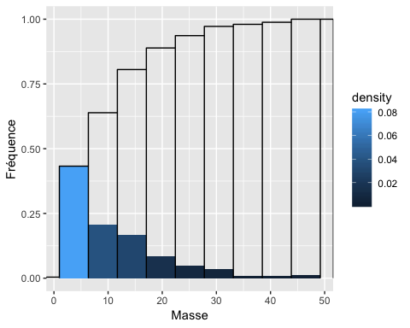

pdf("figure320cggplot.pdf")  
print(g +  
 geom_histogram(aes(y=5.355556*..density..,fill=..density..),binwidth=diff(range(  
 Mesures$masse))/nclass.Sturges(Mesures$masse),boundary = min(Mesures$masse)) +  
 xlab("Masse") + ylab("Fréquence") +  
 stat_ecdf(n=nclass.Sturges(Mesures$masse)+1,direction="vh") +  
 stat_ecdf(n=nclass.Sturges(Mesures$masse)+1,direction="vh",geom="linerange",ymin  
 =0,aes(ymax=..y..)))

## Warning: Ignoring unknown parameters: direction

dev.off()

## quartz_off_screen   
## 2

#depuis ggplot2 2.0 ne freqpoly n'est plus un geom acceptable  
#g+stat_ecdf(n=nclass.Sturges(Mesures$masse)+1,geom=c("rect"),fill="blue",aes(  
#ymax=..y..,ymin=0,xmax=..x..,xmin=..x..-diff(range(BioStatR::Mesures$masse))/  
#grDevices::nclass.Sturges(BioStatR::Mesures$masse)),alpha=.5,colour="blue")+  
#stat_ecdf(n=nclass.Sturges(Mesures$masse)+1,geom=c("freqpoly"),fill="blue",aes(  
#x=masse-5.355556/2,y=..y..))+geom_histogram(aes(y=5.355556*..density..,fill=..  
#density..),binwidth=diff(range(Mesures$masse))/nclass.Sturges(Mesures$masse),  
#alpha=.35,boundary = min(Mesures5$masse))  
#pdf("figure320dggplot.pdf")  
#print(g+stat_ecdf(n=nclass.Sturges(Mesures$masse)+1,geom=c("rect"),fill="blue",  
#aes(ymax=..y..,ymin=0,xmax=..x..,xmin=..x..-diff(range(BioStatR::Mesures$masse)  
#)/grDevices::nclass.Sturges(BioStatR::Mesures$masse)),alpha=.5,colour="blue")+  
#stat_ecdf(n=nclass.Sturges(Mesures$masse)+1,geom=c("freqpoly"),fill="blue",aes(  
#x=masse-5.355556/2,y=..y..))+geom_histogram(aes(y=5.355556*..density..,fill=..  
#density..),binwidth=diff(range(Mesures$masse))/nclass.Sturges(Mesures$masse),  
#alpha=.35,boundary = min(Mesures5$masse)))  
#dev.off()  
#  
g+stat_ecdf(n=nclass.Sturges(Mesures$masse)+1,geom=c("bar"),fill="blue",  
 aes(x=masse-5.355556/2,width=5.355556),alpha=.5,colour="blue")+stat_ecdf(n=  
 nclass.Sturges(Mesures$masse)+1,geom=c("line"),fill="blue",aes(x=masse-5.355556/2,  
 y=..y..))+stat_ecdf(n=nclass.Sturges(Mesures$masse)+1,geom=c("point"),fill="blue",  
 aes(x=masse-5.355556/2,y=..y..))+geom_histogram(aes(y=5.355556*..density..,  
 fill=..density..),binwidth=diff(range(Mesures$masse))/nclass.Sturges(Mesures$masse),  
 alpha=.35,boundary = min(Mesures5$masse))

## Warning: Ignoring unknown aesthetics: width

## Warning: Ignoring unknown parameters: fill

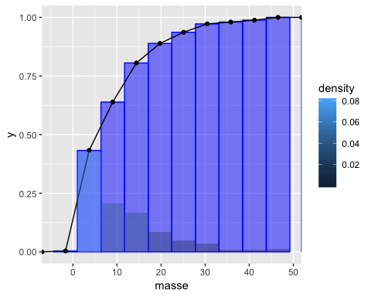

pdf("figure320eggplot.pdf")  
print(g+stat_ecdf(n=nclass.Sturges(Mesures$masse)+1,geom=c("bar"),fill="blue",  
 aes(x=masse-5.355556/2,width=5.355556),alpha=.5,colour="blue")+stat_ecdf(n=  
 nclass.Sturges(Mesures$masse)+1,geom=c("line"),fill="blue",aes(x=masse-5.355556/2,  
 y=..y..))+stat_ecdf(n=nclass.Sturges(Mesures$masse)+1,geom=c("point"),fill="blue",  
 aes(x=masse-5.355556/2,y=..y..))+geom_histogram(aes(y=5.355556*..density..,  
 fill=..density..),binwidth=diff(range(Mesures$masse))/nclass.Sturges(Mesures$masse),  
 alpha=.35,boundary = min(Mesures5$masse)))

## Warning: Ignoring unknown aesthetics: width  
  
## Warning: Ignoring unknown parameters: fill

dev.off()

## quartz_off_screen   
## 2

g+stat_ecdf(n=nclass.Sturges(Mesures$masse)+1,geom=c("bar"),fill="grey50",aes(x=masse-  
 5.355556/2,width=5.355556),alpha=.5,colour="black")+stat_ecdf(n=  
 nclass.Sturges(Mesures$masse)+1,geom=c("line"),fill="grey50",aes(x=masse-5.355556/2,  
 y=..y..))+stat_ecdf(n=nclass.Sturges(Mesures$masse)+1,geom=c("point"),fill="black",  
 aes(x=masse-5.355556/2,y=..y..))+geom_histogram(aes(y=5.355556*..density..,  
 fill=..density..),binwidth=diff(range(Mesures$masse))/nclass.Sturges(Mesures$masse),  
 alpha=.35,boundary = min(Mesures5$masse))+ scale_fill_gradient(low="white", high="black")

## Warning: Ignoring unknown aesthetics: width  
  
## Warning: Ignoring unknown parameters: fill

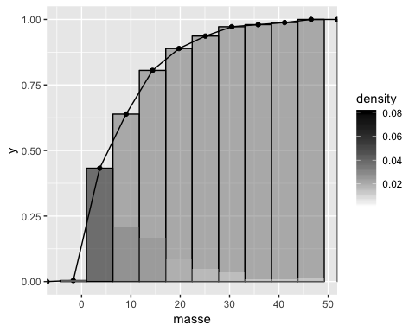

pdf("figure320fggplot.pdf")  
print(g+stat_ecdf(n=nclass.Sturges(Mesures$masse)+1,geom=c("bar"),fill="grey50", aes(x=  
 masse-5.355556/2,width=5.355556),alpha=.5,colour="black")+stat_ecdf(n=  
 nclass.Sturges(Mesures$masse)+1,geom=c("line"),fill="grey50",aes(x=masse-5.355556/2,  
 y=..y..))+stat_ecdf(n=nclass.Sturges(Mesures$masse)+1,geom=c("point"),  
 fill="black",aes(x=masse-5.355556/2,y=..y..))+geom_histogram(aes(y=5.355556*..density..,  
 fill=..density..),binwidth=diff(range(Mesures$masse))/nclass.Sturges(Mesures$masse),  
 alpha=.35,boundary = min(Mesures5$masse))+scale_fill_gradient(low="white", high="black"))

## Warning: Ignoring unknown aesthetics: width  
  
## Warning: Ignoring unknown parameters: fill

dev.off()

## quartz_off_screen   
## 2

#Par groupe  
g+stat_ecdf(n=9+1,geom=c("bar"),fill="blue",aes(x=masse-5.355556/2,width=5.355556/2),  
alpha=.5,colour="blue",binwidth=5.355556)+stat_ecdf(n=9+1,geom=c("line"),fill="blue",  
 aes(x=masse-5.355556/2,y=..y..))+stat_ecdf(n=9+1,geom=c("point"),fill="blue",  
 aes(x=masse-5.355556/2,y=..y..))+facet_wrap(~espece)+geom_histogram(aes(y=  
 5.355556*..density..,fill=..density..),binwidth=5.355556,alpha=.35)

## Warning: Ignoring unknown parameters: binwidth

## Warning: Ignoring unknown aesthetics: width

## Warning: Ignoring unknown parameters: fill

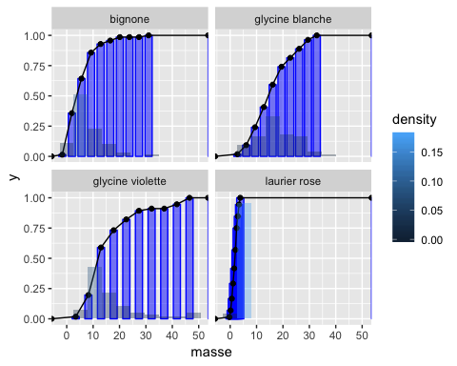

pdf("figure320gggplot.pdf")  
print(g+stat_ecdf(n=9+1,geom=c("bar"),fill="blue",aes(x=masse-5.355556/2,width=5.355556/2),  
alpha=.5,colour="blue",binwidth=5.355556)+stat_ecdf(n=9+1,geom=c("line"),fill="blue",  
aes(x=masse-5.355556/2,y=..y..))+stat_ecdf(n=9+1,geom=c("point"),fill="blue",  
aes(x=masse-5.355556/2,y=..y..))+facet_wrap(~espece)+geom_histogram(aes(y=5.355556*..density..,  
fill=..density..),binwidth=5.355556,alpha=.35))

## Warning: Ignoring unknown parameters: binwidth

## Warning: Ignoring unknown aesthetics: width

## Warning: Ignoring unknown parameters: fill

dev.off()

## quartz_off_screen   
## 2

g+stat_ecdf(n=9+1,geom=c("bar"),fill="blue",aes(x=masse-5.355556/2,width=5.355556/2),  
 alpha=.5,colour="blue")+stat_ecdf(n=9+1,geom=c("line"),fill="blue",aes(x=masse-5.355556/2,  
 y=..y..))+stat_ecdf(n=9+1,geom=c("point"),fill="blue",aes(x=masse-5.355556/2,y=..y..))+  
 facet_wrap(~espece,scales="free_x")+geom_histogram(aes(y=5.355556*..density..,  
 fill=..density..),binwidth=5.355556,alpha=.35)

## Warning: Ignoring unknown aesthetics: width  
  
## Warning: Ignoring unknown parameters: fill

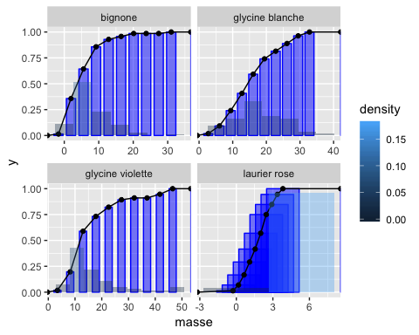

pdf("figure320hggplot.pdf")  
print(g+stat_ecdf(n=9+1,geom=c("bar"),fill="blue",aes(x=masse-5.355556/2,width=5.355556/2),  
 alpha=.5,colour="blue")+stat_ecdf(n=9+1,geom=c("line"),fill="blue",aes(x=masse-5.355556/2,  
 y=..y..))+stat_ecdf(n=9+1,geom=c("point"),fill="blue",aes(x=masse-5.355556/2,y=..y..))+  
 facet_wrap(~espece,scales="free_x")+geom_histogram(aes(y=5.355556*..density..,  
 fill=..density..),binwidth=5.355556,alpha=.35))

## Warning: Ignoring unknown aesthetics: width  
  
## Warning: Ignoring unknown parameters: fill

dev.off()

## quartz_off_screen   
## 2

#page 137  
boxplot(Mesures$masse)  
title("Boîte à moustaches de la variable masse")

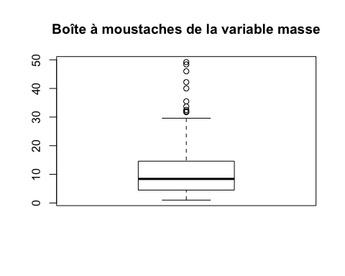

pdf("figure321.pdf")  
boxplot(Mesures$masse)  
title("Boîte à moustaches de la variable masse")  
dev.off()

## quartz_off_screen   
## 2

#En plus ggplot  
ggplot(Mesures, aes(x="",y=masse)) + geom_boxplot()

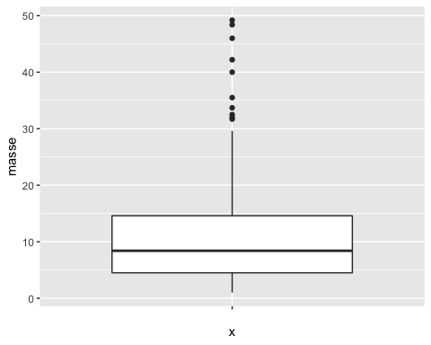

pdf("figure321ggplot.pdf")  
print(ggplot(Mesures, aes(x="",y=masse)) + geom_boxplot())  
dev.off()

## quartz_off_screen   
## 2

#remove label axe x  
ggplot(Mesures, aes(x="",y=masse)) + geom_boxplot() + xlab("")

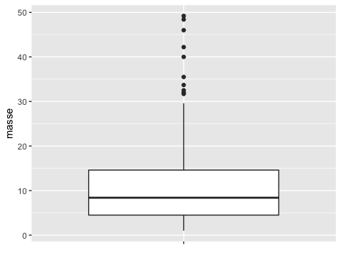

pdf("figure321aggplot.pdf")  
print(ggplot(Mesures, aes(x="",y=masse)) + geom_boxplot() + xlab(""))  
dev.off()

## quartz_off_screen   
## 2

ggplot(Mesures, aes(x="",y=masse)) + geom_boxplot() + coord_flip() + xlab("")

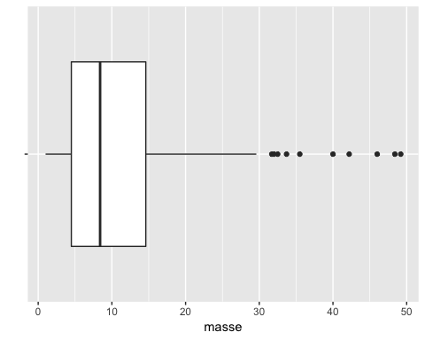

pdf("figure321bggplot.pdf")  
print(ggplot(Mesures, aes(x="",y=masse)) + geom_boxplot() + coord_flip() +  
 xlab(""))  
dev.off()

## quartz_off_screen   
## 2

ggplot(Mesures, aes(x="", y=masse)) + geom_boxplot(width=.5) +  
 stat_summary(fun.y="mean", geom="point", shape=23, size=3, fill="white") +  
 xlab("")

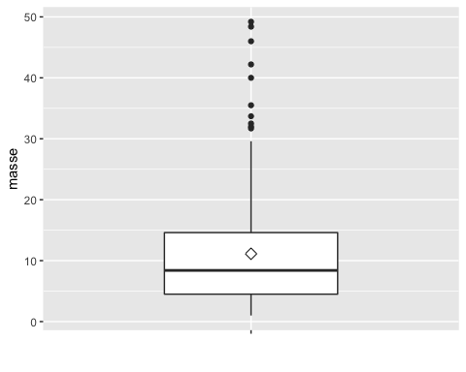

pdf("figure321cggplot.pdf")  
print(ggplot(Mesures, aes(x="", y=masse)) + geom_boxplot(width=.5) +  
 stat_summary(fun.y="mean", geom="point", shape=23, size=3, fill="white") +  
 xlab(""))  
dev.off()

## quartz_off_screen   
## 2

ggplot(Mesures, aes(x="", y=masse)) + geom_violin() + geom_boxplot(width=.1,  
 fill="black") + stat_summary(fun.y=mean, geom="point", fill="white", shape=21, size=2.5)

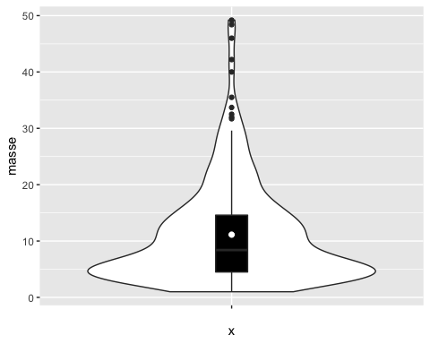

pdf("figure321dggplot.pdf")  
print(ggplot(Mesures, aes(x="", y=masse)) + geom_violin() +  
 geom_boxplot(width=.1, fill="black") + stat_summary(fun.y=mean, geom="point",  
 fill="white", shape=21, size=2.5))  
dev.off()

## quartz_off_screen   
## 2

#Without extreme values  
ggplot(Mesures, aes(x="", y=masse)) + geom_violin() + geom_boxplot(width=.1,  
 fill="black", outlier.colour=NA) + stat_summary(fun.y=mean, geom="point",  
 fill="white", shape=21, size=2.5)

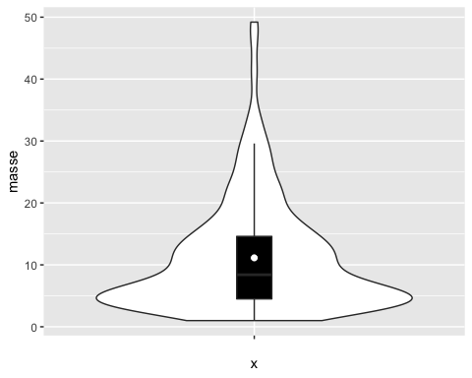

pdf("figure321eggplot.pdf")  
print(ggplot(Mesures, aes(x="", y=masse)) + geom_violin() +  
 geom_boxplot(width=.1, fill="black", outlier.colour=NA) +  
 stat_summary(fun.y=mean, geom="point", fill="white", shape=21, size=2.5))  
dev.off()

## quartz_off_screen   
## 2

#Gaussian kernel is the default and very (too) smooth for a finite population  
ggplot(Mesures, aes(x="", y=masse)) + geom_violin(kernel="rectangular") +  
 geom_boxplot(width=.1, fill="black") + stat_summary(fun.y=mean, geom="point",  
 fill="white", shape=21, size=2.5)

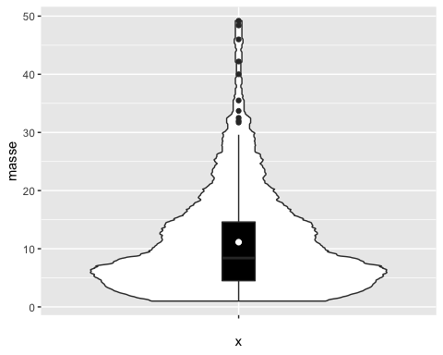

pdf("figure321fggplot.pdf")  
print(ggplot(Mesures, aes(x="", y=masse)) + geom_violin(kernel="rectangular") +  
 geom_boxplot(width=.1, fill="black") + stat_summary(fun.y=mean, geom="point",  
 fill="white", shape=21, size=2.5))  
dev.off()

## quartz_off_screen   
## 2

#Without extreme values  
ggplot(Mesures, aes(x="", y=masse)) + geom_violin(kernel="rectangular") +  
 geom_boxplot(width=.1, fill="black", outlier.colour=NA) +  
 stat_summary(fun.y=mean, geom="point", fill="white", shape=21, size=2.5)

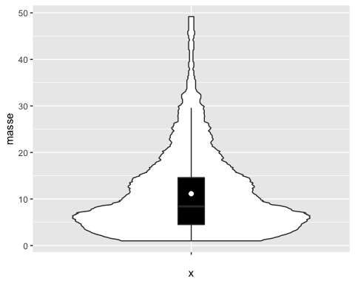

pdf("figure321gggplot.pdf")  
print(ggplot(Mesures, aes(x="", y=masse)) + geom_violin(kernel="rectangular") +  
 geom_boxplot(width=.1, fill="black", outlier.colour=NA) +  
 stat_summary(fun.y=mean, geom="point", fill="white", shape=21, size=2.5))  
dev.off()

## quartz_off_screen   
## 2

#page 138  
boxplot.stats(Mesures$masse)

## $stats  
## [1] 1.0 4.5 8.4 14.6 29.6  
##   
## $n  
## [1] 252  
##   
## $conf  
## [1] 7.39 9.41  
##   
## $out  
## [1] 32.0 35.5 32.5 40.0 49.2 46.0 42.2 48.4 31.7 33.7

boxplot(Mesures$masse~Mesures$espece)

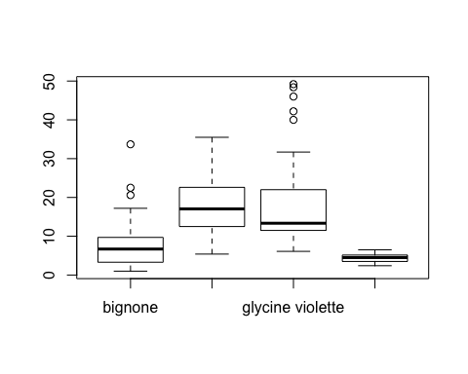

pdf("figure322.pdf")  
boxplot(Mesures$masse~Mesures$espece)  
dev.off()

## quartz_off_screen   
## 2

#page 139  
pdf("figure322color.pdf")  
boxplot(Mesures$masse~Mesures$espece,col=rainbow(4))  
dev.off()

## quartz_off_screen   
## 2

#En plus lattice par groupe  
bwplot(masse~espece,data=Mesures,pch="|")

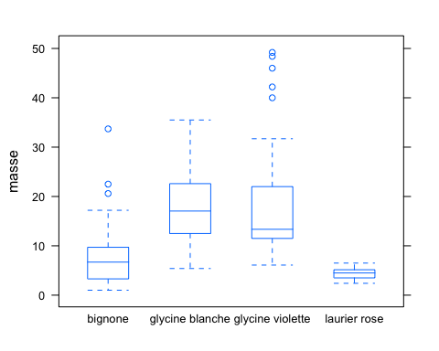

bwplot(~masse|espece,data=Mesures,pch="|")

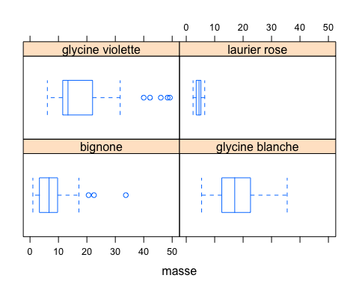

pdf("figure322lattice.pdf")  
bwplot(masse~espece,data=Mesures,pch="|")  
dev.off()

## quartz_off_screen   
## 2

pdf("figure322latticegroupe.pdf")  
bwplot(~masse|espece,data=Mesures,pch="|")  
dev.off()

## quartz_off_screen   
## 2

#En plus ggplot par groupe  
ggplot(Mesures, aes(x=espece,y=masse)) + geom_boxplot()

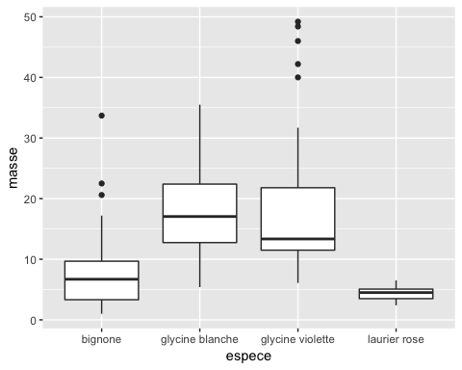

pdf("figure322ggplot.pdf")  
print(ggplot(Mesures, aes(x=espece,y=masse)) + geom_boxplot())  
dev.off()

## quartz_off_screen   
## 2

ggplot(Mesures, aes(x=espece,y=masse)) + geom_boxplot() + coord_flip()

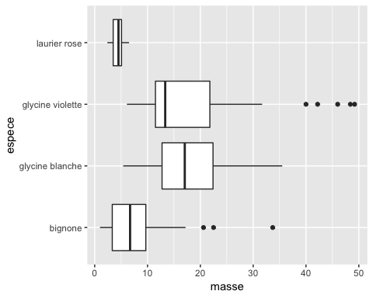

pdf("figure322ggplot.pdf")  
print(ggplot(Mesures, aes(x=espece,y=masse)) + geom_boxplot() + coord_flip())  
dev.off()

## quartz_off_screen   
## 2

ggplot(Mesures, aes(x=espece,y=masse,fill=espece)) + geom_boxplot()

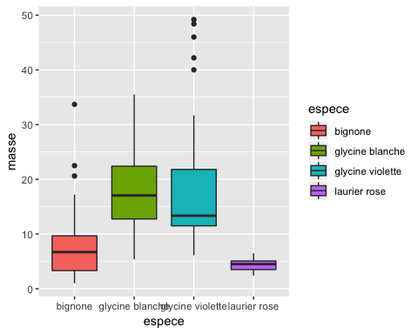

pdf("figure322ggplot.pdf")  
print(ggplot(Mesures, aes(x=espece,y=masse,fill=espece)) + geom_boxplot())  
dev.off()

## quartz_off_screen   
## 2

ggplot(Mesures, aes(x=espece,y=masse,fill=espece)) + geom_boxplot() +  
 coord_flip() + scale_fill_brewer(palette="Set1")

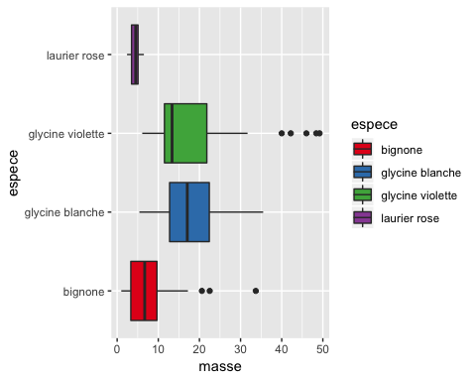

pdf("figure322ggplot.pdf")  
print(ggplot(Mesures, aes(x=espece,y=masse,fill=espece)) + geom_boxplot() +  
 coord_flip() + scale_fill_brewer(palette="Set1"))  
dev.off()

## quartz_off_screen   
## 2

ggplot(Mesures, aes(x="", y=masse)) + geom_violin(kernel="rectangular") +  
 geom_boxplot(width=.1, fill="black", outlier.colour="black") +  
 stat_summary(fun.y=mean, geom="point", fill="white", shape=21,  
 size=2.5)+facet_wrap(~espece)

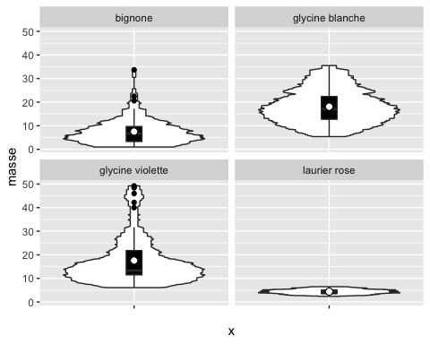

pdf("figure322ggplot.pdf")  
print(ggplot(Mesures, aes(x="", y=masse)) + geom_violin(kernel="rectangular") +  
 geom_boxplot(width=.1, fill="black", outlier.colour="black") +  
 stat_summary(fun.y=mean, geom="point", fill="white", shape=21,  
 size=2.5)+facet_wrap(~espece))  
dev.off()

## quartz_off_screen   
## 2

ggplot(Mesures, aes(x="", y=masse)) +  
 geom_violin(aes(fill=espece),kernel="rectangular",alpha=.2) +  
 geom_boxplot(aes(fill=espece),width=.1) + stat_summary(fun.y=mean, geom="point",  
 fill="white", shape=21, size=2.5)+facet_wrap(~espece)

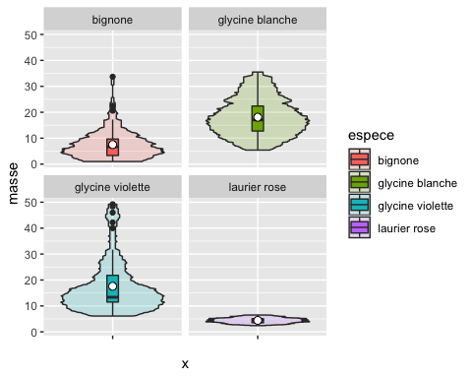

pdf("figure322ggplot.pdf")  
print(ggplot(Mesures, aes(x="", y=masse)) +  
 geom_violin(aes(fill=espece),kernel="rectangular",alpha=.2) +  
 geom_boxplot(aes(fill=espece),width=.1) + stat_summary(fun.y=mean, geom="point",  
 fill="white", shape=21, size=2.5)+facet_wrap(~espece))  
dev.off()

## quartz_off_screen   
## 2

ggplot(Mesures, aes(x="", y=masse)) +  
 geom_violin(aes(fill=espece),kernel="rectangular",alpha=.2) +  
 geom_boxplot(aes(fill=espece),width=.1) + stat_summary(fun.y=mean, geom="point",  
 fill="white", shape=21, size=2.5)+facet_wrap(~espece)+scale_fill_brewer(palette="Set1")

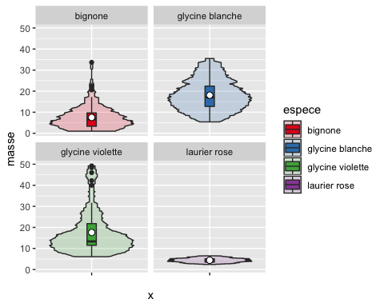

pdf("figure322ggplot.pdf")  
print(ggplot(Mesures, aes(x="", y=masse)) +  
 geom_violin(aes(fill=espece),kernel="rectangular",alpha=.2) +  
 geom_boxplot(aes(fill=espece),width=.1) + stat_summary(fun.y=mean, geom="point",  
 fill="white", shape=21, size=2.5)+facet_wrap(~espece)+scale_fill_brewer(palette="Set1"))  
dev.off()

## quartz_off_screen   
## 2

ggplot(Mesures, aes(x="", y=masse)) +  
 geom_violin(aes(fill=espece,kernel="rectangular"),alpha=.2) +  
 geom_boxplot(aes(fill=espece),width=.1) + stat_summary(fun.y=mean, geom="point",  
 fill="white", shape=21, size=2.5)+facet_wrap(~espece)+scale_fill_brewer(palette="Set2")

## Warning: Ignoring unknown aesthetics: kernel

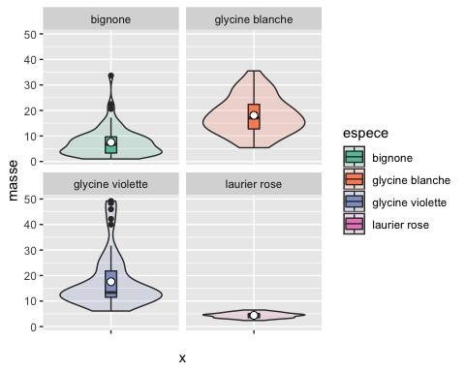

pdf("figure322ggplot.pdf")  
print(ggplot(Mesures, aes(x="", y=masse)) +  
 geom_violin(aes(fill=espece,kernel="rectangular"),alpha=.2) +  
 geom_boxplot(aes(fill=espece),width=.1) + stat_summary(fun.y=mean, geom="point",  
 fill="white", shape=21, size=2.5)+facet_wrap(~espece)+scale_fill_brewer(palette="Set2"))

## Warning: Ignoring unknown aesthetics: kernel

dev.off()

## quartz_off_screen   
## 2

ggplot(Mesures, aes(x="", y=masse)) +  
 geom_violin(aes(fill=espece,kernel="rectangular"),alpha=.2) +  
 geom_boxplot(aes(fill=espece),width=.1) + stat_summary(fun.y=mean, geom="point",  
 fill="white", shape=21, size=2.5)+facet_wrap(~espece)+scale_fill_brewer(palette="Set3")

## Warning: Ignoring unknown aesthetics: kernel

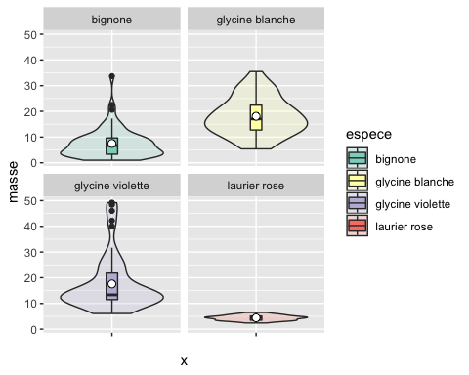

pdf("figure322ggplot.pdf")  
print(ggplot(Mesures, aes(x="", y=masse)) +  
 geom_violin(aes(fill=espece,kernel="rectangular"),alpha=.2) +  
 geom_boxplot(aes(fill=espece),width=.1) + stat_summary(fun.y=mean, geom="point",  
 fill="white", shape=21, size=2.5)+facet_wrap(~espece)+scale_fill_brewer(palette="Set3"))

## Warning: Ignoring unknown aesthetics: kernel

dev.off()

## quartz_off_screen   
## 2

#Without extreme values and with Gaussian kernel  
ggplot(Mesures, aes(x="", y=masse)) + geom_violin() + geom_boxplot(width=.1,  
 fill="black", outlier.colour=NA) + stat_summary(fun.y=mean, geom="point",  
 fill="white", shape=21, size=2.5)+facet_wrap(~espece)

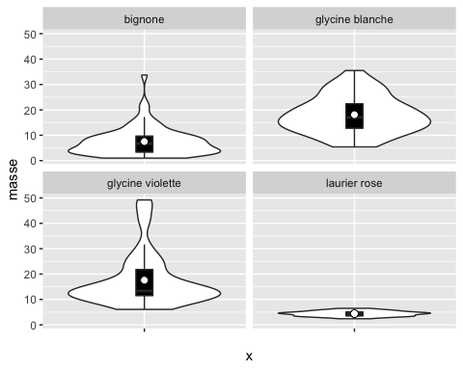

pdf("figure322ggplot.pdf")  
print(ggplot(Mesures, aes(x="", y=masse)) + geom_violin() +  
 geom_boxplot(width=.1, fill="black", outlier.colour=NA) +  
 stat_summary(fun.y=mean, geom="point", fill="white", shape=21,  
 size=2.5)+facet_wrap(~espece))  
dev.off()

## quartz_off_screen   
## 2

ggplot(Mesures, aes(x="", y=masse)) + geom_violin(aes(fill=espece),alpha=.2) +  
 geom_boxplot(aes(fill=espece),width=.1,outlier.color=NA) +  
 stat_summary(fun.y=mean, geom="point", fill="white", shape=21,  
 size=2.5)+facet_wrap(~espece)+ scale_fill_brewer(palette="Set3")

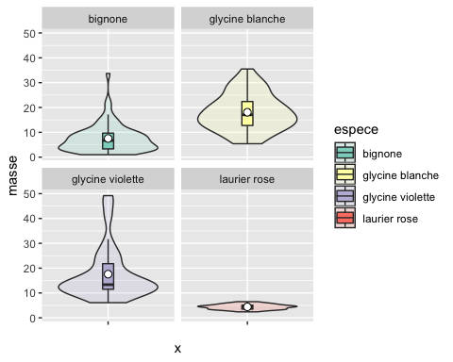

pdf("figure322ggplot.pdf")  
print(ggplot(Mesures, aes(x="", y=masse)) +  
 geom_violin(aes(fill=espece),alpha=.2) +  
 geom_boxplot(aes(fill=espece),width=.1,outlier.color=NA) +  
 stat_summary(fun.y=mean, geom="point", fill="white", shape=21,  
 size=2.5)+facet_wrap(~espece)+ scale_fill_brewer(palette="Set3"))  
dev.off()

## quartz_off_screen   
## 2

#page 140  
stem(Mesures$masse)

##   
## The decimal point is at the |  
##   
## 0 | 0455  
## 2 | 12445667777999990222223333444444455566688899  
## 4 | 00111233444455556677777778888999002333333445556788888  
## 6 | 01122333456677901123469  
## 8 | 0267880002346677  
## 10 | 123366779999333555777  
## 12 | 00024458899234555688  
## 14 | 000223466025799  
## 16 | 444668922338  
## 18 | 02218  
## 20 | 046614568  
## 22 | 445669  
## 24 | 152  
## 26 | 01246  
## 28 | 679026  
## 30 | 7  
## 32 | 057  
## 34 | 5  
## 36 |   
## 38 |   
## 40 | 0  
## 42 | 2  
## 44 |   
## 46 | 0  
## 48 | 42

#page 142  
hist(Mesures$masse,ylab="Effectif",xlab="Masse",main="Histogramme des masses")

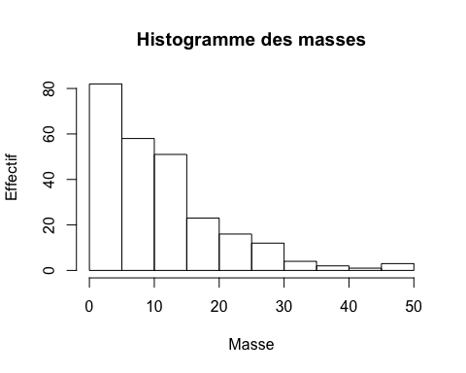

histo<-hist(Mesures$masse,plot=FALSE)  
classes<-histo$breaks  
classes

## [1] 0 5 10 15 20 25 30 35 40 45 50

#page 143  
effectifs<-histo$counts  
effectifs

## [1] 82 58 51 23 16 12 4 2 1 3

which(histo$density==max(histo$density))

## [1] 1

median(Mesures$masse)

## [1] 8.4

quantile(Mesures$masse,0.5,type=6)

## 50%   
## 8.4

#page 144  
quantile(Mesures$masse,0.25,type=6)

## 25%   
## 4.5

quantile(Mesures$masse,0.75,type=6)

## 75%   
## 14.6

quantile(Mesures$masse,c(0.25,0.5,0.75),type=6)

## 25% 50% 75%   
## 4.5 8.4 14.6

#page 145  
quantile(Mesures$masse,type=6)

## 0% 25% 50% 75% 100%   
## 1.0 4.5 8.4 14.6 49.2

#page 146  
options(digits=7)  
mean(Mesures$masse)

## [1] 11.13056

summary(Mesures$masse)

## Min. 1st Qu. Median Mean 3rd Qu. Max.   
## 1.00 4.50 8.40 11.13 14.60 49.20

#page 147  
max(Mesures$masse)-min(Mesures$masse)

## [1] 48.2

diff(range(Mesures$masse))

## [1] 48.2

IQR(Mesures$masse,type=6)

## [1] 10.1

#page 149  
var(Mesures$masse)

## [1] 81.02811

var(Mesures$masse)*length(Mesures$masse)/(length(Mesures$masse)-1)

## [1] 81.35093

#page 150  
sd(Mesures$masse)

## [1] 9.001561

#page 151  
mad(Mesures$masse,constant=1)

## [1] 4.55

mad(Mesures$masse,quantile(Mesures$masse,type=1,probs=.5),constant=1)

## [1] 4.6

median(abs(Mesures$masse-quantile(Mesures$masse,type=1,probs=.5)))

## [1] 4.6

mad(Mesures$masse,constant=1,low=TRUE)

## [1] 4.5

#page 152  
quantile(abs(Mesures$masse-median(Mesures$masse)),type=1,probs=.5)

## 50%   
## 4.5

mad(Mesures$masse,quantile(Mesures$masse,type=1,probs=.5),constant=1,low=TRUE)

## [1] 4.6

quantile(abs(Mesures$masse-quantile(Mesures$masse,type=1,probs=.5)),type=1,probs  
 =.5)

## 50%   
## 4.6

#mads par rapport à une autre référence  
mad(Mesures$masse,quantile(Mesures$masse,type=4,probs=.5),constant=1)

## [1] 4.6

mad(Mesures$masse,quantile(Mesures$masse,type=6,probs=.5),constant=1)

## [1] 4.55

mad(Mesures$masse,quantile(Mesures$masse,type=7,probs=.5),constant=1)

## [1] 4.55

#Autre example de calculs à partir d'un petit échantillon  
x <- c(1,2,3,5,7,8)  
sort(abs(x - median(x)))

## [1] 1 1 2 3 3 4

c(mad(x, constant = 1),  
 mad(x, constant = 1, low = TRUE),  
 mad(x, constant = 1, high = TRUE))

## [1] 2.5 2.0 3.0

quantile(x,type=1,probs=.5)

## 50%   
## 3

quantile(x,type=2,probs=.5)

## 50%   
## 4

mad(x,constant=1,low = TRUE)

## [1] 2

sort(abs(x-quantile(x,type=1,probs=.5)))

## [1] 0 1 2 2 4 5

quantile(abs(x-quantile(x,type=1,probs=.5)),type=1,probs=.5)

## 50%   
## 2

library(BioStatR)  
cvar(Mesures$masse)

## [1] 80.87253

#page 154  
# Asymétrie et aplatissement d'un échantillon  
if(!("agricolae" %in%  
 rownames(installed.packages()))){install.packages("agricolae")}  
library(agricolae)  
skewness(Mesures$masse)

## [1] 1.639849

kurtosis(Mesures$masse)

## [1] 3.080963

#Pour retirer la bibliothèque agricolae de la mémoire de R avant de charger e1071  
detach(package:agricolae)  
if(!("e1071" %in% rownames(installed.packages()))){install.packages("e1071")}  
library(e1071)  
# Asymétrie et aplatissement d'une série statistique (=population)  
skewness(Mesures$masse,type=1)

## [1] 1.630072

kurtosis(Mesures$masse,type=1)

## [1] 2.996456

# Asymétrie et aplatissement d'un échantillon (comme agricolae)  
skewness(Mesures$masse,type=2)

## [1] 1.639849

kurtosis(Mesures$masse,type=2)

## [1] 3.080963

detach(package:e1071)  
  
#Exercice 3.1  
#page 164  
#1)  
Variete<-c(rep(1,4),rep(2,4),rep(3,4))  
Variete

## [1] 1 1 1 1 2 2 2 2 3 3 3 3

Jutosite<-c(4,6,3,5,7,8,7,6,8,6,5,6)  
Jutosite

## [1] 4 6 3 5 7 8 7 6 8 6 5 6

Pommes<-data.frame(Variete,Jutosite)  
Pommes

## Variete Jutosite  
## 1 1 4  
## 2 1 6  
## 3 1 3  
## 4 1 5  
## 5 2 7  
## 6 2 8  
## 7 2 7  
## 8 2 6  
## 9 3 8  
## 10 3 6  
## 11 3 5  
## 12 3 6

#page 165  
#2)  
str(Pommes)

## 'data.frame': 12 obs. of 2 variables:  
## $ Variete : num 1 1 1 1 2 2 2 2 3 3 ...  
## $ Jutosite: num 4 6 3 5 7 8 7 6 8 6 ...

class(Pommes$Variete)

## [1] "numeric"

#3)  
Variete<-factor(Variete)  
Pommes<-data.frame(Variete,Jutosite)  
rm(Variete)  
rm(Jutosite)  
str(Pommes)

## 'data.frame': 12 obs. of 2 variables:  
## $ Variete : Factor w/ 3 levels "1","2","3": 1 1 1 1 2 2 2 2 3 3 ...  
## $ Jutosite: num 4 6 3 5 7 8 7 6 8 6 ...

#page 166  
class(Pommes$Variete)

## [1] "factor"

Pommes

## Variete Jutosite  
## 1 1 4  
## 2 1 6  
## 3 1 3  
## 4 1 5  
## 5 2 7  
## 6 2 8  
## 7 2 7  
## 8 2 6  
## 9 3 8  
## 10 3 6  
## 11 3 5  
## 12 3 6

#4)  
Variete<-factor(c(rep(1,4),rep(2,4),rep(3,4)))  
Jutosite<-c(4,6,3,5,7,8,7,6,8,6,5,6)  
Pommes<-data.frame(Variete,Jutosite)  
str(Pommes)

## 'data.frame': 12 obs. of 2 variables:  
## $ Variete : Factor w/ 3 levels "1","2","3": 1 1 1 1 2 2 2 2 3 3 ...  
## $ Jutosite: num 4 6 3 5 7 8 7 6 8 6 ...

#5)  
Variete<-factor(c(rep(1,4),rep(2,4),rep(3,4)),labels=c("V1","V2","V3"))  
Jutosite<-c(4,6,3,5,7,8,7,6,8,6,5,6)  
Pommes<-data.frame(Variete,Jutosite)  
Pommes

## Variete Jutosite  
## 1 V1 4  
## 2 V1 6  
## 3 V1 3  
## 4 V1 5  
## 5 V2 7  
## 6 V2 8  
## 7 V2 7  
## 8 V2 6  
## 9 V3 8  
## 10 V3 6  
## 11 V3 5  
## 12 V3 6

#page 167  
str(Pommes)

## 'data.frame': 12 obs. of 2 variables:  
## $ Variete : Factor w/ 3 levels "V1","V2","V3": 1 1 1 1 2 2 2 2 3 3 ...  
## $ Jutosite: num 4 6 3 5 7 8 7 6 8 6 ...

#6)  
Variete<-as.factor(c(rep(1,4),rep(2,4),rep(3,4)))  
Jutosite<-c(4,6,3,5,7,8,7,6,8,6,5,6)  
Pommes<-data.frame(Variete,Jutosite)  
Pommes

## Variete Jutosite  
## 1 1 4  
## 2 1 6  
## 3 1 3  
## 4 1 5  
## 5 2 7  
## 6 2 8  
## 7 2 7  
## 8 2 6  
## 9 3 8  
## 10 3 6  
## 11 3 5  
## 12 3 6

str(Pommes)

## 'data.frame': 12 obs. of 2 variables:  
## $ Variete : Factor w/ 3 levels "1","2","3": 1 1 1 1 2 2 2 2 3 3 ...  
## $ Jutosite: num 4 6 3 5 7 8 7 6 8 6 ...

#page 168  
#7)  
tapply(Jutosite,Variete,mean)

## 1 2 3   
## 4.50 7.00 6.25

tapply(Jutosite,Variete,sd)

## 1 2 3   
## 1.2909944 0.8164966 1.2583057

tapply(Jutosite,Variete,quantile,type=6)

## $`1`  
## 0% 25% 50% 75% 100%   
## 3.00 3.25 4.50 5.75 6.00   
##   
## $`2`  
## 0% 25% 50% 75% 100%   
## 6.00 6.25 7.00 7.75 8.00   
##   
## $`3`  
## 0% 25% 50% 75% 100%   
## 5.00 5.25 6.00 7.50 8.00

tapply(Jutosite,Variete,summary)

## $`1`  
## Min. 1st Qu. Median Mean 3rd Qu. Max.   
## 3.00 3.75 4.50 4.50 5.25 6.00   
##   
## $`2`  
## Min. 1st Qu. Median Mean 3rd Qu. Max.   
## 6.00 6.75 7.00 7.00 7.25 8.00   
##   
## $`3`  
## Min. 1st Qu. Median Mean 3rd Qu. Max.   
## 5.00 5.75 6.00 6.25 6.50 8.00

#Exercice 3.2  
#page 169  
#1)  
options(digits=3)  
hist(Mesures$masse,breaks=5,plot=FALSE)

## $breaks  
## [1] 0 10 20 30 40 50  
##   
## $counts  
## [1] 140 74 28 6 4  
##   
## $density  
## [1] 0.05556 0.02937 0.01111 0.00238 0.00159  
##   
## $mids  
## [1] 5 15 25 35 45  
##   
## $xname  
## [1] "Mesures$masse"  
##   
## $equidist  
## [1] TRUE  
##   
## attr(,"class")  
## [1] "histogram"

#page 170  
#2)  
hist(Mesures$masse,breaks=c(0,5,10,15,20,50),plot=FALSE)

## $breaks  
## [1] 0 5 10 15 20 50  
##   
## $counts  
## [1] 82 58 51 23 38  
##   
## $density  
## [1] 0.06508 0.04603 0.04048 0.01825 0.00503  
##   
## $mids  
## [1] 2.5 7.5 12.5 17.5 35.0  
##   
## $xname  
## [1] "Mesures$masse"  
##   
## $equidist  
## [1] FALSE  
##   
## attr(,"class")  
## [1] "histogram"

#page 171  
#3)  
brk <- c(0,5,10,15,20,50)  
table(cut(Mesures$masse, brk))

##   
## (0,5] (5,10] (10,15] (15,20] (20,50]   
## 82 58 51 23 38

head(cut(Mesures$masse,brk))

## [1] (20,50] (20,50] (20,50] (20,50] (20,50] (20,50]  
## Levels: (0,5] (5,10] (10,15] (15,20] (20,50]

data.frame(table(cut(Mesures$masse, brk)))

## Var1 Freq  
## 1 (0,5] 82  
## 2 (5,10] 58  
## 3 (10,15] 51  
## 4 (15,20] 23  
## 5 (20,50] 38

#4)  
if(!("Hmisc" %in% rownames(installed.packages()))){install.packages("Hmisc")}  
library(Hmisc)

## Loading required package: survival

## Loading required package: Formula

##   
## Attaching package: 'Hmisc'

## The following objects are masked from 'package:base':  
##   
## format.pval, units

brk <- c(0,5,10,15,20,50)  
res <- cut2(Mesures$masse, brk)  
head(res)

## [1] [20,50] [20,50] [20,50] [20,50] [20,50] [20,50]  
## Levels: [ 0, 5) [ 5,10) [10,15) [15,20) [20,50]

#page 172  
table(res)

## res  
## [ 0, 5) [ 5,10) [10,15) [15,20) [20,50]   
## 80 60 50 23 39

table(cut2(Mesures$masse, g=10))

##   
## [ 1.0, 3.3) [ 3.3, 4.2) [ 4.2, 4.9) [ 4.9, 6.0) [ 6.0, 8.6) [ 8.6,11.3)   
## 26 27 24 24 25 26   
## [11.3,13.6) [13.6,16.9) [16.9,23.9) [23.9,49.2]   
## 26 24 25 25

table(cut2(Mesures$masse, m=50))

##   
## [ 1.0, 4.2) [ 4.2, 6.0) [ 6.0,11.3) [11.3,16.9) [16.9,49.2]   
## 53 48 51 50 50

#Exercice 3.3  
#1)  
library(BioStatR)  
head(Mesures$masse)

## [1] 28.6 20.6 29.2 32.0 24.5 29.0

#head(masse)  
#  
#page 173  
#2)  
attach(Mesures)  
head(masse)

## [1] 28.6 20.6 29.2 32.0 24.5 29.0

detach(Mesures)  
#head(masse)  
#  
#Exercice 3.4  
options(digits=7)  
#1)  
head(Europe)

## Pays Duree  
## 1 Allemagne 41.7  
## 2 Autriche 44.1  
## 3 Belgique 41.0  
## 4 Chypre 41.8  
## 5 Danemark 40.5  
## 6 Espagne 42.2

#2)  
str(Europe)

## 'data.frame': 25 obs. of 2 variables:  
## $ Pays : Factor w/ 25 levels "Allemagne","Autriche",..: 1 2 3 4 5 6 7 8 9 10 ...  
## $ Duree: num 41.7 44.1 41 41.8 40.5 42.2 41.5 40.5 41 44.1 ...

#page 174  
#3)  
class(Europe)

## [1] "data.frame"

dim(Europe)

## [1] 25 2

#4)  
summary(Europe$Duree)

## Min. 1st Qu. Median Mean 3rd Qu. Max.   
## 39.8 41.0 41.5 41.7 42.5 44.1

#page 175  
histo<-hist(Europe$Duree,xlab="Durée en heures",ylab="Nombre de pays",  
 main="Histogramme de la variable Duree")

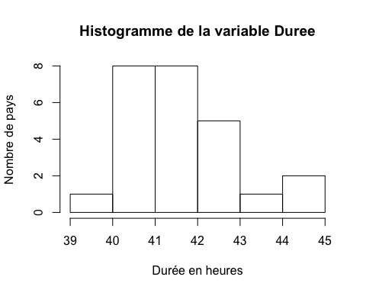

histo<-hist(Europe$Duree)

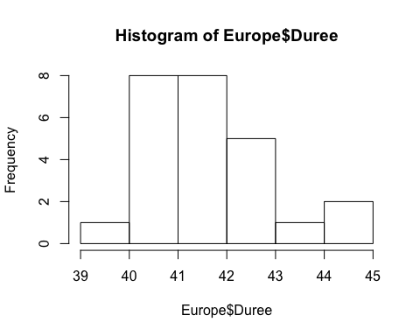

classe<-histo$breaks  
classe

## [1] 39 40 41 42 43 44 45

#page 176  
which(histo$density==max(histo$density))

## [1] 2 3

#5)  
sd(Europe$Duree)

## [1] 1.113358

cvar(Europe$Duree)

## [1] 2.669668

diff(range(Europe$Duree))

## [1] 4.3

#6)  
boxplot(Europe$Duree,ylab="Durée en heures")  
points(1,mean(Europe$Duree),pch=1)

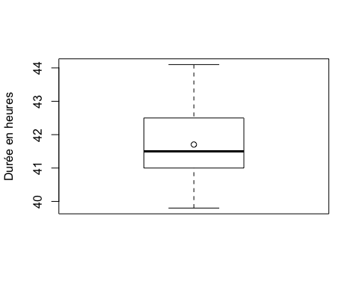

#page 177  
#7)  
pdf(file="boxplot.pdf")  
boxplot(Europe$Duree,ylab="Durée en heures")  
points(1,mean(Europe$Duree),pch=1)  
dev.off()

## quartz_off_screen   
## 2

#page 178  
postscript(file="boxplot.ps")  
boxplot(Europe$Duree,ylab="Durée en heures")  
points(1,mean(Europe$Duree),pch=1)  
dev.off()

## quartz_off_screen   
## 2

#Problème 3.1  
#1)  
Femmes<-c(105,110,112,112,118,119,120,120,125,126,127,128,130,132,133,  
 134,135,138,138,138,138,142,145,148,148,150,151,154,154,158)  
Femmes

## [1] 105 110 112 112 118 119 120 120 125 126 127 128 130 132 133 134 135  
## [18] 138 138 138 138 142 145 148 148 150 151 154 154 158

#page 179  
Hommes<-c(141,144,146,148,149,150,150,151,153,153,153,154,155,156,156,  
 160,160,160,163,164,164,165,166,168,168,170,172,172,176,179)  
Hommes

## [1] 141 144 146 148 149 150 150 151 153 153 153 154 155 156 156 160 160  
## [18] 160 163 164 164 165 166 168 168 170 172 172 176 179

#2)  
histo.fem<-hist(Femmes,breaks=c(104,114,124,134,144,154,164,174,184))  
effectif.fem<-histo.fem$counts  
effectif.fem

## [1] 4 4 8 6 7 1 0 0

sum(effectif.fem)

## [1] 30

histo.frm<-hist(Femmes,breaks=c(104,114,124,134,144,154,164,174,184))

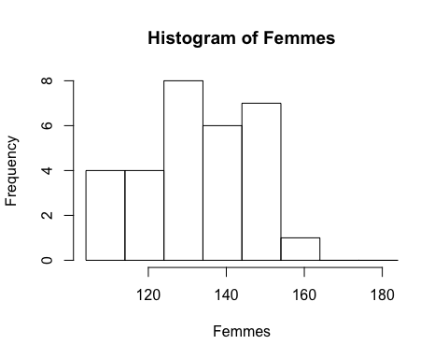

frequence.fem<-effectif.fem/sum(effectif.fem)  
print(frequence.fem,digits=3)

## [1] 0.1333 0.1333 0.2667 0.2000 0.2333 0.0333 0.0000 0.0000

#page 180  
histo.hom<-hist(Hommes,breaks=c(104,114,124,134,144,154,164,174,184))  
effectif.hom<-histo.hom$counts  
effectif.hom

## [1] 0 0 0 2 10 9 7 2

histo.hom<-hist(Hommes,breaks=c(104,114,124,134,144,154,164,174,184))

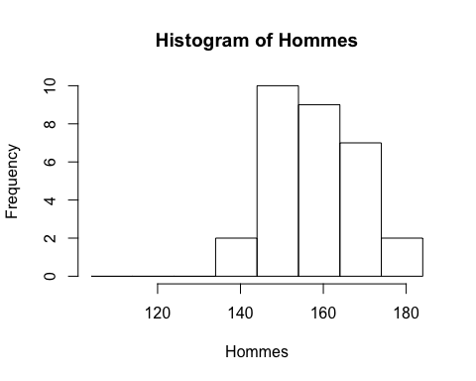

frequence.hom<-effectif.hom/sum(effectif.hom)  
print(frequence.hom,digits=3)

## [1] 0.0000 0.0000 0.0000 0.0667 0.3333 0.3000 0.2333 0.0667

#page 181  
#3)  
histo<-hist(Femmes,breaks=c(104,114,124,134,144,154,164,174,184),  
 main="Histogramme de la variable taux d'hémoglobine pour les  
 Femmes",  
 xlab="Taux d'hémoglobine",ylab="Effectif")

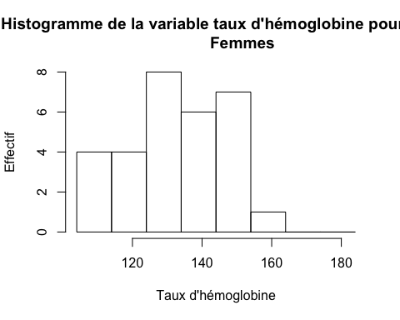

#page 182  
histo<-hist(Hommes,breaks=c(104,114,124,134,144,154,164,174,184),  
 main="Histogramme de la variable taux d'hémoglobine pour les  
 Hommes",  
 xlab="Taux d'hémoglobine",ylab="Effectif")

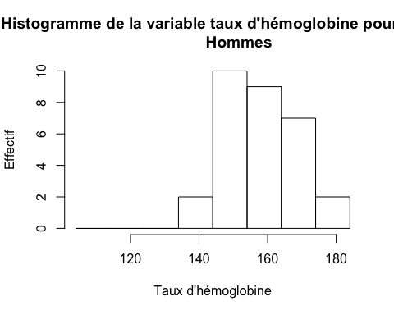

library(lattice)  
Ensemble.df <- make.groups(Femmes,Hommes)  
colnames(Ensemble.df) <- c("Taux","Sexe")  
histogram(~Taux|Sexe,xlab="Taux d'hémoglobine",data=Ensemble.df,  
 breaks=c(104,114,124,134,144,154,164,174,184),layout=c(1,2))

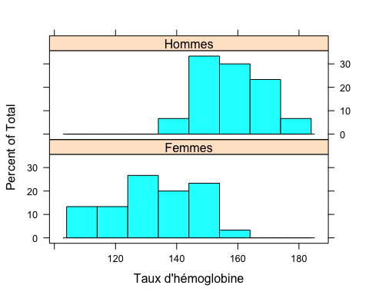

#page 183  
histogram(~Taux|Sexe,xlab="Taux d'hémoglobine",data=Ensemble.df,  
 breaks=c(104,114,124,134,144,154,164,174,184))

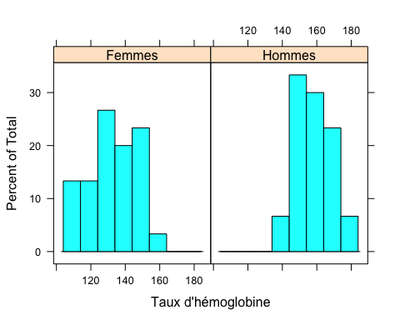

#page 184  
#4)  
Ensemble<-c(Femmes,Hommes)  
Ensemble

## [1] 105 110 112 112 118 119 120 120 125 126 127 128 130 132 133 134 135  
## [18] 138 138 138 138 142 145 148 148 150 151 154 154 158 141 144 146 148  
## [35] 149 150 150 151 153 153 153 154 155 156 156 160 160 160 163 164 164  
## [52] 165 166 168 168 170 172 172 176 179

mean(Ensemble)

## [1] 145.9

mean(Femmes)

## [1] 132.9333

mean(Hommes)

## [1] 158.8667

#5)  
histo.ens<-hist(Ensemble,breaks=c(104,114,124,134,144,154,164,174,184))

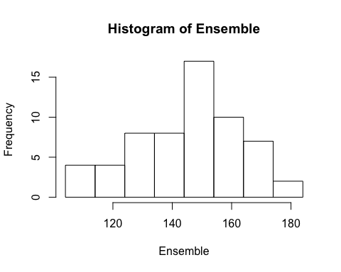

sum(histo.ens$counts*histo.ens$mids)/length(Ensemble)

## [1] 145.3333

#page 185  
sum(histo.fem$counts*histo.fem$mids)/length(Femmes)

## [1] 132.6667

sum(histo.hom$counts*histo.hom$mids)/length(Hommes)

## [1] 158

#6)  
quantile(Ensemble,0.50,type=6)

## 50%   
## 149.5

quantile(Femmes,0.50,type=6)

## 50%   
## 133.5

quantile(Hommes,0.50,type=6)

## 50%   
## 158

#Même résultats avec la fonction median  
median(Ensemble)

## [1] 149.5

median(Femmes)

## [1] 133.5

median(Hommes)

## [1] 158

#page 186  
#7)  
IQR(Ensemble,type=6)

## [1] 26.25

IQR(Femmes,type=6)

## [1] 25.75

IQR(Hommes,type=6)

## [1] 15.75

#8)  
var(Ensemble)*(length(Ensemble)-1)/length(Ensemble)

## [1] 315.3567

var(Femmes)*(length(Femmes)-1)/length(Femmes)

## [1] 201.2622

var(Hommes)*(length(Hommes)-1)/length(Hommes)

## [1] 93.18222

#page 187  
sd(Ensemble)*sqrt((length(Ensemble)-1)/length(Ensemble))

## [1] 17.75828

sd(Femmes)*sqrt((length(Femmes)-1)/length(Femmes))

## [1] 14.18669

sd(Hommes)*sqrt((length(Hommes)-1)/length(Hommes))

## [1] 9.653094

#9)  
# Asymétrie et aplatissement d'une série statistique (=population)  
if(!("e1071" %in% rownames(installed.packages()))){install.packages("e1071")}  
library(e1071)

##   
## Attaching package: 'e1071'

## The following object is masked from 'package:Hmisc':  
##   
## impute

skewness(Femmes,type=1)

## [1] -0.09996127

kurtosis(Femmes,type=1)

## [1] -0.9140576