Initiation à la statistique avec R, code et compléments chapitre 4

Frédéric Bertrand et Myriam Maumy-Bertrand

11 décembre 2018

#  
#Chapitre 4  
#page 207  
#Exercice 4.2  
#2)  
dnorm(0)

## [1] 0.3989423

pnorm(2.58)

## [1] 0.99506

qnorm(0.975)

## [1] 1.959964

rnorm(50)

## [1] -0.48635382 -0.52891993 0.36220974 1.20977013 0.28378622  
## [6] -0.08862676 0.56646921 1.58113445 1.29937352 -0.62203090  
## [11] 1.94203067 0.53644817 -0.01755901 -0.09780675 -0.01808980  
## [16] -0.77885089 -0.15803272 -0.85519607 -1.43293678 -2.27884790  
## [21] -0.40802852 -2.52178340 -1.06031053 -0.94512028 -2.10455199  
## [26] 0.54461979 0.05626385 1.20678036 -1.67733443 -0.73214649  
## [31] -0.92920504 -0.37036744 -0.56433534 -0.72370070 0.09535405  
## [36] -0.89859174 -1.19656046 -0.88527015 -0.02897661 -0.56094672  
## [41] 1.70537399 -1.67136297 -2.20041178 0.04564832 1.14463195  
## [46] -0.28527515 0.10154422 -1.14367634 -0.31374983 -1.16632723

rnorm(20,mean=10,sd=2)

## [1] 11.062906 13.181983 9.400970 6.630369 7.967873 9.306915 10.531701  
## [8] 12.911019 10.744242 10.678511 11.376659 10.684501 10.569499 7.831885  
## [15] 6.506270 10.651440 6.953142 7.977517 10.300713 10.249615

x=seq(-5,5,0.1) ;pdf=dnorm(x) ;plot(x,pdf,type="l",main="Densité d'une loi   
 normale centrée et réduite")  
library(ggplot2)

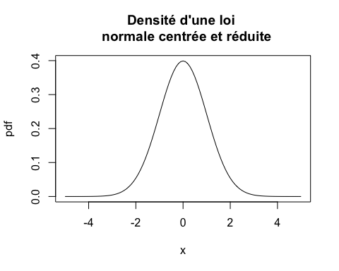

ggplot(data.frame(x=c(-5,5)),aes(x))+stat_function(fun=dnorm)+  
 ggtitle("Densité d'une loi normale centrée et réduite")+ylab("Densité")

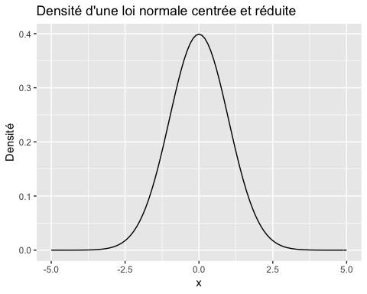

runif(10)

## [1] 0.86130510 0.94899387 0.66484613 0.10088311 0.06964637 0.12899647  
## [7] 0.96573593 0.04643115 0.01006106 0.25346123

rt(10,20)

## [1] 0.7733974 -1.6202967 -2.9812741 0.2197429 1.2710848 -0.2840833  
## [7] -1.3475264 1.9845341 -0.5185121 -0.4957501

#Exercice 4.1  
#page 210  
#1)  
#couleurs <- gray(c(0,.25,.5,.75)) #En nuances de gris comme dans le livre  
couleurs<-c("black","red","green","blue") #En couleurs  
  
fd<-function(x) {dbinom(x,5,0.5)}  
plot(cbind(0:5,sapply(0:5,fd)),xlim=c(0,20),ylim=c(0,.40),type="p",ylab="",xlab="",  
 pch=15,cex=2,lwd=3,col=couleurs[1],cex.axis=2)  
fd<-function(x) {dbinom(x,10,0.5)}  
points(cbind(0:10,sapply(0:10,fd)),xlim=c(0,20),ylim=c(0,.40),type="p",ylab="",xlab="",  
 pch=16,cex=2,lwd=3,col=couleurs[2])  
#L'option new=TRUE n'est pas nécessaire pour que la fonction points ajoute les points   
# au graphique déjà existant  
fd<-function(x) {dbinom(x,20,0.5)}  
points(cbind(0:20,sapply(0:20,fd)),xlim=c(0,20),ylim=c(0,.40),type="p",ylab="",xlab="",  
 pch=17,cex=2,lwd=3,col=couleurs[3])  
#L'option new=TRUE n'est pas nécessaire pour que la fonction points ajoute les points   
# au graphique déjà existant  
legtxt<-c(expression(paste(italic(n)," = 5",sep="")),expression(paste(italic(n)," = 10",  
 sep="")),expression(paste(italic(n)," = 20",sep="")))  
legend("topright",legtxt,title=expression(paste(italic(p)," = 0,5",sep="")),pch=c(15,16,  
 17),col=c(couleurs[1],couleurs[2],couleurs[3]),cex=2,bg="white",inset=.075)

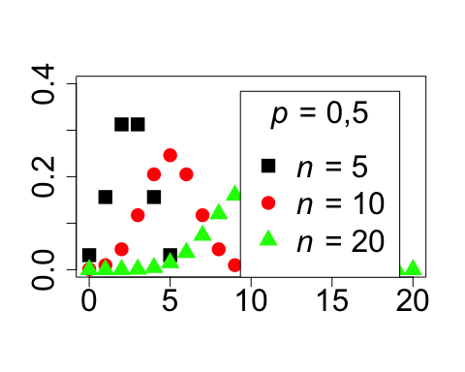

#page 211  
#2)  
dhypergeom<-function(x,N,n,p) (choose(N*p,x)*choose(N*(1-p),n-x)/choose(N,n))  
fd<-function(x) {dhypergeom(x,14,10,0.5)}  
plot(cbind(0:10,sapply(0:10,fd)),xlim=c(0,10),ylim=c(0,.5),type="p",ylab="",xlab="",  
 pch=15,cex=2,lwd=3,col=couleurs[4],cex.axis=2)  
fd<-function(x) {dhypergeom(x,20,10,0.5)}  
points(cbind(0:10,sapply(0:10,fd)),xlim=c(0,10),ylim=c(0,.5),type="p",ylab="",xlab="",  
 pch=16,cex=2,lwd=3,col=couleurs[3],new=T)  
fd<-function(x) {dhypergeom(x,50,10,0.5)}  
points(cbind(0:10,sapply(0:10,fd)),xlim=c(0,10),ylim=c(0,.5),type="p",ylab="",xlab="",  
 pch=17,cex=2,lwd=3,col=couleurs[2],new=T)  
fd<-function(x) {dbinom(x,10,0.5)}  
points(cbind(0:10,sapply(0:10,fd)),xlim=c(0,10),ylim=c(0,.5),type="p",ylab="",xlab="",  
 pch=18,cex=2,lwd=3,col=couleurs[1],new=T)  
legtxt<-c(expression(paste(italic(N)," = 14",sep="")),expression(paste(italic(N)," = 20",  
 sep="")),expression(paste(italic(N)," = 50",sep="")),expression(paste(italic(B),  
 "(10;0,5)",sep="")))  
legend("topright",legtxt,title=expression(paste(italic(n)," = 10 et ",italic(p)," = 0,5",  
 sep="")),pch=c(15,16,17,18),col=c(couleurs[4],couleurs[3],couleurs[2],couleurs[1]),  
 cex=1.6,bg="white",inset=.0)

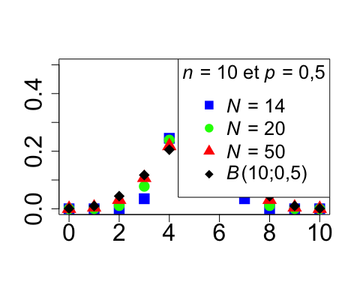

#3)  
fr<-function(x) {pchisq(x,1)}  
curve(fr,from=-1,to=9,ylab="",xlab="",lty=1,lwd=3,col=couleurs[1],type="n",cex.axis=2)  
curve(fr,from=-1,to=-0.000001,ylab="",xlab="",lty=5,lwd=3,add=TRUE,col=couleurs[1])  
curve(fr,from=0.000001,to=9,ylab="",xlab="",lty=5,lwd=3,add=TRUE,col=couleurs[1])  
fr<-function(x) {pchisq(x,3)}  
curve(fr,from=-1,to=-0.000001,ylab="",xlab="",lty=1,lwd=3,col=couleurs[3],add=TRUE)  
curve(fr,from=0.000001,to=9,ylab="",xlab="",lty=4,lwd=3,col=couleurs[3],add=TRUE)  
fr<-function(x) {pchisq(x,2)}  
curve(fr,from=-1,to=-0.000001,ylab="",xlab="",lty=2,lwd=3,add=TRUE,col=couleurs[2])  
curve(fr,from=0.000001,to=9,ylab="",xlab="",lty=2,lwd=3,add=TRUE,col=couleurs[2])  
fr<-function(x) {pchisq(x,6)}  
curve(fr,from=-1,to=-0.000001,ylab="",xlab="",lty=4,lwd=3,add=TRUE,col=couleurs[1])  
#la fin de cette instruction est sur la page 212  
curve(fr,from=0.000001,to=9,ylab="",xlab="",lty=1,lwd=3,add=TRUE,col=couleurs[4])  
  
#page 212  
legtxt<-c(expression(paste(italic(p)," = 1",sep="")),expression(paste(italic(p)," = 2",  
 sep="")),expression(paste(italic(p)," = 3",sep="")),expression(paste(italic(p)," = 6",  
 sep="")))  
legend("bottomright",legtxt,lty=c(5,2,4,1),lwd=3,col=c(couleurs[1],couleurs[2],  
 couleurs[3],couleurs[4]),cex=2,bg="white",inset=.0375)

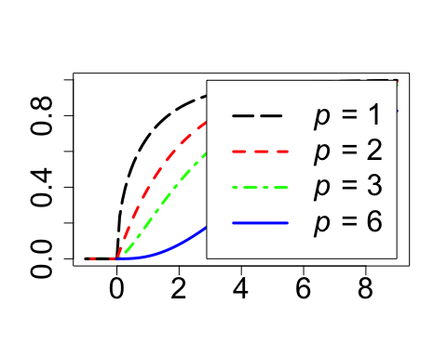

#4)  
fd<-function(x) {dnorm(x)}  
curve(fd,from=-4,to=4,ylab="",xlab="",lty=5,lwd=3,add=FALSE,col=couleurs[1],cex.axis=2)  
fd<-function(x) {dt(x,1)}  
curve(fd,from=-4,to=4,ylab="",xlab="",lty=1,lwd=3,add=TRUE,col=couleurs[2])  
fd<-function(x) {dt(x,2)}  
curve(fd,from=-4,to=4,ylab="",xlab="",lty=2,lwd=3,add=TRUE,col=couleurs[3])  
fd<-function(x) {dt(x,5)}  
curve(fd,from=-4,to=4,ylab="",xlab="",lty=4,lwd=3,add=TRUE,col=couleurs[4])  
legtxt<-c(expression(paste(italic(n)," = 1",sep="")),expression(paste(italic(n)," = 2",  
 sep="")),expression(paste(italic(n)," = 5",sep="")),expression(paste(italic(N),"(0;1)",  
 sep="")))  
legend("topleft",legtxt,lty=c(1,2,4,5),lwd=3,col=c(couleurs[2],couleurs[3],couleurs[4],  
 couleurs[1]),cex=1.6,bg="white",inset=.0375)

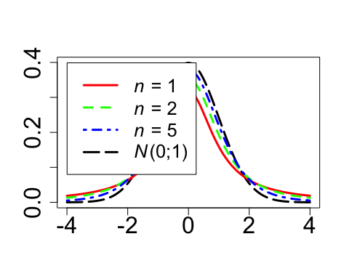

#Exercice 4.2  
dnorm(0)

## [1] 0.3989423

#page 213  
1/sqrt(2*pi)

## [1] 0.3989423

pnorm(2.58)

## [1] 0.99506

qnorm(0.975)

## [1] 1.959964

rnorm(50)

## [1] -0.071768485 1.601155606 -1.591300493 -2.286918889 -1.048685225  
## [6] -1.198444653 -0.810193876 0.388736167 1.160968221 0.153005880  
## [11] 0.165695378 -0.007895026 -0.576053392 1.016425157 -0.486190722  
## [16] 0.186171696 -0.910274952 -0.989399616 -1.786793325 0.506974759  
## [21] -1.991515271 0.972853587 -0.323390250 -0.759489731 0.302786520  
## [26] 0.201190826 1.938724961 0.103289656 -0.526868527 0.201587207  
## [31] 0.030753941 -0.388245041 0.560847881 -0.092226662 -0.305078892  
## [36] -1.380369144 -1.296208029 1.802592539 -1.617824804 0.741967582  
## [41] -0.342593619 0.535762594 0.118137004 -1.136994810 -0.146953377  
## [46] 1.950400852 0.237520654 0.833448103 0.019220209 1.010054286

rnorm(20,mean=10,sd=2)

## [1] 11.259993 12.073632 10.625005 10.694533 8.667367 11.412106 13.829884  
## [8] 13.691031 8.251257 10.650662 7.671359 7.620080 9.554254 7.303518  
## [15] 7.104458 9.663586 8.749269 10.649744 10.435898 6.882863

#page 214  
x=seq(-5,5,0.1) ;pdf=dnorm(x) ;plot(x,pdf,type="l",  
 main="Densité de la loi normale centrée et réduite")

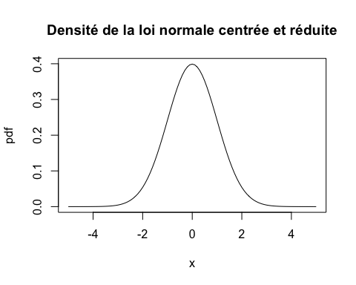

runif(10)

## [1] 0.2624119 0.7576184 0.3238985 0.3013289 0.5276431 0.8153473 0.2844257  
## [8] 0.6752177 0.8462986 0.3444201

#page 215  
rt(10,20)

## [1] 0.4723593 0.2537710 1.1968800 -0.0419151 -1.3664841 1.0237481  
## [7] 0.9087778 0.8068374 -0.3582072 -1.0705152

#Exercice 4.3  
#1)  
dbinom(5,150,0.02)

## [1] 0.1011484

#page 216  
pbinom(3,150,0.02)

## [1] 0.6472395

qbinom(0.99,150,0.02)

## [1] 8

#page 217  
#Exercice 4.4  
#1)  
qbinom(0.95,230,0.85,lower.tail = FALSE)

## [1] 186

qbinom(0.95,240,0.85,lower.tail = FALSE)

## [1] 195

qbinom(0.95,246,0.85,lower.tail = FALSE)

## [1] 200

plot(230:250,qbinom(0.95,230:250,0.85,lower.tail = FALSE))  
abline(h=200)  
abline(v=246)

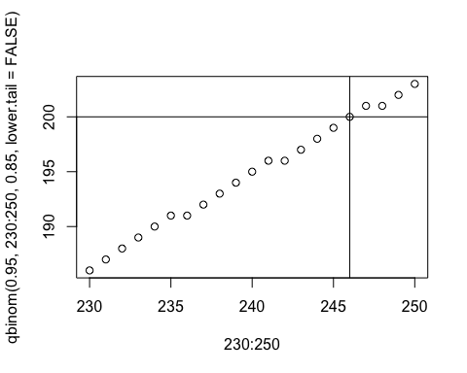

#page 218  
#2)  
which.max(dbinom(0:330,330,.85))

## [1] 282

plot(0:330,dbinom(0:330,330,.85),xlab="n",ylab="Probabilité",lwd=2)

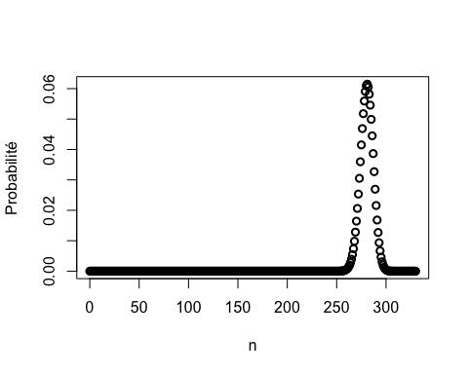

plot(270:285,dbinom(270:285,330,.85),xlab="n",ylab="Probabilité",lwd=2)

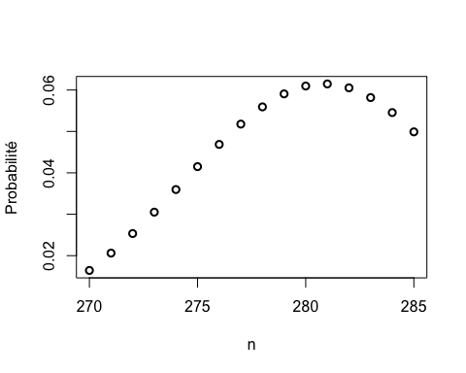

#En plus : code figure 424  
old.par <- par(no.readonly = TRUE)  
layout(t(1:2))  
plot(0:330,dbinom(0:330,330,.85),xlab="n",ylab="Probabilité",lwd=2)  
plot(270:285,dbinom(270:285,330,.85),xlab="n",ylab="Probabilité",lwd=2)  
abline(v=281)

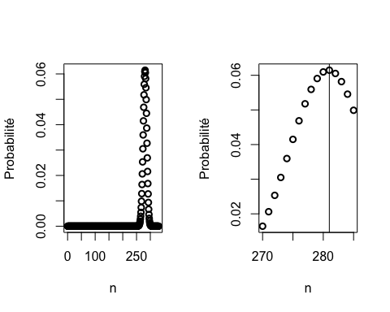

layout(1)  
par(old.par)  
  
old.par <- par(no.readonly = TRUE)  
pdf("figure424.pdf",h=6,w=9)  
layout(t(1:2))  
par(oma=rep(0,4));par(mar=c(4, 4, 2, 2) + 0.1)  
plot(0:330,dbinom(0:330,330,.85),xlab="n",ylab="Probabilité",lwd=2)  
plot(270:285,dbinom(270:285,330,.85),xlab="n",ylab="Probabilité",lwd=2)  
abline(v=281)  
layout(1)  
dev.off()

## quartz_off_screen   
## 2

par(old.par)  
  
#page 219  
#Exercice 4.5  
#1)  
1-pnorm(80,92,8)

## [1] 0.9331928

#page 220  
#2)  
(1-pnorm(80,92,8))*6000

## [1] 5599.157

#3)  
which.max(dbinom(0:6000,6000,.9331928))

## [1] 5601

plot(0:6000,dbinom(0:6000,6000,.9331928),xlab="n",ylab="Probabilité",lwd=2)

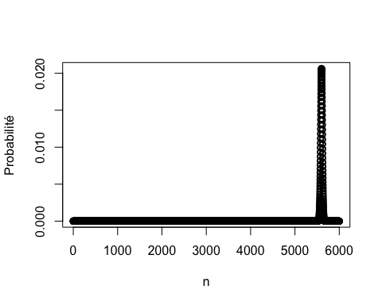

plot(5500:5700,dbinom(5500:5700,6000,.9331928),xlab="n",ylab="Probabilité",lwd=2)

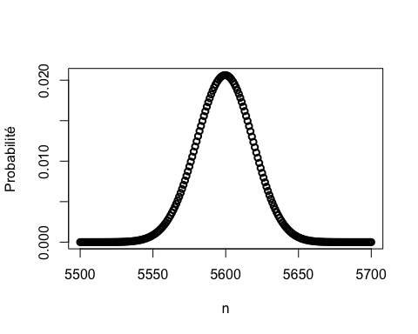

plot(5590:5610,dbinom(5590:5610,6000,.9331928),xlab="n",ylab="Probabilité",lwd=2)

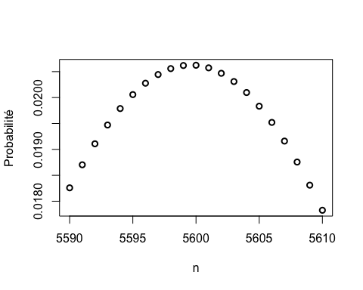

dbinom(5599,6000,.9331928)

## [1] 0.02061832

#page 221  
dbinom(5600,6000,.9331928)

## [1] 0.02062328

#En plus : code figure 425  
old.par <- par(no.readonly = TRUE)  
layout(matrix(c(1,2,1,3),nrow=2))  
par(oma=rep(0,4));par(mar=c(4, 4, 2, 2) + 0.1)  
plot(0:6000,dbinom(0:6000,6000,.9331928),xlab="n",ylab="Probabilité",lwd=2)  
plot(5500:5700,dbinom(5500:5700,6000,.9331928),xlab="n",ylab="Probabilité",lwd=2)  
plot(5590:5610,dbinom(5590:5610,6000,.9331928),xlab="n",ylab="Probabilité",lwd=2)

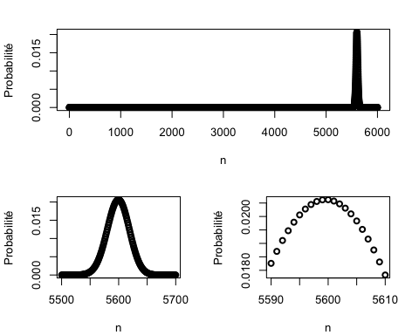

layout(1)  
par(old.par)  
  
old.par <- par(no.readonly = TRUE)  
pdf("figure425.pdf",h=6,w=9)  
layout(matrix(c(1,2,1,3),nrow=2))  
par(oma=rep(0,4));par(mar=c(4, 4, 2, 2) + 0.1)  
plot(0:6000,dbinom(0:6000,6000,.9331928),xlab="n",ylab="Probabilité",lwd=2)  
plot(5500:5700,dbinom(5500:5700,6000,.9331928),xlab="n",ylab="Probabilité",lwd=2)  
plot(5590:5610,dbinom(5590:5610,6000,.9331928),xlab="n",ylab="Probabilité",lwd=2)  
layout(1)  
dev.off()

## quartz_off_screen   
## 2

par(old.par)