Initiation à la statistique avec R, code et compléments chapitre 8

Frédéric Bertrand et Myriam Maumy-Bertrand

11 décembre 2018

#Chapitre 8  
require(BioStatR)

## Loading required package: BioStatR

#page 347  
fisher.test(matrix(c(5,1,0,14),ncol=2,byrow=TRUE))

##   
## Fisher's Exact Test for Count Data  
##   
## data: matrix(c(5, 1, 0, 14), ncol = 2, byrow = TRUE)  
## p-value = 0.000387  
## alternative hypothesis: true odds ratio is not equal to 1  
## 95 percent confidence interval:  
## 4.307393 Inf  
## sample estimates:  
## odds ratio   
## Inf

#page 356  
#Exercice 8.1  
#1)  
Rhesus<-matrix(c(3620,3805,934,172,631,676,165,30),nrow=2,byrow=TRUE)  
rownames(Rhesus)<-c("Rh+","Rh-")  
colnames(Rhesus)<-c("O","A","B","AB")  
#2)  
Rhesus

## O A B AB  
## Rh+ 3620 3805 934 172  
## Rh- 631 676 165 30

#3)  
class(Rhesus)

## [1] "matrix"

Rhesus<-as.table(Rhesus)  
class(Rhesus)

## [1] "table"

#4)  
plot(Rhesus,main="Dénombrements")

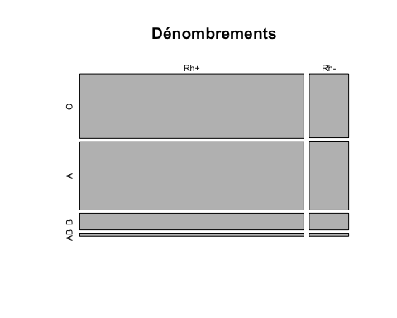

pdf("figexo81.pdf")  
plot(Rhesus,main="Dénombrements")  
dev.off()

## quartz_off_screen   
## 2

#page 357  
#5)  
margin.table(Rhesus)

## [1] 10033

margin.table(Rhesus,margin=1)

## Rh+ Rh-   
## 8531 1502

margin.table(Rhesus,margin=2)

## O A B AB   
## 4251 4481 1099 202

#6)  
chisq.test(Rhesus,simulate.p.value=FALSE)$expected

## O A B AB  
## Rh+ 3614.5999 3810.1675 934.4731 171.75939  
## Rh- 636.4001 670.8325 164.5269 30.24061

chisq.test(Rhesus,simulate.p.value=FALSE)

##   
## Pearson's Chi-squared test  
##   
## data: Rhesus  
## X-squared = 0.10456, df = 3, p-value = 0.9913

#7)  
chisq.test(Rhesus,simulate.p.value=TRUE,B=50000)

##   
## Pearson's Chi-squared test with simulated p-value (based on 50000  
## replicates)  
##   
## data: Rhesus  
## X-squared = 0.10456, df = NA, p-value = 0.9913

#page 358  
#8)  
fisher.test(Rhesus)

##   
## Fisher's Exact Test for Count Data  
##   
## data: Rhesus  
## p-value = 0.991  
## alternative hypothesis: two.sided

#9)  
fisher.test(Rhesus,simulate.p.value=TRUE,B=50000)

##   
## Fisher's Exact Test for Count Data with simulated p-value (based  
## on 50000 replicates)  
##   
## data: Rhesus  
## p-value = 0.9904  
## alternative hypothesis: two.sided

#Exercice 8.2  
#1)  
flor<-matrix(c(34,73,63,16,12,12),nrow=2,byrow=T)  
rownames(flor)<-c("Fleuri","Pas fleuri")  
colnames(flor)<-c("Engrais A","Engrais B","Engrais C")  
flor<-as.table(flor)  
  
#page 359  
#2)  
flor

## Engrais A Engrais B Engrais C  
## Fleuri 34 73 63  
## Pas fleuri 16 12 12

#3)  
dim(flor)

## [1] 2 3

#4)  
plot(flor,main="Dénombrements")

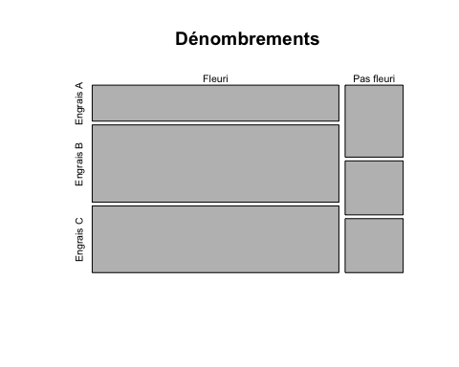

#5)  
chisq.test(flor)$expected

## Engrais A Engrais B Engrais C  
## Fleuri 40.47619 68.80952 60.71429  
## Pas fleuri 9.52381 16.19048 14.28571

chisq.test(flor)

##   
## Pearson's Chi-squared test  
##   
## data: flor  
## X-squared = 7.2316, df = 2, p-value = 0.0269

#En plus : calcul de la p-valeur par simulation  
chisq.test(flor,simulate.p.value=T,B=100000)

##   
## Pearson's Chi-squared test with simulated p-value (based on 1e+05  
## replicates)  
##   
## data: flor  
## X-squared = 7.2316, df = NA, p-value = 0.02703

#page 360  
#6)  
chisq.test(flor)$residuals

## Engrais A Engrais B Engrais C  
## Fleuri -1.0179344 0.5051718 0.2933435  
## Pas fleuri 2.0985256 -1.0414384 -0.6047432

#page 361  
#7)  
if(!("vcd" %in% rownames(installed.packages()))){install.packages("vcd")}  
library(vcd)

## Loading required package: grid

assoc(flor,shade=TRUE)

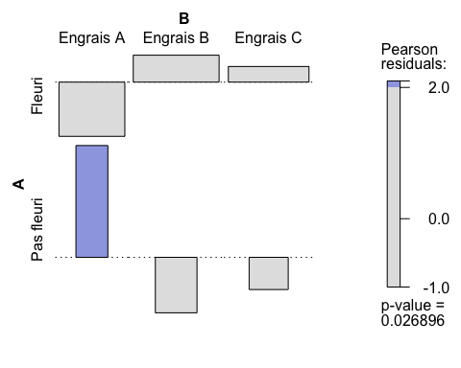

assoc(t(flor),shade=TRUE)

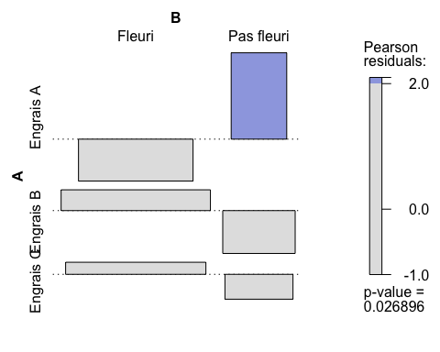

pdf("figexo82.pdf")  
assoc(flor,shade=TRUE)  
dev.off()

## quartz_off_screen   
## 2

pdf("figexo82transpose.pdf")  
assoc(t(flor),shade=TRUE)  
dev.off()

## quartz_off_screen   
## 2

#Exercice 8.3  
res.test<-chisq.test(c(100,18,24,18),p=c(90,30,30,10),rescale.p=TRUE)  
res.test$expected

## [1] 90 30 30 10

res.test

##   
## Chi-squared test for given probabilities  
##   
## data: c(100, 18, 24, 18)  
## X-squared = 13.511, df = 3, p-value = 0.003652

chisq.test(c(100,18,24,18),p=c(90,30,30,10),rescale.p=TRUE,simulate=TRUE)

##   
## Chi-squared test for given probabilities with simulated p-value  
## (based on 2000 replicates)  
##   
## data: c(100, 18, 24, 18)  
## X-squared = 13.511, df = NA, p-value = 0.004498

#page 362  
#Exercice 8.4  
#1)  
radio<-matrix(c(103,12,18,35),nrow=2,byrow=T)  
rownames(radio)<-c("Bras cassé","Bras normal")  
colnames(radio)<-c("Bras cassé","Bras normal")  
radio<-as.table(radio)  
#2)  
radio

## Bras cassé Bras normal  
## Bras cassé 103 12  
## Bras normal 18 35

#4)  
mcnemar.test(radio)

##   
## McNemar's Chi-squared test with continuity correction  
##   
## data: radio  
## McNemar's chi-squared = 0.83333, df = 1, p-value = 0.3613

#page 363  
#5)  
binom.test(radio[2],n=sum(radio[c(2,3)]))

##   
## Exact binomial test  
##   
## data: radio[2] and sum(radio[c(2, 3)])  
## number of successes = 18, number of trials = 30, p-value = 0.3616  
## alternative hypothesis: true probability of success is not equal to 0.5  
## 95 percent confidence interval:  
## 0.4060349 0.7734424  
## sample estimates:  
## probability of success   
## 0.6