# User Guide for BRAIDS

# Abdulmelik Mohammed

# abdulmelik.mohammed@sjsu.edu

# March 3, 2025

# Introduction

BRAIDS is a Maya Python script for the automated generation of DNA helices on the edges of custom mesh wireframes. It enables the design of DNA strands for the construction of custom DNA nanostructures. It is an implementation of the top-down BRAIDS design strategy introduced by Wang et at. in their manuscript titled “Automated design of scaffold-free DNA wireframe nanostructures“. The distributed package contains the following files:

1. braids.py (the main python script for the 2016 version of Autodesk Maya)
2. README.docx (this documentation for the 2016 version of BRAIDS)
3. cube.obj (an optional cube model to test the BRAIDS on)
4. braids_maya_2024.py (BRAIDS with a minor update to be able to run on Autodesk Maya 2024)
5. vHelix_maya_2024.mll (a vhelix compilation for Autodesk Maya 2024, to support BRAIDS Maya 2024)

# System Requirements

BRAIDS has been extensively tested for Autodesk Maya 2016 and the instructions herein are for the 2016 version of Maya. Check the Autodesk website on how to download and install Maya (https://www.autodesk.com/uk/products/maya/overview?term=1-YEAR&tab=subscription). Autodesk provides student/academic licenses for Maya and BRAIDS does not require more Maya functionalities than those provided in the student license. Additionally, BRAIDS uses vHelix[1] to generate the helices and thus requires vHelix to work. Please refer to the vHelix website for information on how to install and use vHelix. vhelix.org provides vHelix for Maya 2016 on the Windows platform only and requires the Visual C++ Redistributable Packages for Visual Studio 2013 available at <https://www.microsoft.com/en-us/download/details.aspx?id=40784>.

As the student version of Maya 2016 is not available, we have provided in this package a modified version of BRAIDS that works on Autodesk 2024, named braids_maya_2024.py and a compilation of vHelix for Maya 2024 on windows. BRAIDS for Maya 2024 only modifies deprecated string finding functions of BRAIDS for Maya 2016 and is functionally equivalent to it. It has been smoke tested on simple models.

BRAIDS is licensed under the MIT license.

# Installation Guide

If Maya and vhelix are installed, installing BRAIDS takes a few minutes on a normal desktop computer. (Installing Maya may take up to an hour, while vHelix should take no more than 10 minutes.) First make sure you have loaded vHelix. You can see if vHelix is loaded into Maya by checking whether the main menubar contains a “Helix” menu, as indicated in the red rectangular box in Figure 1. If vHelix is loaded, you can setup BRAIDS for use. Otherwise, consult the vHelix website for information on how to set up vHelix.

# 

*Figure 1: Checking vHelix menu and opening the Script Editor*

To use BRAIDS, first load the braids.py into the script editor. The Script Editor can be opened by clicking on the Script Editor Button in the lower right corner (see Figure 1.) To load BRAIDS into the script editor, choose File->Load Script in the Script Editor (Figure 2.) and open braids.py from its location (Figure 3). Once braids.py is loaded into the Script Editor, its Python code will be displayed in the Python tab of the Script Editor (Figure 4).

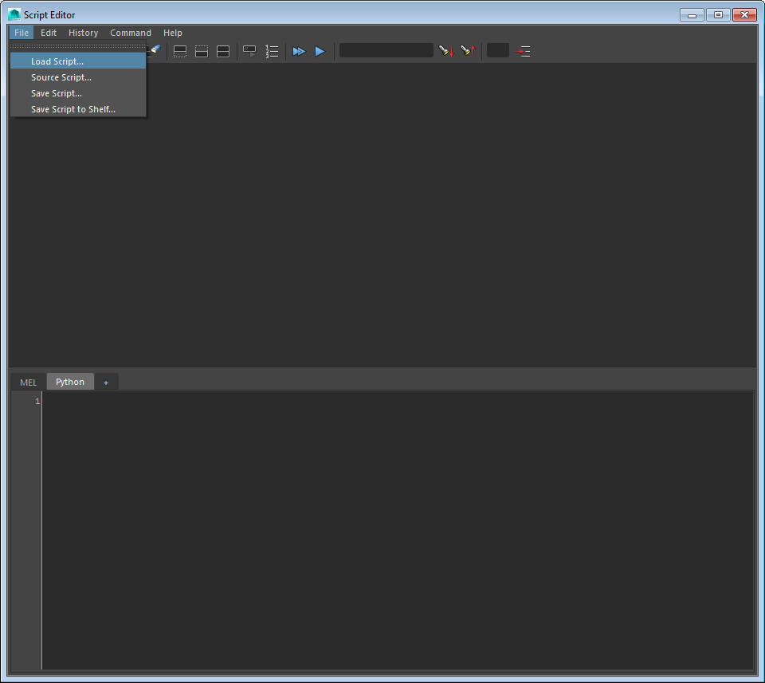

*Figure 2: Loading Cadware into the Script Editor*

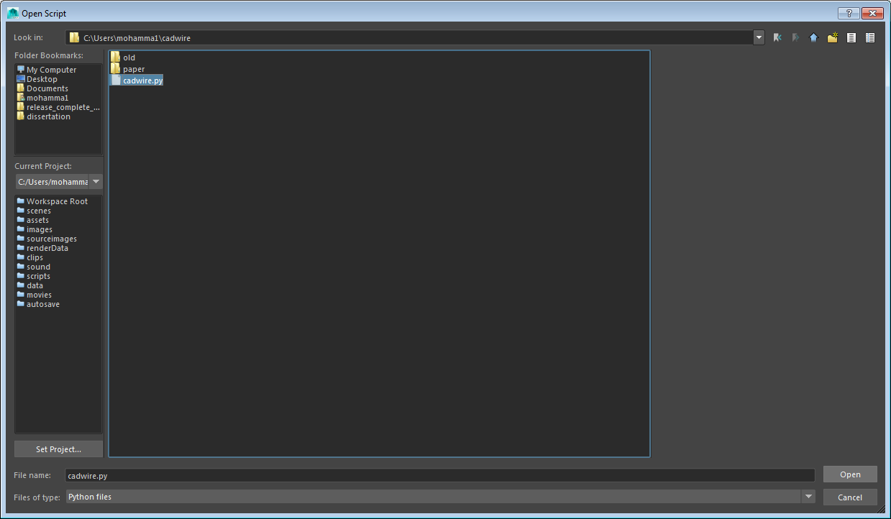

*Figure 3: Opening braids.py*

To run braids.py, select all (CTRL-A) the Python code in the Script Editor and click on Command->Execute or press CTRL-ENTER keyboard combination. However, it is better to save the script to shelf, as shown in Figures 4 and 5, for continuous use. Once the script has been saved to the Maya Shelf, it appears as an icon shown in the red rectangular box in Figure 6.

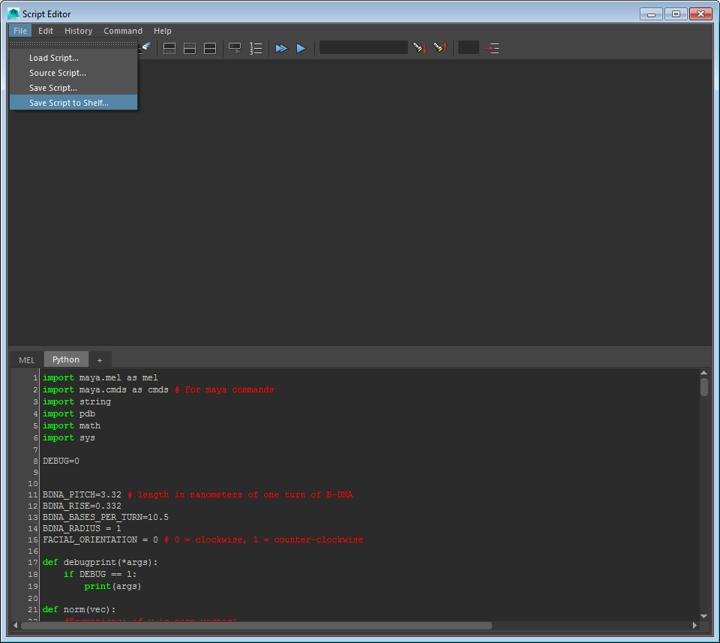

*Figure 4: Saving the script to Maya Shelf*

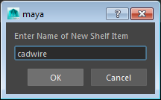

*Figure 5: Entering a shelf name for script*

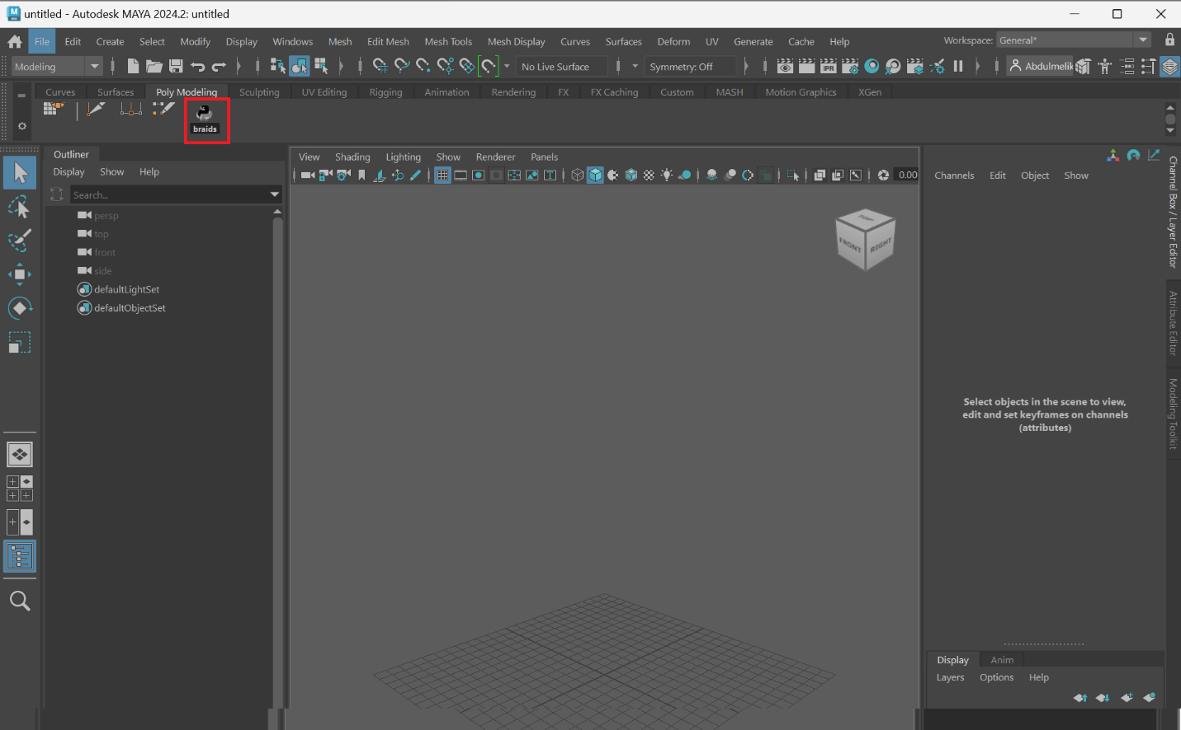

*Figure 6: BRAIDS in the Maya Shelf.* The above snapshot was made in Maya 2024. You may have to scroll the Poly Modeling region to find it. In earlier versions of Maya, such as Maya 2016, the script would be saved under the Polygons submenu. The screenshot here was updated due to a name change in BRAIDS.

# Demo Run

In this example, we create a DNA wireframe cube. For this purpose, we first create the cube using Maya’s polygon primitives. We then use BRAIDS to generate the DNA helices corresponding to the cube edges. (You may also import the cube provided in the package using the File->import submenu.) By the end of the whole process, expect to generate a text file that contains 24 sequences for the DNA cube. The whole process should take no more than 20 minutes on a normal desktop computer.

To create the cube, go to Create->Polygon Primitives, and click on the square on the right of the Cube menu item, as shown in Figure 7. This opens up a dialog for setting the parameters of the cube geometry. Set the Width, Height and Depth to 10 and press create (see Figure 8)[2].

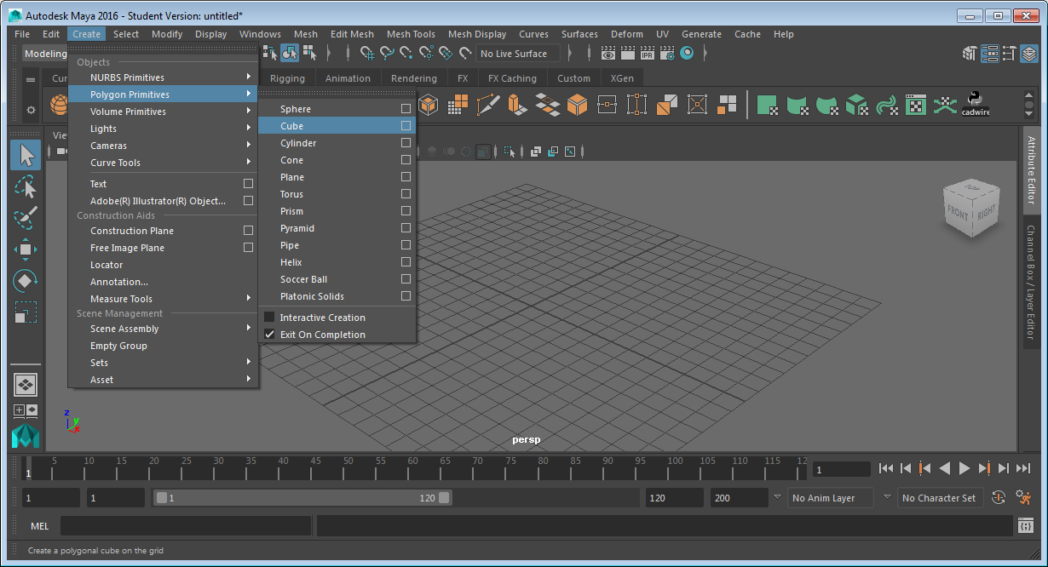

*Figure 7: Opening the cube creation dialogue*

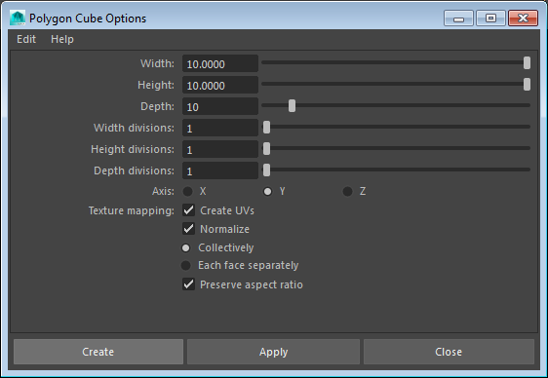

*Figure 8: Setting the cube dimensions and creating the object*

After the cube is created, select the cube by clicking on it (if it is not already selected). Once the cube is selected, press the BRAIDS shelf icon (cf. Figure 6). This brings up the BRAIDS dialogue shown in Figure 9. In this dialogue, press generate helices. If all went well, a DNA wireframe cube like the one in Figure 10 will be created. If the cube is in shaded view as in Figure 10, you can switch to wireframe view (see Figure 11) by clicking on wireframe render icon (red rectangular box in Figure 10). If there are issues, check for error messages in the history log of the Script Editor.

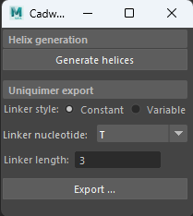

*Figure 9: BRAIDS dialogue*

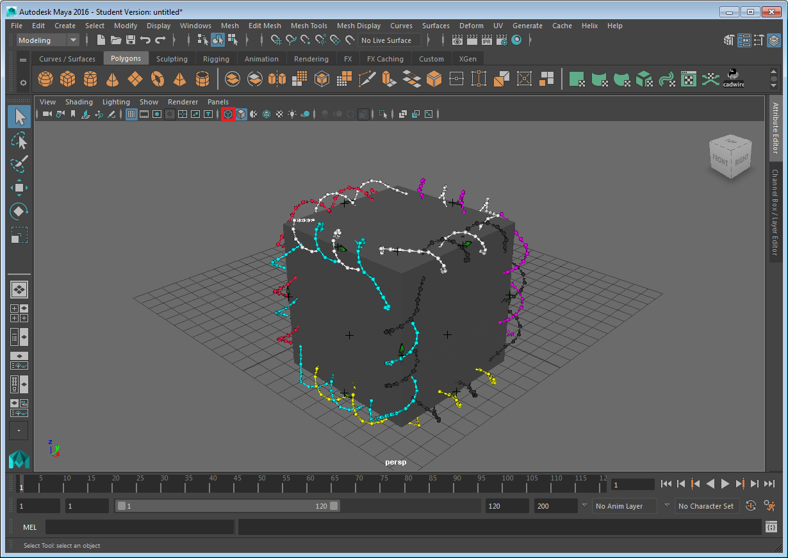

*Figure 10: DNA wireframe cube*

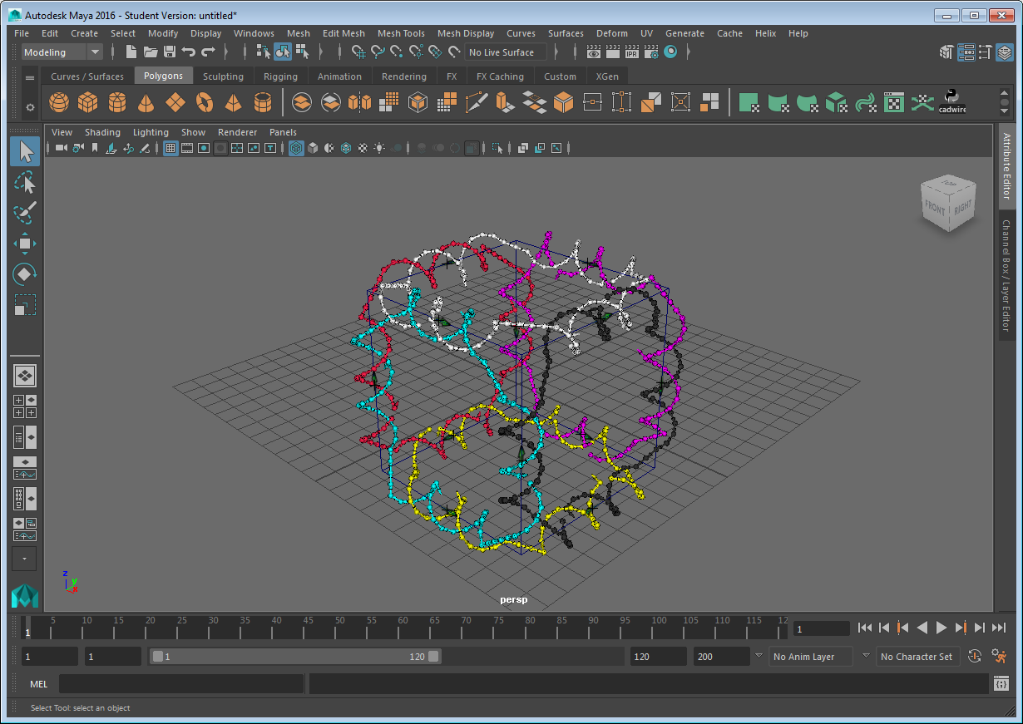

*Figure 11: DNA wireframe cube, wireframe view*

Once the helices are generated, you can export the strands for sequence design in Uniquimer using the export button under the Uniquimer export panel of BRAIDS (see Figure 9). The exported file is an xml file that contains information about strand lengths, pairings and linkers as shown in Figures 12, 13 and 14, respectively. With the constant linker style, the gaps between the three-prime and five-prime ends of connected helices are bridged using fixed-length unpaired segments with homopolymeric sequence of the given linker nucleotide specified in the dialog (Figure 9). If the variable linker type is selected, the linker length is in direct proportion to the distance between the corresponding three prime and five prime ends of the two bridged helices.

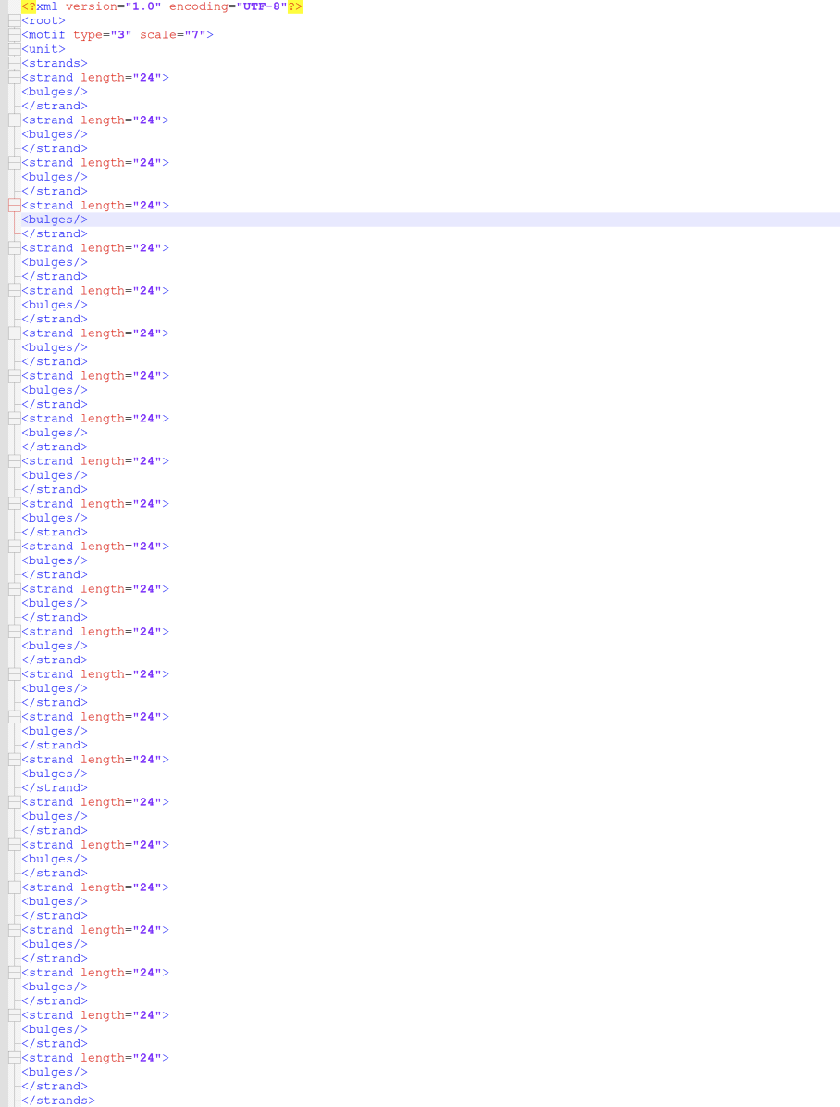

*Figure 12: Strand lengths of the cube from the BRAIDS Uniquimer export xml file*

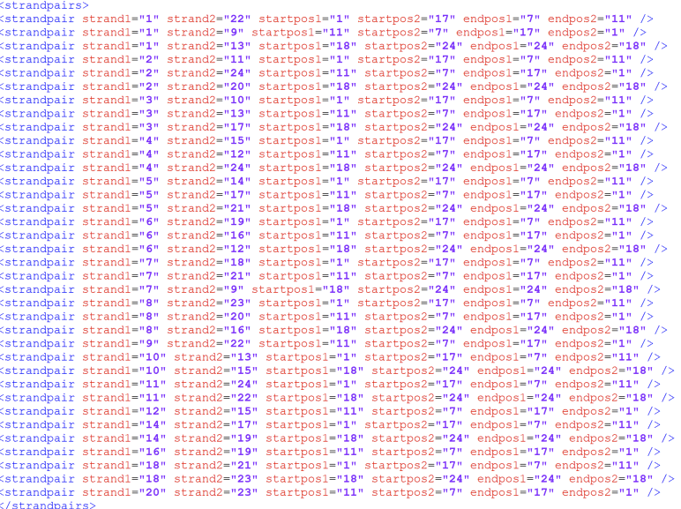

*Figure 13: Strand pairing information of the cube from the BRAIDS Uniquimer export xml file*

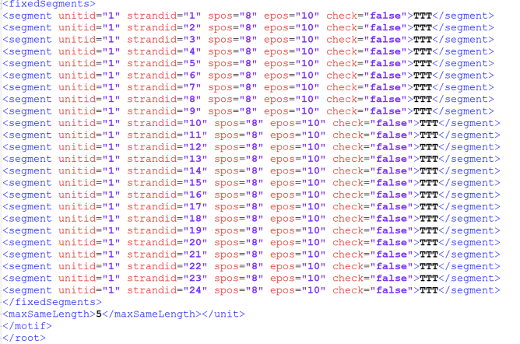

*Figure 14: Constant T linkers of the cube from the BRAIDS Uniquimer export xml file*

The BRAIDS xml file can be imported in Uniquimer from the File -> Load Input File submenu

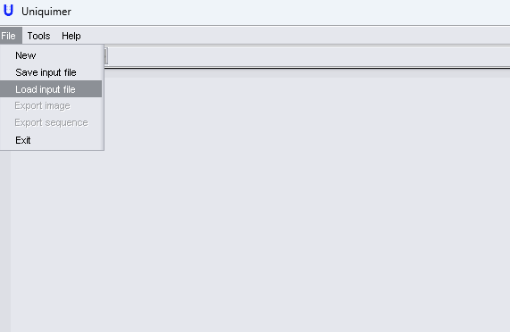

*Figure 15: Uniquimer import*

After selecting the BRAIDS exported file as an input, select other structures in the input wizard as shown in Figure 16. Leave the number of units as 1.

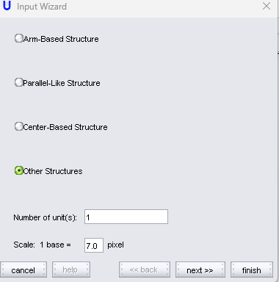

*Figure 16: Uniquimer import Input Wizard*

Press next in the Strand Information page (Figure 17) of the Input Wizard:

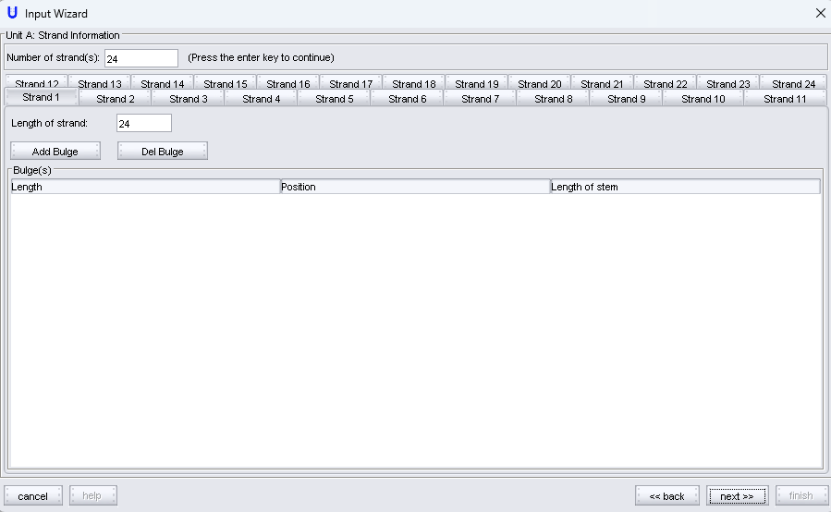

*Figure 17: Uniquimer import Strand Information page*

And again next in the Strand Pairing Information page (Figure 18). These are automatically captured from the XML file.

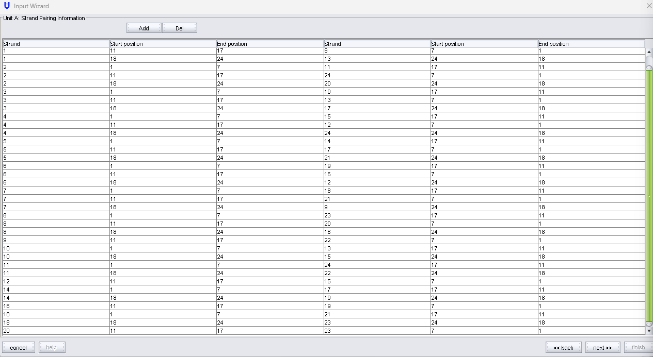*Figure 18: Uniquimer import Strand Pairing page*

Press next again in the Sticky End Matching Strategy (Figure 19) page without adding or deleting anything.

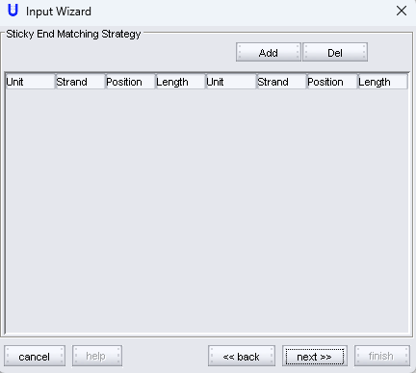

*Figure 19: Uniquimer import Sticky End Matching Strategy page*

In the next page (Figure 20), the BRAIDS specified linkers are populated as Fixed Segments in Uniquimer

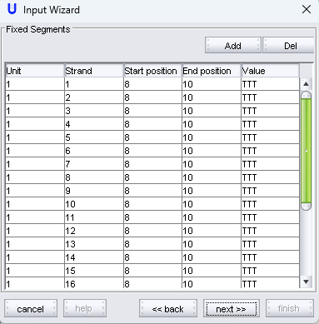

*Figure 20: Uniquimer import Fixed Segments page*

Next, in the Sequence Exclusion page (Figure 21), you can add sequences you wish to exclude from the sequence design space. This may include, for instance, four consecutive As, Cs, Gs or Ts. No sequences are excluded by default. Use the add button to specifically add sequences you wish to exclude.

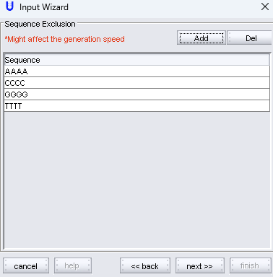

*Figure 20: Adding excluded sequences in Uniquimer*

In the next and final page (Figure 21), you can specify the maximum length of repeating segments, melting temperature for segments and GC percentage.

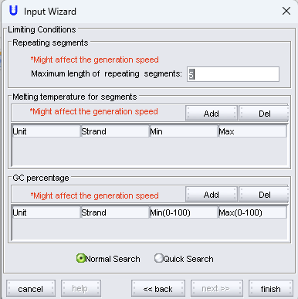

*Figure 21: Final parameters in Uniquimer*

Click Finish to finalize the sequence design and press Yes in the confirmation pop up. You can view the generated sequences in the bottom panel and export the sequences by clicking File -> Export sequence.

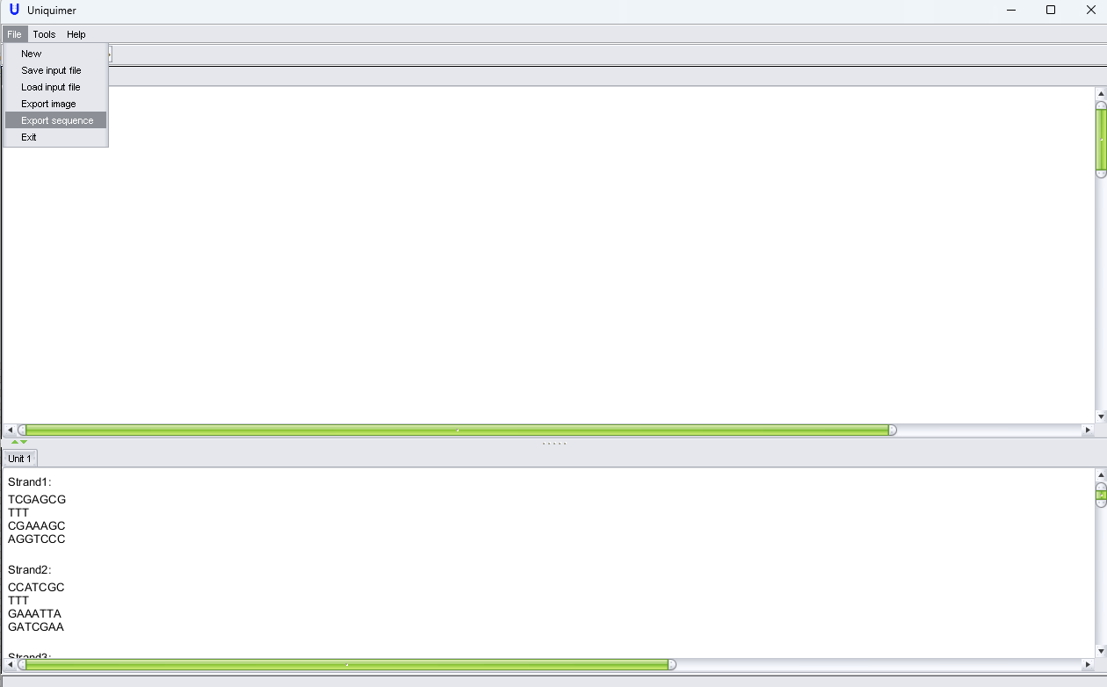

*Figure 21: Uniquimer interface after import wizard is completed.*

The exported sequence appears like shown in Figure 23.

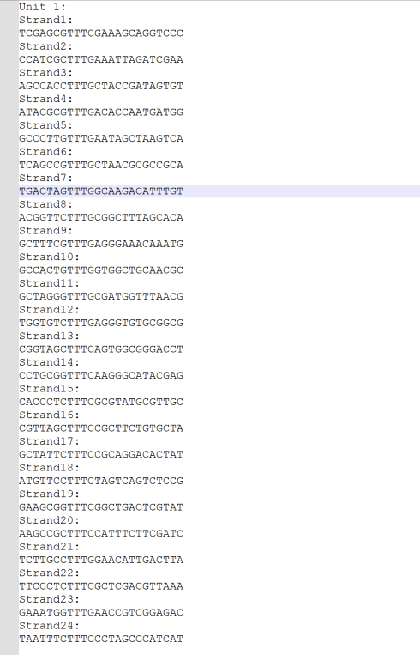

Figure 23: Uniquimer generated and exported sequence.

# Instructions for Use

To run BRAIDS on the meshes in the manuscript “Automated design of scaffold-free DNA wireframe nanostructures”, import the desired mesh obj provided in the Supplementary Data into Maya using the File->Import menu in Maya. Next select the imported mesh and generate the helices using BRAIDS, similar to the way it is done above for the cube. You may export xmls for Uniquimer sequence generation as above as well.

To create your own custom DNA polyhedra, consult Maya documentation and tutorials on how to create the polyhedra and follow the same process as in the cube to generate the helices in BRAIDS and generate the sequences using Uniquimer.

1. <http://www.vhelix.org/>
2. The unit for the dimensions is nanometer, which is the unit that vHelix assigns to 1 “Maya units”.