**Free Falling Object Safety**

This project is aimed at the aircraft sports that can provide a safety free falling subjects (humans and objects). The system will trigger a particular mechanism such as parashot after the subject reaches a 35 meter from the ground, automatically without any control from user.

The project consists of three circuits without any power supply (battery) and one software programmed on Atmega328.

**Demonstration of electronic circuits:**

We have three circuits: 1. Power 2. Timer 3. IC circuits.

All circuits are circles with radius 20mm and are attached with each other’s by connecters.

1. Power Circuit: using wind turbine the circuits are consumes current through LM2576 which provide a stable 5V. The enable pin of the regulator is attached to a circuit with a Zener diode. The purpose of that is to achieve a delay time after turning on the system.

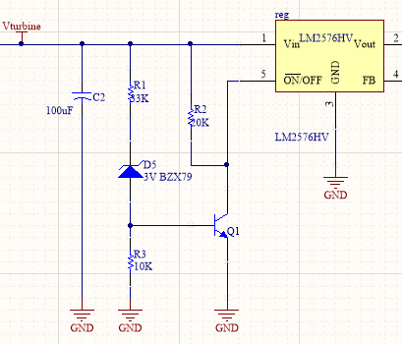

Figure 1: Zener diode with regulator LM2576 which is

enabled when input is greater than 6V for safety

V turbine >= (R1/R3 +1) *VBE + Vz

1. Timer Circuit: using IC 555, A clock signal of frequency of 514 Hz is created. After 1 second, the main capacitor will begin charging. The main capacitor is responsible for triggering the mechanism when Atmega328 ordered.

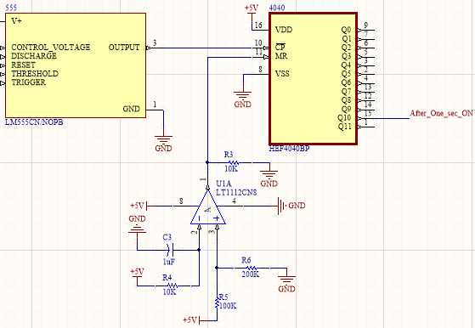

Figure 2: After 1 second, HEF4040 and IC 555 will freeze in high level state.

The op amp is used as comparator to delayed 4040 about RC second.

1. IC circuit: Atmega328 and its peripherals.

We recommend using a natural Power Wind Turbine Alternator Generator 3000 RPM,

Rated power: 0.5-5W, Output Voltage: 2-22V, Output current: 0.002-0.5A.