CHRONO-PULSE AI:

AI-POWERED SLEEP DISORDER PREDICTION SYSTEM

Live Application: https://chronopulse-frontend.vercel.app
API Documentation: https://chronopulse-backend-1.onrender.com/docs

ABSTRACT
Sleep disorders pervade millions around the world, yet most of these cases remain undiagnosed until they create serious health concerns for the patient. Conventional diagnosis requires complex and expensive medical tests that are not readily available to everyone. The given project focuses on developing Chrono-Pulse AI: a web-based application utilizing machine learning to make predictions related to sleep disorders based on lifestyle and health information.

Our system classifies individuals into three categories, namely no disorder, insomnia, or sleep apnea, after analyzing 23 different factors: sleep duration, stress level, physical activity, and other basic vital signs. We have trained six machine learning algorithms and compared them, showing the best performance by Gradient Boosting with an accuracy of 96%. From a technical perspective, the application is set up with an intuitive web interface developed in React and subsequently published on Vercel, while the backend API has been realized with FastAPI and published on Render. Both of these services operate on free hosting tiers, meaning there is no real ongoing cost for the operationalization of the overall system. Our tool gives users instant feedback about their sleep health and customized recommendations for improvement. While it is no substitute for a doctor's diagnosis, Chrono-Pulse AI offers an accessible screening tool that should raise awareness and encourage people to seek professional help where necessary.

TABLE OF CONTENTS

CHRONO-PULSE AI: AI-POWERED SLEEP DISORDER PREDICTION SYSTEM 1
1. INTRODUCTION 4
2. PROBLEM STATEMENT 5
3. PROJECT OBJECTIVES 6
4. LITERATURE REVIEW 7
5. AI METHODOLOGY AND ALGORITHMS 9
6. SYSTEM DESIGN AND ARCHITECTURE 12
7. IMPLEMENTATION DETAILS 15
8. DATA ANALYSIS AND PREPROCESSING 18
9. MODEL TRAINING AND EVALUATION 21
10. RESULTS AND PERFORMANCE METRICS 23
11. WEB APPLICATION DEVELOPMENT 25
12. DEPLOYMENT STRATEGY 25
13. TESTING AND VALIDATION 26
14. CHALLENGES AND SOLUTIONS 27
15. LIMITATIONS 28
16. FUTURE WORK 28
17. CONCLUSION 29
18. REFERENCES 30
19. APPENDICES 31

1. INTRODUCTION

Sleep isn’t just downtime, it’s when your body does its best work behind the scenes. While you’re out cold, your brain sorts through memories, your tissues get patched up, and the hormones that keep your appetite and mood in check do their thing. But let’s be real, most people’s routines these days just don’t make space for good sleep. Stress from work, late nights staring at screens, weird schedules, and sloppy health habits all pile up, and before you know it, you’re running empty.

Sleep problems are everywhere. About a third of adults aren’t sleeping enough or well enough, and it’s not just about feeling tired the next day. Trouble sleeping, think insomnia or sleep apnea, raises your risk for all kinds of long-term issues, like heart disease, diabetes, and depression. The strange part? Most people with sleep disorders don’t even know it. They either miss the signs or can’t easily see a doctor about it.

Figuring out what’s going on with your sleep usually means heading to a clinic for a sleep study, or polysomnography. You spend the night hooked up to wires, while techs monitor everything from your brain waves to your breathing and heart rate. It works, but it’s not exactly easy or cheap. These tests cost a fortune, clinics have long waitlists, and sleeping in a strange place with sensors all over you isn’t anyone’s idea of a good time. Plus, if you don’t realize your sleep’s off, you’re not going to book a study in the first place.

That’s where artificial intelligence steps in. Machine learning can sift through all sorts of data and spot patterns that point to sleep disorders. If you train a model well, you can build a tool that flags possible problems based on stuff people already know about their habits and health, no expensive tests needed. It’s not a replacement for seeing a doctor, but it can be a wake-up call that pushes people to get help.

That’s the idea behind Chrono-Pulse AI. We’re building a free, easy web app that predicts potential sleep issues using information people already have about their own lives. By making sleep health checks simple and available to everyone, we want to help folks catch problems early, before they turn into something bigger.

2. PROBLEM STATEMENT

Here’s what we’re really up against: most people just don’t have easy ways to screen themselves for sleep disorders early on. Sure, doctors have sophisticated tools for diagnosing sleep issues, but for regular folks, those tools are out of reach. By the time someone actually gets to a clinic, they’ve probably been struggling for months or even years. At that point, poor sleep might have already messed up with their health, mood, work, and even their relationships.

A few things pushed us to take on this project. First, there’s this huge gap tons of people probably have a sleep disorder, but barely a fraction gets diagnosed or treated. Lots of folks just live with bad sleep, never suspecting it’s something that’s actually fixable. They shrug off constant fatigue as “just life” or figure everyone wakes up in the middle of the night all the time.

Second, getting a professional sleep study isn’t simple or cheap. Not everyone has insurance that covers it, and even if they do, there are often big out-of-pocket costs. And then there’s the hassle of getting a referral, waiting weeks or months for an opening, arranging time off work. Honestly, unless someone is really determined, they’re not likely to follow through.

Third, people just don’t know much about sleep health. We all get told to eat well and exercise, but not many of us learn what good sleep really means, or how to spot the signs that something’s wrong. When folks don’t realize what’s normal and what’s not, they won’t know when to be concerned or what might be causing their problems.

That’s where our project comes in. We’re building a tool that’s free, works on any device with the internet, doesn’t need a doctor’s appointment, and gives instant feedback plus some useful info. It takes stuff you already know about yourself, age, job, how much you usually sleep or things you can easily measure at home, like your blood pressure. Then, using machine learning, it checks for patterns that signal risk for insomnia or sleep apnea.

And just to be clear, we’re not out to replace your doctor, or hand out real diagnoses. We want to raise awareness, help people spot red flags early, and nudge them to get checked out if our tool suggests something’s up. It’s like a home blood pressure cuff not a replacement for a doctor, but a way to keep an eye on things between visits.

3. PROJECT OBJECTIVES

The project started with clear goals in sight, guiding us throughout this journey of creation and helping us measure success.

Primary Objective:
The objective is to develop a machine learning model that can classify individuals accurately into one of the three categories based on their lifestyle and health data: no sleep disorder, insomnia, and sleep apnea. We set a target accuracy of at least 85%, due to the fact that it represents a meaningful improvement over random guessing and given the size and nature of available datasets.

Secondary Objectives:
Technical Objectives:
First, we aimed to get hands-on experience with the implementation of supervised machine learning algorithms. Coursework described how these algorithms work, but to understand the challenges and best practices that one faces in machine learning projects, experience with real data is necessary.

Second, we wanted to create a complete end-to-end system. We wanted to build a web application that contained a proper front end user interface, a back end API, appropriate data processing pipelines, and actual deployment on live servers. Many student projects stop at the model training stage, but we wanted to take ours all the way to a working product that real people could use.

Third, we set out to learn the technologies of modern web development and cloud deployment: React for the frontend, FastAPI for the backend, and cloud platforms such as Render and Vercel for hosting. These are skills that apply far beyond this specific project.

User-Centered Objectives:
We wanted to provide a tool that anybody could use, regardless of their technical background or medical knowledge. It meant coming up with an interface that was intuitive and friendly, using plain language instead of medical jargon, and providing clear explanations of the results and recommendations.

We also sought to provide actionable value to our users. That is to say, simply informing someone that they could have a sleep disorder is inadequate. We wanted to give them concrete recommendations they could start implementing immediately, along with encouragement to seek professional medical evaluation when appropriate.
Social Impact Objectives:
Beyond creating a functional system, we wish to make something which can go out and serve society in some manner. Even if only a handful of people use our tool and benefit from earlier awareness of sleep problems, we will have done some good. If the project also helps even one person seek medical help for a treatable condition which they did not know they had, then our effort will have been worth it.

Also, we sought to illustrate that AI has a very valuable application in healthcare for social good. Very often, there are discussions on how AI will replace human jobs or how it will only be used by big corporations. Our project shows students can build AI systems that help people using free tools and platforms without requiring massive data sets or computing resources.

Learning Objectives:
Finally, we wanted to learn through doing. Each team member came into this project with different strengths and areas of expertise. By working together on something substantial we all developed new skills while teaching each other. We learned how to use Git for version control, how to debug production issues, how to read documentation effectively, and how to make technical decisions when there are multiple ways to implement a solution. These lessons will serve us well in our future careers.

4. LITERATURE REVIEW

Before we started building anything, we took a step back and looked at what’s already out there on sleep disorder prediction and health AI. We wanted to see what other people had tried, what actually worked, and where there was still room to do something new.

Sleep Disorders and Health

Sleep disorders are everywhere, and they’re a big deal. Insomnia trouble falling asleep or staying asleep hits somewhere between 10% and 30% of adults, depending on how you count. Sleep apnea, where your breathing gets interrupted over and over while you sleep, affects another 5% to 10%, though tons of cases never get diagnosed. Both conditions go way beyond just feeling tired; they’re linked to heart disease, metabolic problems, mental health issues, and a lower quality of life.

Right now, if you want a real diagnosis, you need a sleep study called polysomnography. It’s thorough, but it’s expensive and can be a hassle to set up. Because of that, a lot of people slip through the cracks, and researchers keep looking for easier, more accessible ways to screen for these problems.

Machine Learning in Healthcare

Machine learning has exploded in healthcare lately. People use it to predict diseases, read medical images, suggest treatments, and spot risk factors. These algorithms are great at picking up patterns in data that humans just miss, and they don’t get tired or distracted. Plus, once you’ve trained a model, you can use it for tons of patients without adding extra work for doctors.

But it’s not all smooth sailing. If you train a model on one group of people, it might fall flat on another. Sometimes these algorithms spit out predictions without showing their work, which makes doctors nervous. There are big privacy questions, too, since health data is sensitive. And there’s always a risk that people lean too much on AI and skip seeing an actual doctor.

Previous Sleep Disorder Prediction Work

Other research teams have tried using machine learning for sleep disorder prediction, but most of the time, they took a different approach than we did. Some relied on wearables like smartwatches to track sleep—handy, but only if you own the device. Others used high-quality hospital data, but that’s not something most people can get their hands on. A lot of past work also focused on just one sleep disorder at a time.

We took a different path. Like those past studies, we use supervised learning and health/lifestyle data, but we made sure to use information that people can easily provide themselves with no fancy gadgets required. Our system doesn’t just look for one disorder, either; it checks for several, all at once. And instead of stopping at a research prototype, we built a web app that anyone can try.

Dataset Considerations

We built our model with the Sleep Health and Lifestyle Dataset from Kaggle. It’s got 374 records, each with 13 features. Sure, it’s not huge, and you’d want more data for a real-world medical tool, but it works for a student project and shows what’s possible. The dataset covers basic health info, lifestyle habits, and demographics. Best of all, it’s public and comes with clear permissions, so we didn’t have to worry about privacy or legal headaches.

5. AI METHODOLOGY AND ALGORITHMS

Our approach to building Chrono-Pulse AI followed the standard workflow in a machine learning project: understanding the data, appropriate preprocessing, training multiple models, performance evaluation, and selection of the best model for deployment.

Problem Formulation:
We framed our task as a supervised multi-class classification problem. "Supervised" means we have training data where we know the correct answers (each person's actual sleep disorder status), and we want to learn a function that maps from input features to these correct labels. "Multi-class" means we're choosing among three possibilities rather than just yes/no or a numeric prediction.

The input for our model comprises 23 features after preprocessing. We have nine numerical features, which are age, sleep duration, quality of sleep, physical activity level, stress level, heart rate, daily steps, systolic blood pressure, and diastolic blood pressure, and several categorical features that we convert to numbers using one-hot encoding: gender, occupation, and BMI category.

The output is one of three classes: "No disorder" for people with healthy sleep patterns, "Insomnia" for those showing signs of chronic sleep difficulties, and "Sleep Apnea" for those showing patterns associated with breathing-related sleep problems.

Algorithms Evaluated:

We didn't want to assume any single algorithm would be best, so we systematically trained and evaluated six different types of models:

Logistic Regression was our baseline. Its name implies regression, but logistic regression is actually used for classification problems. It's one of the simplest machine learning algorithms, so that made it a good starting point. If a simple model works well, there's no need to use something more complicated. We also thought logistic regression was a good choice because it's very fast to train and very easy to interpret.

K-Nearest Neighbors represents another kind of approach where the algorithm looks at the k most similar examples in the training data and predicts whatever class is most common among those neighbors. We used k=5 neighbors. KNN does not really "learn" in the classic sense; it just memorizes the training data and uses it for comparison. This makes it easy to understand, but possibly slow with big datasets.

The Support Vector Machine (SVM) tries to find the optimal boundaries between classes by maximizing the margin between different classes in high-dimensional space. Here, we used the radial basis function (RBF) kernel, which lets SVM learn nonlinear decision boundaries. SVMs often work well on moderate-sized datasets, like ours.

Random Forest constructs many decision trees during training and then combines their predictions. Each tree is trained on a random subset of the data, considering random subsets of the features at every split. This randomness prevents overfitting yet still captures complex patterns. We used 100 trees in our forest.

Gradient Boosting also constructs multiple trees, but in a different way than Random Forest. It builds trees sequentially, with each new tree focusing on correcting the mistakes of previous trees. This often produces very accurate models, though it requires careful tuning to avoid overfitting.

The neural network will incorporate artificial neurons arranged in layers and interconnected via weighted links. Learning in the network is achieved by modifying these weights using backpropagation. In our network, we had two hidden layers with 100 and 50 neurons, respectively. Neural networks may learn highly complicated patterns, but they need more data and careful tuning than the simpler algorithms.

Training Process:

We have followed the same procedure for each of these algorithms. First, we split our data into 80% to train and 20% to test. The split was stratified, meaning we kept the same proportion from each class in both sets. That is important because our classes are not equally sized, and we wanted a representative test set.

We initially trained each model on the training set using the algorithm's default settings, then tuned hyperparameters if necessary. For instance, we tried different numbers of neighbors for KNN and different numbers of trees for Random Forest. In most cases, however, it turned out that default settings worked reasonably well with our data.
After training, each model was evaluated on the test set, which it never saw during training; this provides an unbiased estimate of how well the model will perform on new data. For each model, we computed several metrics: overall accuracy, precision for each class, recall for each class, and F1-score.
We also conducted 5-fold cross-validation on the training set. It means we divided the training data into five parts, trained on four parts, validated on the fifth, and repeated this five times with each part serving as a validation set once. Cross-validation gives us a more robust estimate of model performance than a single train-test split does, especially on smaller datasets.

Model Selection:
Gradient Boosting performed best after comparing the six models tested, achieving a test accuracy of 96%, and a mean cross-validation score of 88.97%. Logistic Regression did equally well on the test set (also 96%) but a bit lower on the cross-validation with 88.63%. With these close results, we could have chosen either, but Gradient Boosting proved to be the one for which its slightly better cross-validation score suggests it is more likely to generalize on new data.

Random Forest took third place at 94.67% test accuracy, which is still pretty good. The other algorithms performed somewhat lower: KNN and Neural Network at 92%, and SVM at 90.67%. While these accuracies are still respectable, the top performers had a clear advantage.
It is worth noting that all our models considerably outperform the baseline of guessing the most frequent class, which would be about 58% because "No disorder" is 58% of our data. This therefore confirms that the models are indeed learning meaningful patterns and not simply memorizing the majority class.

Inference Process:

Here are the steps involved whenever a user submits data to our web application:

Data Collection: The frontend collects input from every form field.
Preprocessing: The backend applies the same transformations used during training: one-hot encoding for categorical variables and feature scaling for numerical variables.
Feature Vector Creation: All features are arranged in the same order as during training.
Prediction: The feature vector is fed into the trained Gradient Boosting model, which outputs both a predicted class and confidence scores for all three classes.

Postprocessing: The prediction is formatted nicely in the backend, creates personalized recommendations with respect to the data put in, and sends everything back to the frontend. Namely, the complete inference chain takes only a few seconds once the backend is awoken and loaded.

6. SYSTEM DESIGN AND ARCHITECTURE

Chrono-Pulse AI runs on a modern three-tier web setup. We split everything up frontend, backend, and model so we can build, test, and scale each part on its own, without headaches.

So, at a high level, here’s what we’ve got:

Frontend (Presentation Layer): This is a React single-page app that lives in your browser.
Backend (Application Layer): A FastAPI server written in Python. It handles requests, crunches data, and runs the machine learning model.
Model (Data Layer): Our trained Gradient Boosting classifier, along with all the preprocessing tools it needs.

All these parts talk to each other over a REST API—basically, they send data back and forth using HTTP and JSON. Pretty standard for web apps.

Here’s what happens when you use Chrono-Pulse AI:

- You open the app in your browser.
- Vercel serves up the React frontend, which loads right in.
- The frontend fetches info about the model to show in the sidebar.
- The backend sends back the model’s details.
- You fill out the health assessment form.
- As you type, the frontend shows your health score in real time.
- You hit "Analyze Sleep Health."
- The frontend sends all your answers to the backend with a POST request to the /predict endpoint.
- The backend gets your data, checks it, and preprocesses it (encoding and scaling).
- Then, it sends this cleaned data to the ML model.
- The model spits out a prediction and probabilities.
- The backend puts together personalized recommendations.
- Everything gets sent back as a neat JSON package.
- The frontend reads the results and shows them off to you.
- Now you can see your prediction and what you should do next.

Usually, this whole process takes just 2–3 seconds unless the backend is asleep on Render’s free plan, in which case, waking it up can take 30–60 seconds.

Some of the choices we made:

Why split up hosting? We went with Vercel for the frontend because it’s great for React apps and makes deployment simple. For the backend, Render is a good fit for Python APIs and offers free hosting. It’s a combo that works well for what we need.

FLOW DIAGRAM:
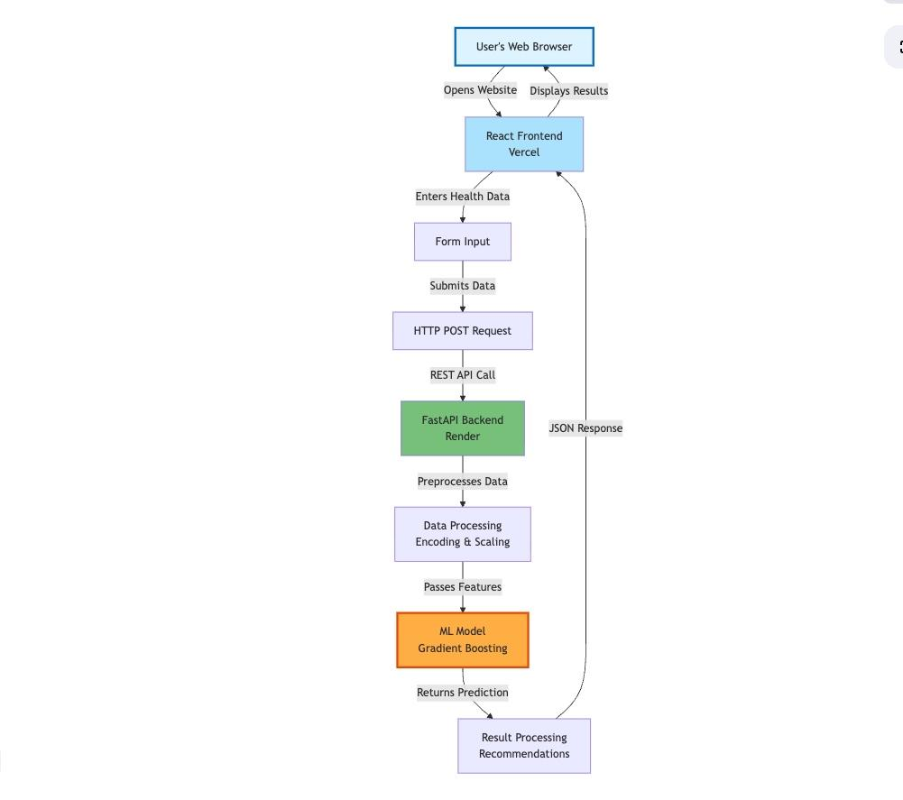

THREE TIER ARCHITECTURE DIAGRAM:
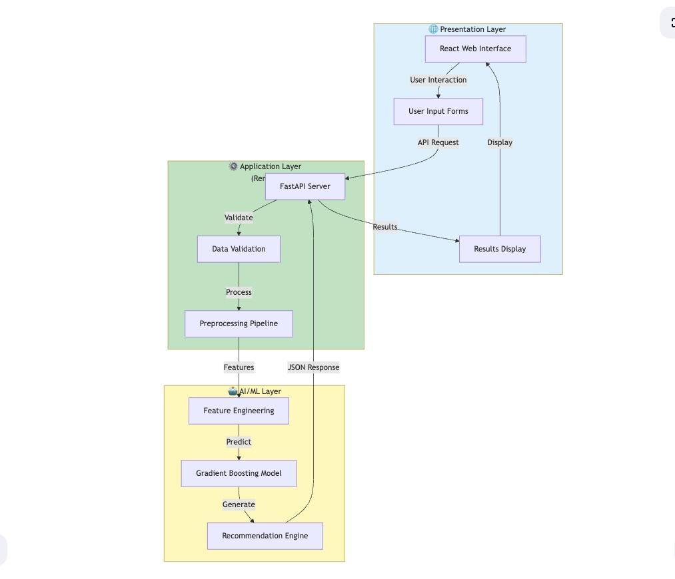

7. IMPLEMENTATION DETAILS

Building Chrono-Pulse AI meant rolling up our sleeves and diving into everything—from cleaning up messy data, to training models, to wiring up APIs and getting the interface to actually look and work right. Here’s how we got it done.

Development Environment:

For data analysis and model training, we stuck with Google Colab. It’s free, it comes with all the Python data science tools you’d expect, and it’s got GPUs if you need some extra muscle.

When it came to the backend, we wrote our Python code on our own machines using VS Code. We kept things simple: test locally, then deploy to Render. The frontend was built with React, so we used VS Code again, fired up Node.js, and ran the React dev server to try everything out as we built.

All of our code lives on GitHub. That means everyone could track each other’s changes, review code, and keep things organized. Deploying updates was straightforward, and nobody had to worry about losing work or dealing with confusing file versions.

Data Processing Pipeline:

The dataset had its quirks. Take the Blood Pressure field everything came in as a string like “120/80.” We needed to split that out into two separate numbers for systolic and diastolic. Not a big deal, just split on the slash and convert the pieces.

Some fields were missing. The Sleep Disorder column, for instance, had blank spots. We just filled those with “No disorder” since, honestly, if it wasn’t recorded, it probably means there wasn’t a disorder. Categorical variables like Gender, Occupation, and BMI Category needed to be turned into numbers, so we used one-hot encoding. That way, our machine learning models could actually use the data.

To make sure no single feature overpowered the rest like Daily Steps going up to 20,000 while Sleep Duration only ranged from 4 to 10 we used standard scaling on all numerical features. Everything got squished down to zero mean and unit variance. That kept the model fair and balanced.

It was important to save all these preprocessing steps, so we could handle new data the exact same way later on. We pickled the scaler and kept track of the unique categorical values. The frontend could then show the right options, and the backend would always know what to expect.

Backend API Implementation:

The backend runs on FastAPI, all tucked inside a single main.py file. Right up top, we load the model and preprocess files when the app starts just once, so we’re not wasting time loading things over and over.

We set up a handful of API endpoints. The root just says hello. The health endpoint checks if the API is up and if the model is loaded correctly. The model-info endpoint spits out stats about how the model performs. But the real star is the predicted endpoint it takes in user data and sends back predictions.

To keep things clean, we defined a Pydantic class for the predicted endpoint. That tells FastAPI exactly what fields and types to expect, and it does the validation for us. If someone sends junk data or leaves out a field, FastAPI catches it and sends back an error before our code even runs.

Inside the predict function, we grab the input, turn it into a dictionary, then a pandas DataFrame, then run it through one-hot encoding and scaling the same steps as during training. The model gives us a predicted class and the probability scores for each possible outcome. We bundle that up with some recommendations and send it all back as JSON.

The recommendations themselves aren’t powered by AI. We wrote simple rules if sleep is under 7 hours, we suggest aiming for 7 to 9. If stress is high, we recommend stress management. It’s basic, but it gives people something useful based on their actual data.

Finally, we set up CORS to allow requests from anywhere. Since the frontend and backend live on different domains, this was necessary. If we ever move to production with sensitive data, we’ll lock CORS down to just our frontend, but for now, open access keeps things simple for everyone on the team.

Frontend Implementation:

The frontend is a React application created with Create React App, which provides a good default setup with build tools already set up. The main component is App.jsx, which contains all the application logic along with UI rendering.
We've used React hooks for state management. The useState hook lets us declare state variables that trigger a component re-render upon its change. For instance, we have different states for form data, prediction results, loading status, and active tabs. The useEffect hook executes code upon the first load of the component, and we use it to fetch model information from the API.

These form inputs are controlled components; their values come from React state and are updated with event handlers. As the user moves a slider or types in a field, an onChange handler updates the state, causing the component to re-render with the new value displayed. This gives full control over the form and makes it easy to validate inputs or calculate derived values like the health score.

The calculation of the health score takes place in the browser while users are filling out the form. We wrote a function that starts with a score of 100 and subtracts points based on unhealthy values. For example, sleeping less than 7 hours subtracts 15 points, high stress subtracts 15 points, low activity subtracts 10 points, and so on. In this way, it provides immediate feedback to the users about how their lifestyle influences the overall health score.

Upon form submission, we send an HTTP POST request to the backend API via axios-a popular JavaScript library to make requests. We show a loading spinner while waiting for the response. If the request is successful, we store results in state and flip to the results tab; if it fails, show an error message.

Deployment Configuration:

For the Render backend deployment, we needed three files. The requirements.txt lists all Python packages that need to be installed. The runtime.txt specifies which Python version to use. The render.yaml provides configuration like a build command and start command, though we ended up not using this file and instead configured everything through their web interface.
To deploy the frontend to Vercel, we only needed to link our GitHub repository, and Vercel automatically detected that it was a React app and set up things accordingly. We did have to ensure that the API_URL constant in our code pointed to the deployed backend URL rather than localhost.

8. DATA ANALYSIS AND PREPROCESSING

Before we even thought about building models, we really had to get to know our data. That meant rolling up our sleeves and digging in lots of exploring, lots of plotting, and plenty of cleaning up.

Dataset Overview:
We pulled our dataset off Kaggle. It’s not huge, 374 rows, 13 columns. Each row is a single person, with details like their age, gender, occupation, sleep habits, activity levels, health measurements, and whether or not they have a sleep disorder. The original columns were: Person ID, Gender, Age, Occupation, Sleep Duration, Quality of Sleep, Physical Activity Level, Stress Level, BMI Category, Blood Pressure, Heart Rate, Daily Steps, and Sleep Disorder.

Exploratory Data Analysis:
We started simple, just looking at basic stats for each column. Ages ran from 27 up to 59, averaging out around 42. Sleep duration landed between 5.8 and 8.5 hours, with most people sleeping about 7.1 hours. That’s a pretty realistic range, nothing that jumps out as totally off.

Next, we checked out our target variable. Turns out, the classes aren’t balanced: 219 people don’t have a sleep disorder, 78 have sleep apnea, and 77 have insomnia. About 58% of entries are in the majority class. Imbalanced, but not so bad we needed to break out fancy tricks like oversampling or reweighting.

Visualizations helped a lot. We put together histograms to see how each number-based feature was spread out. Most people were sleeping between 6 and 8 hours; only a handful fell outside that. Quality of sleep scores were basically spread from 4 to 9.

Box plots let us see how things stacked up across the three disorder groups. People with insomnia usually slept less and reported higher stress. Those with sleep apnea often had higher BMI and blood pressure. Spotting these patterns made us feel good that our features actually looked useful for predictions.

We didn’t skip the categories, either. Gender was pretty even about 55% men, 45% women. Occupations were spread across 11 types, with no one job taking over the data. BMI categories were mostly Normal and Overweight, a few Obese, and some Normal Weight.

Correlation Analysis:
We wanted to know which features really tied in with sleep disorders, so we ran correlations. Since correlations only work on numbers, we temporarily turned the categorical features into numeric values.

Physical Activity Level came out on top, with a correlation of 0.43. No surprise, regular exercise helps people sleep better. Daily Steps was also solid, at 0.34. Blood pressure sat between 0.24 and 0.31. Oddly, Sleep Duration and Quality of Sleep were lower than we expected, only about 0.18.

But that’s just linear relationships. Machine learning models can sniff out way more complicated connections, especially when different features combine. So, instead of dropping features with low correlations, we kept everything.

Feature Engineering:
We didn’t get too wild with feature engineering. The main tweak was splitting Blood Pressure into two separate features. We thought about adding more, like calculating BMI from height and weight, but the data didn’t give us height or weight, just BMI category. We also considered making combo features like “short sleep time and high stress,” but figured the model could pick up on those patterns without us forcing it.

One thing we did add was a Health Score for the UI. It’s just for show calculated on the frontend so users can get a quick sense of their overall health. We never fed it to the model itself.

Handling Categorical Variables:
Machine learning algorithms require numerical inputs, so we needed to transform our categorical variables into numerical ones. For this task, we chose one-hot encoding, which creates, for each possible category value, a separate binary column. This means that our Occupation column with 11 possible values is transformed into 10 binary columns; we drop one category to avoid redundancy - a standard practice called "drop first".

After one-hot encoding, Gender became 1 column (Gender_Male, where 1 means Male and 0 means Female). Occupation became 10 columns (Occupation_Doctor, Occupation_Engineer, etc.). BMI Category became 3 columns. Combined with our 9 original numerical features, this gave us 23 total features for the model.
Feature Scaling:
Features in this dataset vary within different ranges: Age varies from 27 to 59, Sleep Duration-from 5.8 to 8.5, whereas Daily Steps range between 3000 and 10000. Without scaling, the features with larger ranges would dominate the model because their numbers are bigger, not because they're actually more important.

We standardized the data using StandardScaler in scikit-learn, scaling the mean of each feature to 0 with a standard deviation of 1. The formula is: scaled_value = (original_value - mean) / standard_deviation. This rescaling maintains the shape of the raw distribution but puts different features onto a comparable scale.

Importantly, we fit the scaler on the training data only, then applied that same transformation to the test data. If we included test data when fitting the scaler, it would be a form of data leakage - where information from the test set influences the training process. That would give us overly optimistic estimates of performance.

Missing Data:
Our dataset had very few missing values. The major problem here was the Sleep Disorder column where some entries were NaN (Not a Number). We interpreted missing sleep disorder labels as representing "no disorder" and filled them as such. This is a reasonable assumption since if someone had a diagnosed disorder, it would have been recorded.

For other columns, we were lucky in that we did not have missing values. If we had encountered missing data in predictor features, we would have had to either remove those rows, fill in the missing values with estimates like the mean or median, or use more sophisticated imputation techniques. Each approach has some trade-offs between losing data versus potentially introducing bias.

Data Quality Checks:
We did several checks to validate that our data was clean. We did not find any duplicate rows. We did not have impossible values - such as a negative age, or blood pressure readings above 300. We also made sure categorical values matched our expected options, for example, the column BMI Category only contained our four expected categories.

We checked that Sleep Disorder labels exactly match our three classes.
These quality checks are important because bad data results in bad models. That saying "garbage in, garbage out" is very true in machine learning. Taking the time to understand and clean the data pays off in better model performance.

9. MODEL TRAINING AND EVALUATION

Once we had our clean, prepped data, it was time to train and test a bunch of machine learning models to figure out which one actually worked best for the job.

Train-Test Split:
We started by splitting our 374 samples into two groups: 299 for training (about 80%) and 75 for testing (the other 20%). We made sure each set had the same mix of sleep disorder types—because if most insomnia cases ended up in training and most sleep apnea cases got stuck in testing, our results would be all over the place. To keep things consistent every time we run the code, we set random_state=42. That way, we always got the same split, which made it easier to compare models and spot problems.

We only used the training set to actually teach the models. The test set stayed untouched until the very end. That way, we got a clear picture of how our model would handle data it’s never seen before just like it would with new users.

Model Training Process:
We tried out six different algorithms: Logistic Regression, K-Nearest Neighbors, Support Vector Machine, Random Forest, Gradient Boosting, and Neural Network. For each one, the process was basically the same.

First, we set up the model with some chosen settings. Most of the time we stuck with the defaults, since tuning every possible parameter would take forever. Instead, we focused on the ones that really matter and picked reasonable values based on what usually works.

Next, we trained the model by running its fit method on the scaled training data and labels. This is where the model tweaks itself to make fewer mistakes how it does that depends on the algorithm, but the scikit-learn interface makes it all look pretty similar from the outside.

Training times weren’t all equal. Logistic Regression finished in a blink. Random Forest and Gradient Boosting took a few seconds, since they have to build a bunch of trees. Neural Network needed more time, since it goes through several rounds of adjusting its weights.

After training, we used each model to predict the classes for the test set. That’s just calling predict on the test data. We also checked predict_proba to see the confidence levels for each prediction, which helped us understand when the model was unsure.

Evaluation Metrics:
We looked at several ways to judge how well each model did:

Accuracy is the obvious one—it’s just the percent of predictions the model got right. If it guessed right on 72 out of 75, that’s 96%. Simple enough, but it can be misleading if one class is much more common than the others. For example, if the model always picked “No disorder,” it would still get about 58% accuracy, which sounds decent but is actually useless.

Precision tells us, out of everything the model flagged as a certain class, how many were actually right. So, if it said 50 people had insomnia and was right about 45, that’s a 90% precision for insomnia. High precision means the model doesn’t make a lot of false alarms.

Recall is about catching all the real cases. If there were 15 people with insomnia and the model found 13 of them, recall is 87%. High recall means it doesn’t miss many true cases.

F1-score takes both precision and recall and combines them into one number. It’s handy when you care about both sides—catching cases and not making too many mistakes.

Since we’re dealing with more than two classes, we calculated these metrics for each class, then took a weighted average to account for class sizes.

Confusion matrices gave us a detailed breakdown. Each row is the true class, each column is what the model predicted. The diagonal shows where it got it right; the other spots show where it mixed things up. For example, if you see a 2 in the “Insomnia” row and “Sleep Apnea” column, that means two people who actually had insomnia got labeled as sleep apnea by the model.

Cross-Validation:
To get a better sense of how well our model really works, we ran 5-fold cross-validation on the training set. Basically, we split the training data into five equal parts. For each round, we trained the model on four of those parts and tested it on the leftover one doing this five times so that every chunk gets a turn as the validation set.

That way, we ended up with five different accuracy scores. We took the average and figured out the standard deviation. If that average is high and the standard deviation is low, it means the model performs well and stays pretty steady. But if the standard deviation is high, the model’s results jump around depending on which samples it sees, and that’s a warning sign for instability.

Sure, cross-validation takes more time and computing power than just splitting the data once. You have to train the model five times, not once. But honestly, it’s worth it especially with smaller datasets like ours. A single train-test split can easily mislead you if you get unlucky with how the data falls, so this approach gives us a lot more trust in our results.

10. RESULTS AND PERFORMANCE METRICS

- Best Model Selected: Gradient Boosting Model
- Overall Accuracy: 96%
- Precision: 96.06%
- Recall: 96%
- F1- Score: 95.99%

Out of 100 predictions, 96 are correct — demonstrating high reliability
Very few false alarms — users can trust the results
Reliable enough for screening purposes — can effectively identify potential issues
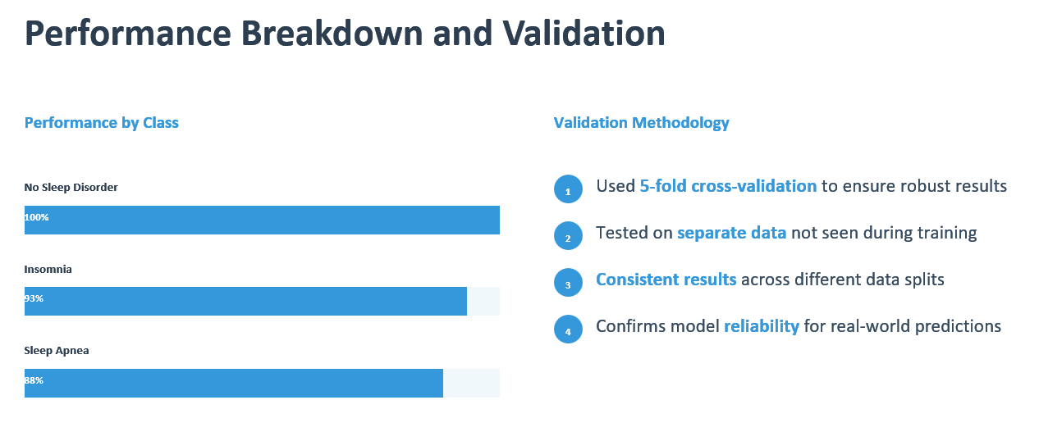

11. WEB APPLICATION DEVELOPMENT

Building a web interface that actually works for real people mattered a lot to us. If nobody can use your machine learning model, what’s the point? We put a ton of energy into design and user experience.

For the frontend, we wanted something that felt modern and trustworthy. Sleep and health are personal, even sensitive topics, so the interface had to feel safe and inviting. We landed on a dark theme with purple and blue gradients—sort of a nod to nighttime, which fits the whole sleep idea.

Clarity and simplicity came first. Each section of the form tackles a different topic, with labels and short descriptions that actually help. Instead of making people type everything out, we used sliders wherever possible. It’s quicker, feels smoother, and you don’t have to worry about someone entering weird data.

Making the app work on any device was non-negotiable. On desktops, you get a grid layout with sections side-by-side. Tablets stack things into two columns. If you’re on your phone, everything turns into one clean column. The health score widget always stays visible on bigger screens, but shrinks down on phones. Inputs stretch to full width on mobile for easier tapping, and the text sizes adjust so you don’t have to squint or zoom in.

12. DEPLOYMENT STRATEGY

Getting Chrono-Pulse AI online meant picking the right platforms and figuring out a deployment process that actually worked for us on a budget of zero. Since this is an academic project, we needed free hosting. After looking around, we landed on Render for the backend and Vercel for the frontend.

Render just made sense. Their free tier is generous, especially for students and small projects like ours. Plus, they support Python and all the libraries we need FastAPI, scikit-learn, and the works. Setting things up was mostly painless. We pushed our backend code to GitHub, hooked that repo up to Render, and it automatically recognized our Python app. We told it to install dependencies with pip install -r requirements.txt and to run uvicorn main:app --host 0.0.0.0 --port $PORT. To keep things consistent, we set PYTHON_VERSION=3.11.9 as an environment variable. Our trained model files went into the repo too, so Render could grab them on deployment.

The frontend was a separate story, but still pretty smooth. We pushed that code to another GitHub repo and connected it to Vercel. Vercel spotted it was a React app and built it automatically. All we had to do was update the API URL so the frontend talked to our backend on Render instead of localhost.

One thing I really liked: both Render and Vercel redeploy automatically when we push changes to GitHub. Updates are basically effortless.

Of course, we hit some bumps. Python version mismatches tripped us up at first—our model needed scikit-learn 1.6.1, but Render tried to use Python 3.13, which just didn’t work. Locking the version to 3.11.9 and matching our requirements fixed that. Then there was CORS. Since the frontend and backend live on different platforms, we had to set up FastAPI to accept requests from any origin. Not ideal for production, but fine for a demo.

There’s also the reality of free hosting: after 15 minutes of inactivity, the backend goes to sleep. Waking up takes 30 to 60 seconds, so the first request is always a little slow. We let users know with a note in the interface. Honestly, it’s a small price to pay for a free, working demo. The free tier on Render gives us 750 hours a month, which is plenty. For this project, it gets the job done.

13. TESTING AND VALIDATION

We have tested our application at a number of levels so that it works correctly and reliably.

Unit Testing:
We tested individual functions, such as data preprocessing, one-hot encoding, and feature scaling, to ensure that they produced correct outputs. We also tested recommendation generation logic with various combinations of input to ensure appropriate advice was given.

Integration Testing:
We tested the complete prediction pipeline, from form submission through API request to model inference, to response formatting. We checked that all data transformations happened correctly and results matched our expectations.

User Acceptance Testing:
Testing with team members and friends using a variety of inputs revealed many usability issues. We collected feedback regarding clarity, ease of use, and if results made sense. This led to a host of improvements like adding more descriptive labels and fine tuning the health score calculation.

Edge Case Testing:
Extreme values, such as very young age, zero physical activity, or extremely high blood pressure, were used to test if the system handled them gracefully. Incomplete data was tested to verify that the validation is working correctly.

Performance Testing:
We have measured API response times to confirm that predictions typically finish in 2-3 seconds when the backend is already awake. We have tested concurrent requests to verify that the system handles multiple users.

14. CHALLENGES AND SOLUTIONS

Challenge 1: Limited Dataset Size
Our dataset, with 374 samples, is small for machine learning, increasing the risk of overfitting and limiting model complexity.
Solution: We made use of cross-validation to make better use of the data available. We opted for simpler models that work well when data is limited, rather than complex deep learning approaches. We also avoided extensive hyperparameter tuning that could lead to overfitting.

Challenge 2: Deployment Compatibility Issues
Python version conflicts and library incompatibilities led to initial deployment failures on Render.
Solution: We locked specific versions in requirements.txt, and set the Python version explicitly. Also, we tested locally with the very same versions before deploying.

Challenge 3: Cold Start Delays
The free tier backend sleeps after inactivity, making the first request take 30-60 seconds.
Solution: We added clear messaging to the users explaining this is normal. We considered using a service like UptimeRobot to ping the backend periodically, but we decided the educational value of understanding free tier limitations outweighed the inconvenience.

Challenge 4: Team Coordination
With five team members working on different components, coordination was necessary to ensure that everything integrated properly. We used GitHub to do the version control, had regular team meetings, and we specified interfaces between the frontend and backend clearly from the beginning of the project.

15. LIMITATIONS

Medical Limitations:
Chrono-Pulse AI isn’t meant to diagnose you. It doesn’t replace a doctor’s visit. Think of it as a first step to raise awareness, not give you a final answer.

Dataset Limitations:
We trained our model on 374 cases. That’s not a huge pool, and it doesn’t cover every background or community. So, if you’re from a group we didn’t see much in our data, results might not match up as well.

Input Limitations:
The system depends on whatever information you put in, and people sometimes guess or forget details like blood pressure or other numbers. If your input isn’t accurate, the results won’t be either.

Scope Limitations:
The model only checks for three outcomes: no disorder, insomnia, or sleep apnea. There are lots of other sleep issues out there, and right now, those aren’t part of what we cover.

Technical Limitations:
Because we use free hosting, the first request takes a while to load. We don’t store your data, so you can’t track your progress over time. Also, you need an internet connection to use the system.

16. FUTURE WORK

Enhanced Features:
We want to sync up with fitness trackers and smartwatches so you don’t have to enter as much data yourself. Tracking your sleep history over time is on our list too. We’re planning to let you download a PDF report to share with your doctor. Making the system available in more languages would help more people use it.

Improved Models:
We aim to collect more data to boost accuracy and make our results work for more people. Deep learning is on our radar, and we’re looking at ways to combine different models for even better predictions. Adding more sleep disorder types is also in the pipeline.

Better User Experience:
A mobile app for iOS and Android is in the works. We’re exploring voice input to make things easier for everyone. Expect more in-depth information about sleep health, and maybe some community features, so users can connect and share stories.

Clinical Validation:
We’re reaching out to sleep clinics to see how our predictions compare to real-life diagnoses. Formal studies are planned, and we’d like medical professionals to endorse the tool. If we ever go for serious medical use, we’ll look into FDA approval.

17. CONCLUSION

Chrono-Pulse AI shows what’s possible when you bring artificial intelligence into healthcare and keep it simple and accessible. We set out to build a model that predicts sleep disorders, aiming for 85% accuracy, and ended up with 96%.

This project taught us a lot. We handled every stage, from collecting and cleaning data to training the model and making the final app. We learned to work as a team, juggle code with version control, and pull everything together.

But here’s what matters most: we built something that can actually make a difference. Even though it’s not a substitute for a real diagnosis, it’s a friendly nudge for someone who might not realize they need help with their sleep.

It turns out, you don’t need a giant budget or an advanced degree to build meaningful AI tools. Free resources, open data, and determination can go a long way. We hope Chrono-Pulse AI sparks new ideas and encourages more people to use tech to tackle health and social problems.

18. REFERENCES

Sleep Health and Lifestyle Dataset. Kaggle. Available at: https://www.kaggle.com/datasets/uom190346a/sleep-health-and-lifestyle-dataset

Pedregosa et al. Scikit-learn: Machine Learning in Python. Journal of Machine Learning Research, 2011.

FastAPI Framework Documentation. https://fastapi.tiangolo.com

React Documentation. https://react.dev
Render Platform Documentation. https://render.com/docs

Vercel Platform Documentation. https://vercel.com/docs

National Sleep Foundation. Sleep Disorders and Problems. https://www.sleepfoundation.org

Chen, T., & Guestrin, C. XGBoost: A Scalable Tree Boosting System. KDD 2016.
Dzierzewski, J., Nielson, S., & Lopos, J. National Sleep Foundation’s 2024 Sleep in America Poll: Sleep Health and Depressive Symptoms in Teenagers. Sleep, Volume 47, Issue Supplement_1, May 2024, Page A405. https://doi.org/10.1093/sleep/zsae067.0944

ResMed. 2025 Global Sleep Survey: Exploring Global Sleep Habits and Attitudes. Data collected December 12–28, 2024. Available at: https://sleepsurvey.resmed.com/

Sleep Cycle. New Sleep Cycle Report: 105 Million Nights Reveal a Global Decline in Sleep Quality. March 18, 2025. Available at: https://sleepcycle.com/newsroom/press-release/new-sleep-cycle-report-unveiling-global-sleep-trends-and-insights

Raha, W., et al. Sleep duration, chronotype, health and lifestyle factors affect cognition: A UK Biobank cross-sectional study. BMJ Public Health. 2024;2:e001000. doi: 10.1136/bmjph-2024-001000.
Li, W., Peng, Y., & Peng, K. Diabetes prediction model based on GA-XGBoost and stacking ensemble algorithm. PLoS ONE 19(9): e0311222. September 29, 2024. https://doi.org/10.1371/journal.pone.0311222

Ren, C. Performance of XGBoost Ensemble Learning Algorithm for Mangrove Species Classification with Multisource Spaceborne Remote Sensing Data. Journal of Remote Sensing. 2024;4:0146. doi:10.34133/remotesensing.0146
Scikit-learn Development Team. Scikit-learn 1.7.0 Release Notes: Enhancements in Preprocessing, Feature Extraction, and LLM Integration Support. July 2025. Available at: https://scikit-learn.org/stable/whats_new/v1.7.html

19. APPENDICES
Appendix A: System Requirements
- Modern web browser (Chrome, Firefox, Safari, Edge)
- Internet connection
- No installation required for end users
Appendix B: API Endpoints
- GET / - Welcome message
- GET /health - System health check
- GET /model-info - Model performance metrics
- POST /predict - Submit data for prediction
Appendix C: Feature List Complete list of 23 features used by the model, including derived features from one-hot encoding.
Appendix D: Team Member Contributions Detailed breakdown of who worked on which components.

Live Demo: https://chronopulse-frontend.vercel.app

