After installing EclEmma plugin in eclipse restart the eclipse and follow bellow steps.

1. Right click on project -> select coverage as -> Junit Test

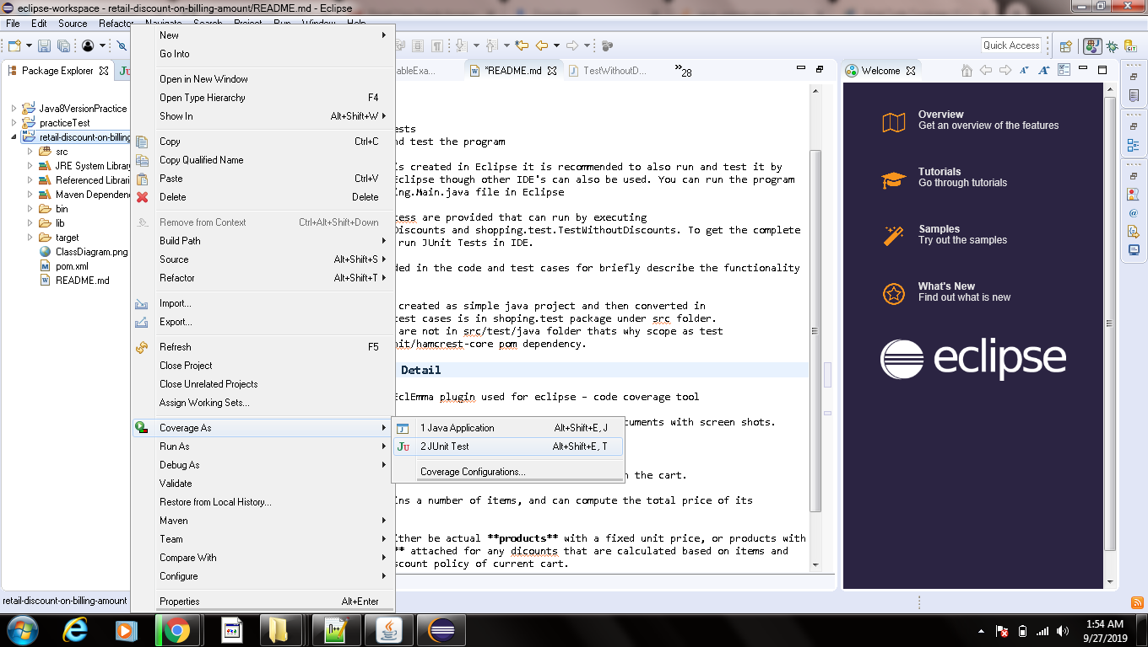

you will get bellow screen with coverage detail.

