
Gradient Descent
for Unconstrained
Minimization
PRACTICAL WORK REPORT

Gradient Descent Methods
Institute of Cybersecurity and Computer Science
Mohammad Azimi
Mohammad Abrahim Abrahimi
Group 5140901/61701 Practical subgroup 1
Methods of Optimization and Decision Making
Instructor: Родионова Елена Александровна
Saint Petersburg
2026

Abstract
We implemented two first order gradient descent methods for the first parameter row of both assignment functions. The study compares numerical accuracy and computational cost and explains the geometry of the generated paths. Both methods reached the gradient norm stopping condition for both functions.
For the exponential function, step division required 10 accepted updates and the golden section version required 5. For the cosine function, they required 33 and 39 updates. The more accurate line minimization did not give a universal improvement in iteration count or execution cost.
The package contains the complete iteration histories, independent checks, comparison experiments and the scientific figures used in this report.

1 Problem Formulation
The assignment defines two functions with six coefficients [1]. Group 1 uses the first data row of both tables. We apply both methods to both resulting functions, giving four main experiments.
Parameter | a | b | c | d | k | m
First data row | 1 | 2 | 1 | 1 | -1 | 2

Analytical derivatives
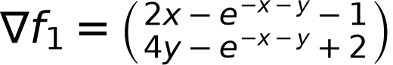
$H_{1} = \left(\begin{matrix}2+t & t \\ t & 4+t\end{matrix}\right), t = e^{−x−y} > 0$
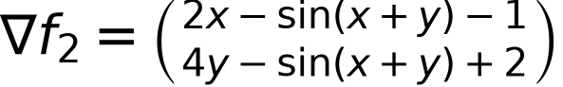
$H_{2} = \left(\begin{matrix}2−q & −q \\ −q & 4−q\end{matrix}\right), q = cos(x+y)$
The gradient determines the search direction. The Hessian is used only for mathematical analysis and independent checks. Neither descent method uses second derivatives.

2 Mathematical Background

Convexity and existence of a minimum
The first Hessian is positive definite everywhere. Its lower eigenvalue bound is 2. For the second function, the cosine factor belongs to the interval from minus one to one, which gives the matrix bounds below.
$\left(\begin{matrix}1 & −1 \\ −1 & 3\end{matrix}\right) ≼ H_{2} ≼ \left(\begin{matrix}3 & 1 \\ 1 & 5\end{matrix}\right)$
The lower matrix has eigenvalues 2 minus square root of 2 and 2 plus square root of 2. The upper matrix has largest eigenvalue 4 plus square root of 2. Both objectives are therefore strongly convex. Completing the squares gives the following lower bounds.
The bounds tend to infinity as the point tends to infinity. Thus each continuous objective attains a minimum, and strong convexity makes that minimum unique and global.

Convergence conditions
The cosine objective has a globally Lipschitz gradient with constant 4 plus square root of 2. The exponential objective does not have a global upper Hessian bound because its exponential term is unbounded. Its initial sublevel set is compact, however, and the Hessian is bounded there. A compact neighbourhood of that set supplies the local Lipschitz bound needed for the step division argument in lecture slides 21 and 22 [2].
With sufficient decrease and a valid reduction factor, standard gradient descent convergence applies on these level sets. The ideal line minimization also yields descent. With an approximate line search, finite inner accuracy and rounding limit how closely the ideal properties can be reproduced. We use the gradient norm to decide actual numerical convergence.
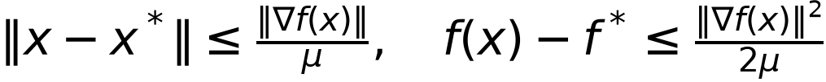
These strong convexity bounds also connect the final gradient residual to point error and objective error. They provide an independent quantitative check on the computed solutions.

Independent Reference Solutions

Exponential objective
Setting the two partial derivatives to zero and introducing the positive scalar t reduces the stationary equations to one variable.

The scalar equation is strictly increasing for positive t. We solved it using SciPy Brent root finding on the bracket from 0.1 to 1 and checked it with the principal Lambert W value. This calculation does not use either gradient descent routine.

Cosine objective
The derivative of s minus three quarters of sin s is at least one quarter, so s equals zero is the only root. The resulting minimum value is exactly 0.25. We also solved each two variable stationarity system independently with SciPy root finding from the origin.
Function | Reference x | Reference y | Reference minimum
F1 | 0.812766807130 | -0.343616596435 | 0.022268227723
F2 | 0.500000000000 | -0.500000000000 | 0.250000000000

The uniqueness proofs establish global optimality. The independent numerical procedures locate and verify the stationary points. Their residuals and mutual differences are recorded in validation.json.

3 Gradient Descent Methods
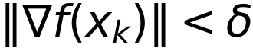

Step division
At each outer iteration we compute the gradient and reset the trial step to alpha0. We accept the first trial satisfying the lecture's sufficient decrease condition [2, slide 19].
If the condition fails, we multiply the trial step by lambda and test again. The accepted point becomes the next iterate. This is an Armijo backtracking rule with the lecture's epsilon coefficient. We keep epsilon distinct from the gradient tolerance delta.

One dimensional minimization
The interval is fixed by lecture slide 25. Golden section search begins with bracket endpoints zero and one and evaluates strictly interior points. It does not expand the bracket. The two interior positions use the following ratio.
Each contraction discards one side, reuses one previous value and evaluates one new interior point. The inner search stops when the absolute bracket width is below its own tolerance. We return the better of the two retained interior points. Strong convexity makes every nonstationary line function strictly convex.

Interpretation of the lecture slides
Slide 18 prints the sufficient decrease inequality next to the step reduction instruction without a clear branch. We reduce only when the acceptance condition fails, consistent with slide 19. Slide 24 combines a line minimization instruction with the preceding backtracking template. For Method 2 we use the complete prose algorithm on slide 25, which selects the line minimum without an extra backtracking stage. This choice preserves the distinction between the two requested methods.

4 Implementation Details
The objective module supplies analytical derivatives. The line search module implements Golden Section. The solver module performs updates, counts work and saves the trace. Separate modules generate figures and calculate reference solutions. NumPy and Matplotlib support the implementation. SciPy is restricted to validation and references.
Setting | Main experiment value
Initial point | (2.0, 2.0)
Initial trial step alpha0 | 0.8
Reduction factor lambda | 0.5
Sufficient decrease epsilon | 0.1
Gradient tolerance delta | 1.000e-06
Golden Section interval | 0 < alpha < 1
Golden Section width tolerance | 1.000e-10
Maximum outer updates | 10000

The assignment and lecture do not prescribe a numerical starting point or these numerical constants. We selected one shared initial point for a controlled comparison. alpha0, lambda and epsilon affect Method 1. They do not enter the Method 2 line minimization.

Iteration records and evaluation counts
Row zero stores the initial point. Each accepted update adds a row containing coordinates, objective value, gradient components and norm, incoming step, actual step length, line search work and cumulative counters. Thus a run with k updates stores k plus one points. Dot products, angles and cosines between successive gradients are also saved.
A function evaluation counts one scalar objective value or one algebraically equivalent objective increment. All rejected trial steps and every new Golden Section sample count. Reused cached values do not count again. The initial value and a final direct objective verification also count. Each initial or accepted point requires one gradient evaluation. Plot grids, references and other runs are outside each run's counters.
Timing uses perf_counter inside the solver, including history and counter bookkeeping. It excludes imports, plotting, disk output and references. We report the median of repeated executions after one warm-up and preserve every timing sample. These are CPU measurements from the recorded environment and are dependent on the computer.

Stable Evaluation and Numerical Checks
Near a minimum, subtracting two almost equal objective values can hide a small decrease. We evaluate the same objective along a line through an algebraically equivalent increment. Let h be the displacement, r the sum of its components, g the current analytical gradient and s the sum of the current coordinates.
The exponential remainder and r minus sin r are evaluated by short Taylor series for small arguments. This avoids cancellation in the nonlinear remainders. The calculation reuses the current gradient and does not evaluate another gradient. Every scalar increment evaluation counts once as an objective oracle call. The final objective value is evaluated directly, so the reported final value does not depend on accumulated increments.

Validation evidence
Independent check | Observed result
Gradient against central differences | 1.821e-11
Hessian against differentiated gradient | 1.477e-11
Stable increment against direct subtraction | 1.614e-15
Golden step against line derivative root | 1.074e-08
Main runs and mathematical error bounds | All four passed
Saved sensitivity run statuses | 42 passed

The first three entries are maximum relative discrepancies across the sampled points. The line step entry is the maximum absolute alpha difference over interior main Golden Section steps. A separate quadratic problem verifies the counters with a known number of calls. We also check every main update, every accepted sufficient decrease condition and the interior or boundary status of every main line minimum.

5 Numerical Experiments
SD denotes Step Division. GSS denotes gradient descent with Golden Section line minimization. All four main runs use the same initial point and gradient tolerance. Every run reached the strict gradient norm stopping condition.
Run | Final x | Final y | Final objective | Gradient norm | Point error
F1 SD | 0.812766886 | -0.343616458 | 0.022268227723 | 7.503e-07 | 1.594e-07
F1 GSS | 0.812766814 | -0.343616598 | 0.022268227723 | 1.628e-08 | 6.654e-09
F2 SD | 0.499999468 | -0.500000360 | 0.250000000000 | 5.744e-07 | 6.420e-07
F2 GSS | 0.500000927 | -0.499999773 | 0.250000000000 | 7.405e-07 | 9.540e-07

Run | Updates | Function calls | Gradient calls | Median ms | Status
F1 SD | 10 | 27 | 11 | 0.734 | converged
F1 GSS | 5 | 252 | 6 | 2.820 | converged
F2 SD | 33 | 58 | 34 | 2.105 | converged
F2 GSS | 39 | 1952 | 40 | 22.926 | converged

Each median uses 31 executions after a warm-up. The single-run times, timing ranges and raw samples are included in the CSV outputs. Small timing differences should be interpreted with the recorded environment and Python overhead in mind.
For F1, GSS used 5 updates compared with 10 for SD, but required 252 function calls compared with 27. It reduced gradient calls from 11 to 6. This can matter when gradients are expensive, although these two-dimensional gradients are inexpensive.
For F2, SD required 33 updates and 58 function calls, while GSS required 39 and 1952. More accurate line minimization improved the immediate line objective but did not produce fewer outer iterations for this starting point and these settings.
The final objective errors are consistent with the gradient residuals and the strong convexity bounds. Objective values alone can look identical after rounding, even when coordinate errors and gradient norms differ.

6 Geometrical Interpretation

Descent and level curves
For a differentiable objective, this negative directional derivative guarantees a decrease for a sufficiently small positive step. Among directions of unit Euclidean length, the normalized negative gradient gives the steepest local decrease.
A level curve keeps the objective constant. Its tangent therefore has zero inner product with the gradient. The gradient is normal to the curve at regular points. This property is distinct from orthogonality between two successive search directions.
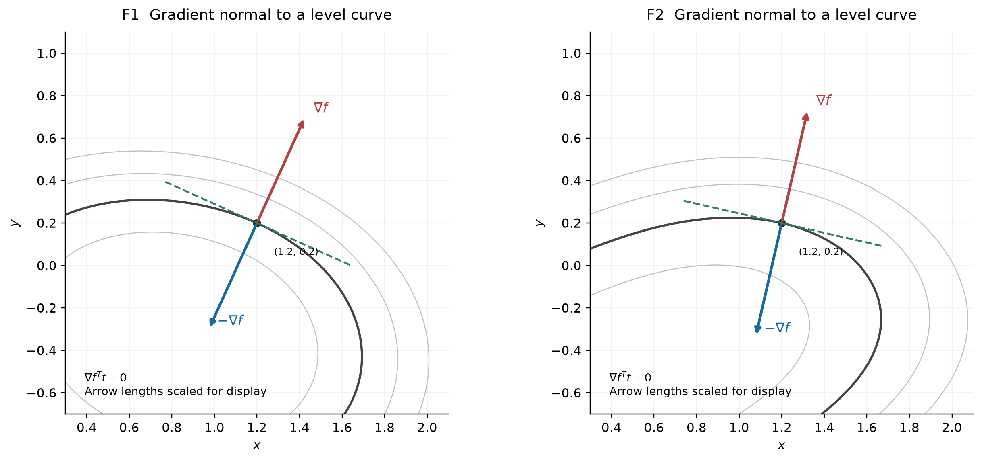
Figure 1. The gradient is normal to the level curve at the marked regular point. The negative gradient points towards lower values. Arrow lengths are scaled for display.
All planar path figures use equal horizontal and vertical scales, preserving angles. Markers show every saved iterate, although points close to the solution overlap at the full path scale. Their complete coordinates remain available in the history CSV files.

Exponential Function Paths
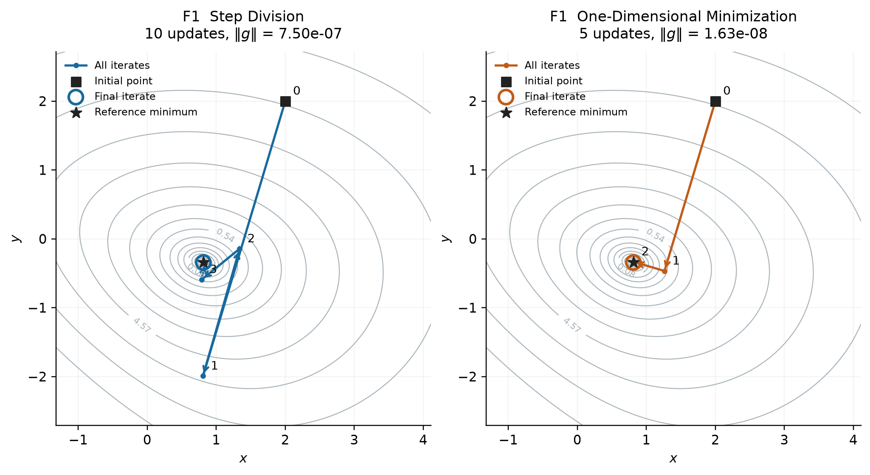
Figure 2. All iteration points for F1. The square marks the common initial point, the circle marks the final iterate and the star marks the independent reference solution. Arrowheads show the search direction.
Method | k | x | y | Incoming alpha | Objective
SD | 0 | 2.0000000 | 2.0000000 | 0.0000000 | 14.01831564
SD | 1 | 0.8073263 | -1.9926737 | 0.4000000 | 7.07242279
SD | 2 | 1.3387605 | -0.1441700 | 0.2000000 | 0.50957700
GSS | 0 | 2.0000000 | 2.0000000 | 0.0000000 | 14.01831564
GSS | 1 | 1.2629459 | -0.4674114 | 0.2471939 | 0.28555034
GSS | 2 | 0.8158114 | -0.3338453 | 0.4161125 | 0.02251960

The table lists the initial point and first two updates as examples. The initial row has zero incoming step. The full history includes all later points and both gradient components.
Step division initially overshoots across the valley and then corrects with smaller accepted steps. The first line minimization puts the iterate near the bottom of its search line, after which the direction changes towards the common minimum.

Cosine Function Paths
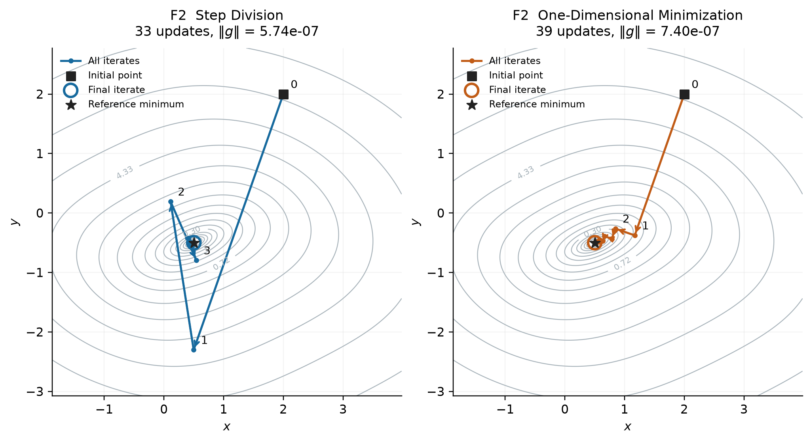
Figure 3. All iteration points for F2. The square marks the common initial point, the circle marks the final iterate and the star marks the independent reference solution. Arrowheads show the search direction.
Method | k | x | y | Incoming alpha | Objective
SD | 0 | 2.0000000 | 2.0000000 | 0.0000000 | 13.34635638
SD | 1 | 0.4972790 | -2.3027210 | 0.4000000 | 5.51711502
SD | 2 | 0.1104171 | 0.1925939 | 0.4000000 | 1.31558978
GSS | 0 | 2.0000000 | 2.0000000 | 0.0000000 | 13.34635638
GSS | 1 | 1.1699827 | -0.3765774 | 0.2209372 | 0.43076538
GSS | 2 | 0.8443686 | -0.2628571 | 0.5191391 | 0.31669661

The table lists the initial point and first two updates as examples. The initial row has zero incoming step. The full history includes all later points and both gradient components.
The contours become elongated around the minimum. The two rules follow different paths through this valley. Successive exact line minima give perpendicular directions, but this geometric property alone does not guarantee fewer iterations than sufficient decrease backtracking.

7 Convergence
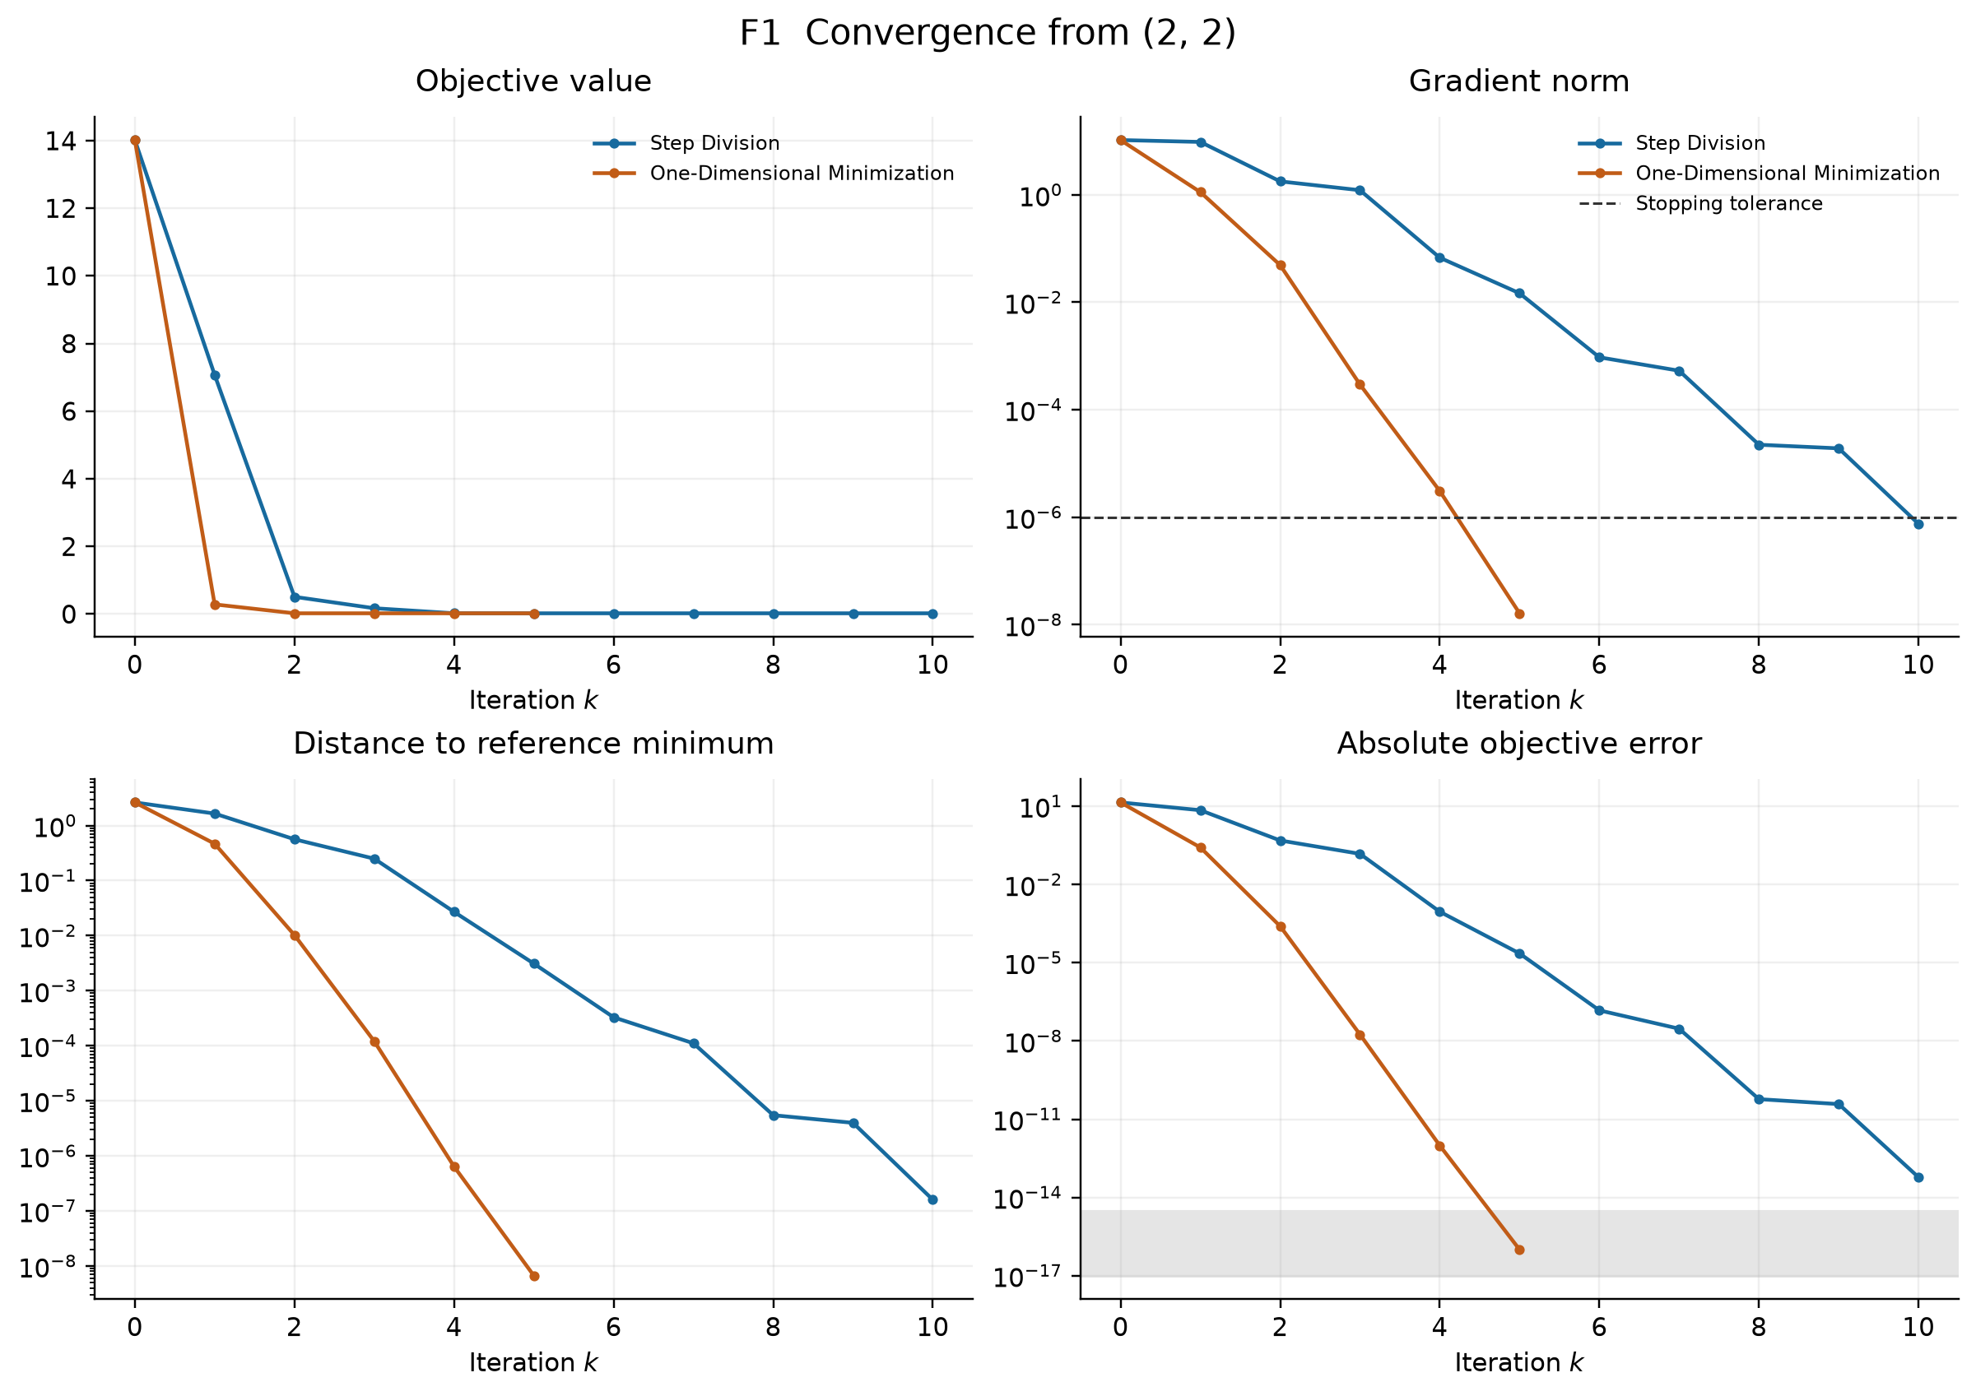
Figure 4. Objective value, gradient norm, distance to the independent minimum and absolute objective error for F1. The dashed line is the stopping threshold. The shaded band indicates the scale where objective rounding becomes relevant.
Both sequences reduce the objective. The line minimization run reaches its terminal gradient residual in fewer outer iterations. The objective gap approaches floating point resolution, so the gradient norm and coordinate error provide a more informative final accuracy check.
The plots show all saved outer iterates. They do not count each trial inside a line search as a separate outer iteration. Computation cost must therefore also be compared using function and gradient evaluation counts.

Convergence of the Cosine Function
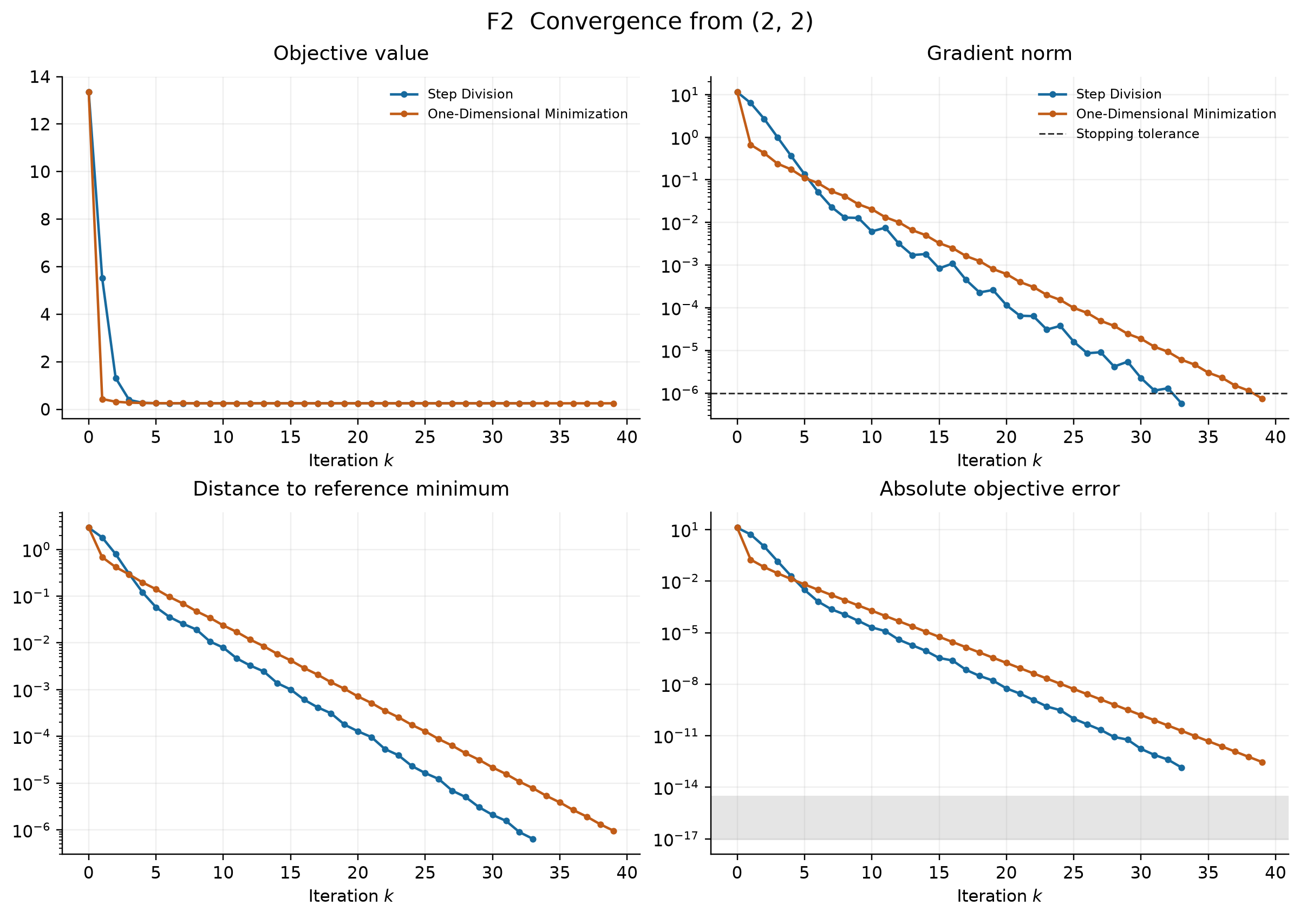
Figure 5. Objective value, gradient norm, distance to the independent minimum and absolute objective error for F2. The dashed line is the stopping threshold. The shaded band indicates the scale where objective rounding becomes relevant.
The gradient norm need not decrease at every accepted step, although the objective decreases. The line minimization sequence has an approximately linear trend on the logarithmic residual plot near the solution. The sufficient decrease sequence reaches the selected stopping threshold earlier in this experiment.
The plots show all saved outer iterates. They do not count each trial inside a line search as a separate outer iteration. Computation cost must therefore also be compared using function and gradient evaluation counts.

8 Orthogonality of Successive Directions
At an exact interior minimum of the one dimensional line problem, its derivative vanishes. Since each search direction equals the negative gradient, the following relation holds [2, slides 27 and 28].
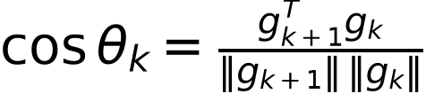
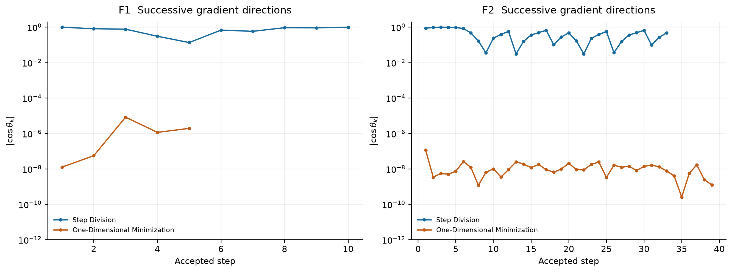
Figure 6. Absolute cosine of the angle between successive gradients. Zero represents orthogonality. Golden Section gives values close to zero in the main runs. Step division does not impose this condition.
The maximum absolute cosine in the main GSS runs was 8.376e-06 for F1 and 1.156e-07 for F2. The residual includes inner search error and floating point effects. When the next gradient is very small, its normalized angle is especially sensitive to rounding.
The interval restriction is essential. A separate F2 run started at (0.49076120, -0.50382683). Its first step was 0.999999999964 and its first successive-gradient cosine was 0.99999995. The line derivative at alpha equal to one was -1.421e-05, so the unrestricted minimum lay beyond the lecture interval. On the open interval, this step approximates a boundary infimum. Orthogonality is not required there.

9 Sensitivity Experiments

Gradient tolerance
We repeated each function and method for three stopping tolerances, keeping the other settings fixed. Every saved run reached its selected gradient threshold.
Run | Delta | Updates | Function calls | Gradient norm
F1 SD | 1e-04 | 8 | 22 | 2.230e-05
F1 SD | 1e-06 | 10 | 27 | 7.503e-07
F1 SD | 1e-08 | 13 | 35 | 1.163e-09
F1 GSS | 1e-04 | 4 | 202 | 3.071e-06
F1 GSS | 1e-06 | 5 | 252 | 1.628e-08
F1 GSS | 1e-08 | 6 | 302 | 1.694e-10
F2 SD | 1e-04 | 21 | 39 | 6.501e-05
F2 SD | 1e-06 | 33 | 58 | 5.744e-07
F2 SD | 1e-08 | 44 | 76 | 5.703e-09
F2 GSS | 1e-04 | 25 | 1252 | 9.917e-05
F2 GSS | 1e-06 | 39 | 1952 | 7.405e-07
F2 GSS | 1e-08 | 52 | 2602 | 8.499e-09

Initial trial step for step division
Function | Alpha0 | Updates | Function calls
F1 | 0.2 | 22 | 24
F1 | 0.5 | 14 | 26
F1 | 0.8 | 10 | 27
F1 | 0.95 | 14 | 39
F2 | 0.2 | 104 | 106
F2 | 0.5 | 42 | 45
F2 | 0.8 | 33 | 58
F2 | 0.95 | 39 | 78

A smaller initial trial step can avoid rejected trials while requiring more outer iterations. A larger trial can decrease iteration count yet increase function evaluations through reductions. These results depend on the objective and the starting point.

Line Accuracy and Starting Point

Golden Section bracket tolerance
Function | Line tolerance | Updates | Function calls | Max absolute cosine
F1 | 1e-04 | 5 | 112 | 6.529e-03
F1 | 1e-07 | 5 | 182 | 9.573e-06
F1 | 1e-10 | 5 | 252 | 8.376e-06
F2 | 1e-04 | 39 | 860 | 4.669e-04
F2 | 1e-07 | 39 | 1406 | 8.566e-08
F2 | 1e-10 | 39 | 1952 | 1.156e-07

A tighter line tolerance substantially increases scalar objective calls. In these experiments it does not change the outer iteration count. The orthogonality residual generally improves, but eventually reaches a rounding floor and need not improve monotonically with a smaller bracket width. Bracket width and step error are different quantities in floating point arithmetic.

Common alternative starting points
Function | Initial point | SD updates | GSS updates | GSS near boundary steps
F1 | (0, 0) | 7 | 7 | 0
F1 | (-2, 1) | 9 | 7 | 0
F1 | (4, -3) | 11 | 15 | 0
F1 | (2, 2) | 10 | 5 | 0
F2 | (0, 0) | 32 | 26 | 1
F2 | (-2, 1) | 34 | 36 | 1
F2 | (4, -3) | 32 | 36 | 1
F2 | (2, 2) | 33 | 39 | 0

Every starting point converged. A near boundary step means alpha exceeded one minus 1e-7. Some alternative F2 starts generate such steps, even though all main line minima are interior. The ranking of methods by outer iteration count also changes with the initial point.

10 Discussion and Conclusion
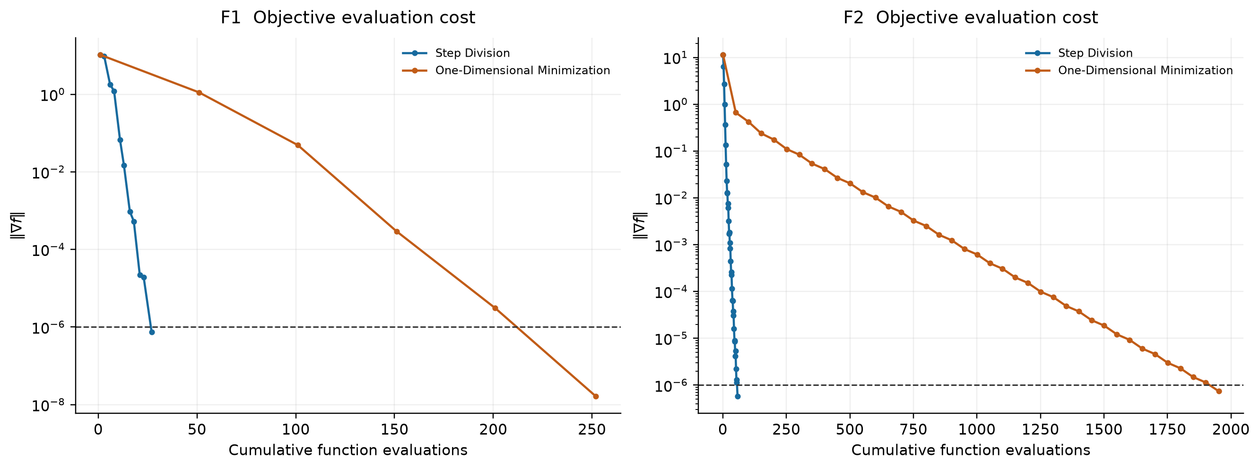
Figure 7. Gradient residual against cumulative function evaluations. The Golden Section method spends many scalar evaluations inside each outer iteration.
The methods reach the same unique minima through different step rules. For the exponential objective, line minimization reduces gradient calls but increases function calls and measured execution time. For the cosine objective and the selected main settings, step division uses fewer updates and fewer evaluations of both types. These small examples support a comparison under stated settings, rather than a universal ranking.
The geometric claims require separate conditions. The gradient is normal to a regular level curve for any differentiable objective. Successive gradient directions become orthogonal only after an exact interior line minimum. Approximate searches and boundary infima need separate treatment, which the main and additional experiments demonstrate.
Both objectives are strongly convex, so the computed stationary points are their unique global minima. Independent references, derivative checks, error bounds and complete iteration records support the results. Step division offers low scalar evaluation cost here. More accurate line minimization gives a useful geometric interpretation but can spend work beyond what is needed for the outer stopping tolerance.

Reproduction
Create the Python environment and install requirements.txt. Then run run_experiments.py, validate.py and build_report.py in that order. The README gives the full Windows CMD commands. The recorded execution used Python 3.12.6, NumPy 2.5.4, Matplotlib 3.11.2 and SciPy 1.18.1. The package runs on a CPU without a GPU dependency.

References
[1] Uncond.docx. Course assignment supplied by the instructor. Questions 1 and 2, first data row of both parameter tables.
[2] Lecture_5_Uncond_1_2026.pptx. Unconditional Minimization Methods, Lecture 5. Supplied course slides. Slides 18 and 19, 21 and 22, and 24 through 28.

