

**Course timetabling project**   
  
Professor:  
 Dr. F. Hooshmand Khaligh  
  
Teaching Assistants:   
Ms. Vista Farahi ,Ms. Fatemeh Vahdat

Student:

Mohammad Bornosi(9713007, [Mohammadbornosi@gmail.com](mailto:Mohammadbornosi@gmail.com))  
 Mohammadreza Ardestani **(**9513004**,** [**ardestani.zr@gmail.com**](mailto:ardestani.zr@gmail.com)**)**

30, Dec, 2021

0) **Introduction**

**0.0) Review our previous related work (Assignment 3)  
 0.1) Dataset  
 0.2) How to Setup and run the code   
 0.3) Output format**   
Phase 1) **Formal Model**

Phase 2) **Gams Code**

Phase 3) **Gams-Python API**

**0.0) Review our previous related work (Assignment 3)**

Our Previous work on Course Timetabling project had three parts:

1. Running the model with hard constraints
2. Softening three hard constraints and using Multi-objective approach
3. Allowing time intervals to have conflict (e.g. 8-10 and 9-11 have conflict)

Our previous work, however, had some bugs in handling the last part (handling intervals conflicts) and also was using Excel input file.

In this work we are going to:

1. Solve our previous work’s issues
2. Enlisting Python to handle input/output data

**0.1) Dataset**

**0.2) How to Setup and run the code**

**0.3) Output format**

Phase 1) **Formal Model**

We have already explained the model in our previous work. We, therefore, in this part just go through all 10 constraints and check them whether there is any need for rewriting them or not.

*Const1:*



This constraint would be correct if and only if all time intervals assigned to the course “c” are free of conflict. We don’t need to rewrite this constraints, since constraint#3 ensures that all professors take all sessions of courses in intervals that do not have any conflicts.

*Const2:*



We have to rewrite this constraint in a way that for each interval (h) and all intervals having conflict with that (hp) we have to give #n number courses in our faculty but #n should be less than K(available classes).

*Const3:*  


We have to rewrite this constraint in a way that each professor doesn’t give two course at the same time at the same day, since it is impossible in real world!

*Const4:*



We have to rewrite this constraint in a way that we give all courses in a specific class in different time intervals. So, we have to also consider all intervals that have conflict with each other when we are iterating over courses with the Sigma

*Const5,6,7,9,10:*

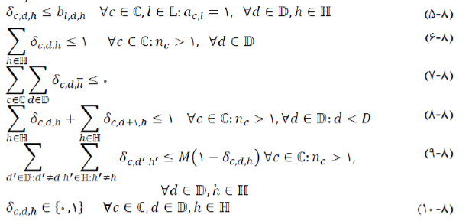

We don’t need to rewrite the rest of constraints, since they have nothing to do with interval conflicts.

Phase 2) **Gams Code**

Phase 3) **Gams-Python API**