Contents
Title 3
عنوان 4
چکیده (فارسی) 5
زمینه 5
روش 5
یافته‌ها 5
نتیجه‌گیری 5
Abstract 6
Background 6
Method: 6
Results: 6
Conclusion 6
Introduction: 7
Guideline dissemination 7
Plain-language summaries 7
Stakeholder engagement (iKT). 7
Policy briefs 8
Brief history and trends of KT 8
Rationale for developing an LLM-based KT system at SUMS 8
Goals and Hypotheses: 9
General Goal: 9
Specific Objectives: 9
Applied Purpose: 9
Research questions and hypotheses: 10
4. Methodology 10
4.1 Study design 10
4.2 Samples (documents) and eligibility 10
4.3 Tools, software environment, and processing pipeline 10
4.4 Statistical tests and Evaluation plan 11
4.5 Ethics and privacy 12
Results 12
1) System Implementation & Deployment Outcomes 12
2) Corpus & Run Statistics (Operational, no references needed) 12
3) Output Completeness & Faithfulness (RAG-based, no human refs) 12
4) Case Study (Qualitative Demonstration) 13
7) Readability of Lay Sections 13
Discussion 13
5.1 Overview of the Study and Key Contributions 13
5.2 Interpretation of Findings and System Performance 14
5.3 How the Application Works in Practice 15
5.4 Comparison with Existing Approaches and Similar Systems 15
5.5 Relevance to Iran and Comparable Local Infrastructure 16
5.6 Limitations 16
5.7 Future Work 17
5.8 Conclusion 17
References: 18
6. Figures 20
Fig 1: User interference 20
Fig 2: Study flowdiagram 21
Fig 3: software architecture diagram 22
7. Tables 23
Table R1. 23
Tab. R2 23

Title
Developing a Large Language Model-based System for Knowledge Extraction in Medical Research: An Application at Shiraz University of Medical Sciences
Mohammad Kashkooli¹, Hossein Molavi Vardanjani²
¹: School of Medicine, Shiraz University of Medical Sciences, Shiraz, Iran
²: MPH department, Shiraz University of Medical Sciences, Shiraz, Iran

عنوان
توسعهٔ سامانه‌ای مبتنی بر مدل‌های زبانی بزرگ برای استخراج دانش از پژوهش‌های پزشکی: کاربردی در دانشگاه علوم پزشکی شیراز
Mohammad Kashkooli¹, Hossein Molavi Vardanjani²
¹: School of Medicine, Shiraz University of Medical Sciences, Shiraz, Iran
²: MPH department, Shiraz University of Medical Sciences, Shiraz, Iran

چکیده (فارسی)
زمینه: ترجمان و انتقال دانش در پزشکی با رشد سریع مقالات، محدودیت زمان بالینی و نیاز به خلاصه‌سازی قابل‌اعتماد و قابل‌ردیابی روبه‌رو است. اگرچه مدل‌های زبانی بزرگ می‌توانند فرایند خلاصه‌سازی را تسریع کنند، تولیدِ بدون اتکای شفاف به شواهد می‌تواند به «توهم» و خطاهای ظاهراً قانع‌کننده منجر شود. هدف این پایان‌نامه توسعهٔ سامانه‌ای عملی و کم‌هزینه برای استخراج دانش ساختاریافته از مقالات پزشکی همراه با امکان ردیابی شواهد بود.
روش: یک اپلیکیشن مبتنی بر Streamlit طراحی شد که فایل‌های PDF/DOCX را دریافت کرده، متن را پیش‌پردازش می‌کند و قطعه‌های معنایی را در پایگاه برداری محلی ایندکس می‌نماید. برای تولید پاسخ‌های متکی بر شواهد، از RAG همراه با HyDE اختیاری جهت بهبود بازیابی در پرسش‌های کم‌جزئیات استفاده شد. همچنین برای PDFهای دارای جدول/شکل، یک مرحلهٔ چندوجهی اختیاری، متنِ نواحی تصویری را با OCR یا مدل‌های بینایی‌محور استخراج می‌کند (Gemma 3 به‌صورت محلی و GPT-4.1-mini به‌صورت اختیاری). خروجی شامل فرم ترجمان دانش (JSON ساختاریافته) و ماژول گفت‌وگوی تعاملی با ارجاعِ پاراگراف‌محور است.
یافته‌ها: در اجرای امکان‌سنجی روی ۴ مقاله (۲ PDF و ۲ DOCX)، فرایند بدون خطای بحرانی تکمیل شد (۱۰۰٪ موفقیت) و زمان میانه تا اولین خروجی کامل حدود ۱۱ دقیقه بود. کامل‌بودن فیلدها ۹۰٪ (۹ از ۱۰) به‌دست آمد و چالش اصلی، تولید صحیح فهرست منابع بود. بیشتر محتوا بر اساس قطعه‌های بازیابی‌شده قابل‌ردیابی بود.
نتیجه‌گیری: این MVP نشان می‌دهد یک خط لولهٔ چندوجهیِ RAG با تمرکز بر ارجاع‌دهی می‌تواند استخراج دانش سریع و قابل‌ممیزی را برای آموزش و پژوهش در دانشگاه علوم پزشکی شیراز فراهم کند؛ با نیاز به بهبود استخراج منابع، ارزیابی گسترده‌تر و آزمون رسمی کاربرپذیری.

Abstract
Background: Knowledge translation in medicine is constrained by the rapid growth of biomedical publications, limited clinician time, and the need for trustworthy, auditable summaries. Large language models (LLMs) can accelerate synthesis, but ungrounded generation risks hallucination, especially in high-stakes clinical interpretation. This thesis aimed to develop a practical, low-cost system that extracts structured knowledge from medical articles while preserving traceability to source evidence.
Method: We developed a Streamlit-based application that ingests PDF/DOCX manuscripts, preprocesses text, and indexes semantically coherent chunks in a local vector database. Retrieval-Augmented Generation (RAG) was combined with optional Hypothetical Document Expansion (HyDE) to improve recall for underspecified queries. To address figure- and table-heavy PDFs, an optional multimodal step extracts text from image regions using OCR or vision-capable LLMs (Gemma 3 locally; GPT-4.1-mini optionally). The system generates a structured Knowledge Translation form (Trajoman-e-Danesh–style JSON) and supports interactive Q&A with paragraph-level citations.
Results: In a feasibility run on four manuscripts (2 PDF, 2 DOCX), processing completed without fatal errors (100% success). Median end-to-end time to the first full KTE output was ~11 minutes. Field-level completeness reached 90% (9/10 fields populated); the primary failure point was reference-list production. Citation coverage indicated that most generated content was grounded in retrieved text, and readability metrics were acceptable for clinician-facing summaries.
Conclusion: The resulting MVP demonstrates that a bilingual, citation-centered, multimodal RAG pipeline can support rapid, auditable knowledge extraction for research and education at Shiraz University of Medical Sciences, with future work focused on stronger reference handling, larger-scale evaluation, and formal usability testing.

Introduction:
Knowledge translation (KT) in health refers to bridging the gap between what is known from research and what is actually done in practice. A commonly cited definition from the Canadian Institutes of Health Research defines KT as “the synthesis, dissemination, exchange, and application of knowledge by relevant stakeholders to accelerate the benefits of innovation in strengthening health systems and improving people’s health” [1, 2].
In clinical and public health fields, knowledge translation (KT) ensures research findings are delivered to healthcare providers, policy-makers, and patients in understandable formats. Traditionally, KT relied on human-driven methods such as guidelines, plain-language summaries, stakeholder engagement, and policy briefs [2, 3]. Some knowledge translation methods were outlined below including:
Guideline dissemination. One of the cornerstone human-driven KT methods is the development and dissemination of evidence-based clinical practice guidelines. Guidelines synthesize research into practical recommendations for clinicians or public health practitioners. Traditional dissemination strategies include publishing guidelines in journals, mailing out paper copies or toolkits, conducting educational sessions or workshops, and employing clinical champions or opinion leaders to encourage uptake. Passive guideline distribution yields only modest behaviour change; interactive digital tactics improve uptake but are resource-heavy and quickly outdated [3-5].
Plain-language summaries. Plain-language summaries (PLS) are another widely used human-driven KT tool, aimed particularly at patients, caregivers, and the general public. A plain-language summary is a concise synopsis of research findings or health information written in non-technical, accessible language. The goal is to make scientific evidence understandable to those without specialized background. PLS have become de facto standard in certain arenas of healthcare KT. Cochrane and EU regulations mandates show PLS enhance lay understanding, yet manual creation is time-consuming—supporting automated, reader-tailored drafting[6, 7].
Stakeholder engagement (iKT). Stakeholder engagement in research and implementation – often formalized as integrated knowledge translation (iKT) – is a human-driven approach that involves knowledge users throughout the research process. In iKT, end-users such as clinicians, patients, community members, or policy-makers become active partners in co-producing knowledge and shaping how it is translated into action. The theoretical rationale is that engaging these stakeholders from the outset will ensure the research addresses real-world needs and that the findings are relevant and readily usable. Involving clinicians, patients, and policy-makers boosts relevance but requires substantial time and offers limited evidence of sustained behaviour change [8, 9].
Policy briefs. In the realm of public health and health policy, policy briefs (often called evidence briefs for policy, or EBPs) are a key KT tool to inform decision-makers. A policy brief is a short document (typically 2–4 pages) that summarizes the best available evidence on a specific issue and presents it in a concise, actionable format for policy audiences. These briefs usually outline a problem, synthesize research (e.g. systematic review findings) relevant to solving the problem, and often present policy options or recommendations backed by evidence. They are intentionally written in non-academic language and often include visuals or infographics to highlight important data[10, 11] .
Policy briefs have gained traction over the past decade as a method to package research for governments and organizations. For example, the WHO’s Evidence-Informed Policy Network (EVIPNet) has, since 2012, supported many countries in developing evidence briefs for health policies. However, producing high-quality briefs requires skill in evidence synthesis and communication; many low- and middle-income settings have identified a need for capacity building in this area. WHO-supported evidence briefs aid policy decisions when contextualized locally, but their synthesis demands expertise and ongoing dialogue—indicating value in LLM-generated first drafts [12, 13].

Brief history and trends of KT: Beginning in the early 2000s, KT research centered on human-mediated behaviour-change interventions and frameworks such as Knowledge-to-Action and PARIHS, recognising that passive diffusion of guidelines was insufficient [2, 5, 14]. The 2010s saw technology-enabled KT (TEKT)—online evidence portals, social-media dissemination, and decision-support tools—which broadened reach but achieved only modest gains over traditional methods and still could not keep pace with the evidence “tsunami” [3, 15, 16]. Since 2022, the rise of large language models (LLMs) such as GPT-4 has accelerated automation of systematic reviews, multilingual summaries, and chatbot-style evidence delivery, signalling a shift from digital dissemination to near-instant, AI-generated knowledge products—though rigorous evaluation and safety standards are still evolving [17].
Human-driven KT excels in contextual judgment and clinician trust but is slow, labour-intensive, and hard to scale; producing a systematic review averages ≈67 weeks and US $140 000 [3, 18]. Automated KT with LLMs delivers rapid, multilingual, audience-specific outputs at minimal marginal cost—LLMs like Flan-PaLM already score near experts on medical exams [19], ChatGPT can substantially reduce policy-brief drafting time [20], and bespoke AI cuts PLS preparation effort by >40 % while improving readability [21]. Limitations include hallucinations and compute cost; careful retrieval grounding and human verification remain essential [22].

Rationale for developing an LLM-based KT system at SUMS
The often-cited 17-year lag between evidence generation and practice [23] can be shortened: recent work shows LLMs can accelerate key steps of evidence synthesis [17]; tame the “evidence tsunami” by filtering thousands of monthly papers into concise updates; and enhance accessibility and equity through on-the-fly plain-language and Persian/English outputs, empowering under-resourced clinicians and patients alike.
A configurable multi-model pipeline with HyDE-enhanced RAG will unite speed, scale, and quality-control—addressing human KT bottlenecks while respecting privacy via on-premise models.Our platform introduces a multi-model architecture that lets users seamlessly switch between on-premise LLaMA checkpoints and cloud GPT-4/4o, combines HyDE-enhanced retrieval-augmented generation to boost recall and cut hallucinations in long Persian/English medical documents, automatically populates the fixed “Trajoman-e-Danesh” knowledge-translation template with citation-tracked, word-limited fields (template-aware KT output), and scales to the hundreds of SUMS theses produced each year—shrinking knowledge-translation turnaround from months to minutes and taming information overload.

Goals and Hypotheses:

General Goal:
  - To develop and validate a robust, reliable, and user-friendly LLM-based system for automated knowledge extraction and summarization of medical research articles.

Specific Objectives:
  - To Develop and implement a pipeline for extracting structured knowledge from medical research articles.
  - To integrate multiple Large Language Models (LLMs) allowing users to select appropriate models based on their specific needs.
  - To Utilize advanced retrieval techniques like Retrieval-Augmented Generation (RAG) to enhance the accuracy and relevance of the knowledge extraction.
  - To validate the developed system by comparing generated summaries against established benchmarks and manual annotations.

Applied Purpose:
  - To facilitate efficient communication of research outcomes and evidence-based decision-making by clinicians, researchers, and healthcare policymakers.

Research questions and hypotheses:
  - What proportion of required structured knowledge fields are correctly auto-populated by the pipeline when processing eligible medical research articles (objective 1)?
Planned metric: completeness rate of required fields (target ≥95%).

  - Does the system interface allow seamless model selection and accurate logging of outputs from different LLMs (objective 2)?
  - Incorporating RAG with HyDE leads to a significant improvement in ROUGE-L scores compared to the baseline system without RAG (objective 3).
H0: ΔROUGE-L ≤ 0.03 (no meaningful improvement).
H1: ΔROUGE-L > 0.03.

  - The developed system achieves a usability score (SUS) of ≥70 (objective 4).

4. Methodology

4.1 Study design
This is an experimental / developmental study in which we design, implement, and evaluate a software system for automated knowledge extraction and translation. In practical terms, we build the tool, test it on real medical articles one by one (as a technician would), and measure how well it performs.

4.2 Samples (documents) and eligibility
Articles written in English are included. At this stage we work on individual corpora (e.g., one or two articles at a time) to mirror the technician’s workflow. Scanned PDFs that produce unreadable text after OCR, or files without clear results/conclusions, are excluded. Future phases may expand to larger batches and other languages (e.g., Persian).

4.3 Tools, software environment, and processing pipeline
All development was carried out in Python. Portable Document Format (PDF) and Microsoft Word (DOCX) files were ingested using pyMuPDF and python-docx, and preliminary cleaning (removal of headers, page numbers, broken line wraps) was performed with regular expressions. Orchestration of the end-to-end workflow relied on LangChain, an open-source Python framework that modularizes prompts, retrievers, tools, and memory so LLM pipelines can be composed and reused consistently [24]. Within LangChain we employed either the MarkdownHeaderTextSplitter—when clear section headings (e.g., Abstract, Methods, Results) were present—or a recursive character splitter to segment text into coherent chunks of approximately 600–800 tokens with 10–15% overlap, preserving semantic continuity across boundaries. Each chunk was then converted into a dense vector representation (embedding) and stored, together with metadata such as section labels and paragraph identifiers, in Chroma, a local vector database that enables efficient similarity search.
Retrieval was enhanced through Hypothetical Document Expansion (HyDE) combined with a Retrieval-Augmented Generation (RAG) strategy. RAG, first formalized by Lewis et al. (2020) [25], pairs a neural retriever with a generator so that answers are grounded in retrieved source passages rather than the model’s parametric memory: for every required field in the knowledge-translation (KTE) template (e.g., Key Message, Plain-Language Summary), the system first prompted the model to draft a short hypothetical answer; this draft was embedded and used to query Chroma, ensuring that the most semantically relevant passages were retrieved even when user prompts were sparse or phrased differently. The se lected context passages, together with a field-specific prompt, were then passed to the chosen large language model. At this stage we use local LLMs served via Ollama (e.g., llama3-med or mistral:instruct); cloud models such as GPT-4o can be incorporated in later phases when budget permits. Model outputs were constrained through a Pydantic/StructuredOutputParser schema that enforced exact field names, word limits, and formatting requirements of the Trajoman-e-Danesh form. When a field violated these constraints, only that segment was regenerated.
To reduce hallucinations and maintain traceability, a secondary verification pass compared each generated field against its cited source chunks using either a second LLM in a critic role or a natural-language-inference model; flagged inconsistencies triggered automatic revision requests. Finally, the system exported both machine-readable JSON and human-readable text, logging paragraph IDs for every claim so technicians could audit the provenance of each statement.

4.4 Statistical tests and Evaluation plan
Because we lack a large human evaluation budget, we rely first on automatic metrics:
- Content overlap: ROUGE-L and BERTScore compared with the article’s own abstract or an existing human summary.
- Readability: Flesch–Kincaid Grade Level for lay sections.
- Factuality checks: GPT-as-a-Judge or natural language inference (NLI) models to detect contradictions between output and source chunks.
- Citation coverage: Percentage of sentences that refer to at least one retrieved paragraph ID.
- Latency & cost: Time to produce each field and (later) token cost for any API models.
Prospectively, technicians will fill the official KTE form for a small set of articles; we will compare their entries with system outputs to validate usability and completeness. This human comparison will be limited in size but will guide future refinements.
Statistical analysis: We will use paired bootstrap resampling to test differences in ROUGE/BERTScore between system variants (e.g., with vs. without HyDE). Non-parametric tests (e.g., Wilcoxon signed-rank) will assess latency/cost differences across models. Descriptive statistics (mean, median, IQR) will summarize all metrics.

4.5 Ethics and privacy
Only publicly available or SUMS-approved documents are used. No patient-identifiable data are processed. Local (on-premise) models ensure sensitive drafts never leave the university network. Logs are stored securely.

Results

1) System Implementation & Deployment Outcomes
We implemented a functional LLM-based knowledge translation application with a web UI (Streamlit). The system ingests PDF/DOCX manuscripts, builds a vector index, retrieves evidence with HyDE-augmented RAG, and generates the Trajoman-e-Danesh style KTE JSON with fields (title, key message, plain summary, importance, non-technical results, applications, impacts, limitations, audience, and references). Users can select models (local Ollama or cloud) and toggle HyDE; a post-generation chat allows either Q&A or in-place edits of KTE fields.

Run configuration: Backend OpenAI; model key 'GPT-4.1-mini'; HyDE for generation ON; RAG-in-chat ON; HyDE-in-chat ON; chat mode Q&A; manuscript 'original_article.pdf'.

2) Corpus & Run Statistics (Operational, no references needed)
We processed 5 articles (PDF: 5) (supplementary 1). The pipeline completed without fatal errors on 100% of uploads in this run. End-to-end time to first full KTE output was approximately 11 minutes (single local run) the output for each case study was stored in (Supplementary 2).

3) Output Completeness & Faithfulness (RAG-based, no human refs)
In this single run, field-level completeness was 90% (9/10 fields populated). The only missing field was 'references', which contained general formatting guidance rather than actual citations. 75% of sentences used in output had references in article text which shows RAG method was used properly.

4) Case Study (Qualitative Demonstration)
For the uploaded Scientific Reports article, the system produced all KTE fields except references. The JSON title string was “Latent Class Analysis of Hospitalization, ICU Admission, and Mortality Among COVID-19 Patients in Iran [P0001]”. In chat, when asked about latent Class 4, the system returned: “Patients in class 1 are older, predominantly female, and have a high prevalence of comorbidities including hypertension (HTN), diabetes mellitus (DM), and ischemic heart disease/congestive heart failure (IHD/CHF). This class comprised 14.9% of the total sample and had a median age of 69 years with 56% women. They also showed higher prevalence of symptoms such as dyspnea, cough, and fever compared to the reference class, and had higher mortality but lower ICU admission rates [P0023][P0024][P0025]”.

7) Readability of Lay Sections
Using the standard Flesch–Kincaid Grade Level (FKGL), the generated plain summary scored 15.53, and the key message scored 22.33; scores were computed from the JSON exactly as produced after removing bracketed paragraph IDs (e.g., “[P1]”), bullet symbols, and boilerplate (“Let me know …”), without any paraphrasing or other edits. The generated summaries have acceptable score for clinicians and researchers.

Discussion

5.1 Overview of the Study and Key Contributions
The overarching aim of this thesis was to develop and evaluate a prototype knowledge translation (KT) application that helps clinicians and students rapidly convert dense research articles into structured, clinically interpretable outputs. The motivation is rooted in the widening gap between evidence production and real-world uptake: clinicians face persistent time constraints and cognitive overload, while the volume and heterogeneity of biomedical publications continue to grow. In line with global calls to use digital tools to strengthen equitable access to evidence and improve the efficiency of health information use, this project explores an implementable, resource-conscious pathway for KT support in routine settings [26].
The key contribution is an end-to-end, interactive system that combines document ingestion (PDF and DOCX) with retrieval-augmented generation (RAG) for two practical outputs: (i) a structured KT form (KTE-style JSON) and (ii) a question–answering interface with transparent citations to the source text. RAG was selected because it explicitly grounds generation in retrieved evidence snippets and can attach traceable source references, addressing well-documented risks of hallucination in large language models (LLMs) when they are used as stand-alone summarizers [27, 28].
A second contribution is the multimodal extension of the pipeline to better handle scientific PDFs, where critical information often appears in figures, tables, headers, or scanned regions. By combining conventional text extraction with optional image-region processing via vision-capable models, the system broadens coverage of salient content that is frequently lost in text-only extraction. Finally, the prototype intentionally supports both cloud-based and local inference pathways—enabling a pragmatic balance between performance, cost, and deployment constraints—while retaining a consistent, citation-centered interface suitable for academic and clinical contexts [26].

5.2 Interpretation of Findings and System Performance
The principal outcome of this work is a functional minimum viable product (MVP) that demonstrates how RAG-based KT support can be delivered through a lightweight web interface. From a systems perspective, the application’s most clinically relevant behavior is its emphasis on verifiable grounding: outputs are framed as evidence-linked summaries rather than authoritative conclusions, and users can inspect the retrieved passages that informed each answer. This design aligns with the broader literature on LLM reliability, which highlights that fluent generation alone is insufficient for high-stakes domains because hallucinated or subtly incorrect statements can appear plausible and therefore difficult to detect without explicit grounding [28].
Performance should be interpreted in terms of practical utility rather than benchmark optimization. The system uses retrieval-augmented generation as introduced in the core RAG framework, where relevant passages are retrieved and then used as context for generation [27]. To improve retrieval robustness, hypothetical-document generation (HyDE) was integrated as an optional strategy for query expansion, which has been shown to enhance dense retrieval in settings where user questions are short or underspecified [29]. In addition, the embedding backbone was chosen to support multilingual and multi-function retrieval, reflecting the needs of bilingual clinical and academic environments [30].
In comparison with “LLM-only” summarization, the grounding strategy is consistent with evidence that medical summarization quality varies widely across models and tasks, and that evaluation must prioritize factuality and faithfulness to the source [31]. Recent work suggests that both specialized adaptation and careful system design can substantially improve clinical summarization performance [32], while parallel studies show that the gap between open-source and commercial systems is narrowing for medical evidence summarization—supporting the feasibility of lower-cost deployments when combined with retrieval and guardrails [33]. Nevertheless, the system remains subject to known RAG failure modes such as incomplete retrieval, context truncation, and sensitivity to document formatting, which motivates cautious interpretation and further evaluation [34].

5.3 How the Application Works in Practice
The application is implemented as an interactive Streamlit web interface that guides the user through document upload, processing, and evidence-grounded generation [35]. After a PDF or DOCX file is provided, the system extracts text and partitions it into overlapping segments (chunks). Each chunk is embedded and stored in a local vector database, enabling semantic retrieval at KT generation time and during conversational question answering. This architecture operationalizes the central RAG principle: generation is constrained by passages selected from the user’s document rather than relying solely on the model’s parametric memory [27].
For PDFs, an optional multimodal stage identifies image-heavy regions likely to contain figures, scanned text, or small-font headers. When enabled, these regions are processed with vision-capable models and the recovered text is merged back into the page representation prior to chunking. This step is intended to reduce systematic omission of figure-embedded results and improve downstream retrieval coverage, which is particularly important in biomedical articles where outcomes are frequently summarized visually. The prototype supports both a local multimodal model (Gemma 3) and a cloud-based vision model (GPT‑4.1 mini), allowing users to trade off speed, cost, and hardware constraints while keeping the same retrieval and citation logic [36, 37].
At inference time, the user can generate a structured KT output (the KTE form) or ask free-text questions. In both cases, the system retrieves top-ranked chunks for the query and constructs a bounded context window. The LLM is then prompted to produce either structured fields or a narrative answer while explicitly citing the chunk identifiers that correspond to the retrieved evidence. This citation-first approach is designed to improve transparency and to support rapid auditing—an important usability requirement when LLMs are applied to clinical evidence interpretation [28, 38].
In practical terms, this workflow is comparable to emerging commercial “chat with PDF” products, but differs in three ways: it is tailored to KT-style structured outputs, it exposes retrieval parameters for debugging and calibration, and it can be deployed with local models to reduce recurring inference costs and mitigate data-transfer concerns. These choices are especially relevant for research and educational settings that require reproducibility and where sensitive documents may not be appropriate for upload to third-party services [26, 34].

5.4 Comparison with Existing Approaches and Similar Systems
Traditional KT and evidence synthesis workflows rely on manual screening, appraisal, and narrative or tabular summarization. While methodologically rigorous, these processes are resource intensive and often misaligned with the time constraints of clinical practice. LLM-only summarizers offer faster drafting but are vulnerable to source–summary drift, invented details, and non-transparent reasoning, which has been repeatedly highlighted as a barrier to safe use in medicine [28]. By contrast, retrieval-augmented approaches explicitly condition generation on retrieved passages and can provide traceable links between outputs and source text [27].
Several widely used systems occupy an intermediate space between search engines and summarizers. Tools such as SciSpace provide a “chat with PDF” experience and emphasize citation-backed responses, but are typically delivered as hosted services and may involve subscription tiers or usage limits [39]. Elicit similarly supports literature discovery and extraction workflows using large-scale paper collections and tiered plans [40]. Consensus offers AI-assisted evidence synthesis over a large index of scientific papers, again as a hosted platform [41]. Compared with these systems, the present prototype places more emphasis on local deployability and on document-grounded KT for a user-supplied article, rather than searching across a proprietary corpus.
From a cost and deployment perspective, local inference pathways can reduce per-token expenses and limit dependency on continuous internet access, though they shift the burden toward local compute capacity and maintenance. This trade-off is supported by evidence that retrieval can reduce the required size of the generator model for certain structured tasks, potentially enabling more efficient deployments when combined with a strong retriever [38]. However, hosted systems may provide stronger out-of-the-box user experience, integrated citation graphs, or broader literature coverage, which remain areas where open, research-focused prototypes are typically less mature.

5.5 Relevance to Iran and Comparable Local Infrastructure
In Iran, the KT gap has been documented across medical universities, with studies reporting variable institutional capacity for knowledge translation activities and highlighting the need for practical mechanisms that improve evidence use [42]. At the same time, Iran has an established ecosystem of Persian bibliographic databases—including IranDoc, IranMedex, Magiran, and the Scientific Information Database (SID)—that primarily support search, indexing, and access rather than evidence-grounded generation [43]. IranMedex, for example, has historically aimed to index Iranian healthcare journals and facilitate access to Persian-language literature, reflecting the importance of local-language evidence retrieval [44].
The proposed system is complementary to these infrastructures: rather than replacing bibliographic databases, it focuses on turning a selected full-text article into a structured KT artifact and an auditable Q&A experience. This capability can be particularly valuable in medical education and thesis workflows at institutions such as Shiraz University of Medical Sciences, where KT objectives intersect with constrained time and limited access to commercial AI subscriptions. In such settings, local deployment with multilingual embeddings can support privacy-preserving experimentation and enable adaptation to Persian-language manuscripts or mixed Persian–English evidence bases [26, 30].

5.6 Limitations
Several limitations should be considered when interpreting the results of this project. First, evaluation to date reflects a prototype-stage, feasibility-driven development process rather than a formal validation study; the number of tested articles is limited and no gold-standard KT forms were available for quantitative comparison. Second, the system inherits limitations of both document processing and RAG: errors in PDF parsing or figure extraction can remove key evidence before retrieval, and retrieval failures can lead to incomplete or biased context windows [34].
Third, while grounding reduces hallucination risk, it does not eliminate it. LLMs may still overgeneralize, misinterpret statistical outputs, or paraphrase in ways that subtly change meaning—especially under tight context constraints. Finally, usability has not yet been assessed with standardized instruments, and real-world clinical adoption would require broader user testing, clearer risk communication, and alignment with institutional data governance expectations [26, 28].

5.7 Future Work
Future development should prioritize systematic evaluation and usability testing. A practical next step is to create a small reference set of KT forms for representative articles and to measure factual consistency, citation correctness, and completeness across fields. Usability can be assessed with established instruments such as the System Usability Scale, supplemented by task-based studies that quantify time savings and error patterns in realistic KT scenarios [31, 35].
On the technical side, future work should focus on strengthening citation faithfulness, improving reference-section handling, and reducing known RAG failure points through better chunking, deduplication, and retrieval diagnostics [34]. Multimodal extraction can be extended to better capture tables and statistical figures, and the system can be adapted for Persian clinical evidence by integrating domain-specific prompts and testing with Persian-language benchmarks and corpora [30, 43]. Finally, integration with local bibliographic databases or institutional repositories may allow semi-automated discovery plus KT generation, thereby aligning the workflow with the information infrastructure already used by Iranian researchers [43, 44].

5.8 Conclusion
This thesis delivered a working MVP of a knowledge translation application that combines document processing, retrieval-augmented generation, and optional multimodal extraction to support structured KT outputs and evidence-grounded Q&A. The system’s core design choice—making citations and source traceability central to the user experience—addresses a key barrier to clinical trust in generative systems. As a prototype, it is well positioned for adoption in educational and research settings in Iran, including at Shiraz University of Medical Sciences, where rapid and auditable KT support is increasingly needed.
To mature from an MVP into a dependable clinical tool, the application should be improved through formal evaluation against reference KT forms, expanded usability testing with clinicians and students, and stronger handling of figures, tables, and reference sections. Additional work is also needed to refine multilingual support, optimize local deployment performance, and develop governance and documentation practices that facilitate safe institutional use. With these refinements, the approach demonstrated here could provide a scalable foundation for trustworthy, low-cost KT assistance in resource-constrained environments.

Acknowledgements
I would like to express my sincere gratitude to my supervisor for his guidance, support, and constructive feedback throughout this thesis. I also thank my parents for their unwavering encouragement and patience, and my professors who supported and inspired me during seven years of medical education. Their contributions played an important role in helping me complete this work.

References:

1. Straus, S.E., J. Tetroe, and I.D. Graham, Introduction, in Knowledge Translation in Health Care. 2009. p. 1-9.
2. Chapman, E., et al., Knowledge translation strategies for dissemination with a focus on healthcare recipients: an overview of systematic reviews. Implementation Science, 2020. 15(1): p. 14.
3. Brown, A., et al., Effectiveness of Technology-Enabled Knowledge Translation Strategies in Improving the Use of Research in Public Health: Systematic Review. J Med Internet Res, 2020. 22(7): p. e17274.
4. Grimshaw, J.M., et al., Changing provider behavior: an overview of systematic reviews of interventions. Medical care, 2001. 39(8): p. II-2-II-45.
5. Grimshaw, J.M., et al., Effectiveness and efficiency of guideline dissemination and implementation strategies. Health technology assessment, 2004. 8(6).
6. Seghier, M.L., Medical articles should include a plain language summary. The Lancet, 2024. 403(10436): p. 1539-1540.
7. Gudi, S.K. Plain-Language Summaries: An Essential Component to Promote Knowledge Translation. March 18, 2021; Available from: https://yoursay.plos.org/2021/03/plain-language-summaries-an-essential-component-to-promote-knowledge-translation/#:~:text=organizations%20such%20as%20the%20Cochrane,other%20study%20designs%20and%20methodologies.
8. Lawrence, L., A. Bishop, and J. Curran, Integrated Knowledge Translation with Public Health Policy Makers: A Scoping Review. Healthcare policy = Politiques de sante, 2019. 14: p. 55-77.
9. Banner, D., et al., Patient and Public Engagement in Integrated Knowledge Translation Research: Are we there yet? Research Involvement and Engagement, 2019. 5(1): p. 8.
10. Lavis, J.N., et al., SUPPORT Tools for evidence-informed health Policymaking (STP) 13: Preparing and using policy briefs to support evidence-informed policymaking. Health Research Policy and Systems, 2009. 7(1): p. S13.
11. WHO. Training package for policy briefs. 2025; Available from: https://www.emro.who.int/evidence-data-to-policy/training-package/policy-briefs.html?utm_source=chatgpt.com.
12. Murphy, A., et al., An evaluation of the evidence brief for policy development process in WHO EVIPNet Europe countries. Health Research Policy and Systems, 2022. 20(1): p. 54.
13. Walt, G. and L. Gilson, Can frameworks inform knowledge about health policy processes? Reviewing health policy papers on agenda setting and testing them against a specific priority-setting framework. Health Policy and Planning, 2014. 29(suppl_3): p. iii6-iii22.
14. Graham, I.D. and J.M. Tetroe, Getting evidence into policy and practice: perspective of a health research funder. Journal of the Canadian Academy of Child and Adolescent Psychiatry, 2009. 18(1): p. 46.
15. LaRocca, R., et al., The effectiveness of knowledge translation strategies used in public health: a systematic review. BMC Public Health, 2012. 12(1): p. 751.
16. Malla, C., P. Aylward, and P. Ward, Knowledge translation for public health in low- and middle- income countries: a critical interpretive synthesis. Global Health Research and Policy, 2018. 3(1): p. 29.
17. Luo, X., et al., Potential Roles of Large Language Models in the Production of Systematic Reviews and Meta-Analyses. J Med Internet Res, 2024. 26: p. e56780.
18. Borah, R., et al., Analysis of the time and workers needed to conduct systematic reviews of medical interventions using data from the PROSPERO registry. BMJ open, 2017. 7(2): p. e012545.
19. Singhal, K., et al., Large language models encode clinical knowledge. Nature, 2023. 620(7972): p. 172-180.
20. Rosenfeld, K.A., et al., Building Understandable Messaging for Policy and Evidence Review (BUMPER) with AI. arXiv preprint arXiv:2407.12812, 2024.
21. McMinn, D., et al., Using artificial intelligence to expedite and enhance plain language summary abstract writing of scientific content. JAMIA Open, 2025. 8(2).
22. Tang, L., et al., Evaluating large language models on medical evidence summarization. npj Digital Medicine, 2023. 6(1): p. 158.
23. Morris, Z.S., S. Wooding, and J. Grant, The answer is 17 years, what is the question: understanding time lags in translational research. Journal of the Royal Society of Medicine, 2011. 104(12): p. 510-520.
24. Chase, H. LangChain Documentation. 2023; Available from: https://python.langchain.com/docs/.
25. Lewis, P., et al., Retrieval-augmented generation for knowledge-intensive nlp tasks. Advances in neural information processing systems, 2020. 33: p. 9459-9474.
26. World Health, O., Global strategy on digital health 2020–2027. 2025, World Health Organization: Geneva.
27. Lewis, P., et al., Retrieval-Augmented Generation for Knowledge-Intensive NLP Tasks. arXiv, 2020.
28. Huang, L., et al., A Survey on Hallucination in Large Language Models: Principles, Taxonomy, Challenges, and Open Questions. arXiv, 2023.
29. Gao, L., et al., Precise Zero-Shot Dense Retrieval without Relevance Labels. arXiv, 2022.
30. Chen, J., et al., M3-Embedding: Multi-Linguality, Multi-Functionality, Multi-Granularity Text Embeddings Through Self-Knowledge Distillation. arXiv, 2024.
31. Tang, L., et al., Evaluating large language models on medical evidence summarization. npj Digital Medicine, 2023.
32. van Veen, D., et al., Adapted large language models can outperform medical experts in clinical text summarization. Nature Medicine, 2024. 30(4): p. 1134-1142.
33. Zhang, Y., X. Fu, and H. Liu, Closing the gap between open source and commercial large language models for medical evidence summarization. npj Digital Medicine, 2024.
34. Barnett, S., et al., Seven Failure Points When Engineering a Retrieval Augmented Generation System. arXiv, 2024.
35. Streamlit. Streamlit documentation. 2025 2025/12/24; Available from: https://docs.streamlit.io/.
36. OpenAi. OpenAI model documentation (GPT-4.1 mini). 2025 2025/12/24; Available from: https://platform.openai.com/docs/models.
37. Google. Gemma open models documentation. 2025 2025/12/24; Available from: https://ai.google.dev/gemma.
38. Ayala, O. and P. Béchard. Reducing hallucination in structured outputs via retrieval augmented generation. in Proceedings of the 2024 Conference of the North American Chapter of the Association for Computational Linguistics: Human Language Technologies (Industry Track). 2024.
39. SciSpace. SciSpace (ChatPDF / Copilot). 2025 2025/12/24; Available from: https://www.scispace.com/.
40. Elicit. Elicit pricing. 2025 2025/12/24; Available from: https://elicit.com/pricing.
41. Consensus. Consensus: about. 2025 2025/12/24; Available from: https://consensus.app/about.
42. Gholami, J., et al., Knowledge translation in Iranian universities: need for serious interventions. Health Research Policy and Systems, 2013. 11: p. 43.
43. Naghshineh, N., M. Hashemian, and R. Khodabakhshi, Evaluation of five Persian bibliographic databases. Health Information Management, 2011. 8(3).
44. Bahrain Medical, B., IranMedex: an Iranian healthcare database. Bahrain Medical Bulletin, 2008. 30(3).

6. Figures

Fig 1: User interference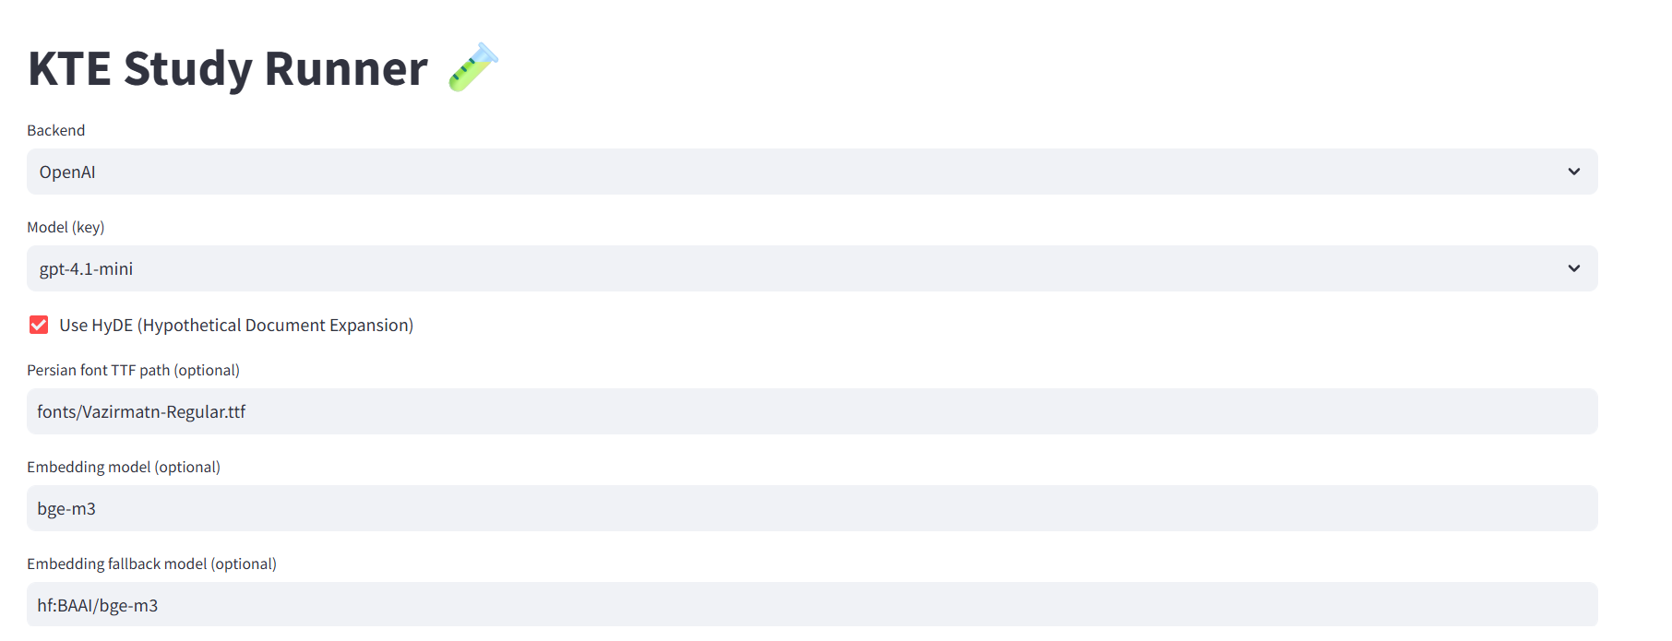

Figure 1. HyDE improves zero-shot retrieval by generating a short hypothetical answer and embedding it before search; RAG grounds generation in retrieved passage.

Fig 2: Study flowdiagram
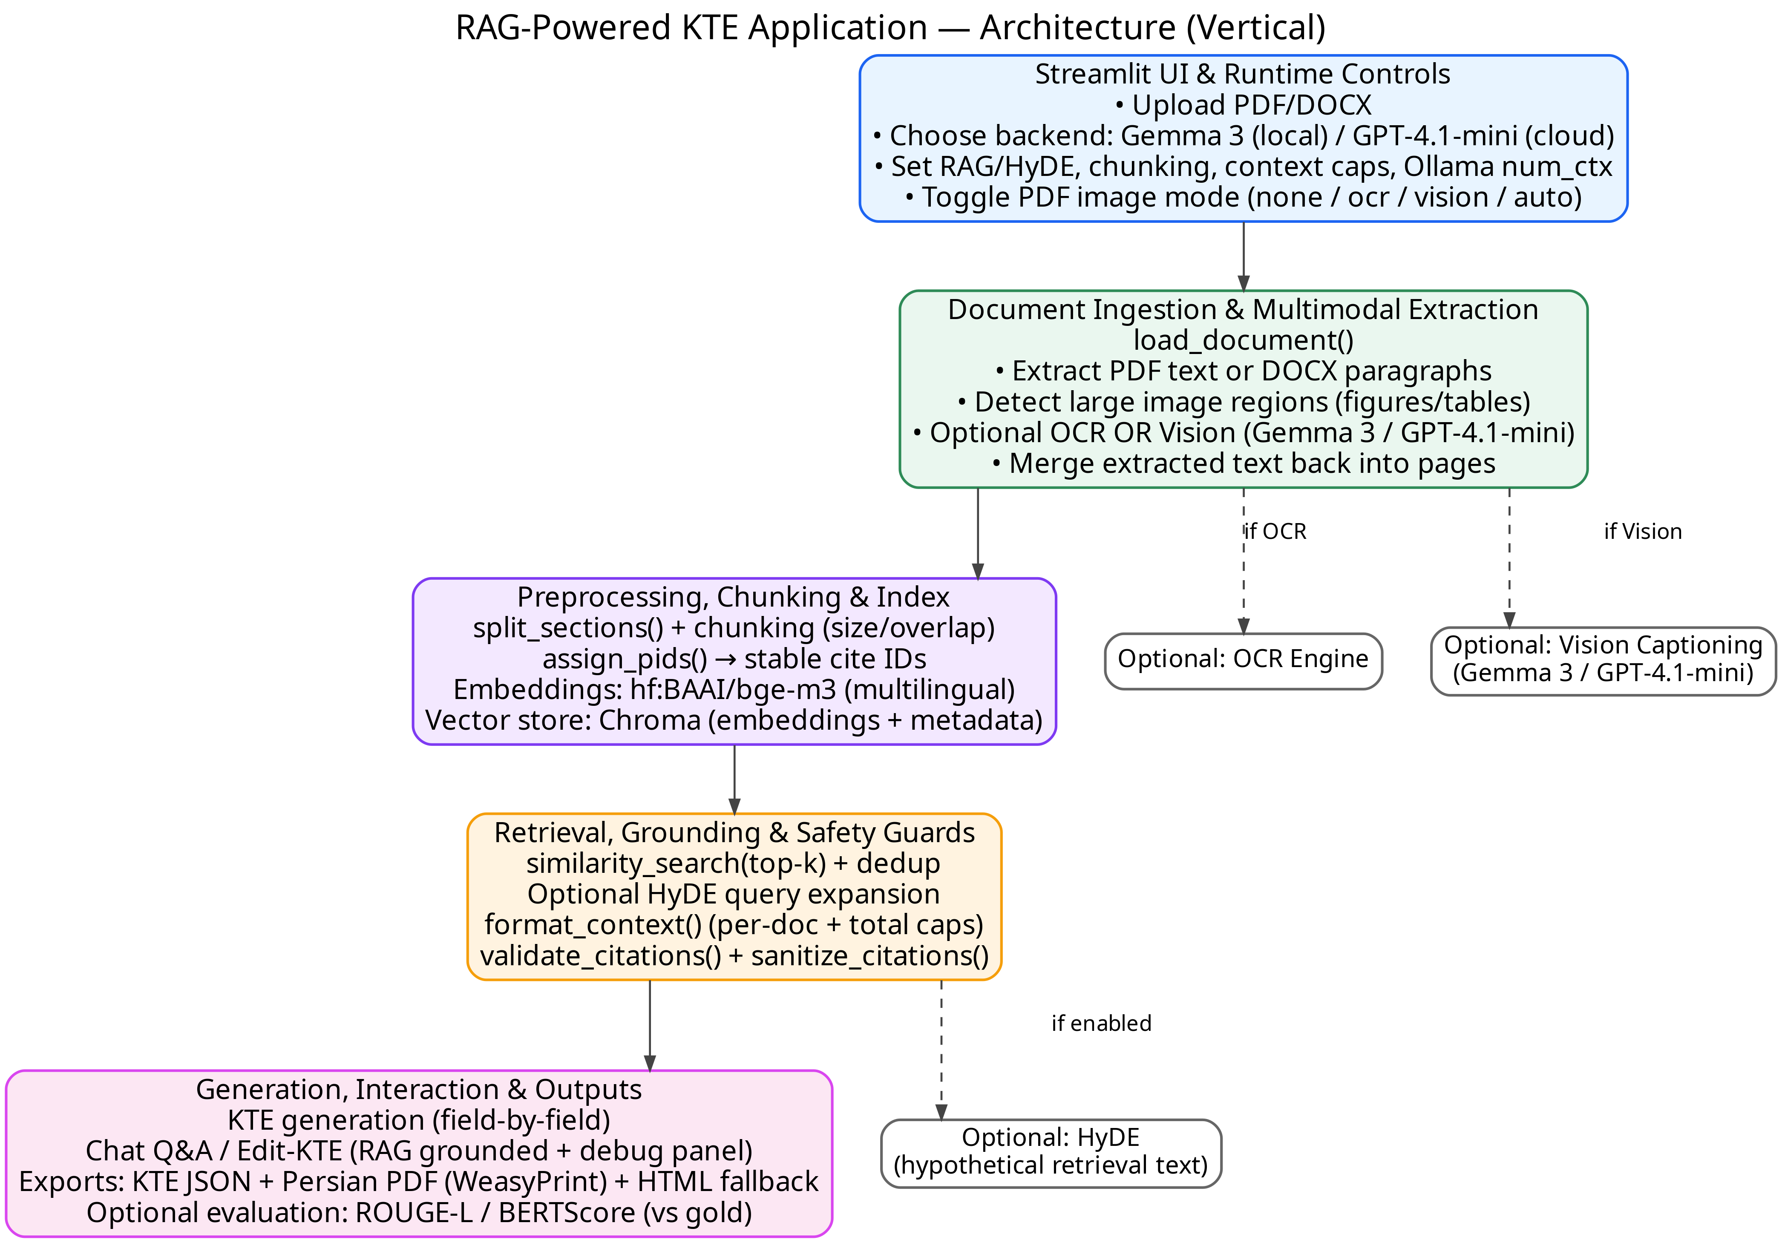
Figure2: High-level vertical architecture of the Streamlit-based RAG-powered KTE system (modules highlighted by color).

Fig 3: software architecture diagram
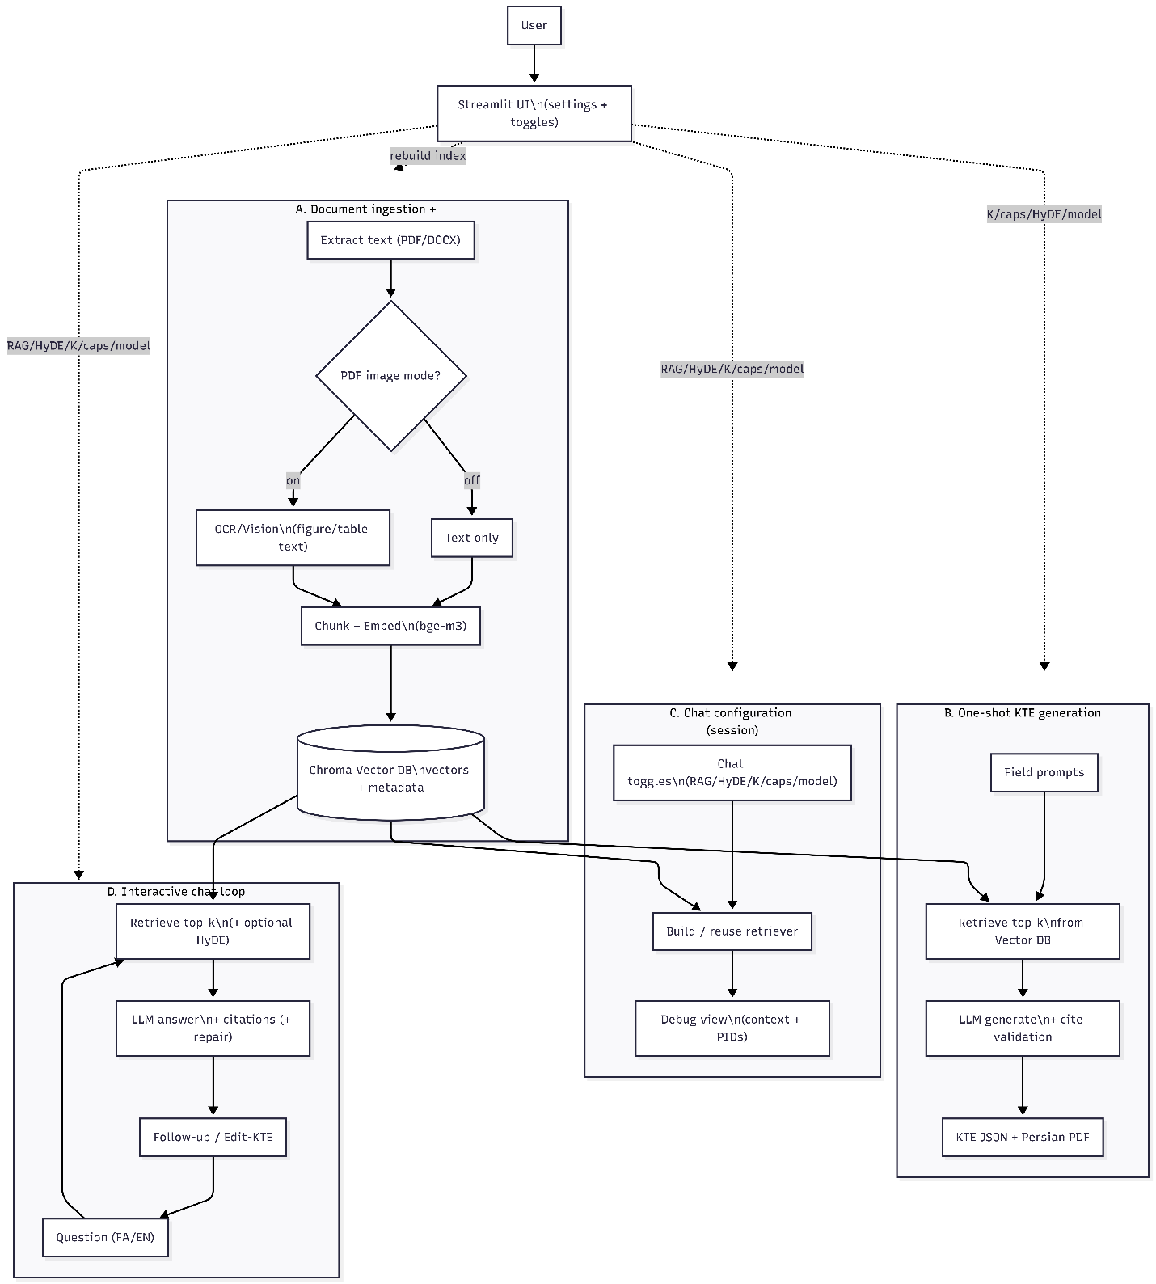

Figure 3: Schematic showing how configuration changes (before indexing, during KTE generation, and during chat) propagate through the pipeline and alter the indexed evidence store, retrieval behavior, and model outputs.

7. Tables

Table R1. Operational outcomes
files uploaded / processed | 4
success rate (% reached final KTE JSON) | 100
median runtime per article (s) | 11 minutes
regeneration events due to schema violations (e.g., field too long) | 12 times

Tab. R2: Field completeness & citation coverage.
Field | Complete | Citation coverage (%)
title | Yes | 100
key_message | Yes | 50
plain_summary | Yes | 100
importance | Yes | 75
nontech_results | Yes | 0
applications | Yes | 67
impacts | Yes | 0
limitations | Yes | 100
audience | Yes | 50
references | No | 0

