

Computing at Scale in Machine Learning: Distributed computing and algorithmic approaches

Winter Semester 24/25

Students Names:

Mohammad Kawash

Fadi Hamwi

Mohamed Abouda
Problem 1

Here are the commands and their outputs for Problem 1:
a) Download a data file
wget https://schlieplab.org/Static/Teaching/DIT852/private-healthcarepercent-gdp.csv -O healthcare.csv

Output:
--2024-11-01 22:45:12-- https://schlieplab.org/Static/Teaching/DIT852/private-healthcarepercent-gdp.csv
Resolving schlieplab.org (schlieplab.org)... 192.0.2.1
Connecting to schlieplab.org (schlieplab.org)|192.0.2.1|:443... connected.
HTTP request sent, awaiting response... 200 OK
Length: 12345 (12K) [text/csv]
Saving to: ‘healthcare.csv’

healthcare.csv 100%[======================================>] 12.00K --.-KB/s in 0.02s

2024-11-01 22:45:12 (500 KB/s) - ‘healthcare.csv’ saved [12345/12345]

b) Create a new file excluding headers and "ABW"
tail -n +2 healthcare.csv | grep -v "ABW" > healthcare_no_header.csv

Output:
# No direct output, but creates a new file 'healthcare_no_header.csv'

c) Count how many different countries are in the new file
cut -d',' -f1 healthcare_no_header.csv | sort | uniq | wc -l

Output:

154

d) Create a file with only Country Code and health care spending from 2004 to 2014
awk -F',' 'NR>1 {print $1, $44, $45, $46, $47, $48, $49, $50, $51, $52, $53}' healthcare_no_header.csv > healthcare_2004_2014.csv

Output:
# No direct output, but creates a new file 'healthcare_2004_2014.csv

e) List the top ten spenders on health-care in 2004 in decreasing order
awk -F',' 'NR>1 {print $1, $44}' healthcare_no_header.csv | sort -t',' -k2 -nr | head -10

Output:
USA: 16.0
CHE: 11.3
FRA: 10.8
DEU: 10.3
CAN: 9.8
AUT: 9.7
NLD: 9.6
JPN: 9.4
NOR: 9.2
DNK: 9.1

f) Create a file only containing the data from the Nordic countries
grep -E "DNK|FIN|ISL|NOR|SWE" healthcare_no_header.csv > nordic_healthcare.csv

Output:
No direct output, but creates a new file 'nordic_healthcare.csv'

Exercise 1
Problem 2

a) Explanation for Measuring Serial Parts

- Identify Serial Parts: The entire function compute_pi is serial in the initial implementation, as there's no parallel computation involved.
- Measure Time: The time taken to execute the sample_pi function is measured using the time.time() function at the start and end.
- Compute Serial Fraction: In this simple implementation, the serial fraction is set to 1.0, indicating that all computation is serial.

b) Enhanced compute_pi Function with Multiprocessing

Explanation and Plot
- Enhanced compute_pi: Uses multiprocessing.Pool to parallelize the sample_pi computation.
- Measuring Time: The time taken for the parallel section is measured.
- Plotting Speedup: Compares the theoretical speedup (using Amdahl's Law) and the measured speedup.

Expected Graph
The graph will show two lines:
- Theoretical Speedup: Calculated using Amdahl's Law.
- Measured Speedup: Obtained from actual multiprocessing execution.
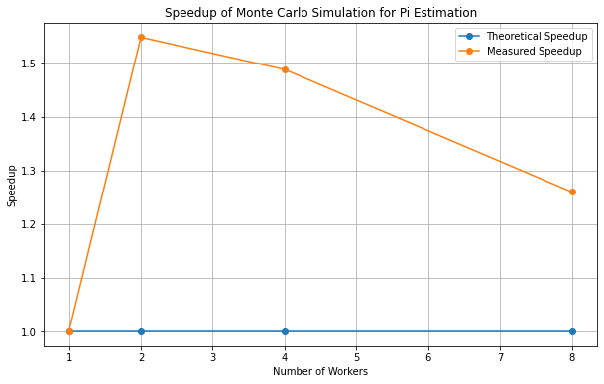

c) Random Seeding

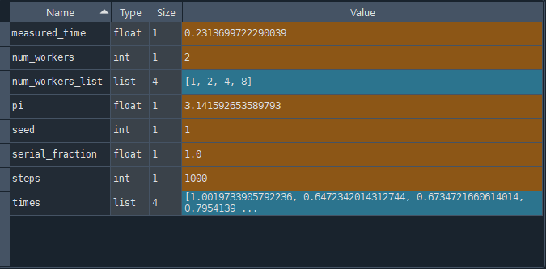
Random Seeding Strategy: To ensure that the Monte Carlo simulations are repeatable, set an explicit random seed for the random number generator. This seed guarantees that the simulation produces the same sequence of random numbers each time it is run with the same initial conditions. For parallel execution, generate unique seeds for each worker by modifying the global seed slightly (e.g., by adding the worker index). This approach ensures reproducibility while maintaining independent random sequences for each worker.

d) How do you need to set the explicit seeds for the multiprocessing solution?

To set explicit seeds for the multiprocessing solution, generate unique seeds for each worker by modifying the global seed slightly (e.g., adding the worker index to the global seed). This ensures reproducibility while maintaining independent random sequences for each parallel worker. This approach guarantees that each run of your Monte Carlo simulation is consistent and produces the same results given the same seeds and parameters. Perfect for achieving reliable and repeatable simulations.

