Data Analysis and Visualization Project:

COVID-19 Data Visualizations - Summary Report

**Names:**

Mohammad Malik

Maida Tahir

Muhammad Afnan

**Roll No:**

22I-1876

22I-1985

22I-1977

**Section:** D

**Department:** Data Science

Table of Contents

Abstract: 3

Table of Figures: 3

1. Forced-Directed Graph: 4

Overview: 4

Design Choices: 4

Key Features: 5

Conclusion: 5

2. Map Representation of Cases 6

Overview: 6

Design Choices: 6

Key Features: 7

Conclusion: 7

3. COVID-19 Infection Timeline 8

Overview: 8

Design Choices: 8

Key Features: 9

Conclusion: 9

4. Hierarchical Tree Map 10

Overview: 10

Design Choices: 10

Key Features: 10

Conclusion: 10

5. Sunburst Chart 12

Overview: 12

Design Choice: 12

Key Features: 13

Conclusion: 13

Final Dashboard: 14

# Abstract:

This report covers with five interactive visualizations of COVID-19 data created with D3.js – each representing a different kind of perspective on the pandemic–from the relationship between the patient and infection to the regional trend. The visualization is interactive, giving users a dynamic way of exploring and understanding the data.

# Table of Figures:

Figure 1: COVID patients Force-Directed Graph 4

Figure 2 Map of Korea 6

Figure 3 COVID Timeline 8

# 1. Forced-Directed Graph:

## Overview:

A force-directed graph visualizing relationships between COVID-19 patient-infection cases, enabling users to explore how patients and cases are connected across geographic regions.

Figure 1: COVID patients Force-Directed Graph

## Design Choices:

* Layout: Dynamic force-directed graph in which nodes are patients connected to infection cases.
* Interactivity: Zoom in/out, panning, filter by case of infection, and hover tooltips.
* Clustering: The nodes are grouped by city and province for better relational interpretation through geography.

## Key Features:

* Zoom & Pan: Zoom and pan to change the view and move the graph.
* Filtering: Filtering Shows cases by specific infection
* Tooltips & Legends: Tooltips and legends for easy node information and explanation regarding node types.

## Conclusion:

This visualization provides an insightful and interactive way to traverse patient-infection case relationship coupled with dynamic features for detail analysis.

# 2. Map Representation of Cases

## Overview:

An interactive map of South Korea showing an interactive view of the spread across the provinces, with highlighted provinces, a regional drop-down filter, zoom for different views, and tooltips on mouse hover.

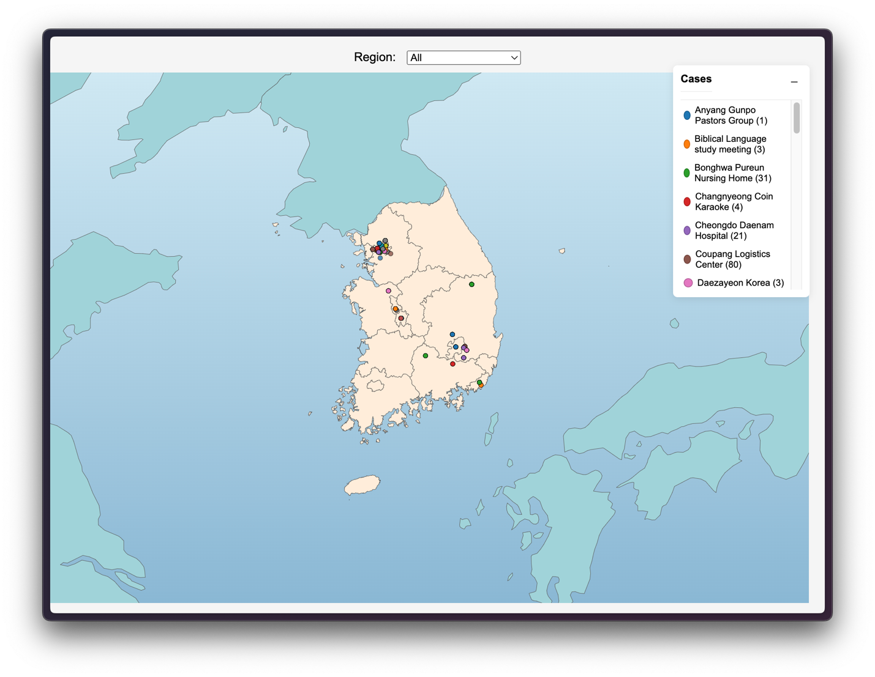

Figure 2 Map of Korea showing COVID cases across provinces

## Design Choices:

* Map Layout: Geo-Mercator projection with South Korea as the center.
* Color Scheme: Korea represented by cream, other countries by teal, and colored pins are used for COVID-19 data points.

## Key Features:

* Region Filter: The dropdown filters the data by province.
* Zoom & Tooltips: The map allows zooming in/out and offers detailed information for each case when hovered over, as well as on provinces.
* Pin Interactions: The pins can be hovered over to provide more information.

## Conclusion:

The map allows for exploring the spread of COVID-19 across South Korea’s provinces through interactivity and detailed data insights while also being easily navigable.

# 3. COVID-19 Infection Timeline

## Overview:

COVID-19 line graph where one can view confirmed cases, released cases, and deceased cases at a monthly pace in time with interactivity to see more in each segment.

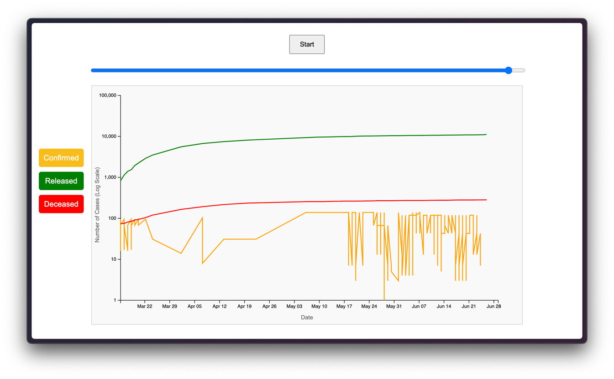

Figure 3 COVID Timeline in South Korea

## Design Choices:

* Data Representation: Used logarithmic scale for the number of cases on a line chart to highlight the change over time.
* Categories: It categorizes the view of cases into confirmed, released, and deceased cases.
* Interactivity: Interactive Hover effects, a play/pause button and the slider and category toggles are enabled

## Key Features:

* Play/Pause: Shows an animation of the timeline.
* Slider: This feature allows manual control of the animation.
* Tooltips & Hover Effects: Show case counts, with highlighting of specific lines.

## Conclusion:

This visualization is detailed and engaging as it provides an animated view of the progression of COVID-19 cases and includes interactive features.

# 4. Hierarchical Tree Map

## Overview:

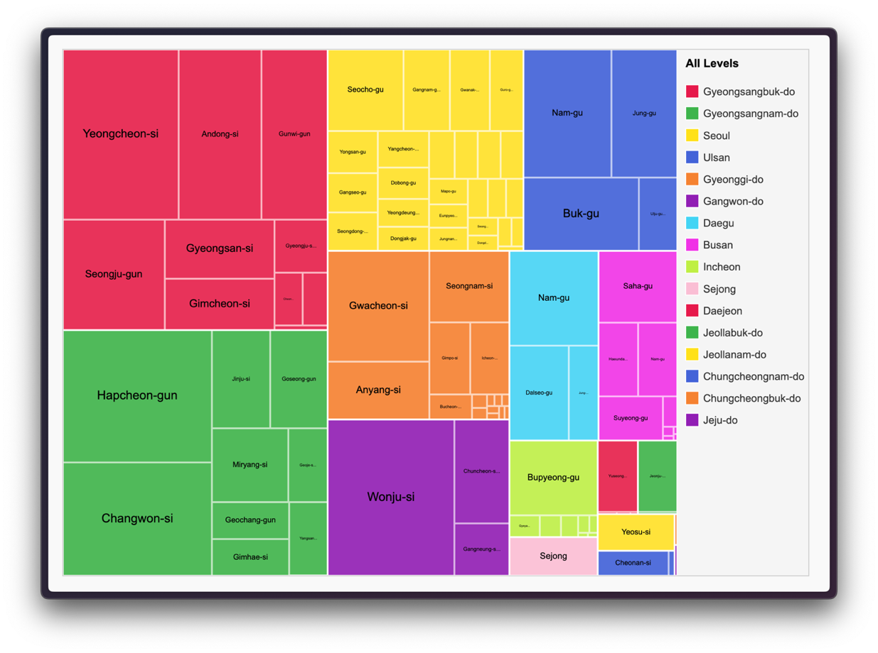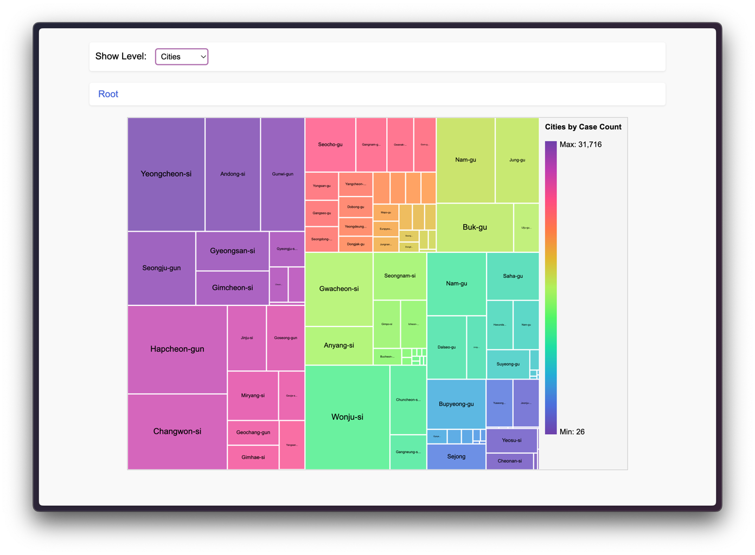A tree map of the number of confirmed cases of COVID-19 in regions (province and cities), with the size of the nodes representing the case count.

Figure 4 Tree-Map of COVID cases across regions

## 

## Design Choices:

* Tree Map: Regional data are shown as nodes scaled by confirmed cases.
* Interactivity: Includes drill-down, breadcrumb navigation, and tooltips
* Color Scheme: Depends on the mode selected:
  + For ‘All’ level view: Each color encompassing cities represents a province they all share, and the size represents case count.
  + For ‘City’ level view: The hue shifts from highest case count to lowest.
  + For ‘Province’ level view, the colors represent distinct regions.

## Key Features:

* Breadcrumb Navigation: The ability to track the path the user is currently traversing the hierarchy.
* Dynamic Level Filter: All levels, Provinces, or Cities
* Drill-Down: Click to zoom into child regions.

## Conclusion:

This visualization enables one to hierarchically browse the case distributions of COVID-19 through South Korea’s provinces and cities, and thus gives an intuitive way to visualize data spread across various regions.

# 5. Sunburst Chart

## Overview:

The Sunburst Chart is an interactive visualization that represents hierarchical data, where each segment in it represents a level in the hierarchy. It is helpful to show how different categories or regions relate to one another, such as in our case COVID-19 cases in different age groups, across the two genders.

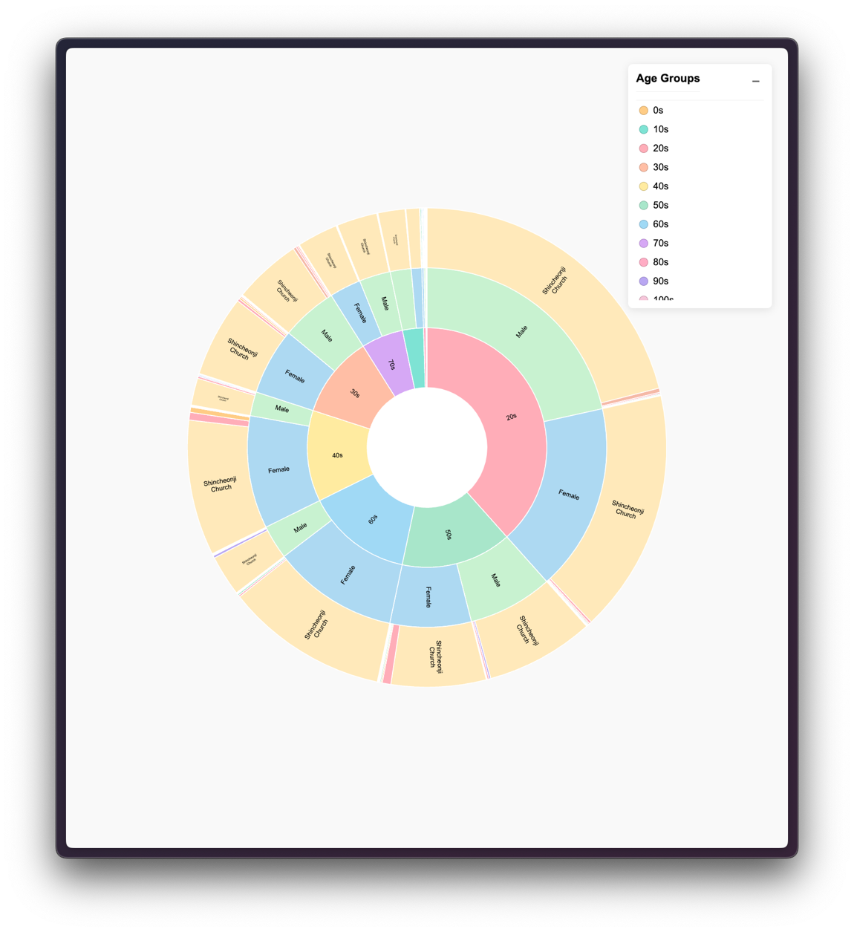

Figure 5 Sunburst chart of COVID across ages, genders

## Design Choice:

* Chart Type: This is a Sunburst chart where there are concentric circles with each ring showing different levels in the hierarchy.
* Interactivity: On the click of a segment, one drills into levels that show further division or breakdowns.
* Color Scheme: Each category at each level is shown with distinct colors that separate the given entities.

## Key Features:

* Drill-Down Navigation: Focuses into a subcategory upon click.
* Tooltips: Hover over bars to get more detail on the category, such as confirmed cases and other metrics.

## Conclusion:

The Sunburst chart provides a view of COVID-19 data through clear hierarchies with ease to understand how a given region or category could be contributing to overall trends. The interactivity of this chart along with an intuitive design gives users engaging ways to analyze and get through complex datasets.

# Final Dashboard:

Every visualization provides a different perspective on COVID-19 in South Korea When combined, they provide a dashboard that uses the powerful visualization capabilities by D3.js for detailed, interactive exploration of data.

Figure 6 The complete D3 Dashboard

Together, these visualizations in the dashboard provide full patient-infection relation, regional patterns, how patients progress over time, and distributions as hierarchies over all regions (cities or provinces), age groups, gender etc.