Project Description

Name:
Student Performance Analysis Project

Problem Statement:
• Overview:
Education systems globally face challenges in improving student performance. A wide array of factors influences academic success, including demographic details, parental involvement, study habits, and extracurricular activities. Understanding these factors can help educators, schools, and policymakers create tailored interventions to improve student outcomes.
• Specific Problem:
The problem to address is understanding how various demographic, behavioral, and environmental factors—such as gender, ethnicity, parental education, study time, and extracurricular participation—impact academic performance. The goal is to uncover insights into these relationships and provide actionable recommendations to enhance educational strategies.

Possible Impact of Your Analysis:
This analysis can provide valuable insights for educators, families, and policymakers, enabling them to:
- Identify the key drivers of academic success.
- Develop targeted programs and initiatives to address disparities in education.
- Foster environments that promote better learning outcomes, particularly for underserved or at-risk students.

By addressing these factors, this project can contribute to creating equitable and effective educational strategies.

Dataset(s):
Student Academic Performance Data
- Source: Kaggle - Students Performance Dataset
- License: Licensed under the Creative Commons Attribution 4.0 International (CC BY 4.0), allowing sharing and adaptation with proper attribution.
Variables:
The dataset includes detailed information about student demographics, study habits, parental involvement, extracurricular participation, and academic performance. Key features include:
- Student ID: Unique identifier for each student.
- Age: Student's age (15–18 years).
- Gender: Gender of the student (0 = Male, 1 = Female).
- Ethnicity: Ethnic background (0 = Caucasian, 1 = African American, 2 = Asian, 3 = Other).
- Parental Education: Education level of the parents (0 = None, 1 = High School, 2 = Some College, 3 = Bachelor's, 4 = Higher).
- Study Time Weekly: Weekly study hours (0–20 hours).
- Absences: Number of school absences (0–30).
- Tutoring: Participation in tutoring programs (0 = No, 1 = Yes).
- Parental Support: Level of parental support (0 = None, 1 = Low, 2 = Moderate, 3 = High, 4 = Very High).
- Extracurricular: Participation in extracurricular activities (0 = No, 1 = Yes).
- Sports: Participation in sports (0 = No, 1 = Yes).
- Music: Participation in music activities (0 = No, 1 = Yes).
- Volunteering: Engagement in volunteering activities (0 = No, 1 = Yes).
- GPA: Grade Point Average (2.0–4.0).
- Grade Class: Final grade classification:
  - 0: 'A' (GPA >= 3.5)
  - 1: 'B' (3.0 <= GPA < 3.5)
  - 2: 'C' (2.5 <= GPA < 3.0)
  - 3: 'D' (2.0 <= GPA < 2.5)
  - 4: 'F' (GPA < 2.0)
This dataset provides a robust foundation for exploratory data analysis (EDA) and model building, making it ideal for understanding the relationships between various factors and student performance.

Project Scoping Document

Business Problem
In education systems worldwide, there are numerous factors that influence student performance, including demographic details, parental education levels, study habits, and extracurricular activities. Despite ongoing efforts, disparities in academic outcomes persist, often linked to socioeconomic status and parental involvement. Understanding the relationship between these variables is crucial for developing interventions that can bridge performance gaps. By identifying the root causes, we can create more effective programs that target students' specific needs, ultimately improving overall educational outcomes.

Business Impact
By conducting a thorough analysis of the factors influencing student performance, educators, policymakers, and parents can gain a deeper understanding of the primary drivers of success or failure in the classroom. Insights from this analysis can help:
- Schools improve their teaching strategies and tailor them to meet the diverse needs of students.
- Policymakers design more effective education policies aimed at improving access and success for underserved communities.
- Parents understand how they can support their children's education more effectively.
Ultimately, the goal is to identify the interventions that will most effectively boost academic achievement and equity among students.

Dataset(s)
The current dataset includes detailed student information, including demographic details, study habits, parental involvement, extracurricular activities, and academic performance. The dataset includes the following variables:
- StudentID (unique identifier)
- Age, Gender, Ethnicity
- Parental Education Level
- Weekly Study Time, Absences, Tutoring Status
- Parental Support, Participation in Extracurricular Activities (Sports, Music, Volunteering)
- GPA (Grade Point Average) and Grade Class (A, B, C, D, F)
Strengths:
- Comprehensive coverage of factors influencing student performance.
- Well-defined variables that are easy to understand and analyze.
- Publicly available dataset with enough sample size for meaningful analysis.
Weaknesses:
- The dataset may be missing additional contextual data (e.g., home environment or school quality) that could further explain performance differences.
- Potential for class imbalance in the target variable (Grade Class).
- Limited to a sample of students with a relatively narrow age range, which may not represent all educational contexts.

Tools and Technologies:

Data Cleaning: Microsoft Excel
Exploratory Data Analysis (EDA): SQL, Excel, Python
Data Visualization: Tableau, Looker Studio
Dashboard Development: Tableau

Methods

Independent Variables: Gender, Ethnicity, Parental Education, Study Time, Absences, Parental Support, Extracurricular Activities, Sports, Music, Volunteering.

Dependent Variable: Grade Class (A, B, C, D, F).
The analysis will include:
- Descriptive Statistics: To summarize key characteristics of the data (e.g., average GPA, gender distribution).
- Correlation Analysis: To identify relationships between the independent variables and GPA or grade class.
- Data Visualization: Use of charts and graphs to visualize patterns and trends (e.g., GPA distribution by gender or ethnicity).
- Predictive Modeling: Developing classification models (e.g., logistic regression, decision trees) to predict grade class based on the other variables.
- Feature Importance: Analyzing which factors most strongly predict student performance.

Dashboard
The final dashboard will provide key insights in an easily digestible format, allowing users to:
- Track student performance by various demographics (gender, ethnicity, parental education level).
- Visualize correlations between study habits, parental involvement, and academic performance.
- Predict student grade class based on various inputs, helping educators identify students who may need additional support.
The dashboard will feature the following components:
- A bar chart showing the average GPA by ethnicity.
- A scatter plot showing the relationship between weekly study time and GPA.
- A pie chart illustrating the distribution of grade classes.
- A heatmap to visualize correlations between variables.

Dashboard mockup 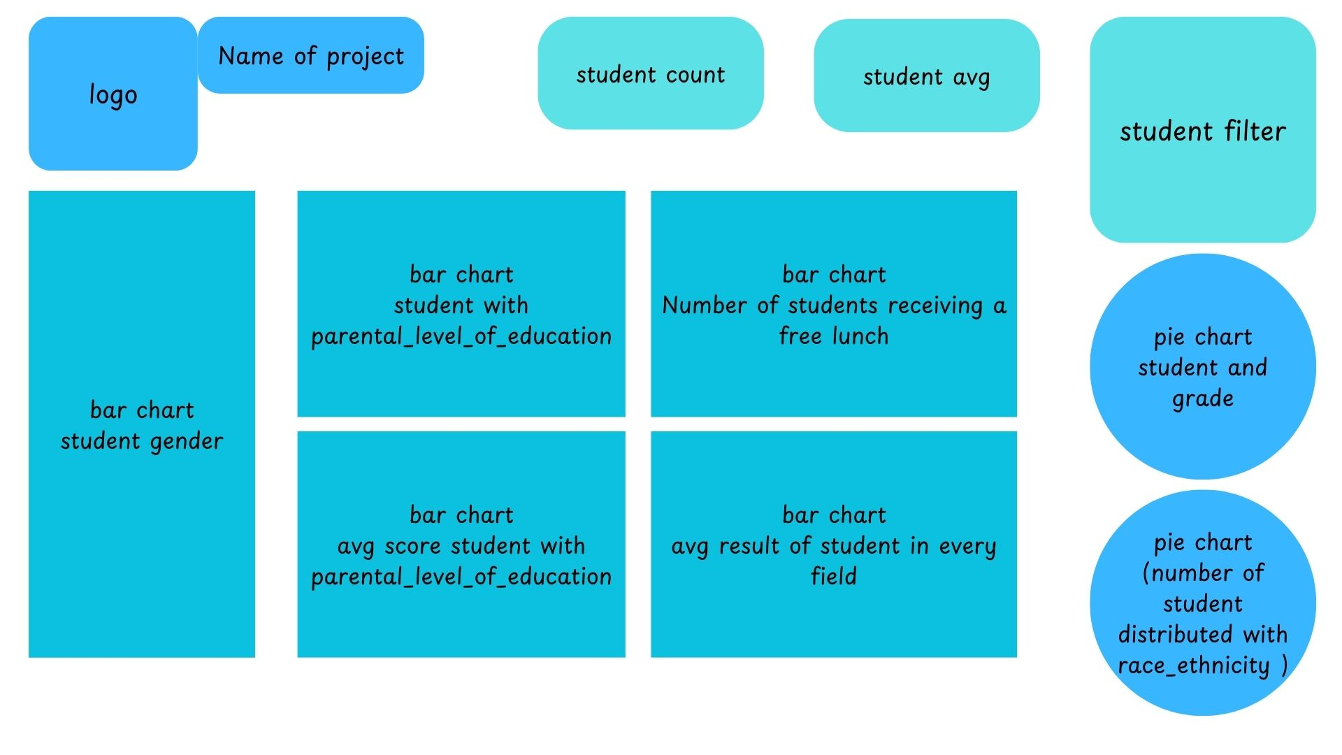

Milestones
- Identify characteristics of variables
- Clean data
- Create visualizations
- Show relationships between variables
- Create dashboard
- Write final report

Timeline
Week | Tasks
Week 1 | - Explore initial dataset  - clean data  - identify characteristics of variables  - envision final product
Week 2 | - Perform exploratory data analysis (EDA)  - create visualizations  - show relationships between variables using Excel, SQL, and Python
Week 3 | - Build dashboard  - finalize visualizations  - write final report

