ITD105 Laboratory Exercises #3
Exploratory Data Analysis
Name: Allan Raymart C. Paraiso
Datasets:
Regression: GlobalTemperatures.csv
Link: https://www.kaggle.com/datasets/sachinsarkar/climate-change-global-temperature-data
Video Link: https://drive.google.com/file/d/1xm2sIIZtD1YLkOyNIjCaBzoMTcIPhkrh/view?usp=sharing

Classification: Cirrhosis Patient Survival Prediction
Link: https://www.kaggle.com/datasets/joebeachcapital/cirrhosis-patient-survival-prediction
Video Link: https://drive.google.com/file/d/1i51TkjZepZsR32DqUvgNTiIeQOju5GVF/view?usp=sharing

Results:
Regression Dataset EDA

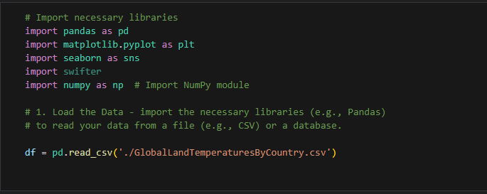

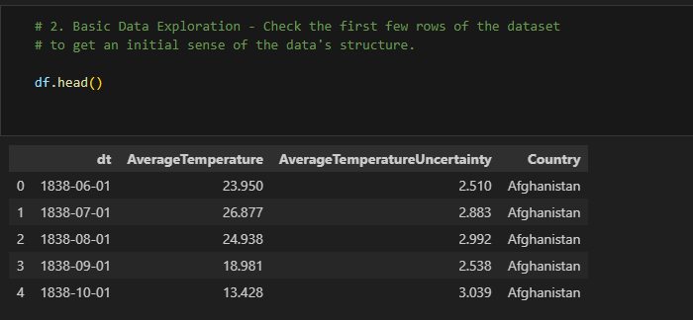

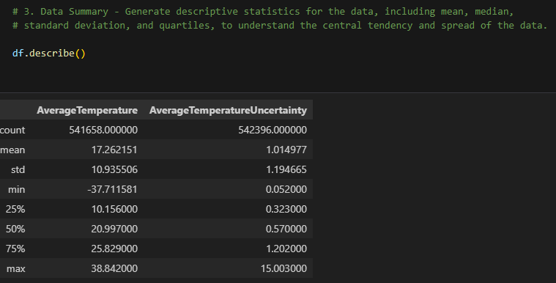

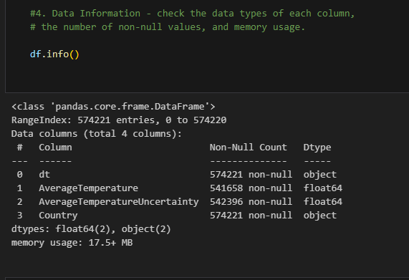

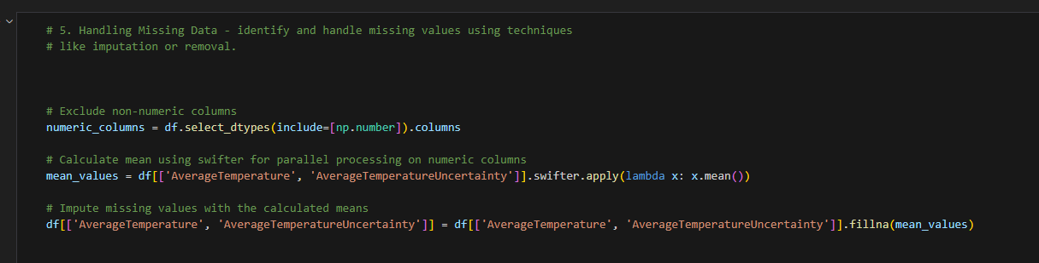

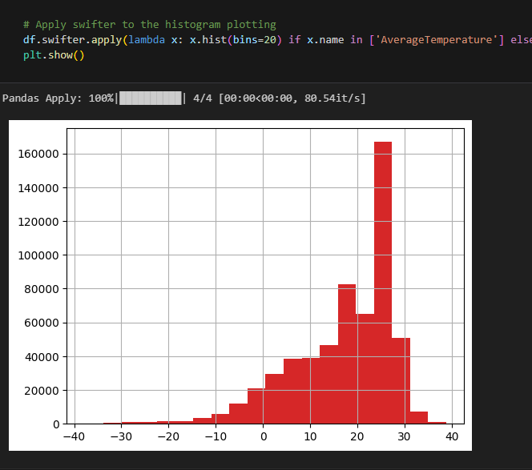

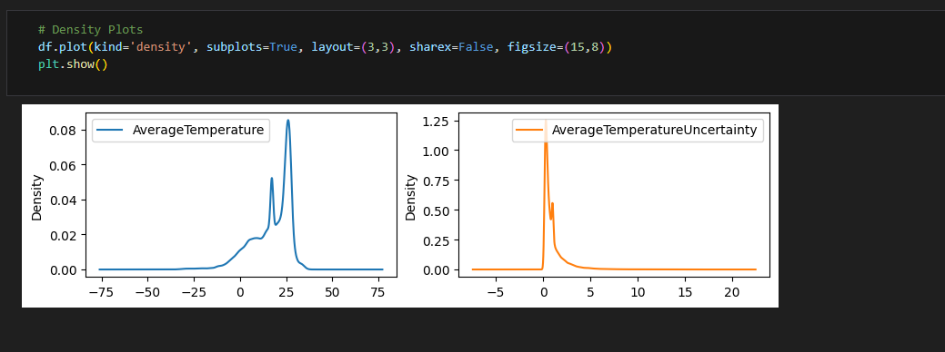
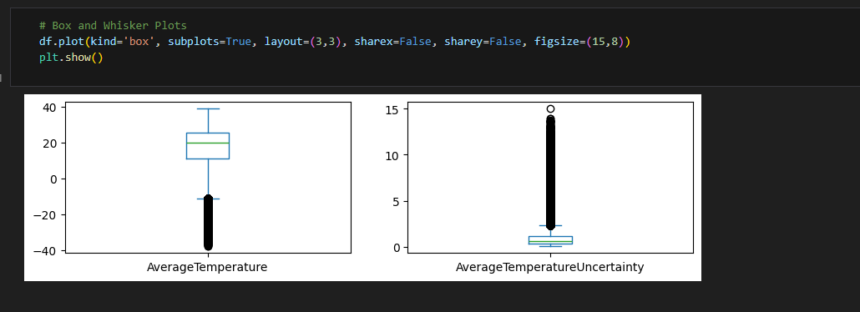

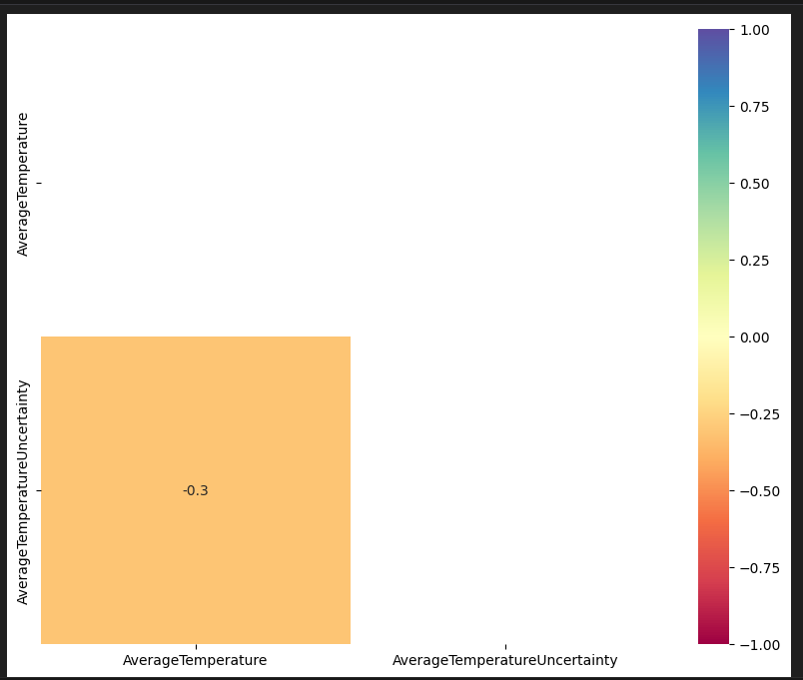
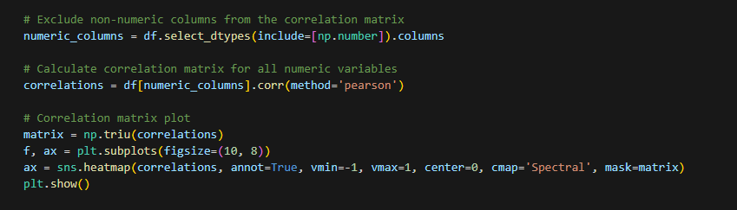

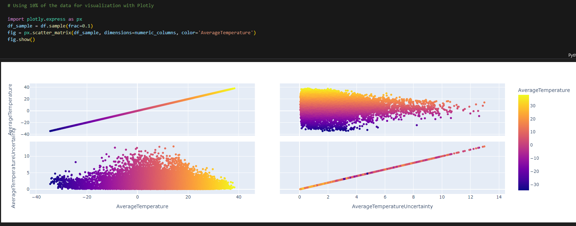

Classification Dataset EDA
