CHAPTER 1
Civics and Government

Types of Historical and Modern Governments
Governments are institutions that make, interpret, and implement laws for the people in a community. These processes maintain order in society and provide security for citizens.
There have been many different kinds of governments throughout history, and many different kinds exist today. In the United States, the citizens play an important role in government. Through elections, Americans choose their leaders. United States citizens benefit from a government that was created to protect their rights and freedoms.
Most governments throughout history can be classified into four basic types: oligarchy, monarchy, dictatorship, and democracy.
An oligarchy is a political system in which power is held by a small group of people. These people are usually members of an upper class such as nobles or military officers. They are not elected by the citizens. In an oligarchy, the rulers typically exercise power in their particular interests rather than on behalf of society at large.
In a monarchy, power is held by a king, queen, emperor, or empress.
This leader generally rules until the end of his or her life. Then leadership is passed on to his or her heirs. In a traditional monarchy, the leader has absolute power. In a constitutional monarchy such as Great Britain or the Netherlands, the ruler’s powers are limited by laws that may be written or unwritten. In modern constitutional monarchies, the ruler has little power and functions mainly as a ceremonial head of state.
A dictatorship is a type of government in which a single leader exercises absolute power over nearly every aspect of life in a country, including political, social, and economic issues. The leader, or dictator, is

not bound by any rules and can enact or change laws at will. Elections, if they are permitted, are usually meaningless because no transfer of power is allowed.
In a democracy, citizens exercise power on their own behalf. The earliest democracy was established in the small city-state of Athens in ancient Greece in 510 BCE. This was a direct democracy in which all citizens participated directly in making laws and in the government.
Today’s democracies, in much larger nations, are representative democracies in which citizens elect representatives to carry out the functions of government. In a democracy, every citizen has a voice, either directly or through elected representatives, in how the country is governed. When the head of state is a person elected by voters (rather than a hereditary constitutional monarch), this form of government is called a republic.
A democracy may be either parliamentary or presidential. A parliamentary democracy, such as those in Australia, Great Britain, and Canada, is a type of government in which government leaders are chosen by the political party that holds a majority of seats in the legislature, or parliament, based on elections. If no party holds a majority, several parties may work together to form a coalition government. Executive power is exercised by a prime minister, premier, or chancellor, assisted by cabinet members. The prime minister is the head of the government and is the leader of the political party that has the most seats in parliament. The government remains in office as long as the parliament supports its policies.
A presidential democracy, such as those in the United States and France, functions somewhat differently. This kind of democracy is headed by a powerful chief executive, called the president, who is elected by the voters, generally for a set number of years. The president is separate from the legislature and exercises a considerable amount of independent power, but his or her actions are limited by the constitution and other laws.
EXERCISE 1

Types of Historical and Modern Governments
Directions: Choose the best answer to each of the following questions.
- In which of the following governments does a leader have the most control over citizens’ lives?
  - oligarchy
  - monarchy
  - dictatorship
  - democracy
- Read each characteristic of a democracy. In the space, indicate whether each characteristic is found in a direct or representative democracy. Use D for direct democracy and R for representative democracy.
Every citizen can place proposals on the ballot, and a proposal becomes law if the majority vote for it.
Citizens elect a legislature to rule the country.
Delegates represent the wishes of the voting citizens.
Power to veto laws rests with the citizens themselves.
Answers are on page 825.

Basic Principles of American Constitutional Democracy
The founders of the American political system based their ideas on a number of principles developed by earlier thinkers in Great Britain and elsewhere in Europe. One of these principles, the philosophy of natural rights, was included in the Declaration of Independence.
According to this idea, individuals have certain rights just by the fact that they are human beings. These rights are derived from nature; they are not allowed by a ruler or permitted by a law. Also, they are absolute and

not revocable. The idea of natural rights dates back to the European Enlightenment of the 17th and 18th centuries. The Scottish philosopher John Locke (1632–1704) stated that the duty of government is to protect people’s rights to life, liberty, and property. The Declaration of Independence states that people are “endowed by their Creator with certain unalienable Rights,” and states that these include the rights to life, liberty, and the pursuit of happiness.
A second principle that contributes to American democracy is popular sovereignty. According to this principle, the government derives its power from the consent of the governed. Furthermore, people who are subject to the government’s decisions have the right to a voice in deciding how those decisions are reached. This was a fundamental belief of the 18th-century American colonists who demanded a say in how the colonies were governed. Following the Revolutionary War, the idea of popular sovereignty was one of the bases on which the government of the United States was founded. The people, through their elected representatives, have a voice in how governmental decisions are made.
Constitutionalism is a way of thinking that combines the ideas of a limited government and the rule of law. These ideas are found throughout the Constitution of the United States. The government is entitled to exercise certain powers, but its powers are also limited in order to protect the rights of the citizens. Limited government means that government’s powers are spelled out and also limited by the laws and the Constitution. The rule of law means that neither the citizens nor the government officials are permitted to break the laws or to violate the Constitution.
The idea of constitutionalism was written into the Preamble of the U.S. Constitution. The Preamble states that the government is given the powers needed to protect the people, but that its powers are limited and cannot be used unjustly against the citizens.
Because the U.S. government is based on the consent of the governed, majority rule is an important basic concept. Simply put, decisions are made by a vote of more than half of the people who participate, whether it is an election or an act of the legislature.
The founders were also aware that a majority might abuse its power and might not respect the rights of a minority. In a democracy, majority rule

needs to be limited so that minority rights are guaranteed. Those with unpopular views, whether they are individuals or minority groups, must be protected from oppression by the majority. One way this protection is granted in the United States is by the Bill of Rights, which protects the basic rights of individual citizens.
Another important principle, called federalism, provides for the separation of powers and functions between the federal government and the governments of the states. The federal government exercises supreme power throughout the country and has exclusive control over issues such as:
- Declaring war
- Making treaties with other countries
- National defense
- Regulating trade
The state governments control:
- Functions that are not assigned to the federal government
- Local issues covered by state and local laws
The Tenth Amendment to the U.S. Constitution grants powers to the states that the Constitution has not assigned specifically to the federal government.
EXERCISE 2

Basic Principles of American Constitutional Democracy
Directions: Read the following statements,
and then choose the principle that is addressed.
- “All . . . will bear in mind this sacred principle, that though the will of the majority is in all cases to prevail, that will to be rightful must be reasonable; that the minority possess their equal rights,

which equal law must protect and to violate would be oppression.”
—Thomas Jefferson
  - limited government
  - minority rights
  - popular sovereignty
  - natural rights philosophy
- Everyone deserves to enjoy certain freedoms and to have the opportunity to obtain a reasonable quality of life.
  - limited government
  - minority rights
  - popular sovereignty
  - natural rights philosophy
- Citizens are able to voice their opinions on the rules and laws by which they are expected to live.
  - limited government
  - minority rights
  - popular sovereignty
  - natural rights philosophy
- The Scottish philosopher John Locke declared that the duty of government is to protect people’s rights to life, liberty, and property.
  - limited government
  - minority rights
  - popular sovereignty
  - natural rights philosophy
- At the time the U.S. Constitution was written, the federal government was not permitted to raise money for itself and had to depend on the states to provide the funds needed to operate the country.
  - limited government

  - minority rights
  - popular sovereignty
  - natural rights philosophy
Answers are on page 825.

Structure and Design of the U.S. Federal Government
The structure of the U.S. federal government is based on a principle called the separation of powers. The Constitution divides the federal government into three branches: the executive branch (the president), the legislative branch (Congress), and the judicial branch (the court system). In this way, power is divided. The division prevents any one branch of the government from having too much power. It also means that if one branch abuses its power, the other two are available to restrain it. Thus each branch checks the power of the other two. This is known as a system of checks and balances. This division of government into three branches was first proposed by the French political philosopher Montesquieu in the 18th century. He believed that this division of power promoted liberty. The idea of separation of powers is one of the main components of modern constitutional government.

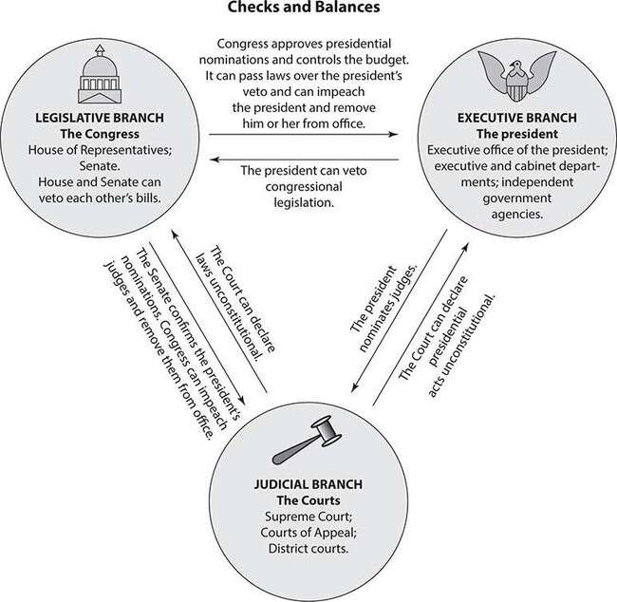
Each of the three branches of government serves a distinct purpose. The legislative branch, which is Congress, makes the laws. The executive branch is the president and the members of his or her administration. The president is elected separately from the members of Congress. The executive branch is responsible for enforcing the laws. It also has the power to veto acts of Congress, thus limiting the power of the legislative branch. The judicial branch, which is the court system, is responsible for interpreting the laws.
EXERCISE 3

Structure and Design of the U.S. Federal Government
Directions: Follow the instructions to answer the question.
1. Read each of the following statements. For each one, decide which branch of government is being checked by the action described. Then indicate the column in the table where each statement belongs. (Note: On the real GED® test, you will click on each statement and “drag” it into position in the diagram.)
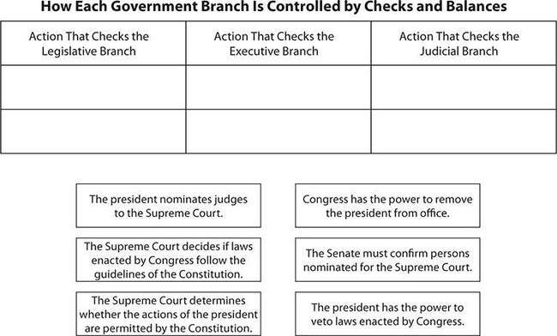
Answers are on page 825.

The Legislative Branch
The legislative branch of government, the U.S. Congress, is composed of two houses. These are the House of Representatives, or the lower house, and the Senate, or the upper house. These two houses are equal in power.

They differ in how they are elected and in the number of members in each house. Members of the House are elected from districts that each include a roughly equal number of voters. The districts are redrawn (“reapportioned”) every 10 years based on the results of a census. States with larger populations contain more electoral districts and therefore elect more members to the House. Members of the House serve two-year terms. In the Senate, by contrast, each state is represented by two senators, regardless of the state’s population. Thus states with small populations have the same number of votes in the Senate as states with large populations. Senators are elected by all the voters in a state. They serve six-year terms, with one-third up for election every two years. The Speaker of the House is the presiding officer of the House and is elected by the members. He or she is typically the leader of the majority party.
The powers of Congress are listed in Article I of the U.S. Constitution. These listed powers are called enumerated powers, although the elastic clause allows Congress to stretch its powers to fit specific situations as needed. Some of the enumerated powers held by Congress include the power to tax, to regulate commerce and the currency, to introduce bills, to declare war, to maintain the army and navy, to admit new states into the Union, to approve treaties, and to impeach the president. Most of these powers are shared by both houses; however, some are assigned to either the Senate or the House only.
EXERCISE 4

The Legislative Branch
Directions: Use the map to answer the following questions. For each question, choose the best answer to the question.

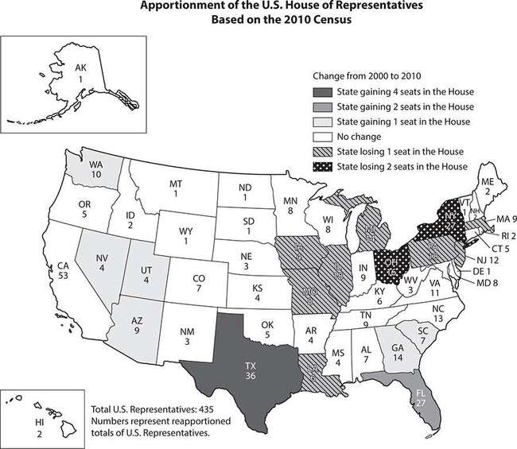
- During the 113th Congress, which began on January 3, 2013, California had 53 representatives. What does that indicate?
  - California had a greater population than any other state at the time the Constitution was ratified.
  - At the time of this session of Congress, the population of California was greater than that of any other state.
  - More voters in California participated in the 2012 presidential election than in any other state.
  - California has the greatest land area, in square miles, of any state in the country.
- What can you infer based on the map?

  - Texas has always had 36 representatives because it is the largest state by area.
  - Certain states will always have the greatest number of representatives.
  - The number of representatives for each state can change every 10 years based on census results.
  - Western states such as California and Oregon have a greater number of representatives than states in the east.
- Which state gained the most representatives in 2010?
  - California
  - Florida
  - Georgia
  - New York
Answers are on page 825.

The Executive Branch
The executive branch of the government includes the president, the vice president, and the agencies that enforce the laws of the United States. The president, who is the head of the government of the United States, is elected by the people for a four-year term, and may serve no more than two terms. Article II of the Constitution outlines the responsibilities of the president, which include serving as commander-in-chief of the armed forces, appointing judges to the Supreme Court, nominating major executive officers, executing and enforcing laws enacted by Congress, and vetoing bills sent by Congress as he sees fit. Congress can override the president’s veto of a law with a two-thirds vote of both houses.
The U.S. Constitution gives the president the power to negotiate and sign treaties with other countries. These treaties must be ratified by a two- thirds vote of the Senate. The Constitution also requires the president to give Congress information regarding the State of the Union, which is traditionally an address to a joint session of Congress each year in January.

The Constitution also established three qualifications for being elected president: a candidate must be at least 35 years old, must be a natural-born citizen of the United States, and must have lived in the country for a minimum of 14 years.
The vice president assumes the presidency if the president is unable to complete a term, for example, if he or she becomes disabled or dies. Thus the vice president’s major responsibility is to be prepared to take on the responsibilities of the president at a moment’s notice. The vice president also serves as president of the Senate, where his or her vote may be needed to break a tie. Other vice presidential duties are assigned at the president’s discretion. The Speaker of the House is third in line to succeed the president, following the vice president.
EXERCISE 5

The Executive Branch
Directions: Choose the best answer to each of the following questions.
- The Constitution specifies the wording of the oath of office of the President of the United States. Read the following excerpts from the Constitution.
Before he enter on the Execution of his Office, he shall take the following Oath or Affirmation: “I do solemnly swear (or affirm) that I will faithfully execute the Office of President of the United States, and will to the best of my Ability, preserve, protect and defend the Constitution of the United States.”
What is the central idea of the oath of office? The president will
  - protect the people of the United States.
  - support the U.S. Constitution.
  - work to preserve the land of the United States.
  - amend the U.S. Constitution as he or she finds it necessary.

- What inference can be made about why the framers of the Constitution included the oath of office?
  - They wanted to ensure that every presidential inauguration included the same words.
  - They believed that every president would need to be protected and defended while in office.
  - They wanted to ensure that all future presidents would follow the guidelines established in the Constitution.
  - They believed that the Constitution should be mentioned every four years so no one would forget about it.
- Read the following:
[The President] shall have power, by and with the advice and consent of the Senate, to make treaties, provided two thirds of the Senators present concur; and he shall nominate, and by and with the advice and consent of the Senate, shall appoint ambassadors, other public ministers and consuls, judges of the Supreme Court, and all other officers of the United States, whose appointments are not herein otherwise provided for, and which shall be established by law: but the Congress may by law vest the appointment of such inferior officers, as they think proper, in the President alone, in the courts of law, or in the heads of departments.
—Excerpt from the U.S. Constitution
Which statement best reflects the point of view of the framers of the Constitution?
  - No single person should have too much power in the government.
  - The Senate should have the power to appoint people to certain public offices.
  - Congress is better able to make decisions about treaties than the president.

  - The president should not make any decisions without the consent of Congress.
Question 4 is based on the following graph:
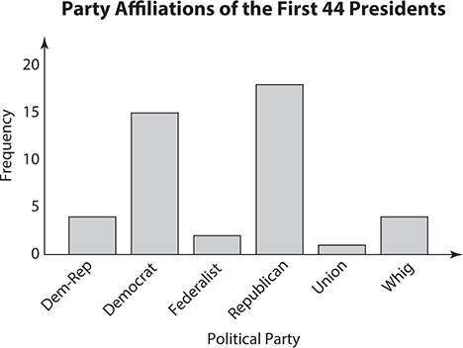

- Based on the graph, which statement is true?
  - Most presidents have had more than one party affiliation.
  - There have been more Republican than Democratic presidents.
  - The last four presidents have been affiliated with the Whig party.
  - The next president is more likely to be a Democrat than Republican.
Answers are on page 825.

The President’s Cabinet

Within the three branches of government are many people who play important roles in the running of the country. The cabinet is a group whose role is to advise the president on subjects related to each member’s office. This group includes not only the Vice President of the United States but also the heads of executive departments, including the Attorney General and the secretaries of Agriculture, Commerce, Defense, Education, Energy, Health and Human Services, Homeland Security, Housing and Urban Development, Interior, Labor, State, Transportation, Treasury, and Veteran’s Affairs. Each of these officials is appointed by the president and then confirmed by the Senate and is responsible for running a major federal agency and for carrying out the day-to-day operations of the federal government. Each cabinet member takes the title of “Secretary” of his or her department, with the exception of the head of the justice department, who is known as the Attorney General. Following the vice president, the Speaker of the House, and the Senate President pro tempore, the cabinet members are included in the line of succession to the presidency in the order in which their departments were created.
Each of the departments and agencies over which the cabinet members preside takes responsibility for a different set of government functions.
- The Department of Agriculture is responsible for ensuring the safety of food and regulating farming.
- The Department of Commerce is responsible for improving the living standards of the citizens of the country through economic development, and for regulating trade, banking, and the economy. The Census Bureau is a part of this department, as is the Patent and Trademark Office.
- The Department of Defense (DOD) is the largest government agency and includes the armed forces of the United States. This department, which is headquartered at the Pentagon in Washington, D.C., helps protect the security of the country.
- The Department of Education is responsible for promoting student achievement and making sure that all students have equal access to a quality education. This department administers financial aid for students and gathers data on schools in order to guide improvements for education in the United States.

- The Department of Energy regulates utilities and is responsible for ensuring the security of the country’s power supplies. It also promotes new technology to conserve energy resources. The department provides funds for scientific research in this area.
- The Department of Health and Human Services includes the Food and Drug Administration (FDA), the Centers for Disease Control (CDC), and the National Institutes of Health and Administration on Aging. This department works to ensure the health of U.S. citizens and administers Medicare and Medicaid, which provide health insurance to approximately 25% of Americans.
- The Department of Homeland Security was established following the terrorist attacks of 2001 and is responsible for security within the United States, and for patrolling the borders. This department was created by combining 22 executive branch agencies. It includes the Immigration and Naturalization Service, the U.S. Secret Service, the
U.S. Coast Guard, and the Transportation Security Administration.
- The Department of Housing and Urban Development (HUD) promotes affordable home ownership for U.S. citizens and makes sure that there is no discrimination against those trying to purchase a home. It provides mortgage and loan insurance, administers public housing, and offers assistance to the homeless.
- The Department of the Interior works to protect, conserve, and nurture national resources, including national parks and wildlife. This department manages about 20% of the land in the United States and protects endangered species. Agencies such as the Fish and Wildlife Service and the Bureau of Indian Affairs fall under the responsibility of this department.
- The Department of Justice is the largest law office in the world. It is responsible for enforcing the laws and for protecting the interests of
U.S. citizens. It works to ensure public safety, control crime, and seek justice for individuals who are guilty of committing crimes. It includes a total of 40 organizations, including the Federal Bureau of Investigation (FBI), the Federal Bureau of Prisons, and the Drug Enforcement Administration (DEA).

- The Department of Labor enforces labor laws in the United States and protects the safety and rights of workers. The programs of this department deal with job training, minimum wage levels, unemployment insurance, and discrimination in hiring. The Occupational Safety and Health Administration (OSHA) and the Bureau of Labor Statistics are part of this department.
- The Department of State is responsible for diplomatic relations with other countries and works to develop and implement the foreign policies of the president. This agency and its representatives reflect the United States as part of the worldwide community. The Secretary of State, who leads this department, is the president’s top advisor on foreign policy.
- The Department of Transportation is responsible for maintaining and ensuring the safety of the nation’s transportation network. It was responsible for establishing the Interstate Highway System, and it includes the Federal Highway Administration, the Federal Aviation Administration, and the National Highway Traffic Safety Administration.
- The Department of the Treasury collects taxes, manages federal finances, produces coins and currency, and oversees the financial and economic stability of the United States. It works with other agencies, with the governments of foreign countries, and with international financial institutions to raise the standard of living and encourage economic growth worldwide.
- The Department of Veterans’ Affairs offers medical care for veterans who are wounded or ill and administers benefits to those who have served in the armed forces and to their families.
EXERCISE 6

The President’s Cabinet
Directions: Choose the best answer to each of the following questions.

- There are currently about 25 million living American veterans. Of these, approximately 75% served the country either during a time of war or during an official time of hostility. This means that about one-fourth of the population of the United States, about 70 million people, could be eligible for veterans’ benefits as a result of either being a veteran or being a family member or survivor of a veteran.
Based on this information, which conclusion can be drawn?
  - The Secretary of Veteran’s Affairs oversees a very large budget.
  - Benefits for veterans and their families will run out within the next decade.
  - The Department of Veteran’s Affairs will have to decrease the amount of benefits awarded.
  - Family members of veterans should not receive benefits because they did not serve our country.
- Which department was created most recently?
  - Department of the Treasury
  - Department of Defense
  - Department of Education
  - Department of Homeland Security
Answers are on page 825.

The Judicial Branch
The judicial branch of the federal government includes the Supreme Court, the most powerful court in the country, whose responsibility is to determine whether or not laws are constitutional. This process is called judicial review. The judicial branch is also responsible for determining the meaning of laws and whether or not laws have been followed.
The Supreme Court is composed of nine justices who are appointed by the president and confirmed by the U.S. Senate. The justices serve for life.

The Chief Justice is the head of this elite group; the others are known as associate justices. The exact number of justices is determined by Congress. Although there have been nine members since 1869, this number had formerly been as low as six. A decision is reached when a majority of these justices agree. One responsibility of the Chief Justice is to administer the oath of office at presidential inaugurations. Another is to preside over impeachment hearings.
According to Article III of the Constitution, the Supreme Court is empowered to rule on cases that involve a state and citizens from a different state, controversies between states, and patent and copyright issues. Because the Supreme Court’s responsibility is to interpret what a law means, it generally does not hold trials. The justices may, however, accept legal briefs, hear arguments, or ask questions of the parties in the case.
In addition to the Supreme Court, the judicial branch also includes the United States district courts and United States courts of appeal. The district courts try most federal cases. The courts of appeal are responsible for reviewing appealed district court cases. These courts must abide by the decisions and interpretations of the Supreme Court. Once the Supreme Court makes a ruling or interprets a law, the inferior courts must apply this interpretation to other cases.
EXERCISE 7

The Judicial Branch
Directions: Questions 1 and 2 are based on the following table. Use the information in the table to fill in the blanks.

Chief Justices of the United States

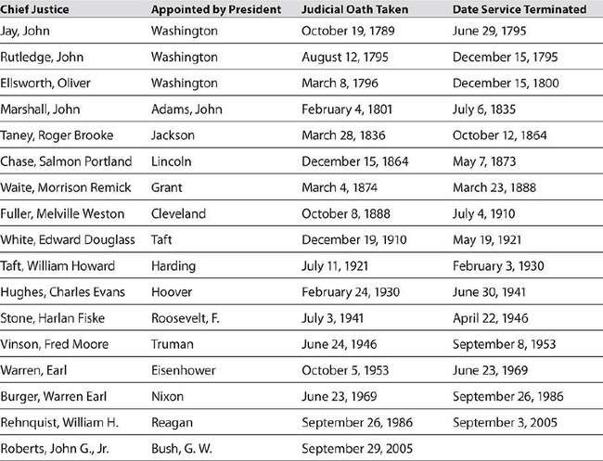

- The Chief Justice who has held this office for the longest period of time is .
- The longest-serving Chief Justice held this position for approximately years.
Answers are on page 826.

Amending the Constitution
According to Article V of the U.S. Constitution, the Constitution can be modified. Only 27 changes have been made despite the fact that thousands have been proposed. These changes or additions to the Constitution are called amendments. The fact that the Constitution can be modified allows the government to adapt to changes that take place in the country.

The amendment process, which is spelled out in Article V of the Constitution, begins one of two ways. Either Congress or a group of state legislatures can propose a change. The president plays no role in the process. The proposed amendment is presented to the states in the form of a joint resolution. Each state governor then submits the amendment to his or her state legislature. After an amendment has been proposed, three- fourths of the state legislatures must ratify, or approve, the change before it becomes law. The only amendment to have been ratified by all 50 states was the Twentieth Amendment. This amendment set the beginning and ending dates for presidential and congressional terms.
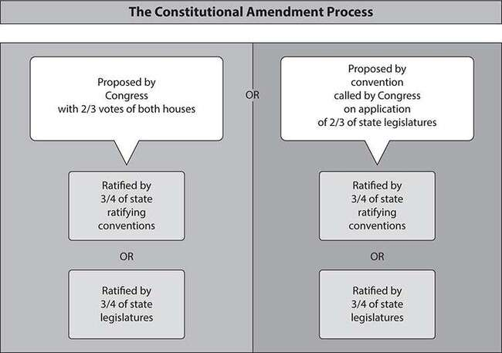
EXERCISE 8

Amending the Constitution
Directions: Choose the best answer to each of the following questions.

- What can be inferred from the ratification of the Twentieth Amendment?
  - Most states do not believe amendments are necessary.
  - States do not believe that the start and end dates for political terms are important.
  - All 50 states will never agree on proposed amendments in the future.
  - Just one amendment was ratified by all 50 states.
- Congress once debated a proposed amendment that would have lowered the voting age from 18 to 16, but the proposal was defeated. What point of view does this defeat reflect?
  - A minority of representatives and senators favored raising the minimum voting age.
  - Most legislators believed that high school students are ready to vote.
  - The president believed that people should not be allowed to vote at 16 years of age.
  - Most representatives and senators thought that only people aged 18 or older should be able to vote.
Answers are on page 826.

The Bill of Rights
The first 10 amendments to the Constitution, which were proposed and ratified by the First Congress, are known as the Bill of Rights. These amendments were proposed by James Madison in 1789 because several states wanted the Constitution to provide stronger protection for individual liberties. The amendments in the Bill of Rights place specific restrictions on the government’s power and guarantee certain rights and civil liberties to the citizens. These civil liberties include freedom of religion, freedom of speech, freedom of the press and assembly, and freedom from unreasonable searches and seizures.

Bill of Rights

Amendment I
Amendment II
Amendment III
Amendment IV
Amendment V
Amendment VI
Amendment VII
Amendment VIII
Amendment IX
Amendment X
Freedom of religion, speech, the press, assembly, and petition
Right to keep and bear arms in order to maintain a well- regulated militia
No quartering of soldiers in private homes without the owner’s consent

Freedom from unreasonable searches and seizures

Right to due process of law; freedom from self- incrimination and double jeopardy
Rights of accused persons, such as the right to a speedy and public trial by jury

Right of trial by jury in civil cases

Freedom from excessive bail and from cruel and unusual punishments

Rights in addition to those stated in the Constitution Powers reserved to the states

EXERCISE 9

The Bill of Rights
Directions: Use the summary of the Bill of Rights to answer the following questions. For each question, choose the best

answer.
- Read each statement. Determine which amendment in the Bill of Rights applies to each situation. Write the number of the amendment on the line.
A newspaper prints an editorial criticizing the actions of a political candidate.
A person is selected to be a member of a jury during the trial of someone accused of criminal activity.
During a routine traffic stop, authorities demand to search for stolen goods in the driver’s vehicle.
A person is tried for a crime and found not guilty; however, many in the community believe that the verdict is wrong and the accused should be tried again.
A homeowner purchases a personal firearm after robberies are committed in the neighborhood.
- Several amendments in the Bill of Rights, including Amendments IV, V, and VI (4, 5, and 6), provide protection for people who are accused of a crime. Indicate which of the following rights are covered by these amendments by placing an X on the line.
Protection against being tried twice for the same crime
The right to freely practice religion
The right to a speedy trial
The right to freedom of the press
Protection from being forced to house soldiers
The right to bear arms
The right to avoid self-incrimination
- Read the following passage, and then answer the question.
The happy Union of these States is a wonder; their Constitution a miracle; their example the hope of Liberty throughout the world.

—President James Madison (1829)
What did Madison mean by the phrase “the hope of Liberty throughout the world”?
  - People in other countries look at the United States and hope that someday Americans will be free.
  - Everyone around the world will someday enjoy the same rights as citizens of the United States.
  - People in the United States do not believe that people in other countries will also gain liberty.
  - People in other countries will see that it is possible for a government to protect the freedom of its people.
Answers are on page 826.

Citizens’ Rights and Civic Responsibilities
The Bill of Rights guarantees certain civil rights of American citizens. Other rights protected by the federal government but not included in the Bill of Rights are economic rights. These include the right to own property or a business. The government also protects people from discrimination by enacting laws that ensure equal treatment of people regardless of race, religion, age, or gender.
American citizens have responsibilities to their country and community as well. Civic responsibilities are key to making a democratic system of government work. Civic responsibilities of the citizens in the United States include paying taxes, registering for military service, performing jury service, and obeying federal, state, and local laws. Paying taxes provides the government with the funds needed to provide public goods and services, such as schools, law enforcement, roads, and parks. Serving on juries enables those accused of crimes to have a trial before a jury of their peers, as guaranteed by the Bill of Rights. Registering for military service helps to protect the country.

Civic responsibilities also include voting. Because the United States is a democracy, it is important for people to voice their opinions by voting. Citizens who have reached the age of 18 can register to vote and thus help select government officials and influence government policy.
Of the 27 amendments to the Constitution, four address who is able to vote. These amendments stipulate that citizens must be 18 years old or older, and may be men or women of any race. The amendments also guarantee that citizens are not required to pay a special tax in order to vote.
EXERCISE 10

Citizens’ Rights and Civic Responsibilities
Directions: Use the following Official Ballot to answer Questions 1 and 2:

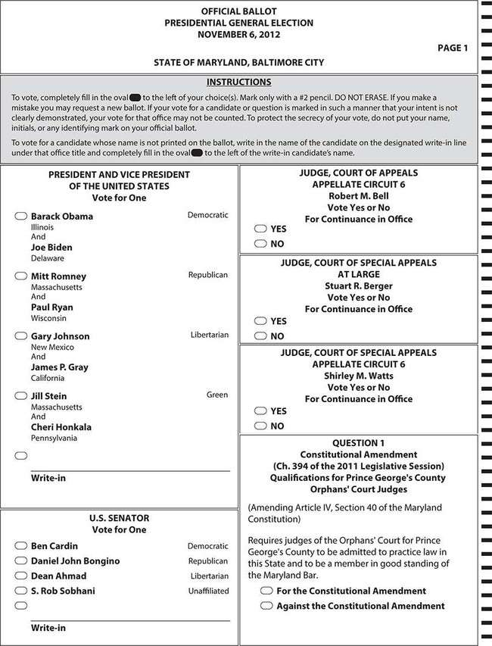

- Fill in the blank with the name of the candidate who is running for judge of Court of Special Appeals Appellate Circuit 6.

- James P. Gray is running for which office?
  - President
  - U.S. senator
  - Vice President
  - Court of Appeals judge
- Suppose a voter wants to vote for a candidate who is not listed as running for the U.S. Senate. Using the information on the ballot, what can the voter do?
  - Contact the Senate
  - Notify a poll worker
  - Create a new ballot that includes the unlisted candidate
  - Write in the name of the unlisted candidate on the ballot
Answers are on page 826.

Political Parties
Political parties are organizations that seek power and influence within the government. The members of a party share similar opinions and ideas about many issues. The members of a party choose a candidate to run for a government office and work to gain public support and votes for their chosen candidate.
In the early years of the United States, there were political parties that were different from the ones we see today. The issues they faced were different from the ones that are the focus of politics today. The first political parties were established by people who had differing visions for the future of America. Thomas Jefferson wanted the federal government to play a less active role. He wanted the powers of the president to be limited, and he wanted the United States to have a close relationship with France. Alexander Hamilton, on the other hand, believed that the United States should have a strong federal government. He also wanted the

country’s president to be strong. He believed that the country should have a strong relationship with Great Britain.
Today in the United States, the two main political parties are the Democrats and the Republicans. There are also a number of minor parties, but the nature of the political system makes it difficult for minor- party (“third party”) candidates to win elections.
Each of the two main parties includes people with a range of different viewpoints. However, each one also has a central core of defining beliefs. In general, Democrats are more liberal, or left wing, and support a broad, more active role for the federal government. Democrats also support laws favoring workers and strong, government-run social programs.
Republicans, on the other hand, are more conservative, or right wing, and generally favor the rights of the states rather than the federal government. They support policies that favor business owners and managers and private solutions to social problems.
EXERCISE 11
Political Parties
Directions: Use the following chart for Questions 1 through 3. For each question, choose the best answer to the question.

Political Parties in the United States

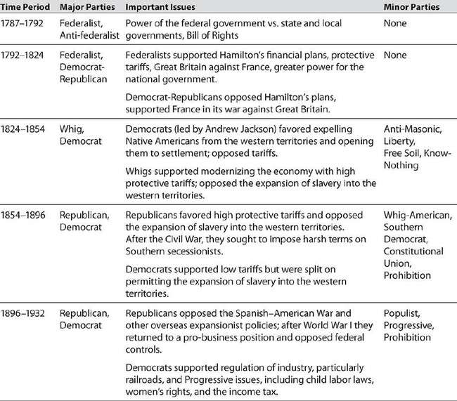
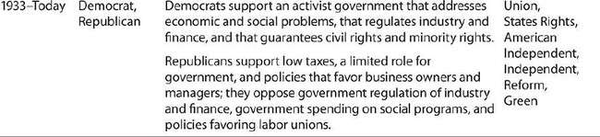

- According to the preceding table, in what period were today’s political parties established?
  - late 1700s
  - early 1800s
  - mid- to late 1800s
  - early 1900s

- Which statement is true?
  - All U.S. citizens are represented politically by one or the other of the two main political parties.
  - Members of different political parties in the United States rarely share any viewpoints on political issues.
  - A range of political beliefs exists among the citizens of the United States.
  - The number of major political parties in the United States has varied widely over time.
- The political party that has a majority in the House of Representatives or the Senate is called the “majority party.” The other party is called the “minority party.” If a Republican is the majority party leader in the Senate, what does this indicate?
  - There are more Republicans than Democrats in the Senate.
  - There are more Republicans than Democrats in the House of Representatives.
  - More Republicans than Democrats were elected to office in the last election.
  - A Republican was most recently elected as President of the United States.
Answers are on page 826.

Political Campaigns, Elections, and the Electoral Process
In the United States, presidential elections are held every four years on the first Tuesday of November. Elections for senators and representatives are held at the same time. Senators and representatives are also elected in
“off-year” elections, which take place midway through the four-year presidential term. In advance of the main “general” elections, political parties hold a series of primary elections. In these elections, candidates

from the same party for the same office run against one another to determine which one will be the party’s nominee in the general election.
Candidates spend many months running their political campaigns in order to gain the support of the most voters. During this organized effort to persuade people to support them, candidates share their ideas about necessary policy changes and spread their message about why they deserve to be elected. Messages are spread through personal appearances, phone calls, websites, mailings, and television and radio advertisements.
Research is conducted to determine who should be included in the candidate’s target audience and what issues are important to these people. Candidates ask supporters to join the campaign by helping to spread the message and making financial contributions.
Despite the fact that millions of citizens vote for their favored candidates in these elections, the president is not elected directly by the people. Rather, the citizens elect members of the Electoral College, which is the formal body that actually elects the president. The number of electors for each state is equal to the number of senators and representatives from that state in Congress. These electors cast votes for the presidential candidates. In order to win the presidency, a candidate must receive at least half of the electoral votes. Generally, the candidate who receives the majority of the citizens’ votes within a state receives all of the electoral votes for that state. Because of the way the Electoral College works, a candidate who receives a majority of citizens’ votes nationwide may still fail to gain a majority of electoral votes and thus lose the presidency.
The following map shows which candidate in the 2012 presidential election won the electoral votes for each state. Although the number of states won by each candidate is similar, the number of electoral votes each received was quite different.

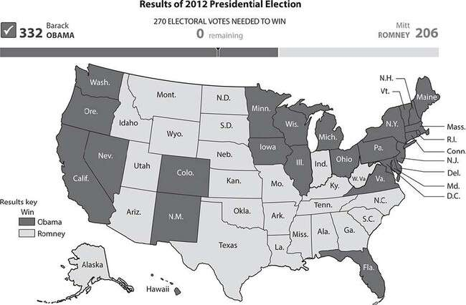
EXERCISE 12

Political Campaigns, Elections, and the Electoral Process
Directions: Choose the best answer to each of the following questions.
- Which claim is supported by the information in this section?
  - The states that are largest in area have the greatest number of electoral votes.
  - The president is elected by receiving the majority of votes from voters on Election Day.
  - A presidential candidate who receives the majority of votes from voters nationwide may still lose the election.
  - In order to win a majority of electoral votes, a candidate must win the election in a majority of states.

- During elections, candidates often use slogans to help voters remember a key point about them or their campaign on Election Day. During his 1864 reelection campaign in the midst of the Civil War, President Abraham Lincoln’s slogan was “Don’t swap horses in the middle of the stream.” What point was he trying to make?
  - Lincoln supported people who raised horses for a living.
  - Lincoln wanted Americans to purchase new horses.
  - Lincoln was urging Americans to keep him in office until the country’s problems were resolved.
  - Lincoln’s wartime policies had all been implemented successfully.
- Herbert Hoover’s presidential campaign during the Great Depression promised a return to economic prosperity. Which was most likely the slogan he used while campaigning for the presidency in 1928?
  - Sunflowers die in November
  - Building a bridge to the 21st century
  - Hoover we trusted—now we’re busted
  - A chicken in every pot (and a car in every backyard)
Answers are on page 826.

Contemporary Public Policy
Public policy is whatever course of action a government adopts regarding a given issue. The actions taken may include passing laws, enforcing rules or regulations, and providing funding or other resources. Most of the public policies of the United States are implemented through the executive branch of the government. When deciding upon a public policy, it must be determined who will benefit from the policy and who will be responsible for the costs. Some major categories of public policy include criminal justice, culture and society, economic affairs, education, the environment,

government operations, health, social welfare, and foreign affairs and national security.
Interest groups are groups of people who share a common interest or a common concern, and who come together to influence the government to adopt a certain policy or to make decisions that support their cause. The goal of these groups may benefit the members of the group, a part of society, or the public in general. Interest groups try to influence public policy by providing information and education on an issue, by advocating for the issue in public speeches or the media, or by organizing campaigns to influence lawmakers to support their cause. Because a democracy is government by the people, interest groups have an important influence on the shaping of public policy.
EXERCISE 13

Contemporary Public Policy
Directions: Use the following graph to answer Questions 1 and 2:
In a recent year, a controversial proposal was on the ballot in a certain state. Contributions by interest groups supporting or opposed to the proposition are shown in the graph.

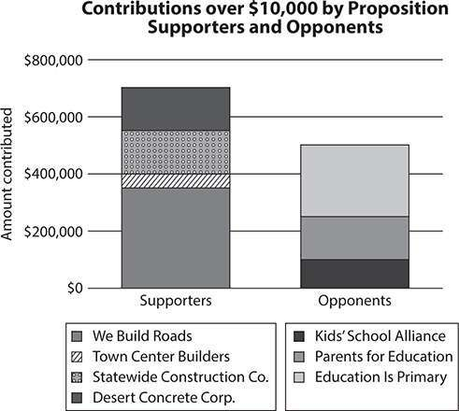

- donated the largest amount of money to oppose the proposition.
- Which interest group donated approximately $350,000 to support the proposition?
  - We Build Roads
  - Kids’ School Alliance
  - Statewide Construction Company
  - Parents for Education
Answers are on page 826.

PRACTICE

Civics and Government
Directions: Choose the best answer to each of the following questions.
- Read the following passage, and then answer the question.
[E]very friend to Republican government ought to raise his voice against the sweeping denunciation of majority governments as the most tyrannical and intolerable of all governments [N]o
government of human device and human administration can be perfect; . . . the abuses of all other governments have led to the preference of republican government as the best of all governments, because the least imperfect; [and] the vital principle of republican governments is the lex majoris partis, the will of the majority.
—Excerpt from a letter by President James Madison (1833)
What concept did Madison support in this letter?
  - majority rule
  - minority rights
  - political parties
  - separation of powers
- Which of the following means that people have the right to request the government to adopt or change a particular policy?
  - Freedom of speech
  - Freedom of assembly
  - Freedom of the press
  - Freedom of petition
- Read the following passage, and then answer the question.
The Senate of the United States shall be composed of two Senators from each State, elected by the people thereof, for six years; and each Senator shall have one vote.

—Excerpt from Seventeenth Amendment to the U.S. Constitution
Before this amendment was adopted, senators were elected by the various state legislatures. This amendment gave voters themselves the right to elect senators. What was the effect of this change?
  - Senators became directly responsible to the voters who elected them.
  - More people registered to vote so that they could participate in electing senators.
  - States with greater numbers of voters would have greater representation in the Senate.
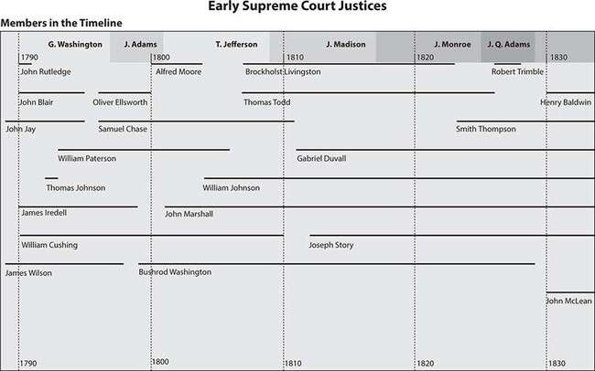
  - The number of senators increased dramatically. Question 4 is based on the following timeline:
- According to the timeline, which president appointed Justice Robert Trimble to the Supreme Court?
  - George Washington
  - John Q. Adams

  - Thomas Jefferson
  - James Madison
- In New England, town meetings are held. All of the citizens who are of voting age gather to discuss political issues. The citizens then vote, and decisions are made by majority rule. This is an example of which concept?
  - Monarchy
  - Aristocracy
  - Direct democracy
  - Representative democracy
- Read the following passage, and then answer the question.
So we can gut education to pay for more tax breaks for the wealthy, or we can decide that in the United States of America, no child should have her dreams deferred because of an overcrowded classroom. No family should have to set aside a college acceptance letter because they don’t have the money. No business should have to look for workers in China because they can’t find ones with the right skills here in the United States. So, Ohio, I am asking you to help me recruit 100,000 new math and science teachers. Help me improve early childhood education. Help me give two million workers the chance to learn the skills they need at community colleges that will lead directly to a new job. Help us work with colleges and universities to cut the cost of tuition. Help us meet those goals. Help us choose that future for America.
—Excerpt from a speech by President Barack Obama during the 2012
election campaign
Which is a public policy that Obama is proposing?
  - building more affordable public housing
  - retraining U.S. workers to give them new job skills
  - recruiting foreign workers for U.S. businesses
  - reducing taxes for middle-class families

Question 7 is based on the following graph:
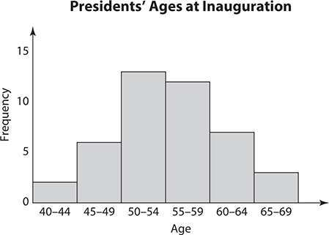

- According to the graph, which statement accurately interprets the data?
  - A few presidents were inaugurated while younger than 40 years old.
  - Most presidents were inaugurated while in their 60s.
  - Most presidents were inaugurated while in their 50s.
  - Fewer presidents were inaugurated while in their 60s than in their 40s.
- Which quotation from the U.S. Constitution best indicates that the nation is a democracy?
  - “We the people of the United States . . .”
  - “. . . in order to form a more perfect Union”
  - “All legislative powers herein granted shall be vested in a Congress . . .”
  - “. . . executive power shall be vested in a President.”
- Which is an example of the checks and balances in the U.S. government?

  - Under the U.S. Constitution, power is divided between the federal government and the state governments.
  - The legislative branch of government is Congress, which is divided into the Senate and the House of Representatives.
  - The executive branch of government can propose laws and is responsible for carrying out laws enacted by Congress.
  - By a two-thirds vote of the Senate and House, Congress can pass a law despite a veto by the president.
- Read the following quotation, and then answer the question.
The local interests of a state ought, in every case, to give way to the interests of the Union.
—Alexander Hamilton, in a speech to the New York Convention of 1788 assembled for the purpose of ratifying the Constitution
Which statement reflects Hamilton’s point of view?
  - Powers should not be divided between the federal and state governments.
  - The federal government should hold more power than the state governments.
  - It is important for the federal government to be granted additional power.
  - The Constitution should have given more powers to individual states.
Answers are on page 826.

CHAPTER 2
United States History

European Exploration of the Americas
The first Europeans to reach North America were Vikings from what is now Norway, under a leader named Leif Ericson. In about the year 1000 they established a settlement in what is now Newfoundland, but the settlement was soon abandoned.
In 1492 the Italian explorer Christopher Columbus, sailing on behalf of the king and queen of Spain, sailed west from Spain in search of a route to Asia that would be faster than the traditional route around Africa. Trade with Asia was very attractive to Europeans, so there was great interest in finding a better route. Columbus was unaware, however, that the continents of North America and South America blocked his path to Asia. When Columbus and his crew made landfall in what is now the Bahamas, they thought they had reached islands near India off the coast of Asia. For this reason, they called the people living there Indians. After Columbus returned home from the New World, he later made three more voyages to Central and South America.
Soon, other explorers came to explore the New World. In the 1500s, Spanish explorers came to North America in search of gold. Juan Ponce de Leon was the first European to reach what is now the United States when he and his crew landed in Florida. Within a few years, Hernando de Soto was sent to settle this area. He traveled through much of what is now the southeastern states and was the first European to reach the Mississippi River. Francisco Vasquez de Coronado explored what is now the American Southwest. Amerigo Vespucci, for whom the Americas are named, was the first European to sight the mouth of the Amazon River.
Other European explorers continued Columbus’s quest to find a sea route to Asia. John Cabot, whose voyage was financed by England, landed

in Canada. Cabot returned to England to report finding rich fishing areas. The Italian Giovanni da Verrazano, in the service of the French King Francis I, explored the Atlantic coast of North America. He was the first European to enter New York Bay. In 1608, Samuel de Champlain established the first permanent French settlement in Canada when he founded a fur-trading post named Quebec. The Dutch, also in search of a way to reach Asia, sent English ship captain Henry Hudson on this quest in 1609. He sailed up what is now called the Hudson River in New York, claiming land on which the Dutch started a colony called New Netherland the next year.
Wherever the Europeans claimed land in the New World, they established settlements and spread their culture. Their influence, including language, customs, and foods, is visible today.
EXERCISE 1

European Exploration of the Americas
Directions: Read the following passage, and then answer the questions.
19 September. Continued on, and sailed, day and night, twenty- five leagues, experiencing a calm. Wrote down twenty-two. This day at ten o’clock a pelican came on board, and in the evening another; these birds are not accustomed to go twenty leagues from land. It drizzled without wind, which is a sure sign of land. The Admiral was unwilling to remain here, beating about in search of land, but he held it for certain that there were islands to the north and south, which in fact was the case and he was sailing in the midst of them. His wish was to proceed on to the Indies, having such fair weather, for if it please God, as the Admiral says, we shall examine these parts upon our return.
Here the pilots found their places upon the chart: the reckoning of the Nina made her four hundred and forty leagues distant from the Canaries, that of the Pinta four hundred and twenty, that of the Admiral four hundred.

—Excerpt from Christopher Columbus’s diary of his voyage in 1492
- Indicate an X next to the statements that helped Columbus know that he and his crew were nearing land.
They sailed day and night.
Two pelicans landed on the boat.
The admiral wanted to keep sailing.
There was a light rain with no wind.
- What is the meaning of the word league as it is used in this passage?
  - an organization
  - a unit of distance
  - the captain of a ship
  - the depth of a body of water
- Which of the following lines from the passage calls the author’s credibility into question?
  - “The reckoning of the Nina made her four hundred and forty leagues distant from the Canaries.”
  - “It drizzled without wind, which is a sure sign of land.”
  - “Wrote down twenty-two.”
  - “We shall examine these parts upon our return.”
Answers are on page 827.

The English Colony in Virginia
The English also wanted to establish colonies in North America. In 1585 a group of English colonists made a settlement on Roanoke Island, off the coast of what is now North Carolina. However, the colonists later disappeared without a trace. Approximately 20 years later, a group of English merchants were granted permission from the king of England to

start a new settlement in North America. About 100 people sailed to the area now known as Virginia, where they established a town called Jamestown. This was the first permanent English colony in what is now the United States. Since the majority of these colonists did not know how to farm, most of them soon died. Soon one of the survivors, John Rolfe, learned from the Native Americans in the area that tobacco was a successful local crop. Knowing that tobacco was popular in England but grew poorly there, the people of Jamestown began growing and selling this crop, for which people in England were willing to pay a high price. This income allowed the settlers to purchase the food and supplies they needed from their home country, and thus the colony was able to survive. In 1619 the colonists in Virginia created an elected legislature called the House of Burgesses. Most of these elected representatives were members of the Church of England (also called the Anglican Church), and soon this became the official church of the colony, forcing members of other religions to move away from the area.
George Washington was elected to the House of Burgesses in 1758 and served in this position for 15 years. Patrick Henry and Thomas Jefferson were also members of this legislature. At the time Washington was elected as a burgess, each county sent two representatives, who by law had to be male landowners and at least 21 years old.
Exercise 2

The English Colony in Virginia
Directions: Choose the best answer to each of the following questions.
- Which of the following contributed to the successful establishment of the colony at Jamestown?
  - Receiving the king’s permission to found a settlement
  - Growing tobacco for sale to England
  - Instituting an official church
  - Creating the House of Burgesses

- What claim about the House of Burgesses can be supported by the text?
  - Some important American leaders began their political careers in the House of Burgesses.
  - All of the members of the House of Burgesses later became presidents of the United States.
  - The House of Burgesses was modeled on the example of the United States Congress.
  - Most people in Virginia were qualified to be elected to the House of Burgesses because they owned land.
Answers are on page 827.

English Colonies in New England and Maryland
During the early 1600s, other English settlements were established on the Atlantic coast of North America. A small group of Separatists, so called because they sought religious freedom from the Church of England, set sail on the Mayflower to establish a religious settlement in Virginia. These people called themselves Pilgrims. Like many before them, they landed in an area different from the one they had intended, and they found themselves in what is now Massachusetts. In order to set up a government for their colony, which they called Plymouth, the Pilgrims drafted the Mayflower Compact, which established a set of basic laws.
Another English religious group, the Puritans, also seeking freedom from the Church of England, set sail for North America in order to establish a colony based on their own religious beliefs. These settlers landed in an area north of Plymouth and built their colony near what is now Boston. The Puritans called their settlement the Massachusetts Bay Colony. This colony proved to be very successful, and many other Puritans came from England to join it. By the 1640s, approximately 20,000 Puritans lived in this region, and as a result, the area became known as New England.

Religion played a significant role in the government of the Massachusetts Bay Colony, and only male colonists who were members of the church and who owned land were able to vote. Despite these regulations, the people of this colony still enjoyed more self-government than those in many other colonies. However, there were some who felt that the Puritan leaders should not have so much control over the colonists’ lives. One prominent colonist named Roger Williams believed that the government should not establish laws dealing with religion. As a result, he was banished by the Puritan leaders. Williams went on to found a new colony, Rhode Island, in 1636. In Rhode Island, government and religion were kept separate, and people could worship as they chose.
Thomas Hooker, a minister, also disagreed with some of the laws established by the Puritan leaders. He led a small group of colonists to an area in Connecticut to establish a community in which all men could vote, regardless of whether or not they were members of the church. The colony of New Hampshire was established when colonists from the Massachusetts Bay Colony moved farther north to settle.
Around this same time, in 1632, King Charles I of England gave North American land to Cecilius Calvert, an English noble also known as Lord Baltimore. Calvert, a Catholic, founded the colony of Maryland so that members of his religion could escape the religious persecution they often faced in England.
Exercise 3

English Colonies in New England and Maryland
Directions: Choose the best answer to each of the following questions. Use the following timeline to answer Question 1:

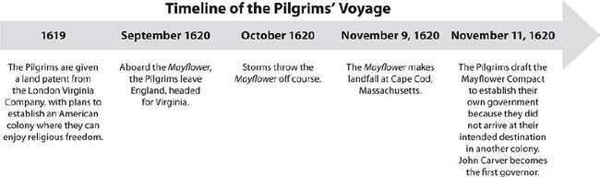

- Which is a true statement inferred from the timeline?
  - It was unusual for weather to impact the course of a ship.
  - It was John Carver’s idea to create the Mayflower Compact.
  - The Pilgrims were disappointed that they did not land in Virginia.
  - The Pilgrims recognized the importance of establishing a government.
- Read the following passage, and then answer the question.
In the name of God, Amen. We whose names are underwritten, the loyal subjects of our dread sovereign lord King James, by the grace of God, of Great Britain, France, and Ireland King, Defender of the Faith, etc.
Having undertaken, for the glory of God, and advancement of the Christian faith, and honor of our king and country, a voyage to plant the first colony in the northern parts of Virginia, do by these presents solemnly and mutually in the presence of God and one of another, covenant, and combine ourselves together into a civil body politic, for our better ordering and preservation, and furtherance of the ends aforesaid; and by virtue hereof to enact, constitute, and frame such just and equal laws, ordinances, acts, constitutions, offices from time to time, as shall be thought most meet and convenient for the general good of the colony: unto which we promise all due submission and obedience. In witness whereof we have hereunder subscribed our names; Cape Cod, the 11th of November, in the year of the reign of our sovereign

lord King James, of England, France and Ireland eighteenth and of Scotland fifty-fourth, Anno Domini 1620.
—Excerpt from the Mayflower Compact
Which of the following true statements is the central idea of the document?
  - The Pilgrims agreed to spread the ideas of their Christian faith.
  - The colony would always be submissive to God and to King James.
  - The laws included in the compact must be obeyed by all of the Pilgrims.
  - The Pilgrims agreed to follow any laws that were later set for the colony.
- Determine which religious group was the basis for the formation of each settlement listed. Indicate Catholic, Puritan, or Pilgrim beside the name of each colony.

Settlement Religious Group

Maryland Massachusetts Bay Colony Plymouth
- Three colonies were established when people left the Massachusetts Bay Colony. These three colonies were ,
, and .
Answers are on page 827.

The Thirteen Colonies Take Shape

In 1663 the new king of England, Charles II, wanted to start another colony in North America. Several European countries, including England, all claimed the land located south of the colony of Virginia. Charles hoped that by establishing a colony in this area, he would keep France and Spain out of the region. The colony that King Charles founded was called Carolina. Colonists began to settle this area because of its quality farmland. In 1729 the colony was separated into North Carolina and South Carolina.
In 1664 the Dutch colony of New Netherland was taken over by English forces. The King of England gave the colony to his brother James, the Duke of York, who kept part of the territory and renamed it New York.
James gave the rest of the territory to two of his friends, John Berkeley and George Carteret, who divided it into two colonies, which later joined to become New Jersey in 1702. James and his friends who owned New Jersey all lived in England, and they found it difficult to control their land from such a great distance. These men chose governors to rule the colonies, and each governor selected a small group of leaders to advise him. The colonists were also given the opportunity to elect representatives to an assembly to work with the governor to enact laws.
During this time, William Penn, an Englishman who belonged to a religious group known as Quakers, hoped to start a colony in which people could peacefully coexist despite religious differences. Quakers believed that everyone should have the freedom to worship as he or she wished.
However, they were often punished for such beliefs in England because everyone was expected to belong to the Church of England. In 1681, Penn was given a large piece of land in North America as repayment for money owed to his family by King Charles II. This new land was called Pennsylvania, and colonists there enjoyed freedom of worship as well as the opportunity to elect representatives to the colony’s assembly. Penn was later given more land by the Duke of York. This land was part of Pennsylvania for a time, but later it became a new colony, Delaware.
In 1732, King George II of England started another colony in an attempt to keep the French and Spanish out of the area to the south of South Carolina. This land was given to James Oglethorpe, who named the colony Georgia in honor of the king. As an English lawmaker, Oglethorpe

established strict rules for this new colony. Colonists were not allowed to consume alcohol, own slaves, or make their own laws. Oglethorpe did, however, envision a colony for debtors and the poor, who would have the opportunity to begin new lives and avoid imprisonment for their debts in England. He brought a group of these people to the colony, free of charge, and gave them small pieces of land to farm.
By the mid-1700s, there were 13 English colonies along the Atlantic coast: New Hampshire, Massachusetts, Rhode Island, Connecticut, New York, New Jersey, Pennsylvania, Maryland, Delaware, Virginia, North Carolina, South Carolina, and Georgia. These colonies, while distinct in many ways, were all based on some of the traditions of England’s government. The populations of the colonies grew steadily, as many were enticed by the economic and political conditions offered, as well as by the opportunity to own land.

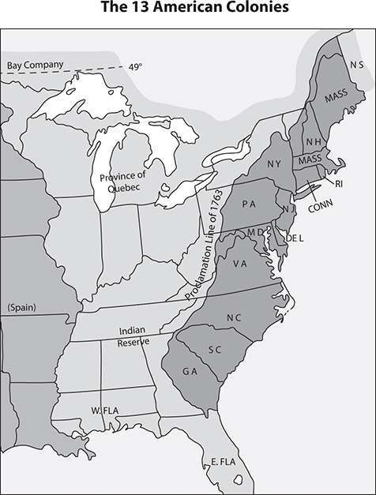
EXERCISE 4

The Thirteen Colonies Take Shape
Directions: Choose the best answer to each of the following questions.
- Read each of the following phrases. Indicate an X before each phrase that describes a reason the English colonists came to

America.
Political freedom
Gold
Economic opportunity
Escape persecution
Search for the Fountain of Youth
Establishment of trade
Questions 2 and 3 are based on the following graph:
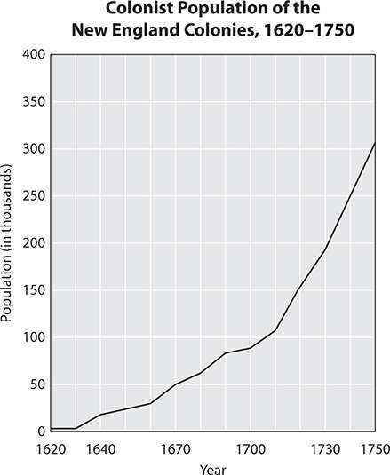

- Which conclusion can be drawn based on the data in the graph?

  - Colonists became increasingly dissatisfied with their decision to come to New England.
  - Colonists became increasingly satisfied with their decision to come to New England.
  - Colonists came to the New England colonies in decreasing numbers over time.
  - Colonists came to the New England colonies in increasing numbers over time.
- Which statement accurately reflects the data in the graph?
  - The fewest colonists arrived in the New England colonies after 1750.
  - The greatest number of colonists arrived in the New England colonies before 1620.
  - More than 300,000 colonists had arrived in the New England colonies by 1750.
  - More than 100,000 colonists had arrived in the New England colonies by 1640.
Answers are on page 827.

Tensions Rise Between the Colonies and Great Britain
When considering the historical documents that have shaped the history of our country, the Declaration of Independence is likely to be one of the first to come to mind. A number of events led to the drafting of this document.
In an effort to deal with a huge war debt, King George III of Great Britain and the British Parliament enacted a number of laws that imposed taxes on the colonists. These included the Sugar Act of 1764, which taxed sugar as well as coffee and cloth. The Stamp Act of 1765 required colonists to pay for a British stamp on any official document. These acts

angered the colonists because they had no say in the passing of the laws. They believed that their own elected representatives, rather than Parliament, should make decisions regarding taxes in the colonies. In order to convince the British government to repeal the Stamp Act, many colonists boycotted British goods.
Although the boycott worked and the Stamp Act was repealed the following year, Parliament enacted new taxes. The Townshend Acts taxed items imported from Britain to the colonies, such as lead, glass, paper, paint, and tea. This caused so much anger among the colonists that they threatened violence against British tax officials. As a result, Britain sent soldiers to protect these officials from the colonists, an act that frustrated the colonists even further. Again, the taxed items were boycotted and the colonists substituted American-made goods for British imports. Britain eventually repealed many of the taxes but retained the tax on tea as a way of asserting Britain’s right to tax the colonists.
In 1770 in Boston, an argument between a group of colonists and a British soldier grew to include several soldiers. Shots were fired, killing five colonists in what was called the Boston Massacre. This event greatly increased the colonists’ distrust and resentment of the British government.
In 1773 the Tea Act gave a British company the right to sell low-priced tea to the colonists. The price of the tea included a tax to which the colonists had not consented. Again, the colonists were angered by what they called “taxation without representation.” A group of colonists dumped the tea into Boston Harbor, an event now known as the Boston Tea Party. In response, the British Parliament passed the Intolerable Acts. These laws were intended to punish the colonists by closing the port of Boston and bringing the government of Massachusetts under tighter British control.
EXERCISE 5

Tensions Rise Between the Colonies and Great Britain

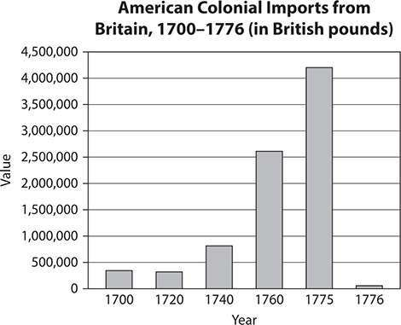
Directions: Choose the best answer to each of the following questions. Questions 1 and 2 are based on the following graph:

- According to the graph, in which year was the value of goods imported from Britain greatest?
  - 1700
  - 1775
  - 1776
  - 1740
- Between which years did the value of colonial imports from Britain increase the most?
  - 1720–1740
  - 1740–1760
  - 1760–1775
  - 1775–1776

Answers are on page 827.

The First Continental Congress and the Beginning of the American Revolution
In September 1774 the delegates from the colonies held the First Continental Congress in Philadelphia, Pennsylvania, to demand that the Intolerable Acts be repealed. They asked to have the same rights as other English citizens, and not to be taxed without their consent. Britain responded by sending 3000 soldiers to occupy Boston, and by sending the navy to prevent ships from entering or leaving Boston Harbor.
In April of 1775, British General Thomas Gage set out to destroy weapons and supplies that the colonists were storing in Concord, Massachusetts. Paul Revere and William Dawes raced ahead of them, alerting the Minutemen, colonial soldiers who would be ready to fight at a minute’s notice. When the British arrived at nearby Lexington, shots were fired, killing or wounding 17 colonists and wounding a British soldier.
This event was later referred to as “the shot heard ’round the world” by the poet Ralph Waldo Emerson.
The British retreated to Boston. On their way the Patriots, colonists who opposed the British, shot at the soldiers and killed or wounded more than 250. Trapped in Boston, the British found themselves surrounded by thousands of armed colonists. Other Patriots built a fort on Breed’s Hill, located across the Charles River from Boston. From there they fired cannons at the British until they ran out of gunpowder. The British then captured the fort. Nevertheless, in this fierce battle, the Patriots killed or wounded more than half of the British soldiers and proved their ability as fighters.
EXERCISE 6

The First Continental Congress and the Beginning of the American Revolution
Directions: Read the following passage, and then answer the questions.
I have made a rule, whenever in my power, to avoid becoming the draughtsman of papers to be reviewed by a public body. I took my lesson from an incident which I will relate to you.
When I was a journeyman printer, one of my companions, an apprentice hatter, having served out his time, was about to open shop for himself. His first concern was to have a handsome signboard, with a proper inscription. He composed it in these words, “John Thompson, Hatter, makes and sells hats for ready money,” with a figure of a hat subjoined. But thought he would submit it to his friends for their amendments. The first he showed it to thought the word “Hatter” tautologous, because followed by the words “makes hats,” which showed he was a hatter. It was struck out. The next observed that the word “makes” might as well be omitted, because his customers would not care who made the hats. If good and to their mind, they would buy them, by whomsoever made. He struck it out. A third said he thought the words “for ready money” were useless, as it was not the custom of the place to sell on credit. Everyone who purchased expected to pay. They were parted with, and the inscription now stood, “John Thompson sells hats.” “Sells hats!” says the next friend. “Why, nobody will expect you to give them away. What then is the use of that word?” It was stricken out, and “hats” followed it, the rather as there was one painted on the board. So the inscription was reduced ultimately to “John Thompson,” with the figure of a hat subjoined.
—Excerpt from a statement by Benjamin Franklin to the First Continental Congress, explaining why he did not want to participate in writing the documents of the Congress
- What was the message Franklin wanted to convey by telling this story?

  - He wanted to be a hatter, not a writer.
  - He recognized the fact that he was not a skilled writer.
  - He believed that his apprentice should write the document.
  - He believed that no matter what he wrote in the document, someone would change it.
- What did the poet Emerson mean by the phrase “the shot heard ’round the world”?
  - The guns used by the soldiers were extremely loud.
  - People in many nations would become aware of what the colonists had done.
  - The colonists wanted to invade other countries.
  - The soldiers used guns that had come from other countries.
Answers are on page 827.

The Second Continental Congress and the Declaration of Independence
The Second Continental Congress began in May of 1775 in Philadelphia in the building now known as Independence Hall. The members determined that a new army, the Continental Army, should be created, and that these soldiers would be well trained in order to be prepared for the war that was anticipated against Britain. George Washington was chosen as the commander. Over the next several months, the Continental Army trained. Meanwhile, the British soldiers retreated from Boston in March 1776.
In early 1776, Thomas Paine wrote a popular pamphlet called “Common Sense,” which presented strong arguments for separating the colonies from Britain. The pamphlet was very widely read in the colonies and greatly increased support for independence. The colonists were also inspired by the Magna Carta, a document signed by the English King John in 1215. This document established certain key rights for people in

Britain, such as the right to a representative government with powers over taxation, the right to trial by jury, and the right to due process in legal matters. The colonists believed that they had been deprived of these rights and were determined to recover them, by establishing their own government if necessary.
The delegates to the Second Continental Congress decided that the 13 colonies should be self-governing. They asked one of the delegates, Thomas Jefferson from Virginia, to explain in writing their reasons for the break with the government of Great Britain. He composed the Declaration of Independence. The document was approved by the Second Continental Congress on July 4, 1776, a date that has since been recognized as the birth of the United States.
EXERCISE 7

The Second Continental Congress and the Declaration of Independence
Directions: Choose the best answer to each of the following questions. Question 1 is based on the following passage:
We hold these truths to be self-evident, that all men are created equal, that they are endowed by their Creator with certain unalienable Rights, that among these are Life, Liberty and the pursuit of Happiness.—That to secure these rights, Governments are instituted among Men, deriving their just powers from the consent of the governed, —That whenever any Form of Government becomes destructive of these ends, it is the Right of the People to alter or to abolish it, and to institute new Government, laying its foundation on such principles and organizing its powers in such form, as to them shall seem most likely to effect their Safety and Happiness.
—Excerpt from the Declaration of Independence (1776)

- The Declaration of Independence lists rights that should not be taken away. Indicate these rights with an X on the line before each one.
Liberty
Life
Power
Pursuit of happiness
Safety
Truthfulness
- The Second Continental Congress chose which of the following to be the Commander of the Continental Army?
  - George Washington
  - Thomas Jefferson
  - Thomas Paine
  - Benjamin Franklin
Answers are on page 827.

The Revolutionary War
Even after the Declaration of Independence was signed, about 20% of Americans still favored British rule of the colonies. These people were known as Loyalists because they were loyal to King George III. The beginning of the Revolutionary War forced the colonists to decide which side they would support.
Battles continued for several years, first in New York and Pennsylvania and later in the southern colonies. George Washington and his army were outnumbered by the British, but the Americans had the advantage of fighting on familiar ground. Eventually, Britain proved unable to sustain and supply a large military force over a long period in distant North America. In addition, in 1778 France joined the war on the American side, providing the colonists with money, arms, and naval support.

In October 1781, the British surrendered at Yorktown in the last large battle of the war. In September 1783, the war ended with the signing of the Treaty of Paris, which granted independence to the United States. It also gave the new country more land.
EXERCISE 8

The Revolutionary War
Directions: Choose the best answer to each of the following questions. Questions 1 through 3 are based on the following table:

Major Battles of the American Revolution
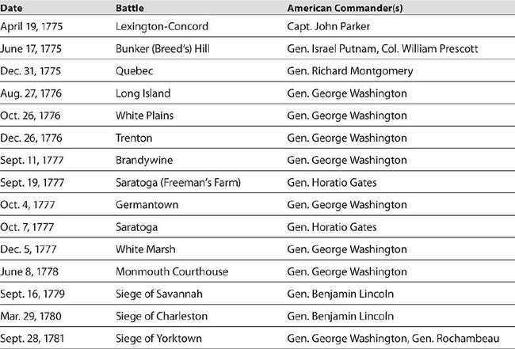
- The battles of the American Revolution lasted for approximately
years.

- During which year did the greatest number of major battles of the Revolution occur?
  - 1775
  - 1776
  - 1777
  - 1788
- During the Battle of Trenton, the American forces were led by which commander?
  - Israel Putnam
  - Richard Montgomery
  - George Washington
  - Horatio Gates
Answers are on page 827.

From the Articles of Confederation to the U.S. Constitution
The first government of the new country operated under a document called the Articles of Confederation. Each of the 13 colonies, now the 13 states, wanted to have its own authority, which limited the power of the central government. This posed a problem when facing major issues such as regulating trade and national defense.
In 1787 delegates from the states met to amend the Articles of Confederation in order to correct these problems. Instead, those delegates created the Constitution of the United States, which continues in force today. The U.S. Constitution is actually the oldest such document currently in effect in the world today. The Constitution created a federal system with a central government and state governments. The central government is divided into three branches: executive, legislative, and judicial. It has power over functions involving the entire nation, such as defense and the

regulation of trade. The state governments maintain authority over all functions not specifically assigned to the central government.
The following chart compares the Articles of Confederation and the
U.S. Constitution.
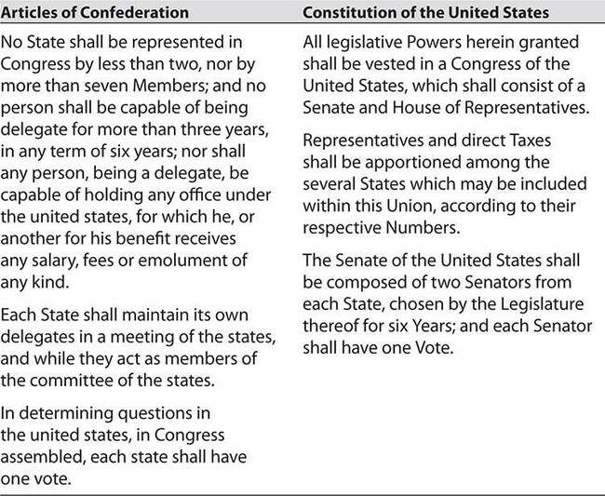

During the drafting of the Constitution two distinct political groups emerged: the Federalists and the Anti-Federalists. The Federalists were mostly those who wanted the central government to have control over the states. The Anti-Federalists, on the other hand, thought that the states would not have enough freedom if the central government was too strong. The following list shows the reasons why the Anti-Federalists objected to the Constitution.

Anti-Federalists’ Reasons for Objecting to the Constitution
Opposed the strong central government outlined in the Constitution
Believed that a strong central government threatened the power of the states and the rights of individuals
Thought that a Bill of Rights should be included Feared that the Constitution favored the wealthy
Compromises were made to ensure that the concerns of both groups were addressed. The Bill of Rights, comprising the first 10 amendments to the Constitution, was later added to guarantee individual rights.
Exercise 9

From the Articles of Confederation to the U.S. Constitution
Directions: Choose the best answer to each of the following questions.
- The Preamble to the U.S. Constitution begins with the words “We the people. . . .” Which of the following is indicated by these words?
  - Rights are guaranteed to certain people.
  - The people who wrote the document are powerful.
  - The power of the government comes from the people.
  - Some people deserve to be given more rights than others.
- Which group wanted a Bill of Rights to be included in the Constitution?
  - Federalists
  - Anti-Federalists
  - Senators

  - Representatives
Answers are on page 828.

The War of 1812
Over the next several years, the boundaries of the United States expanded. In 1803, while Thomas Jefferson was president, the Louisiana Purchase added a large area of land to the country. This purchase from France doubled the size of the United States.
The following map shows the territorial expansion of the United States during the presidency of Thomas Jefferson.
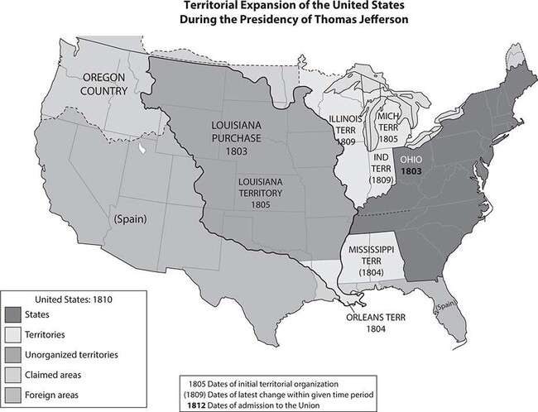

During this period, Great Britain and France were at war with each other in Europe. As president, Thomas Jefferson tried to keep the United States neutral in this conflict. When James Madison became president in 1808, he too wanted the United States to remain neutral, and he wanted trade to continue with both Britain and France. However, when British naval vessels stopped American merchant ships at sea and forced captured American sailors to serve in the British navy, Americans were outraged.
Americans also believed the British were supplying weapons to the Native Americans who were fighting with settlers in the West. For these reasons, Congress declared war on Britain in June 1812. The British navy then began blocking U.S. ships bound for France as a way to stop trade and harm the American economy.
In August 1814, Washington, D.C., was attacked by the British. The British burned buildings in the city, including the White House. Although the Americans did win some battles, neither country was winning the war, and the Treaty of Ghent was signed to end the conflict. The treaty did not award territory to either country; each country ended with the same territory it had prior to the start of the war.
The British blockades that had blocked overseas trade during the war caused shortages of many products. As a result, Americans began to manufacture many goods for themselves. The war thus produced not only a strong sense of nationalism, but also a time of prosperity for Americans.
EXERCISE 10

The War of 1812
Directions: Choose the best answer to each of the following questions.
- Which event led the United States to enjoy a period of prosperity in the early 1800s?
  - fighting a war and winning some battles
  - signing the Treaty of Ghent
  - manufacturing goods to substitute for products formerly obtained by trade

  - being invaded by a British army that attacked the capital
- Which event led to the United States becoming involved in the war between Britain and France?
  - Washington, D.C., was attacked by a British army.
  - France sold a vast North American territory to the United States.
  - British naval vessels stopped American ships and captured U.S. sailors.
  - The British navy blocked U.S. ships in order to interfere with French trade.
Answers are on page 828.

The Monroe Doctrine
When James Monroe was elected President of the United States two years after the end of the War of 1812, he was concerned that European armies might again invade the United States or other countries in the Americas. In 1823, Monroe announced a new foreign policy called the Monroe Doctrine. Under this policy, the United States proclaimed that it would resist, by force if necessary, any effort by European countries to establish new colonies in North or South America or to attack any countries in the Americas. The United States also promised to remain neutral in any European conflicts as long as the European countries did not interfere in the Americas. The Monroe Doctrine was significant in that it introduced the United States as a player in worldwide politics.
EXERCISE 11
The Monroe Doctrine
Directions: Choose the best answer to each of the following questions.
- Read the following passage, and then answer the question.

In the discussions to which this interest has given rise and in the arrangements by which they may terminate the occasion has been judged proper for asserting, as a principle in which the rights and interests of the United States are involved, that the American continents, by the free and independent condition which they have assumed and maintain, are henceforth not to be considered as subjects for future colonization by any European powers.
—Excerpt from President James Monroe’s State of the Union Address,
1823
What is the central idea of this excerpt?
  - No other countries can establish colonies in the Americas.
  - The United States plans to begin more colonies in the future.
  - Each of the states in the United States is free and independent.
  - The continents of the Americas can be ruled by European powers.
- Read the following passage, and then answer the question.
Our policy in regard to Europe, which was adopted at an early stage of the wars which have so long agitated that quarter of the globe, nevertheless remains the same, which is, not to interfere in the internal concerns of any of its powers; to consider the government de facto as the legitimate government for us; to cultivate friendly relations with it, and to preserve those relations by a frank, firm, and manly policy, meeting in all instances the just claims of every power, submitting to injuries from none.
—Excerpt from President James Monroe’s State of the Union Address,
1823
What is the central idea of this excerpt?
  - The United States believes that wars in Europe have lasted for too long.

  - The United States will not interfere with events in European countries.
  - The United States will submit to the governments of the European countries.
  - The United States plans to model its government after the governments in Europe.
Answers are on page 828.

U.S. Policy Toward Native Americans
Following the end of the War of 1812, U.S. military officer Andrew Jackson and his army defeated a group of Creek Native Americans in what is now Alabama. The Creeks were forced to cede about 22 million acres of land in Georgia and Alabama to the United States. Jackson then invaded Spanish Florida to fight the Seminoles, acquiring more land in this area. Between 1814 and 1824, Jackson negotiated many additional treaties with Native American peoples. Under these treaties, the Native Americans gave up land in what is now the southeastern United States for land in the West.
The Cherokee, who lived mainly in Georgia and nearby areas, appealed to the U.S. Supreme Court to protect their land from settlers. In 1831, after several failed attempts, the tribe won their suit. The Court ruled that the tribe had the right to their own government and that the laws of Georgia did not apply to them. The state, however, refused to follow this ruling, and Jackson, who was now President of the United States, refused to enforce it.
Shortly after Jackson took office, Congress passed the Indian Removal Act. This act authorized the forcible removal of Native Americans east of the Mississippi River to a new “Indian territory” in the West.
In Florida, the majority of the Seminoles refused to leave their land. As a result, the U.S. army waged three wars against them in the mid-1800s.
Eventually, the U.S. government paid the remaining Seminoles to move to land in the West.

Among the Cherokee, a small minority faction agreed to a treaty with the United States permitting removal of the tribe to the West. The majority, however, wished to remain on their lands. When the tribe had not moved west by the deadline in the treaty, the U.S. government sent troops to expel 16,000 Cherokee by force. Their journey west was called the Trail of Tears because 4000 Cherokee died along the way of hunger, cold, and disease.
By 1837, a total of 46,000 Native Americans had been expelled from their lands in the East by Jackson and his administration. Jackson’s policy added 25 million acres of land for settlers.
EXERCISE 12

U.S. Policy Toward Native Americans
Directions: Choose the best answer to each of the following questions.
- Read the following passage, and then answer the question.
The instrument in question is not the act of our Nation; we are not parties to its covenants; it has not received the sanction of our people. The makers of it sustain no office nor appointment in our Nation, under the designation of Chiefs, Head men, or any other title, by which they hold, or could acquire, authority to assume the reins of Government, and to make bargain and sale of our rights, our possessions, and our common country. And we are constrained solemnly to declare, that we cannot but contemplate the enforcement of the stipulations of this instrument on us, against our consent, as an act of injustice and oppression, which, we are well persuaded, can never knowingly be countenanced by the Government and people of the United States; nor can we believe it to be the design of these honorable and high minded individuals, who stand at the head of the Govt., to bind a whole Nation, by the acts of a few unauthorized individuals. And, therefore, we, the parties to be affected by the result, appeal with confidence to the justice, the magnanimity,

the compassion, of your honorable bodies, against the enforcement, on us, of the provisions of a compact, in the formation of which we have had no agency.
—Excerpt from a letter by Cherokee Chief John Ross to the Senate and House of Representatives in 1836, describing the treaty signed by a minority of the tribe, authorizing removal of the Cherokee to the West
Which reflects the opinion of the author?
  - The Cherokee people have been treated unfairly.
  - The Cherokee accept the treaty and believe it to be fair.
  - The Cherokee are eager to move to the West.
  - The U.S. government will not help the Cherokee.
- The American lawmakers who enacted the Indian Removal Act most likely believed which of the following?
  - Native Americans can stay in the Southeastern states.
  - Native Americans will benefit from moving to a new territory.
  - The land in the West is better for Native Americans than the land in the Southeast.
  - The United States has more rights to the land in the Southeast than the Native Americans do.
Answers are on page 828.

Manifest Destiny
In 1845, while James Polk was president, the United States annexed the Texas Republic. This event reignited efforts to further expand the United States. Many people, including many in positions of power, believed that the country had a “manifest destiny” to occupy the entire North American continent, from the Atlantic Ocean to the Pacific Ocean. After defeating Mexico in the Mexican–American War in 1846–1848, the United States

gained huge new territories in the West. During a four-year period, the area of the United States increased by more than 60%. Large numbers of people migrated westward, and new territories and states were organized in areas west of the Mississippi River. In 1849, gold was discovered in California, and thousands of Americans headed west to the goldfields.
California became a state in 1850.
EXERCISE 13

Manifest Destiny
Directions: Choose the best answer to each of the following questions.
- People who believed in the idea of manifest destiny thought that the United States should eventually include all the land between
  - Texas and the Mississippi River.
  - Texas and the Pacific Ocean.
  - the Atlantic Ocean and the Pacific Ocean.
  - the Atlantic Ocean and Texas.
- In the late 1840s the United States gained new territories in western North America by
  - purchasing Texas from Mexico.
  - establishing a state government in California.
  - defeating Mex ico in a war.
  - conquering the Texas Republic. Question 3 is based on the following graph:

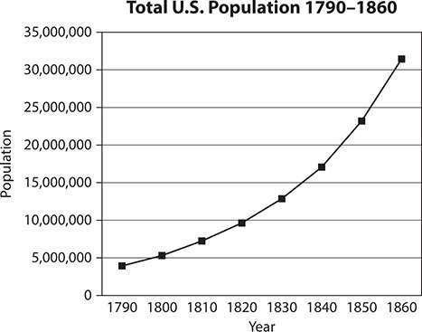

- How do the data in the graph relate to the idea of manifest destiny?
  - The addition of new territories in the mid-1800s caused the population of the United States to increase.
  - The rapid growth of the U.S. population in the mid-1800s created a demand for more territory.
  - There was not enough population growth in the 1800s to justify the addition of new territories.
  - Enough land was gained in the 1840s to support the increasing population.
Answers are on page 828.

Civil War and Reconstruction
In the early 1800s, there were important economic, cultural, and political differences between the various regions of the country. As a result, the different regions favored different policies and made different demands on

the central government. The problems caused by these regional differences were called sectionalism.
In the northern states, the economy was increasingly based on industry and trade. Northerners supported policies that favored manufacturing, including high tariffs that protected new industries from foreign competition.
In the southern states, by contrast, the economy was based on agriculture, much of it using slave labor. Southerners favored policies that protected slavery and that supported southern exports of agricultural goods such as cotton. They also opposed high tariffs, which made manufactured goods more expensive.
Over time, the sectional differences between North and South became greater and greater. Sectionalism caused people to become more loyal to their region than to the country as a whole. Political strife between northerners and southerners became more and more intense.
The biggest issue dividing the country was slavery. As each new territory was added to the Union, a decision had to be made about whether it would permit slavery (as a “slave state”) or ban it (as a “free state”).
Some people, particularly many southerners, believed that the residents of each state or territory should have the right to make this and other important decisions for themselves. This idea was called “states’ rights.” Many southerners hoped thereby to increase the number of slave states and thus the power of the South in Congress. Other people thought that slavery should be banned in the new territories, but permitted to continue in areas where it was already allowed. Some people, known as Abolitionists, thought that slavery was wrong and should not be allowed in any state.
Although compromises were attempted, a lasting solution to the issue of slavery was not found.
In 1857 a slave named Dred Scott sued for his freedom when his master took him into a free territory. The Supreme Court ruled that slaves like Scott were property that belonged to the master and had no legal rights.
The southern states supported the Dred Scott decision, but the northern states did not. The Dred Scott case divided the states even further.

In 1860, Abraham Lincoln, the candidate of the new Republican Party, was elected president. Lincoln promised no restrictions on slavery in the states where it already existed, but he opposed permitting it to expand to new states. The southern states claimed that this was unfair and rejected any further attempts to limit slavery. They voted to form their own government and secede from the United States. The southern states established the Confederate States of America and elected Jefferson Davis of Mississippi as president. Lincoln believed the southern states were not obeying the laws and that this act could not be tolerated.
In April 1861 the Confederacy launched the Civil War by firing on Fort Sumter, a federal base in the harbor of Charleston, South Carolina. In the war that followed, the North had many advantages over the South. Not only did the North already have an established army, it also had stronger financial institutions, more industry, greater natural resources, and many more miles of railroad. However, most battles were fought in the South, where southerners had the advantage of familiarity with the local terrain.
The war lasted four years and cost the lives of more than 600,000 men.
In 1862, Lincoln’s Emancipation Proclamation decreed that all slaves in the states at war with the Union were henceforth free. Following this, 180,000 former slaves joined the Union army to fight against the South. In April 1865, the war ended when the general of the Confederate army, Robert E. Lee, surrendered to the Union commander, Ulysses S. Grant.
Following the Civil War, the nation needed to be reunited. Lincoln had a Reconstruction plan that would allow the southern states to rejoin the Union. However, he was assassinated by a southern sympathizer shortly after the war ended. Andrew Johnson, from Tennessee, became the president. In December 1865 the Thirteenth Amendment to the U.S. Constitution was passed, abolishing slavery in the United States.
President Johnson’s Reconstruction policy angered many radical
Republicans in Congress, who considered it to be too lenient toward the South. The radical Republicans wanted the South to be punished as an enemy that had been at war with the Union. When the southern legislatures enacted Black Codes (laws restricting the rights of African Americans), the radicals claimed they were trying to avoid compliance with the

Thirteenth Amendment. The radicals supported the Freedman’s Bureau,
which helped the freed slaves.
When the radicals in Congress passed laws protecting the freedoms of the former slaves, President Johnson vetoed some of them. However, the radicals still managed to pass the Fourteenth Amendment, which granted citizenship to the former slaves, and the Fifteeenth Amendment, which outlawed restrictions on voting based on race.
EXERCISE 14

Civil War and Reconstruction
Directions: Choose the best answer to each of the following questions.
- Place an X before each phrase that names an issue that led to the Civil War.
Lack of farmland for a growing population
The expansion of slavery into new territories
War with Mexico
Differences between North and South on economic issues
The election of President Abraham Lincoln
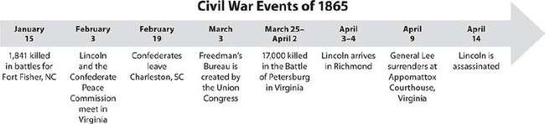
New amendments to the U.S. Constitution Question 2 is based on the following timeline:

- Which statement is true, based on the information in the timeline?
  - January was the most deadly month of fighting in 1865.

  - More Civil War battles were fought in 1865 than in any other year.
  - President Lincoln was assassinated less than a week after the end of the Civil War.
  - Much of the military action in the last few months of the war took place in North Carolina.
Answers are on page 828.

The United States Becomes a Major Industrial Nation
The United States underwent two Industrial Revolutions. The first began in 1793, with the invention of the cotton gin. This machine could process as much cotton in one day as 1000 slaves; southern planters found that it multiplied their profits tenfold. The invention of the steamboat, which could sail upstream against the current, made it possible to move huge boatloads of cotton north; this made possible a thriving New England textile industry.
The first wave of the U.S. national transportation system included canals, paved roads, and the transcontinental railroad, completed in 1869. The purpose of a national system of transportation was to link the agricultural and industrial regions so that both would benefit as sellers expanded into new territories and found new markets for their goods. For example, the railway boom made possible the cattle boom of the 1870s. Railroads took the cattle north to the slaughterhouses of Chicago. As profits grew, so did the sizes of towns and the movement of settlers.
There were no safety or wage regulations to protect factory workers until after the Civil War. Owners set wages as low as they could, demanded a 60- to 85-hour workweek, and shrugged off unsafe working conditions because the constant flood of new immigrants meant that dissatisfied or injured workers could easily be replaced. Factories exposed workers to high levels of industrial pollution. Machinery was dangerous to operate at the best of times—more so when workers were always exhausted from the

long hours. Labor unions and federal regulations to protect the workers finally arrived with the Second Industrial Revolution.
The Second Industrial Revolution took place during the post–Civil War era. Instant long-distance communication (telegraph, telephone), a machine that could produce a perfectly printed letter (typewriter), and cheap, steady lamplight with the flick of a switch (the electric lightbulb) made great changes in the way people lived and worked. Before electricity, most people rose and went to bed with the sun; when electricity was perfected, people could work or enjoy themselves in brightly lit rooms all through the night if they wanted to.
The Bessemer process, which made possible the easy and cheap conversion of iron ore into steel, led to a rise in steel production and became the most important factor in the success of the Second Industrial Revolution. Men at the head of heavy industries and large-scale construction companies made fortunes, and American cities became forests of skyscrapers, suspension bridges, and elevated train lines. With the rise of the reform-minded Progressive Party and the creation of labor unions, workers were also in a position to enjoy some of the profits of their labor.
EXERCISE 15

The United States Becomes a Major Industrial Nation
Directions: Chose the best answer to each of the following questions. Questions 1 and 2 refer to the following political cartoon from 1896:

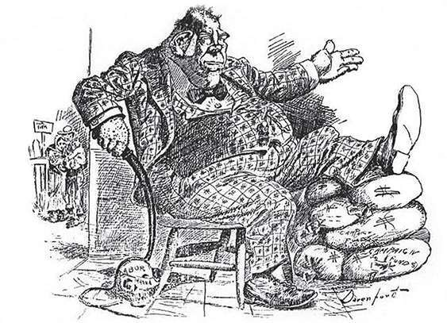

“I am confident the workingmen are with us.”
Cartoon by Homer Davenport
- The cartoon shows a man with his foot resting on money bags. This image most likely represents
  - a striking coal miner.
  - a wealthy industrialist.
  - a foreign diplomat.
  - President Ulysses S. Grant.
- The man in the cartoon holds a whip draped across a skull marked “Labor.” The cartoonist most likely means that the man in the chair
  - supports the Progressive Party.
  - wants to restrict immigration.
  - does not support labor unions.
  - favors attacking foreign countries.

Answers are on page 828.

The United States Becomes a World Power
At the start of the 20th century, the United States was a wealthy and strong nation, but not a world power. Occupied with internal issues such as the Civil War, Reconstruction, industrialization, and westward expansion, the United States had taken very little active interest in world affairs. In 1900, Western Europe dominated world politics and the world economy. Great Britain, France, Austria-Hungary, Russia, and the recently unified Germany were the great powers of the world.
The United States had several motives for acquiring colonies. The first was to gain trade partners on favorable terms—partners that could supply natural resources the United States could not, such as sugar, rubber, and coffee. The second was to establish naval bases. The third was simply to prove to the world that the United States was a great power—a force other nations would have to reckon with. Between 1898 and 1903, the United States annexed Hawaii, Guam, Puerto Rico, and the Philippines, made Cuba a protectorate, and took control of the construction of the Panama Canal. The United States would retain control of this important trade route for most of the 20th century.
EXERCISE 16

The United States Becomes a World Power
Directions: Choose the best answer to the following question.
Question 1 is based on the following political cartoon from the era of the Spanish–American War (1898):

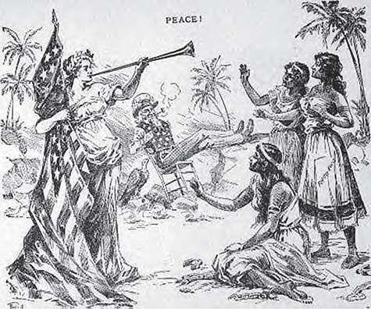

- In the cartoon, a “goddess of liberty” heralds freedom for Cuba, Puerto Rico, and the Philippines. The man in the background represents
  - Europe.
  - the United States.
  - Abraham Lincoln.
  - the King of Spain.
The answer is on page 828.

World War I
World War I—called at the time the “Great War”—marked the United States’ first major entry into world affairs. The war began in 1914 as a territorial conflict among European nations, with the Central Powers (Austria and Germany) on one side and the Entente or Allied Powers

(Britain, Russia, and France) on the other. By 1916, the United States was supplying money and arms to the Allied Powers; U.S. troops joined the fight in late 1917, and the Central Powers surrendered in November 1918.
Despite its late entry into the war, the United States was treated as an equal partner at the peace conference, marking the first time in history that a non-European nation had played a major role in the peace settlements of a European war. The United States had played a small but crucial role on the battlefield, and it ended the war in a much stronger military and economic position than the European nations, which had suffered much greater losses. Ironically, President Woodrow Wilson’s dream of the League of Nations—an international organization to settle differences over a conference table, taking up arms only as a last resort— was realized without American participation.
EXERCISE 17

World War I
Directions: Choose the best answer to each of the following questions.
Questions 1 and 2 are based on the following political cartoon from 1919 commenting on the formation of the League of Nations. The sign reads “This League of Nations Bridge was designed by the President of the U.S.A.”

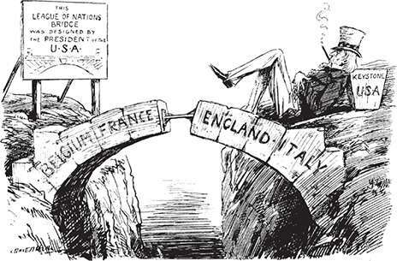

The Gap in the Bridge
Cartoon by Leonard Raven-Hill.
Appeared in Punch magazine, December 10, 1919.
- In the cartoon, the reclining figure, representing the United States, can best be described as
  - indifferent.
  - eager.
  - angry.
  - ashamed.
- The artist of this cartoon is suggesting that the League of Nations
  - has too many members and does not need the United States.
  - will be headquartered in England and Italy rather than in Belgium and France.
  - will not be successful without the United States as a member.
  - needs to build a bridge from France to England.
Answers are on page 828.

The Great Depression
The Great Depression began with the crash of the stock market in October 1929. Although the United States had weathered several financial panics since the 1790s, this one was nicknamed “great” because it was the worst, longest-lasting economic crisis in U.S. history.
The simple cause of the stock market crash was the practice of margin buying, which had become common during the 1920s. Speculators would borrow money and buy stock, then keep an eye on its value and sell it as soon as its price went up. The large number of speculators meant that share prices were constantly fluctuating, usually upward. This meant a booming market built on an insubstantial foundation of unpaid debt. When buyers lost confidence in the market and began selling their shares, prices dropped and debts fell due. Banks failed because people could not repay their loans. When a bank failed, everyone who had an account with that bank lost all of his or her money; there was no mechanism in place to protect account holders from loss. Across the nation, businesses closed and workers were laid off. Landlords evicted tenants who could not pay rent. Millions could not make their mortgage payments and so lost their houses. All social and economic classes were affected.
The failure of businesses and banks coincided with many months of drought in the Great Plains, turning the 50-million-acre Breadbasket into the Dust Bowl. The topsoil in this region was a thin layer over hard, dry dirt. With no rain to keep it moist and anchored in place, the thin topsoil blew away during dust storms, and the crops failed. Thousands of small farmers lost everything they had. These “Okies” (nicknamed for the state of Oklahoma, although they were from several neighboring states as well) migrated westward, hoping for a fresh start in the favorable climate of California. All they found there was hostility, prejudice, and starvation wages.
Many Americans blamed the Depression on President Herbert Hoover, who had failed to predict it and seemed not only unable but unwilling to resolve it. People who had lost their homes built shantytowns called “Hoovervilles” in ironic tribute to the president. In the 1932 presidential election, Hoover lost in a landslide to Franklin Delano Roosevelt.

Roosevelt immediately took action to address the financial crisis. His New Deal programs created millions of jobs and restored the nation’s banks to a sound financial footing. During Roosevelt’s first term, unemployment dropped by about 8%. Unsurprisingly, he was reelected in 1936 in the greatest landslide in 100 years.
EXERCISE 18

The Great Depression
Directions: Choose the best answer to each of the following questions.
- Which statement is supported by the preceding text?
  - The Great Plains was the region least affected by the Great Depression.
  - Proper farming techniques are essential to maintaining healthy soil.
  - Immigrants from New York and California settled in the Dust Bowl area in the 1930s.
  - In the Great Plains in the 1930s, crops failed because of drought and dust storms.
Question 2 is based on the following graph:

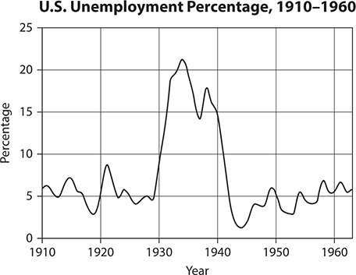

- According to the graph, the unemployment percentage in the United States reached a peak of 21% in
  - 1924.
  - 1934.
  - 1941.
  - 1949.
Answers are on page 828.

World War II
It took World War II to bring the United States out of the Depression and back to prosperity. The military draft and the change to a war production economy combined to put millions of Americans back to work. The United States officially entered the war in December 1941, after Japan attacked the American naval base at Pearl Harbor, Hawaii. America was faced with a two-front war; it joined Britain’s battle against Nazi Germany in Western Europe, and it sent troops to the Pacific to fight the Japanese. The United

States was a formidable ally against Germany because of its almost unlimited manpower and its ability to produce an endless flow of military supplies and weapons.
The war in Europe ended in the spring of 1945; Japan held out until the United States dropped atomic bombs on Hiroshima and Nagasaki at the end of August 1945. At the peace conference at Potsdam, Germany, it was clear that the United States and the Soviet Union were the only great powers left in the world. The munitions industry had completely reinvigorated the American economy, American casualties had been minor compared to European losses, and the United States itself was far from the combat zones and physically undamaged. Britain, France, and the other European nations recovered, but they would never again be more than second-rate powers.
At the time of the Japanese attack on Pearl Harbor, more than 110,000 Americans of Japanese descent were living on the West Coast of the United States. The U.S. government feared espionage and sabotage in this part of the country and moved these Japanese-Americans to internment camps in the middle of the country and California for the duration of the war. This detainment was later recognized by the United States as a violation of these citizens’ human and civil rights.
EXERCISE 19

World War II
Directions: Read the following passage, and then answer the question.
Armed defense of democratic existence is now being gallantly waged in four continents. If that defense fails, all the population and all the resources of Europe and Asia, and Africa and Austral-Asia will be dominated by conquerors. And let us remember that the total of those populations in those four continents, the total of those populations and their resources greatly exceed the sum total of the population and the resources
of the whole of the Western Hemisphere—yes, many times over.

In times like these it is immature—and, incidentally, untrue
—for anybody to brag that an unprepared America, single- handed and with one hand tied behind its back, can hold off the whole world.
—Excerpt from a speech to Congress by President Franklin Roosevelt, January 6, 1941
- What message is President Roosevelt giving to Congress and the American people?
  - The United States can easily beat any enemy in the world.
  - Other countries will defend democracy, so Americans need not worry.
  - The defense of democracy is already a lost cause.
  - Americans need to begin preparing seriously for possible war.
The answer is on page 828.

Postwar America
Following World War II, Americans enjoyed an era of prosperity and plenty after the hard times of the Great Depression. In 1944, the GI Bill, also known as the Servicemen’s Readjustment Act, was passed in Congress. This bill provided benefits to veterans to help them transition back into civilian life after serving their country. Under this act, assistance was provided immediately to servicemen and women. Although some changes occurred over time, the original bill provided three main benefits:
- Subsidized education or career training
- Guaranteed low-interest loans for homes, businesses, or agriculture
- One year of unemployment benefits if the veteran was unable to obtain work
The GI Bill gave veterans the chance to get a college education, buy a house or a farm, attend training school for a particular profession, or start

a business. This enabled many to marry, start families, and move to the newly built suburbs. People began buying cars, television sets, and other consumer goods.
Also after the war, Americans moved to rebuild the European countries that were devastated by the years of fighting. Secretary of State George Marshall proposed a plan to help rebuild Europe in order to provide political stability and help the world economy. Congress then passed the Economic Cooperation Act of 1948, also known as the Marshall Plan, which helped to restore productivity in the areas of agriculture and industry, prevented famine, and helped the nations of Europe avoid political chaos.
EXERCISE 20

Postwar America
Directions: Choose the best answer to each of the following questions. Questions 1 and 2 are based on the following passage:
The modern system of the division of labor upon which the exchange of products is based is in danger of breaking down. . . . Aside from the demoralizing effect on the world at large and the possibilities of disturbances arising as a result of the desperation of the people concerned, the consequences to the economy of the United States should be apparent to all. It is logical that the United States should do whatever it is able to do to assist in the return of normal economic health to the world, without which there can be no political stability and no assured peace. Our policy is not directed against any country, but against hunger, poverty, desperation, and chaos. Any government that is willing to assist in recovery will find full cooperation on the part of the USA. Its purpose should be the revival of a working economy in the world so as to permit the emergence of political and social conditions in which free institutions can exist.

—Excerpt from a speech on the Marshall Plan by Secretary of State
George C. Marshall, June 5, 1947
- Based on the passage, you can infer that Marshall
  - wanted defeated Germany and Japan to pay for global economic recovery after World War II.
  - thought that the United States should play a leading role in global economic recovery after World War II.
  - favored letting European allies solve their own economic problems.
  - believed that only allies of the United States deserved to receive American economic aid.
- Secretary of State Marshall would most likely agree with which of the following statements?
  - The United States should take no further part in international affairs.
  - The biggest threat to stability in Europe is political parties that promote democracy.
  - Prosperity is possible only under conditions of political and social stability.
  - Efforts to aid postwar economic recovery should focus only on
U.S. allies.
Answers are on page 828.

The Cold War
In foreign affairs, the late 1940s ushered in a new era of “Cold War” between the two superpowers: the United States and the Soviet Union. With their opposing political systems and economic policies, these World War II allies quickly became enemies; throughout the Cold War, each tried to contain the other’s sphere of influence. The war was called “cold” because the two enemies did not actually fire on one another.

To counter the Soviet threat, the United States and its European allies created a military alliance called the North Atlantic Treaty Organization (NATO). In 1947, President Harry Truman called for immediate economic and military support for Greece and Turkey to protect those countries from a possible Soviet-backed Communist takeover. Under the Truman Doctrine, the United States promised similar help to all countries threatened by Communism.
Germany was another Cold War flashpoint. At the end of World War II, Germany had been divided into West Germany and East Germany. East Germany was a Communist country dominated by the Soviet Union. West Germany was a non-Communist ally of the United States, Great Britain, and France. The city of Berlin was also divided. In 1948 the Soviet Union attempted to force the United States and its allies to leave West Berlin by blocking access to the city. The allies responded by delivering supplies to Berlin by airplane in what was called the Berlin Airlift. In 1961 the East Germans built the Berlin Wall to separate their part of the city from the part controlled by the allies. In the meantime, the Soviet Union joined with East Germany, Hungary, Poland, Romania, Bulgaria, and Czechoslovakia to form the military alliance called the Warsaw Pact.
When civil wars erupted in Korea and Vietnam, the Soviets backed one side and the United States the other. The Korean War ended in a stalemate and the Vietnam War in a Communist victory.
The Cold War started to break down during the 1980s when Mikhail Gorbachev became leader of the Soviet Union. Gorbachev relaxed controls over Soviet society and over the Warsaw Pact countries. In 1989 those countries overthrew their Communist governments and broke free of Soviet control, and East Germany and West Germany were soon reunited. In 1991 the Soviet Union itself collapsed as Communism proved to be economically unsustainable. The Soviet government was replaced by a non-Communist Russia and other independent republics. The Cold War was over.
EXERCISE 21

The Cold War
Directions: Choose the best answer to the following question.
- All of the following statements about the Cold War are true EXCEPT:
  - The Truman Doctrine, first applied to Greece and Turkey, was later also applied to other countries threatened by Communist takeover.
  - Although World War II was over, Americans remained willing to play an active role in global affairs.
  - The end of the Cold War resulted in part from changes in policy by the Soviet government.
  - Attempts by the Soviet Union to expel the United States and its allies from West Berlin were eventually successful.
The answer is on page 828.

The Civil Rights Movement and the Women’s Movement
In postwar America, racial discrimination remained a major problem. In many states, particularly in the South, so-called “Jim Crow laws” dating from the late 19th and early 20th centuries enforced a system of legal segregation, or separation of the races. Laws providing for “separate but equal” accommodations for different races had been upheld by the Supreme Court in a case called Plessy v. Ferguson (1896).
After World War II, a Civil Rights movement took root. Americans eager to claim the leadership of the “free world” against Communist foes began to realize that the legal segregation of African Americans seriously undermined that claim. Furthermore, African Americans who had fought for freedom overseas were no longer willing to accept legal restrictions when they returned home. President Harry S. Truman ordered the integration of the U.S. military.

In 1954, a milestone decision was made in the Supreme Court case Brown v. Board of Education. The court, led by Chief Justice Earl Warren, ruled it unconstitutional to separate children in public schools based on race. Through the decade that followed, African Americans used nonviolent protests and civil disobedience to protest against racial discrimination. Black students across the South staged a series of sit-ins that ended segregation in many public places. Martin Luther King Jr., a clergyman from Georgia, organized and led many of these protests, which were often met with violence.
In response to growing public sympathy for the protesters, Congress passed the Civil Rights Act of 1964, which outlawed discrimination in schools, colleges, places of employment, and public accommodations such as restaurants and public transportation. This was followed by the Voting Rights Act of 1965, which outlawed restrictions that had been used to prevent African Americans from voting.
In postwar society, women also began protesting against discrimination.
Women had won the right to vote in 1919 through the passage of the Nineteenth Amendment to the U.S. Constitution, but they were still kept out of many jobs and positions of influence in society. During World War II, many women had gone to work in traditionally male jobs (including military service) and proved very capable. After the war, women were no longer content with the old assumption that they should have no ambitions beyond marriage and children. By the 1960s, more and more women were getting college educations and competing for skilled professional jobs. A proposed Equal Rights Amendment to the Constitution failed to pass, but American women made great strides toward social and legal equality during the last decades of the 20th century.
EXERCISE 22

The Civil Rights Movement and the Women’s Movement
Directions: Choose the best answer to each of the following questions.

Question 1 is based on the following passage:
Our Constitution is color-blind, and neither knows nor tolerates classes among citizens.
—Excerpt from a statement by Justice John Marshall Harlan, the only Supreme Court justice to dissent from the ruling in the case of Plessy v. Ferguson
- In which way did Justice Harlan’s opinion differ from that of the other justices? He believed that
  - all races and classes are guaranteed the same rights.
  - the Constitution supports the idea of “separate but equal.”
  - civil rights should be based on class, but not on race.
  - citizens should be given equal opportunities, even if laws keep them separate.
Question 2 is based on the following passage:
More than half of the population of the United States is female. But women occupy only 2% of the managerial positions. They have not even reached the level of tokenism yet. No women sit on the AFL-CIO council or Supreme Court. There have been only two women who have held Cabinet rank, and at present there are none. Only two women now hold ambassadorial rank in the diplomatic corps. In Congress, we are down to one Senator and 10 Representatives. Considering that there are about 3½ million more women in the United States than men, this situation is outrageous . . .
Existing laws are not adequate to secure equal rights for women. Sufficient proof of this is the concentration of women in lower paying, menial, unrewarding jobs and their incredible scarcity in the upper level jobs. If women are already equal, why is it such an event whenever one happens to be elected to Congress?

—Excerpt from a speech by Congresswoman Shirley Chisholm delivered in 1969 on the floor of the House of Representatives as she reintroduced the Equal Rights Amendment for consideration
- Based on the excerpt, which statement reflects Congresswoman Chisholm’s opinion?
  - Because there are more women in the United States than men, women should receive special treatment under the Constitution.
  - Only in the federal executive branch have women achieved high-ranking positions.
  - Women hired in high-ranking positions either in private business or in governmental positions are considered “tokens.”
  - Lack of female representation in private business and in the federal government proves that women do not have equal rights.
Answers are on page 828.

The Great Society, the Vietnam War, and Watergate
When Lyndon B. Johnson became president in 1963 following the assassination of President John F. Kennedy, he persuaded Congress to pass not only the Civil Rights Act of 1964 (see the previous section) but also the Economic Opportunity Act of 1964 and other measures intended to alleviate poverty and boost employment. Johnson declared his intention to create a Great Society in which poverty would be eliminated.
However, starting in 1965, Johnson’s administration became increasingly embroiled in the Vietnam War, an effort to prevent a Communist takeover of a country in Southeast Asia. Eventually more than 600,000 U.S. troops were sent to Vietnam, but victory over Vietnamese guerrilla fighters proved elusive. As the war dragged on, protests against it

mounted in the United States. Finally, in 1968, peace talks were begun and Johnson retired from public life.
His successor as president, Richard M. Nixon, continued the peace talks but also pursued the war for another four years. U.S. troops were not finally withdrawn from Vietnam until 1973. During the 1972 presidential campaign, burglars were arrested in the Democratic National Committee’s office in the Watergate building in Washington, D.C. Eventually it was revealed that the burglars had ties to the Nixon administration and that White House officials were attempting to cover up their involvement.
Faced with the threat of impeachment over this Watergate Scandal, Nixon resigned the presidency in 1974.
EXERCISE 23

The Great Society, the Vietnam War, and Watergate
Directions: Choose the best answer to each of the following questions.
- Which of the following is an opinion, not a fact?
  - Despite the start of peace talks in 1968, United States forces remained in Vietnam until 1973.
  - As president, Lyndon Johnson continued to pursue policies begun by President John Kennedy.
  - The protests against the Vietnam War were harmful to the nation and disrespectful of the soldiers who served.
  - President Nixon’s resignation in 1974 resulted directly from the involvement of his administration in the Watergate Scandal.
Question 2 is based on the following passage:
Although the economic well-being and prosperity of the United States have progressed to a level surpassing any achieved in world history, and although these benefits are widely shared

throughout the Nation, poverty continues to be the lot of a substantial number of our people. The United States can achieve its full economic and social potential as a nation only if every individual has the opportunity to contribute to the full extent of his capabilities and to participate in the working of our society. It is, therefore, the policy of the United States to eliminate the paradox of poverty in the midst of plenty in this Nation by opening to everyone the opportunity for education and training, the opportunity to work and the opportunity to live in decency and dignity.
—Excerpt from the Statement of Purpose of the
Economic Opportunity Act, 1964
- Which of the following is the central idea of the passage?
  - No one should have to live in poverty in such a prosperous country.
  - If everyone had a quality education, the nation would be more prosperous.
  - Many people in our society are wealthy; however, a few are forced to live in poverty.
  - Because everyone contributes to his or her full potential, our country has progressed further than any other.
Answers are on page 829.

Presidencies in the Late 20th and Early 21st Centuries
Former Hollywood actor and California Republican governor Ronald Reagan served two terms as president in 1980–1988. His administration implemented highly conservative policies that would have long-lasting effects. Tax rates were lowered and regulations on industry were loosened A massive military buildup was also undertaken. In foreign affairs,

Reagan’s government followed an aggressive anti-Communist policy and provided support to antigovernment rebels in Central America. Eventually, however, administration officials became mired in the so-called Iran- Contra scandal, which involved secret funding of the rebels with the proceeds from arms sales to Iran.
Politics in the 1990s were dominated by the Democrat Bill Clinton, who served as president from 1992 to 2000. Clinton’s achievements were primarily domestic. In a time of great financial prosperity, with record-low poverty and unemployment rates, the Clinton administration introduced social policies such as the Family and Medical Leave Act (FMLA) and welfare reform. Customs barriers between the United States, Canada, and Mexico were dramatically lowered by the North American Free Trade Agreement (NAFTA).
Republican George W. Bush succeeded Clinton in 2001 and served two terms in office. His presidency was controversial from the beginning because the 2000 presidential election, in which Bush faced Clinton’s vice president Al Gore, was extremely close. Gore won more of the popular vote, but after the U.S. Supreme Court halted a vote recount in Florida, Bush was awarded the state’s Electoral College votes and had enough Electoral votes to win the presidency.
On September 11, 2001, terrorists from an ultra-Islamist group called Al-Qaeda hijacked four commercial jetliners, crashing two into the World Trade Center towers in New York City and one into the Pentagon. The fourth crashed in a field in Pennsylvania. Nearly 3000 people died in the attacks, now referred to collectively as 9/11. In response, Bush launched what he called a War on Terror, which included:
- The passage of the USA Patriot Act, which gave intelligence organizations broad surveillance power
- The War in Afghanistan, a U.S.-led invasion of Afghanistan prompted by its government’s support of Al Qaeda. The war began in October 2001, and the United States military withdrew in December 2014.
- The Iraq War, a U.S.-led invasion of Iraq prompted by intelligence reports that the country’s leader, Saddam Hussein, had weapons of mass destruction that could be used against the United States and its

allies. The invasion began in 2003, and the United States withdrew in 2011.
Bush was succeeded in 2009 by Barack Obama, the country’s first African-American president. Obama was reelected in 2012. Before Obama took office, the 2008 global financial crisis pushed countries around the world into deep recession and nearly destroyed the international banking system. Obama’s first years in office were focused on economic recovery efforts. His signature piece of legislation was the Affordable Care Act (often called “Obamacare”) of 2010. This major overhaul of the healthcare system was designed to lower the number of Americans without health insurance.
EXERCISE 24

Presidencies in the Late 20th and Early 21st Centuries
Directions: Choose the best answer to the following question.
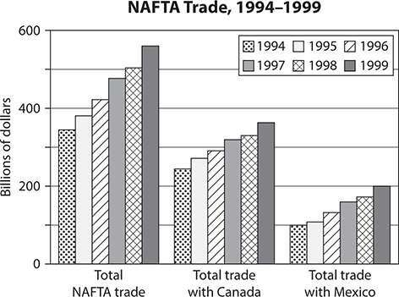

- According to the graph, in what year did total NAFTA trade first exceed $500 billion?
  - 1996
  - 1997
  - 1998
  - 1999
The answer is on page 829.

Issues Facing the United States at the Start of the 21st Century
The first decade of the 21st century was a time of crisis and dramatic changes. In the presidencies of George W. Bush (2000–2008) and Barack Obama (2008–2016), the United States faced several major challenges.
- Economic issues. Following a crisis in the financial markets and the collapse of several major financial institutions in 2008, the United States and other industrial countries entered a prolonged period of slow economic growth and high unemployment. This worsened a long- term trend toward increasing economic inequality, which saw a growing share of the country’s wealth and profits flow to those in the highest income brackets.
- Technology. At the turn of the 21st century, a technological revolution swiftly changed the way Americans communicate. The advent of e- mail, cell phones, personal computers, online social networks, and portable Internet access made sweeping changes to society, both at home and on the job. Financial security and personal privacy became major social and legal concerns due to a rise in hacking, the practice of illegally breaking into electronic data systems.
- Immigration. A great wave of Latin American immigration to the United States began in the late 20th century and continued into the 21st century. For the first time, American culture began changing to meet the needs of the immigrants, rather than expecting the immigrants to

assimilate. One result was a nativist backlash among some groups of non-Hispanic Americans, who called for increased border security and the deportation of immigrants who lacked proper documentation.
- Climate change. Scientists have become increasingly concerned that human activities, especially the burning of fossil fuels, are changing the climate of the planet. Anticipated changes include droughts, severe storms, and significant rises in sea level that will likely flood coastal areas. Opinion remains divided regarding the most effective response to these threats.
- Overseas military operations. After Arab terrorists attacked the United States on September 11, 2001, destroying the World Trade Center in New York and damaging the Pentagon in Washington, D.C., there was a violent breach in U.S.-Arab relations. U.S. troops attacked the fundamentalist Islamic group Al Qaeda and its local allies in Afghanistan, and in 2003, U.S. forces invaded Iraq and toppled its government. After an occupation marked by violence, the United States withdrew from Iraq in 2011. Fighting by U.S. forces continues against Al Qaeda forces in Afghanistan and in other Arab countries.

PRACTICE

United States History
Directions: Choose the best answer to each of the following questions.
- Which U.S. Constitutional amendment gave women the right to vote?
  - Nineteenth
  - Twentieth
  - Twenty-first
  - Twenty-second
Question 2 is based on the following timeline:

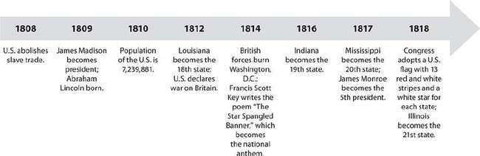

- Place an X beside each conclusion that can be drawn from the timeline.
James Madison was against the slave trade.
James Monroe was the fifth president of the United States.
The United States declared war on Great Britain in 1812.
Abraham Lincoln encouraged Illinois to join the United States as a free state.
Lyrics to the national anthem were written by Frances Scott Key.
Question 3 is based on the following table:

Estimated Population of the Middle Colonies,
1630–1780 (in thousands)

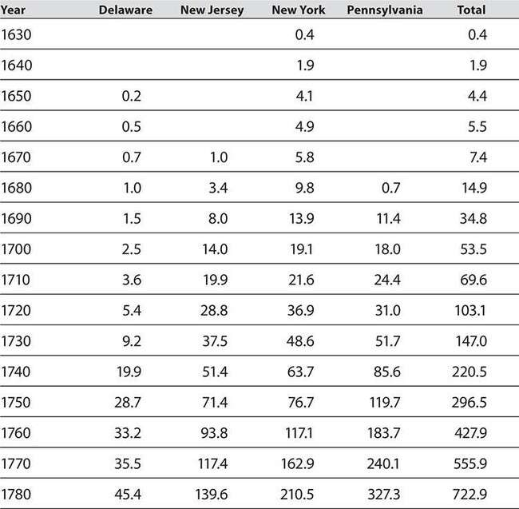

- Which colony had the largest population in 1720?
  - New Jersey
  - New York
  - Pennsylvania
  - Delaware
Question 4 is based on the following passage:

Perhaps the sentiments contained in the following pages, are not yet sufficiently fashionable to procure them general favor; a long habit of not thinking a thing wrong, gives it a superficial appearance of being right, and raises at first a formidable outcry in defence of custom. But the tumult soon subsides. Time makes more converts than reason.
—Excerpt from “Common Sense” by Thomas Paine (1776)
- Which statement best reflects the ideas Paine included in this introduction? He believed that people
  - would never read or understand his statements and reasoning.
  - would always think that the ideas shared in the text were wrong.
  - who are sufficiently fashionable have a habit of correct thinking.
  - may not have been ready to hear the information he would share in the text.
- Place an X next to countries that were Axis Powers in World War II.
United States
Japan
Germany
Great Britain
Question 6 is based on the following map:

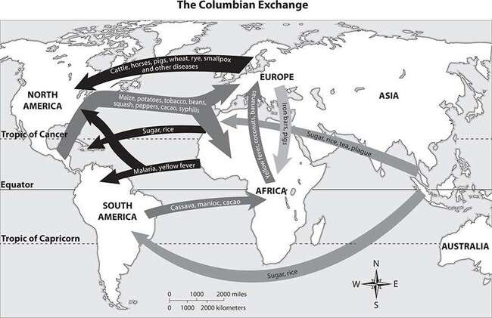

- The “Columbian Exchange” refers to a time beginning with Columbus’s voyage in 1492 and extending through the years of discovery. During this time, plants, animals, diseases, and technology were exchanged between the Old and New Worlds, changing the ways of life for both Europeans and Native Americans. Based on the map, which statement is true?
  - Pigs were transported to Europe from Asia.
  - Smallpox was carried from Europe to North America.
  - Tobacco was shipped from Africa to North America.
  - Plague was carried from North America to Asia. Question 7 is based on the following map:

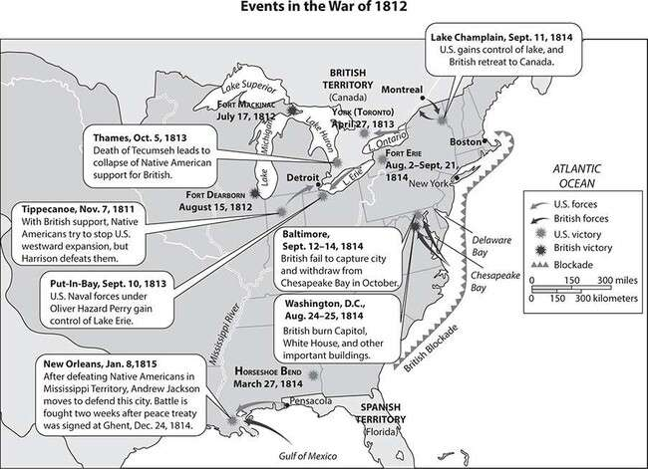
- The map shows some events that occurred during the War of 1812. According to the map, which battle was won by Andrew Jackson?
  - The Battle of Tippecanoe
  - The Battle of Fort Dearborn
  - The Battle of New Orleans
  - The Battle of Fort Erie
Question 8 is based on the following passage:
I do not believe that the American people and the Congress wish to turn a deaf ear to the appeal of the Greek government. Greece is not a rich country. Lack of sufficient natural resources has always forced the Greek people to work hard to make both ends meet.
Since 1940, this industrious and peace-loving country has suffered invasion, four years of cruel enemy occupation, and bitter internal strife. When forces of liberation entered Greece they found that the retreating Germans had destroyed virtually all the railways, roads,

port facilities, communications, and merchant marine. More than a thousand villages had been burned. Eighty-five percent of the children were tubercular. Livestock, poultry, and draft animals had almost disappeared. Inflation had wiped out practically all savings. As a result of these tragic conditions, a militant minority, exploiting human want and misery, was able to create political chaos which, until now, has made economic recovery impossible.
—Excerpt from a speech by President Harry S. Truman (1947)
- Based on the passage, which of the following is President Truman’s opinion about Greece?
  - The country has not suffered invasions by enemies for several years.
  - Greece’s transportation systems were destroyed by the Americans.
  - Greece has an abundance of natural resources available for use.
  - The United States needs to offer to assist the country in its recovery.
- Which president of the United States is best known for programs to eliminate poverty?
  - George W. Bush
  - Ronald Reagan
  - Richard M. Nixon
  - Lyndon B. Johnson
- Before the Civil War, which section of the United States was the most industrialized?
  - Northeast
  - Southwest
  - Midwest
  - Southeast
Answers are on page 829.

CHAPTER 3
Economics

Fundamental Economic Concepts
The term economics refers to the continuous exchange of goods, services, and resources that is necessary in any human society.
The most basic principle of economics is that you cannot get something for nothing; everything has a cost. You have to give something up in order to get something. Cost may not be a matter of money, or not money alone. It may be computed in money, time, effort, or a combination of those things. Also, the things you want may not be material things. They may be intangibles like academic success or excellence in a particular sport.
Individual choice also plays an important role in economics. Individuals make choices about what to do and not do, or what to buy or not to buy.
Every economic issue involves individual choice. People must also make choices about what to give up in order to make a particular purchase.
Opportunity cost refers to gains that are passed over in the choice of doing one thing instead of another.
To make the best economic choices, you can conduct a cost-benefit analysis. This means weighing the cost (what you have to give up) against the benefits (what you will gain). For example, if you want to produce a product, you need to add up all the costs involved in producing that product (and the opportunity costs involved in producing that product instead of doing something else) and compare those costs to the income you are likely to earn from selling the product. You will want to know whether the likely income exceeds the costs.
Goods and services in an economy are produced by labor and capital working in conjunction. Labor refers to workers and the work they do— mental work as well as physical work. Capital is the wealth used to finance a business. Capital can include money, buildings, or the equipment

used in manufacturing. Wages refers to the money workers earn from their labor.
Profit is the excess capital earned when a good is sold for more than it cost to produce. A business has a comparative advantage in producing a particular good if it can produce that good at a lower cost than any other business can. A business with a comparative advantage can make a greater profit.
Productivity refers to the output per unit of labor, or the rate at which goods or services are produced.
Entrepreneurship is the quality of being an entrepreneur, or someone who owns and manages a business and therefore shoulders the risk and effort involved in running that business.
Specialization means focusing on a limited area of economic activity. Companies or individuals that specialize usually do so because the chosen activity is one they do well, or one that earns them the most profit.
An economic incentive motivates or encourages people to do something. Positive economic incentives reward people financially for making certain choices and behaving a certain way. For example, a tax deduction for gifts to charity is an incentive for people to donate to charities.
A balanced budget is one in which income is equal to or greater than expenses. If you spend more than your income and borrow to make up the shortfall, you will end up in debt. Some people find that their debts grow so large they cannot repay them. In extreme cases of debt, individuals can declare bankruptcy, a legal procedure in which the individual’s property is used to repay a portion of the debt.
EXERCISE 1

Fundamental Economic Concepts
Directions: Choose the best answer to each of the following questions.

- A business decides that it will reduce expenses if it purchases an updated computer system. This business has made a(n)
.
  - incentive
  - balanced budget
  - cost-benefit analysis
  - comparative advantage
- The money and equipment that a business uses to create a product are called its .
  - comparative advantage
  - capital
  - competition
  - specialization
Answers are on page 829.

Microeconomics and Macroeconomics

Microeconomics
A market is any place where the seller of a particular good or service can meet with buyers. Microeconomics is the study of individual markets.
Markets operate according to the law of supply and demand. Supply, simply stated, is the amount of a good that is available. Demand is the amount of an item that consumers wish to purchase.
When an item is scarce, demand can be greater than the available supply, and the price of the item will rise. By contrast, if the item is so abundant that the supply is greater than the demand, the price of the item will fall.
When the price of an item rises, producers tend to supply more of it in an effort to increase their profits. This trend is shown in the following

supply curve.

By contrast, when the price of an item falls, consumers tend to demand more of it because they consider it to be a better buy. This trend is shown in the following demand curve.
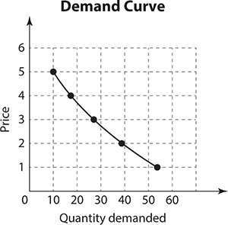
Equilibrium is the price at which the supply and demand for an item are balanced. At the equilibrium price, producers can sell all that they produce, and consumers can purchase all that they demand.

Small businesses and larger companies and corporations form the major part of a market-based economy. Companies earn money by selling goods or services. They spend money to pay wages and to purchase supplies and equipment or goods for resale. The purpose of these operations is to earn profits; that is, to take in more money than the company spends. The company can save profits, distribute them to owners and/or workers, or invest them in ways that expand or improve the business. A company may spend more than it earns. The excess spending is called a loss or a deficit. If a company fails to earn a profit, it can wind up in bankruptcy, and it may go out of business.
Competition occurs when more than one seller provides the same good or service. Sellers compete to attract buyers for their product. They set prices that attract consumers, or they improve their product in order to offer consumers better value.
A monopoly, by contrast, occurs when a seller is the only one to offer a certain good or service. When a seller has a monopoly, he or she can charge a higher price than would be possible in a competitive market because that particular good or service is not available from anyone else.
Besides sales, another way to earn money is through investments. An investment is an item that is purchased in the hope that it will become more valuable in the future. For example, an individual may buy a house as an investment in the hope that it will increase in value. Businesses make investments by, for example, purchasing new equipment in the hope that it will help them produce more and better products and earn more money. Individuals and businesses also purchase stock (issued by corporations) and bonds (issued by corporations or governments) as investments. The corporations and governments sell the stocks and bonds to raise money. Over time, a stock or bond may increase in value, and the purchaser may also receive interest or dividends.

Macroeconomics
The study of the overall workings of a national economy, and of its relationship to international markets, is called macroeconomics.
Macroeconomics deals with what nations as a whole produce and trade,

and with the major government and private institutions that operate in the national and world economy.
Major institutions involved in macroeconomics include government agencies that collect tax revenue, such as the Internal Revenue Service, and those that regulate economic activity on a national scale, such as the
U.S. Federal Reserve. Major private institutions include leading banks, financial services companies, and corporations doing business nationwide and worldwide.
Fiscal policy refers to the way in which government collects and spends tax revenues. Each year, the president presents a budget to Congress regarding fiscal policy. Congress then considers which programs to fund.
Monetary policy relates to the supply of money, which is controlled by factors such as interest rates and reserve requirements for banks. Monetary policies include manipulating the money supply or interest rates in order to promote economic growth or to combat inflation. Tariffs are taxes or duties paid on specified classes of imports or exports. A tariff adds to the cost of an imported good and is one of several trade policies a country can enact.
Economists define inflation as a general, ongoing rise in the prices of goods and services. The inflation rate is generally reported as an annual percentage. In other words, if the inflation rate is 5%, prices in general have risen by 5% in a year, and consumers’ dollars will now buy less than they did formerly. Deflation, on the other hand, refers to a general reduction of prices in an economy.
Gross domestic product, or GDP, is one of the primary indicators used to measure the strength of a country’s economy. It represents the total dollar value of all the goods and services produced by a country over a specific time period. The gross domestic product is the main measure of production in the United States.
Another gauge of a country’s economic health is the unemployment rate. A person actively searching for employment who is unable to find work is considered unemployed. Every month, the U.S. Bureau of Labor Statistics reports the percentage of Americans who are unemployed.

During the Great Depression of the 1930s, unemployment rates in the United States reached 25% of all workers. The rate in the mid-2010s was between 7 and 8%. While policymakers strive for low unemployment rates, what exactly is acceptable has changed over time.
EXERCISE 2

Microeconomics and Macroeconomics
Directions: Choose the best answer to each of the following questions.
- Microeconomics concerns itself with national and governmental economic policies.
TRUE or FALSE
- The point at which supply and demand are balanced is called
.
Answers are on page 829.

Banking and Credit
Banks provide services such as checking and savings accounts, and they offer loans and credit cards at a cost. Checking accounts allow customers to deposit their money into the account and then use the money to pay for goods and services by writing checks. Many banks charge a fee for maintaining a checking account. Savings accounts allow customers to deposit money into the account and earn interest on the account balance. The amount of interest paid is a percentage of the balance in the account. Deposits in checking and savings accounts up to $250,000 are insured by the Federal Deposit Insurance Corporation (FDIC), an independent agency created by the U.S. Congress.
Banks earn money by making loans to individuals and businesses. You can borrow money to make a purchase, but you must pay back the sum you

borrowed plus additional money called interest. Interest represents the cost of borrowing. For a very expensive purchase such as a house, you can arrange a mortgage with a bank. The bank pays the seller in full at the time of purchase, and you repay the bank an agreed amount per month, most often over a period of 30 years. The monthly mortgage payments include interest charges based on the total number of years of the loan.
Early repayment means you pay less overall, because you save the interest charges. The mathematical equation for calculating interest is R × P × T = I (Rate × Principle × Time = Interest). Other expensive purchases for which people routinely take out loans include cars and college educations.
Many banks also offer credit cards. Credit is an arrangement that allows consumers to finance a purchase without having to pay the total cost at the time the purchase is made. When a credit cardholder makes a purchase, the bank pays the seller on the cardholder’s behalf. The cardholder then repays the bank, with interest if repayment is not made immediately. The bank also collects a fee from the seller for processing the transaction. There are many consumer and credit laws in place to protect the rights of people and businesses that interact with credit card companies and to establish rules for the credit industry.
Exercise 3

Banking and Credit
Directions: Choose the best answer to each of the following questions.
- What might a bank offer to a customer?
  - loans
  - savings accounts
  - credit cards
  - all of the above
- The FDIC is the National Bank of the United States.
TRUE or FALSE

Answers are on page 829.

The Role of Government in the National Economy
In a capitalist economy, business and industry are in private hands, and a free, competitive market sets wages and prices. In a socialist economy, the government owns all business and industry and fixes prices artificially. A mixed economy is a combination of these two systems. The United States has developed as a largely capitalist economy. Most other Western nations have mixed economies.
In the United States, the federal, state, and local governments have income (called revenue) and expenses. Revenue comes mainly from two sources: payment of taxes and the sale of bonds. Income tax is a percentage of individual or business income paid to the government. Sales tax is a small percentage added to the price of an item or a service. A government bond is, in effect, a loan. Investors pay the government the price of the bond. They can cash in the bond at any time, but the longer they hold it, the more it is worth, because the government pays them interest based on the length of time they hold the bond.
Governments use these sources of revenue to meet their expenses. For the federal government, expenses include financing the armed forces and paying the salaries of all government workers all the way up to the president. The federal government also funds education at all levels; runs programs such as Medicare, Medicaid, and Social Security; regulates commerce and enforces safety standards; provides funding for the arts and scientific research; maintains national parks and nature preserves; and helps to fund and maintain a national transportation system.
State taxes pay for things like the state police force and bridge and highway maintenance. Local city taxes pay for things like public schools, garbage collection, the library system, and municipal parks. State governments also depend on taxes for their revenue. Each state determines what taxes it will assess. For example, Pennsylvania charges a state income tax but does not charge sales tax on clothing.

The federal government helps to manage the national economy by setting tax rates and interest rates and by regulating businesses and industries. It sets and enforces rules governing minimum wages, workplace standards, and fair business practices. For example, it can penalize large financial institutions that have been found to have defrauded customers in numerous states. States regulate certain industries by requiring them to follow specified rules when doing business within the state.
EXERCISE 4

The Role of Government in the National Economy
Directions: Follow the instructions below.
- For each of the following items, decide whether it is a function of the federal government or of the state or local government. Then indicate in which column of the chart each item belongs. (Note: On the real GED® test, you will click on the items and “drag” them into position on the chart.)

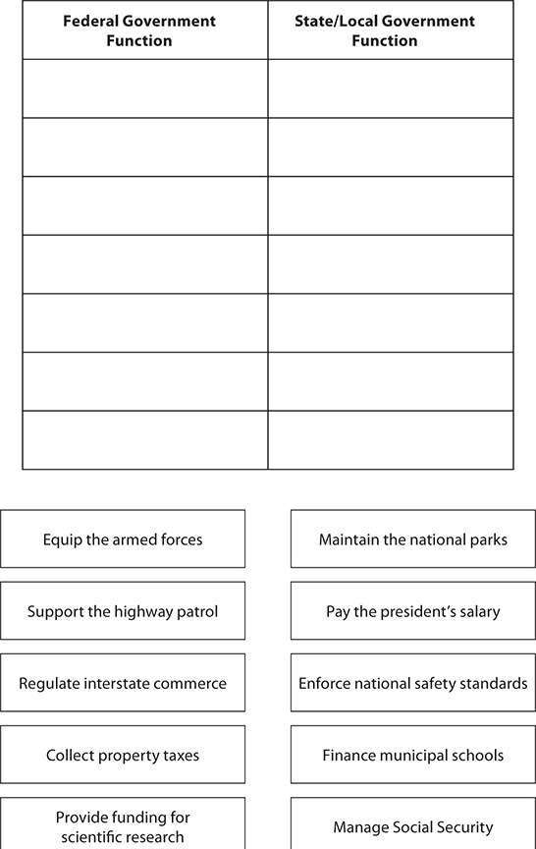

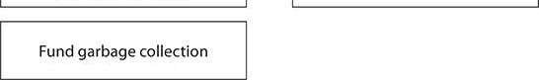
Answers are on page 829.

International Trade
A trade is an exchange—something you do not need for something you want. In international trade, people and businesses export (sell to foreigners) the goods they do not need, and import (buy from foreigners) the goods they want.
Geography is closely connected to international trade. A nation’s geographic location determines its climate and its natural resources. Nations must trade to obtain the natural resources or manufactured products they cannot provide for themselves. Often a nation will have surplus of products it can trade away. For example, Argentina’s climate is perfect for raising cattle—but all wrong for growing coffee. The cattle can supply all the meat the Argentines need with plenty left over to trade away for the coffee they cannot produce.
Nations also export natural resources or manufactured goods in order to earn income. The income is used to create or buy more goods and services, which strengthens the nation’s economy. A nation that is well suited to manufacture a certain product can often undersell competitors and earn substantial profits from foreign trade.
It is easy to see the connection between international trade and foreign policy. Economics can drive foreign policy, and foreign policy can dictate economic choices. Colonization is one example of how economics can drive foreign policy. When a country acquires a colony, it controls the trade relationship. This fact helped to shape a foreign policy of aggressive European colonization from about 1500 to 1945, when colonies in Asia, Africa, and the Americas provided a number of commodities and

resources Europeans could not produce for themselves—coffee, tea, sugar, cotton, spices, potatoes, copper, tin, and many more.
Trading with other independent nations is different from trading with a colony because the bargaining power between the two is more equal. If a nation is your enemy, it may refuse to trade with you—or it may demand unreasonably high prices for its goods. If an enemy nation is rich in a commodity you want to import, you are under economic pressure to improve your political relations with that nation. If nations can become allies, they are much more likely to come to a trade agreement that will please both sides, but sometimes, a nation may decide that the best way to obtain natural resources from a neighboring country is through a war of conquest.
A nation that has a political dispute with another country may sometimes employ a tactic called an embargo in order to apply pressure against its opponent. When you establish an embargo against a country, you do not export to that country and you do not import its goods. This means finding alternatives to whatever goods that country produces. An example of this occurred during the U.S. Civil War, when, for political reasons, Britain decided to break off trade relations with the Confederacy. Instead of importing American cotton, Britain imported cotton from India until after the war ended and the Confederacy rejoined the Union.
EXERCISE 5

International Trade
Directions: Choose the best answer to each of the following questions. Questions 1 and 2 are based on the following graphs and information:

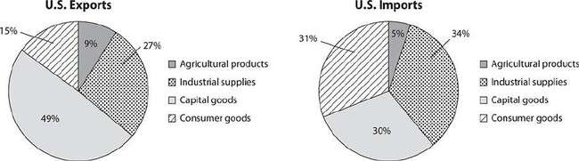

The graphs show current U.S. imports and exports for the following:
- Agricultural products: soybeans, fruit, corn, etc.
- Industrial supplies: chemicals, crude oil, etc.
- Capital goods: computers, telecommunications equipment, motor vehicle parts, office machines, etc.
- Consumer goods: automobiles, clothing, toys, furniture, medicines, etc.
- According to the first graph, nearly half of all U.S. exports are
  - agricultural products.
  - industrial supplies.
  - capital goods.
  - consumer goods.
- According to the graphs, the United States imports
as many consumer goods as it exports.
  - half
  - twice
  - three times
  - exactly
Answers are on page 830.

Key Economic Events in U.S. History
The economy of the United States has been shaped by many events during its history. The causes of these financial events have included actions by individuals, natural and social processes, and the influence of ideas.
In early American history, the federal government had little involvement in economic affairs. One economic issue that stirred controversy was the proposal to create a national bank. At the urging of Alexander Hamilton, Congress established the Bank of the United States in 1791. Many, including Thomas Jefferson, opposed this action. The bank had a 20-year charter, which expired in 1811.
There were also doubts about the government’s right to interfere in economic matters. However, in 1824, in the case of Gibbons v. Ogden, the Supreme Court ruled that Congress had the right to regulate interstate commerce, under Article I of the Constitution. The court said that the only limits on Congress’s power in this area were those specifically stated in the Constitution. The court also said that the states could not interfere with the use of harbors and rivers.
Beginning in the early 1800s, the country’s westward expansion was a key economic event. Settlers established farms in the Midwest and the Great Plains, motivated by a sharp rise in agricultural commodity prices and new methods of shipping farm products to world markets. The discovery of gold in California in 1849 speeded up the pace of western migration and brought new wealth to many. The second half of the 19th century was the great age of railroad building and the rapid growth of industries based on steel and coal.
After the end of the 19th century, government began taking a more active role in economic affairs. It did so in response to demands from farmers, businesspeople, and labor movements that the government intercede on their behalf. The Interstate Commerce Act (1887) strengthened the role of Congress in regulating trade across state lines and increased its power to regulate railroads. The Sherman Antitrust Act (1890) gave Congress the power to limit the establishment of business monopolies.

The Federal Reserve Act (1913) created the modern banking system. This act established the Federal Reserve System, under which the country is divided into 12 Federal Reserve Districts. The system includes the Federal Reserve Board as the primary governing body of all U.S. banks, as well as 12 regional Federal Reserve Banks, one in each District. The Federal Reserve banks jointly implement the monetary policies decided on by the federal government. Each bank also regulates the commercial banks in its district.
In the 1930s, in response to the Great Depression, President Franklin Roosevelt and Congress enacted a set of far-reaching economic measures called the New Deal. These measures were needed to address the dire economic conditions and to help those who were suffering. The New Deal greatly expanded the role of the federal government in domestic affairs.
Some of its programs provided food, shelter, and financial security to those in economic need. Others provided funds for building dams, roads, bridges, and other large structures. These building projects provided employment for thousands of people. Another major New Deal program, Social Security, still provides a guaranteed income to millions of Americans.
World War II brought an end to the Depression. The demand for weapons, ships, and airplanes created jobs and paychecks for millions of workers. When the war was over, people spent money freely on everything that had been postponed during the war years: starting families, buying houses, and purchasing all kinds of consumer goods developed by new industries. The result was an unprecedented economic boom that lasted for 25 years. During this period, the United States consolidated its position as the greatest economic power in the world.
EXERCISE 6

Key Economic Events in U.S. History
Directions: Choose the best answer to each of the following questions.

- President Roosevelt’s response to the Great Depression was the New Deal policy, which
  - discouraged economic growth in the United States.
  - discouraged unemployed people from finding work.
  - funded the building of roads, dams, and other infrastructure projects.
  - encouraged people to buy stock on margin.
- At the end of World War II there was strong economic growth due to
  - a housing boom.
  - increased consumer demand.
  - development of new industries.
  - all of the above.
Answers are on page 830.

PRACTICE

Economics
- The Great Depression lasted into the late 1930s. How did economic conditions change when the United States entered World War II?
  - More people were employed.
  - Investment in new factories declined.
  - Fewer people owned homes.
  - The funds people had in savings decreased.
- A sharp rise in the prices of agricultural commodities was just one factor that drove the westward expansion that began in the United States in 1807. Another was the search for
  - spices.

  - gold.
  - religious freedom.
  - trade routes.
- Which of the following established the modern banking system in the United States?
  - Sherman Antitrust Act
  - Interstate Commerce Act
  - Federal Reserve Act
  - The New Deal
- Which is the definition of profit?
  - money received over a period of time
  - purchase of an item in the hope that it will increase in value
  - the point at which the supply of an item equals the demand for it
  - excess income after expenses are paid
- Place an X beside the people or groups responsible for determining the federal government’s fiscal policy.
Congress
President
Supreme Court
Secretary of Defense
Questions 6 through 8 are based on the following data:

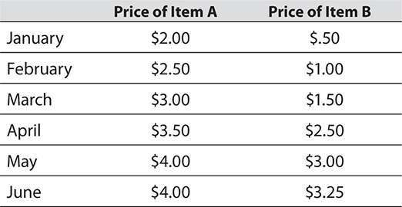

- Construct a scatter plot of the data in two variables.
- The relationship between the price of Item A and the price of Item B is best described by which of the following?
  - As the price of Item A increases, the price of Item B also increases.
  - As the price of Item A increases, the price of Item B decreases.
  - As the price of Item A increases, the price of Item B decreases and then increases.
  - As the price of Item A increases, the price of Item B increases and then decreases.
- Which of the following can be most properly inferred from the data?
  - A change in the price of Item A causes a change in the price of Item B.
  - A change in the price of Item B causes a change in the price of Item A.
  - The prices of Items A and B are correlated.
  - There is no relationship between the price of Item A and the price of Item B.
Question 9 is based on the following map:

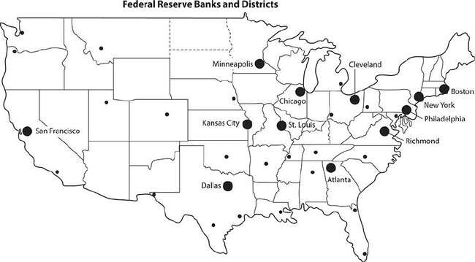

- What does the location of these banks most likely indicate?
  - There are more people in Boston than in San Francisco.
  - The northeastern United States is the main center of banking activity in the country.
  - Banking activity is concentrated in the western portion of the United States.
  - Banking practices in the Midwest are radically different from those in the South.
The following sentence contains several numbered blanks, each marked “Select. . . .” Beneath each one is a set of choices. Indicate the choice from each set that is correct and belongs in the blank. (Note: On the real GED® test, the choices will appear as a “drop down” menu. When you click on a choice, it will appear in the blank.)
- According to the law of supply and demand, if
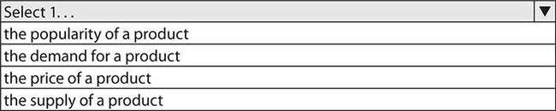

is greater than ,
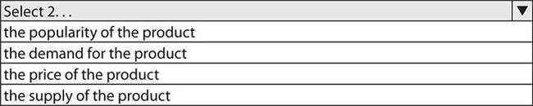
the will fall.
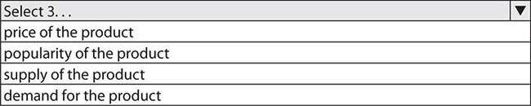

Answers are on page 830.

CHAPTER 4
Geography and the World

Ecosystems
Over millions of years, physical processes have shaped and reshaped Earth’s surface. The continents we know today did not always exist in their current form. Over time, landmasses break away from one another or collide with one another, forming new landmasses. Forces inside Earth cause mountain ranges to rise up, but over time, wind and water wear the rocks away. As a result, Earth has a highly varied landscape. Different locations have different landforms and different climates, and they are inhabited by different groups of plants and animals.
The climate of a region encompasses many things: the prevailing winds, temperatures, and the amount and type of precipitation, averaged over time. Climate is affected by geographical factors such as the proximity of mountains or large bodies of fresh or saltwater. Climate can change when any of these factors changes.
The term ecosystem refers to the ongoing interaction between the land, the climate, and living organisms in a particular location. All the factors work together in a certain way to create a natural system that sustains the organisms that live there. For example, in a forest in a temperate region of North America, trees produce nuts and fruits as part of their reproductive cycle. Small animals and birds survive by eating the nuts and fruits.
Wolves and hawks survive by preying on the smaller animals and birds. Other animals survive by eating the insects that live in the soil and on the trees. The remains of dead plants and animals supply nutrients to the soil that nourish plants and trees. The whole system works together to sustain one generation of living things after another.
Earth is divided into many different ecosystems. For example, the
tropical ecosystem of the South American rain forests is completely

different in terms of climate, precipitation, and living organisms from the desert ecosystem in the southwestern United States. Much of the United States and Western Europe is located in an area of moderate climate called the temperate zone.
Exercise 1

Ecosystems
Directions: Choose the best answer to each of the following questions.
- Which of the following is NOT a global ecosystem?
  - Temperate
  - Desert
  - Tropical
  - Deciduous
Question 2 is based on the following passage:
Storms from the Pacific Ocean usually drop their moisture when they reach the western slopes of the mountains in California, Oregon, and Washington. The area east of the mountains, where little rain falls, is said to be in a rain shadow.
- What kind of ecosystem would you expect to find in a rain shadow?
  - Temperate
  - Desert
  - Tropical
  - Arctic
Answers are on page 830.

Geography and the Development of Human Societies
Geography largely determines how and where people live. The climate and the physical features, or topography, of the land are very important. Areas with very cold climates, like northern Canada, are sparsely populated.
Areas with very dry climates also generally have few inhabitants. Mountainous areas with harsh climates are usually less populated than plains, where farming is easier. Throughout history, people have tended to settle in places where the soil is fertile, where freshwater is abundant, and where travel is relatively easy. That is why, for example, river valleys in the temperate zones, such as the Nile valley in Egypt or the Yangtze valley in China, were the sites of the earliest civilizations. Today population tends to be greatest in coastal areas, often near harbors where shipping makes it easy to transport people and goods. These areas attract people because they provide comparatively more economic opportunities.
Geography and climate affect the choices people make. The climate determines the clothing people wear, the crops they grow, the animals they raise for food, and the kinds of transportation they use. For example, the Italian peninsula is mountainous, with dry, rocky soil. Together with the mild temperatures of the Mediterranean region, this makes the perfect environment for growing grapes. These geographical factors have made Italy a major producer and exporter of wine since the days of ancient Rome.
Geography also affects conflicts between human societies. Countries must always consider how easily they can defend their borders. Countries with natural border defenses such as wide oceans or high mountain ranges are easier to defend than countries located in the middle of broad plains and surrounded by hostile neighbors.
Geographical factors can also dictate success or failure in war. Distance is one important factor—this was especially true before the invention of airplanes. The farther an army marches from its sources of supply, the greater the risk of defeat. Invading armies can also encounter harsh, unfamiliar weather conditions or mountainous terrain that makes

transportation difficult. Geography has been a major factor in wars throughout human history.
EXERCISE 2

Geography and the Development of Human Societies
Directions: Choose the best answer to each of the following questions.
- Which of the following is NOT a reason why many cities are built beside rivers?
  - The surrounding area is fertile and suitable for agriculture.
  - Freshwater for people and livestock is readily available.
  - Ports make travel and trade quick and convenient.
  - River banks are easy to defend against invaders.
- are natural borders that countries have used as defenses against invaders and conquerors.
  - Broad plains
  - Wide river valleys
  - High mountains
  - Dry, rocky soils
Answers are on page 830.

Human Changes to the Environment
Human beings have significantly altered every natural environment in which they have settled.
They turn over the soil and sow crops. They may fell whole forests in order to clear land for farming or building. They create systems for

irrigation and waste disposal. They build walls and fences to mark property borders. Large human civilizations go beyond these steps. They build bridges, roads, and cities. Since the beginning of the industrial age, people have been building factories, mines, and railroads. All these human activities alter an environment.
Large human societies need to manage resources. A natural resource is something of value that is supplied by the environment that is needed by or useful to living beings. This includes water, forests, minerals, air, animals, fossil fuels, plants, and rocks. Since the start of the Industrial Revolution in the early 19th century, people have been consuming natural resources at an ever-increasing rate. Some natural resources, such as coal, oil, and natural gas, are limited or finite. With continual use, they will one day run out. Sustainability refers to a way of using natural resources without depleting or destroying them.
Industrialization has produced pollution of air, land, and water on a massive scale. The problem has only grown worse over time; as the 21st century begins, it has resulted in global warming. Average temperatures have risen all over Earth, melting glaciers and causing sea levels to rise. Societies have responded to environmental problems in a variety of ways, creating a “green movement.” People recycle used products in order to reduce the amount of waste. They plant gardens in cities, on vacant land, and on rooftops. Farmers have changed their farming methods to make better use of the soil. Some farmers forgo the use of manufactured pesticides to raise organic crops. However, not all nations participate in these protective measures; some fear damage to their economies if they have to convert factories to cleaner, more environmentally responsible methods of production and waste disposal.
EXERCISE 3

Human Changes to the Environment
Directions: Choose the best answer to the following question. Question 1 is based on the following graph:

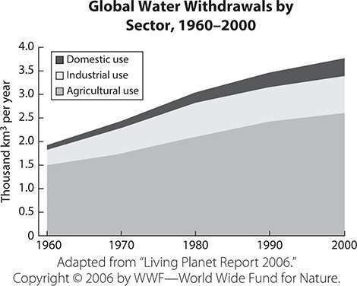

- According to the graph, in which decade did total water use begin to exceed 3000 km³ per year?
  - 1970s
  - 1980s
  - 1990s
  - 2000s
- According to the graph, the amount of water used for agriculture increased from 1500 km³ per year in 1960 to
km³ in 2000.
Answers are on page 830.

Human Migration
Migration is the movement of large numbers of people from one country, place, or region to another. Human migrations have occurred throughout

history prompted by population trends and issues. There is a connection between human migration and geography and environment. In many cases, people migrate to regions where farmland is available or where crops can be grown more successfully. People also migrate in order to find a better climate, to obtain jobs or natural resources, or to avoid poverty, wars, or the effects of a natural disaster.
To immigrate means to move into a country, usually to establish permanent residence. To emigrate, on the other hand, means to leave in order to settle in another place. People may immigrate or emigrate for a variety of reasons. At times, groups of people have been dispersed outside of their homelands either by choice or involuntarily. This scattering of groups of people is called a diaspora.
When people move to new lands, they experience new culture. Culture refers to the way of life of a particular group of people. This includes their arts, music, literature, language, values, religion, shared beliefs, clothing, and food. Cultural diffusion describes the spread of cultural ideas to new groups of people. This can take place when people with different cultures live in close proximity to one another. Over time, contact between the cultures leads to a mix. Cultural diffusion can also occur when one country conquers another and the defeated people are forced to accept the culture of the victors. Today, technology such as the media and the Internet plays a part in the widespread sharing of cultural ideas and beliefs. When people from different ethnic backgrounds integrate into the main culture of a society, they are said to assimilate. People in this situation do not necessarily abandon their traditional culture, but they accept many of the cultural ideas and practices of the dominant main culture.
EXERCISE 4

Human Migration
Directions: Choose the best answer to each of the following questions.
- Tex-Mex, a combination of traditional Mexican cuisine and foods popular with American settlers in Texas, is an example of

.
  - assimilation
  - migration
  - cultural diffusion
  - sustainability
- Read the passage, and then answer the question.
The great famine of 1845–1852 in Ireland was a catastrophe for the Irish. As many as 80% of Irish people left home and settled in countries as far away as the United States, Canada, Argentina, Australia, and New Zealand. This mass emigration was one of history’s great diasporas.
Which of the following would NOT be termed a diaspora?
  - the expulsion of Jewish people from Europe prior to and during World War II
  - the enslavement of West African people and their forcible transportation to the New World
  - the migration of Chinese people throughout Southeast Asia in search of better economic opportunities
  - the conquest of Native American peoples in South America by the Spanish
Answers are on page 830.

Population Trends and Issues
In early history, nearly all people lived in rural societies centered on agriculture. By contrast, much of today’s world is an urban society in which most people live in towns and cities. Today more than 50% of the world’s population lives in urban areas. This is the first time in history that this has been true. The growth of urban populations is expected to continue. There are numerous reasons for this trend. Cities offer many

more opportunities for employment, education, and health care than rural areas with lower populations.
However, moving from a rural area to an urban area does not guarantee a higher quality of life. Particularly in developing countries in Asia, Africa, or Latin America, many people who move to cities with little or no resources of their own soon find themselves living in poverty. In those countries, the cities do not provide enough economic opportunities to support the rapidly increasing population. Poverty levels are usually highest in areas where population growth is fastest.
In 2013 the estimated total world population was 7.2 billion. This is expected to increase to 10.9 billion by the beginning of the next century. Most of this population growth is expected to occur in developing countries. In the more developed countries—the European and North American countries and Japan—population growth is much slower, mainly because family size is typically significantly smaller.
EXERCISE 5

Population Trends and Issues
Directions: Choose the best answer to the following questions. Questions 1 and 2 are based on the following graph:

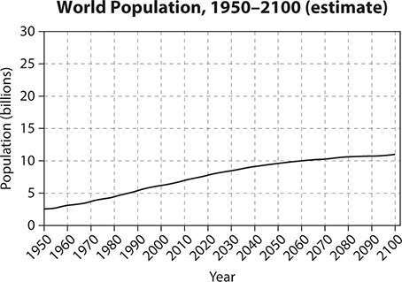

- Based on the graph, which inference can be made?
  - Experts can predict the world’s exact population in the year 2100.
  - Experts agree that the world’s population will decrease by 2100.
  - The world’s population is expected to continue to increase over the next 75 years.
  - The world’s population is expected to triple in the second half of the 21st century.
- By 2070, the world’s population is expected to be three times as great as it was in 1970. TRUE or FALSE
Answers are on page 831.

Geography Tools and Skills
We use the term place or region to refer to a location on Earth. A place is an individual location—a single country, town, or city. A region is a group

of locations—the collective identity of several adjoining countries, states, or provinces.
Various tools are used to show the spatial organization of people, places, and environments on Earth’s surface. A globe is the most accurate representation because it is the same spherical shape as Earth. However, even the largest globe is scaled down so far in size from the actual Earth that it cannot show much detail. Flat maps distort the actual curvature of the land, but a close-up map of a small area can show much more detail than a globe.
Different types of maps can show many physical and human characteristics of places and regions. Take, for instance, an ordinary map of the United States. It shows how Americans decided to divide their country into specific states for political purposes. You might take the same map and shade it to show the different regions: Northeast, Midwest, Southeast, Southwest, and Northwest. You might shade the map in different colors to show where different major crops are grown—such as wheat, corn, potatoes, and oranges. You might shade the map to show average temperature, rainfall, or elevation above sea level.
Maps come in many varieties. A political map shows the names and borders of countries, provinces or states, cities, and towns. A topographical map shows comparative elevation above sea level. A climate map can show which areas receive the most and least annual rainfall and which have the coldest and hottest temperatures.
You can locate any place on Earth by plotting its latitude and longitude. When you look at a globe, you will see a crisscross grid of latitude and longitude lines. A location’s latitude gives its distance north or south of the equator. A location’s longitude is an angular measure giving its distance east or west of the prime meridian, a north-south line running through a location near London in Great Britain. Latitude and longitude are measured in degrees (°) and minutes ('). The equator is considered to be 0° latitude. The north and south pole are located at 90° north and 90° south latitude, respectively. The prime meridian is considered to be 0° longitude.

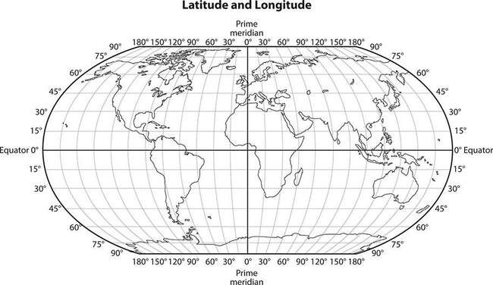
EXERCISE 6

Geography Tools and Skills
Directions: Choose the best answer to each of the following questions.
- If you want to plan a route for a hiking trip in a mountainous area, which kind of map would you be likely to consult?
  - climate
  - political
  - highway
  - topographical
- The equator crosses which continents?
  - South America, Africa, and Asia
  - North America, Europe, and Asia
  - South America, Europe, and Australia
  - North America, Africa, and Asia

Answers are on page 831.

PRACTICE

Geography and the World
Directions: Choose the best answer to each of the following questions.
- Which statement is true regarding how geography affects the development of societies?
  - Groups of people often establish their first settlements in mountainous regions.
  - People usually locate their settlements away from large bodies of water.
  - The availability of natural resources influences where people settle.
  - Societies develop in areas where health care is easily available. Question 2 is based on the following graph:

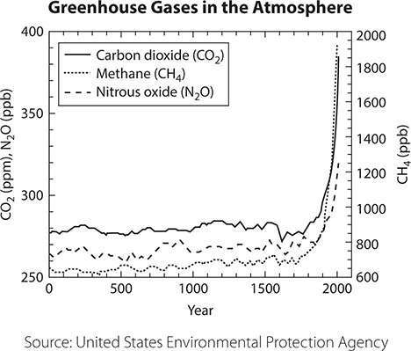

- Which of the following can be inferred from this graph?
  - Greenhouse gases in the atmosphere have increased rapidly since the start of industrialization in the 18th century.
  - Greenhouse gases in the atmosphere have decreased as world population has increased.
  - There was less carbon dioxide than methane in the atmosphere before Europeans colonized the New World.
  - There was more carbon dioxide in the atmosphere before the European colonization of the New World than there is today.
- Humans have often migrated in search of land available for farming.
TRUE or FALSE
- The Prime Meridian
  - measures distance from east to west.
  - is located near the equator.
  - is located at 0 degrees longitude.

  - measures distance from north to south.
- At which location is the climate most likely to be temperate?
  - 5 degrees north latitude
  - 40 degrees north latitude
  - 25 degrees south latitude
  - 75 degrees south latitude
- By comparison to a tropical ecosystem, a temperate ecosystem has
  - cooler temperatures and less rainfall.
  - less wind and more sunshine.
  - more frequent and more violent storms.
  - warmer nighttime temperatures. Question 7 is based on the following passage:
The invasion of Russia in 1812 by French troops commanded by Napoleon ended in disaster. A main reason was that the French were unprepared for the Russian winter. They had expected fighting to end before winter began, and therefore did not have proper clothing or supplies. The French soldiers were still wearing summer uniforms when snow began falling. In the icy conditions, many died from hypothermia or starvation. As a result, the French were forced to retreat, and the campaign ended in failure.
- Which of the following statements is supported by the passage?
  - The French retreated because they were outnumbered by the Russians.
  - Napoleon’s army was overwhelmed by the Russian climate.
  - The French invasion failed because the Russians had better generals.
  - The Russians considered the winter of 1812–1813 to be comparatively mild.
Answers are on page 831.

CHAPTER 5
Focusing Themes

What Are Focusing Themes on the Social Studies Test?
All of the content knowledge tested on the Social Studies test will be related to one of two “focusing themes.” In fact, nothing that cannot be attached to a focusing theme will appear on the test. The two themes are:
- Development of modern liberties and democracy
- Dynamic responses in societal systems
What this means is that you will need to have a basic idea of the historical roots of U.S. government and social structures. You will also need to understand how societies respond to world events of all sorts. Almost all of the content information you need is provided in the earlier chapters of this section. However, there is some required background knowledge that falls outside the scope of Civics and Government, United States History, Economics, or Geography and the World. Though world history is not a specific content area on the Social Studies test, a broad understanding of how major world civilizations rose and fell will be necessary.

The Earliest Civilizations
A civilization is more than a group of people; it represents the next step toward social organization. In a civilization, people organize governments and social classes, establish writing systems, build cities, create works of art, study science and mathematics, and invent new ways of doing things.
To sustain human life, two things are required: a temperate climate and ready sources of food and freshwater. Under the right conditions, this leads

to a surplus of food and thus an increase in health, life span, and income. With extra resources and more spare time, people turn to pursuits beyond the hunting and gathering of food—they create civilizations.
Human beings began to create civilizations around 3500 BCE (Before the Common Era). The Fertile Crescent (present-day Iraq, Syria, and Egypt) was home to the early civilizations. This period is called the Bronze Age for the copper-tin alloy people discovered around 3000 BCE. Bronze produced stronger tools and weapons than copper alone.
Mesopotamia (present-day Iraq) gave the world its first written language, its first organized religion, the basics of modern mathematics, the wheel (used first for making pottery, then for transportation), and the first literary epic (The Descent of Inana). The first city-states were created in southern Mesopotamia by a people called the Sumerians.
Archaeologists have unearthed many luxury objects at Sumerian sites, including musical instruments, game boards, and jewelry. These artifacts allow us to conclude the existence of a wealthy class of Sumerians: only the wealthy can purchase luxury items. The use of metal in a region where no metal exists proves that the Sumerians traded with other civilizations.
The Babylonian Empire came into being around 2000 BCE. Babylonians could plot the fixed stars, follow the course of the sun, and predict lunar eclipses. Their mathematicians were the first to use the number 60 as a base for measuring circles, spheres, and time; we use that system today. Babylonian law codes, such as the Code of Hammurabi, show that in ancient times, people valued the concept of abstract justice and believed in punishing criminals. Another great civilization arose at the same time in the Nile River valley in Egypt. The Great Pyramids of Egypt prove that the Egyptians were able not only to design monumental buildings, but also to plan and carry out their construction—a remarkable engineering feat in an era with no technology beyond the wheel and the lever. Less is known about the Indus Valley Civilization in present-day Pakistan because historians have not yet been able to decipher its written records.
EXERCISE 1

The Earliest Civilizations
Directions: Choose the best answer to each of the following questions.
- Based on the information above, which of the following statements is NOT true?
  - The earliest known civilizations arose in what is now the Middle East.
  - The written records of the ancient Indus Valley people remain a mystery to this day.
  - Babylonian mathematicians established systems and conventions that we still use today.
  - Early civilizations discovered that using copper for tools was better than using bronze.
- Based on the information above, which of the following statements is an opinion, not a fact?
  - The presence of luxury items among Sumerian artifacts found by archaeologists shows some Sumerians were wealthy.
  - Archaeologists have found clear evidence that Sumerians traded with other ancient civilizations.
  - The foundations of modern mathematics were developed by the Mesopotamians.
  - A Mesopotamian writer created the first known work of literary fiction.
Answers are on page 831.

Early China
China has existed as a culturally unified entity since at least 1000 BCE; aspects of Chinese culture that may date back even further include the domestication of silkworms, the production of ceramic and jade objects,

and the use of chopsticks. The classical Chinese written language, originating well before 1000 BCE, served as an important unifying force.
The early Chinese settlements were located along the rivers—the highways of the ancient world. China was isolated from the Fertile Crescent not only by distance, but by obstacles such as deserts and mountain ranges. There is no evidence that ancient China and the ancient Near East had any knowledge of one another.
K’ung-fu-tzu, known in the West as Confucius, became influential in Chinese thought. Born in the 6th century BCE into the minor nobility, Confucius became a teacher and a scholar. Confucius supported the established order of society, in which everyone had a place. If each person knew and kept his place, did his duty, and respected tradition, society would function smoothly.
Under the Han dynasty (206 BCE–AD 220) China achieved a free- market economy, the invention of paper, a universal law code, and a merit- based bureaucracy. This period also saw the establishment of the Silk Road, a major overland trade route from Luoyang in the east all the way to Constantinople and Alexandria in the west. Horses from Iran, luxury objects from Rome, silks from China, spices and cotton from India, and stories and ideas from all cultures were traded along the Silk Road.
Exercise 2

Early China
Directions: Choose the best answer to each of the following questions.
- Before the establishment of the Silk Road, the peoples of the Fertile Crescent and China
  - shared a common language and religion.
  - were unable to domesticate horses.
  - were unaware of each other’s existence.
  - made war on each other repeatedly.

- Based on the information above, which of the following existed in China as early as 1000 BCE?
  - wine
  - diamond jewelry
  - steel
  - chopsticks
Answers are on page 831.

Early India
Geography played a major role in the isolation of ancient India. The Himalayas, which include some of the world’s tallest mountains, blocked access from the north; the other two sides of the triangular peninsula border on the Indian Ocean. This unique geographical location ensured that India could be invaded only from the northwest, through present-day Pakistan.
The Aryans, Eastern Europeans who invaded and settled in Persia and the Indus Valley around 1500 BCE, had a lasting influence on Indian culture. Historians believe that Hinduism is a mix of Indian and Aryan ideas and beliefs. Hinduism links a religious belief in sacrifice with a caste system based on duty to others; it continues to hold sway over present-day India.
Siddhartha Gautama, born into the nobility in 563 BCE, is known to history as the Buddha (the title means “Enlightened One”). The Buddha taught that since all suffering and conflict in the world came from frustrated ambition, passion, or egotism, the elimination of these emotions would lead to contentment and spiritual peace. Buddhism also opposed the caste system. Today, Buddhism has its greatest influence in China, not India.
Exercise 3

Early India
Directions: Choose the best answer to the following question.
- Based on the information above, it can be assumed that
  - Himalayan mountain passes made easy routes for invaders.
  - the caste system, which still influences Indian society, has existed for centuries.
  - the Buddha fought the caste system by becoming a powerful and wealthy emperor.
  - the Aryans entered India from the east by traveling from Mongolia through Nepal.
The answer is on page 831.

Classical Greece
The beginning of an identifiable Greek culture goes back to 2000 BCE and the arrival of the Achaeans from the present-day Balkan region of southeastern Europe. The peninsular and island culture of Greece meant a close relationship with the sea; trading was done by boat, and the navies of the Greek states became the strongest and best of the era.
The Greek idea of abstract philosophy—that people could use their reasoning powers to understand the workings of the universe—is Greece’s most important contribution to the development of Western culture.
During the Greek Classical Age (roughly 750–400 BCE), the Greeks created the basis of Western art, architecture, literature, science, philosophy, and government.
At a time when the world was ruled by the principle of the divine right of emperors, some of the Greek city-states featured a new form of government called democracy. This was not democracy as we understand it today; neither slaves nor free women had many legal rights or freedoms, and only men in positions of power (about 10% of the total population) could vote. Still, the government did give some of its citizens some say in

the laws they had to live by. This principle of government by the consent of the governed would eventually hold sway throughout the Western world.
The northern Greek kingdom of Macedonia took over the Greek civilization under Philip II and his son and successor Alexander the Great. During the 4th century BCE, Alexander’s wars of conquest spread Greek culture, language, and customs all the way from the Danube River in Europe to the Indus River in India.
EXERCISE 4

Classical Greece
Directions: Choose the best answer to each of the following questions.
- Based on the information above, you can assume that
  - the Roman emperors modeled their laws on those of Greek emperors.
  - Greek navies were superior to all others in the ancient world.
  - Alexander the Great tried to conquer China but failed to do so.
  - democracy ended in Greece because of slave revolts.
- What claim about philosophy is supported by the information above?
  - The philosophers of ancient Greece continue to be read and studied.
  - The word philosophy comes from philo, meaning love, and
sophia, meaning wisdom.
  - Alexander the Great was an avid student of philosophers such as Socrates.
  - The ancient Greek language used in philosophical texts is no longer understood.
Answers are on page 831.

Rome
The Roman Empire (500 BCE–AD 476) was the largest and most impressive political achievement of the ancient world. With the aid of its bureaucracy and army, Rome brought all the Western civilizations together into a unified whole that allowed each individual culture to flourish. The phrase “Western Civilization” refers to the Greco-Roman heritage—the history, culture, and understanding of the world common to all Western nations that were part of the Roman Empire or influenced by it.
The key to the Roman Empire’s success and longevity was tolerance. Roman rulers allowed diversity to flourish, requiring only three things: obedience to the Roman law code, payment of taxes, and loyalty to the Roman state. Worship of the Roman gods was mandatory, but the people might also worship any other gods they pleased.
Romans adopted elements of mythology, religion, and culture from the Greeks and the Etruscans (an earlier Italian people). Rome’s most important original achievements were in law, government, and engineering. Latin, the Roman language, would be the common language of all educated Westerners for well over 1000 years after the Empire fell. Rome began as a monarchy, but in 509 BCE a republic was established.
Both patricians (aristocrats) and plebeians (commoners) were represented in the Senate, and the plebeians’ representatives had veto power over those of the patricians. By 100 BCE the republic had become a dictatorship, but the institution of the Senate endured.
Christianity came into existence under the Roman Empire as a new sect of Judaism, the ancient religion of the Hebrews. Judaism was revolutionary for two things: its followers worshipped only one god instead of many, and its moral code (the Ten Commandments) applied to all people, from monarchs to slaves. This defied the common ancient belief that monarchs were divine and not to be questioned.
Christians and Jews worship the same god, but Christians believe that Jesus of Nazareth was the son of God, the Messiah or Christ (both words mean “anointed one”) whose appearance on Earth was foretold in the Hebrew Bible. After Jesus’ execution, his most influential follower, Paul, preached his message of universal love and eternal salvation through the

eastern half of the Roman Empire. To make Christianity appeal to his culturally Greek audience, Paul blended Hebrew beliefs with elements of Hellenistic culture and religion, such as the abstract philosophy of the Trinity. Christianity spread rapidly across the Roman Empire, and would hold sway throughout Western Europe for centuries to come.
By the 4th century AD, the Roman Empire had become too large to govern effectively from one city; it split into two halves, with the eastern half eventually breaking away altogether as the Byzantine Empire, governed from Constantinople (founded AD 330). Disagreements over dogma split the Christian religion; Rome became the seat of Roman Catholicism, while Constantinople became the seat of Eastern Orthodoxy. Rome was culturally Latin while Constantinople was culturally Greek— another reason for the division. Finally, the Roman Empire was mired in economic troubles and faced serious threats of invasion from the north.
EXERCISE 5

Rome
Directions: Choose the best answer to each of the following questions. Questions 1 and 2 are based on the following map:

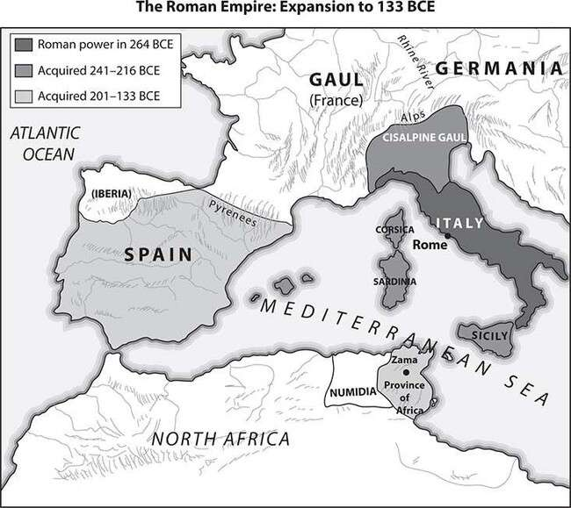

- During which time period did the Roman Empire expand to include Spain?
  - before 264 BCE
  - 241–218 BCE
  - 201–133 BCE
  - after 133 BCE
- Which statement is true?
  - By 133 BCE the Roman Empire included regions on two continents.
  - The Roman Empire reached to the Atlantic Ocean by 264 BCE.
  - Britain was acquired by the Roman Empire in 133 BCE.

  - Gaul was acquired by the Roman Empire before 264 BCE.
Answers are on page 831.

The Great Migration and the Middle Ages
From the 6th millennium BCE, people had inhabited the steppes of Central Asia—bleak grasslands bordered by the Ural Mountains and the Gobi desert. Small tribes of people roamed the harsh terrain, following the herds on which they depended for milk and meat. By mastering horses and learning to work with iron—they were the first people to make wheels with spokes—the Central Asian tribes became formidable bands of warriors. They spearheaded a great westward migration that ended in the settlement of Europe.
Peoples from Central Asia migrated into Europe in waves. The Goths established a stronghold around present-day Poland and Hungary; the Huns drove them out between AD 100 and 300. The Goths moved south, defeating the Roman army at Adrianople and achieving official Roman recognition of a Goth state in 382. By 550–600 the Slavs had become the dominant culture in southeastern Europe. In the West, the Germanic tribe of the Franks divided, with the West Franks eventually becoming the French and the East Franks eventually becoming the Germans. The West Franks dominated a mixed culture that included Roman Gauls, Bretons, Belges, Vikings, and a mix of others; the East Franks absorbed Slav elements into their culture. At the same time, the Sueves, Burgundians, and Anglo-Saxons established themselves in present-day Spain, France, and Britain. The culture of these nomadic migrants was primitive compared to Greco-Roman Classical civilization, which is why the Romans referred to all the Northern peoples as “barbarians.” Instead of emphasizing intellectual and artistic achievement or creating sophisticated governments and law codes, the Northern tribes concentrated on pillage and plunder.
The Middle Ages, also known as the medieval period, was an era of conflict that began in the 5th century with various migrating peoples

continually struggling for supremacy. The early medieval period, especially the years from 750 to 1054, was a time of continual raids on France, Britain, and Eastern Europe by Viking tribes from Scandinavia. In the same period, Vikings traveling through what is now Russia founded the cities of Kiev and Novgorod; the local Muscovy princes would later absorb these states into the expanding Russian empire. After the Christian conversion of Vladimir I in 988, Kiev became culturally more Slavic and Byzantine. To meet the threat of the Viking invaders, the local Slavs began reorganizing themselves along Viking-style political lines; this led to greater social organization and thence to true civilization rather than tribal culture.
EXERCISE 6

The Great Migration and the Middle Ages
Directions: Choose the best answer to each of the following questions.
- Which of the following tribes of nomadic migrants became part of West Frank culture?
  - Sueves
  - Burgundians
  - Bretons
  - Slavs
- Viking tribes traveled through many parts of Europe, including areas in which of the following modern-day countries?
  - Spain
  - Portugal
  - Greece
  - Russia
Answers are on page 831.

Feudalism
The feudal system developed during this early medieval era—not only in Europe, but also in India, China, and Japan. The social contract between classes was based on an oath of loyalty, which people of this era considered legally binding. The monarch provided warriors with vast land grants and noble titles in exchange for their loyal military service. The warrior thus became the lord of a large estate—the ruler of his own small feudal realm, in which he protected and housed his vassals in exchange for their military service, loyalty, and obedience. The “lord” of the estate might even be a lady; very few medieval women were warriors (there were rare exceptions even to this rule, such as Joan of Arc), but some women achieved positions of great power through marriage or widowhood.
The monarch and the lords worked out an uneasy balance of power. The monarch wanted to control the realm and command the obedience of all his subjects, but the lords held so much independent power on their estates that they might easily defy the monarch, even though they agreed that the monarch ruled by divine right. The Magna Carta is an example of what could happen when the lords united against the monarch. King John of England had such a disgraceful record of bad administration and unwise rule that in 1215, the lords forced him to sign the Magna Carta, which specifically stated that even the monarch was not above the law, and laid the foundations for the parliamentary system that England would eventually adopt.
EXERCISE 7

Feudalism
Directions: Choose the best answer to each of the following questions.
- Feudal vassals were given housing and farmland by lords in exchange for
  - military service and obedience.
  - a promise of marriage.

  - giving up one child for slavery.
  - taxes on sales at the local market.
- King John of England signed the Magna Carta following disputes with
  - the king of France.
  - English lords.
  - English commoners.
  - French knights.
Answers are on page 831.

The Middle East and Africa
Islam, the religion that would eventually unify the entire Near East, was founded in the early 7th century in Arabia. Muslims worship the same god as Jews and Christians; Allah is simply the Arabic name for him. Muslims regard Jesus as a great prophet, but secondary to Islam’s founder, Muhammad. Islam is based on the Five Pillars: faith, prayer, alms, fasting, and pilgrimage to Mecca.
By the end of the 10th century, Islam had taken firm hold on a sizeable region of the world. Muhammad was not only the founder of a major world religion; he was also an extraordinary political leader who unified all the Arab tribes under one central government for the first time in their history. Muslim armies conquered an empire that was highly diverse, embracing Turkish, Persian, and North African cultural and artistic traditions. The Muslims even penetrated Europe as far as northern Spain; they would remain in power on the Iberian Peninsula for the better part of 800 years.
Starting in the 15th century, much of the Middle East was controlled by Ottoman Turkish rulers based in Constantinople. Under the Ottomans, the Islamic world reached a zenith of cultural, literary, and artistic achievement—but soon lagged behind the West, partly due to its inability or refusal to embrace new scientific methods. While Europeans devised

their first printing press in 1455, the Arab peoples did not acquire this technology until 1727. At a time when a pendulum clock was an ordinary household object in Europe, it was a curiosity and a rare luxury in India. Beginning around the mid-1700s, the Ottoman Empire steadily lost power and influence; the Islamic world would not play a significant power role in international politics again until the 1970s.
The major African civilizations of the first millennium included Nubia, located on the Nile River in what is now Sudan and southern Egypt, and Axum, located in what is now northern Ethiopia. The kingdom of Ghana, on the coast of West Africa, prospered from about 830 to 1235. It traded extensively by camel caravan with the countries north of the Sahara desert, providing them with gold, ivory, and salt. Foreign invasion, religious conversion, and international trade are the major themes of these civilizations.
EXERCISE 8

The Middle East and Africa
Directions: Choose the best answer to each of the following questions.
- Which statement is supported by the information above?
  - The Muslim empire required its Persian, Turkish, and North African subjects to abandon their native cultures.
  - The African kingdom of Ghana had little contact with the outside world.
  - The kingdom of Nubia was located in what is now northern Ethiopia.
  - The Ottoman Empire lasted from the 15th century into the 20th century.
- According to the text, which of the following statements is an opinion, not a fact?
  - Muslim rulers governed Spain for hundreds of years.
  - The Ottoman Empire grew steadily weaker after the mid-1700s.

  - The kingdom of Nubia was the greatest of the ancient African civilizations.
  - Muslim armies conquered Persia, Turkey, and much of North Africa.
Answers are on page 831.

Civilizations in the Americas
Native Americans created numerous civilizations throughout the Americas. In North America, hundreds of different peoples developed ways of life that were well adapted to the continent’s different environments. Their settlements were often linked by long-distance trade networks. In the eastern forests, people lived in villages and lived by hunting, fishing, and farming based on growing maize (corn). In the Great Plains, people followed a nomadic lifestyle and survived by hunting bison and other animals. In the desert southwest, Native Americans built towns and practiced agriculture, often by irrigation.
To the south, Native American people created advanced civilizations and established empires. The Maya dominated Central America and built stone cities with large temples before AD 900. They developed a complex writing system and an accurate calendar. Later the Aztecs conquered a large empire in what is now Mexico and built their capital city where Mexico City is located today.
Farther south, in the Andes Mountains of South America, the Inca created an empire that lasted until the early 1500s. The Inca built large cities and developed an efficient administration system to make their empire run smoothly. The Aztec and the Inca civilizations flourished until their conquest by the Spanish in the early 16th century.
Exercise 9

Civilizations in the Americas

Directions: Choose the best answer to the following question.
- Based on the information above, you can infer that
  - the Maya kept careful track of days and years.
  - Native American tribes in North America had little contact with each other.
  - no Native Americans ever lived in large cities.
  - native peoples in Central America failed to develop a writing system.
The answer is on page 831.

Renaissance and Reformation in Europe
Two important factors made the Renaissance, a cultural movement that began in Italy around 1350, a great turning point in Western history. One was a resurgence of interest in Classical philosophy, literature, and art.
The second was a sharp rise in literacy—the effect of the development of moveable type and the printing press.
The Koreans invented movable type; it was modified in Germany and ended up having a much greater effect in the West than in Korea and China. With books readily available, people could read on their own instead of simply trusting what the learned authorities told them.
The religious movement called the Reformation began in 1517 with the founding of the Lutheran Church. By 1600, thousands of Europeans— particularly Northern Europeans—were worshipping in Lutheran, Calvinist, and Anglican churches. The success of Protestantism (it gets its name because its believers protested against Catholic doctrine) had multiple causes: a growing realization that the Catholic Church was neither all-powerful nor morally above reproach, a rise in secular political power, and the perfection of the printing process. People could now read the Bible (and all other books) for themselves; they no longer had to accept the Church’s interpretation of Scripture.

EXERCISE 10

Renaissance and Reformation in Europe
Directions: Choose the best answer to each of the following questions.
- Based on the text, which of the following statements is true?
  - Protestantism was the result of protests against the Lutheran Church.
  - The concept of movable type, or the printing press, was not invented in Europe.
  - The Renaissance began in Korea and China before spreading to Western Europe.
  - Calvinists thought that only church officials should be permitted to read.
- Based on the information above, it can be inferred that
  - Lutherans, Calvinists, and Anglicans do not agree on Christian dogma.
  - the Catholic Church was opposed to Classical literature and art.
  - the sharp rise in literacy in Europe had a profound effect on history.
  - people in southern Europe were predominantly Muslim.
Answers are on page 831.

The Scientific Revolution, the Enlightenment, and the Industrial Revolution
The Scientific Revolution was a time of great progress in human understanding of the laws of the universe. This era changed not only what people thought but, more important, how they thought. The discoveries of the Scientific Revolution (such as the moons of Jupiter and the paths of

the planets around the sun) were the product of practical experimentation rather than abstract philosophy.
The philosophes (French for philosophers) of the 18th-century Enlightenment applied this scientific process of critical thinking to social and political problems. They argued that all people were born free and equal and that individuals should be able to make their way in the world as reasonable beings as to how they wished to live. Their works encouraged people to believe that they did not have to accept existing conditions and that they could create new institutions to their own liking. In the end, Enlightenment teachings led directly to major revolutions in British North America and in France.
Later on in the 18th and 19th centuries, the Industrial Revolution demonstrated a third way of using the process of observation and experimentation: by applying it to the mechanical challenges of manufacturing and agriculture. New machines appeared with bewildering rapidity, permanently altering the pace of human life and shifting the Western economy from a basis in agriculture to a basis in mass production.
Exercise 11

The Scientific Revolution, the Enlightenment, and the Industrial Revolution
Directions: Choose the best answer to each of the following questions.
- The philosophes of the Enlightenment applied what process to social and political problems?
  - resource management, like that used in agriculture
  - mass production, like that used in manufacturing
  - critical thinking, like that used in science
  - cataloguing, like that used in libraries

- The progress and discoveries of the Scientific Revolution were based on
  - the opinions of French aristocrats.
  - the machines of the Industrial Revolution.
  - practical experimentation rather than abstract philosophy.
  - the migration of workers form rural areas to big cities.
Answers are on page 831.

The Age of Exploration
At the end of the 1400s, European monarchs began sponsoring voyages of exploration beyond the world they knew. Their purposes were fourfold: trade, conquest and expansion, religious conversion, and curiosity.
- Trade. The natural resources of the colonized regions—Asia, Africa, and the Americas—included such non-European items as rice, coffee, sugar, rubber, silk, cotton, gold, diamonds, and spices. West Africa was also the source of slave labor throughout the 18th century. Colonization meant that Europeans could set their own prices for what they bought from the colonies and what they sold to them.
- Conquest, expansion, and profit. A larger population meant more revenue for the crown in taxes, more income for the churches in tithes, and more soldiers in the army. Therefore three of the most powerful branches of society—the court, the clergy, and the military—were united in the desire to explore the seas and lands beyond Europe in the hope of establishing colonies that would make them richer and stronger than their neighbors.
- Religious conversion. The third motive, religious conversion, was a product of the universal Christian belief that it was a Christian’s duty to convert non-Christians and thus save their souls.
- Curiosity. The last motive, and a very powerful one, was the universal human sense of adventure and curiosity—the drive to find out things

that has characterized human beings since the beginning of civilization.
EXERCISE 12

The Age of Exploration
Directions: Choose the best answer to each of the following questions.
- Which of the following was NOT a motive of explorers in the Age of Exploration?
  - conquest
  - religious conversion
  - curiosity
  - hostility
- Religious conversion was a key objective in the Age of Exploration because Christian explorers thought it was their duty to convert non-Christians to Christianity.
TRUE or FALSE
Answers are on page 832.

Building Empires
Nations become empires in two ways—either by swallowing up adjoining land and thus expanding their borders or by seizing colonies some distance away. Rome, China, India, Russia, and the United States are examples of the first type of empire (the United States would acquire a few offshore colonies at the turn of the 20th century). Spain, France, Prussia (later Germany), and Britain are examples of the second.
The European powers colonized the entire continent of Africa (except Ethiopia and Liberia), and all the Southeast Asian kingdoms except Siam

(present-day Thailand). These colonies could not match the military might of the invaders, so they had to accept foreign rule.
Spain colonized all of Mexico, Central America, most of South America except for Brazil, and the Philippines in Asia. It also conquered nearly one-third of the present-day United States. Portugal colonized Brazil as well as Angola, Mozambique, and Guinea-Bissau in Africa and Macau in Asia.
France colonized Vietnam, much of North and West Africa, Canada, the Great Lakes region, and the Louisiana Territory, which it later sold to the United States. French Canada was conquered by Britain. France and Britain fought over control of India; in 1850 Britain won the fight and would govern India until after World War II. Britain also held colonies in Africa and Asia and sent settlers to colonize Australia and New Zealand.
The European countries profited from the colonies by extracting natural resources such as gold, oil, metals, and timber. The colonies also served as protected markets for the goods manufactured in Europe. The age of colonization ended with World War II for two reasons; the European powers could no longer afford to maintain colonies, and the people who lived in the colonized countries began to rebel against foreign rule.
EXERCISE 13

Building Empires
Directions: Choose the best answer to the following question.
- For each country or region in the following list, indicate which country colonized it by writing the name in the proper column in the table. Then indicate the column in the table where each statement belongs. (Note: On the real GED® test, you will click on the country name and “drag” it into position in the diagram.)

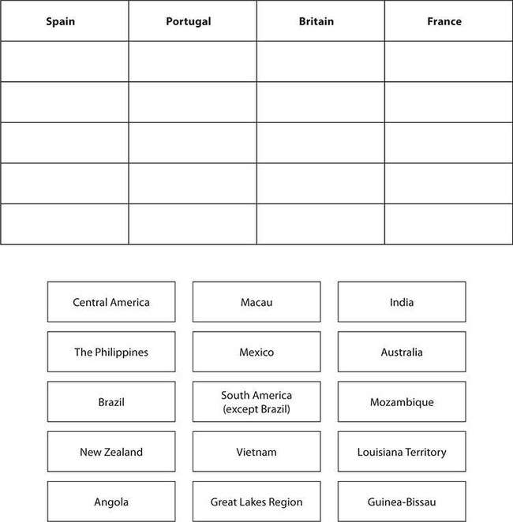
The answers are on page 832.

Revolutions in Britain and France
Between 1689 and 1789, the West saw three major political revolutions— one in England, one in America, and one in France.
In Great Britain, 50 years of violent conflict between Parliament and the absolutist monarchy led to the Glorious Revolution. In 1649,

following defeat in battle, Charles I was captured by Parliamentary forces and executed for treason; after a brief military dictatorship under Oliver Cromwell, Charles’s son Charles II was crowned in 1660. When Charles II died and his unpopular Catholic brother became king as James II, Parliament rebelled, inviting James’s Protestant daughter Mary and her husband William of Orange (in Holland) to rule jointly. James II fled to France, and the Glorious Revolution was won without a shot being fired.
The English Bill of Rights, passed by Parliament in 1689, ushered in a new era of individual rights and constitutional monarchy.
In the French Revolution of 1789, commoners rebelled against an absolute monarch and an overprivileged aristocracy. Unable to devise a viable republican government to replace the monarchy, France became a military dictatorship under Napoleon Bonaparte. His attempt to conquer all of Europe united all the other nations against France and ended in his defeat and exile. The French monarchy was restored, but with constitutional limits on the monarch’s power.
EXERCISE 14

Revolutions in Britain and France
Directions: Choose the best answer to each of the following questions.
- According to the information above, which of the following statements is true?
  - William and Mary were childless and assumed that the monarchy would end with them.
  - No actual battles were fought during the Glorious Revolution of 1688.
  - The French Revolution was an uprising against the military dictatorship of Napoleon Bonaparte.
  - James II of England fled to France in 1649 following the execution of his father Charles I.

- The English and French revolutions both eventually led to what change in the powers of the monarch?
  - Constitutional limits were placed on the monarch’s powers.
  - The monarch became a military dictator.
  - All restrictions on the monarch’s powers were removed.
  - All of the monarch’s powers were transferred to Parliament.
Answers are on page 832.

New Political Ideas in the 19th Century
Many new political forces came into being in the 19th century— liberalism, socialism, nationalism, conservatism, and Marxism. This table explains what each term means.

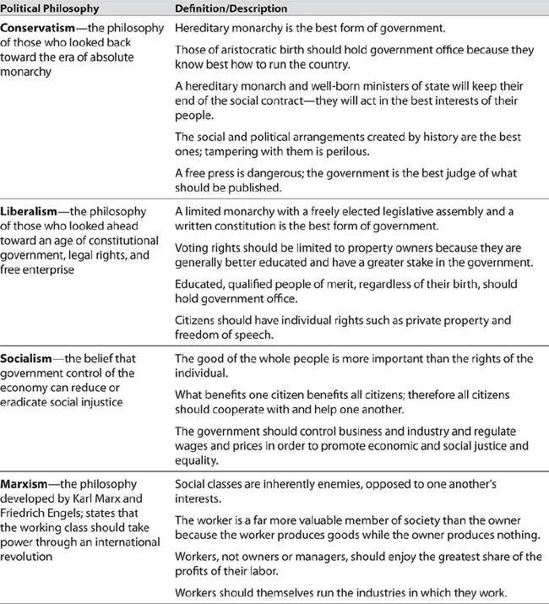
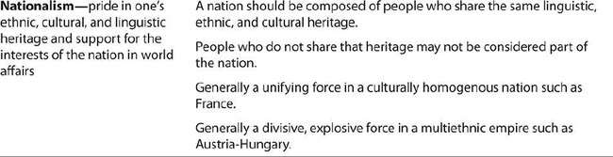

EXERCISE 15

New Political Ideas in the 19th Century
Directions: Choose the best answer to each of the following questions.
- Which political philosophy holds that government should control business and regulate wages and prices?
  - liberalism
  - socialism
  - nationalism
  - conservatism
- Nineteenth-century conservatives and liberals both supported monarchy, but they differed in regard to
  - the right to strike.
  - freedom of the press.
  - pride in their country.
  - government control of business.
Answers are on page 832.

Political Developments in 19th-Century Europe
Examples of constitutional governments in Great Britain, France, and the United States led to loud calls for written constitutions in many European nations. One wave of European revolutions took place in 1830 and another in 1848. In those revolutions, the forces of liberalism, which supported representative government, scored some victories—although conservative governments were still in power in several countries at the end of the century.
One of the most conservative was the Austro-Hungarian Empire, which included a diverse mix of Germans, Czechs, Hungarians, Croats, and

Italians. Nationalism—pride in one’s culture and language—made all these groups chafe at living in an empire instead of being independent. The growing strength of nationalism was a major factor in the unification of Italy in 1861 and of Germany in 1871. Nationalism in Ireland made the Irish restive under British rule and led to some reforms in Britain’s Irish policy.
Nationalism also contributed to the decline and fall of the Ottoman Empire. Throughout the 10th century the Ottomans steadily lost territory and influence, until the Empire was eliminated altogether after World War
I. In 1923 the Empire was transformed into Turkey, a secular Islamic republic.
In Russia, a rebellion in 1905 did not succeed in overthrowing the tsar, but it did lay the groundwork for the Revolution of 1917.
EXERCISE 16

Political Developments in 19th-Century Europe
Directions: Choose the best answer to each of the following questions.
- Which statement is supported by the text?
  - Ireland gained independence from Great Britain in 1871.
  - The unification of Italy resulted from the revolutions of 1830.
  - Nationalism divided Austria-Hungary, but it united the states that joined to form Italy and Germany.
  - The Czechs and Croats were the most liberal groups in Austria- Hungary.
- Which conclusion can be drawn about the Ottoman Empire?
  - In the later 19th century, the Ottomans became close allies of the French.
  - The armies of Europe were no match for the forces of the Ottoman Empire.
  - The people of Turkey still refer to themselves as Ottomans.

  - Throughout the 19th century the Ottoman Empire steadily lost territory and influence.
Answers are on page 832.

World War I and the Russian Revolution
World War I (called the Great War at the time, since no one anticipated World War II) happened primarily for two reasons. The first was nationalism: nationalist agitation among Serbs and other Slavs in Austria’s Balkan provinces threatened the power of the Austro-Hungarian Empire, and German nationalism had led to a major buildup of the German military during the 1910s. The second reason for going to war was maintaining the European balance of power. The unification of Germany had created a large, strong, powerful nation-state whose ambitions caused grave concern to Britain, Russia, and especially France. Those three countries formed a defensive alliance. Germany allied itself with Austria- Hungary. When a Serb nationalist assassinated an Austrian archduke at Sarajevo in 1914, Austria declared war on Serbia, Russia mobilized to defend the Serbs, and the alliances went into action. Soon Britain, France, and Russia (the “Allies”) were at war with Germany, Austria, and the Ottoman Empire (the “Central Powers”).
The war wrecked the European economy; Russian farmers and workers were especially hard hit. Tsar Nicholas II was unable to take control and improve matters. Resentment against the tsar led to a popular uprising in 1917, and as a result Nicholas abdicated. After a chaotic power struggle, control of the government passed to the leftist Bolshevik Party led by V. I. Lenin. Lenin signed a peace treaty with Germany, withdrew Russian troops from the war, and began to convert the newly renamed Soviet Union into a Communist dictatorship. Britain and France, dismayed by the abrupt withdrawal of a powerful ally, were heartened when the United States joined the war. The tide turned in the Allies’ favor and Germany agreed to an armistice on November 11, 1918.

At the peace conference, the Allied leaders did three things to restore the balance of power in Europe. First, they partially redrew the map of Europe along nationalist lines, creating new states, expanding others, and breaking up the Austro-Hungarian Empire. Second, after making Germany accept responsibility for the war, they reduced Germany’s strength by ordering the Germans to maintain the German Rhineland as a demilitarized zone, to pay enormous reparations, and to reduce the size of the German army and navy. Third, the Allied leaders created the League of Nations as an international forum for resolving conflicts and maintaining peace.
Exercise 17

World War I and the Russian Revolution
Directions: Choose the best answer to each of the following questions.
- Which event upset the European balance of power and led to World War I?
  - the unification of Germany as a powerful, ambitious nation state
  - revolution in Russia and its transformation into a Communist dictatorship
  - the breakup of Austria-Hungary into separate nations
  - the weakness of the Allies compared to the Central Powers
- After the war, the Allies redrew the map of Europe in response to the wishes of
  - the Central Powers.
  - Russian Communists.
  - European nationalists.
  - the League of Nations.
- At the peace conference, the Allies imposed harsh measures on Germany. You can infer that these measures were intended to

  - stop Germany from joining the Soviet Union.
  - prevent Germany from starting another war.
  - encourage a revival of the German economy.
  - keep the League of Nations from interfering in German affairs.
Answers are on page 832.

The Rise of Fascism
During the 1920s and 1930s, fascist governments arose in Italy, Germany, Spain, and Eastern Europe; by 1937, Japan was also under strict military rule, and Communist forces were on the rise in China.
Fascism was a political doctrine that promoted extreme nationalism as a way of achieving national unity and eliminating domestic social and economic strife. In this it differed from Communism, which in theory offered a new social order run by the working class, and fascists and Communists despised each other. In day-to-day practice, however, fascism and Communism often amounted to the same thing—absolute dictatorship of a police state, with only one political party that tolerated no opposition.
In Germany, the fascists, who were called National Socialists (“Nazis”), also implemented policies of racial persecution, particularly of Jews, whom they blamed for the country’s economic and other ills. Social and political developments of the period gave rise to these dictatorships. The first was the rise of mass political parties. The second was dissension among liberals in government and parliaments and their helplessness to respond effectively when a massive economic depression struck in the 1930s. The third was the large class of World War I veterans who made an enthusiastic audience for nationalist rhetoric.
EXERCISE 18

The Rise of Fascism

Directions: Choose the best answer to each of the following questions.
- According to the text, the rise of fascism in Germany was aided by
  - the rejection of nationalism by all political parties.
  - the growing strength of Communist parties in Asia.
  - the government’s failure to effectively combat economic depression.
  - interference in German politics by outsiders.
- German fascists used which of the following to attract supporters?
  - alliance with the Communists
  - strikes for higher wages
  - promises to veterans that there would be no more wars
  - extreme nationalism
Answers are on page 832.

World War II
World War II was a war of German aggression—a war fought partly to change the defeat of World War I into a victory and partly to take over Europe as Napoleon had temporarily succeeded in doing at the beginning of the 19th century.
World War II began in 1939 when Germany, after taking over Austria and Czechoslovakia, invaded Poland. France and Great Britain declared war, but Germany soon conquered the Netherlands, Belgium, and France and launched air attacks on Britain. After failing to conquer Britain, Germany began an invasion of the Soviet Union. Germany and its ally Italy (the “Axis” powers) maintained control of the war until late 1942. Their well-planned invasions succeeded more or less by surprise. The German troops were extremely effective, and Germany and Italy eventually controlled almost all of Europe and a sizable chunk of North Africa.

In the Pacific, Japan had invaded the Manchurian region of China and was seeking further conquests. It joined Germany and Italy in the Axis alliance, and when Japan attacked the United States at Pearl Harbor in Hawaii in 1941, Germany also declared war on the United States. Great Britain, the United States, and the Soviet Union then joined in a great alliance to defeat Germany, and their numerical and economic strength eventually turned the tide. Additionally, the distant American factories were well out of danger of being bombed or captured, so the Allied source of tanks and munitions never dried up.
During the time when Germany ruled most of Europe, the fascist Nazis implemented extreme racial persecution measures within the occupied countries. Approximately six million European Jews were forced into concentration camps and murdered—an event known as the Holocaust.
Millions of other Europeans were also killed by the Nazis.
The war is accurately called a world war because of the extent of the fighting outside of Europe. After more than three years of fighting in the Pacific, Japan finally conceded defeat after it was attacked with nuclear weapons in 1945.
EXERCISE 19

World War II
Directions: Choose the best answer to each of the following questions.
- Great Britain and France declared war on Germany in 1939 after Germany invaded
  - Poland.
  - Austria.
  - France.
  - the Netherlands.
Question 2 is based on the following passage:

Yesterday, December 7, 1941—a date which will live in infamy
—the United States of America was suddenly and deliberately attacked by naval and air forces of the Empire of Japan. The United States was at peace with that nation, and, at the solicitation of Japan, was still in conversation with its government and its emperor looking toward the maintenance of peace in the Pacific.
—Excerpt from the speech to Congress by President Franklin Roosevelt, requesting a declaration of war, December 8, 1941
- According to the speech, December 7, 1941, will “live in infamy” because
  - the attack on Pearl Harbor had no effect on the United States.
  - the United States was already at war with Germany in Europe.
  - Japan had never before attacked another country.
  - the attack on the United States was unprovoked, with no declaration of war.
Answers are on page 832.

The End of European Dominance and the Formation of the European Union
At the start of the 20th century, Europe was the world’s most powerful region, controlling many parts of Asia and most of Africa. After 1945, the former European powers had no resources to spare for their colonial empires; all their energies and resources were concentrated on rebuilding. The postwar era therefore saw a wave of independence throughout all of Africa. It was not gained easily, peacefully, or overnight, and in some African nations it led to an era of harsh military rule, corruption, and violent social and political unrest.
India also finally broke free from British rule and was divided into two separate states: a Hindu India and an Islamic Pakistan. Millions of Indian

Muslims immediately crossed the border into Pakistan, while Pakistani Hindus fled to India.
During the late 1950s, Western European nations began to profit from the experience of their wartime alliance; they realized they were stronger united than they were on their own, and that peaceful cooperation was better than wars of conquest. A European Economic Community was created, and this led to the formation of the European Union (EU) in 1991. EU nations are entirely independent and self-governing, but they share common foreign and security policies and they cooperate on matters of domestic policy and affairs of international justice. They have had a common currency, the euro, since 1999.
EXERCISE 20

The End of European Dominance and the Formation of the European Union
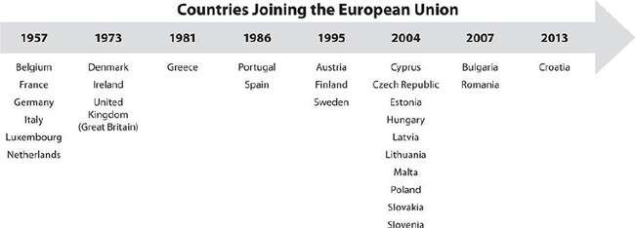
Directions: Choose the best answer to the following question. Questions 1 and 2 are is based on the following timeline:

- According to the timeline, countries joined the European Union in 2004.

- In the early 2000s, the majority of the countries that joined the European Union were located in
  - western Europe
  - eastern Europe
  - northern Europe
  - southern Europe
The answer is on page 832.

The End of the Soviet Union
By 1945, the Soviet Union held total political sway over all of Eastern Europe. Puppet Communist governments under the control of Moscow existed in all these small Slavic nations except Yugoslavia, ruled by the fiercely independent Marshall Tito. Germany was divided into two nations, democratic West Germany and Communist East Germany. A political border nicknamed the Iron Curtain would exist between Western and Eastern Europe from the late 1940s until 1989. In the divided city of Berlin, the Iron Curtain became an actual concrete wall in 1961; the Berlin Wall would be the most powerful symbol of the Cold War. The Soviet Union did not hesitate to use brute force in suppressing popular uprisings and attempts at reform such as the Prague Spring of 1968.
Soviet Communism proved economically unfeasible, despite major Soviet victories in the “space race” with the United States. Each superpower tried to outdo the other in exploring the universe beyond Earth. After the death of dictator Joseph Stalin and a lengthy period of economic stagnation, a gradual thaw in Soviet policy eventually led to the end of the Cold War, successful political uprisings, and the coming of democratic government to Eastern Europe. The Berlin Wall was demolished in 1989, and the Soviet Union broke up into independent republics in 1991.
EXERCISE 21

The End of the Soviet Union
Directions: Choose the best answer to the following question.
- Which of the following contributed to the collapse of the Soviet Union?
  - the suppression of the “Prague Spring”
  - the division of Germany into two nations
  - a lengthy period of economic stagnation
  - the building of the Berlin Wall
The answer is on page 832.

China Today
Communist one-party rule was established in China in 1949 after a civil war. After several decades of isolation, a certain amount of market free enterprise was reintroduced, and Communist China began rising to world prominence and power. The early 21st century has been a time of great prosperity for some groups and regions in China.
However, the country continues to suffer grave social problems.
Chinese citizens do not have unrestricted access to outside information sources, the press is censored, and political dissidence is not tolerated.
Tens of thousands of workers earn extremely low wages turning out electronic devices; cheap, low-quality clothing and household items; and other export items, which the United States and other nations continue to import because the prices are so low.
EXERCISE 22

China Today
Directions: Choose the best answer to the following question.

Question 1 is based on the following graph:
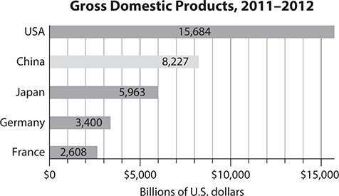

- According to the graph, China’s gross domestic product (GDP) in 2011–2012 was approximately
  - $2.6 trillion.
  - $3.4 trillion.
  - $8.2 trillion.
  - $15.7 trillion.
The answer is on page 832.

The Arab World
A massive demand for oil in the post–World War II era led to an enormous economic change in the Middle East. As the source of most of the world’s oil, the region leapt into a position of international consequence and great prosperity almost overnight. In 1960, five of the Arab nations created a cartel called the Organization of Petroleum Exporting Countries (OPEC) with the purpose of regulating oil prices and controlling the supply of oil to the rest of the world. Today, OPEC has 12 member nations including 4 in Africa and 2 in South America.

Most Middle Eastern nations are either military dictatorships or monarchies; the press is heavily censored in these countries. In many of these countries, Islamic leaders constantly pressure their governments to enforce Islamic values and practices.
The creation of the state of Israel in the late 1940s caused great turmoil in the region, and the situation was worsened when Israel began a long- term occupation of territories with Arab populations during the “Six-Day War” in 1967. In 2011 a series of popular uprisings in Arab countries (dubbed the Arab Spring) raised hopes for the creation of democratic governments, but they also opened new conflicts between pro-Western liberals and Islamists.
EXERCISE 23

The Arab World
Directions: Choose the best answer to the following question.
- What claim about the modern Middle East is supported by the text?
  - In many Middle Eastern countries, politics and religion are frequently intertwined.
  - The state of Israel was created after the “Six-Day War” in 1967.
  - OPEC allows only Middle Eastern countries as members.
  - The “Arab Spring” put an end to monarchies in the Middle East.
The answer is on page 832.

PRACTICE

Focusing Themes

Directions: Fill in the blank with the word or phrase that makes the sentence true.
- The earliest human civilizations occurred in a region we call the
because its climate was ideal for good harvests.
  - Silk Road
  - Rift Valley
  - Spice Islands
  - Fertile Crescent
- The Romans referred to Northern tribes like the Goths and Huns as
because Northern tribal culture was based on plunder and pillage, not on building cities, writing law codes, and creating works of art.
  - patricians
  - plebeians
  - barbarians
  - Gauls
- The medieval kingdom of Ghana, located in
, was known for its long-distance trade network of precious metals and spices.
  - West Africa
  - Persia
  - Arabia
  - the Indus Valley
- , defined as pride in one’s country’s ethnic and cultural heritage, was a major force driving political change in 19th-century Europe.
  - Communism
  - Liberalism
  - Socialism
  - Nationalism

- was a medieval system that bound together people of different social classes with oaths of loyalty and mutual responsibilities and duties.
  - Slavery
  - Feudalism
  - Colonialism
  - Monarchy
Choose the best answer to each of the following questions.
- The thinkers of the 18th-century Enlightenment taught that people do not have to accept existing conditions and can create new institutions to their own liking. Which of the following is true in regard to this idea?
  - Few people thought it was important.
  - Europeans used it to justify their empires.
  - It was popular with European kings.
  - It inspired the American and French Revolutions. Question 7 is based on the following passage:
We have before us an ordeal of the most grievous kind. We have before us many, many long months of struggle and of suffering. You ask, what is our policy? I can say: It is to wage war, by sea, land and air, with all our might and with all the strength that God can give us; to wage war against a monstrous tyranny, never surpassed in the dark, lamentable catalogue of human crime. That is our policy. You ask, what is our aim? I can answer in one word: It is victory, victory at all costs, victory in spite of all terror, victory, however long and hard the road may be; for without victory, there is no survival.
—Excerpt from a speech by Prime Minister Winston Churchill to the British Parliament early in World War II
- Which of the following can be inferred from the speech?

  - Churchill wanted the British to know that they faced a long and difficult war.
  - Churchill wanted Parliament to realize that Britain faced defeat.
  - Many people in Britain did not think the war was worth fighting.
  - Churchill thought that the war would soon be over.
- The colonial power that ruled India until 1947 was
  - Spain.
  - France.
  - Great Britain.
  - Portugal.
- Which of the following is true in regard to the European Union (EU)?
  - EU nations have never shared a common currency.
  - EU nations cooperate on matters of domestic policy.
  - EU nations all obey a single central government.
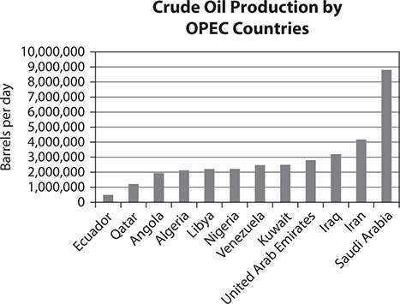
  - EU nations joined together in order to conquer other countries. Question 10 is based on the following graph:

- According to the graph, every OPEC country produces at least 2 million barrels of oil per day EXCEPT
  - Algeria and Angola.
  - Nigeria and Liberia.
  - Iran and Saudi Arabia.
  - Qatar, Ecuador, and Angola.

Answers are on page 832.

ANSWERS AND EXPLANATIONS
Social Studies

Chapter 1 Civics and Government
Exercise 1: Types of Historical and Modern Governments
- Correct answer: C
- D Every citizen can place proposals on the ballot, and a proposal becomes law if the majority vote for it.
R Citizens elect a legislature to rule the country.
R Delegates represent the wishes of the voting citizens.
D Power to veto laws rests with the citizens themselves.
Exercise 2: Basic Principles of American Constitutional Democracy
- Correct answer: B
- Correct answer: D
- Correct answer: C
- Correct answer: D

- Correct answer: A
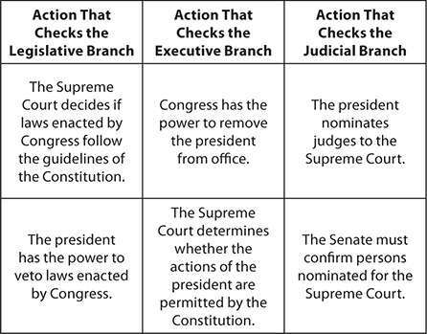
Exercise 3: Structure and Design of the U.S. Federal Government 1.

Exercise 4: The Legislative Branch
- Correct answer: B
- Correct answer: C
- Correct answer: B
Exercise 5: The Executive Branch
- Correct answer: B
- Correct answer: C
- Correct answer: A

- Correct answer: B
Exercise 6: The President’s Cabinet
- Correct answer: A
- Correct answer: D
Exercise 7: The Judicial Branch
- Correct answer: John Marshall
- Correct answer: 34
Exercise 8: Amending the Constitution
- Correct answer: D
- Correct answer: D Exercise 9: The Bill of Rights 1.

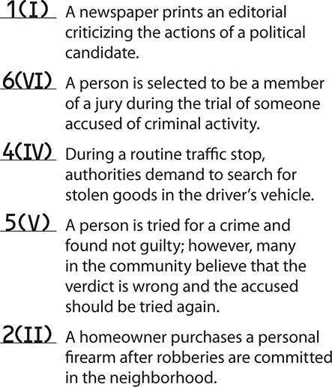

2.

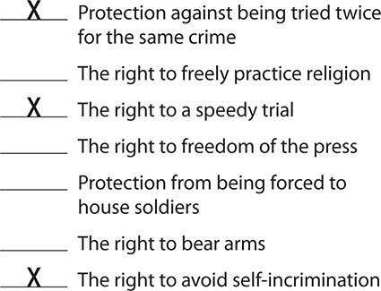

- Correct answer: D
Exercise 10: Citizens’ Rights and Civic Responsibilities
- Correct answer: Shirley M. Watts
- Correct answer: C
- Correct answer: D Exercise 11: Political Parties
- Correct answer: C
- Correct answer: C
- Correct answer: A
Exercise 12: Political Campaigns, Elections, and the Electoral Process
- Correct answer: C
- Correct answer: C

- Correct answer: D
Exercise 13: Contemporary Public Policy
- Correct answer: Education Is Primary
- Correct answer: A
Practice: Civics and Government
- Correct answer: A
- Correct answer: D
- Correct answer: A
- Correct answer: B
- Correct answer: C
- Correct answer: B
- Correct answer: C
- Correct answer: A
- Correct answer: D
- Correct answer: B

Chapter 2 United States History
Exercise 1: European Exploration of the Americas
- ​

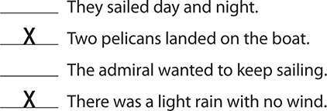

- Correct answer: B
- Correct answer: C. The line “Wrote down twenty-two” shows that Columbus may not be a credible source. He lied to his crew about the distance they had sailed. In the previous line he says they actually sailed 25 leagues.
Exercise 2: The English Colony in Virginia
- Correct answer: B
- Correct answer: A
Exercise 3: English Colonies in New England and Maryland
- Correct answer: D
- Correct answer: D
- ​
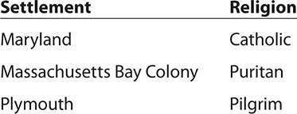

- Correct answer: Connecticut, New Hampshire, Rhode Island Exercise 4: The Thirteen Colonies Take Shape

- ​
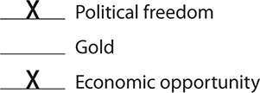
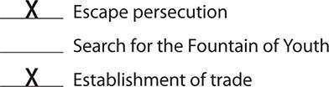

- Correct answer: D
- Correct answer: C
Exercise 5: Tensions Rise Between the Colonies and Great Britain
- Correct answer: B
- Correct answer: B
Exercise 6: The First Continental Congress and the Beginning of the American Revolution
- Correct answer: D
- Correct answer: B
Exercise 7: The Second Continental Congress and the Declaration of Independence
- ​

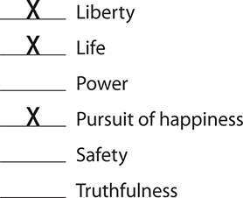

- Correct answer: A
Exercise 8: The Revolutionary War
- Correct answer: 6
- Correct answer: C
- Correct answer: C
Exercise 9: From the Articles of Confederation to the U.S. Constitution
  - Correct answer: C
  - Correct answer: B Exercise 10: The War of 1812
- Correct answer: C
- Correct answer: C
Exercise 11: The Monroe Doctrine
- Correct answer: A

- Correct answer: B
Exercise 12: U.S. Policy Toward Native Americans
- Correct answer: A
- Correct answer: D Exercise 13: Manifest Destiny
- Correct answer: C
- Correct answer: C
- Correct answer: B
Exercise 14: Civil War and Reconstruction
- ​
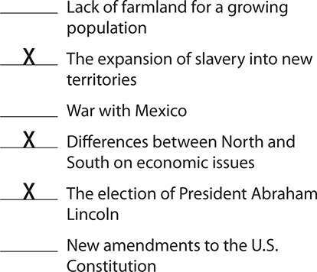

- Correct answer: C

Exercise 15: The United States Becomes a Major Industrial Nation
- Correct answer: B
- Correct answer: C
Exercise 16: The United States Becomes a World Power
- Correct answer: B Exercise 17: World War I
- Correct answer: A
- Correct answer: C
Exercise 18: The Great Depression
- Correct answer: D
- Correct answer: B Exercise 19: World War II
- Correct answer: D Exercise 20: Postwar America
- Correct answer: B
- Correct answer: C Exercise 21: The Cold War
- Correct answer: D
Exercise 22: The Civil Rights Movement and the Women’s Movement
- Correct answer: A

- Correct answer: D
Exercise 23: The Great Society, the Vietnam War, and Watergate
- Correct answer: C
- Correct answer: A
Exercise 24: Presidencies in the Late 20th and Early 21st Centuries
- Correct answer: C Practice: United States History
- Correct answer: A
- ​
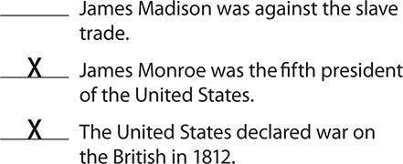
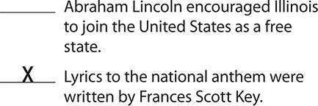

- Correct answer: B
- Correct answer: D
- ​

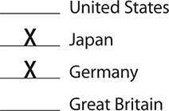

- Correct answer: B
- Correct answer: C
- Correct answer: D
- Correct answer: D
- Correct answer: A

Chapter 3 Economics
Exercise 1: Fundamental Economic Concepts
- Correct answer: C
- Correct answer: B
Exercise 2: Microeconomics and Macroeconomics
- Correct answer: False
- Correct answer: equilibrium Exercise 3: Banking and Credit
- Correct answer: D
- Correct answer: False

Exercise 4: The Role of Government in the National Economy
1.
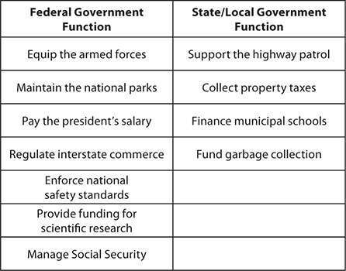

Exercise 5: International Trade
- Correct answer: C
- Correct answer: B
Exercise 6: Key Economic Events in U.S. History
- Correct answer: C
- Correct answer: D Practice: Economics
- Correct answer: A
- Correct answer: B

- Correct answer: C
- Correct answer: D
- X Congress
X President
Supreme Court
Secretary of Defense
- Correct answer:
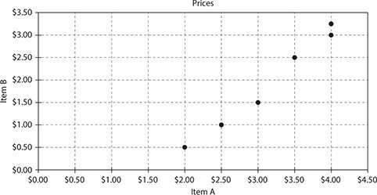

- Correct answer: A. If you draw a line of best fit for the data in the scatter plot, you can see that, in general, as the price of Item A increases, the price of Item B also increases.
- Correct answer: C. A scatter plot shows how data may or may not be correlated. This scatter plot shows that the prices of Item A and Item B are positively correlated, but that does not show anything about causation.
- Correct answer: B
- Correct answer: According to the law of supply and demand, if the supply of the product is greater than the demand for a product, the price of the product will fall.

Chapter 4 Geography and the World
Exercise 1: Ecosystems
- Correct answer: D
- Correct answer: B
Exercise 2: Geography and the Development of Human Societies
- Correct answer: D
- Correct answer: C
Exercise 3: Human Changes to the Environment
- Correct answer: B
- Correct answer: B Exercise 4: Human Migration
- Correct answer: C
- Correct answer: D
Exercise 5: Population Trends and Issues
- Correct answer: C
- Correct answer: False
Exercise 6: Geography Tools and Skills
- Correct answer: D
- Correct answer: A

Practice: Geography
- Correct answer: C
- Correct answer: A
- Correct answer: True
- Correct answer: C
- Correct answer: B
- Correct answer: A
- Correct answer: B

Chapter 5 Focusing Themes
Exercise 1: The Earliest Civilizations
- Correct answer: D
- Correct answer: A Exercise 2: Early China
- Correct answer: C
- Correct answer: D Exercise 3: Early India
- Correct answer: B Exercise 4: Classical Greece
- Correct answer: B

- Correct answer: A Exercise 5: Rome
- Correct answer: C
- Correct answer: A
Exercise 6: The Great Migration and the Middle Ages
- Correct answer: C
- Correct answer: D Exercise 7: Feudalism
- Correct answer: A
- Correct answer: B
Exercise 8: The Middle East and Africa
- Correct answer: D
- Correct answer: C
Exercise 9: Civilizations in the Americas
- Correct answer: A
Exercise 10: Renaissance and Reformation in Europe
- Correct answer: B
- Correct answer: C
Exercise 11: The Scientific Revolution, the Enlightenment, and the Industrial Revolution

- Correct answer: C
- Correct answer: C
Exercise 12: The Age of Exploration
- Correct answer: D
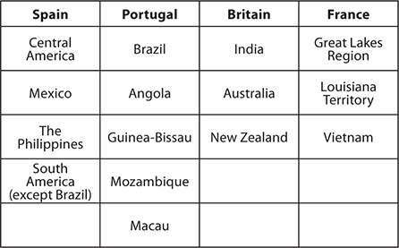
- Correct answer: True Exercise 13: Building Empires 1.

Exercise 14: Revolutions in Britain and France
- Correct answer: B
- Correct answer: A
Exercise 15: New Political Ideas in the 19th Century
- Correct answer: B
- Correct answer: B

Exercise 16: Political Developments in 19th-Century Europe
- Correct answer: C
- Correct answer: D
Exercise 17: World War I and the Russian Revolution
- Correct answer: A
- Correct answer: C
- Correct answer: B
Exercise 18: The Rise of Fascism
- Correct answer: C
- Correct answer: D Exercise 19: World War II
- Correct answer: A
- Correct answer: D
Exercise 20: The End of European Dominance and the Formation of the European Union
- Correct answer: 10
- Correct answer: B
Exercise 21: The End of the Soviet Union
- Correct answer: C Exercise 22: China Today

- Correct answer: C Exercise 23: The Arab World
- Correct answer: A Practice: Focusing Themes
- Correct answer: D
- Correct answer: C
- Correct answer: A
- Correct answer: D
- Correct answer: B
- Correct answer: D
- Correct answer: A
- Correct answer: C
- Correct answer: B
- Correct answer: D

