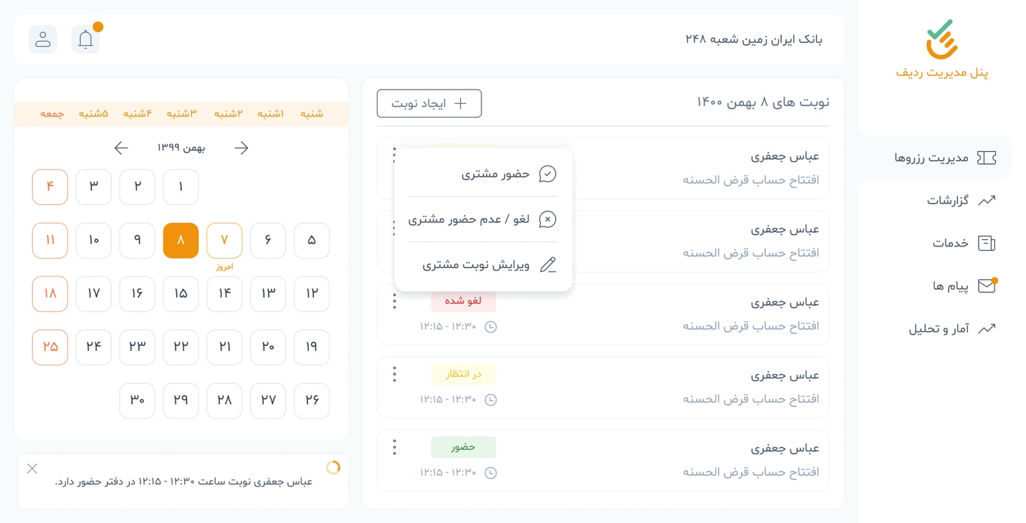

End Points:

* ​Filterable Turn List (GET): /rqueue​/turn​/
  + Filter based on queue_list__service (This value can be taken from logged in user)
  + And status__icontains should be equal to reserved to fetch only reserved orders.
* **{**
* **"id": 174,**
* **"track_code": "2270616174",**
* **"time": "2022-01-10T22:36:26Z",**
* **"status": "free",**
* **"presence_status": "Pending",**
* **"paid_status": false,**
* **"is_others": false,**
* **"others_info": null,**
* **"reserved_at": null,**
* **"created_at": "2022-01-10T12:23:51.269846Z",**
* **"updated_at": "2022-01-10T12:23:51.270845Z",**
* **"user": null,**
* **"queue_list": 6**
* **}**
* Turn Status Change (PATCH): /rqueue/turn/{id}/
  + Consider to send status as reserved when you. Want to change presence status.

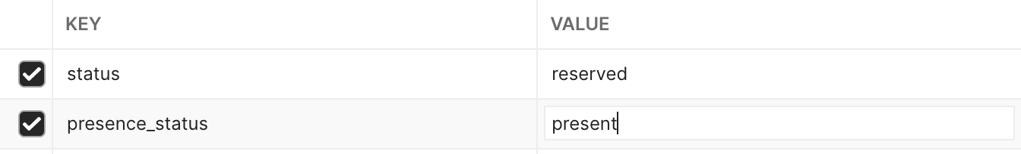

The List should return following data for Turn Detail

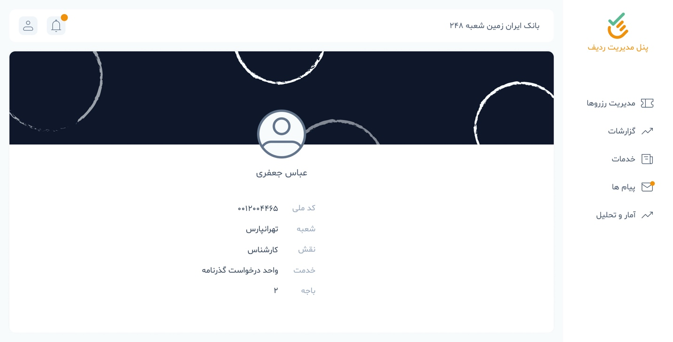

Totally Turn data can be fetched using the following end point:

* Fetch specific turn GET: /rqueue/turn/{id}

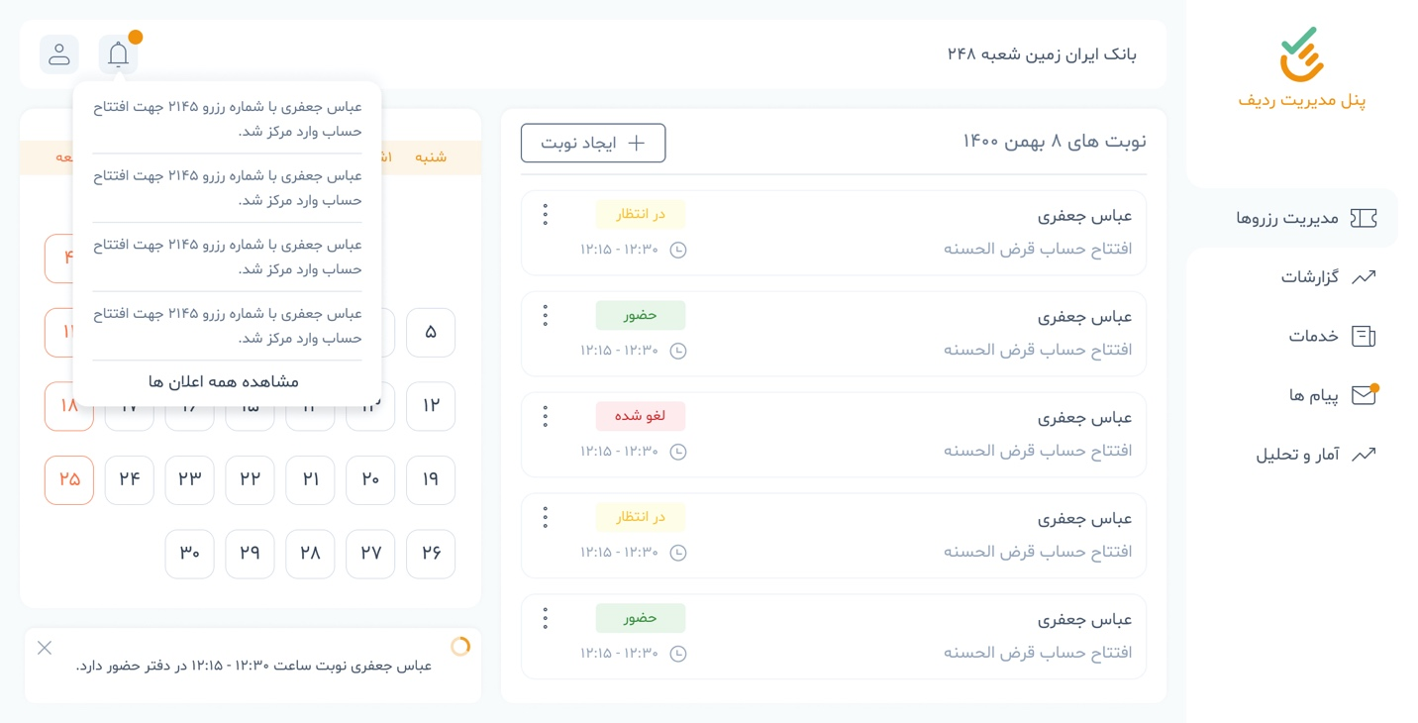

Notifications:

* Filterable Notification List (GET): /notification/notification/
* To mark notifications as read: /notification/mark-notification-as-read/
* **[**
* **{**
* **"id": 1,**
* **"title": "سلام",**
* **"content": "سلام دوباره",**
* **"url": "http://127.0.0.1:8000/admin/notification/notification/add/",**
* **"position": "left",**
* **"device": "test device",**
* **"created_at": "2022-01-15T15:20:02.329403Z",**
* **"updated_at": "2022-01-15T15:20:02.329403Z",**
* **"obb_id": 1,**
* **"users": [**
* **1**
* **],**
* **"send_approach": [**
* **1**
* **]**
* **}**
* **]**

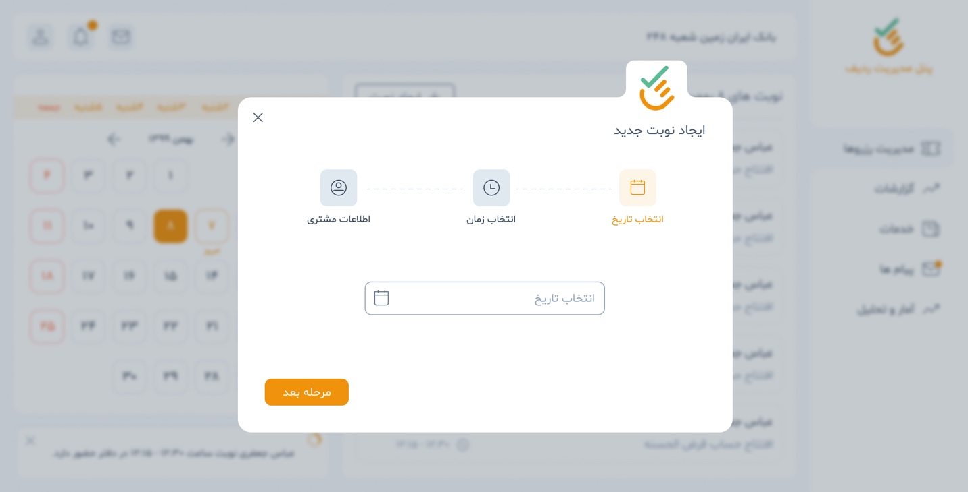

* Exactly like the application despite the turn is submitted for others

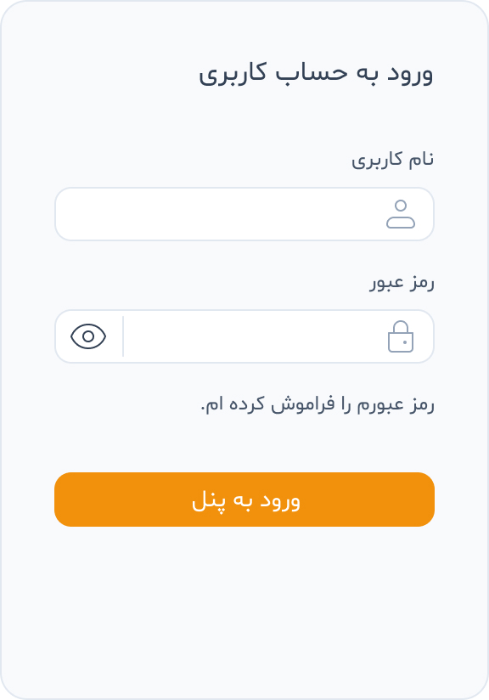

* Login By Password (POST): /accounts/login-by-password/

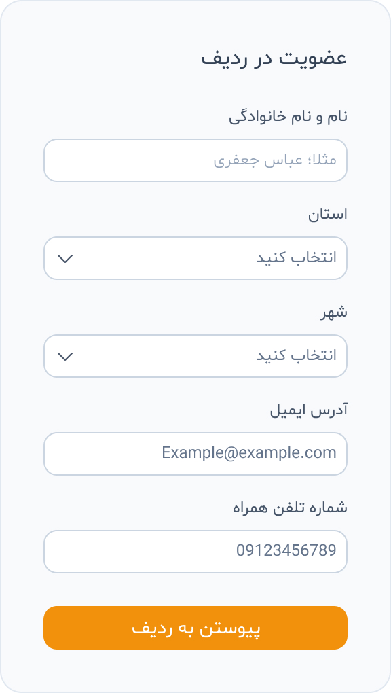

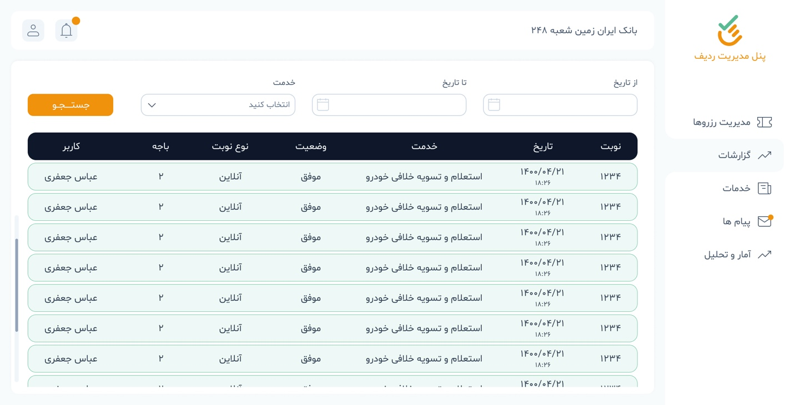

* Filterable Turn List (GET): /rqueue​/turn​/

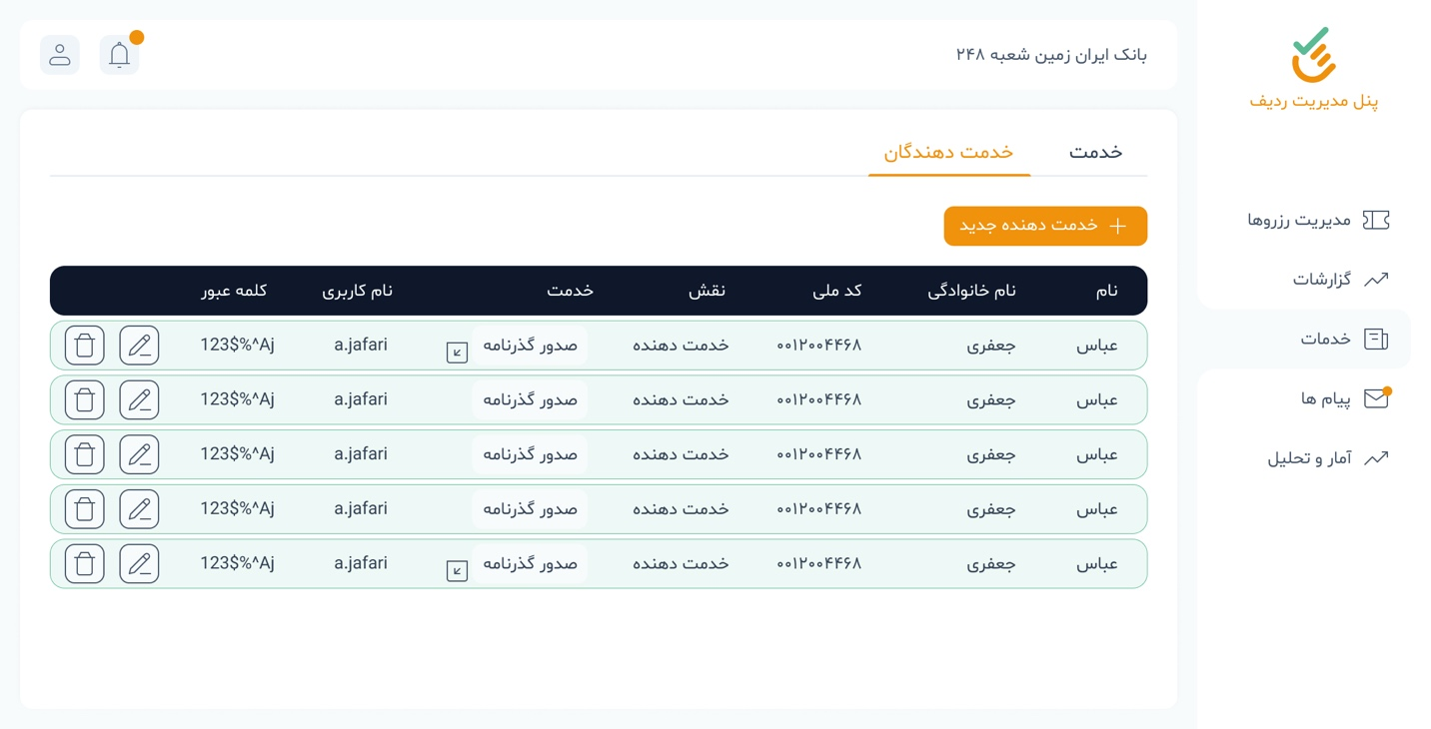

* Organization Employee List (GET): /organization/employee/

**{**

**"id": 1,**

**"user": {**

**"id": 1,**

**"wallet": null,**

**"last_login": "2022-01-31T17:38:38.976031Z",**

**"is_superuser": true,**

**"first_name": "سیده سپیده",**

**"last_name": "فیاضی",**

**"email": "",**

**"is_staff": true,**

**"is_active": true,**

**"date_joined": "2021-12-30T10:36:00.672058Z",**

**"username": "+989388221501",**

**"phone": "+989388221507",**

**"father_name": "",**

**"should_change_pass": false,**

**"national_code": "1830198440",**

**"birthday": "1992-05-25",**

**"sex": "female",**

**"deposit": "0.00",**

**"user_type": "",**

**"avatar": null,**

**"groups": [],**

**"user_permissions": []**

**},**

**"created_at": "2021-12-30T10:40:06.283243Z",**

**"updated_at": "2021-12-30T10:40:06.283243Z",**

**"obp": 1,**

**"role": 1**

**},**

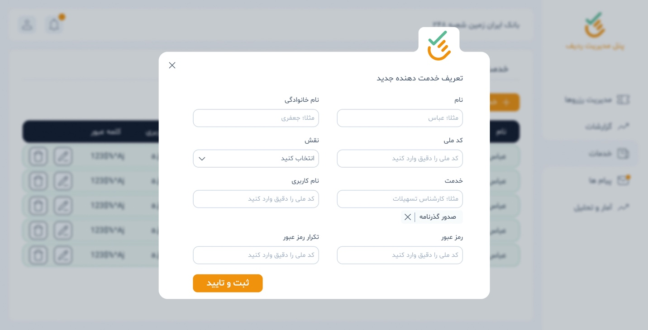

* Add Employee (POST): /organization/add-employee/
* Add Employee Service (POST): /service/employee-service/

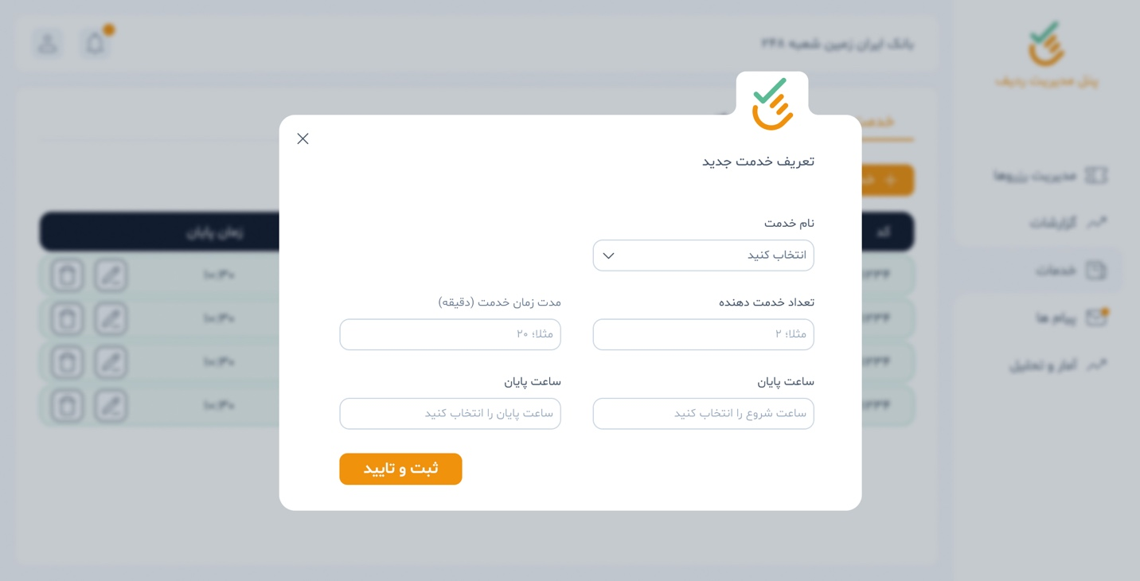

* General Service Regardless of organization (POST): /service/service/
* Organization Brand Branch Service (POST): /service/obb-service/
* Filterable List for OBB services (GET): /service/obb-service/
* **[**
* **{**
* **"id": 1,**
* **"name": "تستی",**
* **"price": "20000.00",**
* **"created_at": "2021-12-30T10:39:27.270368Z",**
* **"updated_at": "2021-12-30T10:39:27.270368Z",**
* **"organization_brand_branch": 1,**
* **"service": 1**
* **}**
* **]**

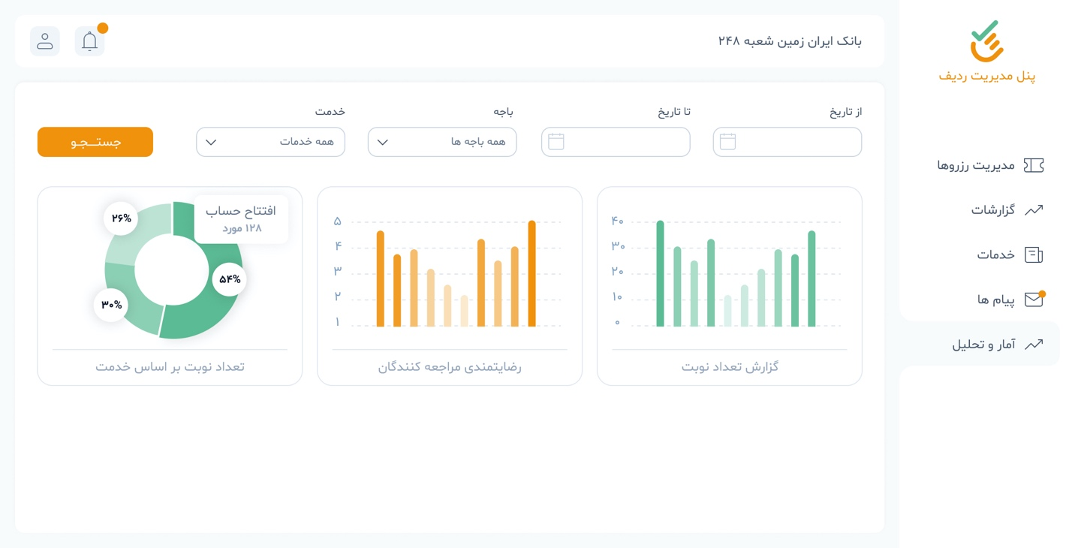

* Fetching system statistics (POST): /service/system-stats/

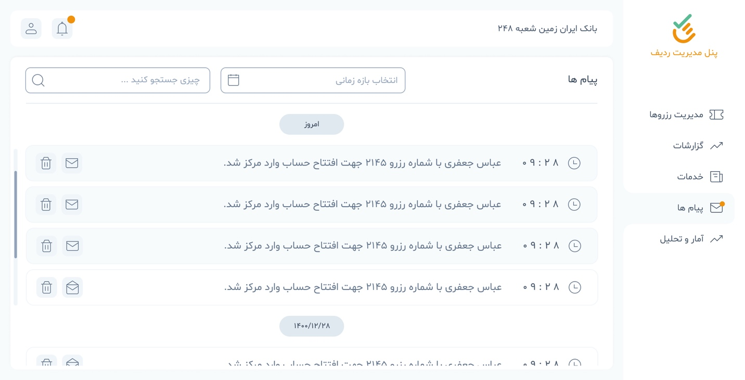

* Filterable Notification List (GET): /notification/notification/