

COMPANY PROFILE

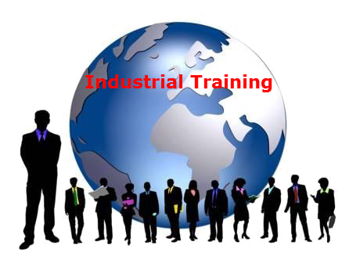**ABOUT US**

**EXCELLENCE TECHNOLOGY (ET)** is India based leading strategic IT Company offering integrated IT solutions with the vision to provide Excellence in software solution. We at EXCELLENCE TECHNOLOGY bring innovative ideas and cutting edge technologies into business of customers. EXCELLENCE TECHNOLOGY is having rich experience in providing high technology end to end solutions in **MOBILE APP AND WEB DEVELOPMENT.**

4

**PHILOSOPHY**

* To impart hardcore practical quality training among students/developers about latest technologies trending today.
* To share knowledge of information security and create awareness in the market. The solution to clients' as per the International standard practices and governance.
* To support good business practices through continual employee training and education
* To equip a local team with a strong knowledge of international best practices and international expert support so as to provide practical advisories in the best interests of our clients

**OUR MISSION**



To Protect Client's information system by

Detecting Threats, Deterring Attacks, and provide best solution in the ever changing

Info - Security Challenges. We accomplish this by integrating our People, Process, and Technology in the most efficient way to increase value for all stakeholders

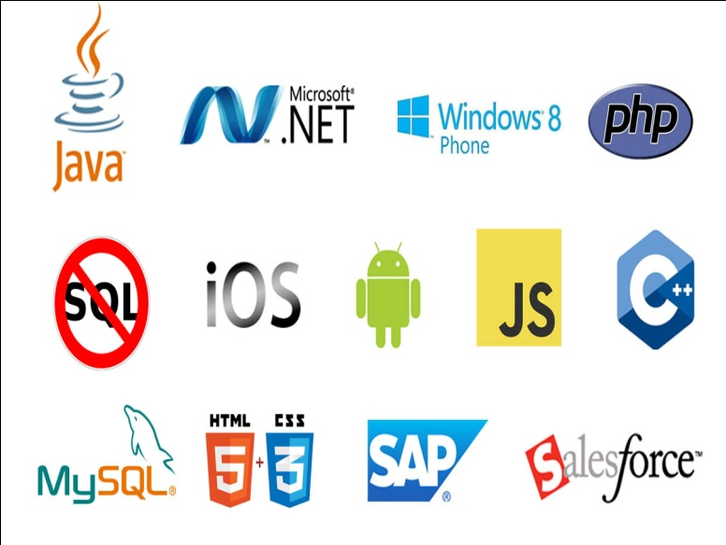**OUR SERVICES**

* RISK Management Services
* Quality Control
* Business Process Re-Engineering
* Network Risk Analysis
* Software Testing
* Mobile Application Testing
* Wireless Penetration Testing
* Network Penetration Testing
* Application Security Testing

**OUR SERVICES IN SOFTWARE DEVELOPMENT**

***We are proficient in all platforms of software Development practices — Agile, SCRUM, Lean, Waterfall, Prototype, Incremental, Iterative, and V-Model.***

With the EXCELLENCE TECHNOLOGY experience the incredible services such as agile software development and the problems related to outsourcing. We comprise of the team of experienced and professionals members who with their skills efficiently get the job done and innovatively help you to transform your ideas into the successful business.



Why Choose Us?

* **Hundreds of Clients & Nearly a Decade of Experience**
* **Goal Oriented, ROI-Driven Focus**
* **A Streamlined / Quality-Driven Process**
* **Talented Designers & Expert Developers**
* **Our Websites & E-marketing Platforms are Easy to Manage**
* **We Are Dedicated to Our Clients’ Success**
* **EXCELLENCE TECHNOLOGY** is steadfast to undertake the projects cutting edge to technology competence and know-how abilities. The project execution is held with dedication and responsibility to perform our best with the essence of knowledge, creativity and skills to the utmost and efficiently.
* At **EXCELLENCE TECHNOLOGY,** we have competence to expand and adjust as per client specific requirements.
* **Skilled Workforce:** At EXCELLENCE TECHNOLOGY you deal with the highly professional and proficient employees.
* **Cost Efficiency:** We help you to reduce the unnecessary investment and ask for the reasonable amount of money.
* **Quality Of the Product:** Our software service sector has been maintaining the highest international standards of quality.
* **Infrastructure:** Well organized team and tools to handle the projects with responsible approach Hardware, Software, Networking, Voice, Conferencing, disaster recovery all infra all you need for international projects.
* **Ongoing Involvement:** EXCELLENCE TECHNOLOGY products are “built for change” as we are well responsive that the necessity to improve a Web solution generally arises even before the solution is out of the door. We delivers long-term product enhancement if desired.
* **Partnership:** EXCELLENCE TECHNOLOGY considers every client a partner. From the initial stages, you are closely involved into the procedure of technical classification, development, and testing.

**OUR CLIENTS**

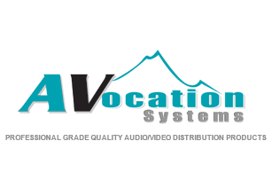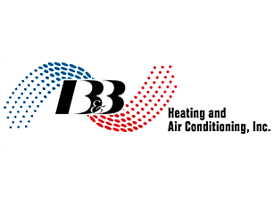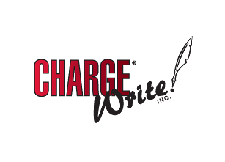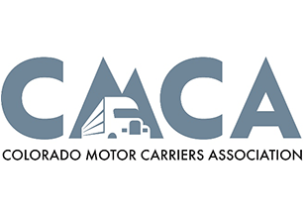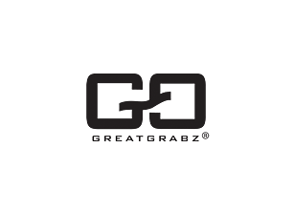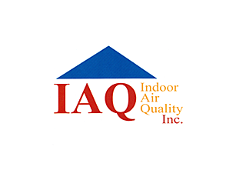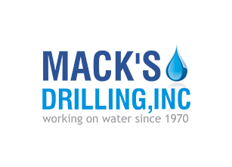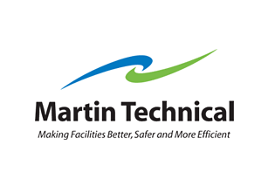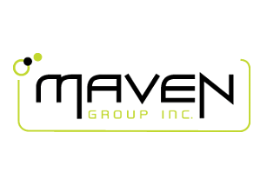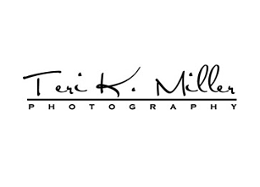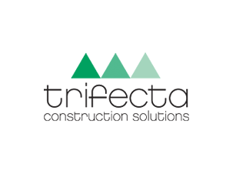

**KEY PROFESSIONALS:**

In addition to a panel of eminent consultants and advisors, we have a dedicated pool of trained Developers and Trainer, investigators, working under the guidance of professional managers. **“A Ship is as good as the crew who sail her**.**”** Our Technical team of professionals handing, designing & delivering of projects has a strong presence in the North India & the US. Our engineers are already working on the latest technologies like **I-Phone & Android** Applications, **Robotics**, **VLSI-VHDL**, Embedded System, Networking and **Cloud computing.** Some of the key professionals and advisors are listed below:

**Mr. Deepak Kashyap:** (**Branch Manager**)

He is the backbone of Excellence Technology and a man with more than 10 year rich practical experience who believes in taking up new ventures and projects. Head-IT, Global Award Winner from India for AGILE and OPEN GRAPH implementation in **Sudan Taxation Chamber**. Divisional Award and Star Award Winner in Year 2011 for his exemplary work in process improvement for IT Service Delivery Domains. MASTERS in Computer applications and Certified from PTU Certification. Holds total of 10 Years of rich experience including 5 Years in Information Security Implementation, Maintenance and Auditing and initial over 10 years experience in Project Management, Client Relationship Management and Server, Desktop and IT Service Delivery.

**Ms. Sunita Thakur :** (**Dean Academics**)

AWoman who believes that “Honour Time & Place, then you will be honored.” She has more than 4 years solid industrial experience in a software companies & is very dashing and innovative in her technical approach.MCA, Diploma in Information Technology, expertise in search engine optimization and webdesigning.

**Mr. Gurpreet Singh : (Technical Head - Python & GIT HUB)**

A man who strongly feel that “Nothing is Impossible”. A very committed team leader who has been professionally attached with Multinational companies for more than 18 years and has lead the marketing teams in all states of North India.MCA (Engineering),in computer Science PTU Approved trained and Certified. Successfully MCA master degree Training program for a leading Technology. Holds total of 5 Years of rich experience including 3 Years in Software developer, Maintenance and Auditing and initial over 4 years experience in Project Management, Client Relationship Management and IT Service Delivery.

**Miss. Anjali Sharma : (Sr. Counselor)**

A woman who believes that “Challenges are what make life interesting and overcoming them is what makes life meaningful.” She has more than 3years experience in business development.B.A. – (Punjab University) Lead Consultant - Due Diligence, Strategy, Operations, Business Continuity, Risk Management, Mergers & Acquisitions.

**Mr. Akshit Dogra : (Mechanical Head)**

A man believes that “don’t wait for extra ordinary opportunities, seize common occasions and make them great.” He has more than 4 years experience in marketing field.B.Tech (Mech), Engineer and Value, is a approved by AICTE (HPTU). He is having total 5 years of experience in 3 years of experience in Autocad, Solidworks, Catia, Pro-e, Ansys etc.

**Mr. Paramveer Singh : (Mobile Application & Web Developer)**

B.Tech(CSE) – IKG-PTU, Expertise in Reviewing current systems, Presenting ideas for web development soft wares, including Application softwares, Working closely with analysts, Senior Developers, Programmers, designers and staff, Producing detailed specifications and writing the program codes, Testing the product in controlled, real situations before going live, Preparation of training manuals for users and Maintaining the systems once they are up and running

**Corporate Office:** C-133, First Floor

Industrial Area, Phase-8, Sector-72, Mohali .

**PH.**:0172-4698755,93177-88822 ,93562-55522

**E-MAIL**: excellencehead@gmail.com,

**URL:** www.excellencetechnology.in