Apple ME665HN/A MacBook Pro (3rd Gen Ci7/ 16GB/ 512GB Flash/ Mac OS X Mountain Lion/ 1GB Graph/ Retina Display)

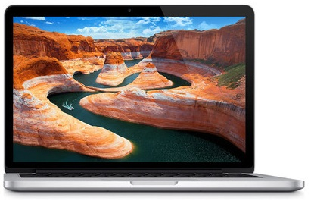

**APPLE ME665HN/A MACBOOK PRO (3RD GEN CI7/ 16GB/ 512GB FLASH/ MAC OS X MOUNTAIN LION/ 1GB GRAPH/ RETINA DISPLAY) (SILVER) PRICE: RS.179900**

**Key Features**

* Equipped with Latest Intel Processors
* Remarkably Thin and Light
* All-flash Architecture
* Comes with Retina Display
* Ground Breaking Retina Display

Mac Book Pro 15-inch Retina has an aluminium unibody enclosure and consists of - SD card slot, 2 x USB 3.0 ports, FireWire 800 port (up to 800Mbps), Thunderbolt port and combined headphone/line in (supports digital output). The built-in powerful battery provides up to 7 hours of backup.

**SPECIFICATIONS OF APPLE ME665HN/A MACBOOK PRO (3RD GEN CI7/ 16GB/ 512GB FLASH/ MAC OS X MOUNTAIN LION/ 1GB GRAPH/ RETINA DISPLAY) (SILVER)**

|  |  |
| --- | --- |
| **IN THE BOX** | |
| Sales Package | MacBook Pro with Retina Display, Magsafe 2 Power Adapter, Power Lead, AC Wall Plug |

|  |  |
| --- | --- |
| **GENERAL** | |
| Brand | Apple |
| Model Name | MacBook Pro |
| Series | Mac |
| Lifestyle | Gaming |
| Color | Silver |
| Model ID | ME665HN/A |

|  |  |
| --- | --- |
| **PROCESSOR** | |
| Processor | Core i7 (2nd Generation) |
| Brand | Intel |
| Clock Speed | 2.7 GHz with Turbo Boost Upto 3.7 GHz |
| Cache | 6 MB |

|  |  |
| --- | --- |
| **MEMORY** | |
| System Memory | 16 GB DDR3 |

|  |  |
| --- | --- |
| **STORAGE** | |
| HDD Capacity | 512 GB |
| SSD Capacity | Yes, 512 GB |

|  |  |
| --- | --- |
| **OPTICAL DISK DRIVE** | |
| Optical Drive | Not Available |

|  |  |
| --- | --- |
| **PLATFORM** | |
| Operating System | Mac OS X Mountain Lion |

|  |  |
| --- | --- |
| **DISPLAY** | |
| Screen Size | 15 inch |
| Resolution | 2880 x 1800 Pixel |
| Screen Type | Retina Display with LED Backlit and IPS Technology |

|  |  |
| --- | --- |
| **GRAPHICS** | |
| Dedicated Graphics Memory Type | GDDR5 |
| Dedicated Graphics Memory Capacity | 1 GB |
| Graphic Processor | NVIDIA GeForce GT 650M |

|  |  |
| --- | --- |
| **INPUT** | |
| Web Camera | 720p FaceTime HD Webcam |
| Pointer Device | Multi-touch Trackpad |
| Keyboard | Full-size Backlit Keyboard |

|  |  |
| --- | --- |
| **AUDIO** | |
| Internal Mic | Dual Microphones |
| Speakers | Stereo speakers |
| Sound | Stereo Speakers |

|  |  |
| --- | --- |
| **COMMUNICATION** | |
| Ethernet | 10/100/1000BASE-T Gigabit Ethernet |
| Wireless LAN | IEEE 802.11a/b/g/n |
| Bluetooth | v4.0 |

|  |  |
| --- | --- |
| **POWER** | |
| Battery Backup | Up to 7 hours |
| Power Supply | 85 W MagSafe 2 Power Adapter |

|  |  |
| --- | --- |
| **PORTS/SLOTS** | |
| USB Port | 2 x USB 3.0 |
| HDMI Port | Yes |
| Multi Card Slot | Yes |
| Other Ports | 2 x Thunderbolt Ports, 1 x Headphone Port |

|  |  |
| --- | --- |
| **MACHINE DIMENSIONS** | |
| Weight | 2.02 kg |
| Dimension | 358.9 x 247.1 x 18 mm |
| Color | Silver |

|  |  |
| --- | --- |
| **WARRANTY** | |
| Warranty Summary | 1 Year International Carry In Warranty |

Apple MD761HN/A MacBook Air (4th Gen Ci5/ 4GB/ 256GB Flash/ Mac OS X Mountain Lion)

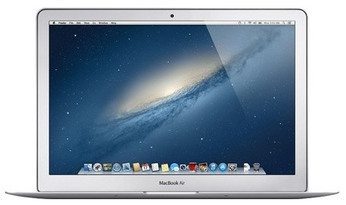

|  |  |
| --- | --- |
| * Core i5 (4th Gen) * 4 GB DDR3 RAM | * 256 GB SSD * Mac OS X Mountain Lion |

**SPECIFICATIONS OF APPLE MD761HN/A MACBOOK AIR (4TH GEN CI5/ 4GB/ 256GB FLASH/ MAC OS X MOUNTAIN LION) (SILVER)**

|  |  |
| --- | --- |
| **IN THE BOX** | |
| Sales Package | MacBook Air, Power Adapter, AC Wall Plug, Power Cord |

|  |  |
| --- | --- |
| **GENERAL** | |
| Brand | Apple |
| Model Name | MacBook Air |
| Lifestyle | Everyday Use |
| Color | Silver |
| Model ID | MD761HN/A |

|  |  |
| --- | --- |
| **PROCESSOR** | |
| Processor | Core i5 (4th Gen) |
| Brand | Intel |
| Clock Speed | 1.3 GHz with Turbo Boost Technology Upto 2.6 GHz |
| Cache | 3 MB |

|  |  |
| --- | --- |
| **MEMORY** | |
| System Memory | 4 GB DDR3 |

|  |  |
| --- | --- |
| **STORAGE** | |
| SSD Capacity | Yes, 256 GB |

|  |  |
| --- | --- |
| **OPTICAL DISK DRIVE** | |
| Optical Drive | Not Available |

|  |  |
| --- | --- |
| **PLATFORM** | |
| Operating System | Mac OS X Mountain Lion |

|  |  |
| --- | --- |
| **DISPLAY** | |
| Screen Size | 13 inch |
| Resolution | 1440 x 900 Pixel |
| Screen Type | LED Backlit Glossy Display |

|  |  |
| --- | --- |
| **GRAPHICS** | |
| Graphic Processor | Intel HD Graphics 5000 |

|  |  |
| --- | --- |
| **INPUT** | |
| Web Camera | 720p FaceTime HD Webcam |
| Pointer Device | Multi-touch Trackpad |
| Keyboard | Full-size Backlit Keyboard |

|  |  |
| --- | --- |
| **AUDIO** | |
| Internal Mic | Dual Microphones |
| Speakers | Yes |
| Sound | Stereo Speakers |

|  |  |
| --- | --- |
| **COMMUNICATION** | |
| Wireless LAN | IEEE 802.11a/b/g/n/ac |
| Bluetooth | v4.0 |

|  |  |
| --- | --- |
| **POWER** | |
| Battery Backup | Upto 12 hours |
| Power Supply | 45 W MagSafe 2 Power Adapter |

|  |  |
| --- | --- |
| **PORTS/SLOTS** | |
| USB Port | 2 x USB 3.0 |
| Multi Card Slot | Yes |
| Other Ports | 1 x Headphone Port, 1 x Thunderbolt Port |

|  |  |
| --- | --- |
| **MACHINE DIMENSIONS** | |
| Weight | 1.35 kg |
| Dimension | 325 x 227 x 17 mm |
| Color | Silver |

|  |  |
| --- | --- |
| **WARRANTY** | |
| Warranty Summary | 1 Year International Carry In Warranty |

The Apple TV

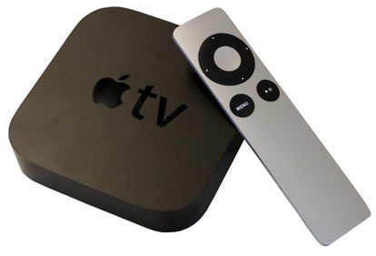

**KEY FEATURES OF THE APPLE TV**

* Full HD Media Player
* HDMI Support

**SPECIFICATIONS OF THE APPLE TV**

|  |  |
| --- | --- |
| **GENERAL** | |
| Brand | Apple |
| Ideal For | TV |
| Enclosure Type | Desktop |
| Model Name | TV |

|  |  |
| --- | --- |
| **AUDIO VIDEO FEATURES** | |
| Video Resolution | 480p, 720p, 1080p |

|  |  |
| --- | --- |
| **HDMI CONNECTORS** | |
| HDMI | Yes, HDMI |
| HDMI Ports | 1 (Output) |

|  |  |
| --- | --- |
| **AUDIO VIDEO CONNECTORS** | |
| Other Audio Video Connectors | Optical Audio and Ethernet Ports |

|  |  |
| --- | --- |
| **ADDITIONAL FEATURES** | |
| Other Features | Wireless: Wi-Fi (802.11a/b/g/n), iTunes Store, Simple Setup, Browse and Play Content from Netflix, MLB and WSJ Live, Show Photos from Photo Stream in 1080p, AirPlay, Turn on AirPlay Mirroring for an iPad2 or iPhone 4S, Stream Video, Music, Photos from iPhone, iPad, or iPod Touch, AppleCare Protection Plan for Apple TV |

Apple 3 TB Time Capsule 3076 GB External Hard Disk

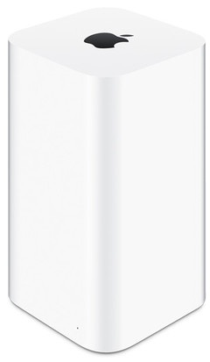

**APPLE 3 TB TIME CAPSULE 3076 GB EXTERNAL HARD DISK (WHITE) PRICE: RS.25800**

**Key Features**

* Connectivity: Gigabit Ethernet

With AirPort Time Capsule, you get a superfast Wi-Fi base station and an easy-to-use backup device all in one. And backing up your data couldn not be simpler. Just set it up once and AirPort Time Capsule does the rest. It works with Time Machine in OS X to back up your Mac automatically and wirelessly, so you never have to worry about losing anything important again. Every photo, every file, every song, even your apps and OS X settings are saved. AirPort Time Capsule stores it all up to 2TB or 3TB of data.

Was this product information helpful?

**Yes**

**No**

**SPECIFICATIONS OF APPLE 3 TB TIME CAPSULE 3076 GB EXTERNAL HARD DISK (WHITE)**

|  |  |
| --- | --- |
| **GENERAL SPECIFICATIONS** | |
| Brand | Apple |
| Model Name | 3 TB Time Capsule |
| Color | White |
| Capacity | 3076 GB |
| Connectivity | Gigabit Ethernet |
| Dimensions | 98 x 98 x 168 mm |
| Form Factor | Network |
| Model | ME182HN/A |
| OS Supported | Mac OS |
| In The Box | 3TB Time Capsule |
| Weight | 1480 g |

|  |  |
| --- | --- |
| **WARRANTY** | |
| Warranty Summary | 1 year Apple India Warranty |
| Covered in Warranty | Manufacturing defects |
| Not Covered in Warranty | Damage |
| Warranty Service Type | carry in |

# Apple MD102HN/A MacBook Pro (3rd Gen Ci7/ 8GB/ 750GB/ Mac OS X Mountain Lion)

(Silver)

|  |  |
| --- | --- |
| * Core i7 (3rd Gen) * 8 GB DDR3 RAM | * 750 GB HDD * Mac OS X Mountain Lion |

**Rs. 99600**

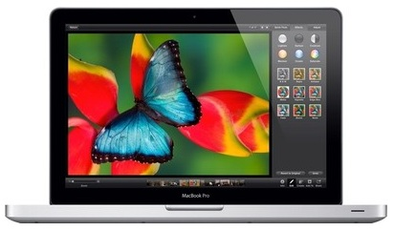

**SPECIFICATIONS OF APPLE MD102HN/A MACBOOK PRO (3RD GEN CI7/ 8GB/ 750GB/ MAC OS X MOUNTAIN LION) (SILVER)**

|  |  |
| --- | --- |
| **IN THE BOX** | |
| Sales Package | MacBook Pro, Power Adapter, AC Wall Plug, Power Cord |

|  |  |
| --- | --- |
| **GENERAL** | |
| Brand | Apple |
| Model Name | MacBook Pro |
| Lifestyle | Everyday Use |
| Color | Silver |
| Model ID | MD102HN/A |

|  |  |
| --- | --- |
| **PROCESSOR** | |
| Processor | Core i7 (3rd Gen) |
| Brand | Intel |
| Clock Speed | 2.9 GHz with Turbo Boost Technology Upto 3.6 GHz |
| Cache | 4 MB |

|  |  |
| --- | --- |
| **MEMORY** | |
| System Memory | 8 GB DDR3 |

|  |  |
| --- | --- |
| **STORAGE** | |
| RPM | 5400 |
| HDD Capacity | 750 GB |

|  |  |
| --- | --- |
| **OPTICAL DISK DRIVE** | |
| Read/Write Speed | 8x |
| Optical Drive | SuperDrive |

|  |  |
| --- | --- |
| **PLATFORM** | |
| Operating System | Mac OS X Mountain Lion |

|  |  |
| --- | --- |
| **DISPLAY** | |
| Screen Size | 13 inch |
| Resolution | 1280 x 800 Pixel |
| Screen Type | LED Backlit Glossy Display |

|  |  |
| --- | --- |
| **GRAPHICS** | |
| Graphic Processor | Intel HD Graphics 4000 |

|  |  |
| --- | --- |
| **INPUT** | |
| Web Camera | 720p FaceTime HD Webcam |
| Pointer Device | Multi-touch Trackpad |
| Keyboard | Full-size Backlit Keyboard |

|  |  |
| --- | --- |
| **AUDIO** | |
| Internal Mic | Omnidirectional Microphone |
| Speakers | Yes |
| Sound | Stereo Speakers with Subwoofer |

|  |  |
| --- | --- |
| **COMMUNICATION** | |
| Ethernet | Gigabit LAN |
| Wireless LAN | IEEE 802.11a/b/g/n |
| Bluetooth | v4.0 |

|  |  |
| --- | --- |
| **POWER** | |
| Battery Backup | Upto 7 hours |
| Power Supply | 60 W MagSafe Power Adapter |

|  |  |
| --- | --- |
| **PORTS/SLOTS** | |
| USB Port | 2 x USB 3.0 |
| Firewire Port | Yes |
| RJ45 LAN | Yes |
| Multi Card Slot | Yes |
| Other Ports | 1 x Headphone Port, 1 x Thunderbolt Port |

|  |  |
| --- | --- |
| **SECURITY** | |
| Lock Port | Kensington Lock Slot |

|  |  |
| --- | --- |
| **MACHINE DIMENSIONS** | |
| Weight | 2.06 kg |
| Dimension | 325 x 227 x 24.1 mm |
| Color | Silver |

|  |  |
| --- | --- |
| **WARRANTY** | |
| Warranty Summary | 1 Year International Carry In Warranty |

**Apple MacBook Pro Mac MD101HN/A Laptop**

|  |  |
| --- | --- |
| * Core i5 (2nd Generation) * 4 GB DDR3 RAM | * 500 GB HDD * Mac OS X Lion |

**Rs. 76299**

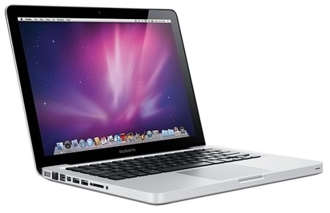

**SPECIFICATIONS OF APPLE MACBOOK PRO MAC MD101HN/A LAPTOP (SILVER)**

|  |  |
| --- | --- |
| **IN THE BOX** | |
| Sales Package | MacBook Pro, AC Wall Plug, Power Lead, Magsafe 2 Power Adapter |

|  |  |
| --- | --- |
| **GENERAL** | |
| Brand | Apple |
| Model Name | MacBook Pro |
| Series | Mac |
| Color | Silver |
| Model ID | MD101HN/A |

|  |  |
| --- | --- |
| **PROCESSOR** | |
| Processor | Core i5 (2nd Generation) |
| Brand | Intel |
| Clock Speed | 2.5 GHz |

|  |  |
| --- | --- |
| **MEMORY** | |
| System Memory | 4 GB DDR3 |

|  |  |
| --- | --- |
| **STORAGE** | |
| HDD Capacity | 500 GB |

|  |  |
| --- | --- |
| **PLATFORM** | |
| Operating System | Mac OS X Lion |

|  |  |
| --- | --- |
| **DISPLAY** | |
| Screen Size | 13 inch |
| Resolution | 1280 x 800 |
| Screen Type | LED-backlit Display with IPS Technology |

|  |  |
| --- | --- |
| **GRAPHICS** | |
| Graphic Processor | Intel HD Graphics 4000 |

|  |  |
| --- | --- |
| **INPUT** | |
| Web Camera | 720p FaceTime HD camera |

|  |  |
| --- | --- |
| **AUDIO** | |
| Speakers | Stereo speakers |

|  |  |
| --- | --- |
| **COMMUNICATION** | |
| Ethernet | 10/100/1000BASE-T Gigabit Ethernet |
| Wireless LAN | IEEE 802.11a/b/g |
| Bluetooth | v4.0 |

|  |  |
| --- | --- |
| **POWER** | |
| Battery Backup | Up to 7 hours |
| Power Supply | 60W MagSafe Power Adapter |

|  |  |
| --- | --- |
| **PORTS/SLOTS** | |
| USB Port | 2 x USB 3.0 |
| Multi Card Slot | Yes |

|  |  |
| --- | --- |
| **MACHINE DIMENSIONS** | |
| Weight | 1.62 kg |
| Dimension | 314 x 219 x 19 mm |
| Color | Silver |

# Apple MD712HN/A MacBook Air (4th Gen Ci5/ 4GB/ 256GB Flash/ Mac OS X Mountain Lion)

|  |  |
| --- | --- |
| * Core i5 (4th Gen) * 4 GB DDR3 RAM | * 256 GB SSD * Mac OS X Mountain Lion |

**Rs. 72000**

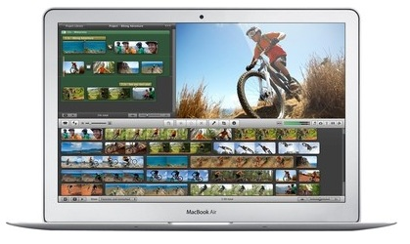

**SPECIFICATIONS OF APPLE MD712HN/A MACBOOK AIR (4TH GEN CI5/ 4GB/ 256GB FLASH/ MAC OS X MOUNTAIN LION) (SILVER)**

|  |  |
| --- | --- |
| **IN THE BOX** | |
| Sales Package | MacBook Air, Power Adapter, AC Wall Plug, Power Cord |

|  |  |
| --- | --- |
| **GENERAL** | |
| Brand | Apple |
| Model Name | MacBook Air |
| Lifestyle | Everyday Use |
| Color | Silver |
| Model ID | MD712HN/A |

|  |  |
| --- | --- |
| **PROCESSOR** | |
| Processor | Core i5 (4th Gen) |
| Brand | Intel |
| Clock Speed | 1.3 GHz with Turbo Boost Technology Upto 2.6 GHz |
| Cache | 3 MB |

|  |  |
| --- | --- |
| **MEMORY** | |
| System Memory | 4 GB DDR3 |

|  |  |
| --- | --- |
| **STORAGE** | |
| SSD Capacity | Yes, 256 GB |

|  |  |
| --- | --- |
| **OPTICAL DISK DRIVE** | |
| Optical Drive | Not Available |

|  |  |
| --- | --- |
| **PLATFORM** | |
| Operating System | Mac OS X Mountain Lion |

|  |  |
| --- | --- |
| **DISPLAY** | |
| Screen Size | 11 inch |
| Resolution | 1366 x 768 Pixel |
| Screen Type | LED Backlit Glossy Display |

|  |  |
| --- | --- |
| **GRAPHICS** | |
| Graphic Processor | Intel HD Graphics 5000 |

|  |  |
| --- | --- |
| **INPUT** | |
| Web Camera | 720p FaceTime HD Webcam |
| Pointer Device | Multi-touch Trackpad |
| Keyboard | Full-size Backlit Keyboard |

|  |  |
| --- | --- |
| **AUDIO** | |
| Internal Mic | Dual Microphones |
| Speakers | Yes |
| Sound | Stereo Speakers |

|  |  |
| --- | --- |
| **COMMUNICATION** | |
| Wireless LAN | IEEE 802.11a/b/g/n/ac |
| Bluetooth | v4.0 |

|  |  |
| --- | --- |
| **POWER** | |
| Battery Backup | Upto 9 hours |
| Power Supply | 45 W MagSafe 2 Power Adapter |

|  |  |
| --- | --- |
| **PORTS/SLOTS** | |
| USB Port | 2 x USB 3.0 |
| Other Ports | 1 x Headphone Port, 1 x Thunderbolt Port |

|  |  |
| --- | --- |
| **MACHINE DIMENSIONS** | |
| Weight | 1.08 kg |
| Dimension | 300 x 192 x 17 mm |
| Color | Silver |

|  |  |
| --- | --- |
| **WARRANTY** | |
| Warranty Summary | 1 Year International Carry In Warranty |

# Apple Macbook Pro Laptop

(Silver)

|  |  |
| --- | --- |
| * Core i5 (4th Gen) * 8 GB DDR3 RAM | * 256 GB HDD * Mac OS X Mavericks |

**Rs. 99190**

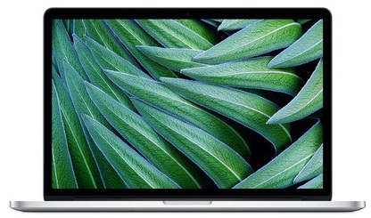

**SPECIFICATIONS OF APPLE MACBOOK PRO LAPTOP (SILVER)**

|  |  |
| --- | --- |
| **IN THE BOX** | |
| Sales Package | Charger, Battery, Laptop |

|  |  |
| --- | --- |
| **GENERAL** | |
| Brand | Apple |
| Model Name | Macbook Pro |
| Color | Silver |
| Model ID | ME865HN/A |

|  |  |
| --- | --- |
| **PROCESSOR** | |
| Processor | Core i5 (4th Gen) |
| Brand | Intel |

|  |  |
| --- | --- |
| **MEMORY** | |
| System Memory | 8 GB DDR3 |

|  |  |
| --- | --- |
| **STORAGE** | |
| HDD Capacity | 256 GB |

|  |  |
| --- | --- |
| **PLATFORM** | |
| Operating System | Mac OS X Mavericks |

|  |  |
| --- | --- |
| **DISPLAY** | |
| Screen Size | 13.3 inch |
| Resolution | 2560 x 1600 pixel |

|  |  |
| --- | --- |
| **GRAPHICS** | |
| Graphic Processor | Intel Iris Graphics |

|  |  |
| --- | --- |
| **INPUT** | |
| Web Camera | 720p FaceTime HD Camera |

|  |  |
| --- | --- |
| **COMMUNICATION** | |
| Wireless LAN | IEEE 802.11a/b/g/n |
| Bluetooth | v4.0 |

|  |  |
| --- | --- |
| **POWER** | |
| Battery Backup | Up to 9 hours |

|  |  |
| --- | --- |
| **MACHINE DIMENSIONS** | |
| Color | Silver |