Lenovo ThinkPad X1 Carbon (34608E1) Ultrabook (3rd Gen Ci5/ 4GB/ 256GB SSD/ Win8 Pro)

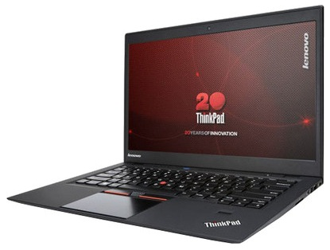

|  |  |
| --- | --- |
| * Core i5 (3rd Gen) * 4 GB DDR3 RAM | * 256 GB SSD * Windows 8 Pro |

### SPECIFICATIONS OF LENOVO THINKPAD X1 CARBON (34608E1) ULTRABOOK (3RD GEN CI5/ 4GB/ 256GB SSD/ WIN8 PRO) (BLACK)

|  |  |
| --- | --- |
| **IN THE BOX** | |
| Sales Package | Laptop, Battery, AC Adapter, User Guide and Manuals |

|  |  |
| --- | --- |
| **GENERAL** | |
| Brand | Lenovo |
| Model Name | Thinkpad |
| Series | X |
| Lifestyle | Everyday Use |
| Color | Black |
| Model ID | X1 Carbon/34608E1 |

|  |  |
| --- | --- |
| **PROCESSOR** | |
| Processor | Core i5 (3rd Gen) |
| Variant | 3337U |
| Chipset | Mobile QM77 Express |
| Brand | Intel |
| Clock Speed | 1.8 GHz with Turbo Boost Upto 2.7 GHz |
| Cache | 3 MB |

|  |  |
| --- | --- |
| **MEMORY** | |
| System Memory | 4 GB DDR3 |

|  |  |
| --- | --- |
| **STORAGE** | |
| SSD Capacity | Yes, 256 GB |

|  |  |
| --- | --- |
| **OPTICAL DISK DRIVE** | |
| Optical Drive | Not Available |

|  |  |
| --- | --- |
| **PLATFORM** | |
| Operating System | Windows 8 Pro |
| System Architecture | 64 bit |
| OS Architecture | 64 bit |

|  |  |
| --- | --- |
| **DISPLAY** | |
| Screen Size | 14 inch |
| Screen Type | HD Anti-glare Display |

|  |  |
| --- | --- |
| **GRAPHICS** | |
| Graphic Processor | Intel HD Graphics 4000 |

|  |  |
| --- | --- |
| **INPUT** | |
| Web Camera | 720p HD Webcam |
| Pointer Device | Multi Gesture Glass Touchpad |
| Keyboard | Island Keyboard with Backlit |

|  |  |
| --- | --- |
| **AUDIO** | |
| Internal Mic | Dual-array Microphones |
| Speakers | Yes |
| Sound | Stereo Speakers |

|  |  |
| --- | --- |
| **COMMUNICATION** | |
| Ethernet | Yes |
| Wireless LAN | Yes |
| Bluetooth | Yes |

|  |  |
| --- | --- |
| **POWER** | |
| Battery Backup | Upto 8 hours |
| Battery Cell | 4 cell |

|  |  |
| --- | --- |
| **PORTS/SLOTS** | |
| USB Port | 1 x USB 2.0 (Always On), 1 x USB 3.0 |
| Multi Card Slot | 4-in-1 Card Reader |
| Other Ports | 1 x Mini Display Port, SIM Card Slot |

|  |  |
| --- | --- |
| **SECURITY** | |
| Fingerprint Sensor | Yes |

|  |  |
| --- | --- |
| **MACHINE DIMENSIONS** | |
| Weight | 1.36 kg |
| Dimension | 331 x 226 x 18.9 mm |
| Color | Black |

|  |  |
| --- | --- |
| **WARRANTY** | |
| Warranty Summary | 3 Years Onsite Warranty |

Lenovo Ideapad Yoga 13 (59-341124) Laptop (3rd Gen Ci5/ 4GB/ 128GB SSD/ Win8/ Touch)

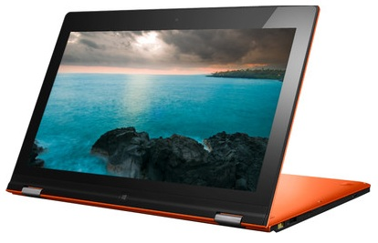

|  |  |
| --- | --- |
| * Core i5 (3rd Gen) * 4 GB DDR3 RAM | * 128 GB SSD * Windows 8 |

### SPECIFICATIONS OF LENOVO IDEAPAD YOGA 13 (59-341124) LAPTOP (3RD GEN CI5/ 4GB/ 128GB SSD/ WIN8/ TOUCH) (SUNSHINE ORANGE)

|  |  |
| --- | --- |
| **IN THE BOX** | |
| Sales Package | Laptop, Battery, AC Adapter, User Guide and Manuals |

|  |  |
| --- | --- |
| **GENERAL** | |
| Brand | Lenovo |
| Model Name | Ideapad Yoga 13 |
| Lifestyle | Everyday Use |
| Color | Sunshine Orange |
| Model ID | 59-341124 |

|  |  |
| --- | --- |
| **PROCESSOR** | |
| Processor | Core i5 (3rd Gen) |
| Variant | 3317U |
| Chipset | Mobile HM76 Express |
| Brand | Intel |
| Clock Speed | 1.7 GHz with Turbo Boost Upto 2.6 GHz |
| Cache | 3 MB |

|  |  |
| --- | --- |
| **MEMORY** | |
| Expandable Memory | Upto 8 GB |
| Memory Slots | 2 (Unused Slot - 0) |
| System Memory | 4 GB DDR3 |

|  |  |
| --- | --- |
| **STORAGE** | |
| SSD Capacity | Yes, 128 GB |

|  |  |
| --- | --- |
| **OPTICAL DISK DRIVE** | |
| Optical Drive | Not Available |

|  |  |
| --- | --- |
| **PLATFORM** | |
| Operating System | Windows 8 |
| System Architecture | 64 bit |

|  |  |
| --- | --- |
| **DISPLAY** | |
| Screen Size | 13.3 inch |
| Resolution | 1600 x 900 Pixel |
| Screen Type | HD Plus IPS Capacitive Multi-touch Display and 10 Point Multi-touch |

|  |  |
| --- | --- |
| **GRAPHICS** | |
| Graphic Processor | Intel HD Graphics 4000 |

|  |  |
| --- | --- |
| **INPUT** | |
| Web Camera | 1.0 Megapixel 720p HD Webcam |
| Pointer Device | Touchpad |
| Keyboard | AccuType Keyboard |

|  |  |
| --- | --- |
| **AUDIO** | |
| Speakers | Yes |
| Sound | 2 x 1 W Speakers, Stereo Speakers |

|  |  |
| --- | --- |
| **COMMUNICATION** | |
| Wireless LAN | IEEE 802.11b/g/n |
| Bluetooth | v4.0 |

|  |  |
| --- | --- |
| **POWER** | |
| Battery Backup | Upto 6 hours |
| Power Supply | 65 W AC Adapter |
| Battery Cell | 6 cell |

|  |  |
| --- | --- |
| **PORTS/SLOTS** | |
| USB Port | 1 x USB 2.0, 1 x USB 3.0 |
| HDMI Port | Yes |
| Multi Card Slot | 3-in-1 Card Reader |
| Other Ports | 2-in-1 (Headphone and Mic) |

|  |  |
| --- | --- |
| **MACHINE DIMENSIONS** | |
| Weight | 1.54 kg |
| Dimension | 333.4 x 224.8 x 16.9 mm |
| Color | Sunshine Orange |

|  |  |
| --- | --- |
| **WARRANTY** | |
| Warranty Summary | 1 Year Onsite and Accidental Damage Protection (ADP) |

Lenovo Essential A10 (59-388639) Slatebook (Quad Core A9/ 1GB/ 16GB eMMC/ Android 4.2/ Touch)

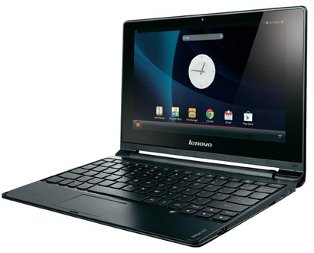

|  |  |
| --- | --- |
| * Cortex A9 Quad Core * 1 GB DDR3 RAM | * 16 GB SSD * Android v4.2 (Jelly Bean) |

### SPECIFICATIONS OF LENOVO ESSENTIAL A10 (59-388639) SLATEBOOK (QUAD CORE A9/ 1GB/ 16GB EMMC/ ANDROID 4.2/ TOUCH) (BROWN)

|  |  |
| --- | --- |
| **IN THE BOX** | |
| Sales Package | Laptop, Battery, AC Adapter, User Guide and Manuals |

|  |  |
| --- | --- |
| **GENERAL** | |
| Brand | Lenovo |
| Model Name | Ideapad |
| Series | A10 |
| Lifestyle | Everyday Use |
| Color | Brown |
| Part Number | 59-388639 |
| Model ID | A10/59-388639 |

|  |  |
| --- | --- |
| **PROCESSOR** | |
| Processor | Cortex A9 Quad Core |
| Brand | ARM |
| Clock Speed | 1.6 GHz |

|  |  |
| --- | --- |
| **MEMORY** | |
| System Memory | 1 GB DDR3 |

|  |  |
| --- | --- |
| **STORAGE** | |
| SSD Capacity | Yes, 16 GB |

|  |  |
| --- | --- |
| **OPTICAL DISK DRIVE** | |
| Optical Drive | Not Available |

|  |  |
| --- | --- |
| **PLATFORM** | |
| Operating System | Android v4.2 (Jelly Bean) |

|  |  |
| --- | --- |
| **DISPLAY** | |
| Screen Size | 10.1 inch |
| Resolution | 1366 x 768 Pixel |
| Screen Type | HD LED Display with 10 Point Multi-touch Screen |

|  |  |
| --- | --- |
| **GRAPHICS** | |
| Graphic Processor | Integrated Graphics |

|  |  |
| --- | --- |
| **INPUT** | |
| Web Camera | 0.3 Megapixel |
| Pointer Device | Touchpad |
| Keyboard | Full Size AccuType Keyboard |

|  |  |
| --- | --- |
| **AUDIO** | |
| Speakers | Yes |
| Sound | Stereo Speakers |

|  |  |
| --- | --- |
| **COMMUNICATION** | |
| Wireless LAN | IEEE 802.11b/g/n |
| Bluetooth | v2.1 |

|  |  |
| --- | --- |
| **POWER** | |
| Battery Backup | Upto 9 hours |
| Power Supply | 22.6 W AC Adapter |
| Battery Cell | 2 cell |

|  |  |
| --- | --- |
| **PORTS/SLOTS** | |
| USB Port | 1 x Micro USB, 2 x USB 2.0 |
| Mic In | Yes |
| HDMI Port | Yes |
| Multi Card Slot | Micro SD |
| Other Ports | 1 x Headphone Out/Microphone-in Combo Jack |

|  |  |
| --- | --- |
| **MACHINE DIMENSIONS** | |
| Weight | 1 kg |
| Dimension | 269 x 185 x 17.3 mm |
| Color | Brown |

|  |  |
| --- | --- |
| **WARRANTY** | |
| Warranty Summary | 1 Year Onsite Warranty |

Lenovo Essential G505 (59-379446) Laptop (APU Dual Core/ 2GB/ 500GB/ DOS)

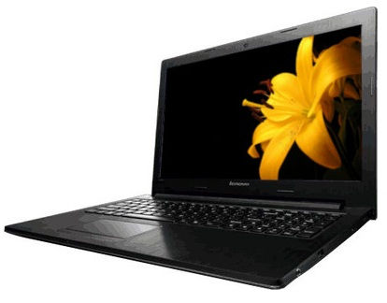

|  |  |
| --- | --- |
| * APU Dual Core * 2 GB DDR3 RAM | * 500 GB HDD * Free DOS |

### LENOVO ESSENTIAL G505 (59-379446) LAPTOP (APU DUAL CORE/ 2GB/ 500GB/ DOS) (BLACK) PRICE: RS.20182

### Key Features

* Battery-Saving Technology
* HD Widescreen Display
* Spill-resistant, Island-style Keyboard
* Dolby Advanced Audio
* 72p HD High-sense Webcam

**Details in HD**

The Lenovo G505 is from the highly recognized Essential series which is equipped with a high quality HD Widescreen display. This 15.6 inch display is capable of resolutions of 1366 X 768 pixels and can easily display high definition visuals.

**Island Keyboard**

The keyboard layout is of the **Island Style** which allows for high speed typing thanks to equally spaced out keys that can help in greater accuracy. You also have a layout that has been designed to be spill resistant in case you spill some liquid onto it.

**Power Saver**

The Lenovo comes equipped with **power management**tools that can effectively and efficiently manage the power such that you get the most out of a single full charge.

**High Quality Webcam**

With the inclusion of a**720 p capable webcam**, you can take high quality images and interact with your distant friends with the help of video calls and other methods that take advantage of the high quality camera.

**Superior Sound**

The laptop comes with a**Dolby Advanced Audio** enhancement that can help in producing high quality audio no matter which speaker set you use. If you connect a pair of headphones, you can still experience the goodness of the Dolby Audio.

### SPECIFICATIONS OF LENOVO ESSENTIAL G505 (59-379446) LAPTOP (APU DUAL CORE/ 2GB/ 500GB/ DOS) (BLACK)

|  |  |
| --- | --- |
| **IN THE BOX** | |
| Sales Package | Laptop, Battery, AC Adapter, User Guide and Manuals |

|  |  |
| --- | --- |
| **GENERAL** | |
| Brand | Lenovo |
| Model Name | Essential |
| Series | G |
| Lifestyle | Everyday Use |
| Color | Black |
| Model ID | G505/59-379446 |

|  |  |
| --- | --- |
| **PROCESSOR** | |
| Processor | APU Dual Core |
| Variant | E1-2100 |
| Chipset | A68M |
| Brand | AMD |
| Clock Speed | 1.4 GHz |
| Cache | 1 MB |

|  |  |
| --- | --- |
| **MEMORY** | |
| Expandable Memory | Upto 4 GB |
| Memory Slots | 1 (Unused Slot - 0) |
| System Memory | 2 GB DDR3 |

|  |  |
| --- | --- |
| **STORAGE** | |
| RPM | 5400 |
| HDD Capacity | 500 GB |

|  |  |
| --- | --- |
| **OPTICAL DISK DRIVE** | |
| Optical Drive | DVD RW Drive |

|  |  |
| --- | --- |
| **PLATFORM** | |
| Operating System | Free DOS |

|  |  |
| --- | --- |
| **DISPLAY** | |
| Screen Size | 15.6 inch |
| Resolution | 1366 x 768 Pixel |
| Screen Type | HD LED Display |

|  |  |
| --- | --- |
| **GRAPHICS** | |
| Graphic Processor | AMD Radeon HD 8210 |

|  |  |
| --- | --- |
| **INPUT** | |
| Web Camera | 0.3 Megapixel 720p HD Webcam |
| Pointer Device | Touchpad |
| Keyboard | Standard Keyboard |

|  |  |
| --- | --- |
| **AUDIO** | |
| Speakers | Yes |
| Sound | Stereo Speakers with Dolby Advanced Audio |

|  |  |
| --- | --- |
| **COMMUNICATION** | |
| Ethernet | 10/100 Mbps LAN |
| Wireless LAN | Yes |
| Bluetooth | Yes |

|  |  |
| --- | --- |
| **POWER** | |
| Battery Backup | Upto 4 hours |
| Power Supply | 65 W AC Adapter |
| Battery Cell | 6 cell |

|  |  |
| --- | --- |
| **PORTS/SLOTS** | |
| USB Port | 1 x USB 2.0, 2 x USB 3.0 |
| Mic In | Yes |
| RJ45 LAN | Yes |
| HDMI Port | Yes |
| Multi Card Slot | Yes |
| Other Ports | 2-in-1 (Headphone and Mic) |

|  |  |
| --- | --- |
| **MACHINE DIMENSIONS** | |
| Weight | 2.6 kg |
| Dimension | 377 x 250 x 34 mm |
| Color | Black |

|  |  |
| --- | --- |
| **WARRANTY** | |
| Warranty Summary | 1 Year Onsite Warranty |

Lenovo IdeaCentre A720 All-in-One (3rd Gen Ci5/ 4GB/ 750GB/ Win7 HP/ 1GB Graph)

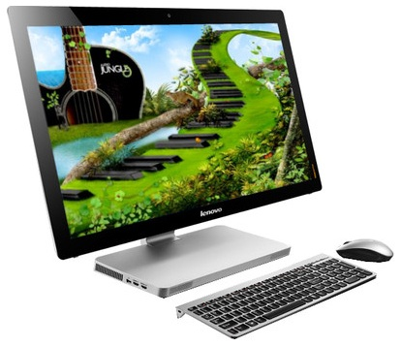

### KEY FEATURES OF LENOVO IDEACENTRE A720 ALL-IN-ONE (3RD GEN CI5/ 4GB/ 750GB/ WIN7 HP/ 1GB GRAPH)

* 27 inch Display
* Windows 7 Home Premium
* Wi-Fi
* Media Card Reader
* NVIDIA GT 630M Graphics
* Integrated Dolby V4 Speaker System

### SPECIFICATIONS OF LENOVO IDEACENTRE A720 ALL-IN-ONE (3RD GEN CI5/ 4GB/ 750GB/ WIN7 HP/ 1GB GRAPH)

|  |  |
| --- | --- |
| **SALES PACKAGE** | |
| In The Box | All In One Desktop, Wireless Keyboard, Wireless Mouse, Power Adapter |

|  |  |
| --- | --- |
| **GENERAL** | |
| Model Name | A720 (57-306177) |
| Series | IdeaCentre |
| Part Number | 57-306177 |
| Brand | Lenovo |

|  |  |
| --- | --- |
| **SYSTEM FEATURES** | |
| Cache Memory | 3 MB |
| Processor Name | Core i5 (3rd Generation) |
| Chipset | B75 Express |
| Processor Brand | Intel |
| Processor Frequency | 2.5 GHz with Turbo Boost Upto 3.1 GHz |
| Operating System | Windows 7 Home Premium |
| Processor Model | 3210M |

|  |  |
| --- | --- |
| **MEMORY** | |
| System Memory | 4 GB DDR3 |

|  |  |
| --- | --- |
| **DISPLAY** | |
| Touchscreen Support | Yes |
| Display Size | 27 inch |
| Full HD | Yes |
| Display Resolution | 1920 x 1080 |
| Display Type | LED Display |

|  |  |
| --- | --- |
| **GRAPHICS** | |
| Dedicated Graphic Memory | 1 GB |
| Dedicated Graphic Processor | NVIDIA GT 630M |
| Integrated Graphic Processor | Intel HD Graphics 4000 |

|  |  |
| --- | --- |
| **WEBCAM** | |
| Sensor resolution | HD megapixel |
| Built-in Webcam | Yes |

|  |  |
| --- | --- |
| **STORAGE** | |
| Storage Interface | SATA |
| Reading speed | 5400 RPM |
| Hard Drive | 750 GB |

|  |  |
| --- | --- |
| **AUDIO** | |
| Built-in Microphone | Yes |
| Other Audio features | Integrated Dolby V4 Speaker System |

|  |  |
| --- | --- |
| **OPTICAL DRIVE** | |
| Drive Type | DVD RW Drive |

|  |  |
| --- | --- |
| **CONNECTIVITY** | |
| USB | USB 3.0 x 2, USB 2.0 x 2 |
| Bluetooth | Yes |
| Headphone Jack | Yes |
| HDMI | HDMI In x 1, HDMI Out x 1 |
| Memory Card Reader | 6-in-1 Card Reader |

|  |  |
| --- | --- |
| **NETWORK** | |
| Wireless | IEEE 802.11b/g/n |
| Ethernet | 10/100/1000 LAN |

|  |  |
| --- | --- |
| **INPUT DEVICES** | |
| Mouse | Wireless Mouse |
| Keyboard | Wireless Keyboard |

|  |
| --- |
| **WARRANTY** |
| 3 Year Warranty |

Lenovo Ideapad B490 Laptop

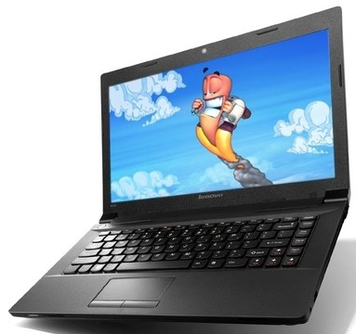

|  |  |
| --- | --- |
| * Pentium Dual Core (3rd... * 2 GB DDR3 RAM | * 500 GB HDD * Free DOS |

### LENOVO IDEAPAD B490 LAPTOP (BLACK) PRICE: RS.25200

This 14 Inch small business laptop features improved graphics support, enhanced multimedia.

### SPECIFICATIONS OF LENOVO IDEAPAD B490 LAPTOP (BLACK)

|  |  |
| --- | --- |
| **IN THE BOX** | |
| Sales Package | Laptop, Battery, AC Adapter |

|  |  |
| --- | --- |
| **GENERAL** | |
| Brand | Lenovo |
| Model Name | Ideapad |
| Series | B490 |
| Color | Black |
| Model ID | 59382575 |

|  |  |
| --- | --- |
| **PROCESSOR** | |
| Processor | Pentium Dual Core (3rd Gen) |
| Variant | 2020M |
| Chipset | Intel HM70 |
| Brand | Intel |
| Clock Speed | 2.4 GHz |

|  |  |
| --- | --- |
| **MEMORY** | |
| System Memory | 2 GB DDR3 |

|  |  |
| --- | --- |
| **STORAGE** | |
| HDD Capacity | 500 GB |

|  |  |
| --- | --- |
| **OPTICAL DISK DRIVE** | |
| Optical Drive | DVD SuperMulti |

|  |  |
| --- | --- |
| **PLATFORM** | |
| Operating System | Free DOS |

|  |  |
| --- | --- |
| **DISPLAY** | |
| Screen Size | 14 inch |
| Resolution | 1366 x 768 pixel |
| Screen Type | LED Backlit Display |

|  |  |
| --- | --- |
| **GRAPHICS** | |
| Graphic Processor | Intel HD Graphics |

|  |  |
| --- | --- |
| **INPUT** | |
| Web Camera | Yes |

|  |  |
| --- | --- |
| **AUDIO** | |
| Speakers | Stereo Speakers |

|  |  |
| --- | --- |
| **COMMUNICATION** | |
| Ethernet | Gigabit Ethernet |
| Wireless LAN | IEEE 802.11b/g/n |
| Bluetooth | Yes |

|  |  |
| --- | --- |
| **POWER** | |
| Battery Backup | Up to 3 hours |

|  |  |
| --- | --- |
| **PORTS/SLOTS** | |
| USB Port | Yes |
| HDMI Port | Yes |
| Multi Card Slot | 4-in-1 Card Reader |

|  |  |
| --- | --- |
| **MACHINE DIMENSIONS** | |
| Weight | 2.2 kg |
| Color | Black |

|  |  |
| --- | --- |
| **WARRANTY** | |
| Warranty Summary | 1 Year Lenovo On Site |

Lenovo Essential G510 (59-382826) Laptop (4th Gen Ci5/ 4GB/ 500GB/ Win8)

**Rs. 41490**

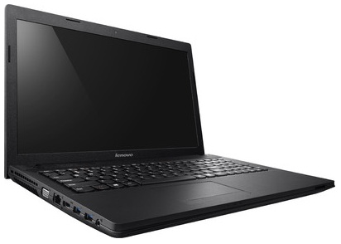

### SPECIFICATIONS OF LENOVO ESSENTIAL G510 (59-382826) LAPTOP (4TH GEN CI5/ 4GB/ 500GB/ WIN8) (BLACK)

|  |  |
| --- | --- |
| **IN THE BOX** | |
| Sales Package | Laptop, Battery, AC Adapter, User Guide and Manuals |

|  |  |
| --- | --- |
| **GENERAL** | |
| Brand | Lenovo |
| Model Name | Essential |
| Series | G |
| Lifestyle | Everyday Use |
| Color | Black |
| Model ID | G510/59-382826 |

|  |  |
| --- | --- |
| **PROCESSOR** | |
| Processor | Core i5 (4th Gen) |
| Variant | 4200M |
| Chipset | QM87 |
| Brand | Intel |
| Clock Speed | 2.5 GHz with Turbo Boost Technology Upto 3.1 GHz |
| Cache | 3 MB |

|  |  |
| --- | --- |
| **MEMORY** | |
| Expandable Memory | Upto 16 GB |
| Memory Slots | 2 (Unused Slot - 1) |
| System Memory | 4 GB DDR3 |

|  |  |
| --- | --- |
| **STORAGE** | |
| RPM | 5400 |
| HDD Capacity | 500 GB |

|  |  |
| --- | --- |
| **OPTICAL DISK DRIVE** | |
| Optical Drive | Rambo Drive |

|  |  |
| --- | --- |
| **PLATFORM** | |
| Operating System | Windows 8 |
| System Architecture | 64 bit |
| OS Architecture | 64 bit |

|  |  |
| --- | --- |
| **DISPLAY** | |
| Screen Size | 15.6 inch |
| Resolution | 1366 x 768 Pixel |
| Screen Type | HD LED Glare Display |

|  |  |
| --- | --- |
| **GRAPHICS** | |
| Graphic Processor | Intel HD Graphics 4600 |

|  |  |
| --- | --- |
| **INPUT** | |
| Web Camera | 720p HD Webcam |
| Pointer Device | Multi-touch Touchpad |
| Keyboard | Chiclet Keyboard |

|  |  |
| --- | --- |
| **AUDIO** | |
| Internal Mic | Analog Microphone |
| Speakers | Yes |
| Sound | 2 x 1.5 W Speakers, Dolby Advanced Audio |

|  |  |
| --- | --- |
| **COMMUNICATION** | |
| Ethernet | 10/100M LAN |
| Wireless LAN | IEEE 802.11g/n |
| Bluetooth | Yes |

|  |  |
| --- | --- |
| **POWER** | |
| Battery Backup | Upto 5 hours |
| Power Supply | 65 W AC Adapter |
| Battery Cell | 6 cell |

|  |  |
| --- | --- |
| **PORTS/SLOTS** | |
| USB Port | 1 x USB 2.0, 2 x USB 3.0 |
| Mic In | Yes |
| RJ45 LAN | Yes |
| HDMI Port | Yes |
| VGA Port | Yes |
| Multi Card Slot | 2-in-1 Card Reader |
| Other Ports | 1 x Stereo Headphone/Microphone Combo Jack |

|  |  |
| --- | --- |
| **MACHINE DIMENSIONS** | |
| Weight | 2.6 kg |
| Dimension | 377 x 250 x 34 mm |
| Color | Black |

|  |  |
| --- | --- |
| **WARRANTY** | |
| Warranty Summary | 1 Year Onsite 1 Year Accidental Damage Protection (ADP) |

Lenovo IdeaPad Z510 (59-398016) Laptop (4th Gen Ci7/ 8GB/ 1TB 8GB SSD/ Win8.1/ 2GB Graph)

**Rs. 58990**

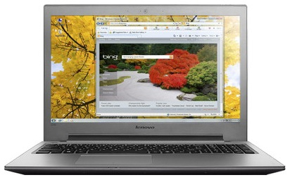

### SPECIFICATIONS OF LENOVO IDEAPAD Z510 (59-398016) LAPTOP (4TH GEN CI7/ 8GB/ 1TB 8GB SSD/ WIN8.1/ 2GB GRAPH) (DARK CHOCOLATE)

|  |  |
| --- | --- |
| **IN THE BOX** | |
| Sales Package | Laptop, Battery, AC Adapter, User Guide and Manuals |

|  |  |
| --- | --- |
| **GENERAL** | |
| Brand | Lenovo |
| Model Name | Ideapad |
| Series | Z |
| Lifestyle | Gaming |
| Color | Dark Chocolate |
| Model ID | Z510/59-398016 |

|  |  |
| --- | --- |
| **PROCESSOR** | |
| Processor | Core i7 (4th Gen) |
| Variant | 4702MQ |
| Chipset | HM87 |
| Brand | Intel |
| Clock Speed | 2.2 GHz with Turbo Boost Upto 3.2 GHz |
| Cache | 6 MB |

|  |  |
| --- | --- |
| **MEMORY** | |
| Expandable Memory | Upto 8 GB |
| Memory Slots | 2 (Unused Slot - 0) |
| System Memory | 8 GB DDR3 |

|  |  |
| --- | --- |
| **STORAGE** | |
| Hardware Interface | SATA |
| RPM | 5400 |
| HDD Capacity | 1 TB |
| SSD Capacity | Yes, 8 GB |

|  |  |
| --- | --- |
| **OPTICAL DISK DRIVE** | |
| Optical Drive | DVD RW Drive |

|  |  |
| --- | --- |
| **PLATFORM** | |
| Operating System | Windows 8.1 |
| System Architecture | 64 bit |
| OS Architecture | 64 bit |

|  |  |
| --- | --- |
| **DISPLAY** | |
| Screen Size | 15.6 inch |
| Screen Type | HD Anti-glare Display with LED Backlit |

|  |  |
| --- | --- |
| **GRAPHICS** | |
| Dedicated Graphics Memory Type | DDR3 |
| Graphic Processor | NVIDIA N14P-GV2 |

|  |  |
| --- | --- |
| **INPUT** | |
| Web Camera | 1.0 HD Webcam |
| Pointer Device | Touchpad |
| Keyboard | AccuType Backlit Keyboard |

|  |  |
| --- | --- |
| **AUDIO** | |
| Internal Mic | Array Microphones |
| Speakers | JBL Speakers |
| Sound | JBL Designed Stereo Speaker, Dolby Home Theatre v4 |

|  |  |
| --- | --- |
| **COMMUNICATION** | |
| Bluetooth | Yes |

|  |  |
| --- | --- |
| **POWER** | |
| Power Supply | 48 W AC Adapter |
| Battery Cell | 4 cell |

|  |  |
| --- | --- |
| **PORTS/SLOTS** | |
| HDMI Port | Yes |
| VGA Port | Yes |

|  |  |
| --- | --- |
| **MACHINE DIMENSIONS** | |
| Weight | 2.7 kg |
| Color | Dark Chocolate |

|  |  |
| --- | --- |
| **WARRANTY** | |
| Warranty Summary | 1 Year Onsite Warranty |

Lenovo Ideapad S210 T (59-379334) Netbook (3rd Gen Ci3/ 4GB/ 500GB/ Win8/ Touch)

**Rs. 34500**

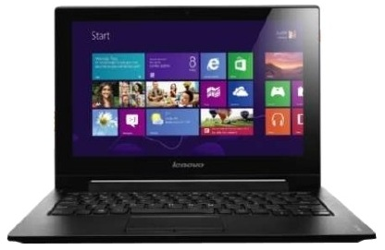

### SPECIFICATIONS OF LENOVO IDEAPAD S210 T (59-379334) NETBOOK (3RD GEN CI3/ 4GB/ 500GB/ WIN8/ TOUCH) (BLACK)

|  |  |
| --- | --- |
| **IN THE BOX** | |
| Sales Package | Laptop, Battery, AC Adapter, User Guide and Manuals |

|  |  |
| --- | --- |
| **GENERAL** | |
| Brand | Lenovo |
| Model Name | Ideapad |
| Series | S |
| Lifestyle | Everyday Use |
| Color | Black |
| Model ID | S210 T/59-379334 |

|  |  |
| --- | --- |
| **PROCESSOR** | |
| Processor | Core i3 (3rd Gen) |
| Variant | 3217U |
| Chipset | Mobile HM76 Express |
| Brand | Intel |
| Clock Speed | 1.8 GHz |
| Cache | 3 MB |

|  |  |
| --- | --- |
| **MEMORY** | |
| Expandable Memory | Upto 8 GB |
| Memory Slots | 1 (Unused Slot - 0) |
| System Memory | 4 GB DDR3 |

|  |  |
| --- | --- |
| **STORAGE** | |
| RPM | 5400 |
| HDD Capacity | 500 GB |

|  |  |
| --- | --- |
| **OPTICAL DISK DRIVE** | |
| Optical Drive | Not Available |

|  |  |
| --- | --- |
| **PLATFORM** | |
| Operating System | Windows 8 |
| System Architecture | 64 bit |
| OS Architecture | 64 bit |

|  |  |
| --- | --- |
| **DISPLAY** | |
| Screen Size | 11.6 inch |
| Resolution | 1366 x 768 Pixel |
| Screen Type | HD LED Display with 10 Point Multi-touch |

|  |  |
| --- | --- |
| **GRAPHICS** | |
| Graphic Processor | Intel HD Graphics 4000 |

|  |  |
| --- | --- |
| **INPUT** | |
| Web Camera | 720p HD Webcam |
| Pointer Device | Touchpad |
| Keyboard | AccuType Keyboard |

|  |  |
| --- | --- |
| **AUDIO** | |
| Speakers | Yes |
| Sound | Stereo Speakers with Dolby Advanced Audio v2 |

|  |  |
| --- | --- |
| **COMMUNICATION** | |
| Wireless LAN | IEEE 802.11b/g/n |
| Bluetooth | Yes |

|  |  |
| --- | --- |
| **POWER** | |
| Battery Backup | Upto 4 hours |
| Battery Cell | 3 cell |

|  |  |
| --- | --- |
| **PORTS/SLOTS** | |
| USB Port | 1 x USB 2.0, 1 x USB 3.0 |
| Mic In | Yes |
| RJ45 LAN | Yes |
| HDMI Port | Yes |
| Multi Card Slot | 2-in-1 Card Reader |
| Other Ports | 2-in-1 (Headphone and Mic) |

|  |  |
| --- | --- |
| **MACHINE DIMENSIONS** | |
| Weight | 1.5 kg |
| Dimension | 299 x 207 x 22.3 mm |
| Color | Black |

|  |  |
| --- | --- |
| **WARRANTY** | |
| Warranty Summary | 1 Year Onsite Warranty |