Samsung NP300E5V-A02IN Laptop (3rd Gen Ci3/ 2GB/ 500GB/ DOS)

**Rs. 30430**

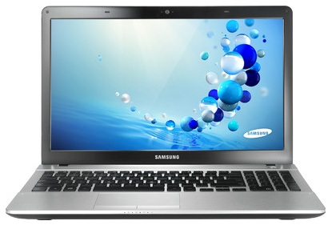

### SPECIFICATIONS OF SAMSUNG NP300E5V-A02IN LAPTOP (3RD GEN CI3/ 2GB/ 500GB/ DOS) (SLEEK SILVER)

|  |  |
| --- | --- |
| **IN THE BOX** | |
| Sales Package | Laptop, Manual, Adapter |

|  |  |
| --- | --- |
| **GENERAL** | |
| Brand | Samsung |
| Series | NP300 |
| Lifestyle | Everyday Use |
| Color | Sleek Silver |
| Model ID | NP300E5V-A02IN |

|  |  |
| --- | --- |
| **PROCESSOR** | |
| Processor | Core i3 (3rd Gen) |
| Variant | 3120M |
| Chipset | Mobile HM75 Express |
| Brand | Intel |
| Clock Speed | 2.5 GHz |
| Cache | 3 MB |

|  |  |
| --- | --- |
| **MEMORY** | |
| Expandable Memory | Upto 8 GB |
| Memory Slots | 2 (Unused Slot - 1) |
| System Memory | 2 GB DDR3 |

|  |  |
| --- | --- |
| **STORAGE** | |
| RPM | 5400 |
| HDD Capacity | 500 GB |

|  |  |
| --- | --- |
| **OPTICAL DISK DRIVE** | |
| Optical Drive | SuperMulti DVD RW Drive |

|  |  |
| --- | --- |
| **PLATFORM** | |
| Operating System | Free DOS |
| System Architecture | 64 bit |

|  |  |
| --- | --- |
| **DISPLAY** | |
| Screen Size | 15.6 inch |
| Screen Type | Anti Reflective Display |

|  |  |
| --- | --- |
| **GRAPHICS** | |
| Graphic Processor | Intel HD Graphics 4000 |

|  |  |
| --- | --- |
| **INPUT** | |
| Web Camera | 720p HD Webcam |
| Pointer Device | Touchpad |
| Keyboard | Standard Keyboard |

|  |  |
| --- | --- |
| **AUDIO** | |
| Speakers | Yes |
| Sound | SoundAlive |

|  |  |
| --- | --- |
| **COMMUNICATION** | |
| Ethernet | 10/100 LAN |
| Wireless LAN | Yes |
| Bluetooth | v4.0 |

|  |  |
| --- | --- |
| **POWER** | |
| Battery Backup | Upto 6 hours |
| Power Supply | 65 W AC Adapter |
| Battery Cell | 6 cell |

|  |  |
| --- | --- |
| **PORTS/SLOTS** | |
| USB Port | 3 x USB 2.0 |
| Mic In | Yes |
| RJ45 LAN | Yes |
| HDMI Port | Yes |
| VGA Port | Yes |
| Multi Card Slot | Yes |

|  |  |
| --- | --- |
| **MACHINE DIMENSIONS** | |
| Weight | 2.2 kg |
| Color | Sleek Silver |

|  |  |
| --- | --- |
| **WARRANTY** | |
| Warranty Summary | 1 Year Standard On-site Warranty |

Samsung NP530U4C-S06IN Laptop (3rd Gen Ci3/ 4GB/ 750GB 24GB ExpressCache/ Win8)

**Rs. 38790**

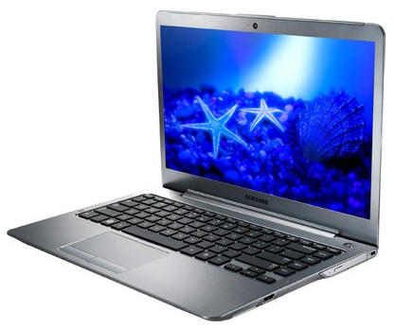

### SPECIFICATIONS OF SAMSUNG NP530U4C-S06IN LAPTOP (3RD GEN CI3/ 4GB/ 750GB 24GB EXPRESSCACHE/ WIN8) (LIGHT TITAN)

|  |  |
| --- | --- |
| **IN THE BOX** | |
| Sales Package | Laptop, Battery, Manual, Power Cable |

|  |  |
| --- | --- |
| **GENERAL** | |
| Brand | Samsung |
| Lifestyle | Everyday Use |
| Color | Light Titan |
| Model ID | NP530U4C-S06IN |

|  |  |
| --- | --- |
| **PROCESSOR** | |
| Processor | Core i3 (3rd Gen) |
| Variant | 3227U |
| Chipset | Mobile HM76 Express |
| Brand | Intel |
| Clock Speed | 1.9 GHz |
| Cache | 3 MB |

|  |  |
| --- | --- |
| **MEMORY** | |
| Expandable Memory | Upto 8 GB |
| Memory Slots | 1 (Unused Slot - 0) |
| System Memory | 4 GB DDR3 |

|  |  |
| --- | --- |
| **STORAGE** | |
| Hardware Interface | SATA II |
| RPM | 5400 |
| HDD Capacity | 750 GB |
| SSD Capacity | Yes, 24 GB |

|  |  |
| --- | --- |
| **OPTICAL DISK DRIVE** | |
| Optical Drive | SuperMulti Drive with Dual Layer Support |

|  |  |
| --- | --- |
| **PLATFORM** | |
| Operating System | Windows 8 |
| System Architecture | 64 bit |
| OS Architecture | 64 bit |

|  |  |
| --- | --- |
| **DISPLAY** | |
| Screen Size | 14 inch |
| Resolution | 1366 x 768 Pixel |
| Screen Type | HD LED Anti Reflective Display |

|  |  |
| --- | --- |
| **GRAPHICS** | |
| Graphic Processor | Intel HD Graphics 4000 |

|  |  |
| --- | --- |
| **INPUT** | |
| Web Camera | 1.3 Megapixel |
| Pointer Device | Touchpad |
| Keyboard | Island Keyboard |

|  |  |
| --- | --- |
| **AUDIO** | |
| Internal Mic | Yes |
| Speakers | Yes |
| Sound | Stereo Speakers (2 Watts x 2), Sound Effect: SoundAlive |

|  |  |
| --- | --- |
| **COMMUNICATION** | |
| Ethernet | 10/100/1000 Gigabit LAN |
| Wireless LAN | IEEE 802.11a/b/g/n |
| Bluetooth | v4.0 |
| Wireless WAN | Intel Centrino Advanced-N 6235 |

|  |  |
| --- | --- |
| **POWER** | |
| Battery Backup | Upto 3.5 hours |
| Power Supply | 60 W AC Adapter |
| Battery Cell | 8 cell |

|  |  |
| --- | --- |
| **PORTS/SLOTS** | |
| USB Port | 1 x USB 2.0, 2 x USB 3.0 |
| Mic In | Yes |
| RJ45 LAN | Yes |
| HDMI Port | Yes |
| VGA Port | Yes |
| Multi Card Slot | 3-in-1 Card Reader |
| Other Ports | 1 x Headphone Out/Mic-in Combo Port |

|  |  |
| --- | --- |
| **SECURITY** | |
| Lock Port | Yes |

|  |  |
| --- | --- |
| **MACHINE DIMENSIONS** | |
| Weight | 1.81 kg |
| Dimension | 333 x 229.5 x 20.9 mm |
| Color | Light Titan |

|  |  |
| --- | --- |
| **WARRANTY** | |
| Warranty Summary | 1 Year Standard On-site Warranty |

Samsung NP550P5C-S06IN Laptop (3rd Gen Ci5/ 6GB/ 1TB/ Win8/ 2GB Graph)

**Rs. 58490**

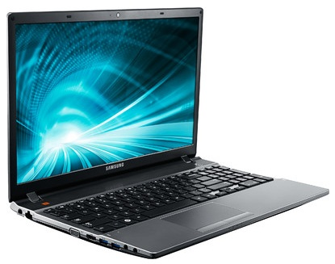

### SPECIFICATIONS OF SAMSUNG NP550P5C-S06IN LAPTOP (3RD GEN CI5/ 6GB/ 1TB/ WIN8/ 2GB GRAPH) (SILVER)

|  |  |
| --- | --- |
| **IN THE BOX** | |
| Sales Package | Laptop, Battery, AC Adapter, User Guide and Manuals |

|  |  |
| --- | --- |
| **GENERAL** | |
| Brand | Samsung |
| Series | Series 5 |
| Lifestyle | Gaming |
| Color | Silver |
| Model ID | NP550P5C-S06IN |

|  |  |
| --- | --- |
| **PROCESSOR** | |
| Processor | Core i5 (3rd Gen) |
| Variant | 3230M |
| Chipset | Mobile HM75 Express |
| Brand | Intel |
| Clock Speed | 2.6 GHz with Turbo Boost Upto 3.2 GHz |
| Cache | 3 MB |

|  |  |
| --- | --- |
| **MEMORY** | |
| Expandable Memory | Upto 8 GB |
| Memory Slots | 2 (Unused Slot - 0) |
| System Memory | 6 GB DDR3 |

|  |  |
| --- | --- |
| **STORAGE** | |
| Hardware Interface | SATA II |
| RPM | 5400 |
| HDD Capacity | 1 TB |

|  |  |
| --- | --- |
| **OPTICAL DISK DRIVE** | |
| Optical Drive | Blu-ray Drive |

|  |  |
| --- | --- |
| **PLATFORM** | |
| Operating System | Windows 8 |
| System Architecture | 64 bit |
| OS Architecture | 64 bit |

|  |  |
| --- | --- |
| **DISPLAY** | |
| Screen Size | 15.6 inch |
| Resolution | 1600 x 900 Pixel |
| Screen Type | HD SuperBright LED Anti Reflective Display |

|  |  |
| --- | --- |
| **GRAPHICS** | |
| Dedicated Graphics Memory Type | DDR3 |
| Graphic Processor | NVIDIA GeForce GT 650M |

|  |  |
| --- | --- |
| **INPUT** | |
| Web Camera | 1.3 Megapixel HD Webcam |
| Pointer Device | Touchpad |
| Keyboard | Island Keyboard with Numeric Keypad |

|  |  |
| --- | --- |
| **AUDIO** | |
| Internal Mic | Yes |
| Speakers | JBL Speakers |
| Sound | Stereo Speakers (2 x 2 Watts) with Sub-woofer (5 Watts), SoundAlive, Max Bass Boost Subwoofer |

|  |  |
| --- | --- |
| **COMMUNICATION** | |
| Ethernet | 10/100/1000 Gigabit LAN |
| Wireless LAN | IEEE 802.11 a/b/g/n |
| Bluetooth | v4.0 |
| Wireless WAN | Intel Centrino Advanced-N 6235 |

|  |  |
| --- | --- |
| **POWER** | |
| Battery Backup | Upto 3 hours |
| Power Supply | 90 W AC Adapter |
| Battery Cell | 6 cell |

|  |  |
| --- | --- |
| **PORTS/SLOTS** | |
| USB Port | 2 x USB 2.0, 2 x USB 3.0 |
| Mic In | Yes |
| RJ45 LAN | Yes |
| HDMI Port | Yes |
| VGA Port | Yes |
| Multi Card Slot | 3-in-1 Card Reader |
| Other Ports | 1 x Headphone Out |

|  |  |
| --- | --- |
| **SECURITY** | |
| Lock Port | Yes |

|  |  |
| --- | --- |
| **MACHINE DIMENSIONS** | |
| Weight | 2.5 kg |
| Dimension | 367.9 x 242.8 x 30.4 mm |
| Color | Silver |

|  |  |
| --- | --- |
| **WARRANTY** | |
| Warranty Summary | 1 Year Limited Warranty |

Samsung NP370R5E-S06IN Laptop (3rd Gen Ci3/ 4GB/ 750GB/ Win8/ 2GB Graph)

**Rs. 39990**

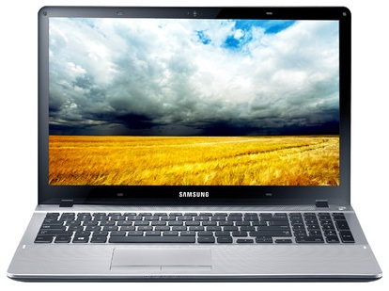

### SPECIFICATIONS OF SAMSUNG NP370R5E-S06IN LAPTOP (3RD GEN CI3/ 4GB/ 750GB/ WIN8/ 2GB GRAPH) (SLEEK SILVER)

|  |  |
| --- | --- |
| **IN THE BOX** | |
| Sales Package | Laptop, Battery,Manual, Power Cable |

|  |  |
| --- | --- |
| **GENERAL** | |
| Brand | Samsung |
| Series | 3 370R |
| Lifestyle | Entertainment |
| Color | Sleek Silver |
| Model ID | NP370R5E-S06IN |

|  |  |
| --- | --- |
| **PROCESSOR** | |
| Processor | Core i3 (3rd Gen) |
| Variant | 3120M |
| Chipset | Mobile HM76 Express |
| Brand | Intel |
| Clock Speed | 2.5 GHz |
| Cache | 3 MB |

|  |  |
| --- | --- |
| **MEMORY** | |
| Expandable Memory | Upto 8 GB |
| Memory Slots | 2 (Unused Slot - 1) |
| System Memory | 4 GB DDR3 |

|  |  |
| --- | --- |
| **STORAGE** | |
| Hardware Interface | SATA II |
| RPM | 5400 |
| HDD Capacity | 750 GB |

|  |  |
| --- | --- |
| **OPTICAL DISK DRIVE** | |
| Optical Drive | Not Available |

|  |  |
| --- | --- |
| **PLATFORM** | |
| Operating System | Windows 8 |
| System Architecture | 64 bit |
| OS Architecture | 64 bit |

|  |  |
| --- | --- |
| **DISPLAY** | |
| Screen Size | 15.6 inch |
| Resolution | 1366 x 768 Pixel |
| Screen Type | HD LED Anti Reflective Display |

|  |  |
| --- | --- |
| **GRAPHICS** | |
| Dedicated Graphics Memory Type | GDDR3 |
| Graphic Processor | AMD Radeon HD 8750M |

|  |  |
| --- | --- |
| **INPUT** | |
| Web Camera | 720p HD Webcam |
| Pointer Device | Touchpad |
| Keyboard | Island Keyboard with Numeric Keypad |

|  |  |
| --- | --- |
| **AUDIO** | |
| Internal Mic | Digital Microphone |
| Speakers | Yes |
| Sound | Stereo Speakers (1.5 Watts x 2), SoundAlive |

|  |  |
| --- | --- |
| **COMMUNICATION** | |
| Ethernet | 10/100/1000 Gigabit LAN |
| Wireless LAN | IEEE 802.11b/g/n |
| Bluetooth | v4.0 |

|  |  |
| --- | --- |
| **POWER** | |
| Battery Backup | Upto 3 hours |
| Power Supply | 65 W AC Adapter |
| Battery Cell | 3 cell |

|  |  |
| --- | --- |
| **PORTS/SLOTS** | |
| USB Port | 2 x USB 2.0, 1 x USB 3.0 |
| Mic In | Yes |
| RJ45 LAN | Yes |
| HDMI Port | Yes |
| VGA Port | Yes |
| Multi Card Slot | 3-in-1 Card Reader |
| Other Ports | 1 x Headphone Out/Mic-in Combo Port |

|  |  |
| --- | --- |
| **SECURITY** | |
| Lock Port | Yes |

|  |  |
| --- | --- |
| **MACHINE DIMENSIONS** | |
| Weight | 1.99 kg |
| Dimension | 376 x 248 x 22.9 mm |
| Color | Sleek Silver |

|  |  |
| --- | --- |
| **WARRANTY** | |
| Warranty Summary | 1 Year Standard On-site Warranty |

Samsung ATIV Smart PC (3rd Gen Ci5/ 4GB/ 128GB SSD/ Win8/ Touch)

**Rs. 74490**

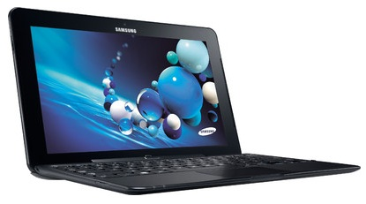

### SPECIFICATIONS OF SAMSUNG ATIV SMART PC (3RD GEN CI5/ 4GB/ 128GB SSD/ WIN8/ TOUCH) (BLACK)

|  |  |
| --- | --- |
| **IN THE BOX** | |
| Sales Package | Laptop, Battery, AC Adapter, User Guides and Manuals, S Pen |

|  |  |
| --- | --- |
| **GENERAL** | |
| Brand | Samsung |
| Model Name | XE700T1C-A01IN |
| Lifestyle | Everyday Use |
| Color | Black |
| Model ID | XE700T1C-A01IN |

|  |  |
| --- | --- |
| **PROCESSOR** | |
| Processor | Core i5 (3rd Gen) |
| Variant | 3317U |
| Chipset | Mobile HM76 Express |
| Brand | Intel |
| Clock Speed | 1.7 GHz with Turbo Boost Upto 2.6 GHz |
| Cache | 3 MB |

|  |  |
| --- | --- |
| **MEMORY** | |
| Memory Slots | 1 (Unused Slot - 0) |
| System Memory | 4 GB DDR3 |

|  |  |
| --- | --- |
| **STORAGE** | |
| SSD Capacity | Yes, 128 GB |

|  |  |
| --- | --- |
| **OPTICAL DISK DRIVE** | |
| Optical Drive | Not Available |

|  |  |
| --- | --- |
| **PLATFORM** | |
| Operating System | Windows 8 |
| System Architecture | 64 bit |
| OS Architecture | 64 bit |

|  |  |
| --- | --- |
| **DISPLAY** | |
| Screen Size | 11.6 inch |
| Resolution | 1920 x 1080 Pixel |
| Screen Type | Full HD LED Display with 10 Finger Multi-touch |

|  |  |
| --- | --- |
| **GRAPHICS** | |
| Graphic Processor | Intel HD Graphics 4000 |

|  |  |
| --- | --- |
| **INPUT** | |
| Web Camera | 2.0 Megapixel Webcam (Front), 5.0 Megapixel Webcam (Rear) |
| Pointer Device | Touchpad |
| Keyboard | Island Keyboard |

|  |  |
| --- | --- |
| **AUDIO** | |
| Internal Mic | Dual Array Digital Microphone |
| Speakers | Yes |
| Sound | 2 x 1 W Speakers, SoundAlive, Stereo Speakers |

|  |  |
| --- | --- |
| **COMMUNICATION** | |
| Ethernet | Yes |
| Bluetooth | v4.0 |
| Wireless WAN | Intel Centrino Advanced-N 6235 |

|  |  |
| --- | --- |
| **POWER** | |
| Power Supply | 40 W AC Adapter |
| Battery Cell | 4 cell |

|  |  |
| --- | --- |
| **PORTS/SLOTS** | |
| USB Port | 1 x USB 3.0 |
| Dock Port | Yes |
| Mic In | Yes |
| HDMI Port | Yes |
| Multi Card Slot | microSD Card Support |
| Other Ports | 1 x Headphone Out/Mic-in Combo, 1 x Micro HDMI |

|  |  |
| --- | --- |
| **SECURITY** | |
| Security Chip | Trusted Platform Module (TPM) |

|  |  |
| --- | --- |
| **MACHINE DIMENSIONS** | |
| Weight | 0.888 kg |
| Dimension | 304 x 189.4 x 11.9 mm |
| Color | Black |

Samsung NP530U4C-S04IN Ultrabook (3rd Gen Ci3/ 4GB/ 750GB 24GB ExpressCache/ Win8/ 1GB Graph)

**Rs. 40000**

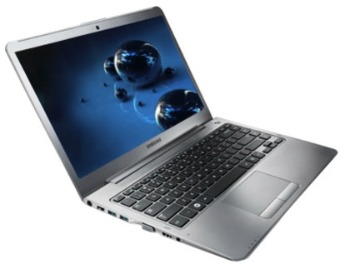

### SPECIFICATIONS OF SAMSUNG NP530U4C-S04IN ULTRABOOK (3RD GEN CI3/ 4GB/ 750GB 24GB EXPRESSCACHE/ WIN8/ 1GB GRAPH) (LIGHT TITAN)

|  |  |
| --- | --- |
| **IN THE BOX** | |
| Sales Package | Laptop, Battery, AC Adapter, User Guides and Manuals |

|  |  |
| --- | --- |
| **GENERAL** | |
| Brand | Samsung |
| Lifestyle | Entertainment |
| Color | LIGHT TITAN |
| Model ID | NP530U4C-S04IN |

|  |  |
| --- | --- |
| **PROCESSOR** | |
| Processor | Core i3 (3rd Gen) |
| Variant | 3217U |
| Chipset | Mobile HM76 Express |
| Brand | Intel |
| Clock Speed | 1.8 GHz |
| Cache | 3 MB |

|  |  |
| --- | --- |
| **MEMORY** | |
| Expandable Memory | Upto 8 GB |
| Memory Slots | 1 (Unused Slot - 1) |
| System Memory | 4 GB DDR3 |

|  |  |
| --- | --- |
| **STORAGE** | |
| Hardware Interface | SATA II |
| RPM | 5400 |
| HDD Capacity | 750 GB |

|  |  |
| --- | --- |
| **OPTICAL DISK DRIVE** | |
| Optical Drive | SuperMulti Drive with Dual Layer Support |

|  |  |
| --- | --- |
| **PLATFORM** | |
| Operating System | Windows 8 |
| System Architecture | 64 bit |
| OS Architecture | 64 bit |

|  |  |
| --- | --- |
| **DISPLAY** | |
| Screen Size | 14 inch |
| Resolution | 1366 x 768 Pixel |
| Screen Type | SuperBright HD LED Anti-Reflective Display |

|  |  |
| --- | --- |
| **GRAPHICS** | |
| Dedicated Graphics Memory Type | GDDR3 |
| Graphic Processor | NVIDIA GeForce GT 620M |

|  |  |
| --- | --- |
| **INPUT** | |
| Web Camera | 1.3 Megapixel HD Webcam |
| Pointer Device | Touchpad |
| Keyboard | Island Keyboard |

|  |  |
| --- | --- |
| **AUDIO** | |
| Internal Mic | Yes |
| Speakers | Yes |
| Sound | Stereo Speakers, SoundAlive, 4 Watts Speaker (2 Watts x 2) |

|  |  |
| --- | --- |
| **COMMUNICATION** | |
| Ethernet | 10/100/1000 Gigabit LAN |
| Wireless LAN | Intel Centrino Advanced-N 6235, 2x2 802.11 abg/n (Upto 300 Mbps), Widi Support |
| Bluetooth | v4.0 |

|  |  |
| --- | --- |
| **POWER** | |
| Battery Backup | Upto 3 hours |
| Power Supply | 60 W AC Adapter |
| Battery Cell | 8 cell |

|  |  |
| --- | --- |
| **MACHINE DIMENSIONS** | |
| Weight | 1.81 kg |
| Dimension | 333 x 229.5 x 20.9 mm |
| Color | LIGHT TITAN |

Samsung NP300E5X-A09IN Laptop (2nd Gen PDC/ 2GB/ 500 GB/ DOS)

**Rs. 23900**

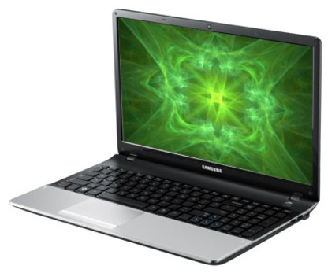

### SPECIFICATIONS OF SAMSUNG NP300E5X-A09IN LAPTOP (2ND GEN PDC/ 2GB/ 500 GB/ DOS) (TITAN SILVER)

|  |  |
| --- | --- |
| **IN THE BOX** | |
| Sales Package | Laptop, Battery, AC Adapter, User Guide and Manuals |

|  |  |
| --- | --- |
| **GENERAL** | |
| Brand | Samsung |
| Series | Series 3 |
| Lifestyle | Everyday Use |
| Color | Titan Silver |
| Model ID | NP300E5X-A09IN |

|  |  |
| --- | --- |
| **PROCESSOR** | |
| Processor | Pentium Dual Core (2nd Gen) |
| Variant | B970 |
| Chipset | Mobile HM70 Express |
| Brand | Intel |
| Clock Speed | 2.3 GHz |
| Cache | 2 MB |

|  |  |
| --- | --- |
| **MEMORY** | |
| Expandable Memory | Upto 8 GB |
| Memory Slots | 2 (Unused Slot - 1) |
| System Memory | 2 GB DDR3 |

|  |  |
| --- | --- |
| **STORAGE** | |
| Hardware Interface | SATA |
| RPM | 5400 |
| HDD Capacity | 500 GB |

|  |  |
| --- | --- |
| **OPTICAL DISK DRIVE** | |
| Optical Drive | SuperMulti Drive with Dual Layer Support |

|  |  |
| --- | --- |
| **PLATFORM** | |
| Operating System | Free DOS |
| System Architecture | 64 bit |

|  |  |
| --- | --- |
| **DISPLAY** | |
| Screen Size | 15.6 inch |
| Resolution | 1366 x 768 Pixel |
| Screen Type | HD LED Display |

|  |  |
| --- | --- |
| **GRAPHICS** | |
| Graphic Processor | Intel HD Graphics |

|  |  |
| --- | --- |
| **INPUT** | |
| Web Camera | 1.3 Megapixel |
| Pointer Device | Touchpad |
| Keyboard | Standard Keyboard with Numeric Keypad |

|  |  |
| --- | --- |
| **AUDIO** | |
| Speakers | Yes |
| Sound | HD Audio, SoundAlive, Stereo Speakers |

|  |  |
| --- | --- |
| **COMMUNICATION** | |
| Ethernet | 10/100/1000 Gigabit LAN |
| Wireless LAN | IEEE 802.11b/g/n |
| Bluetooth | v4.0 |

|  |  |
| --- | --- |
| **POWER** | |
| Battery Backup | Upto 3 hours |
| Power Supply | 60 W AC Adapter |
| Battery Cell | 6 cell |

|  |  |
| --- | --- |
| **SECURITY** | |
| Lock Port | Security Slot |

|  |  |
| --- | --- |
| **MACHINE DIMENSIONS** | |
| Weight | 2.3 kg |
| Dimension | 367.9 x 243 x 34.9 mm |
| Color | Titan Silver |

Samsung NP350V5C-S08IN Laptop (3rd Gen Ci7/ 8GB/ 1 TB/ Win8/ 2GB Graph)

**Rs. 56990**

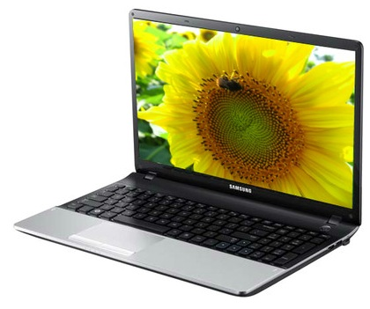

### SPECIFICATIONS OF SAMSUNG NP350V5C-S08IN LAPTOP (3RD GEN CI7/ 8GB/ 1 TB/ WIN8/ 2GB GRAPH) (TITAN SILVER)

|  |  |
| --- | --- |
| **GENERAL** | |
| Brand | Samsung |
| Series | Series 3 |
| Lifestyle | Gaming |
| Color | Titan Silver |
| Model ID | NP350V5C-S08IN |

|  |  |
| --- | --- |
| **PROCESSOR** | |
| Processor | Core i7 (3rd Gen) |
| Variant | 3630QM |
| Brand | Intel |
| Clock Speed | 2.4 GHz with Turbo Boost Upto 3.4 GHz |
| Cache | 6 MB |

|  |  |
| --- | --- |
| **MEMORY** | |
| Memory Slots | 2 (Unused Slot - 0) |
| System Memory | 8 GB DDR3 |

|  |  |
| --- | --- |
| **OPTICAL DISK DRIVE** | |
| Optical Drive | SuperMulti DVD RW Drive |

|  |  |
| --- | --- |
| **PLATFORM** | |
| Operating System | Windows 8 |
| System Architecture | 64 bit |
| OS Architecture | 64 bit |

|  |  |
| --- | --- |
| **DISPLAY** | |
| Screen Size | 15.6 inch |
| Screen Type | Anti Reflective Display |

|  |  |
| --- | --- |
| **INPUT** | |
| Web Camera | 1.3 Megapixel |
| Pointer Device | Touchpad |
| Keyboard | Standard Keyboard |

Samsung NP355V5C-S05IN Laptop (APU Quad Core A8/ 6GB/ 1TB/ Win8/ 1.5GB Graph)

**Rs. 36990**

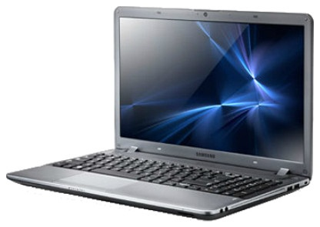

### SPECIFICATIONS OF SAMSUNG NP355V5C-S05IN LAPTOP (APU QUAD CORE A8/ 6GB/ 1TB/ WIN8/ 1.5GB GRAPH) (TITAN SILVER)

|  |  |
| --- | --- |
| **IN THE BOX** | |
| Sales Package | Laptop, Battery, AC Adapter, User Guides and Manuals |

|  |  |
| --- | --- |
| **GENERAL** | |
| Brand | Samsung |
| Lifestyle | Entertainment |
| Color | Titan Silver |
| Model ID | NP355V5C-S05IN |

|  |  |
| --- | --- |
| **PROCESSOR** | |
| Processor | APU Quad Core A8 |
| Variant | 4500M |
| Chipset | A70M |
| Brand | AMD |
| Clock Speed | 1.9 GHz with Turbo Core Technology Upto 2.8 GHz |
| Cache | 4 MB |

|  |  |
| --- | --- |
| **MEMORY** | |
| Expandable Memory | Upto 8 GB |
| Memory Slots | 2 (Unused Slot - 0) |
| System Memory | 6 GB DDR3 |

|  |  |
| --- | --- |
| **STORAGE** | |
| HDD Capacity | 1 TB |

|  |  |
| --- | --- |
| **OPTICAL DISK DRIVE** | |
| Optical Drive | SuperMulti DVD RW Drive |

|  |  |
| --- | --- |
| **PLATFORM** | |
| Operating System | Windows 8 |
| OS Architecture | 64 bit |

|  |  |
| --- | --- |
| **DISPLAY** | |
| Screen Size | 15.6 inch |
| Screen Type | Anti Reflective Display |

|  |  |
| --- | --- |
| **GRAPHICS** | |
| Dedicated Graphics Memory Type | GDDR3 |
| Graphic Processor | 512 MB AMD Radeon HD 7640G(Integrated) and 1 GB HD 7670M Dual Graphics (Dedicated) |

|  |  |
| --- | --- |
| **INPUT** | |
| Web Camera | 1.3 Megapixel |
| Pointer Device | Touchpad |
| Keyboard | Standard Keyboard |

|  |  |
| --- | --- |
| **COMMUNICATION** | |
| Ethernet | Gigabit Lan |
| Wireless LAN | Yes |
| Bluetooth | v4.0 |

|  |  |
| --- | --- |
| **POWER** | |
| Battery Backup | Upto 6 hours |
| Power Supply | 65 W AC Adapter |
| Battery Cell | 6 cell |

|  |  |
| --- | --- |
| **PORTS/SLOTS** | |
| USB Port | 2 x USB 2.0, 2 x USB 3.0 |
| RJ45 LAN | Yes |
| HDMI Port | Yes |

|  |  |
| --- | --- |
| **MACHINE DIMENSIONS** | |
| Weight | 2.33 kg |
| Dimension | 372.5 x 243 x 33 mm |
| Color | Titan Silver |

|  |  |
| --- | --- |
| **WARRANTY** | |
| Warranty Summary | 1 Year Standard On-site Warranty |