Toshiba Satellite C50D-A 60010 Laptop (APU Quad Core A6/ 4GB/ 750GB/ Win8.1/ 512MB Graph)

**Rs. 29949**

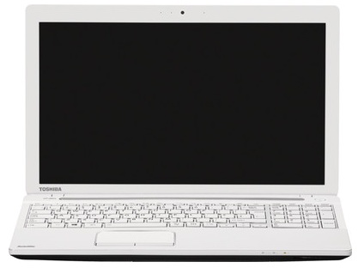

|  |  |
| --- | --- |
| **GENERAL** | |
| Color | Luxury White Pearl |

|  |  |
| --- | --- |
| **PROCESSOR** | |
| Processor | APU Quad Core A6 |

|  |  |
| --- | --- |
| **MEMORY** | |
| System Memory | 4 GB DDR3 |

|  |  |
| --- | --- |
| **PLATFORM** | |
| Operating System | Windows 8.1 |

|  |  |
| --- | --- |
| **DISPLAY** | |
| Screen Size | 15.6 inch |

|  |  |
| --- | --- |
| **INPUT** | |
| Web Camera | HD Webcam |

|  |  |
| --- | --- |
| **MACHINE DIMENSIONS** | |
| Dimension | 380 x 242 x 33.35 mm |

Toshiba Satellite C50-A X0011 Laptop (4th Gen Ci5/ 4GB/ 500GB/ No OS)

**Rs. 34714**

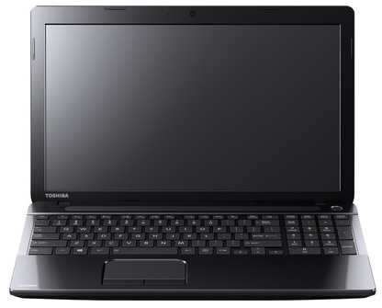

|  |  |
| --- | --- |
| **GENERAL** | |
| Color | Premium Glossy Black |

|  |  |
| --- | --- |
| **PROCESSOR** | |
| Processor | Core i5 (4th Gen) |

|  |  |
| --- | --- |
| **MEMORY** | |
| System Memory | 4 GB DDR3 |

|  |  |
| --- | --- |
| **PLATFORM** | |
| Operating System | No OS |

|  |  |
| --- | --- |
| **DISPLAY** | |
| Screen Size | 15.6 inch |

|  |  |
| --- | --- |
| **INPUT** | |
| Web Camera | HD Webcam |

|  |  |
| --- | --- |
| **MACHINE DIMENSIONS** | |
| Dimension | 380 x 242 x 33.35 mm |

Toshiba Satellite U40-A I0110 Laptop (4th Gen Ci3/ 4GB/ 750GB/ Win8.1)

**Rs. 37990**

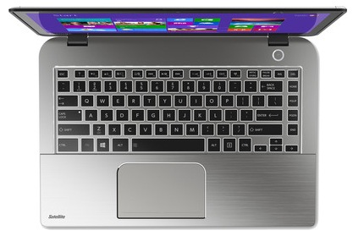

|  |  |
| --- | --- |
| **GENERAL** | |
| Color | Metallic Smart Silver With Hairline |

|  |  |
| --- | --- |
| **PROCESSOR** | |
| Processor | Core i3 (4th Gen) |

|  |  |
| --- | --- |
| **MEMORY** | |
| System Memory | 4 GB DDR3 |

|  |  |
| --- | --- |
| **PLATFORM** | |
| Operating System | Windows 8.1 |

|  |  |
| --- | --- |
| **DISPLAY** | |
| Screen Size | 14 inch |

|  |  |
| --- | --- |
| **INPUT** | |
| Web Camera | HD Webcam |

|  |  |
| --- | --- |
| **MACHINE DIMENSIONS** | |
| Dimension | 340.18 x 234.12 x 21.46 mm |

Toshiba Satellite L750-X531B Laptop (2nd Gen Ci5/ 6GB/ 750GB/ Win7 HP/ 2GB Graph)

**Rs. 41900**

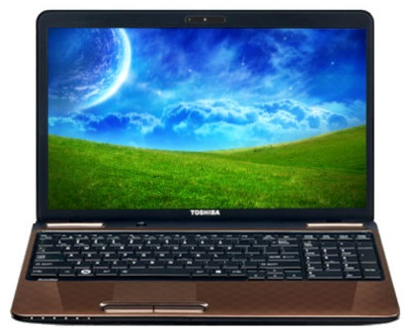

|  |  |
| --- | --- |
| **GENERAL** | |
| Brand | Toshiba |
| Color | Sparkling Maroon Brown With 3D Dots Pattern |

|  |  |
| --- | --- |
| **PROCESSOR** | |
| Processor | Core i5 (2nd Gen) |

|  |  |
| --- | --- |
| **MEMORY** | |
| System Memory | 6 GB DDR3 |

|  |  |
| --- | --- |
| **PLATFORM** | |
| Operating System | Windows 7 Home Premium |

|  |  |
| --- | --- |
| **DISPLAY** | |
| Screen Size | 15.6 inch |

|  |  |
| --- | --- |
| **INPUT** | |
| Web Camera | 1.3 Megapixel |

|  |  |
| --- | --- |
| **MACHINE DIMENSIONS** | |
| Dimension | 380 x 227 x 37.5 mm |

Toshiba Satellite P50-A Y3110 Laptop (4th Gen Ci7/ 8GB/ 1TB/ Win8.1/ 2GB Graph)

**Rs. 73740**

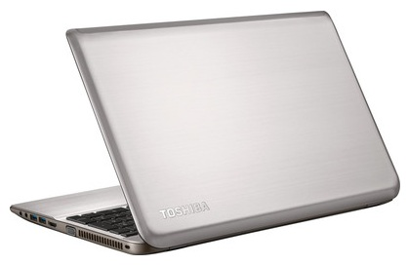

|  |  |
| --- | --- |
| **GENERAL** | |
| Color | Premium Brushed&Metallic Smart Silver |

|  |  |
| --- | --- |
| **PROCESSOR** | |
| Processor | Core i7 (4th Gen) |

|  |  |
| --- | --- |
| **MEMORY** | |
| System Memory | 8 GB DDR3 |

|  |  |
| --- | --- |
| **PLATFORM** | |
| Operating System | Windows 8.1 |

|  |  |
| --- | --- |
| **DISPLAY** | |
| Screen Size | 15.6 inch |

|  |  |
| --- | --- |
| **INPUT** | |
| Web Camera | HD Webcam with Stereo Mic |

|  |  |
| --- | --- |
| **MACHINE DIMENSIONS** | |
| Dimension | 377.5 x 244 x 23.45 mm |

Toshiba Satellite C850-X5214 Laptop (3rd Gen Ci5/ 4GB/ 500GB/ Win7 HB/ 1GB Graph)

**Rs. 44000**

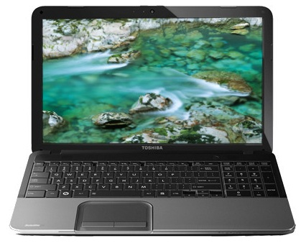

|  |  |
| --- | --- |
| **GENERAL** | |
| Color | Gloss Shining Silver With Crossline Pattern |

|  |  |
| --- | --- |
| **PROCESSOR** | |
| Processor | Core i5 (3rd Gen) |

|  |  |
| --- | --- |
| **MEMORY** | |
| System Memory | 4 GB DDR3 |

|  |  |
| --- | --- |
| **PLATFORM** | |
| Operating System | Windows 7 Home Basic |

|  |  |
| --- | --- |
| **DISPLAY** | |
| Screen Size | 15.6 inch |

|  |  |
| --- | --- |
| **INPUT** | |
| Web Camera | HD Webcam |

|  |  |
| --- | --- |
| **MACHINE DIMENSIONS** | |
| Dimension | 380 x 242 x 33.55 mm |

Toshiba Satellite P50-A X3111 Laptop (4th Gen Ci5/ 4GB/ 1TB/ Win8.1/ 2GB Graph)

**Rs. 50343**

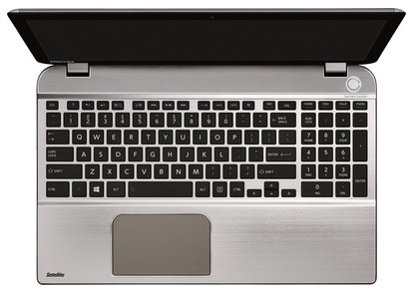

|  |  |
| --- | --- |
| **GENERAL** | |
| Color | Premium Brushed&Metallic Smart Silver |

|  |  |
| --- | --- |
| **PROCESSOR** | |
| Processor | Core i5 (4th Gen) |

|  |  |
| --- | --- |
| **MEMORY** | |
| System Memory | 4 GB DDR3 |

|  |  |
| --- | --- |
| **PLATFORM** | |
| Operating System | Windows 8.1 |

|  |  |
| --- | --- |
| **DISPLAY** | |
| Screen Size | 15.6 inch |

|  |  |
| --- | --- |
| **INPUT** | |
| Web Camera | HD Webcam with Stereo Mic |

|  |  |
| --- | --- |
| **MACHINE DIMENSIONS** | |
| Dimension | 377.5 x 244 x 23.45 mm |

Toshiba Satellite U940-X0110 Ultrabook (3rd Gen Ci5/ 4GB/ 500GB 32GB SSD/ Win8)

**Rs. 49490**

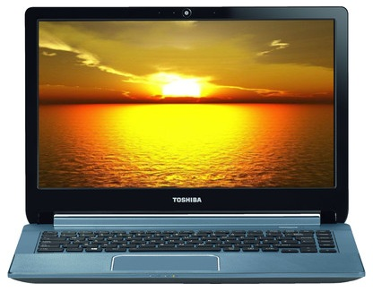

|  |  |
| --- | --- |
| **GENERAL** | |
| Color | Ice Silver With Woven Texture |

|  |  |
| --- | --- |
| **PROCESSOR** | |
| Processor | Core i5 (3rd Gen) |

|  |  |
| --- | --- |
| **MEMORY** | |
| System Memory | 4 GB DDR3 |

|  |  |
| --- | --- |
| **PLATFORM** | |
| Operating System | Windows 8 |

|  |  |
| --- | --- |
| **DISPLAY** | |
| Screen Size | 14.0 inch |

|  |  |
| --- | --- |
| **INPUT** | |
| Web Camera | HD Webcam |

|  |  |
| --- | --- |
| Color | Ice Silver With Woven Texture |