
Abu Dhabi University
College of Engineering

ITE 408: Information Security
Lab 3 Report
Part A: Access Control in a Linux System
Part B: Getting Started with Keycloak Identity Provider

Student Name | Anas Syed
Student ID | 1091080
Course | ITE 408 – Information Security
Semester | Fall 2026-27
Submission Date | 8th November 2026
Total Marks | 5 (Part A: 2.5, Part B: 2.5)

Individual Submission

Table of Contents
1. Introduction
2. Part A – Access Control in a Linux System
2.1 Part 1 – Adding a New Group
2.2 Part 2 – Adding and Verifying Users, Groups and Passwords
2.3 Part 3 – Symbolic Permissions
2.4 Part 4 – Absolute (Octal) Permissions
2.5 Part 5 – SUID, SGID and Sticky Bit (Self-Learning)
2.6 Summary of Special Permission Bits
2.7 Critical Analysis – Part A
3. Part B – Getting Started with Keycloak Identity Provider
Steps 1–10
3.1 Critical Analysis – Part B
4. Conclusion
References

1. Introduction
Access control decides who can do what with which resource. This lab looks at two levels of it. Part A is about the operating system: on Linux, every file and folder has an owner, a group, and permissions for the user, the group and everyone else. Part B is about applications: it uses Keycloak, a free tool that logs users in and hands out secure login tokens (OAuth 2.0 and OpenID Connect).

1.1 Environment
- Operating system: Ubuntu 24.04 LTS, used instead of the CSE-LABVM (the lab allows an Ubuntu machine).
- Prompt: the terminal prompt was set with PS1="\d \@ [1091080]", so every screenshot shows the date, the time and my student ID. After the ID the prompt also shows the user name and the folder, so you can see who ran each command.
- Switching users: the lab uses the desktop "Switch User" menu. I used su - sam and su - danny in the terminal instead. The result is the same: each command runs with that user's ID and groups.

2. Part A – Access Control in a Linux System

2.1 Part 1 – Adding a New Group

Step 1.1: Prompt changed to show student ID and privileges escalated to root
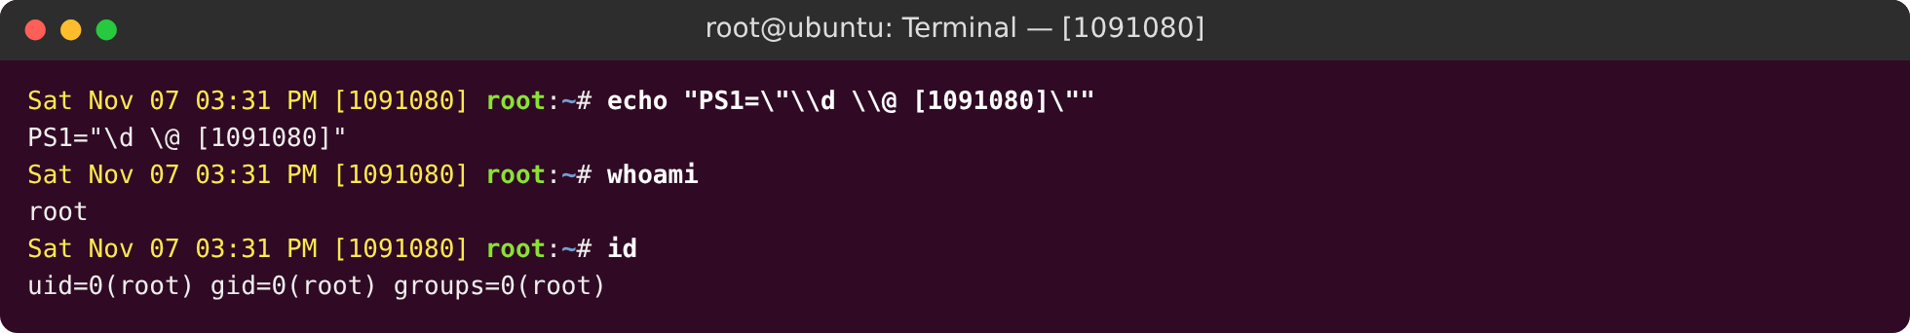
Figure 1: Prompt changed to show student ID and privileges escalated to root
sudo su makes the session run as root (user ID 0). Adding groups and users changes system files (/etc/group, /etc/passwd, /etc/shadow), so only root can do it. id shows uid=0(root).
Good practice: use sudo <command> for one admin task instead of staying in a root shell. It lowers the chance of mistakes and keeps a record in /var/log/auth.log.

Step 1.2: Add the DEVELOPERS group
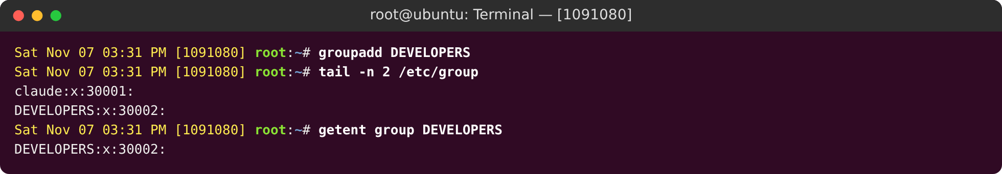
Figure 2: Add the DEVELOPERS group
groupadd DEVELOPERS creates the group. The last line of /etc/group shows DEVELOPERS:x:<GID>:. The fields are: group name, a password placeholder (x), the group ID, and the list of members (empty for now). getent reads the same information.

2.2 Part 2 – Adding and Verifying Users, Groups and Passwords

Step 2.1: Add user sam (password samPass) and place him in DEVELOPERS
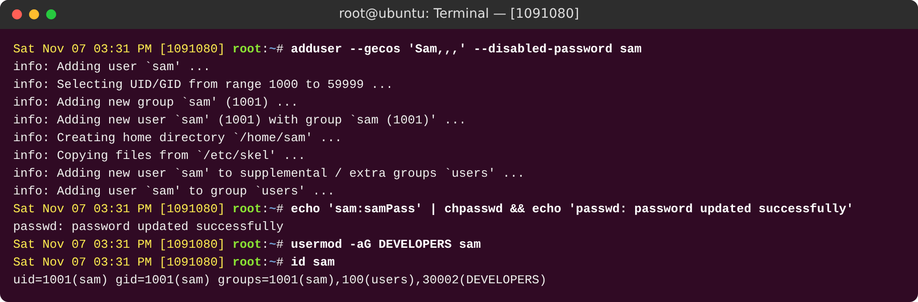
Figure 3: Add user sam (password samPass) and place him in DEVELOPERS
adduser is an easy tool for creating users on Ubuntu. It makes a private group with the same name, makes a home folder, copies the starter files from /etc/skel and saves the full name. I set the password samPass with chpasswd, which gives the same result as typing it when asked.
Correction to the lab handout: the handout uses usermod -G DEVELOPERS sam. The -G option replaces all other groups. I used usermod -aG, which adds the group and keeps the others. id sam shows that DEVELOPERS was added.

Step 2.2: Add user danny (password dannyPass) and place him in DEVELOPERS
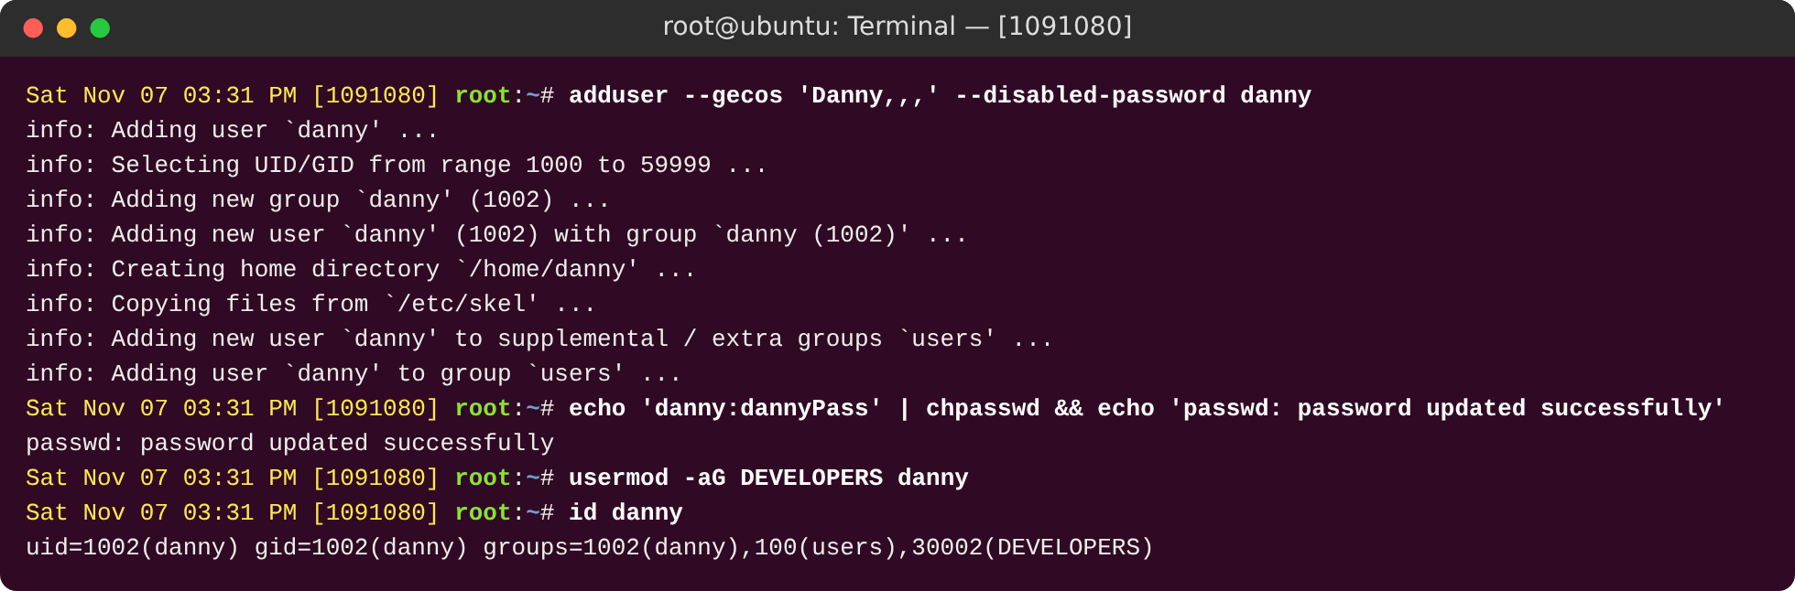
Figure 4: Add user danny (password dannyPass) and place him in DEVELOPERS
The same steps were done for danny with the password dannyPass. Each user gets its own ID (1001 for sam, 1002 for danny) and a private group.

Step 2.3: Verify the new users in /etc/passwd and /etc/group
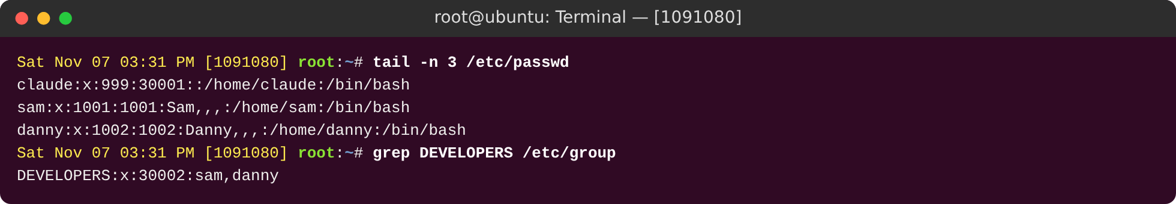
Figure 5: Verify the new users in /etc/passwd and /etc/group
/etc/passwd has 7 fields separated by colons: user name, x (the password is kept in the shadow file), user ID, group ID, full name, home folder and login shell. /etc/group now lists sam,danny as members of DEVELOPERS.

Step 2.4: Verify the password hashes in /etc/shadow
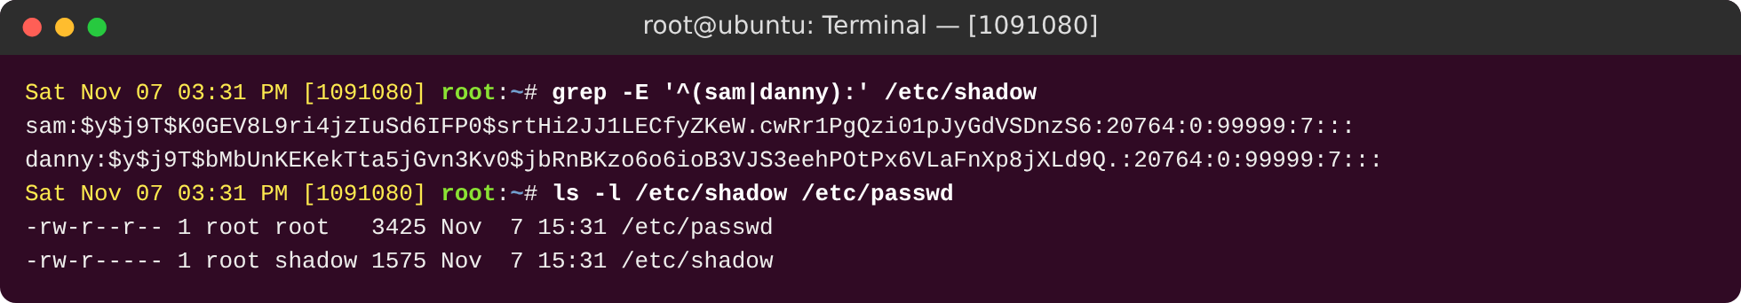
Figure 6: Verify the password hashes in /etc/shadow
/etc/shadow stores password hashes, not the real passwords. The start $y$ means the hash type is yescrypt, the default on Ubuntu 22.04 and newer (the handout shows $6$, an older type called SHA-512). Every hash uses a random salt, so the same password gives a different hash each time. The other fields are: day of the last change (counted from 1970), minimum age 0, maximum age 99999 and warning time 7 days.
Look at the permissions: everyone can read /etc/passwd (-rw-r--r--), but /etc/shadow is -rw-r----- and belongs to root and the group shadow. Normal users cannot read the hashes, so they cannot try to crack them offline.

2.3 Part 3 – Symbolic Permissions

Step 3.0: Default home-directory mode on Ubuntu 24.04 (HOME_MODE) and lab baseline
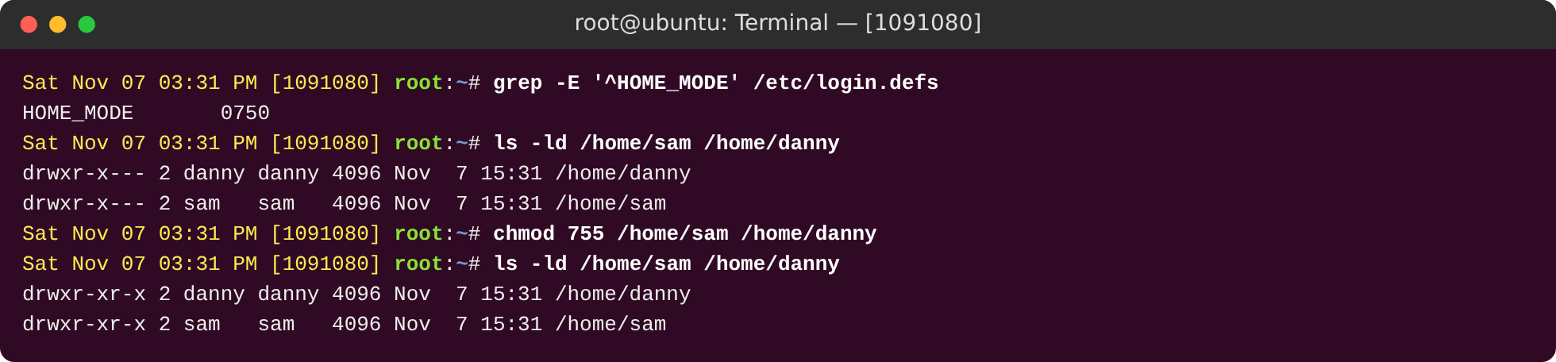
Figure 7: Default home-directory mode on Ubuntu 24.04 (HOME_MODE) and lab baseline
Finding: Ubuntu 21.04 and newer create home folders with mode 0750 (drwxr-x---), so other users cannot enter them. This is safer than the drwxr-xr-x shown in the handout. To repeat the lab situation, I first set both home folders to 755.

Step 3.1: Switch to sam and explore the environment
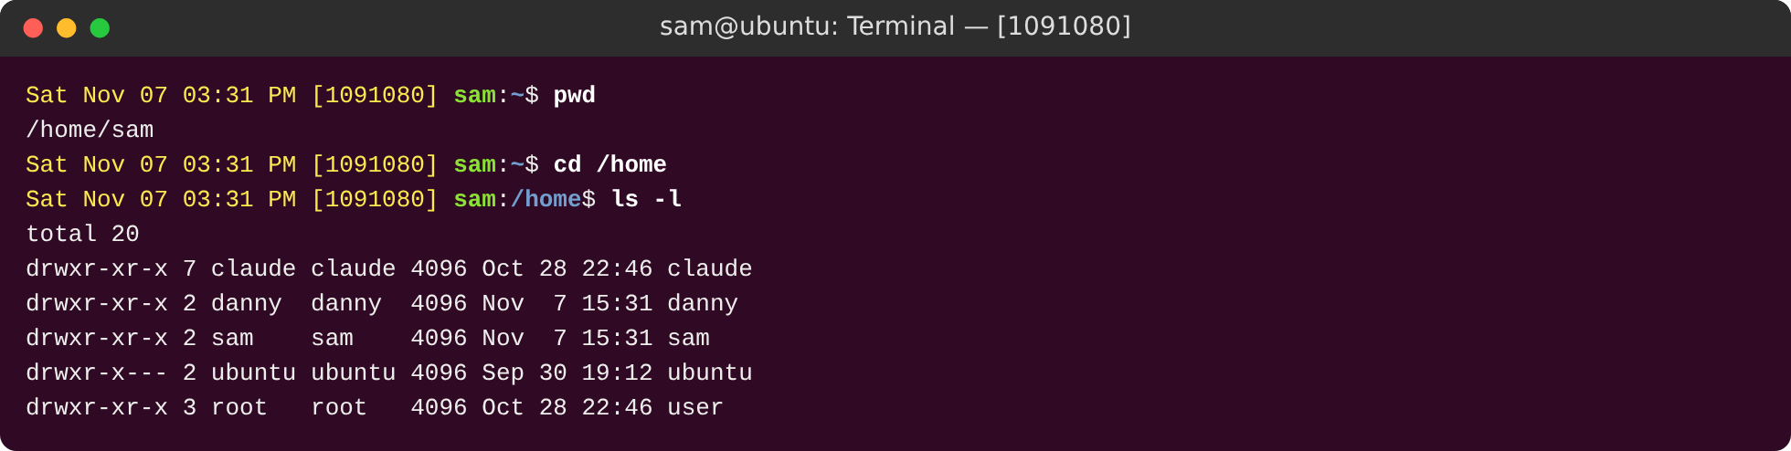
Figure 8: Switch to sam and explore the environment
As sam, ls -l /home shows a 10-character permission string. Character 1: d means directory. Characters 2 to 4: owner (rwx). Characters 5 to 7: group (r-x). Characters 8 to 10: others (r-x).

Step 3.2: sam can enter danny's directory but cannot write in it
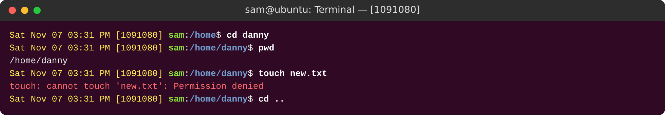
Figure 9: sam can enter danny's directory but cannot write in it
Others have r-x on danny's home folder, so sam can enter it (x) and list it (r). touch new.txt fails with "Permission denied" because creating a file changes the folder, and that needs write (w) on the folder. Others do not have it.

Step 3.3: As root, remove execute for others on danny's directory (chmod o-x)
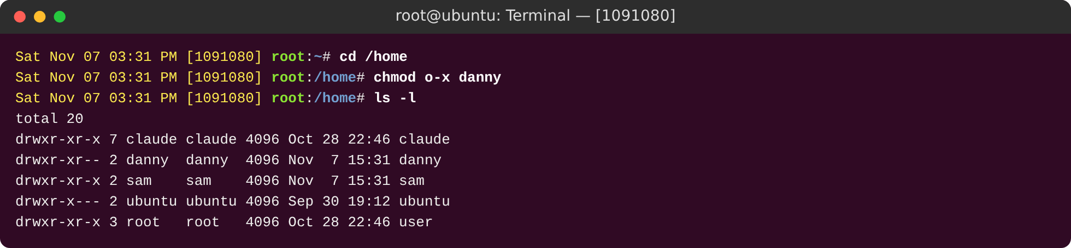
Figure 10: As root, remove execute for others on danny's directory (chmod o-x)
Symbolic mode: chmod o-x danny removes (-) the execute right (x) from others (o). The string changes from drwxr-xr-x to drwxr-xr--. Other examples: u+rwx, g-w, o=r, a+x.

Step 3.4: Verify sam can no longer access danny's directory
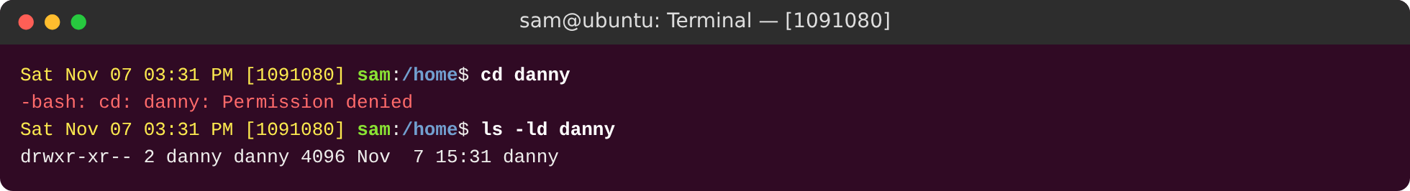
Figure 11: Verify sam can no longer access danny's directory
Now sam gets "Permission denied" on cd danny. For a folder, x means the right to enter it. Without x you cannot go into the folder or reach anything inside it, even if r is still set.

2.4 Part 4 – Absolute (Octal) Permissions
Octal | Binary | Permission | Meaning
7 | 111 | rwx | Read, write, execute
6 | 110 | rw- | Read and write
5 | 101 | r-x | Read and execute
4 | 100 | r-- | Read only
3 | 011 | -wx | Write and execute
2 | 010 | -w- | Write only
1 | 001 | --x | Execute only
0 | 000 | --- | No permission
Table 1: Octal permission values

Step 4.1: Switch to danny and view current permissions
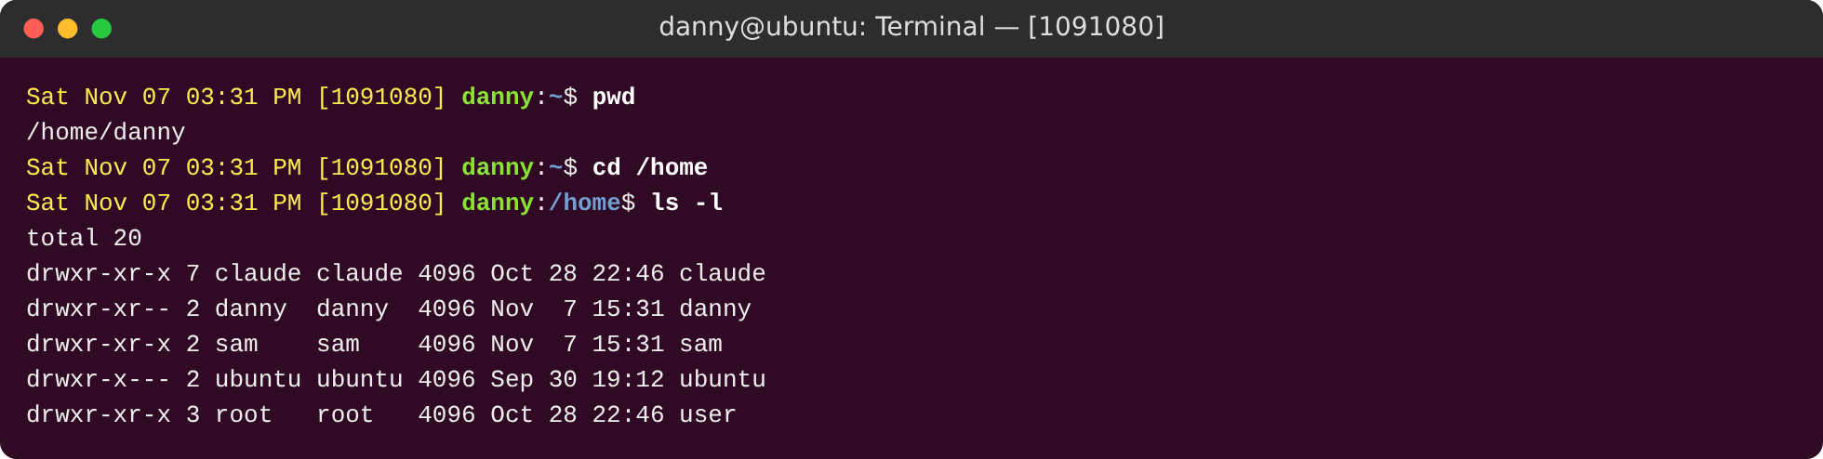
Figure 12: Switch to danny and view current permissions
Logged in as danny, the listing shows that others have r-- on /home/danny (from the last step).

Step 4.2: Absolute mode: chmod 705 danny (owner rwx, group ---, others r-x)
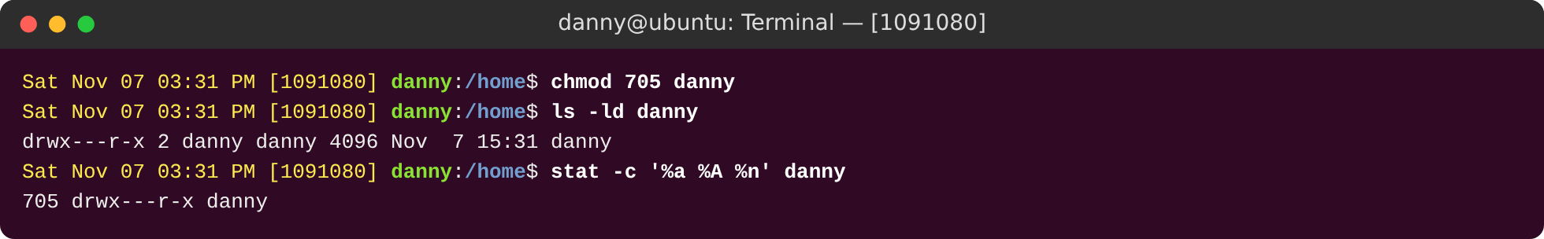
Figure 13: Absolute mode: chmod 705 danny (owner rwx, group ---, others r-x)
Absolute (octal) mode: each digit is the sum of r=4, w=2 and x=1. 705 means owner 7 (rwx), group 0 (---) and others 5 (r-x), so the result is drwx---r-x. stat -c %a confirms 705. Danny owns the folder, so he can change it without root. This is the "discretionary" part of DAC (the owner decides). Interesting point: the group digit is 0, so group members are blocked while others are allowed. Linux checks the owner first, then the group, then others, and uses only the first one that matches.

Step 4.3: Create test.txt in danny's directory
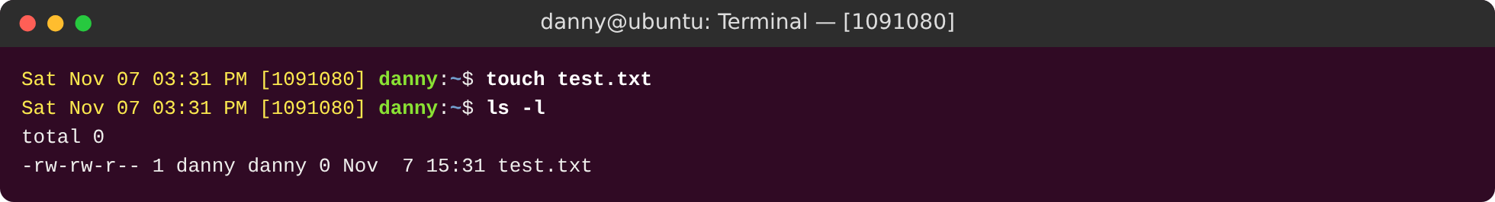
Figure 14: Create test.txt in danny's directory
test.txt is created as -rw-rw-r-- (664). New files start at 666 and the umask (002) removes write for others. New files never get execute by default.

Step 4.4: As sam: read access to danny's directory and test.txt
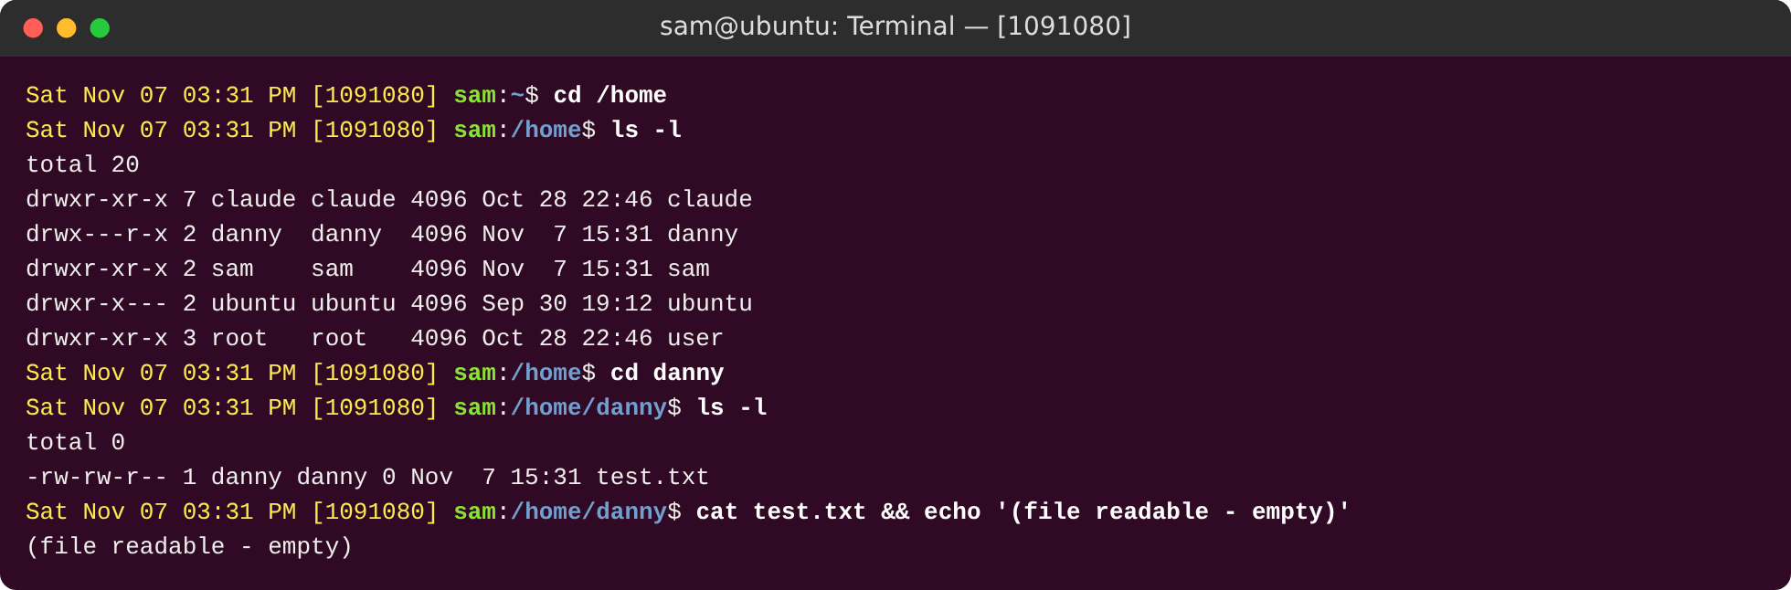
Figure 15: As sam: read access to danny's directory and test.txt
sam is one of the "others". He can enter (x) and list (r) danny's folder, and he can read test.txt because the file has r-- for others.

Step 4.5: As sam: attempt to create a file in danny's directory
Figure 16: As sam: attempt to create a file in danny's directory
sam still cannot create Sam.txt because others have no w on the folder. Access is read-only, which is what the 705 setting is meant to do.

2.5 Part 5 – Exploring SUID, SGID and Sticky Bit (Self-Learning)

Step 5.1: SUID: create test directory, write and compile the C program (owner danny)
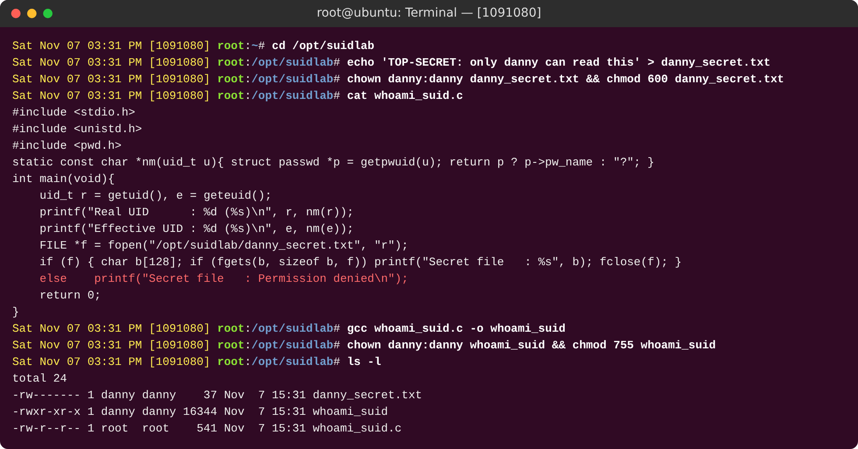
Figure 17: SUID: create test directory, write and compile the C program (owner danny)
SUID test setup. A small C program prints the real UID (getuid(), the user who started it) and the effective UID (geteuid(), the identity Linux uses for permission checks). It also tries to read danny_secret.txt, which only danny can read (mode 600). The program file belongs to danny.

Step 5.2: SUID BEFORE: sam runs the program (runs as sam)
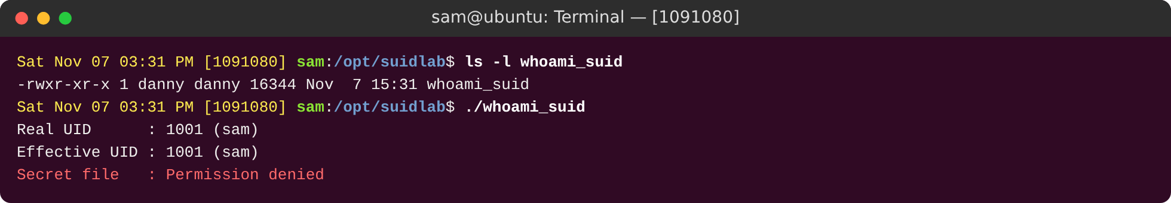
Figure 18: SUID BEFORE: sam runs the program (runs as sam)
Before SUID, the program runs as sam: the real UID and the effective UID are both 1001. It cannot read the secret file.

Step 5.3: Apply SUID with chmod u+s
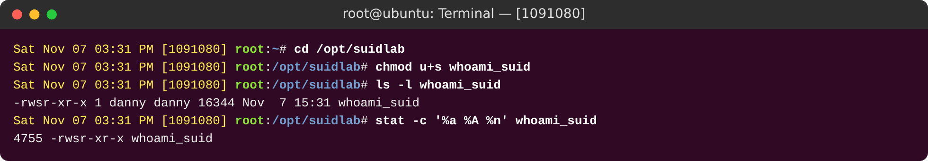
Figure 19: Apply SUID with chmod u+s
chmod u+s sets the SUID bit. The owner's x changes to s (-rwsr-xr-x) and the octal mode becomes 4755 (4 = SUID, 2 = SGID, 1 = sticky).

Step 5.4: SUID AFTER: sam runs the program (effective UID = danny)
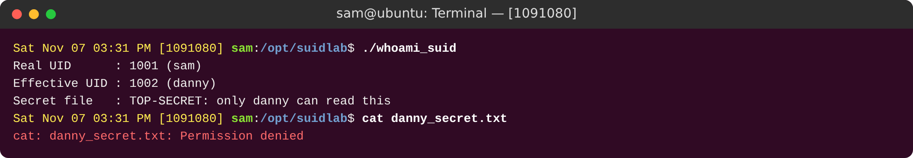
Figure 20: SUID AFTER: sam runs the program (effective UID = danny)
After SUID, the real UID is still sam, but the effective UID is danny, so the program can read danny's secret. If sam runs cat directly, he is still denied. So the extra power exists only inside the SUID program.

Step 5.5: Real-world SUID binaries and how auditors find them
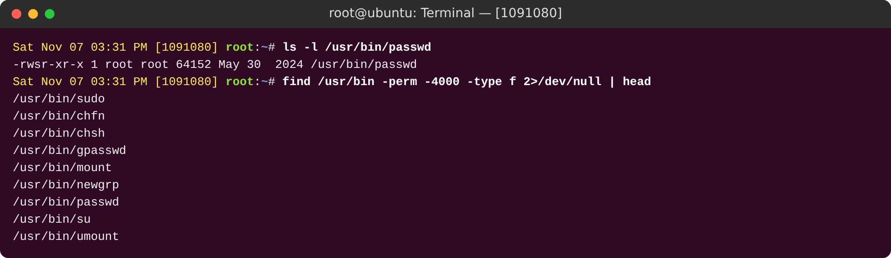
Figure 21: Real-world SUID binaries and how auditors find them
Real systems use SUID for programs such as passwd, which must write to /etc/shadow for a normal user. SUID programs owned by root are a favourite target for attackers, so auditors list them with find / -perm -4000 and compare the list with a known good one.

Step 5.6: SGID BEFORE: shared directory owned by DEVELOPERS, no SGID
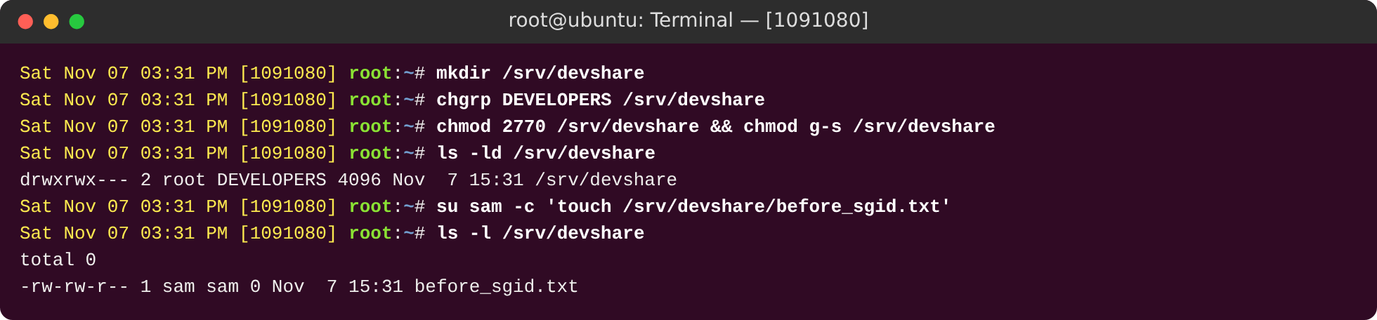
Figure 22: SGID BEFORE: shared directory owned by DEVELOPERS, no SGID
SGID before: /srv/devshare belongs to the group DEVELOPERS (mode 770). A file that sam creates gets sam's own group (sam), so danny cannot share it through the group.

Step 5.7: SGID AFTER: chmod g+s - new files inherit the DEVELOPERS group
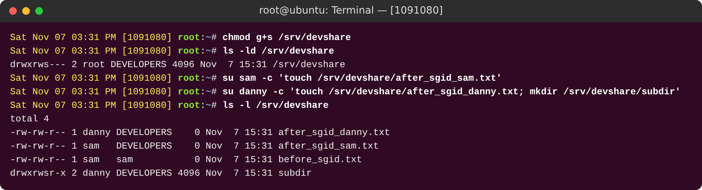
Figure 23: SGID AFTER: chmod g+s - new files inherit the DEVELOPERS group
chmod g+s sets SGID on the folder (drwxrws---). New files from sam and danny now get the DEVELOPERS group, and new sub-folders also get SGID (drwxrwsr-x). The old file keeps the group sam, because SGID only affects new files. This is the usual way to make a shared team folder.

Step 5.8: Sticky BEFORE: world-writable /tmp/teststicky - danny deletes sam's file
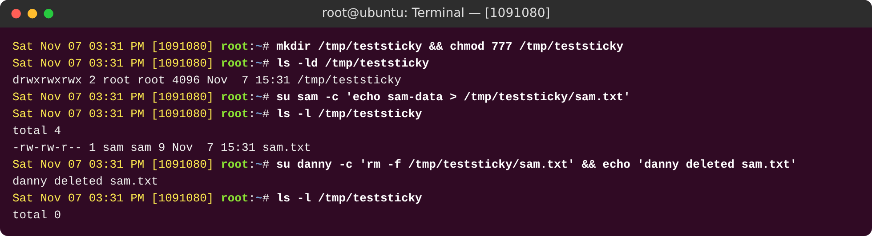
Figure 24: Sticky BEFORE: world-writable /tmp/teststicky - danny deletes sam's file
Sticky bit before: /tmp/teststicky is open to everyone (777). danny deletes sam's file without any problem, because deleting a file needs write permission on the folder, not on the file.

Step 5.9: Sticky AFTER: chmod +t - only owner or root can delete
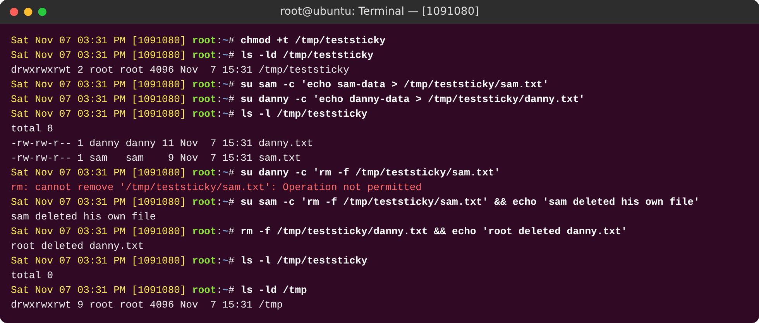
Figure 25: Sticky AFTER: chmod +t - only owner or root can delete
chmod +t sets the sticky bit (drwxrwxrwt, mode 1777). Now danny gets "Operation not permitted" when he deletes sam's file. Only the file owner (sam) or root can delete it. The system folder /tmp uses the same bit for the same reason.

2.6 Summary of Special Permission Bits
Bit | Octal | Set with | On files | On directories
SUID | 4000 | chmod u+s | Runs with the file owner's user ID | No effect on Linux
SGID | 2000 | chmod g+s | Runs with the file's group | New files get the folder's group
Sticky | 1000 | chmod +t | Ignored on Linux | Only the owner or root can delete or rename files
Table 2: Special permission bits compared

2.7 Critical Analysis – Part A
What worked well. DAC is simple and fast, and each owner manages their own data. Danny secured his folder with chmod 705 without needing root. Groups together with SGID make it easy to share project files without opening them to everyone.
Weaknesses I saw.
- The owner decides. A careless owner can open files to everyone (chmod 777) and the system does not stop them. Mandatory Access Control (SELinux or AppArmor) adds system-wide rules that the owner cannot change.
- Only three classes. You cannot say "sam may read but Eve may not" when both are in "others". POSIX ACLs (setfacl -m u:sam:rx) solve this.
- SUID is powerful and risky. My test showed sam reading danny's secret through the program. If a SUID program owned by root has a bug (for example a buffer overflow), an attacker can get a full root shell. A real example is CVE-2021-4034 (PwnKit) in pkexec. Rules to follow: avoid your own SUID programs, mount user-writable disks with nosuid, and check regularly with find / -perm -4000.
- Weak lab passwords. samPass and dannyPass would fail a real password policy. In production I would use pam_pwquality (length and complexity), password ageing with chage, and account lockout with pam_faillock.
My own reflection. The most useful lesson was that permissions on a folder mean something different from permissions on a file. Whether you can delete someone else's file depends on the folder's w bit, and that is exactly why the sticky bit exists. I also saw that new Ubuntu versions are "secure by default" (home mode 0750 and yescrypt hashes), which is stronger than the older setup in the handout.

3. Part B – Getting Started with Keycloak Identity Provider
Keycloak is a free, open-source tool for Identity and Access Management. It gives Single Sign-On (one login for many apps) and can connect to other login systems. It uses the standards OAuth 2.0, OpenID Connect (OIDC) and SAML 2.0. Applications send users to Keycloak to log in and get back signed JSON Web Tokens (JWT), so the applications never handle the passwords.
Key words: a realm is a separate space with its own users, roles and clients. A user is an identity that can log in. A role is a named permission given to users or service accounts. A client is an application that asks Keycloak to log in a user (or to log in itself).

Step 1: Running Keycloak using Docker
sudo su
docker run -d --name keycloak -p 8080:8080 \
-e KC_BOOTSTRAP_ADMIN_USERNAME=Anas \
-e KC_BOOTSTRAP_ADMIN_PASSWORD=1091080 \
keycloak-local:26.8.2 start-dev
docker ps

What I ran: the lab uses the image quay.io/keycloak/keycloak:latest, but my machine could not reach quay.io. So I downloaded the official Keycloak 26.8.2 release from Maven Central (its checksum matched) and built a small local Docker image from it (keycloak-local:26.8.2, on top of Eclipse Temurin Java 21). I used the same command as the lab with start-dev, plus -d (run in the background) and --name keycloak. -p 8080:8080 opens port 8080 on the computer. KC_BOOTSTRAP_ADMIN_USERNAME and KC_BOOTSTRAP_ADMIN_PASSWORD create the first temporary admin. start-dev is development mode (plain HTTP and a built-in test database) and must never be used in production. docker ps shows that the container is running.
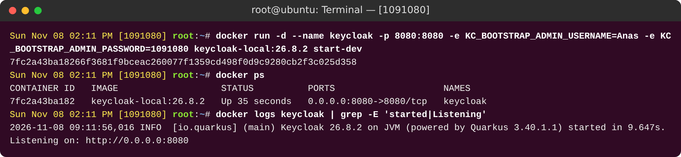
Figure 26: docker ps output showing the Keycloak container running

Step 2: Logging into the Keycloak Admin Console
Browser → http://localhost:8080/ → username: Anas password: 1091080

The admin console belongs to the master realm. Keycloak shows the user name in lower case (anas) because it always saves user names in lower case. The yellow banner says I am a temporary admin, which is normal for the first admin account.
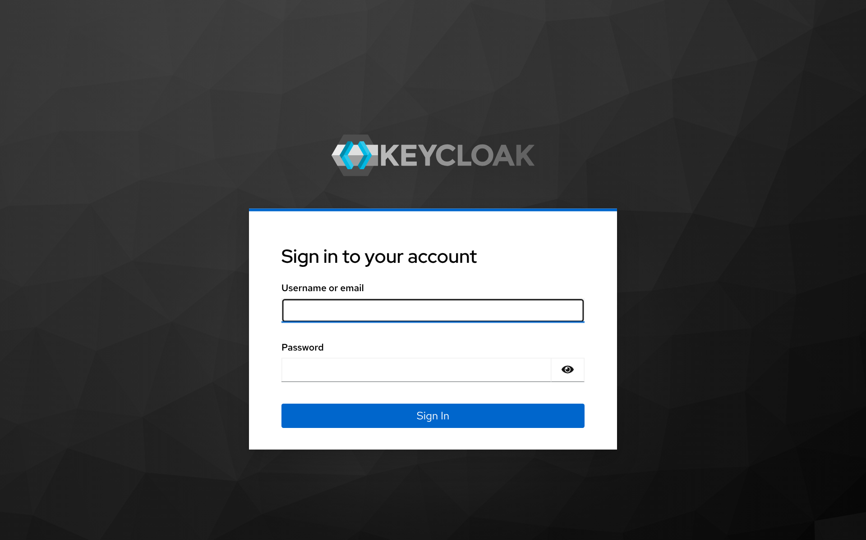
Figure 27: Keycloak admin login page
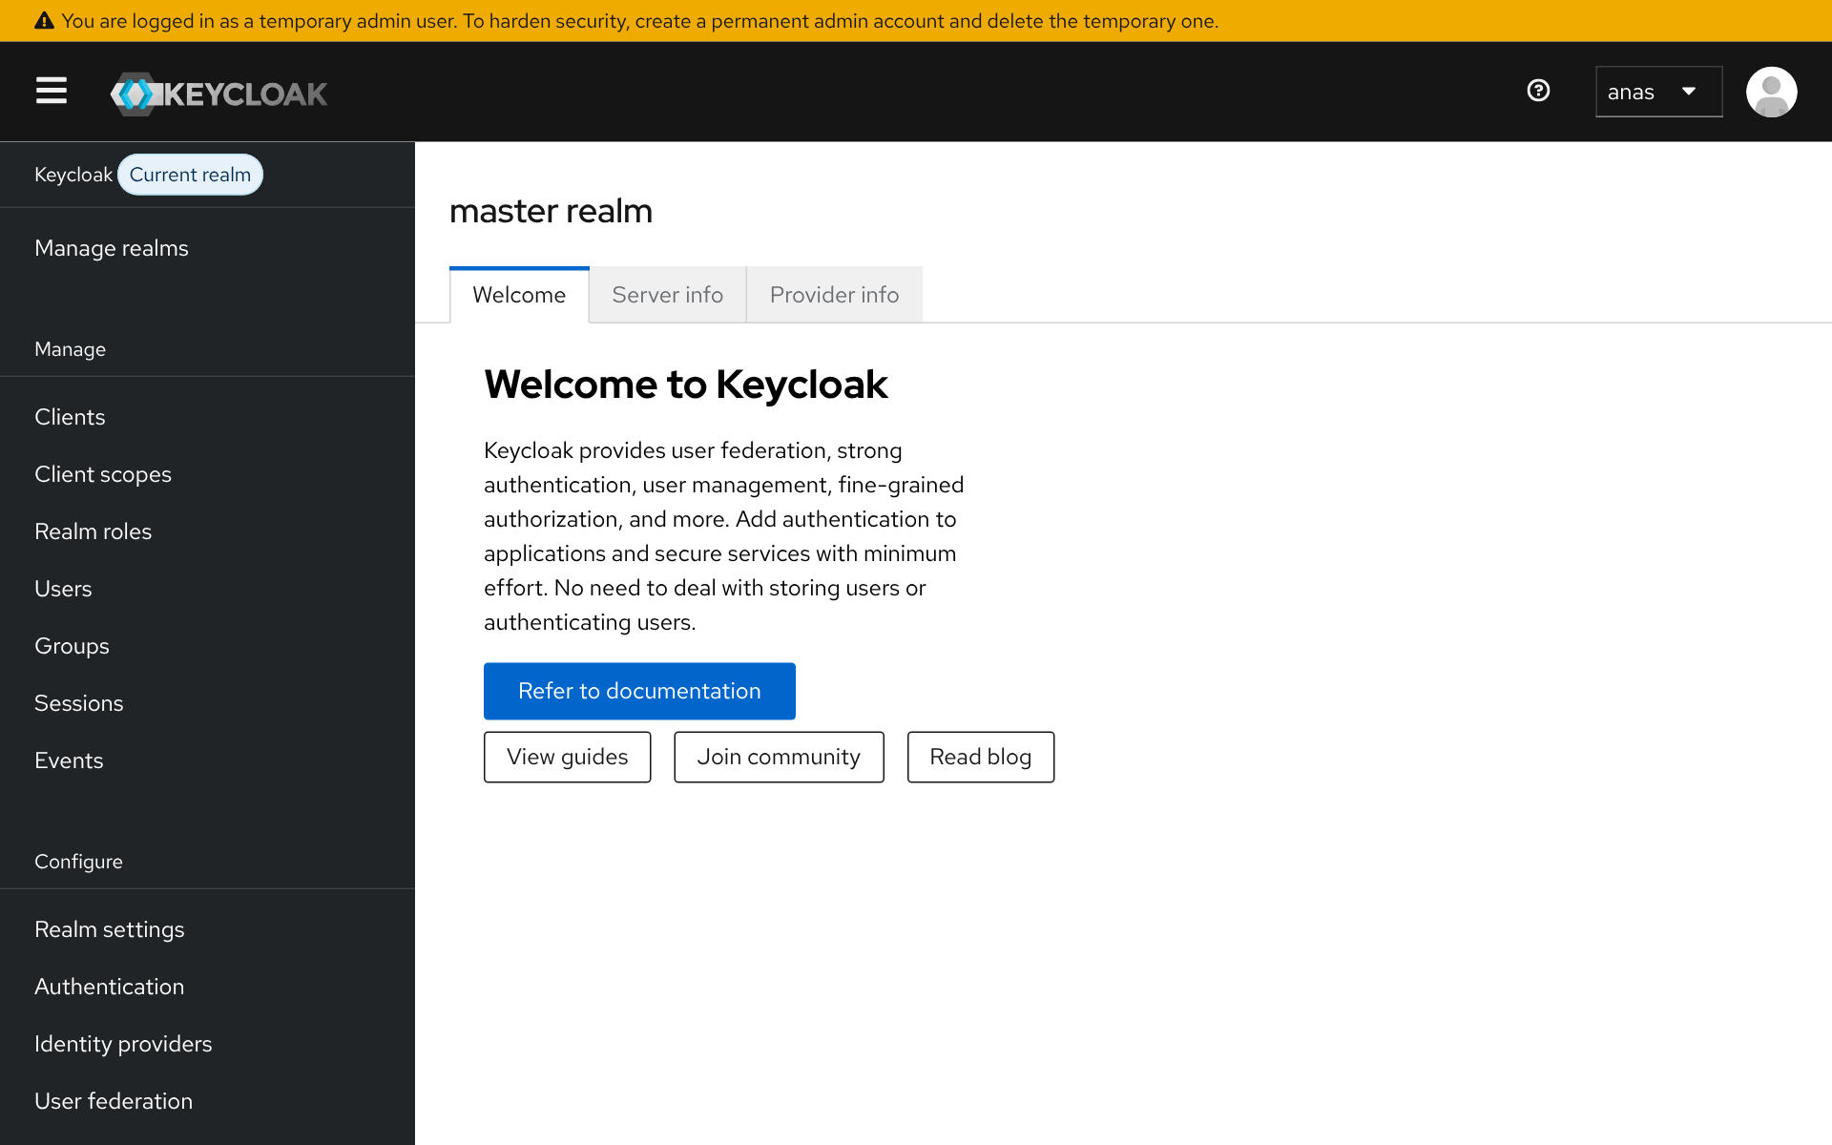
Figure 28: Admin console after successful login

Step 3: Configuring OTP (two-factor authentication) for the admin user
Users → Anas → Details → Required user actions: Configure OTP → Save
Sign out → sign in again → set up the authenticator (QR code, or the key under 'Unable to scan?') → enter the 6-digit code

OTP adds a second step to the login: something you have (the phone) as well as something you know (the password). Keycloak uses TOTP (RFC 6238): the QR code shares a secret key, and both sides use that key and the current 30-second time window to work out the same 6-digit code. If someone steals the admin password, they still cannot log in. On my lab machine I used the key shown under "Unable to scan?" and a small script to work out the 6-digit code (the same TOTP method as an authenticator app). Keycloak refused the same code when I used it a second time inside the same 30 seconds, which stops codes from being reused.
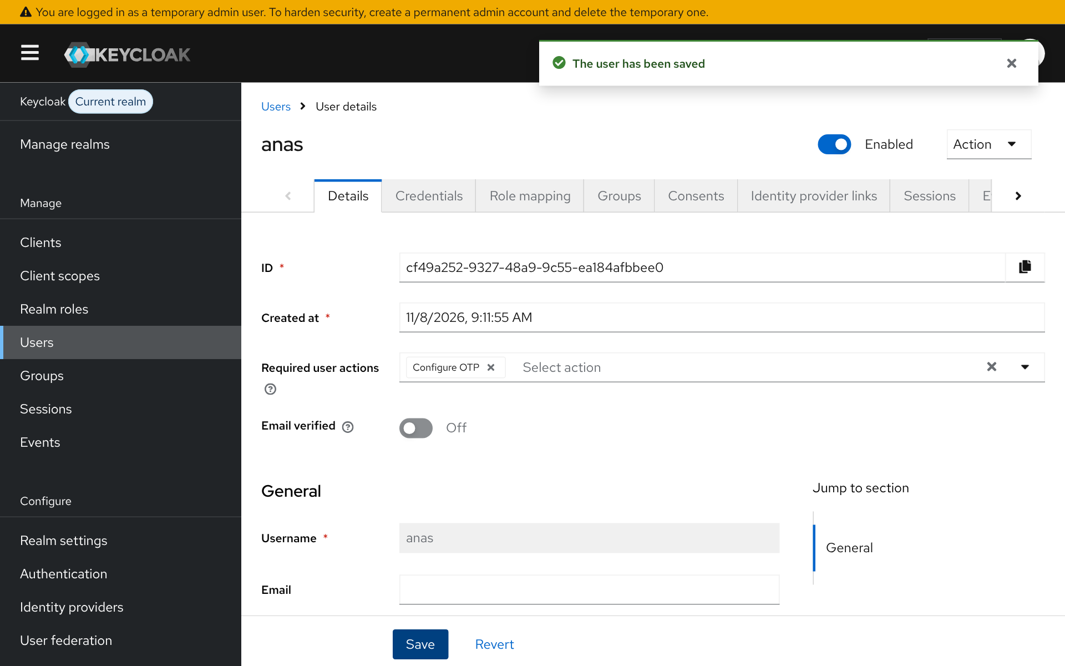
Figure 29: User details page with the 'Configure OTP' required action (saved)
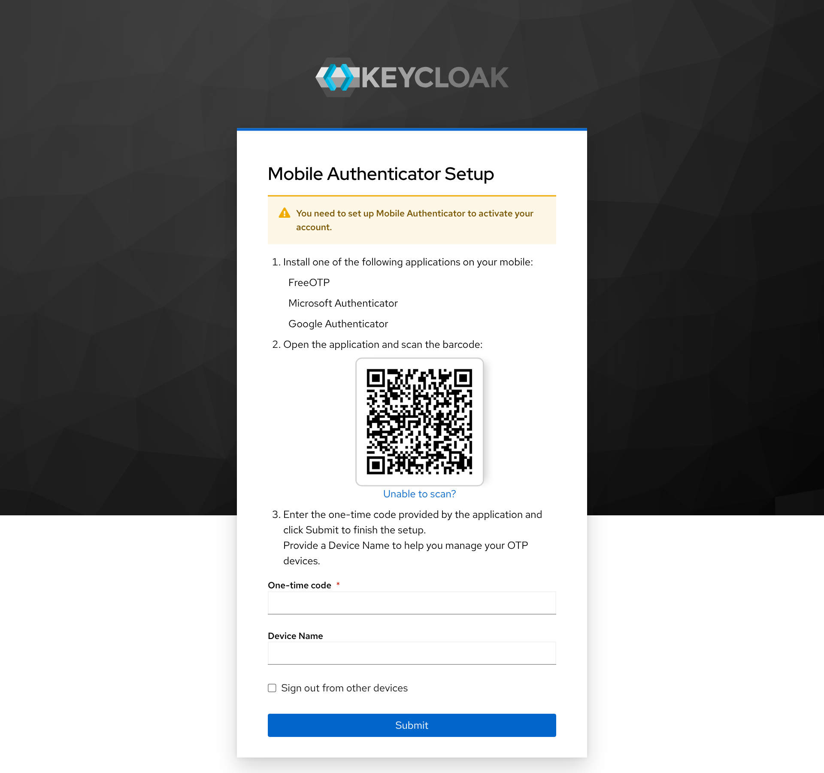
Figure 30: QR code / Mobile Authenticator Setup page
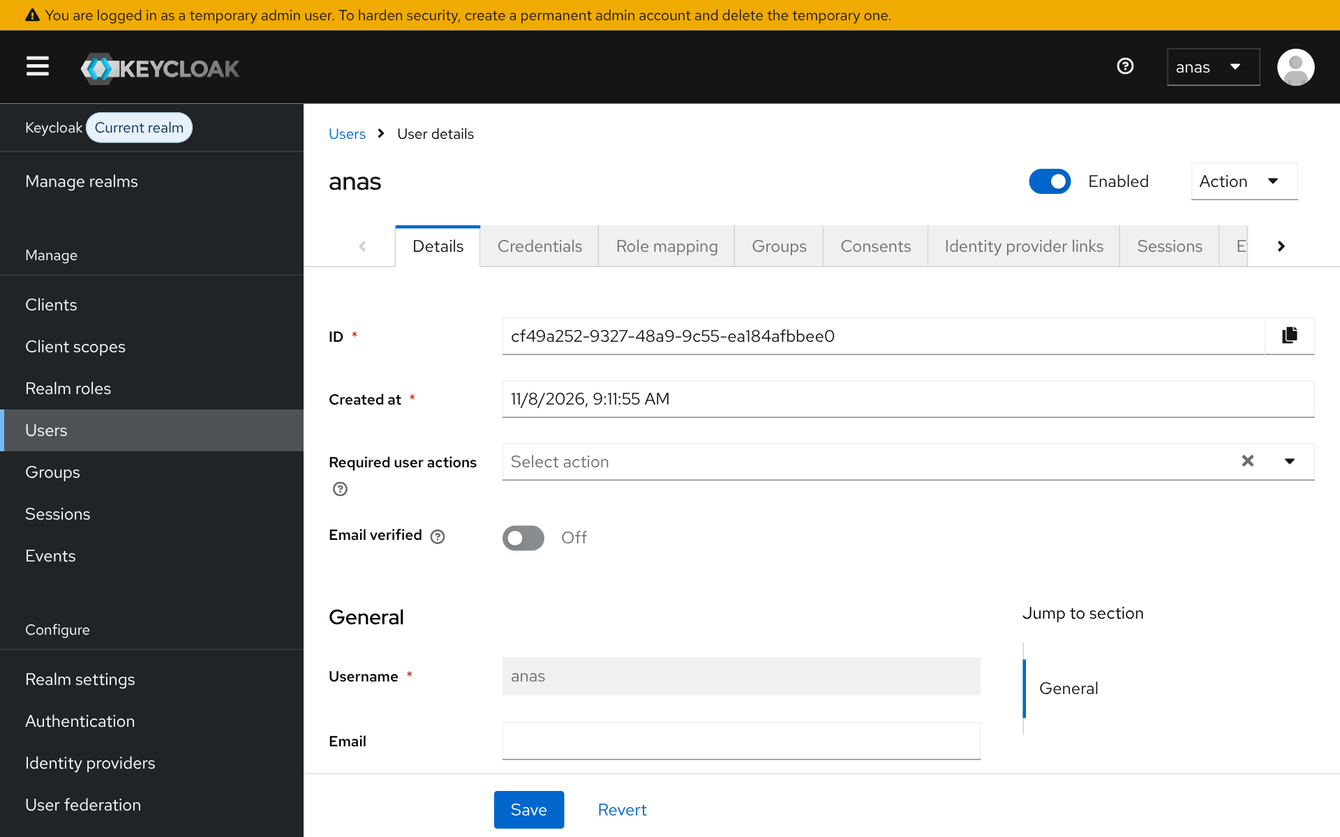
Figure 31: Successful login after entering the OTP (the Configure OTP action is now cleared)

Step 4: Creating a new realm MyApp080
Manage realms → Create realm → Realm name: MyApp080 → Create

Keeping applications out of the master realm follows the rule of least privilege. If an application user is hacked, they cannot reach the realm that controls Keycloak. Each realm has its own users, keys and settings. My realm is MyApp080 (080 are the last three digits of my student ID).
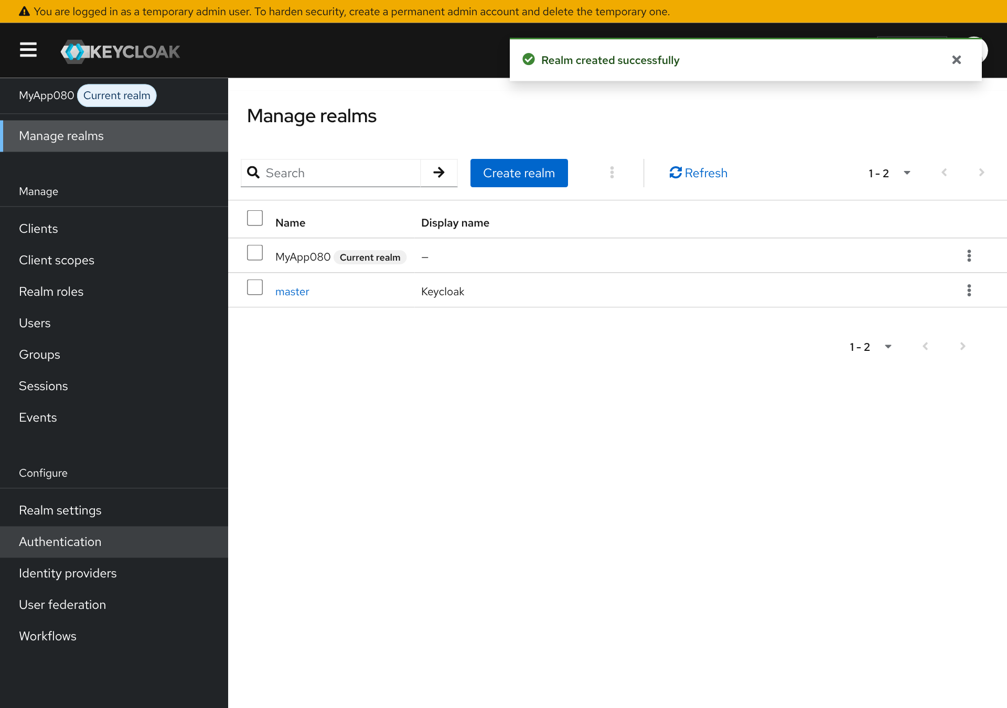
Figure 32: Realm MyApp080 created

Step 5: Creating a new user
MyApp080 → Users → Add user → Username: syed → Create
Credentials → Set password: 1091080, Temporary: OFF → Save
Test: http://localhost:8080/realms/MyApp080/account

The handout's screenshot note says "first name", but the instructions say "family name". I followed the instructions: my family name is Syed, so the user name is syed. I set the password to my student ID and turned Temporary off, so Keycloak does not force a password change. At the first login, Keycloak asked me to complete my profile (email, first name and last name) and then opened the account page. This shows that the user can log in to the new realm.
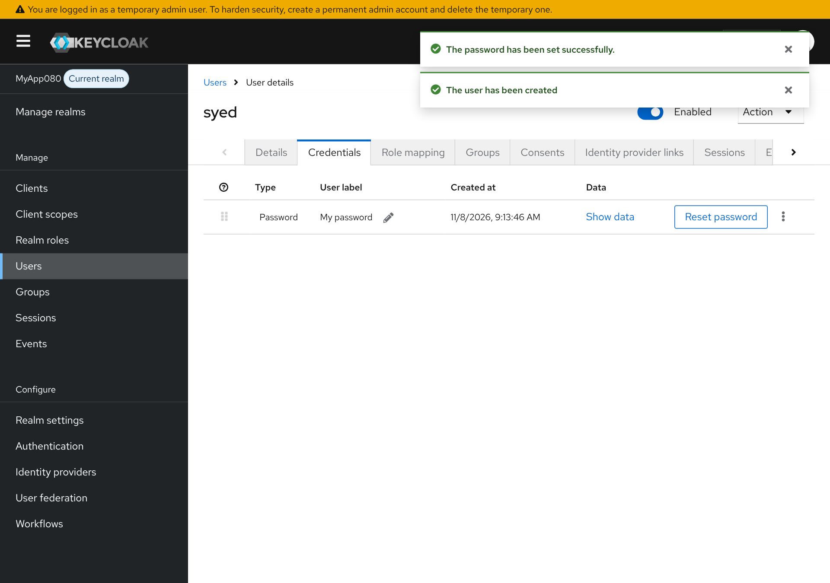
Figure 33: New user created in realm MyApp080
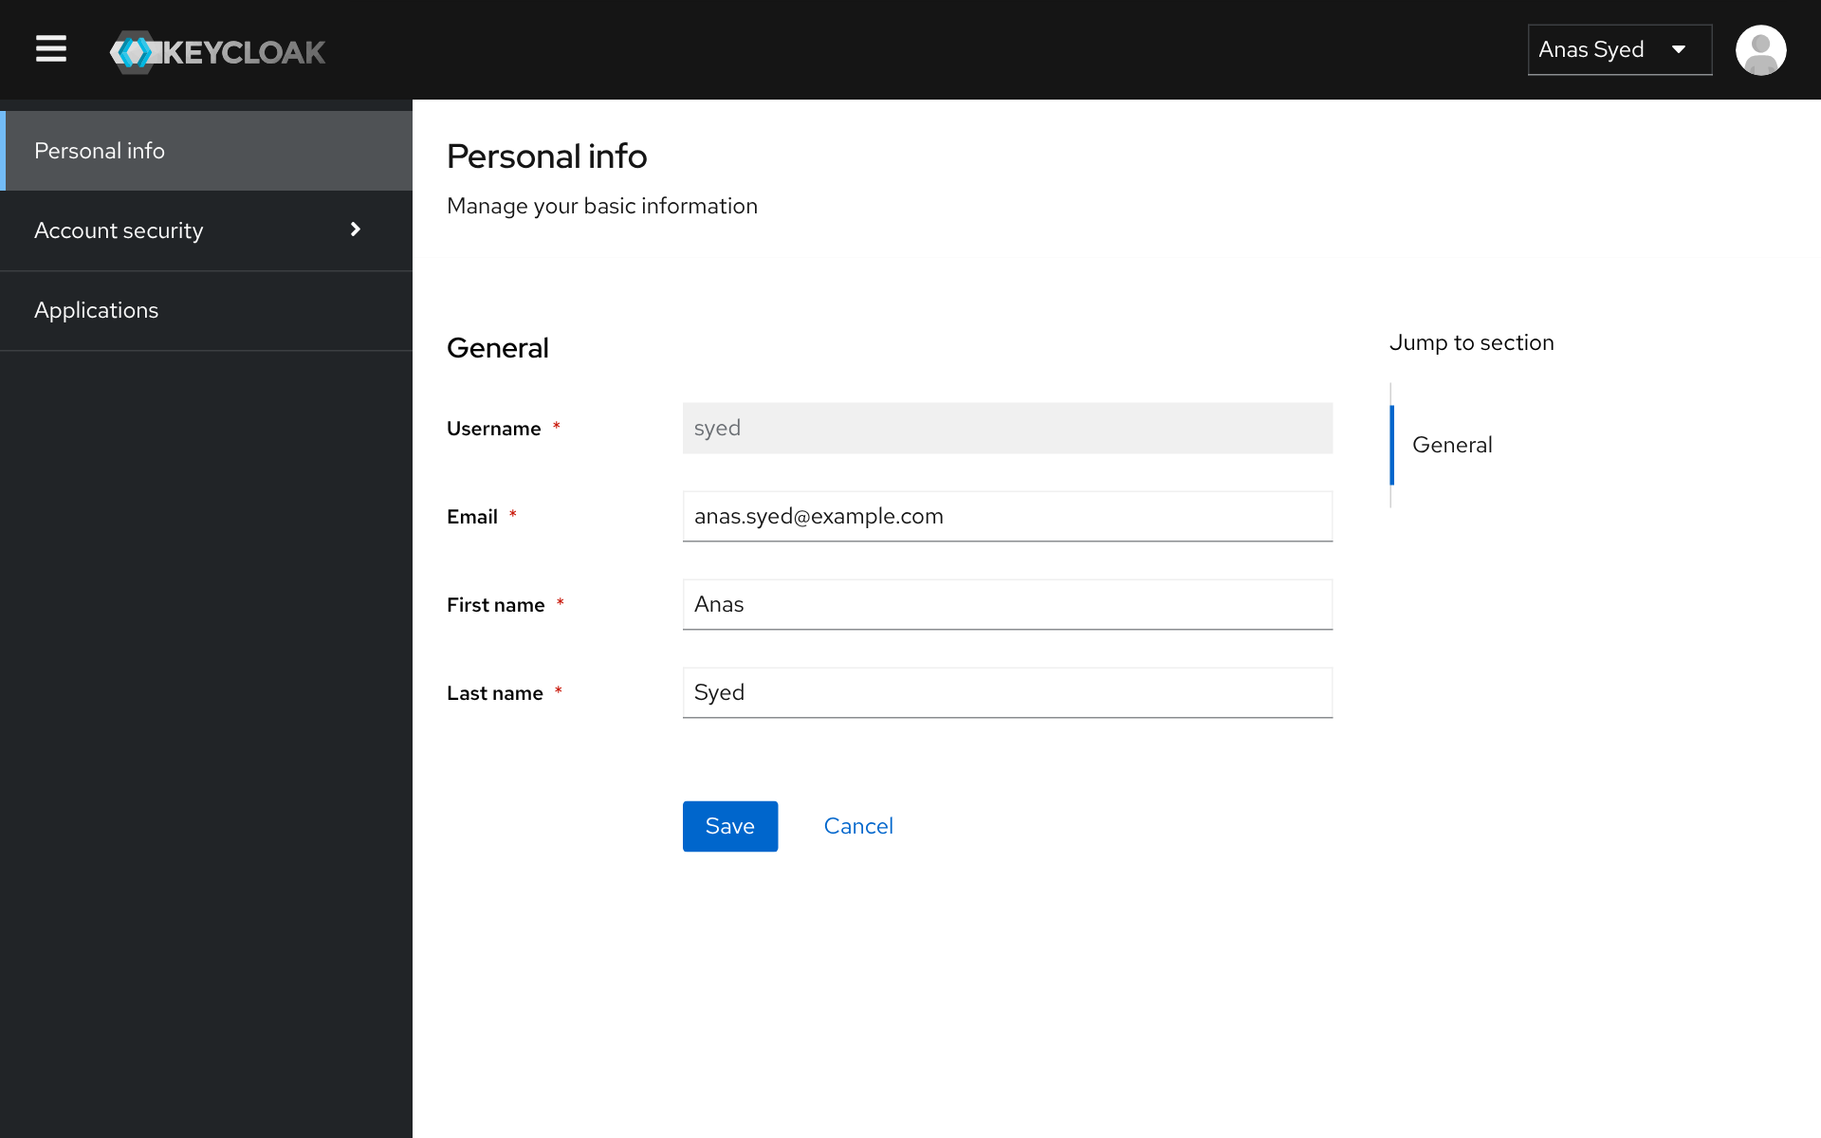
Figure 34: Successful login to the realm account page

Step 6: Creating a public client my-client080
Clients → Create client → Client type: OpenID Connect → Client ID: my-client080
Client authentication: OFF · Standard flow: ON · Direct access grants: ON
Valid redirect URIs: https://www.keycloak.org/app/* Web origins: https://www.keycloak.org → Save

A public client (a browser or phone app) cannot keep a secret safely, so it has no client secret. Its safety comes from checking the redirect URI exactly, and from PKCE. Web origins controls CORS, so only the page at keycloak.org can call the token address from a browser. Keycloak turns Direct access grants off by default, so I switched it on as the lab says.
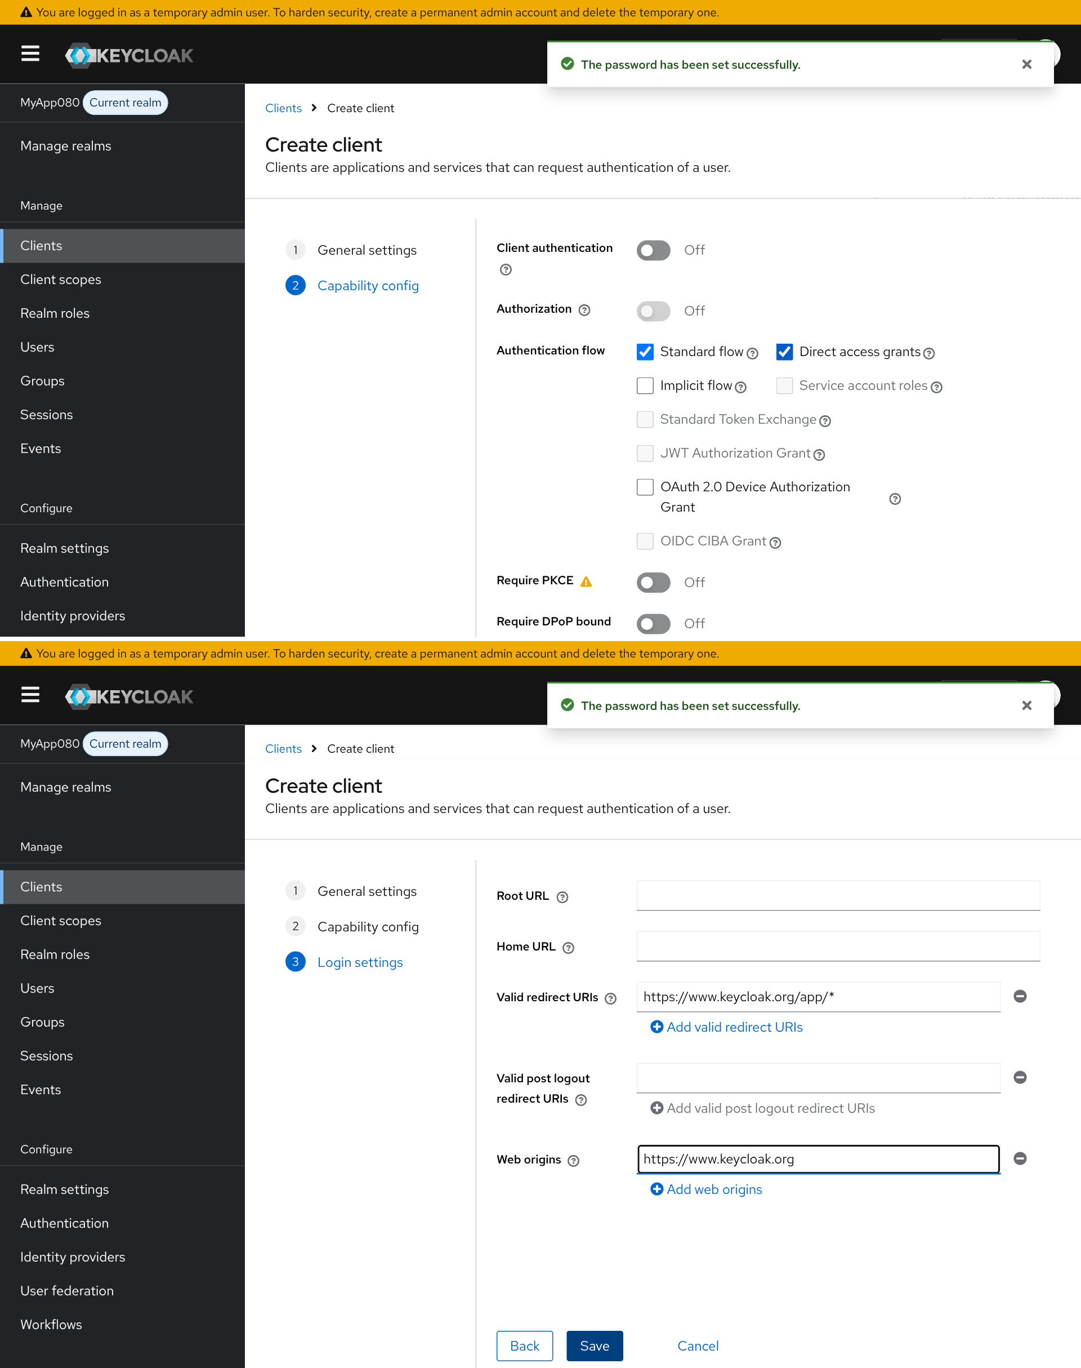
Figure 35: Public client my-client080: capability settings (top) and login settings (bottom)

Step 7: Testing the public client with the Keycloak demo application
https://www.keycloak.org/app/ → Realm: MyApp080, Client: my-client080 → Sign in
Log in as syed → read the /token request and response (Network tab, filter 'token')

This uses the Authorization Code flow: the browser goes to Keycloak, the user logs in there, and Keycloak sends back a short-lived code. The app swaps the code at /token for an access_token, an id_token and a refresh_token. Note: my lab machine could not reach https://www.keycloak.org/app/, so the browser opened a small local copy of the demo page at the same address. The Keycloak login page, the redirect and the token request and response are real. Figure 37 shows the captured token request.
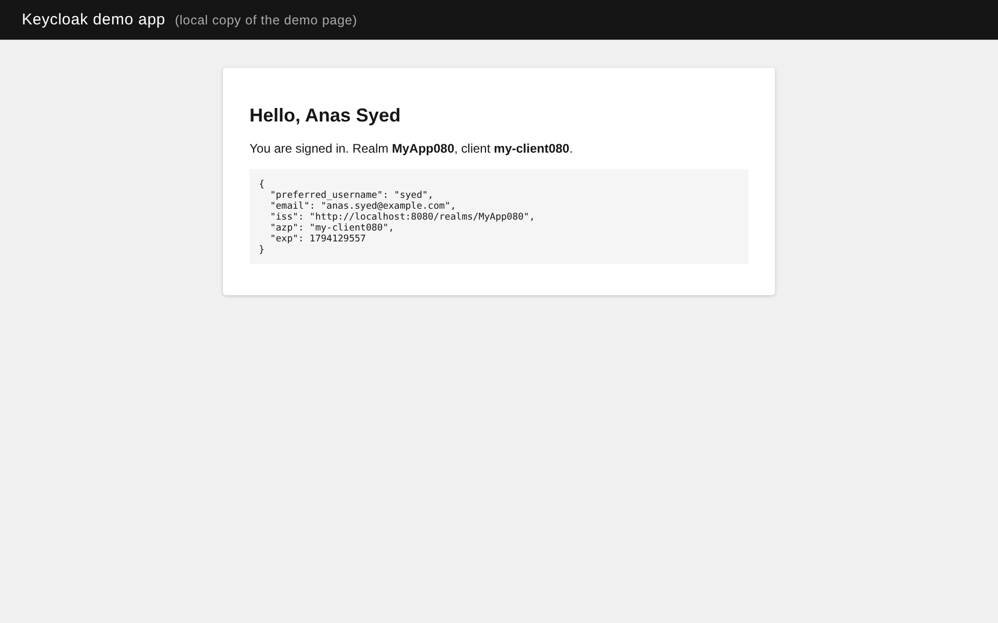
Figure 36: Test page signed in as the new user (local copy of the Keycloak demo page)
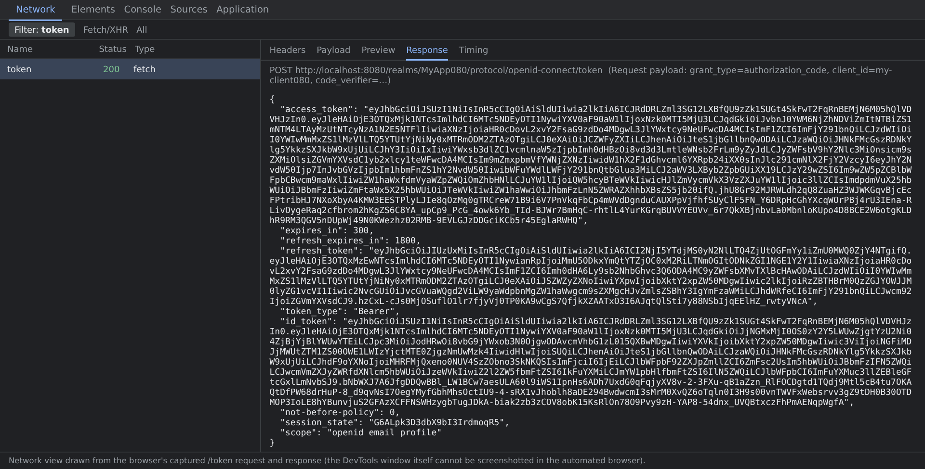
Figure 37: Network view of the /token request and response (drawn from the captured browser traffic)

Step 8: Creating a confidential client my-Confidential-Client080
Clients → Create client → Client ID: my-Confidential-Client080
Client authentication: ON · Direct access grants: ON · Service accounts roles: ON → Save → Credentials tab → copy Client secret

A confidential client is a server-side application that can keep a secret. Turning on Service accounts roles lets the client get tokens for itself (machine to machine) with the Client Credentials grant. Keycloak makes the client secret automatically and shows it on the Credentials tab.
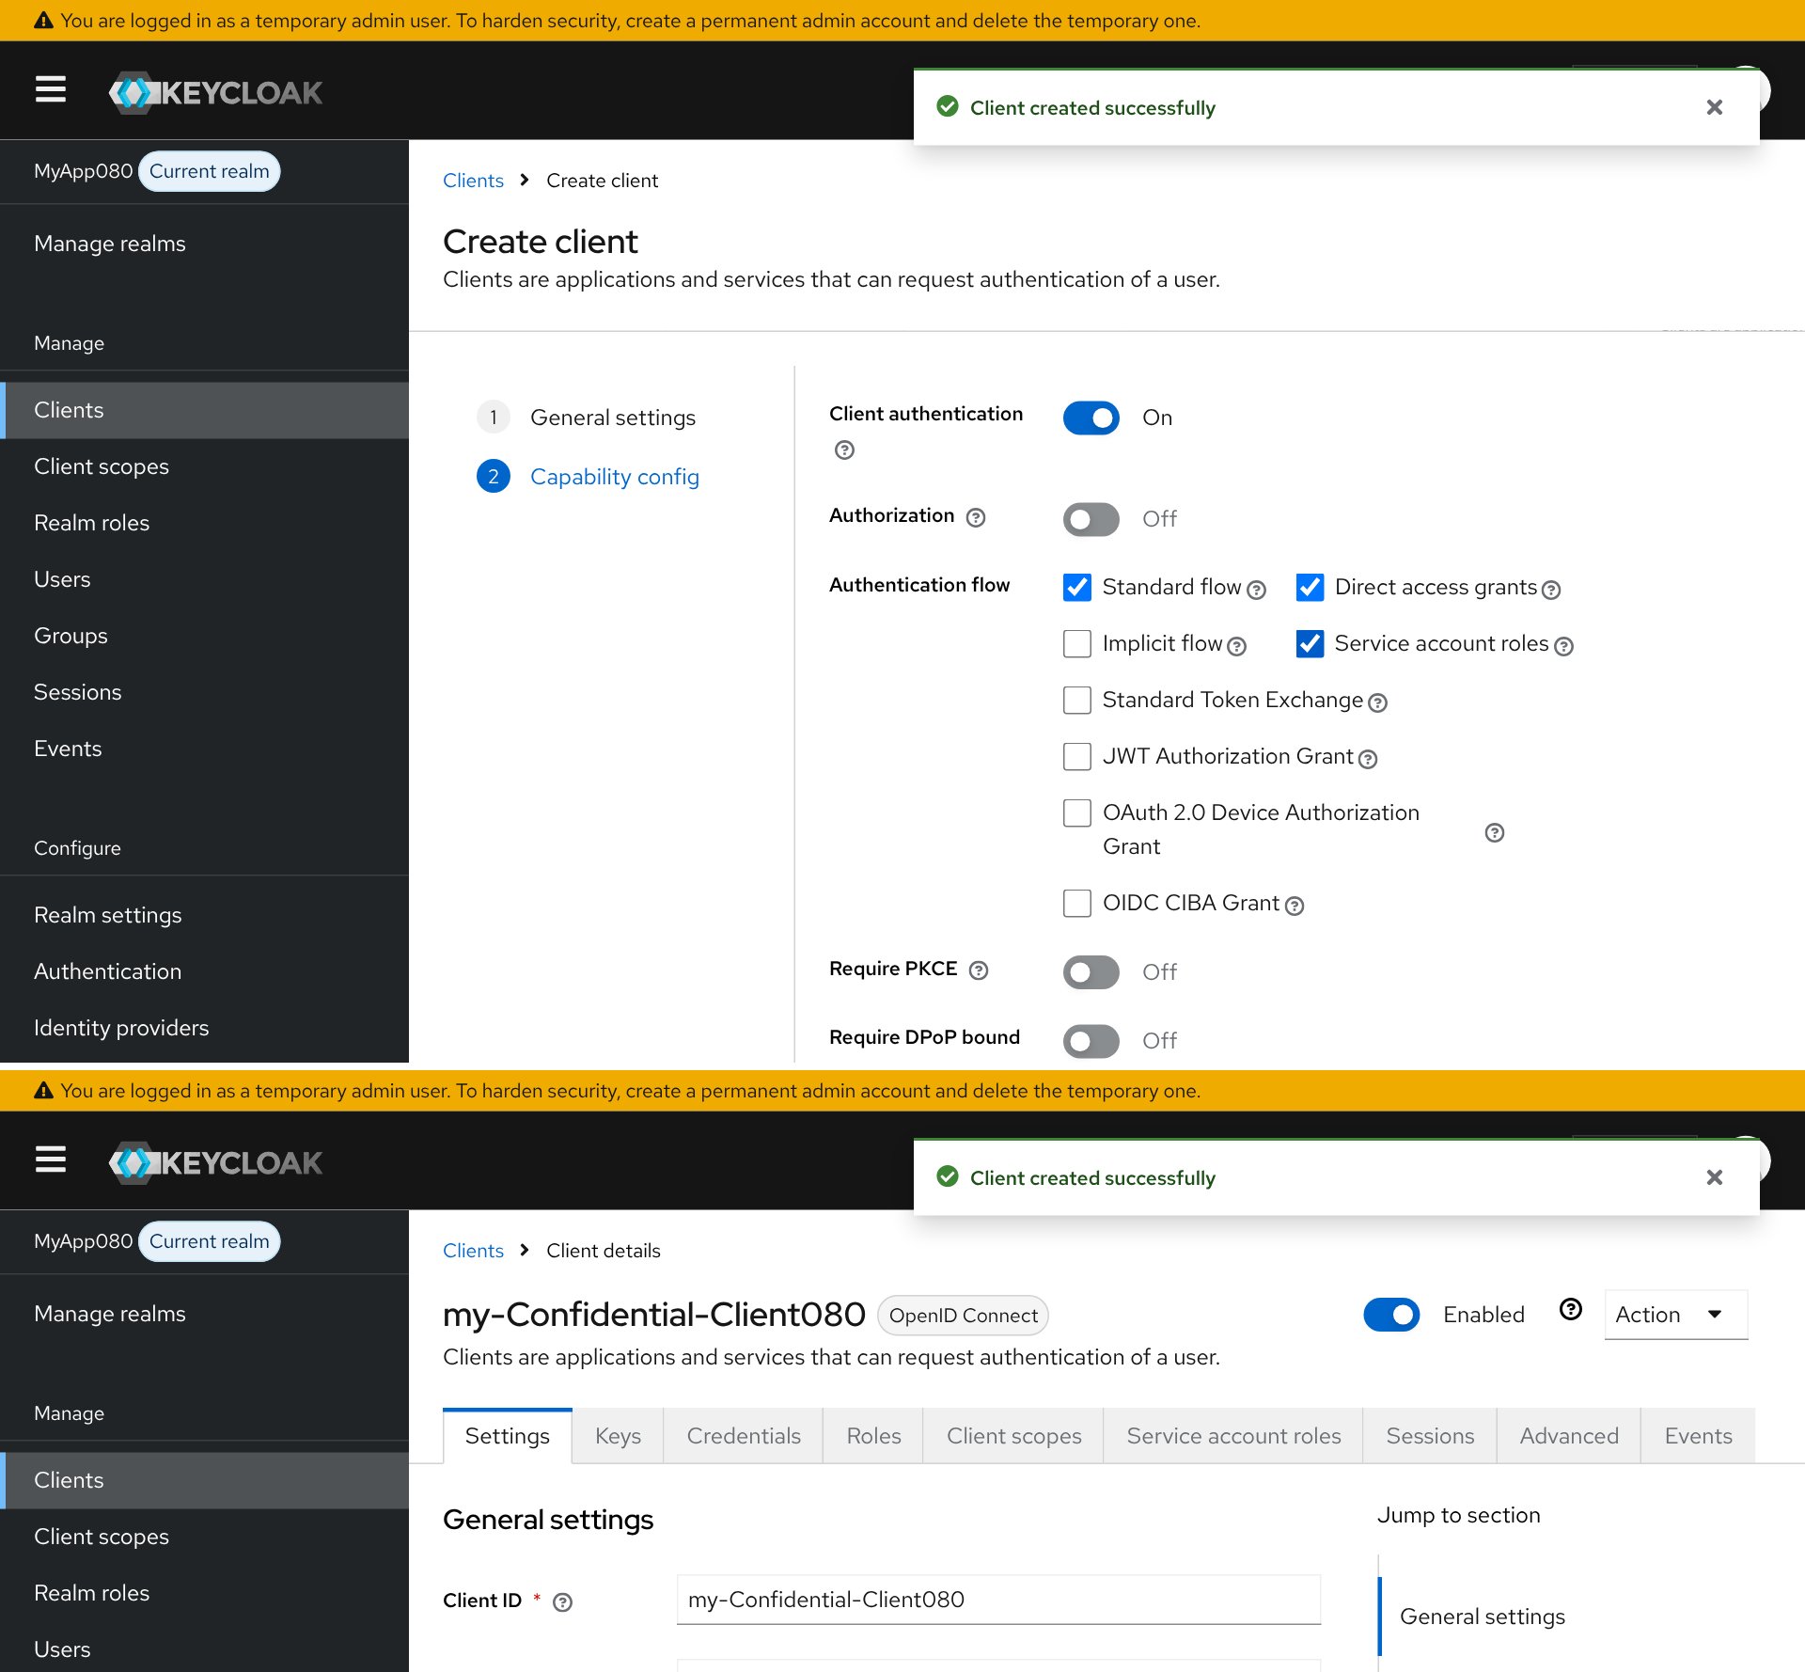
Figure 38: Confidential client my-Confidential-Client080: capability settings (top) and the created client (bottom)
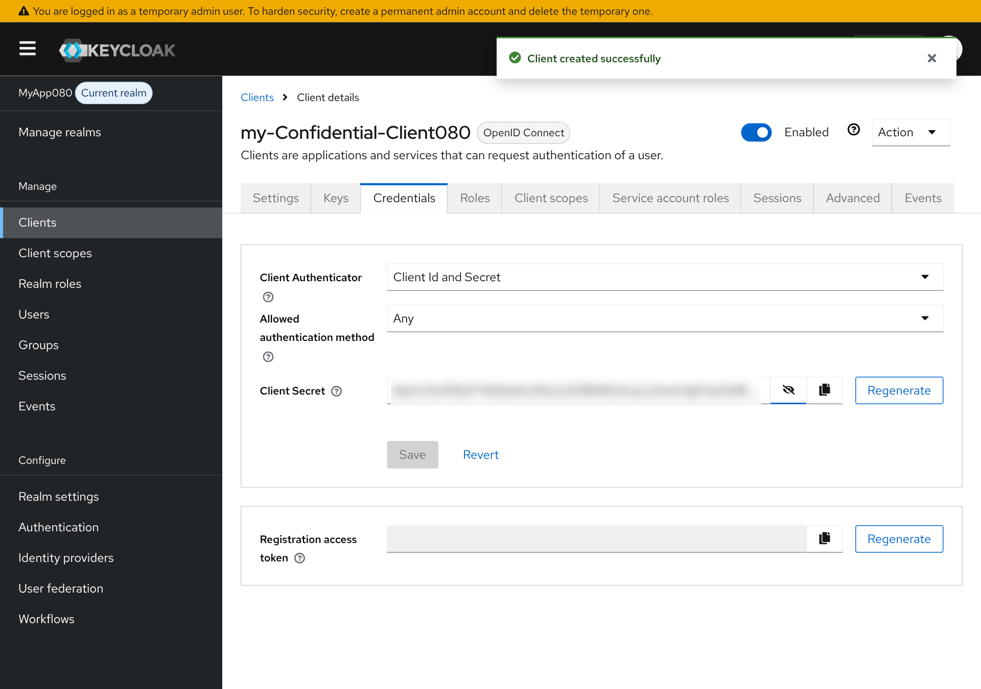
Figure 39: Credentials tab with client secret

Step 9: Requesting a token with curl and inspecting the JWT
curl -L -X POST 'http://localhost:8080/realms/MyApp080/protocol/openid-connect/token' \
-H 'Content-Type: application/x-www-form-urlencoded' \
--data-urlencode 'client_id=my-Confidential-Client080' \
--data-urlencode 'client_secret=******** (hidden)' \
--data-urlencode 'grant_type=client_credentials'

Correction to the handout: the given command has a space after client_secret=, which makes the login fail with invalid_client, so I left the space out. Also, the Client Credentials grant gives a token for the client's service account (preferred_username: service-account-my-confidential-client080), not for the user from Step 5.
Reading the JWT: a JWT has three parts joined by dots: header.payload.signature (each part is Base64URL text). The header shows alg: RS256 and kid (which signing key was used). The payload holds the claims: iss (the realm address), exp and iat (expiry time and issue time, 5 minutes apart by default), azp and client_id (which client asked), realm_access.roles and scope. The signature is checked with the realm's public key from /realms/MyApp080/protocol/openid-connect/certs. Anyone can read a JWT, so secrets must never be put inside it; the signature protects it from changes. The token in Figure 41 was decoded locally because jwt.io could not be reached.
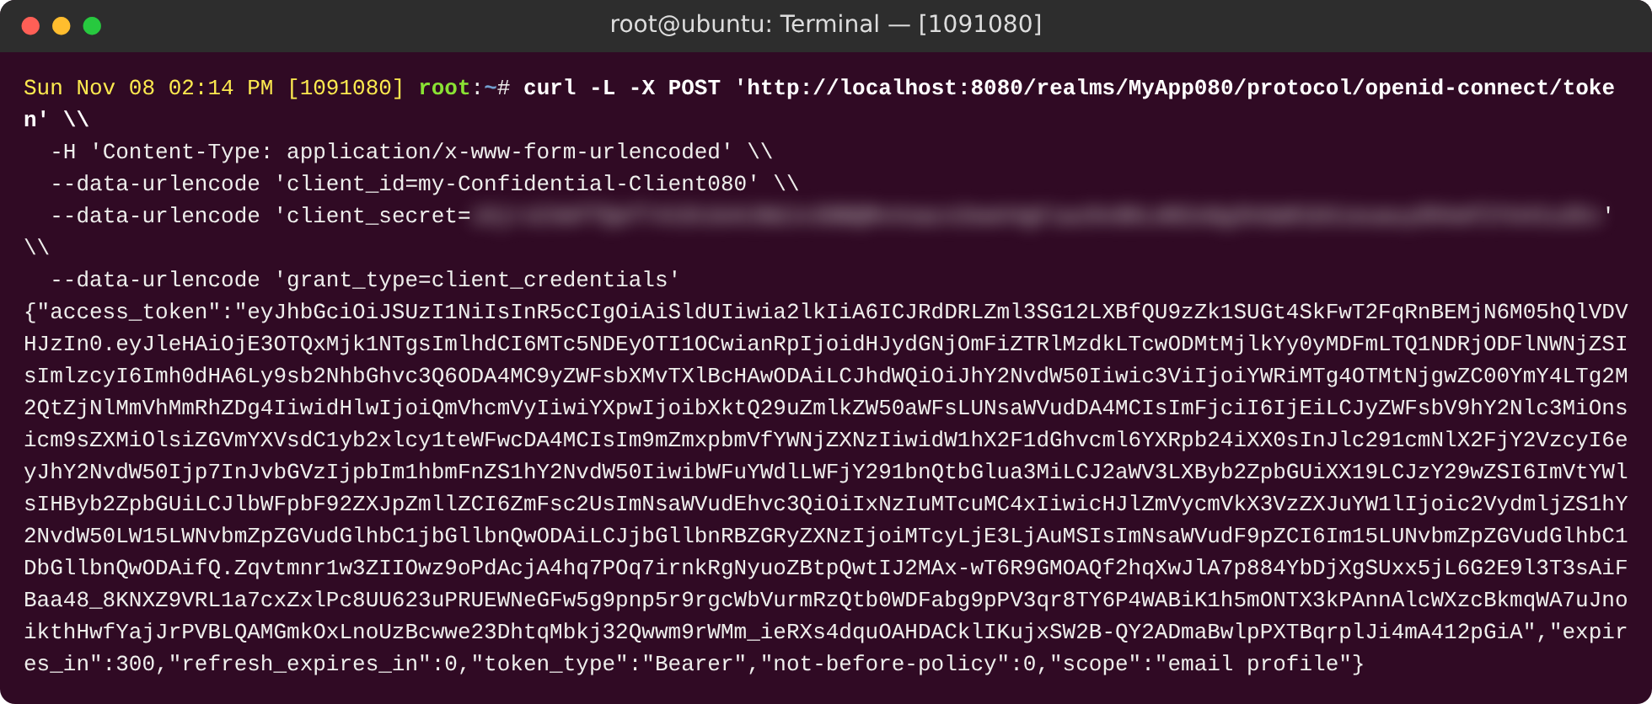
Figure 40: curl request and successful token response
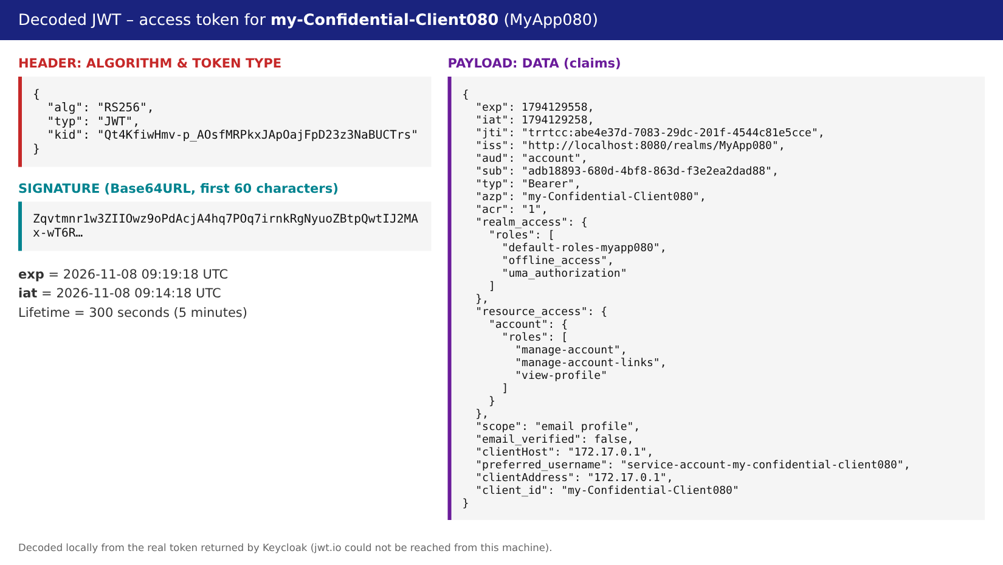
Figure 41: Decoded JWT (header and payload), decoded locally

Step 10: Gmail login via Google identity provider (Self-Learning)
Google Cloud Console → APIs & Services → OAuth consent screen (External, add test user)
Credentials → Create OAuth client ID → Web application
Authorized redirect URI: http://localhost:8080/realms/MyApp080/broker/google/endpoint
Keycloak → MyApp080 → Identity providers → Google → paste Client ID + Client secret → Add
Test: http://localhost:8080/realms/MyApp080/account → 'Sign in with Google'

This is identity brokering. Keycloak hands the login over to Google using OIDC. On the first login, Keycloak creates a user that is linked to the Google account. Users do not need another password, and the application still gets Keycloak tokens. Google allows http://localhost redirect addresses for testing, but a real website must use HTTPS.
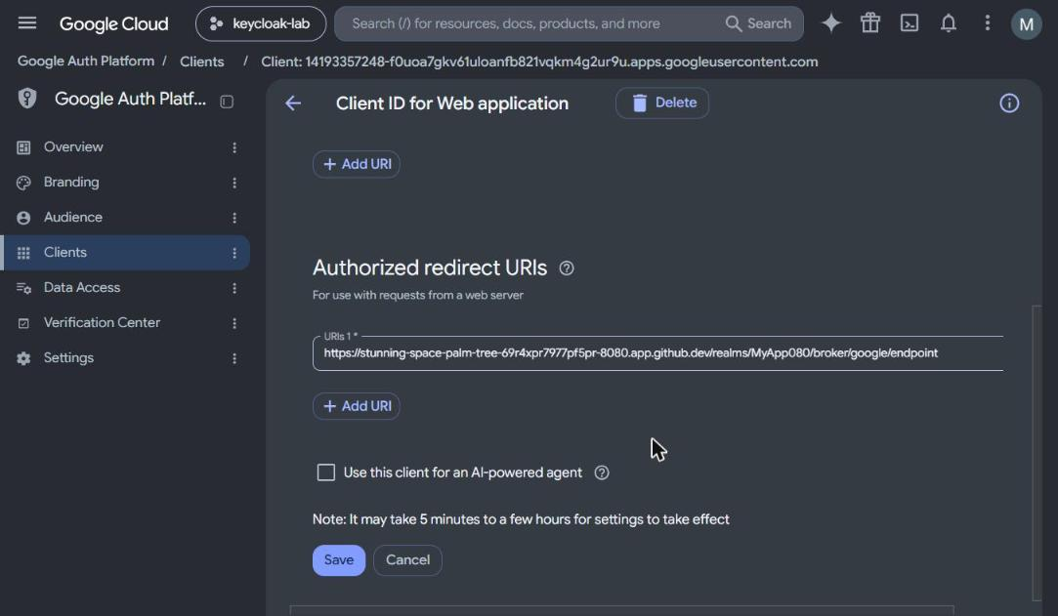
Figure 42: Google Cloud OAuth client with redirect URI
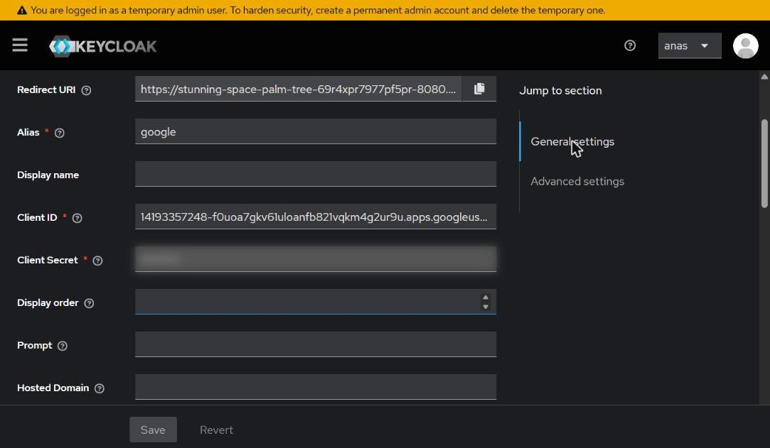
Figure 43: Keycloak Google identity provider configuration (client secret blurred)
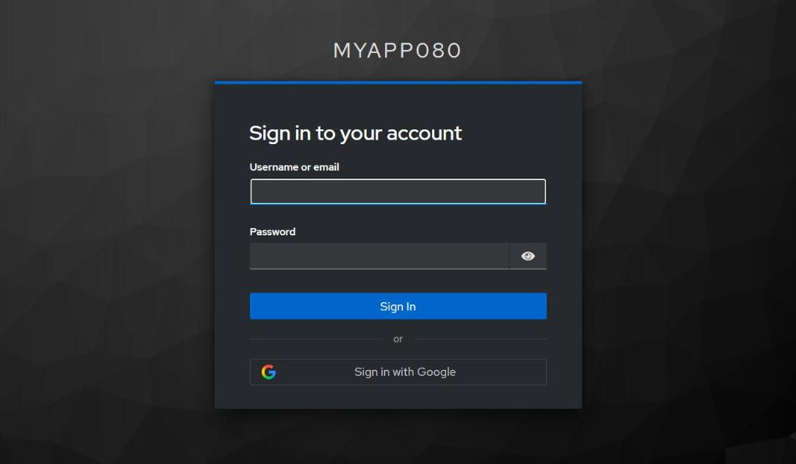
Figure 44: Login page with 'Sign in with Google'

3.1 Critical Analysis – Part B
- One central login means applications do not store passwords, and it gives SSO, multi-factor login and one place to cut off a user. The downside is that Keycloak becomes a valuable target and a single point of failure, so it needs backup servers, updates and strong admin MFA.
- Dev mode is not safe by design. It uses plain HTTP and a test database, and the admin password was typed in the command line, where docker inspect and the shell history can show it. Production needs HTTPS, a real database, secret storage and the start command.
- Bearer tokens work for anyone who holds them. Short lifetimes (exp), HTTPS only, and checking the audience (aud) lower the risk if a token is stolen. In my test the token was valid for only 300 seconds.
- My own reflection: the clearest lesson was the difference between public and confidential clients: who can keep a secret decides which login flow is safe. I also learned that small details matter. Keycloak switches off Direct access grants by default, and it refused a one-time code that was used twice.

4. Conclusion
Part A showed access control at the operating-system level: users, groups, hashed passwords, symbolic and octal permissions, and the special bits SUID, SGID and sticky. Part B moved access control to the application level with Keycloak: realms, users, an admin protected by OTP, public and confidential clients, and signed JWT tokens. Together they show "defence in depth": least privilege in the operating system and strong central login in the application.

References
- Kerrisk, M. (2010). The Linux Programming Interface. No Starch Press. Ch. 9 (Process Credentials) & Ch. 15 (File Attributes).
- Linux man-pages project. chmod(1), adduser(8), usermod(8), shadow(5), credentials(7). https://man7.org/linux/man-pages/
- Canonical. (2021). Ubuntu 21.04 release notes – private home directories (HOME_MODE 0750). https://discourse.ubuntu.com/
- Qualys Research Team. (2022). PwnKit: Local Privilege Escalation Vulnerability in polkit's pkexec (CVE-2021-4034).
- Keycloak. (2026). Server Administration Guide & Getting Started with Docker. https://www.keycloak.org/documentation
- Hardt, D. (2012). RFC 6749 – The OAuth 2.0 Authorization Framework. IETF.
- Jones, M., Bradley, J., Sakimura, N. (2015). RFC 7519 – JSON Web Token (JWT). IETF.
- M'Raihi, D. et al. (2011). RFC 6238 – TOTP: Time-Based One-Time Password Algorithm. IETF.

