Automated Mobile Security Assessment using DIVA and MobSF
ABU DHABI UNIVERSITY
College of Engineering — Department of Computer Science and Information Technology
CSE410 – Mobile Device Security

Automated Mobile Security Assessment using DIVA and MobSF
Laboratory Exercise Report — CLO1: Implement an automated security assessment of mobile devices
Semester | Fall 2026–2027
Instructor | Dr. Muhammad Nasir Mumtaz Bhutta
Student Name(s) | [Student Name]
Student ID(s) | [Student ID]
Group ID | [Group ID]
Submission Date | [DD Month 2026] (deadline: Sunday 1 November 2026)
Assessment Date | 28 October 2026

2. Executive Summary
This lab implemented an automated static security assessment of DIVA (Damn Insecure and Vulnerable App for Android), an intentionally vulnerable application supplied for education. The DIVA source code was obtained from the official Payatu repository, its native library was compiled with make/ndk-build, and the application was built into a signed debug APK (diva-app-debug.apk, package jakhar.aseem.diva). The APK was then uploaded to a local MobSF v4.6.2 instance running in Docker, which performed manifest, certificate, code (SAST), binary, API and secret analysis.
MobSF gave the application a security score of 47/100 (Grade B, “Medium Risk”) and reported 2 High, 8 Medium (warning), 1 Info, 1 Secure and 1 Hotspot finding. Five findings were selected, analysed and prioritised:
- Unprotected exported Content Provider (.NotesProvider) – any installed app can read, change and delete the private notes. High priority, fixed first.
- SQL injection through a raw, string-concatenated SQL query in SQLInjectionActivity – dumps every stored user, password and credit card number. High.
- Credentials written to external storage (InsecureDataStorage4Activity, plus a temp file in InsecureDataStorage3Activity) – any app with storage access can read them. High.
- Exported activities with intent filters (.APICredsActivity, .APICreds2Activity) – any app can open the screens that show API credentials. Medium.
- Sensitive information written to the system log (LogActivity: credit card numbers). Medium.
Validation showed that automated static analysis is useful but incomplete. The “hardcoded secret” pkey: notespin is a false positive (it is a SharedPreferences key name). Several real hardcoded secrets are false negatives: vendorsecretkey, 123secretapikey123 and the native key olsdfgad;lh. Overall conclusion: the evidence shows a weak security posture. The most important problems are broken access control on exported components, injection, and insecure storage of credentials. Each can be fixed at its root cause with the remediation in Section 11.

3. Introduction
Mobile applications process credentials, payment data and personal information on devices that the developer does not control. An automated mobile application security assessment uses tooling to inspect an application package systematically, without running it. Such a tool decompiles the code, parses the manifest, inspects certificates and native binaries, and matches the results against rule sets mapped to standards such as CWE, OWASP Mobile Top 10 and OWASP MASVS. Automation makes assessments fast, repeatable and consistent, which is why it is used in secure SDLC pipelines and as the first phase of a penetration test.
In this lab the target is DIVA, published by Payatu specifically to teach insecure logging, hardcoding, insecure data storage, input validation and access control flaws in both Java and native (C) code. The assessment platform is MobSF (Mobile Security Framework), an open-source automated framework for Android/iOS static and dynamic analysis. The scenario is that of a junior mobile application security analyst: establish scope, prepare the target, run the automated assessment, and turn the raw results into prioritised, evidence-based findings with remediation.

4. Assessment Scope and Authorization
Item | Details
In scope | The DIVA Android application (jakhar.aseem.diva, version 1.0, versionCode 1). It was built by the student from the official source github.com/payatu/diva-android (commit 2bb63b5, 15 Jan 2016). The APK assessed is diva-app-debug.apk (SHA-256 4adc2de8…9fa28331).
Assessment type | Automated static analysis with MobSF (manifest, certificate, code/SAST, shared-library binary, Android API, permissions, secrets/strings, trackers).
Out of scope / excluded | Dynamic analysis and instrumentation (Frida/emulator), exploitation of findings, network testing, real devices, and any personal, production, university or third-party application. No other APK was uploaded to the MobSF instance.
Test environment | An isolated lab host (Ubuntu 24.04.5 LTS, x86-64). MobSF ran locally in a Docker container bound to 127.0.0.1:8000, and only the lab operator could reach it.
Authorization | The assessment was authorised by the CSE410 laboratory exercise (Instructor: Dr. Muhammad Nasir Mumtaz Bhutta). DIVA is deliberately vulnerable and is published for educational testing. All work was done in this controlled environment.
Data handling | No personal data was used. The MobSF REST API key printed at container start-up is redacted in all evidence. Only the default lab credentials (mobsf/mobsf) appear, as documented by MobSF.

5. Tools and Environment
Component | Version / Detail | Purpose
Host operating system | Ubuntu 24.04.5 LTS, Linux 6.18 x86-64, 4 CPU / 16 GB RAM | Lab host
DIVA Android | payatu/diva-android @ 2bb63b531ba6 | Assessment target
Android Studio | [record your installed version, e.g. Help → About] | IDE used to open/sync/build the project (see 6.2)
Android SDK build-tools | 35.0.0 (aapt2, d8, zipalign, apksigner) | APK build toolchain (what Android Studio’s Gradle build invokes)
Android SDK platform | android-34 (android.jar) | Compile SDK
Android NDK | 29.0.14206865 (ndk-build) | Native library libdivajni.so
Android Support Library | appcompat-v7 / design / support-v4 / recyclerview-v7 23.1.0 (the exact versions DIVA declares) | App dependencies
Java | OpenJDK 21.0.12 | javac, keytool
Docker Engine | 29.9.2 (Docker Desktop on Windows/macOS provides the same engine) | Container runtime
MobSF | v4.6.2, image opensecurity/mobile-security-framework-mobsf:latest (digest sha256:637cdb70…6d301) | Automated assessment
JADX (used by MobSF) | 1.5.0 | DEX → Java decompilation for code analysis
Browser | Chromium (Playwright) | MobSF web interface & screenshots
Official references used: DIVA https://github.com/payatu/diva-android and README https://github.com/payatu/diva-android#readme; Android Studio https://developer.android.com/studio and https://developer.android.com/studio/install; MobSF https://github.com/MobSF/Mobile-Security-Framework-MobSF, docs https://mobsf.github.io/docs/ and Docker guide https://github.com/MobSF/docs/blob/master/running_mobsf_docker.md; Docker Desktop https://www.docker.com/products/docker-desktop/ and https://docs.docker.com/desktop/setup/install/windows-install/.

6. DIVA Application Preparation (Stage 1)

6.1 Step 1.1 – Obtaining the source
The official repository was cloned. No pre-built APK was used.
git clone https://github.com/payatu/diva-android.git
The repository contains a standard Android Studio project: app/ with Java sources under app/src/main/java/jakhar/aseem/diva/, resources, AndroidManifest.xml, and native code in app/src/main/jni/ (divajni.c, Android.mk, Application.mk, Makefile).
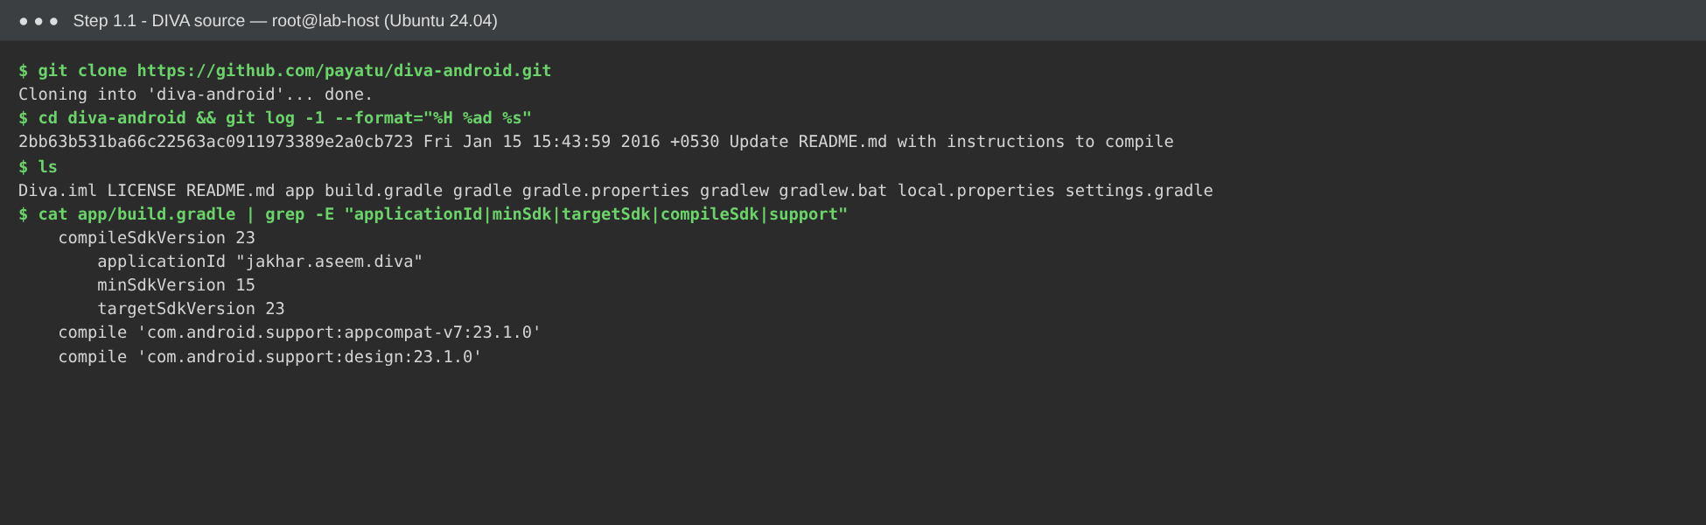
Figure 1. Official DIVA source cloned from github.com/payatu/diva-android. The figure shows the commit and the SDK/dependency settings in app/build.gradle (applicationId jakhar.aseem.diva, minSdk 15, targetSdk 23, support library 23.1.0).

6.2 Step 1.2 – Opening the project in Android Studio
Procedure: Android Studio → File → Open → select the diva-android folder → Trust Project → allow Gradle sync, and install any SDK components it asks for.
Version difference (documented as required by Section 5 of the lab sheet). DIVA was written in 2015. Its build scripts use Android Gradle Plugin 1.3.0, Gradle 2.4, the jcenter() repository (shut down) and compile dependency syntax. A current Android Studio cannot sync these, and it offers to upgrade the project with the AGP Upgrade Assistant. Only normal project/build dependency errors were fixed. The application code, its vulnerabilities and its SDK levels were not changed. The fixes are in Build/diva-android-studio-modernization.patch and are already applied in Source/diva-android/:
- build.gradle: AGP 8.7.3 with google() + mavenCentral() in place of jcenter(). Gradle wrapper set to 8.9.
- app/build.gradle: namespace, compileSdk 34, implementation, and AndroidX (appcompat 1.6.1, material 1.4.0) in place of the removed support-library artefacts. minSdk 15 / targetSdk 23 are unchanged.
- gradle.properties: android.useAndroidX=true.
- AndroidManifest.xml: package= removed, because AGP 8 takes it from namespace.
- Java/XML imports renamed from android.support.* to androidx.* / com.google.android.material.*.
- res/values-v21/styles.xml: fixed an upstream typo (<resources>>) that the modern aapt2 resource compiler rejects as an error.
Insert screenshot — Figure 2. DIVA project opened in Android Studio (Project view showing app/src/main/java/jakhar/aseem/diva, Gradle sync finished). Record the Android Studio version from Help → About in Section 5.

6.3 Step 1.3 – Preparing the native component
As the DIVA README instructs, the native library was compiled from app/src/main/jni with make. The Makefile runs ndk-build (with APP_ABI := all) and copies the results into app/src/main/jniLibs/. The NDK must be on the PATH (Android Studio → SDK Manager → SDK Tools → NDK (Side by side)). On Windows, ndk-build.cmd can be run directly, followed by copying libs\* to jniLibs\.
cd app/src/main/jni
make
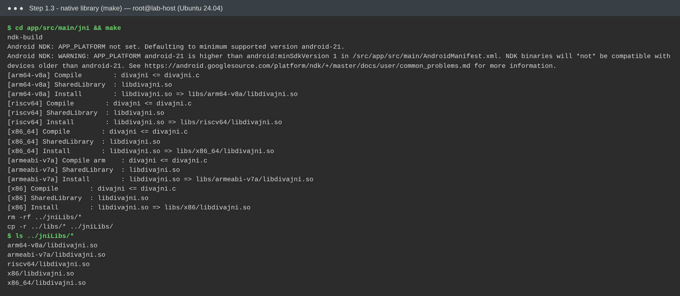
Figure 3. make in app/src/main/jni compiled libdivajni.so for armeabi-v7a, arm64-v8a, x86, x86_64 and riscv64 and copied the libraries into jniLibs/.
Observation: NDK r29 cannot target API levels below 21. It warns that the native library will not load on devices older than Android 5.0, even though the app’s minSdkVersion is 15. This does not affect static analysis.

6.4 Step 1.4 – Building the application
In Android Studio, the build is Build → Make Project (assembleDebug), which writes app/build/outputs/apk/debug/app-debug.apk. On the headless lab host, the same debug build was run directly with the Android SDK build tools that the Gradle plugin uses internally (Build/build_diva_apk.sh). The script runs aapt2 compile/link (resources, manifest, R.java) → javac (DIVA sources) → d8 (DEX) → packages classes.dex and jniLibs → zipalign → apksigner, signed with the standard Android debug keystore (CN=Android Debug). It compiles the original, unmodified DIVA Java code against the exact support libraries DIVA declares (23.1.0), so the assessed binary matches the upstream application as closely as possible.
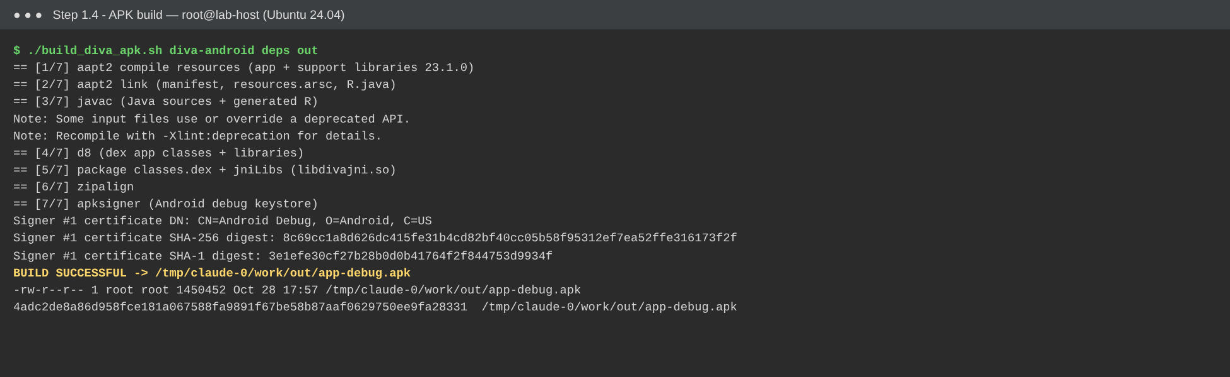
Figure 4. Successful build of the DIVA debug APK (BUILD SUCCESSFUL). It shows the seven build stages, the debug-signing certificate and the SHA-256 of the output.
Insert screenshot — Figure 5. Android Studio Build window showing BUILD SUCCESSFUL after Build → Make Project, and the Project view (or Build → Build APK(s) → locate) showing app/build/outputs/apk/debug/app-debug.apk.

6.5 Step 1.5 – Assessment environment record
Field | Value
Application name | Diva
Package / application ID | jakhar.aseem.diva
Version | 1.0 (versionCode 1)
minSdk / targetSdk / compileSdk | 15 / 23 / 34
Main activity | jakhar.aseem.diva.MainActivity
Generated APK | diva-app-debug.apk (renamed copy of app-debug.apk), 1,450,452 bytes (1.38 MB)
APK SHA-256 | 4adc2de8a86d958fce181a067588fa9891f67be58b87aaf0629750ee9fa28331
APK MD5 (MobSF scan hash) | 299b15c63aac6aae44ce42281e768b4c
Signing | Android debug certificate, APK signature schemes v1 + v2 + v3
Native libraries | lib/{armeabi-v7a,arm64-v8a,x86,x86_64,riscv64}/libdivajni.so
Build OS / Android Studio | Ubuntu 24.04.5 LTS / [your Android Studio version]
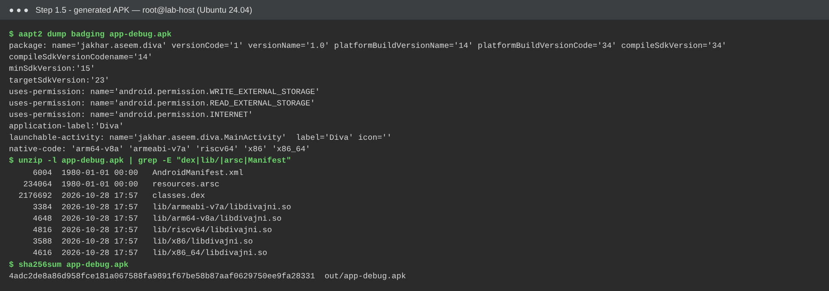
Figure 6. Generated APK checked with aapt2 dump badging: package jakhar.aseem.diva, SDK levels, permissions, classes.dex, resources.arsc and the bundled native libraries.

7. MobSF Setup (Stage 2)
Step 2.1 – Docker. Docker Engine 29.9.2 was installed and running (docker --version, docker info). On Windows/macOS, Docker Desktop is installed from https://www.docker.com/products/docker-desktop/ and started before continuing.
Step 2.2 – Official image.
docker pull opensecurity/mobile-security-framework-mobsf:latest
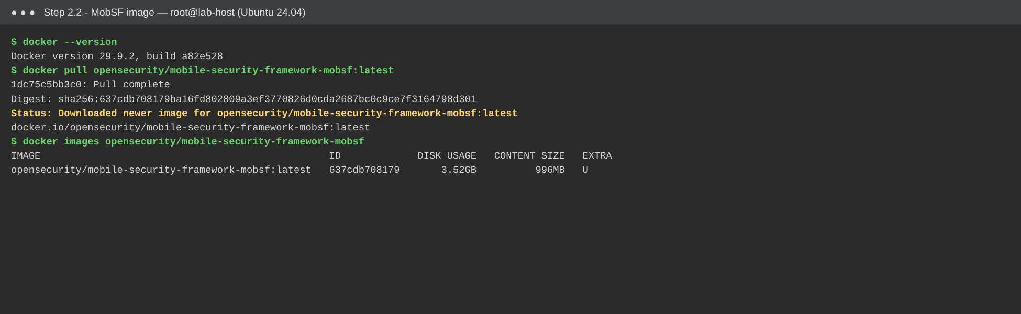
Figure 7. Official MobSF image pulled from Docker Hub (Status: Downloaded newer image …).
Step 2.3 – Starting MobSF. The official command is docker run -it --rm -p 8000:8000 opensecurity/mobile-security-framework-mobsf:latest. On the headless host the same image was run detached with a container name, using docker run -d --name mobsf -p 8000:8000 …, so it would keep running between steps. The port mapping and image are identical.
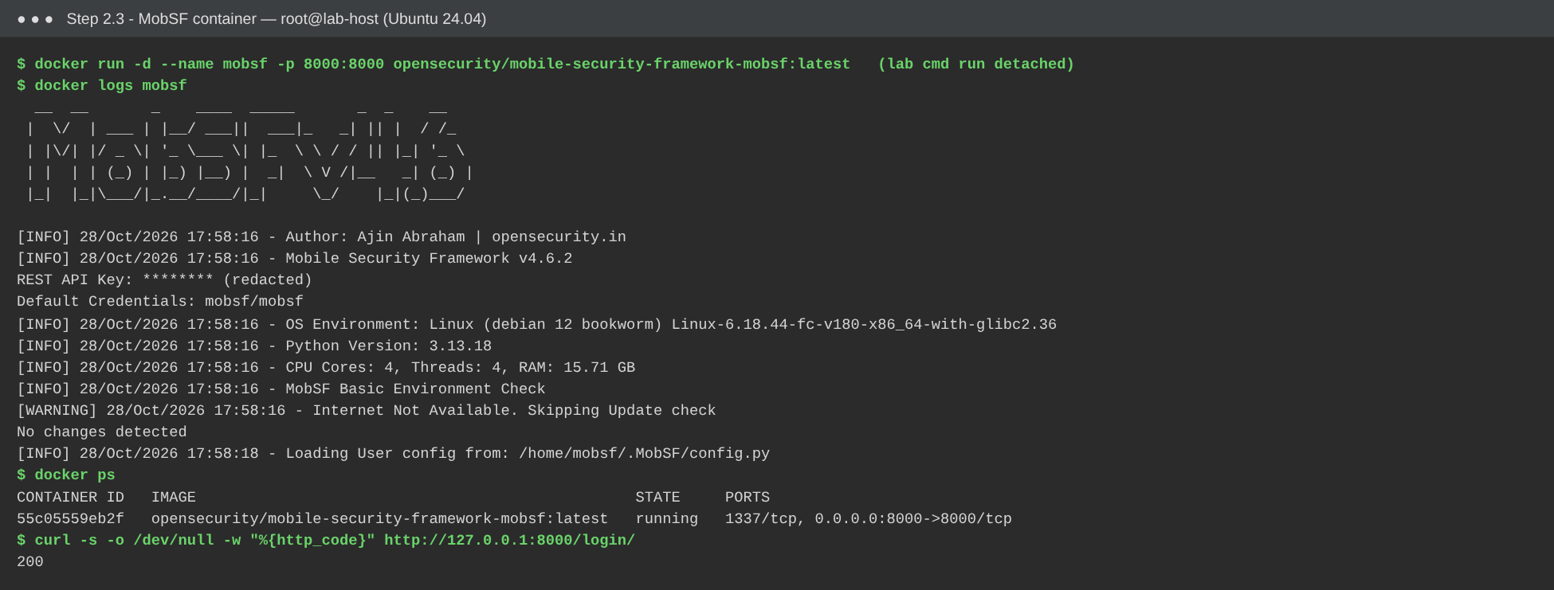
Figure 8. MobSF container start-up log: MobSF v4.6.2 banner, default credentials mobsf/mobsf, and the container listening on 0.0.0.0:8000. The REST API key is redacted.
Step 2.4 – Web interface. http://127.0.0.1:8000 opened the MobSF login page. The documented default credentials mobsf / mobsf were used.
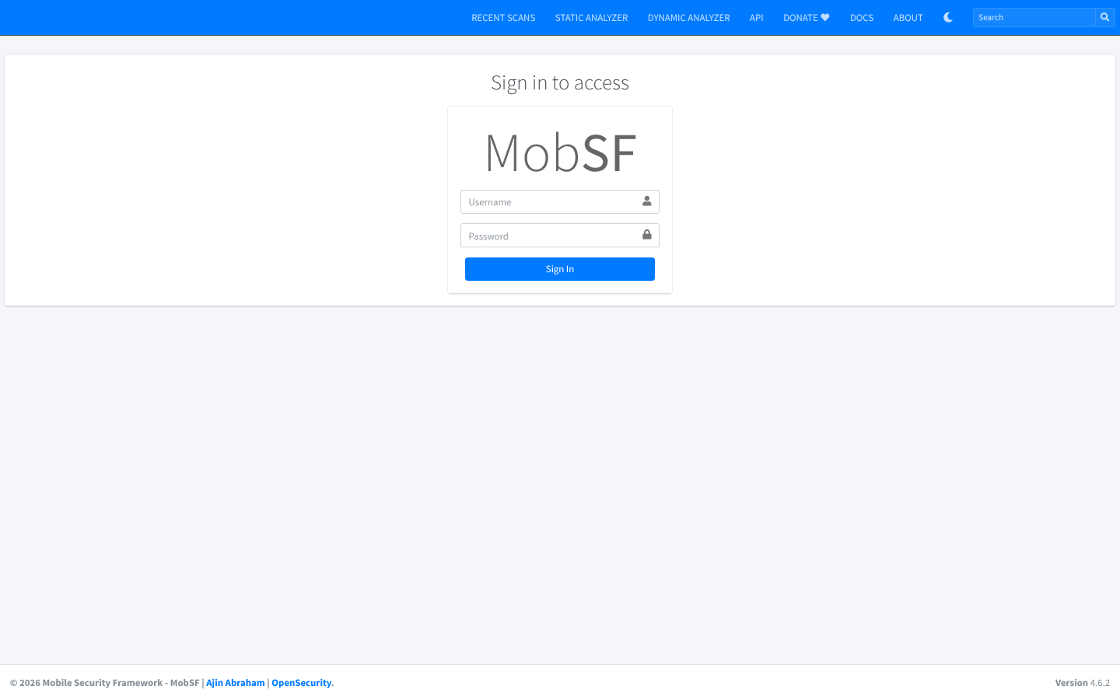
Figure 9. MobSF login page at http://127.0.0.1:8000 (version 4.6.2 shown in the footer).
Step 2.5 – Platform confirmed. The dashboard (“Upload & Analyze”) loaded. MobSF version: v4.6.2.
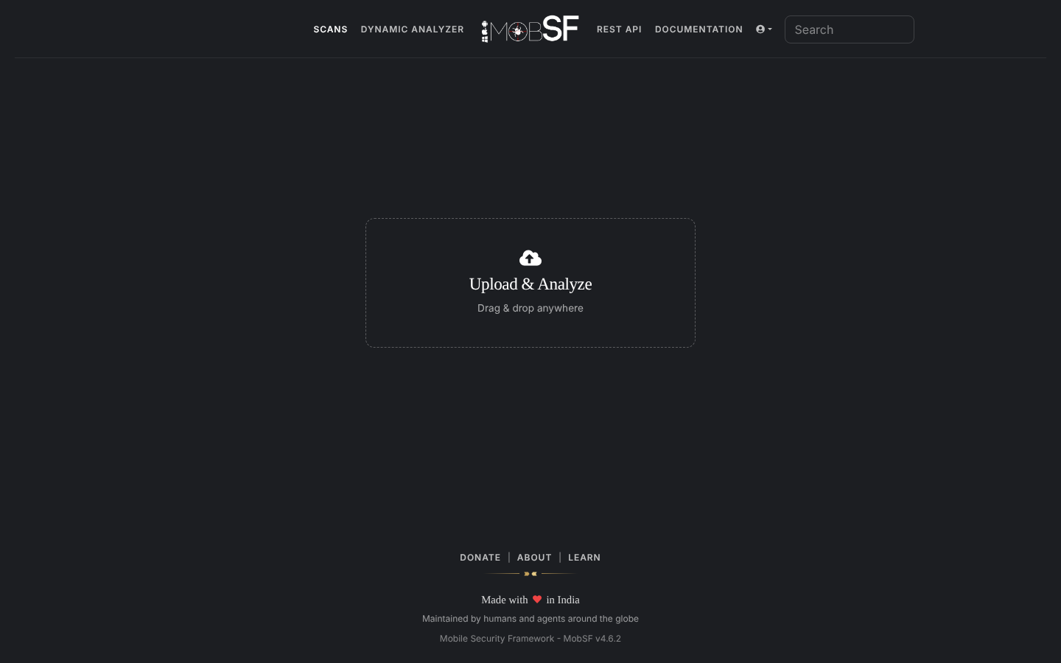
Figure 10. MobSF dashboard after login, ready for upload. The footer confirms “Mobile Security Framework – MobSF v4.6.2”.
Observation (documented setup difference): MobSF downloads the JADX decompiler on first start. The lab container had no direct internet access, so the first scan logged “Decompiling with JADX failed” and produced an empty code-analysis section. The official JADX 1.5.0 release (the version MobSF requests) was placed in ~/.MobSF/tools/jadx/ and the container was restarted, because MobSF’s anti-tampering check hashes tool binaries at start-up. The scan was then repeated. On a normal student PC with internet access this happens automatically.

8. Automated Security Assessment Procedure (Stage 3)
- Step 3.1 – Locate the APK: diva-app-debug.apk from Stage 1 (SHA-256 above).
- Step 3.2 – Upload: on the MobSF dashboard, Upload & Analyze → select diva-app-debug.apk. MobSF accepted the file (MIME application/vnd.android.package-archive) and created the scan hash 299b15c63aac6aae44ce42281e768b4c.
- Step 3.3 – Automated analysis: analysis was not interrupted. MobSF unpacked the APK, parsed it with androguard/aapt2, decoded the manifest with apktool, analysed the certificate and the five native libraries, ran APKiD, decompiled to Java (JADX 1.5.0) and Smali, and ran SAST, Android API, permission-mapping, behaviour, string/secret, URL and tracker analysis. The analysis took about 15 seconds.
- Step 3.4 – Review: every section of the static-analysis report was reviewed (Figures 13–21).
- Step 3.5 – Evidence saved: screenshots were captured, and the report was exported with PDF Report (MobSF_Reports/MobSF_DIVA_report.pdf, 25 pages). The full JSON report and the scorecard JSON were also exported.
- Step 3.6 – Metadata: APK diva-app-debug.apk; MobSF v4.6.2; assessment date 28 October 2026 (scan timestamp 2026-10-28T18:02:33Z); app Diva 1.0, package jakhar.aseem.diva, main activity .MainActivity, target SDK 23, min SDK 15.
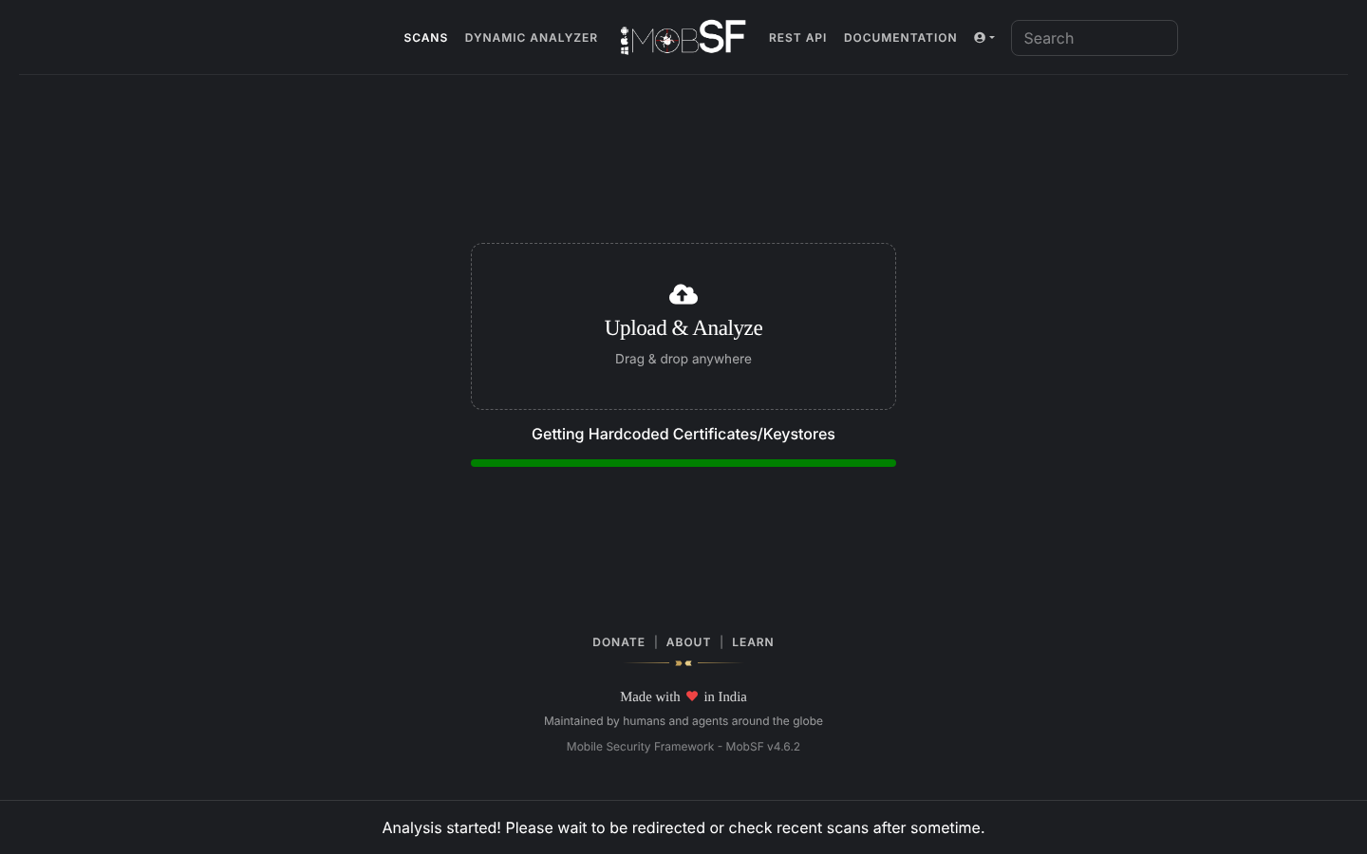
Figure 11. DIVA APK uploaded through the MobSF web interface; the static analysis is running.
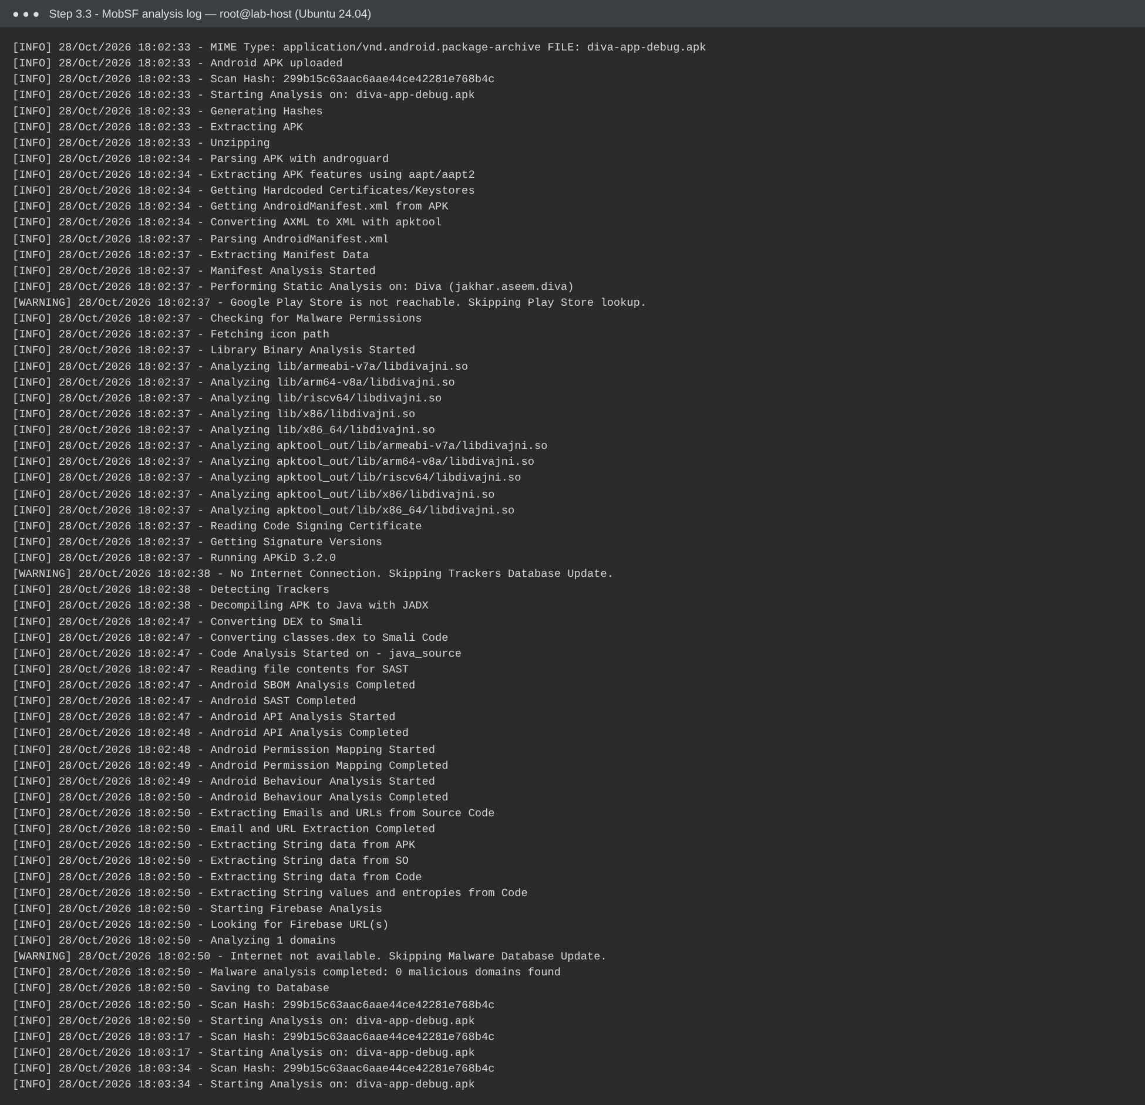
Figure 12. MobSF analysis log for the scan. It shows each automated step, including successful JADX decompilation and SAST.
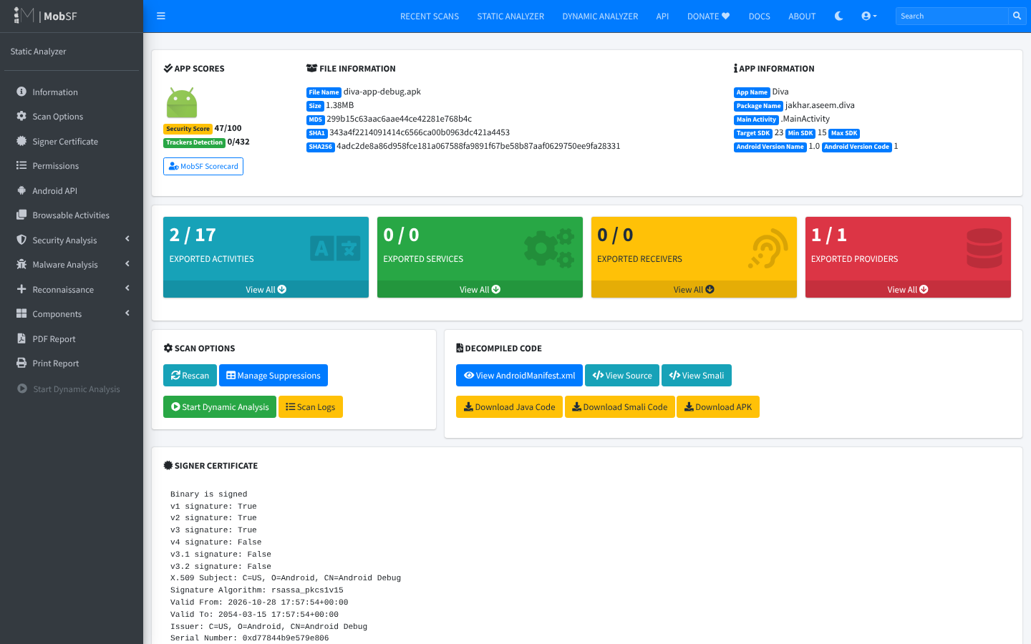
Figure 13. MobSF result page for the student-built DIVA APK. It shows the security score of 47/100, file hashes, application information (Diva, jakhar.aseem.diva, Target SDK 23, Min SDK 15), 2/17 exported activities, 1/1 exported provider and the signer certificate.
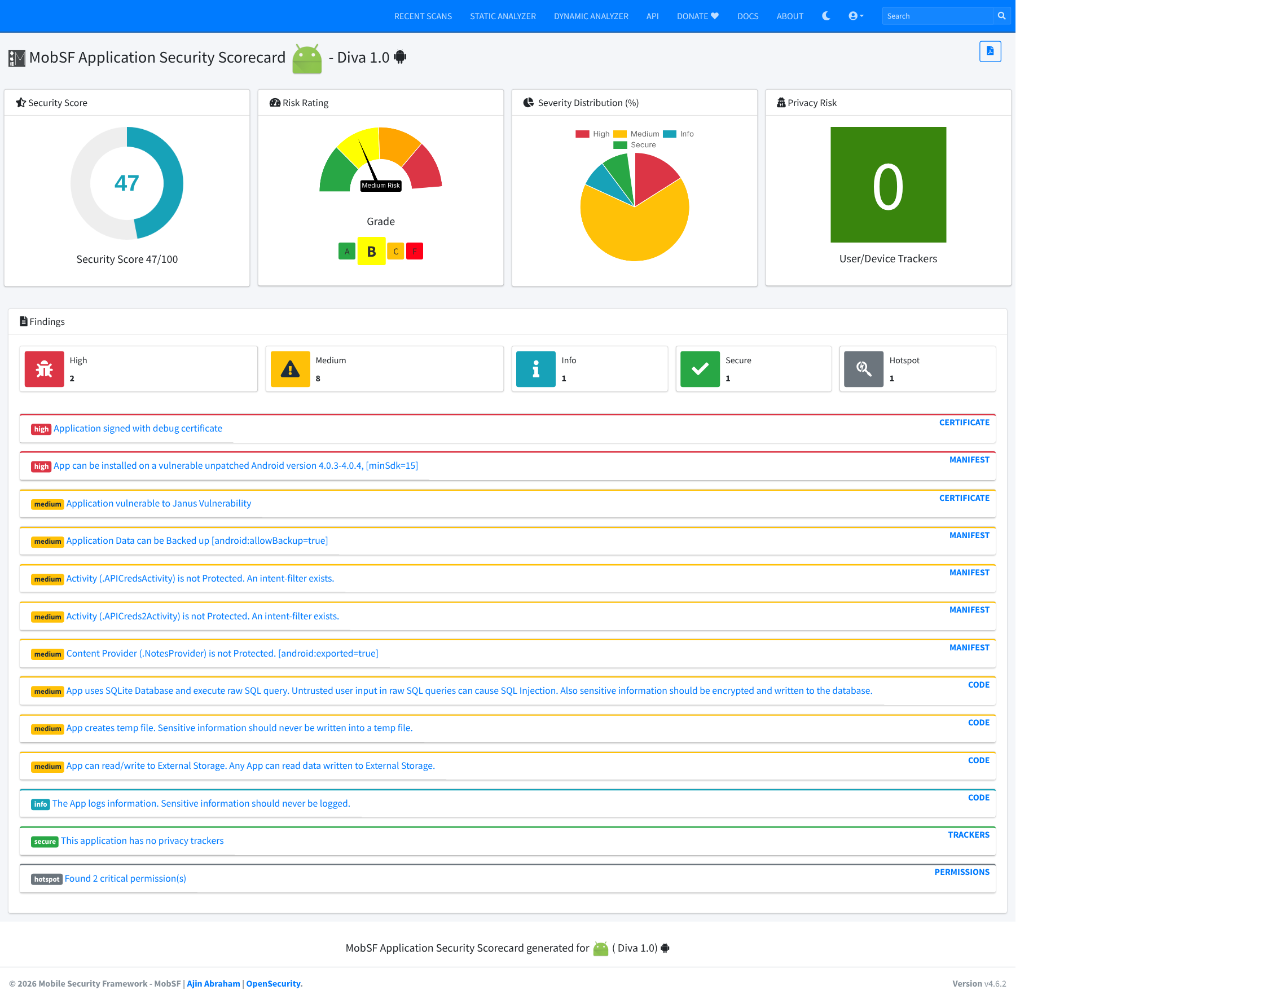
Figure 14. MobSF Application Security Scorecard: score 47, Grade B, “Medium Risk”, and High 2 / Medium 8 / Info 1 / Secure 1 / Hotspot 1, with each finding and its source section.
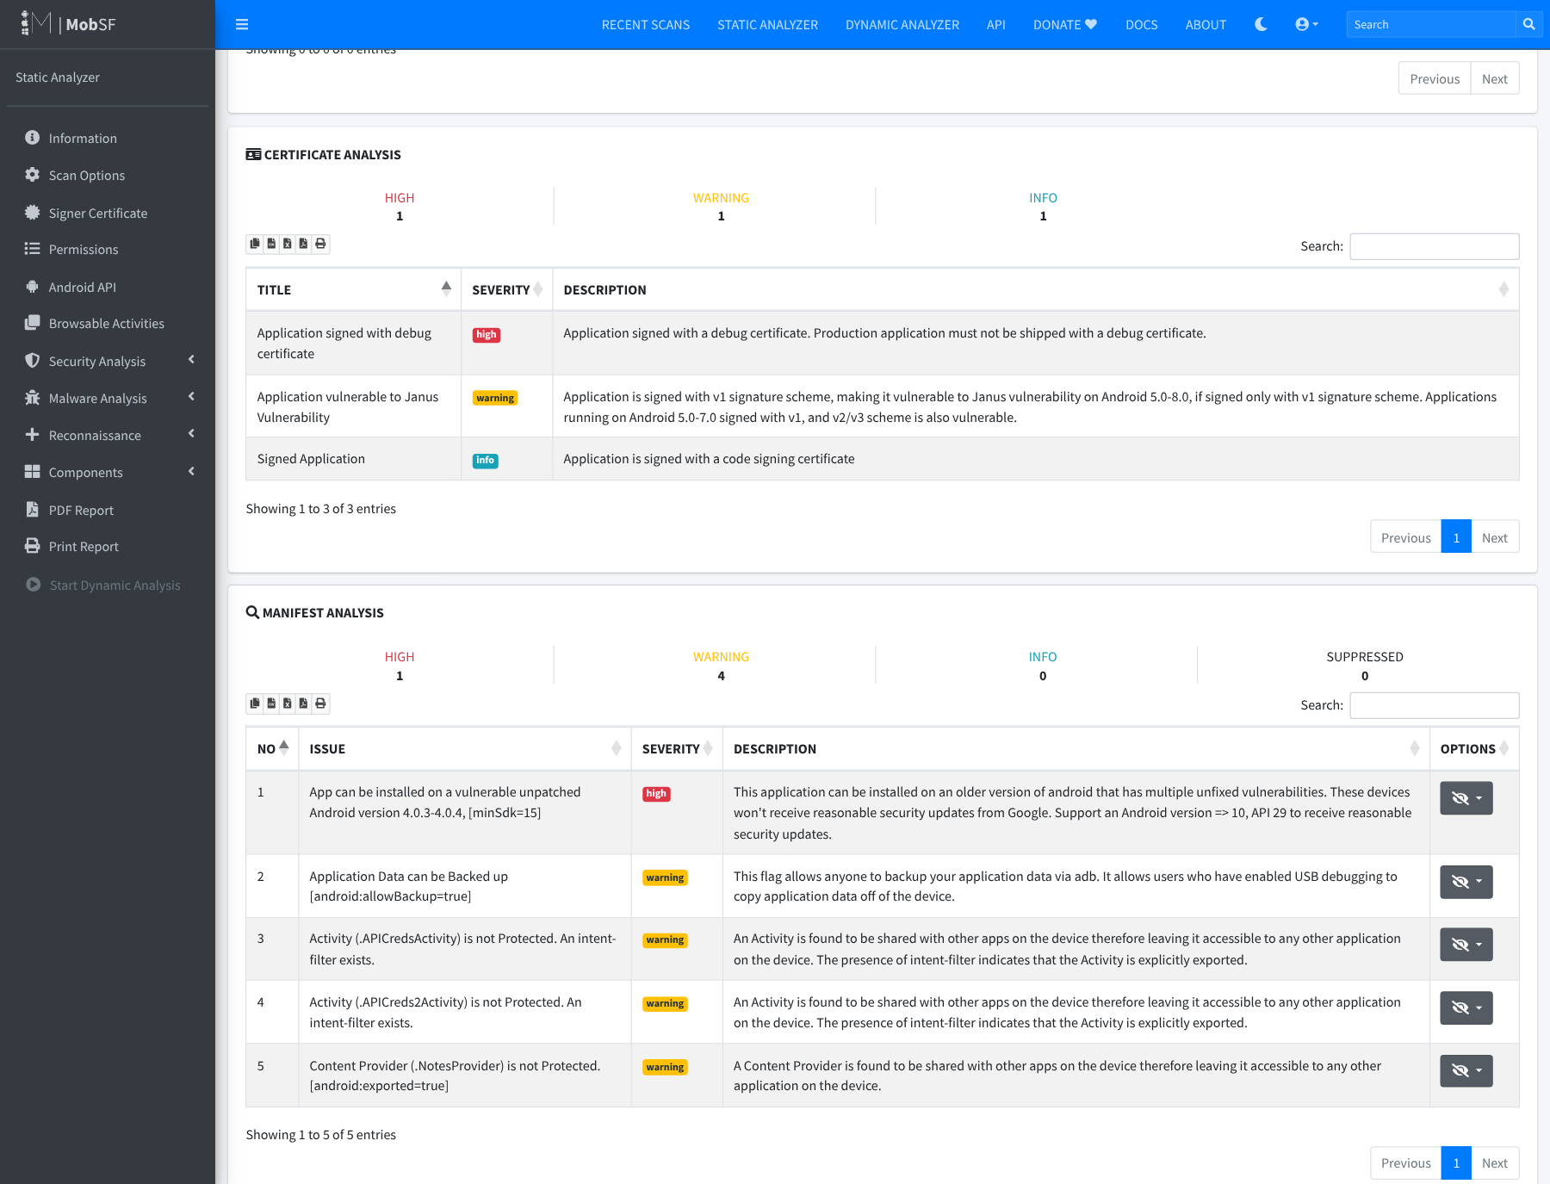
Figure 15. Certificate analysis: the APK is signed with a debug certificate (high) and has a v1 signature, so MobSF flags Janus (warning).
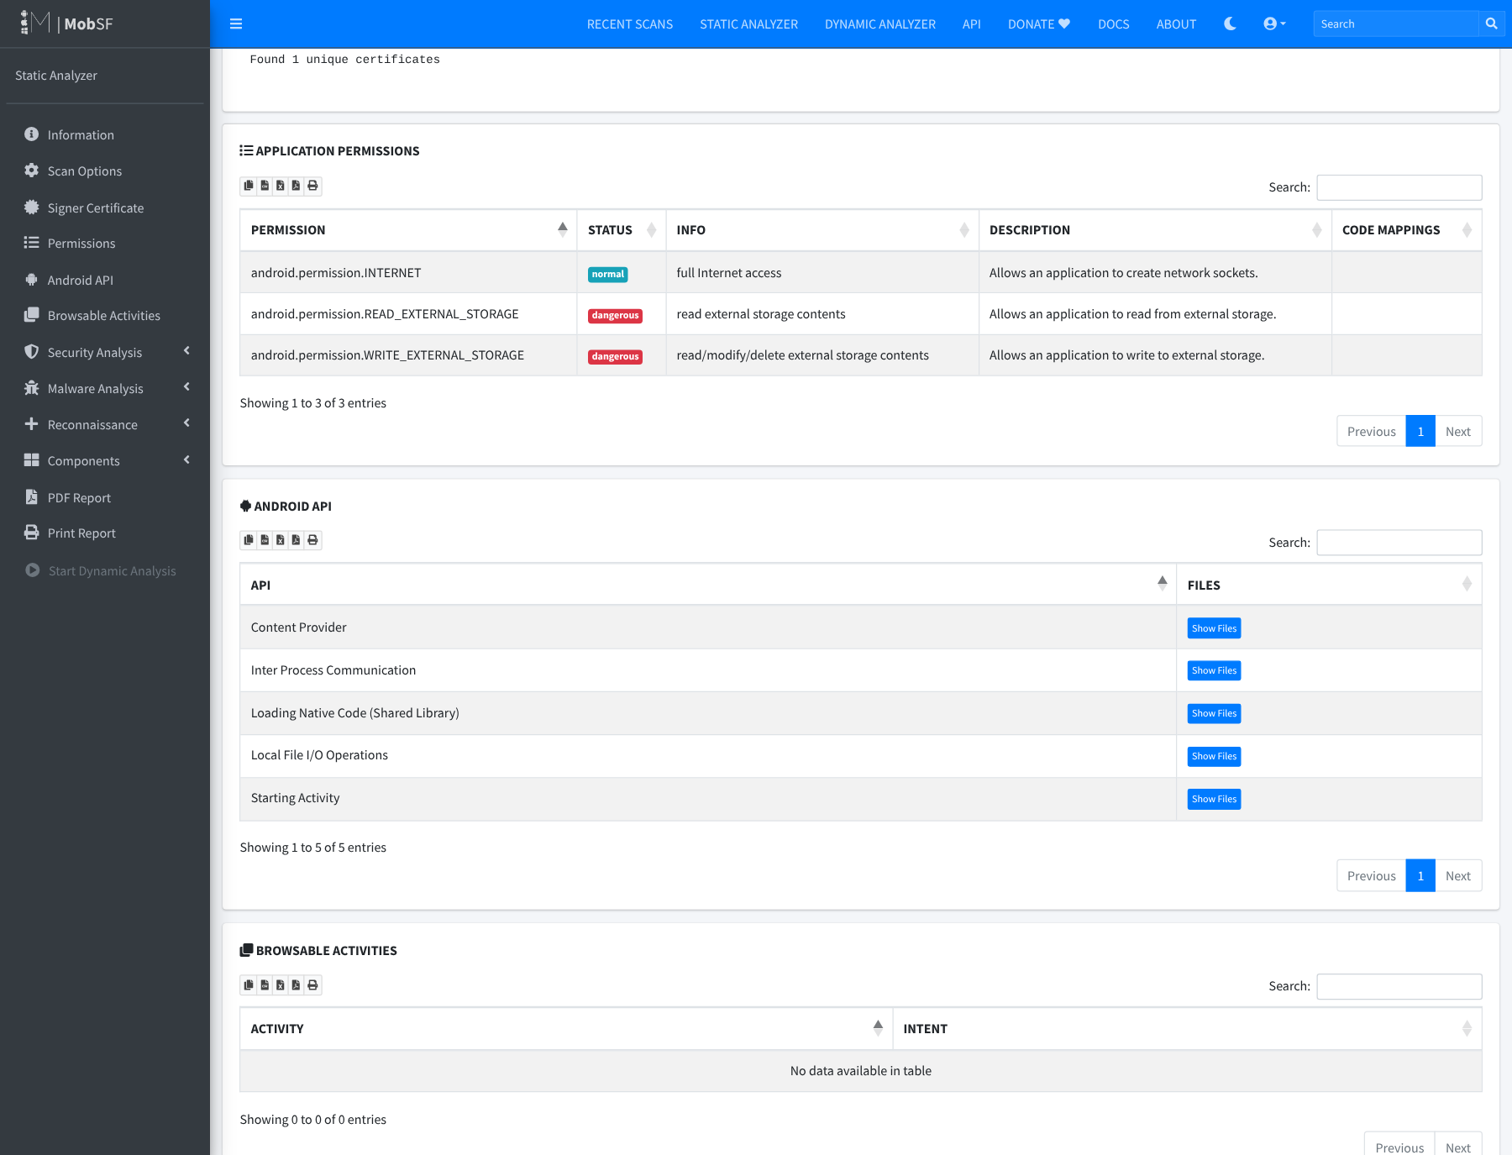
Figure 16. Permissions: WRITE_EXTERNAL_STORAGE and READ_EXTERNAL_STORAGE (dangerous) and INTERNET (normal).
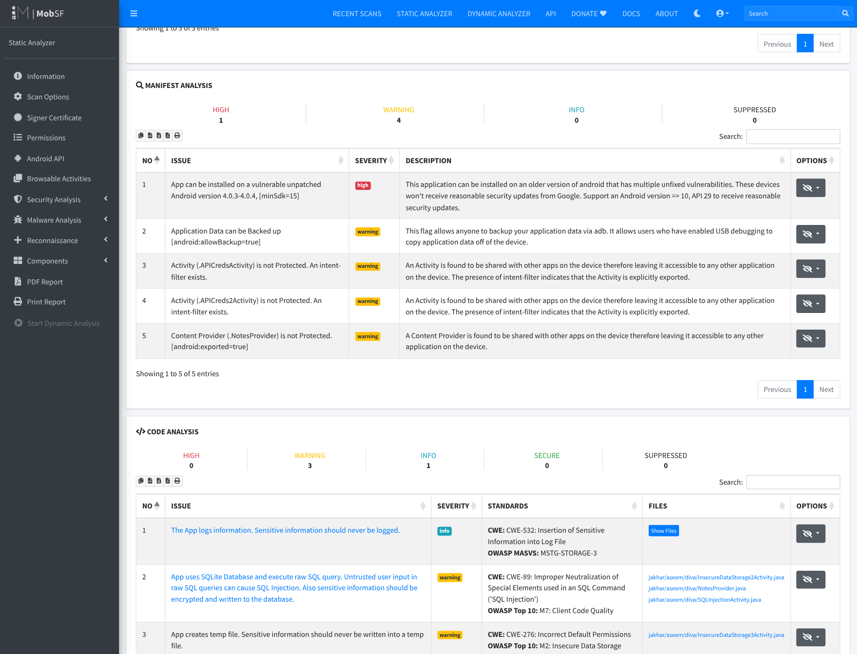
Figure 17. Manifest analysis: minSdk 15 (high); allowBackup=true; exported .APICredsActivity and .APICreds2Activity with intent filters; exported, unprotected .NotesProvider (warning).
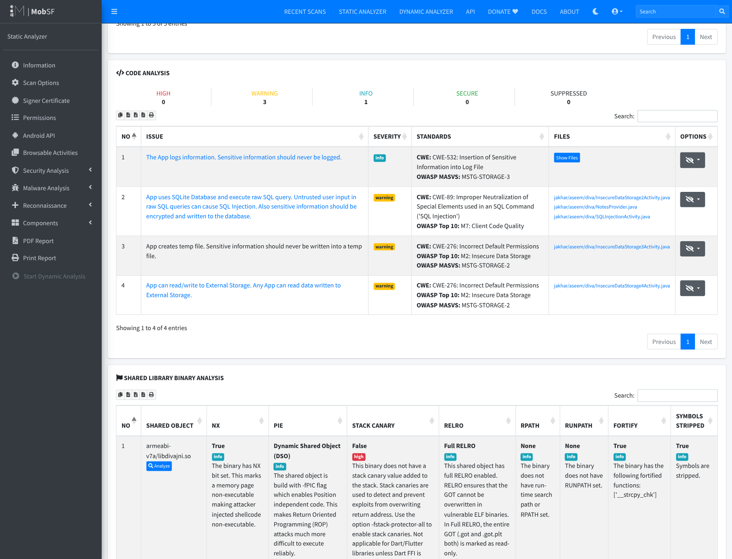
Figure 18. Code analysis (SAST): logging of sensitive information (CWE-532), raw SQL queries (CWE-89), temp-file creation and external-storage read/write (CWE-276), with the affected DIVA classes.
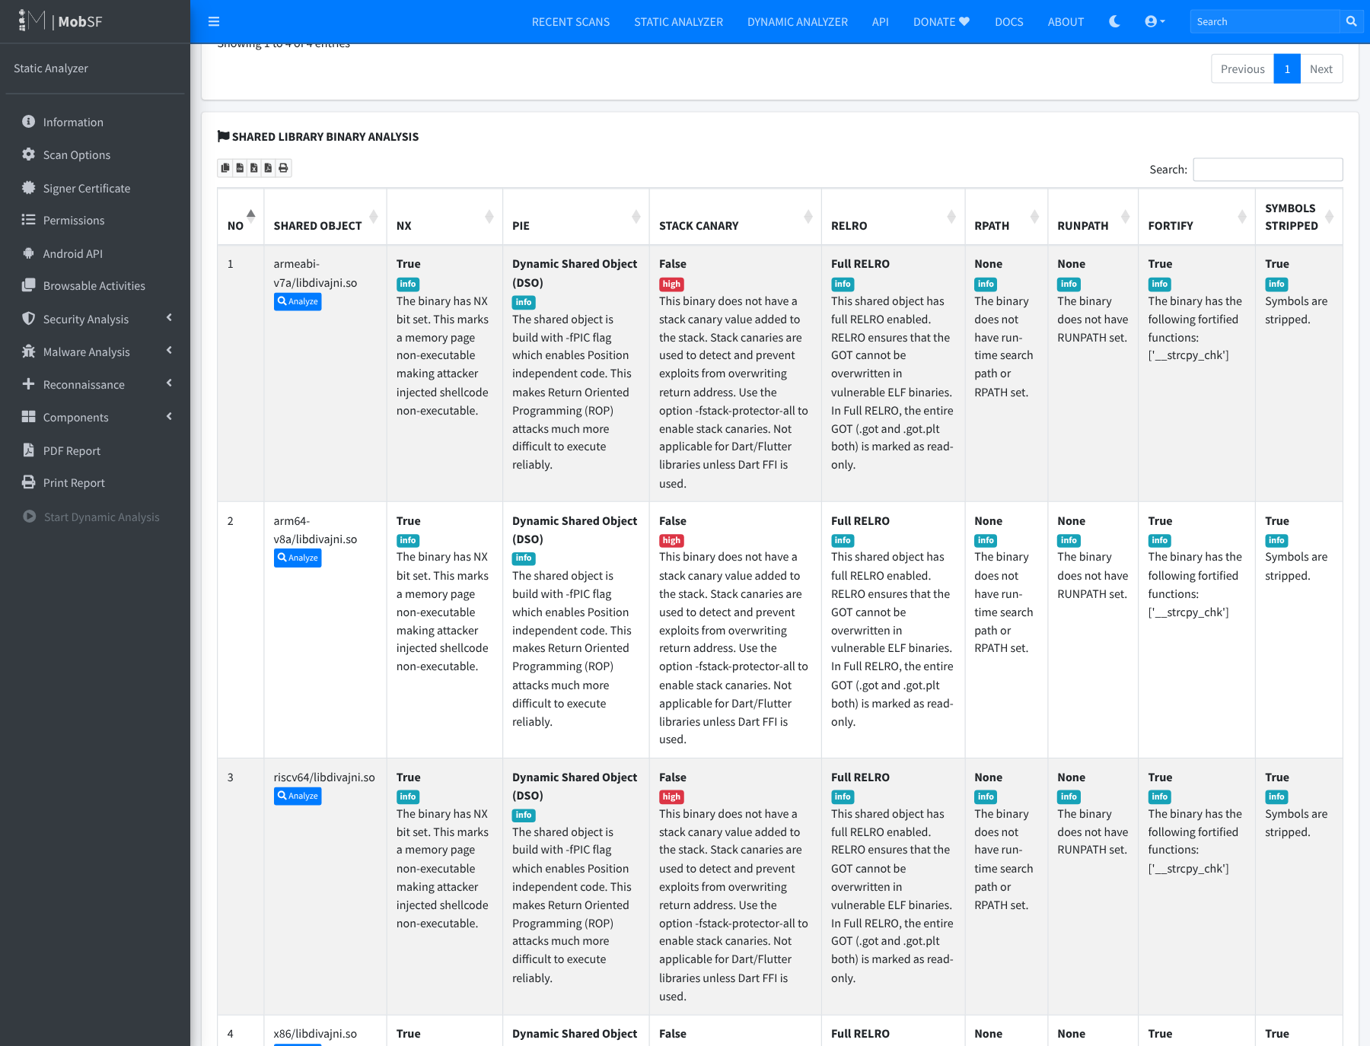
Figure 19. Shared-library binary analysis of libdivajni.so: NX, PIC and Full RELRO are present, but there is no stack canary (high), because Android.mk builds with -fno-stack-protector. FORTIFY replaced strcpy with __strcpy_chk.
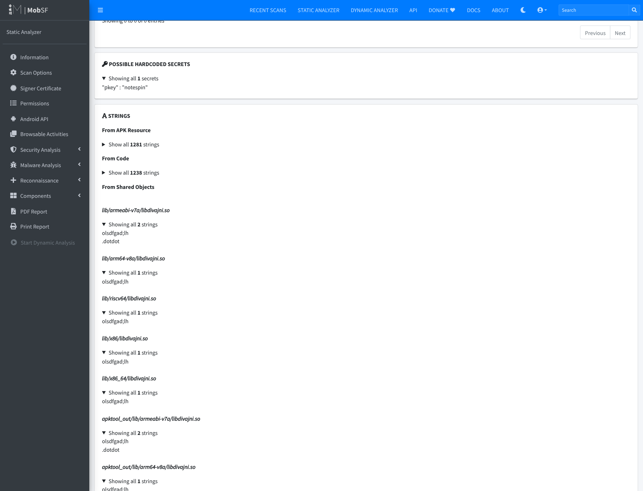
Figure 20. Possible hardcoded secrets ("pkey" : "notespin") and strings extracted from the native libraries, including the native vendor key olsdfgad;lh and the code .dotdot.

9. Assessment Results
Overall MobSF result: security score 47/100, grade B (Medium Risk), 0 trackers. Manifest analysis: 1 high, 4 warning. Code analysis: 3 warning, 1 info. Certificate: 1 high, 1 warning. Binary: no stack canary in all libdivajni.so builds. Exported components: 2/17 activities, 0 services, 0 receivers, 1/1 provider. Dangerous permissions: 2.
Required Assessment Results Table (selected findings)
# | Finding | MobSF Severity | Evidence / Location | Security Impact | Recommended Fix
1 | Content Provider .NotesProvider is not protected [android:exported=true] | Warning (Manifest; scorecard “medium”) | AndroidManifest.xml line 37: <provider … exported="true" authorities="jakhar.aseem.diva.provider.notesprovider"> with no android:permission. NotesProvider.java query()/update()/delete() (decompiled lines 63–144) | Any app on the device, with no permissions, can read, modify and delete the PIN-protected private notes. This breaks confidentiality, integrity and authorization, and bypasses the PIN check in Access Control 3. | Set android:exported="false". If sharing is needed, require a signature-level permission. Use parameterised selections.
2 | Raw SQL query built from user input (SQL injection) | Warning — CWE-89, OWASP M7 | SQLInjectionActivity.java line 36: rawQuery("SELECT * FROM sqliuser WHERE user = '" + input + "'", null). Plaintext passwords and card numbers stored at lines 23–26. Also InsecureDataStorage2Activity, NotesProvider | Input such as ' OR '1'='1 returns every row: all usernames, passwords and credit card numbers. Attackers can also bypass authentication-style lookups. Affects confidentiality and integrity. | Use parameterised queries (rawQuery("… WHERE user = ?", new String[]{input}) or SQLiteDatabase.query). Validate input. Do not store passwords/PAN in plaintext. Encrypt the database (SQLCipher/Keystore).
3 | App reads/writes External Storage (credentials stored world-readable) | Warning — CWE-276, OWASP M2, MSTG-STORAGE-2 | InsecureDataStorage4Activity.java line 26: Environment.getExternalStorageDirectory() → writes username:password to /sdcard/.uinfo.txt. Related: InsecureDataStorage3Activity.java line 25 File.createTempFile("uinfo","tmp") (warning) | Any app holding READ_EXTERNAL_STORAGE, a USB/adb user, or someone with the SD card can read third-party credentials in plaintext. The file stays after the app is uninstalled. | Do not store passwords. Use app-private internal storage (getFilesDir()) with Jetpack Security EncryptedFile/EncryptedSharedPreferences and Android Keystore keys. Remove the storage permissions.
4 | Activities .APICredsActivity / .APICreds2Activity not protected (intent-filter exists) | Warning (Manifest) | AndroidManifest.xml lines 24–36: intent filters jakhar.aseem.diva.action.VIEW_CREDS / VIEW_CREDS2 make them exported. APICredsActivity shows API Key: 123secretapikey123 … | Any app (or adb shell am start -a jakhar.aseem.diva.action.VIEW_CREDS) can open the screens and show vendor API credentials without the app’s own checks. Authorization bypass leading to credential disclosure. | Remove the intent filters and set android:exported="false", or protect with a signature permission. Check authorization inside the activity. Never ship API secrets in the client; issue short-lived tokens from a backend.
5 | The app logs sensitive information | Info — CWE-532, MSTG-STORAGE-3 | LogActivity.java line 24: Log.e("diva-log", "Error while processing transaction with credit card: " + cc). Further log calls in AccessControl1/2, InsecureDataStorage2/3/4, SQLInjection | Credit card numbers reach logcat, where adb users, crash/bug-report tools and (on Android ≤ 4.0, which minSdk 15 still allows) apps with READ_LOGS can read them. Privacy and PCI-DSS confidentiality impact. | Never log secrets or PAN. Remove or mask the values. Strip Log.* from release builds (R8/ProGuard -assumenosideeffects). Use a logging wrapper that is turned off in production.
Other notable MobSF results (not selected for detailed analysis): application signed with a debug certificate (High); installable on unpatched Android 4.0.3–4.0.4, minSdk 15 (High); Janus/v1 signature (Warning); android:allowBackup="true" (Warning); libdivajni.so without stack canary (High, binary analysis); 2 dangerous storage permissions (Hotspot).

10. Detailed Analysis of Selected Findings (Stage 4)
Prioritisation method (Step 4.5). Priority combines (a) the MobSF severity, (b) the potential impact on the CIA properties and authorization, and (c) likelihood/exposure: who can trigger the flaw, whether a permission or user interaction is needed, and whether any app on the device can reach it. MobSF’s severities are recorded unchanged. Where my remediation priority differs from MobSF’s rating, the reason is given.

10.1 Finding 1 – Unprotected exported Content Provider (.NotesProvider) — Priority: HIGH
- MobSF severity: Warning (Manifest analysis; shown as “medium” in the scorecard). Also counted in the dashboard as 1/1 exported providers.
- What MobSF detected and where: in the manifest, <provider android:name=".NotesProvider" android:enabled="true" android:exported="true" android:authorities="jakhar.aseem.diva.provider.notesprovider"/> has no android:permission, readPermission or writePermission (Figure 22, line 37). The provider (Figure 24) exposes query, insert, update and delete on the notes table of divanotes.db, and builds "_id = " + uri.getLastPathSegment() and caller-supplied selection strings directly into SQL.
- Why it is a weakness: an exported component is an IPC entry point that any other installed application can call. The app protects the notes behind a PIN in the UI (Access Control 3), but the provider exposes the same data with no access check. Access control is enforced only in the user interface, not at the data layer (CWE-926 / CWE-284).
- Impact: a malicious app with no permissions can run content://jakhar.aseem.diva.provider.notesprovider/notes and read every private note (confidentiality). It can also update or delete them (integrity, availability), and inject into selection to reach other tables. In a real app the same pattern would leak messages, health or financial records.
- Why HIGH (although MobSF says warning): exposure is maximal, because any co-installed app can exploit it silently, with no user interaction and no permission. The fix is trivial, so the risk-reduction-to-effort ratio is the best of all findings.

10.2 Finding 2 – SQL injection via raw query — Priority: HIGH
- MobSF severity: Warning — CWE-89 (SQL Injection), OWASP Mobile M7 (Client Code Quality).
- What/where: MobSF’s rule android_sql_raw_query matched SQLInjectionActivity.java (decompiled lines 4 and 36), InsecureDataStorage2Activity.java and NotesProvider.java. At line 36 (Figure 23) the user’s text is concatenated into the statement: rawQuery("SELECT * FROM sqliuser WHERE user = '" + editText.getText() + "'", null). Lines 23–26 create the table with plaintext password and credit_card columns.
- Why it is a weakness: user input becomes part of the SQL grammar. A single quote breaks out of the string literal, so the attacker controls the query logic.
- Impact: entering ' OR '1'='1 makes the query return every row. The app then shows all users, passwords and credit card numbers (confidentiality). With other statements, data can be altered (integrity). The plaintext storage makes the impact worse, because the leaked data is directly usable. A real app would suffer account takeover and payment-card disclosure.
- Why HIGH: the flaw is directly exploitable and needs no special tools. It leads to full disclosure of the most sensitive data in the app.

10.3 Finding 3 – Credentials stored on external storage / temp files — Priority: HIGH
- MobSF severity: Warning — CWE-276 (Incorrect Default Permissions), OWASP M2 (Insecure Data Storage), MSTG-STORAGE-2. Related warning: App creates temp file (InsecureDataStorage3Activity.java line 25).
- What/where: InsecureDataStorage4Activity.java line 26 (Figure 25) calls Environment.getExternalStorageDirectory(), then writes username + ":" + password to /sdcard/.uinfo.txt and calls setReadable(true) / setWritable(true). The app requests WRITE_/READ_EXTERNAL_STORAGE (Figure 16, flagged as “dangerous” and a Hotspot).
- Why it is a weakness: shared external storage is outside the Android application sandbox. On the app’s target SDK (23), any app with storage permission can read it. A dot-prefixed file name only hides the file and does not protect it.
- Impact: third-party credentials are disclosed to other apps, backup tools, anyone with USB access, or someone who removes the SD card. The file stays after uninstall. This is a loss of confidentiality that leads to compromised third-party accounts (authentication).
- Why HIGH: the data is credentials, the storage location is world-readable by design, and exploiting it needs only a common permission.

10.4 Finding 4 – Exported activities with intent filters (.APICredsActivity, .APICreds2Activity) — Priority: MEDIUM
- MobSF severity: Warning (Manifest) — “Activity is not Protected. An intent-filter exists.” The dashboard shows 2/17 exported activities.
- What/where: in the manifest (Figure 22, lines 24–36) the activities declare intent filters for the custom actions jakhar.aseem.diva.action.VIEW_CREDS / VIEW_CREDS2 with category.DEFAULT. Because of this they are implicitly exported (target SDK 23), with no permission. APICredsActivity puts the string "API Key: 123secretapikey123\nAPI User name: diva\nAPI Password: p@ssword" on screen. APICreds2Activity is meant to require a PIN, but it trusts an intent extra.
- Why it is a weakness: an exported activity can be started by any app. Using intent filters for internal navigation exposes screens that should only be reached after an in-app check (CWE-926).
- Impact: adb shell am start -a jakhar.aseem.diva.action.VIEW_CREDS, or a malicious app, opens the credentials screen directly. That bypasses the authorization flow and discloses API credentials. Those could be used against the vendor backend.
- Why MEDIUM: the impact is credential disclosure, but exposure is lower than in Finding 1. The data appears on screen rather than being returned to the calling app, so harvesting it needs adb/screen access or a second weakness. The root problem, hardcoded API credentials in the client, also needs fixing.

10.5 Finding 5 – Sensitive information written to logs — Priority: MEDIUM
- MobSF severity: Info — CWE-532 (Insertion of Sensitive Information into Log File), MSTG-STORAGE-3. MobSF’s rating is kept as “info”. I raise only the remediation priority to Medium, because the logged value is a full payment card number.
- What/where: LogActivity.java decompiled line 24 (Figure 26): Log.e("diva-log", "Error while processing transaction with credit card: " + cctxt.getText()). MobSF also lists log calls in AccessControl1/2, InsecureDataStorage2/3/4 and SQLInjectionActivity. Those mostly log exception messages and are lower risk.
- Why it is a weakness: logcat is a shared system facility. Its contents are kept in buffers, included in bug reports, read by crash-reporting SDKs, and visible to anyone using adb.
- Impact: cardholder data is disclosed (privacy, PCI-DSS). On Android 4.0.x, which is still allowed by minSdk 15, any app with READ_LOGS can read the logs of other apps.
- Why MEDIUM: reading the log needs adb, a bug report or a legacy device, so exposure is lower than for Findings 1–3. The data is still highly sensitive, and the fix is trivial.

10.6 Step 4.6 – Limitation / false positive requiring manual verification
- False positive – “Possible hardcoded secret” "pkey" : "notespin" (Figure 20). Manual review of res/values/strings.xml (line 85) and AccessControl3Activity.java (line 72) shows that notespin is only the name of the SharedPreferences key under which the PIN is stored. It is not a secret. MobSF’s entropy and keyword matching flagged it because of the name pkey.
- False negatives – real secrets that MobSF did not report as secrets. HardcodeActivity.java compares input with the literal "vendorsecretkey" (Figure 27). APICredsActivity contains 123secretapikey123 and p@ssword. The native library contains the vendor key olsdfgad;lh, which appears only in the raw Strings list (Figure 20) and not under Secrets. InsecureDataStorage1Activity stores the password in plaintext SharedPreferences, which MobSF did not flag at all.
- Context-dependent “High” findings. Application signed with debug certificate and minSdk 15 are true for this lab build, but they come from how the build was configured, not from DIVA’s code. A release build signed with a production key and minSdk ≥ 29 would remove them. They should be checked against the release artefact before being reported to a developer.
- Native buffer overflow only partly visible. divajni.c copies user input into a 20-byte stack buffer with strcpy (Input Validation 3). MobSF reports only the missing stack canary. It also shows that FORTIFY replaced the call with __strcpy_chk, which, when the compiler knows the buffer size, aborts on overflow instead of letting it be exploited. Whether the overflow is still exploitable can only be confirmed dynamically, for example on an emulator with a long input, or under a debugger.
Why manual verification is required: static analysis matches patterns without runtime context. It cannot tell whether a string is really a credential, whether a code path can be reached, whether a component is protected at runtime, or whether a compiler mitigation already neutralises a bug. Confirming the findings needs manual code review plus dynamic testing on an emulator: MobSF dynamic analysis, adb shell content query --uri content://jakhar.aseem.diva.provider.notesprovider/notes, adb shell am start -a jakhar.aseem.diva.action.VIEW_CREDS, adb logcat, and Frida/drozer. These steps were out of scope for this static lab.

11. Remediation Recommendations (Stage 5)
# | Finding | Root-cause remediation (Step 5.1) | How it reduces risk (Step 5.2)
1 | Exported unprotected NotesProvider | Set android:exported="false" on the <provider> because it is used only internally. If another app genuinely needs it, declare <permission android:name="jakhar.aseem.diva.permission.NOTES" android:protectionLevel="signature"/> and set it as android:readPermission/writePermission. Replace the string-built "_id = " + segment with selection "_id=?" plus selectionArgs, and use SQLiteQueryBuilder.setStrict(true) and a projection map. | Removes the unauthenticated IPC entry point. Only the app itself (or apps signed with the same key) can reach the data, so access control is enforced at the data layer instead of only in the UI. Parameterisation removes the injection path through the provider.
2 | SQL injection in SQLInjectionActivity | Use bound parameters: db.rawQuery("SELECT user FROM sqliuser WHERE user = ?", new String[]{ input }), or db.query(...) with selectionArgs. Return only the columns that are needed. Add server-side style input validation (allow-list for usernames). Do not store passwords (store a salted hash such as PBKDF2/bcrypt, or authenticate on the server). Do not store card numbers (use tokenisation), and encrypt the database (SQLCipher with a Keystore-protected key). | Bound parameters are passed as data and never parsed as SQL, so input cannot change the query. Hashing, tokenisation and encryption limit the damage even if the database is read some other way (defence in depth).
3 | Credentials on external storage / temp file | Do not persist third-party passwords. Use an OAuth/refresh token where possible. If something must be stored, write it to app-private internal storage (Context.getFilesDir(), MODE_PRIVATE) with Jetpack Security EncryptedFile/EncryptedSharedPreferences, using a key from the Android Keystore. Delete temp files immediately, or keep them in getCacheDir(). Remove WRITE_/READ_EXTERNAL_STORAGE and raise targetSdk to get scoped storage. | Data moves inside the application sandbox, where other apps cannot read it. It is encrypted with a hardware-backed key, so even root/backup extraction gives only ciphertext. Removing the permissions shrinks the attack surface.
4 | Exported APICredsActivity / APICreds2Activity | Remove the intent filters and set android:exported="false", launching the activities with explicit intents from inside the app. If they must be exported, protect them with a signature permission and re-check authorization in onCreate() instead of trusting intent extras. Remove the hardcoded API key and password from the APK, and have the backend issue short-lived, per-user tokens after authentication. | Other apps can no longer start the screens to skip the authorization flow. Moving secrets to the server means nothing usable can be pulled from the client, even by reverse engineering.
5 | Sensitive data in logs | Remove the card number from the log message (log an error code or a masked value such as **** 5678). Use a logging wrapper that is turned off in release builds, and add an R8/ProGuard rule -assumenosideeffects class android.util.Log { public static *** d(...); public static *** e(...); … }. Add a lint or code-review check that blocks logging of PII. | Sensitive values never reach logcat, bug reports or crash tools, so the leak is removed at its source. The release-build stripping protects against future mistakes.
Additional hardening for the other MobSF results: sign release builds with a production key (APK Signature Scheme v2/v3+), raise minSdkVersion to ≥ 29 and targetSdkVersion to the current level, set android:allowBackup="false" (or add dataExtractionRules), and build the native library with -fstack-protector-strong and -D_FORTIFY_SOURCE=2. Replace strcpy with a length-checked copy such as strlcpy/snprintf, and release the JNI string with ReleaseStringUTFChars.
Step 5.3 – First remediation priority: Finding 1 (exported, unprotected NotesProvider). It is the only finding that any co-installed app can exploit silently, with no permission and no user interaction, and it gives full read/write access to private data, including injection through the provider. Setting android:exported="false" is a one-line change that removes the whole attack surface at once.

12. Limitations and Validation
- Static analysis only. MobSF examined the code and configuration without running the app. It cannot prove exploitability, detect runtime-only behaviour (dynamically loaded code, server-side logic, values decrypted at runtime) or see compiler and OS mitigations in action. See Section 10.6 for concrete examples of a false positive (pkey: notespin) and false negatives (vendorsecretkey, 123secretapikey123, native key olsdfgad;lh, plaintext SharedPreferences).
- Severity needs context. MobSF’s severities are generic. Debug certificate is “High” but expected for a lab debug build, while logging of a credit card is only “Info”. Analyst judgement (Section 10) is needed to rank by real exposure and impact.
- Decompilation fidelity. The line numbers MobSF reports refer to JADX-decompiled code, not to the original source files. Each one was checked against the original DIVA source before being cited.
- Tool and environment dependencies. The first scan silently produced no code findings because JADX was missing, although the report still rendered. This shows that the analyst must check the scan log (Figure 12) before trusting an empty section.
- Build differences. The APK was built with the SDK command-line toolchain (Section 6.4), and the native libraries target API 21+ because of NDK r29. Neither changes the Java code or the manifest that MobSF analysed. An Android Studio (AGP 8) build of Source/diva-android/ will produce an APK with AndroidX libraries instead of support library 23.1.0. That changes library code, not DIVA’s own findings.
- Recommended validation (next phase): run the APK on an Android emulator and confirm each finding dynamically, using MobSF Dynamic Analyzer, adb content query/am start/logcat, drozer, and Frida. Then retest after the remediation is in place.

13. Conclusion
The lab carried out CLO1 end to end. The DIVA target was built from source (native library plus APK), MobSF v4.6.2 was deployed with Docker, and an automated static assessment of the student-built APK was completed and documented. MobSF scored the app 47/100 (Grade B, Medium Risk) and, within seconds, pointed to the main classes of weakness that DIVA is designed to teach: broken access control on exported components, SQL injection, insecure data storage, sensitive logging, and weak build and signing configuration.
Interpreting the results mattered as much as running the tool. Analyst review turned 13 raw results into a ranked list of five findings with evidence. One false positive was rejected, several hardcoded secrets that the tool missed were found, and two context-dependent High findings were identified. Based on the evidence, DIVA’s security posture is poor. Sensitive data (notes, credentials, card numbers) can be reached by other apps or users through several independent paths, and the most urgent fix, making NotesProvider private, is also the cheapest. Automated assessment is an efficient first line of defence, but it must be combined with manual review and dynamic validation before conclusions are final.

14. References
- Payatu, DIVA Android – official source repository. https://github.com/payatu/diva-android
- Payatu, DIVA Android – README / build instructions. https://github.com/payatu/diva-android#readme
- Google, Android Studio – download. https://developer.android.com/studio
- Google, Android Studio – installation guide. https://developer.android.com/studio/install
- MobSF, Mobile Security Framework – GitHub project. https://github.com/MobSF/Mobile-Security-Framework-MobSF
- MobSF, Official documentation. https://mobsf.github.io/docs/
- MobSF, Running MobSF with Docker. https://github.com/MobSF/docs/blob/master/running_mobsf_docker.md
- Docker Inc., Docker Desktop – download. https://www.docker.com/products/docker-desktop/
- Docker Inc., Install Docker Desktop on Windows. https://docs.docker.com/desktop/setup/install/windows-install/
- OWASP, Mobile Application Security Verification Standard (MASVS) / MASTG. https://mas.owasp.org/
- MITRE, CWE-89, CWE-276, CWE-532, CWE-926. https://cwe.mitre.org/
- Google, Android security best practices – content providers, data storage, logging. https://developer.android.com/privacy-and-security/security-tips

Appendix A – Screenshots and Evidence
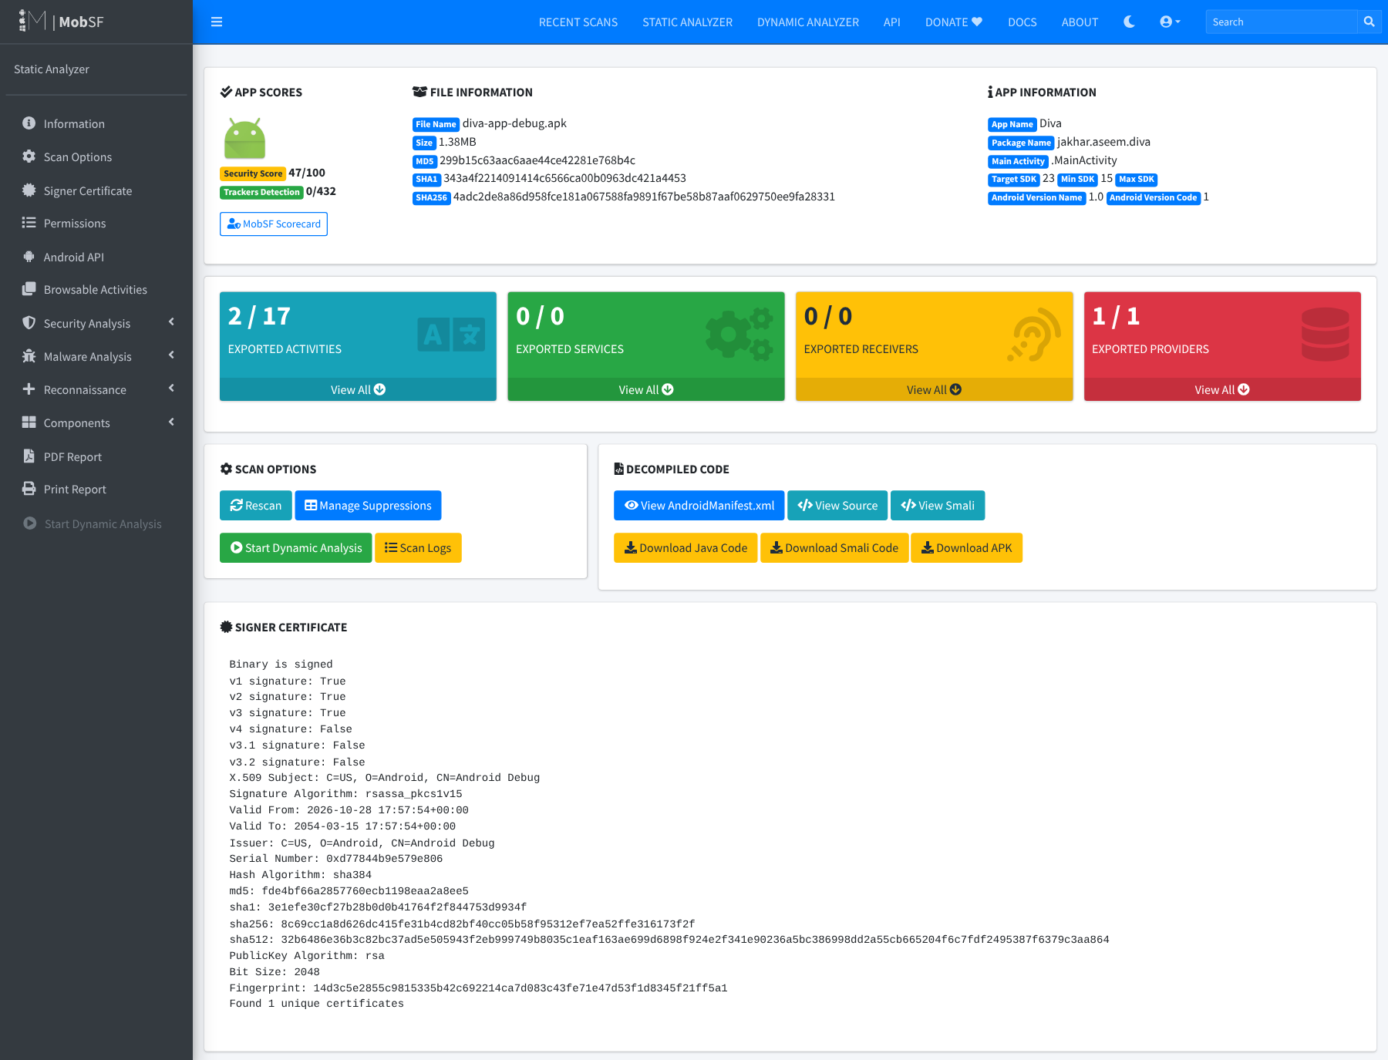
Figure 21. Application information section of the MobSF report.
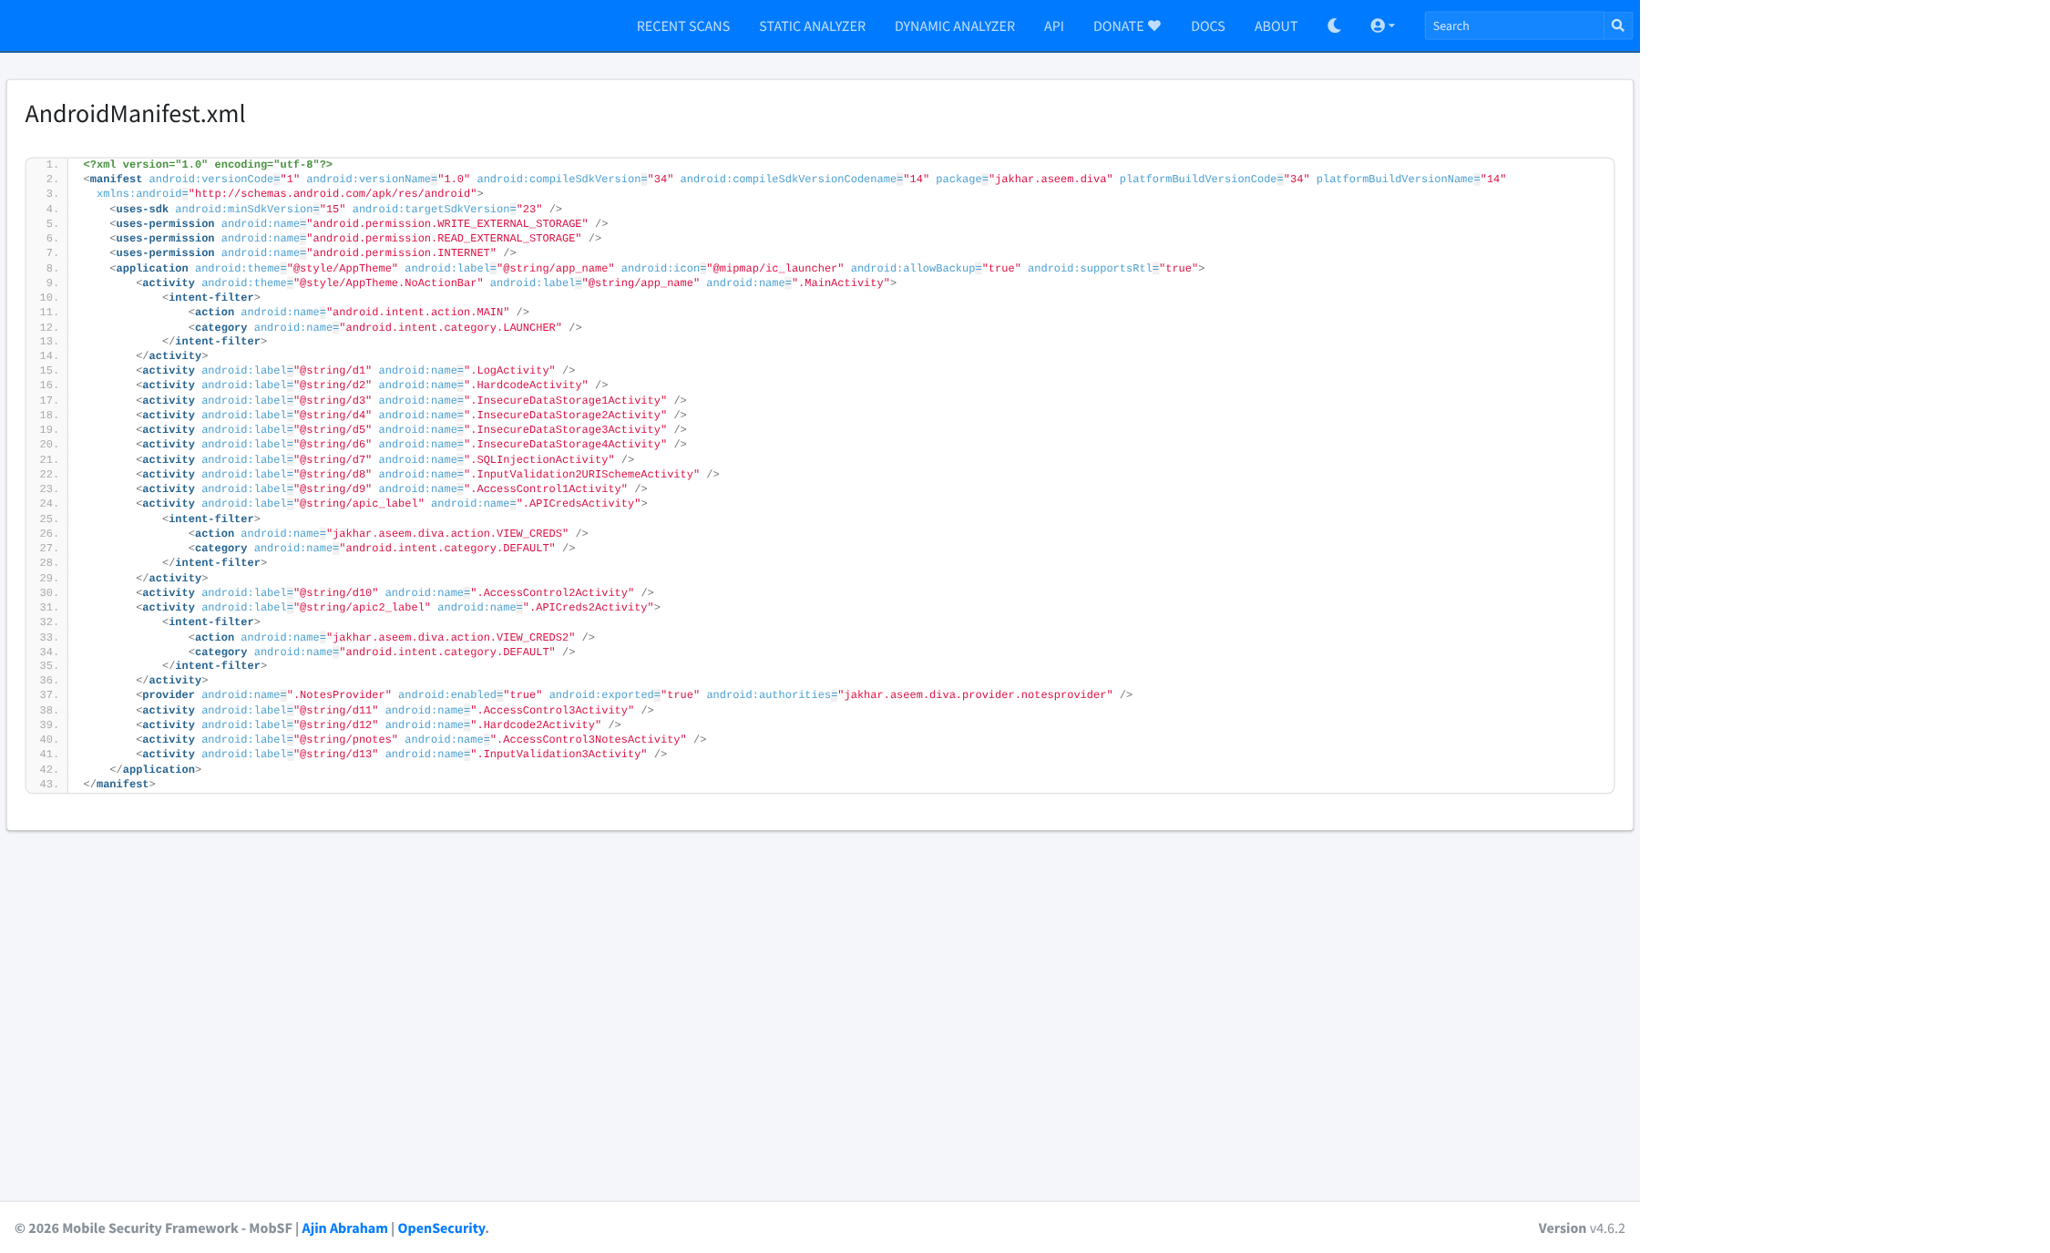
Figure 22. Decoded AndroidManifest.xml as shown by MobSF (evidence for Findings 1 and 4: provider at line 37, exported activities at lines 24–36, allowBackup="true" at line 8).
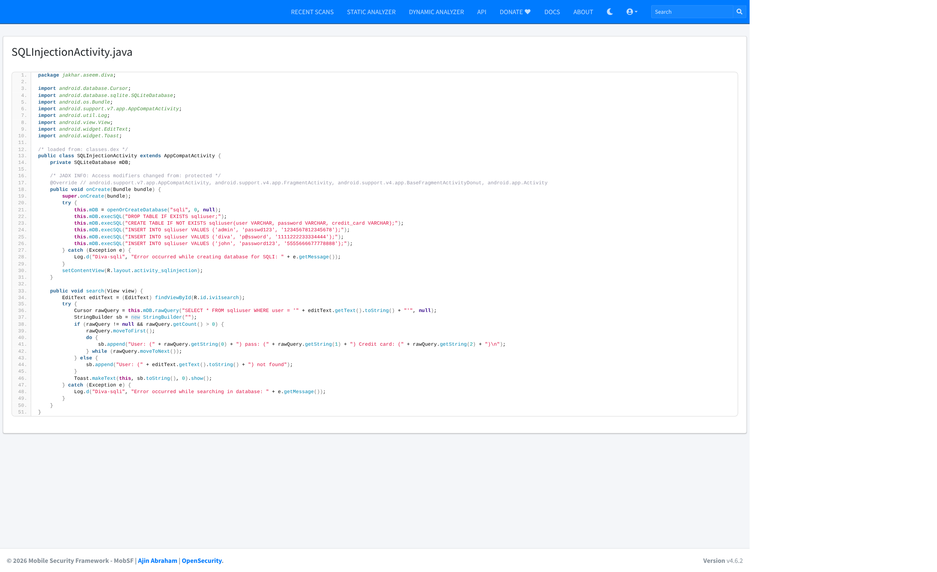
Figure 23. MobSF source view of SQLInjectionActivity.java: plaintext credentials and card numbers (lines 23–26) and string-concatenated rawQuery (line 36) – Finding 2.
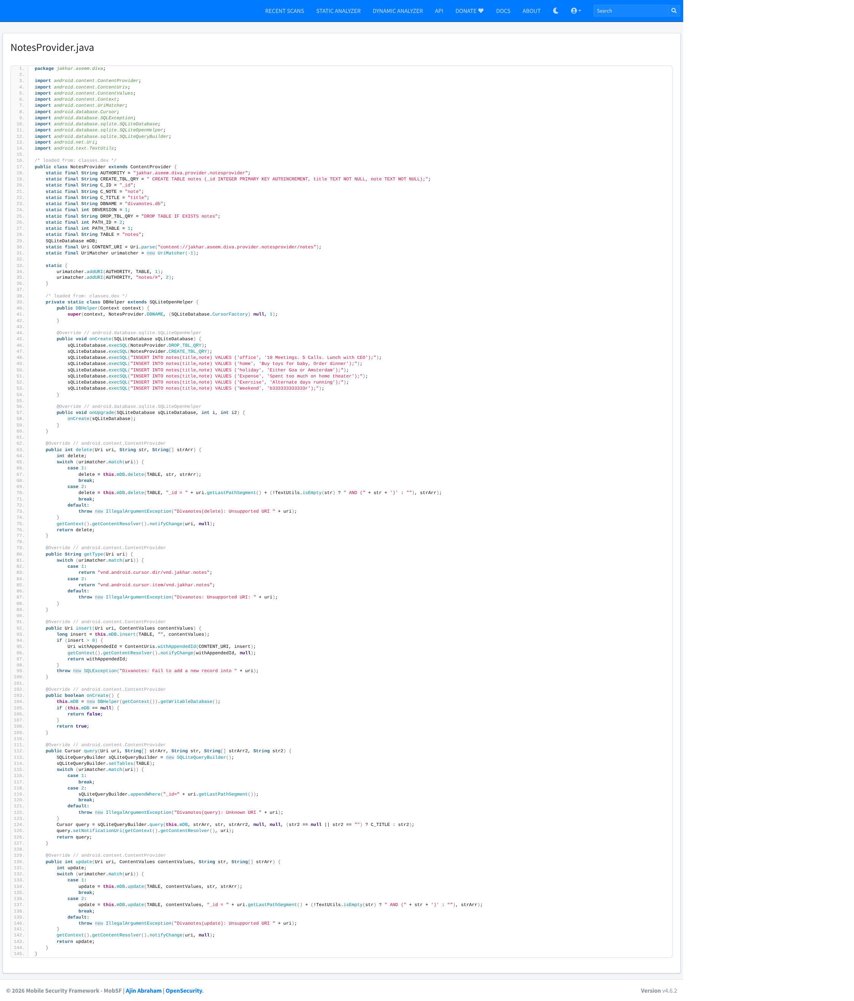
Figure 24. MobSF source view of NotesProvider.java: unrestricted query/insert/update/delete on private notes and SQL built from URI segments – Finding 1.
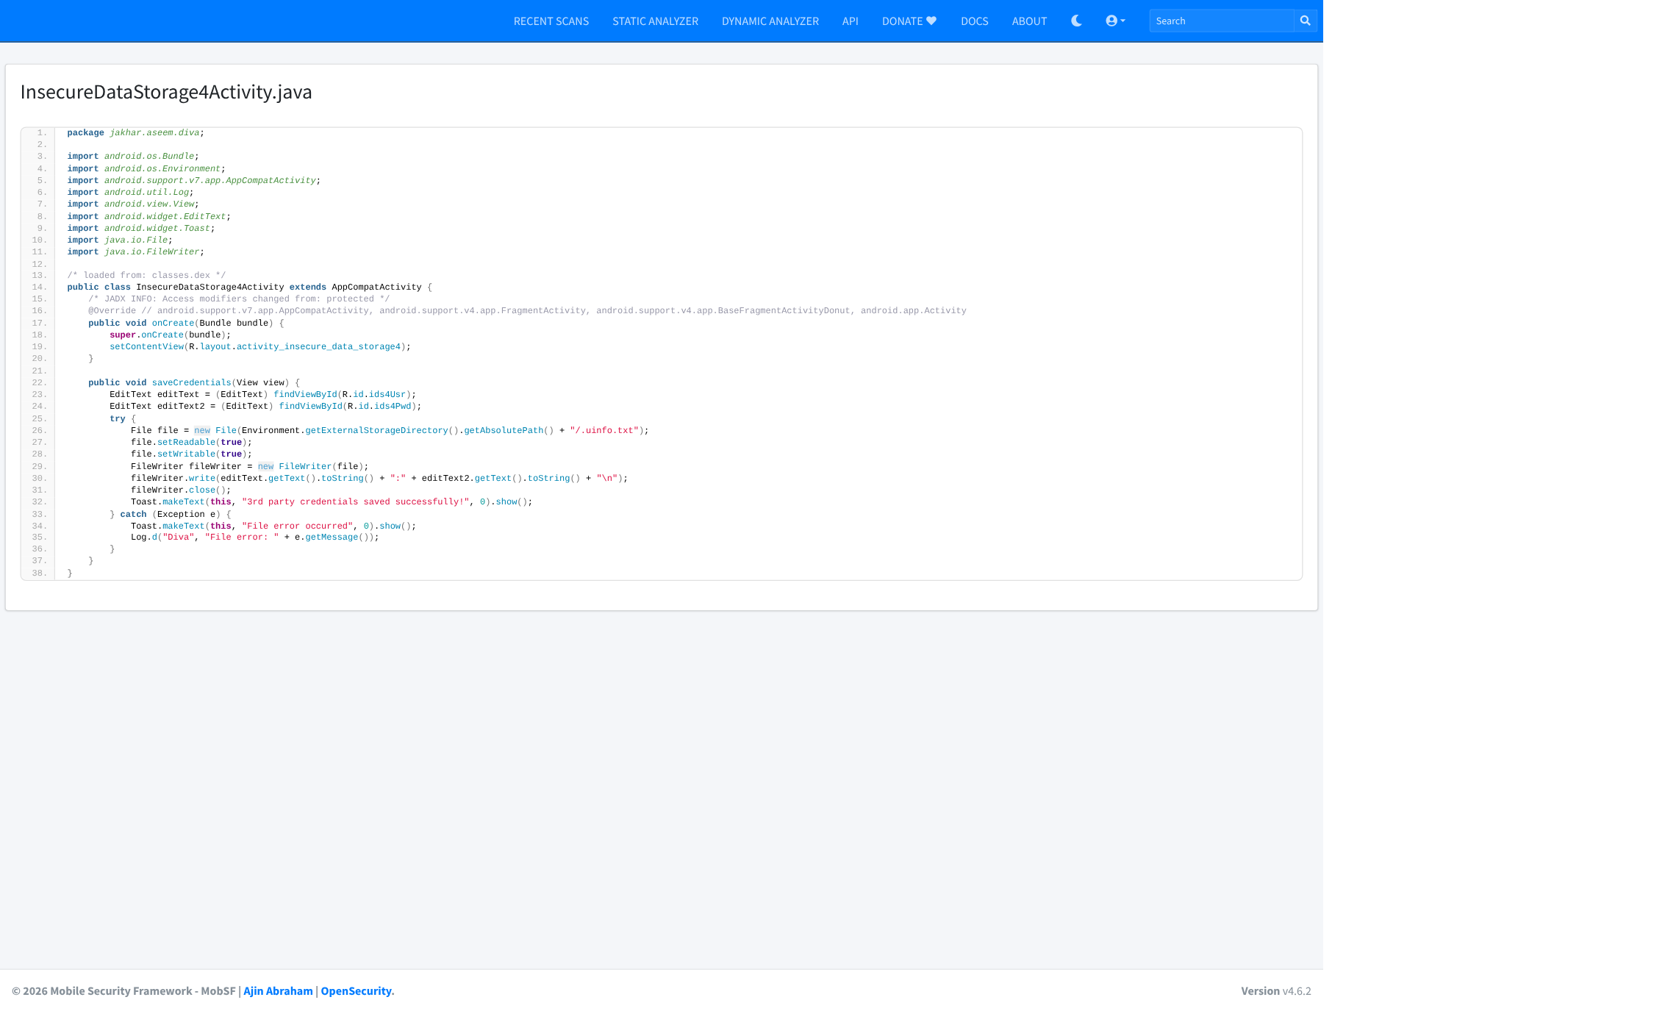
Figure 25. MobSF source view of InsecureDataStorage4Activity.java: credentials written to /sdcard/.uinfo.txt – Finding 3.
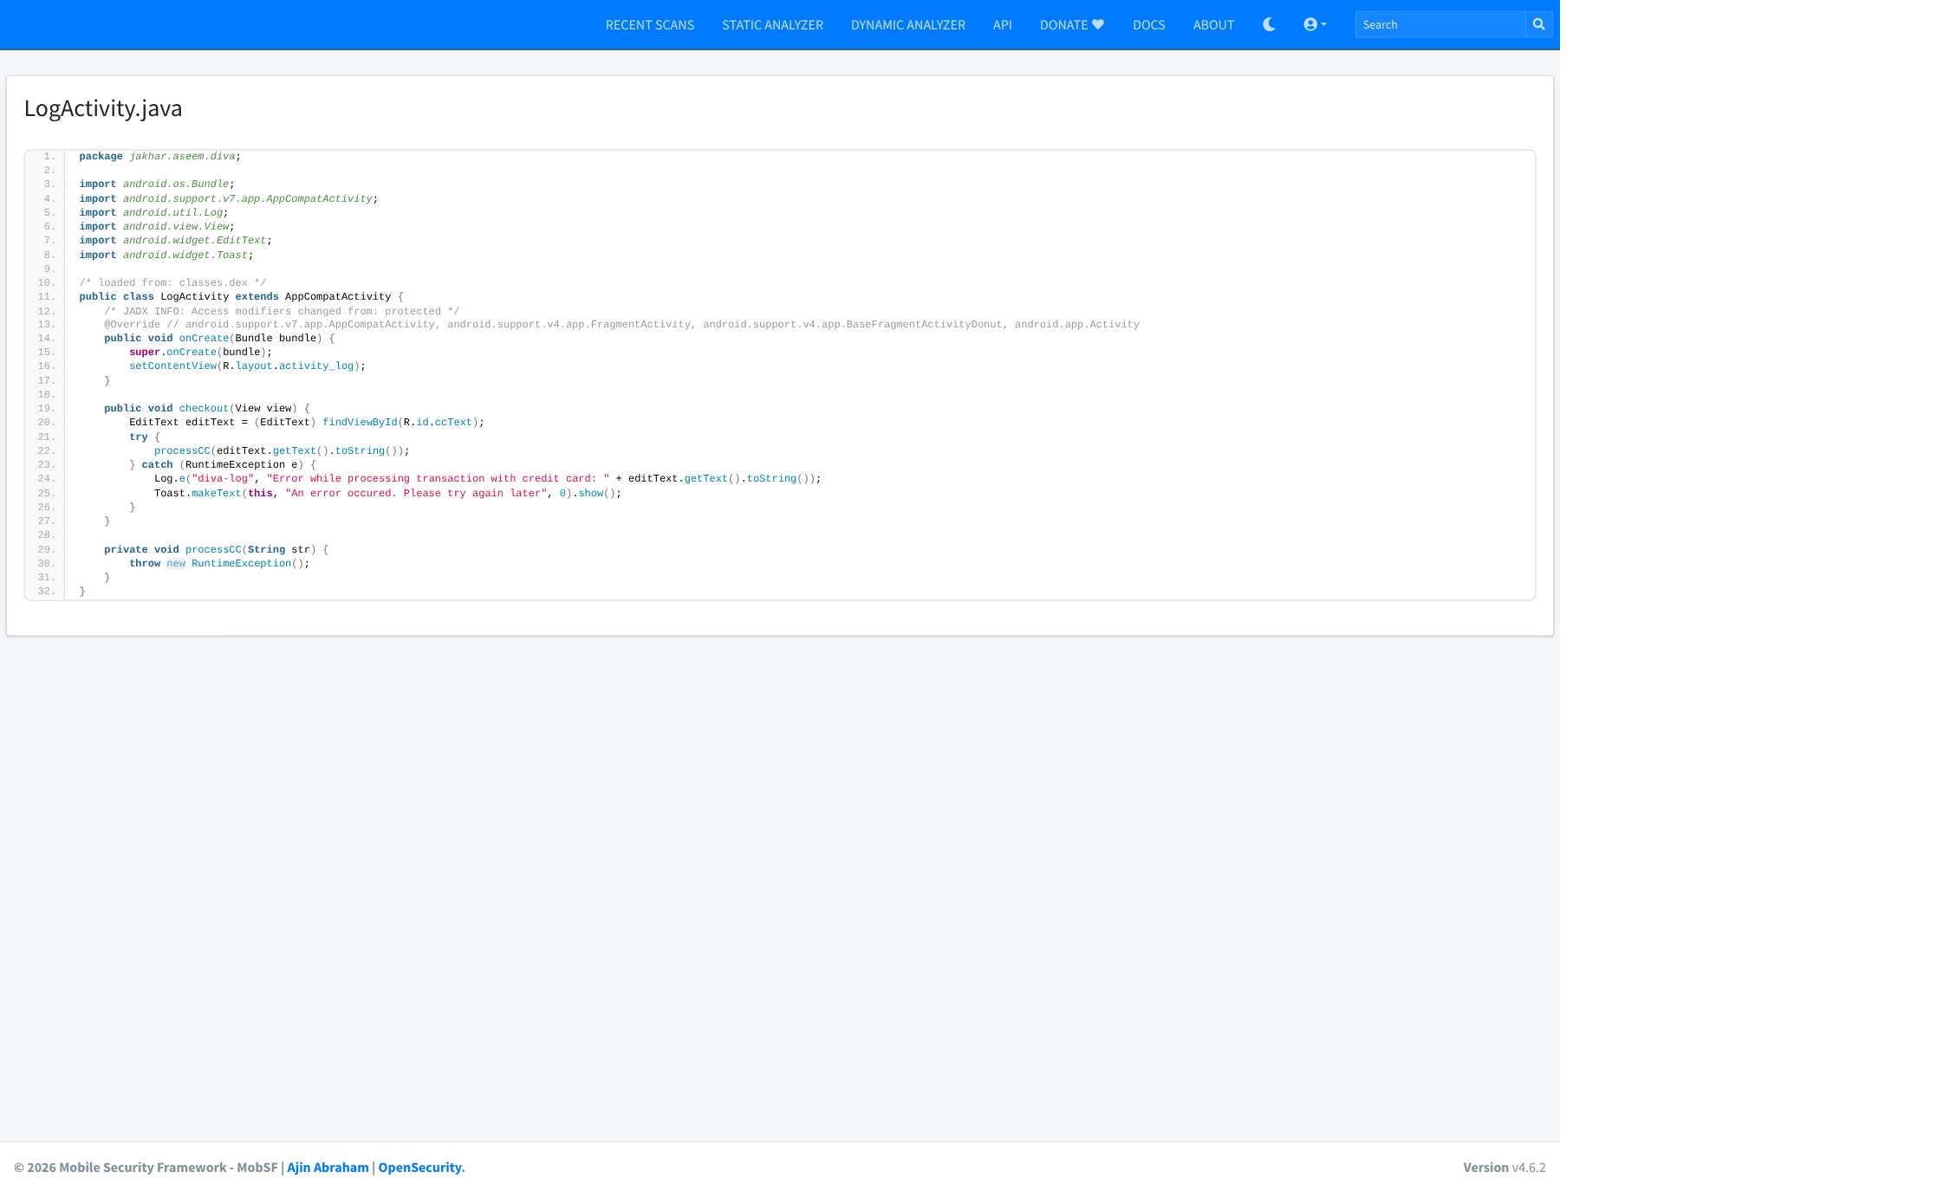
Figure 26. MobSF source view of LogActivity.java: credit card number written to logcat with Log.e – Finding 5.
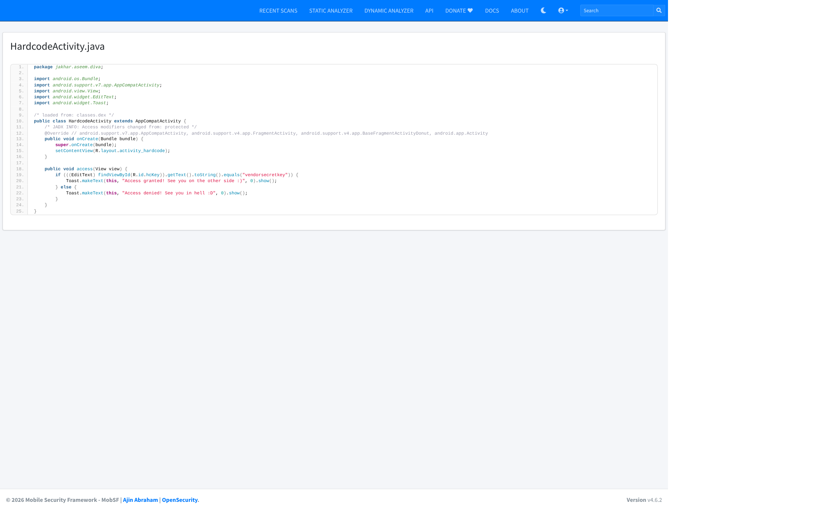
Figure 27. MobSF source view of HardcodeActivity.java: hardcoded key vendorsecretkey, which MobSF did not flag as a secret (false negative, Section 10.6).
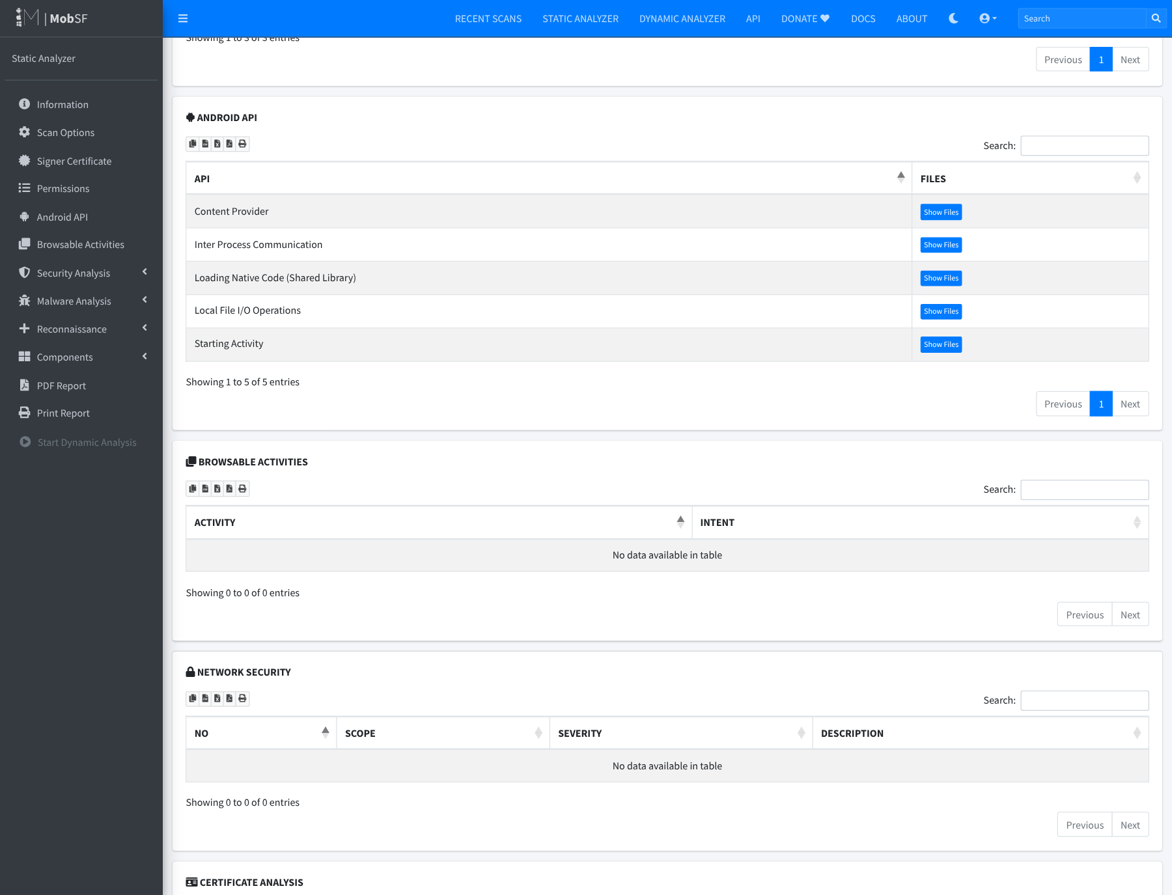
Figure 28. Android API usage detected by MobSF (IPC, local file I/O, native code, content provider, start activity).
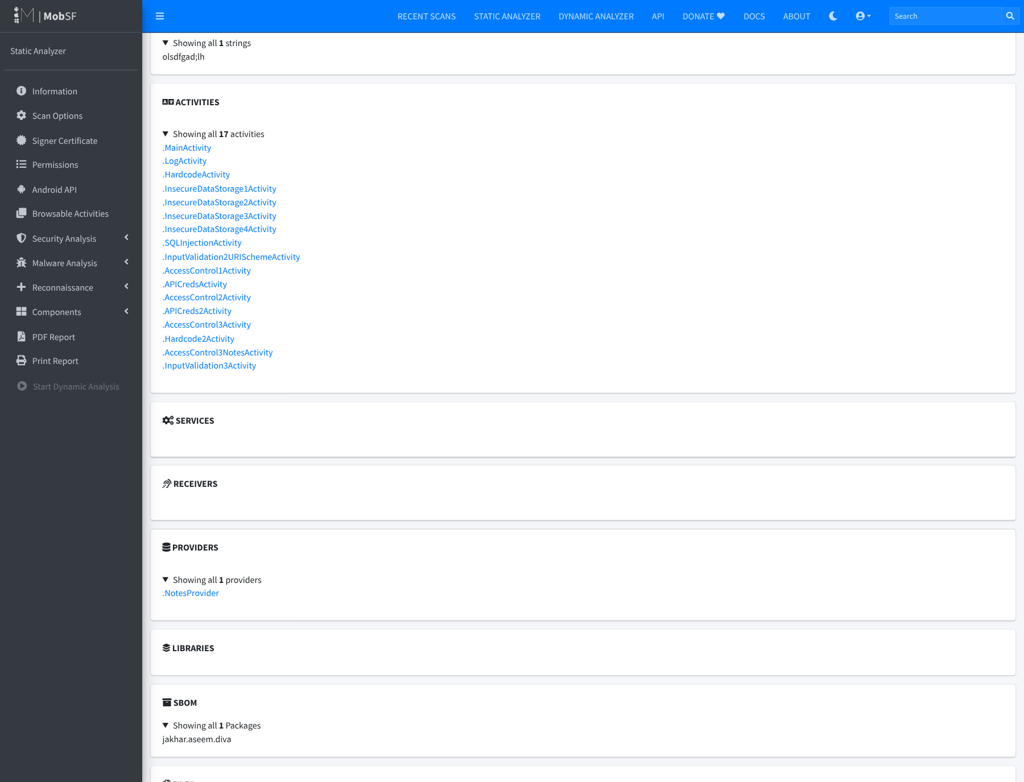
Figure 29. Components section of the MobSF report (activities and providers).
Supporting files in the submission package: MobSF_Reports/MobSF_DIVA_report.pdf (MobSF’s own 25-page export), MobSF_DIVA_report.json and MobSF_DIVA_scorecard.json; APK/diva-app-debug.apk with its SHA-256; Build/ (build script, logs, Android Studio modernization patch, evidence capture scripts); Screenshots/ (all figures at full resolution, including the full-length report page 28_appendix_full_mobsf_report_page.png); Source/diva-android/ (Android-Studio-ready DIVA project with the native libraries built).

