Mohammad Abir
T00621921
- Database Definition Language (DBDL)
Here is the normalized structure. I have added primary keys (PK) and foreign keys (FK) to establish relationships.
- OFFICE (OfficeNumber, FloorNumber, OfficeSize)
- DOCTOR (DoctorID, DoctorFName, DoctorLName, Specialty, OfficeNumber)
OfficeNumber FK
- DEGREE (DegreeID, DegreeType, DegreeTitle)
- DOCTOR_DEGREE (DoctorID, DegreeID, DateObtained)
DoctorID FK from Doctor table
DegreeID FK from Degree table
- INSURANCE (InsuranceCode, InsuranceName, InsurancePhone)
- PATIENT (PatientNum, PatientYearBorn, InsuranceCode)
InsuranceCode FK from in INSURANCE table
- APPOINTMENT (DoctorID, PatientNum)
DoctorID FK from Doctor Table
PatientNum FK from Patient Table

- Crow's Foot ERD Representation :
Relationship :
- One OFFICE can have many DOCTORS. Each DOCTOR works in one OFFICE.
Relationship: 1:M
2. One DOCTOR can have many DEGREE records. One DEGREE can belong to many DOCTORS. This creates a many-to-many relationship resolved using DOCTOR_DEGREE.
Relationship: M:N
3. One DOCTOR can treat many PATIENTS. One PATIENT can visit many DOCTORS. This relationship is resolved using the APPOINTMENT table.
Relationship: M:N
4. One INSURANCE company can cover many PATIENTS.Each PATIENT has one primary INSURANCE provider.
Relationship: 1:M

ER-D:
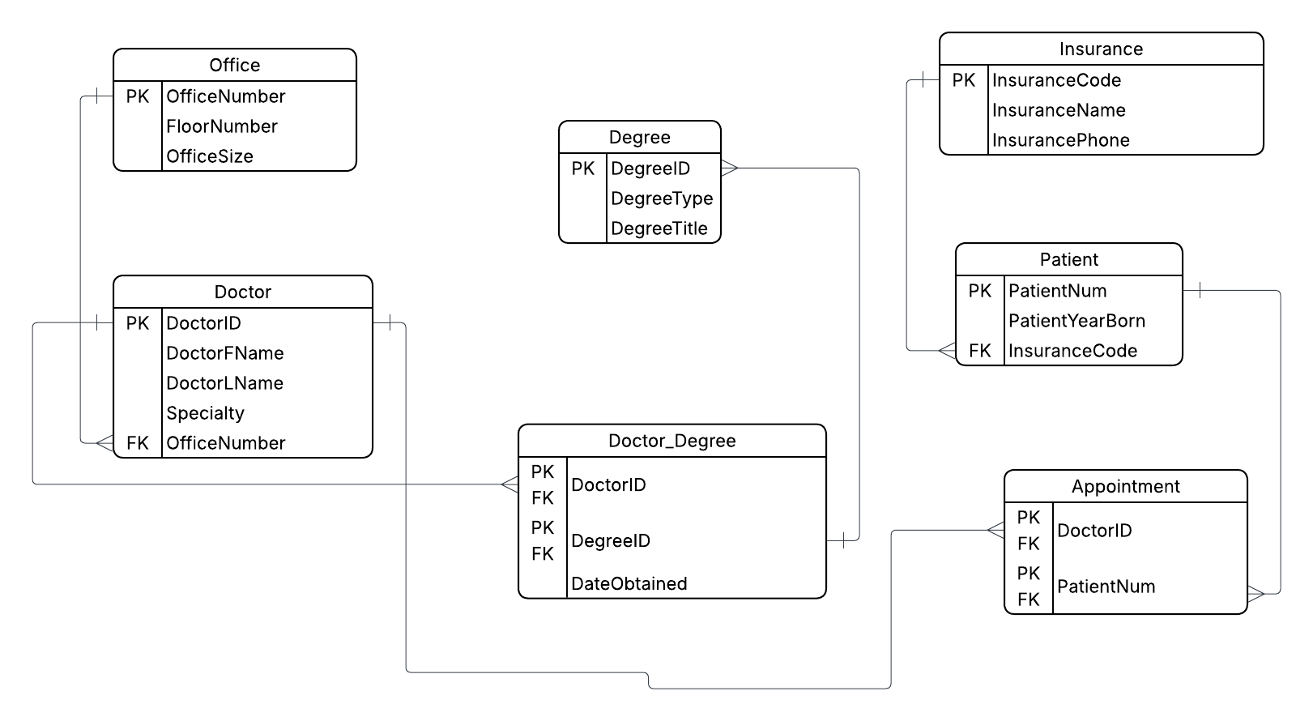

https://lucid.app/lucidchart/388719ad-642d-4bbd-a654-d0dd0257606a/edit?viewport_loc=-1294%2C-251%2C2791%2C1401%2C0_0&invitationId=inv_a1797c76-89f9-4b4e-bed0-3899548e6014

