Mobile and Web Development

Department of Automation and Applied Informatics

**HTML**

Created: 1/2024/2025

**Dr. Mohammad Saleem**

[msaleem@aut.bme.hu](mailto:msaleem@aut.bme.hu)

# Introduction

HTML (HyperText Markup Language) is the standard language used to create and design web pages. It structures the content on the web using elements and tags. HTML tells the web browser how to display text, images, links, forms, and other media on a web page.

Web browsers receive HTML documents from a web server or from local storage and render the documents into multimedia web pages. HTML describes the structure of a web page semantically and originally included cues for its appearance.

## A graph of a number of html codes Description automatically generated with medium confidenceHistory

HTML was created by **Tim Berners-Lee** in 1991 while he was working at CERN, to facilitate the sharing of information via hypertext on the early World Wide Web. Initially, it had a limited set of elements for basic document formatting, linking, and media embedding. Over time, HTML evolved with new versions—most notably **HTML 2.0** in 1995, which standardized earlier efforts, **HTML 4.01** in 1999, which added support for multimedia and scripting, and **HTML5** in 2014, which revolutionized the web by supporting rich media, modern APIs, and greater device compatibility, cementing its role as the foundation of web development.

## HTML5

HTML5 is the latest major version of the HTML standard, introduced to enhance the functionality and versatility of web development. Released in 2014, it brought significant improvements over previous versions, focusing on enabling rich multimedia, interactivity, and cross-platform compatibility without the need for additional plugins like Flash.

Key features of HTML5:

* **New semantic elements**: HTML5 introduced tags like <header>, <footer>, <article>, and <section> to improve content structure and make web pages more accessible and SEO-friendly.
* **Multimedia support**: It natively supports audio and video playback through <audio> and <video> tags, eliminating the need for third-party plugins.
* **Canvas and SVG**: The <canvas> element allows for dynamic graphics rendering, useful for games and visualizations, while SVG (Scalable Vector Graphics) supports vector-based images.
* **Improved form controls**: HTML5 introduced new input types (e.g., date, email, number) and attributes to enhance form validation and user input handling.
* **APIs**: HTML5 added various APIs (Application Programming Interfaces) such as the Geolocation API, Web Storage API, and Web Workers, enabling developers to build more interactive, dynamic, and responsive web applications.

HTML5 was a response to the growing needs of modern web applications, mobile browsing, and multimedia-rich experiences. It became the foundation of modern web development.

# The structure of HTML pages

Key points about HTML:

* **Elements**: HTML is built using elements, defined by tags (like <p>, <h1>, <a>, etc.), which structure the content.
* **Tags**: These are enclosed in angle brackets (e.g., <p>) and typically come in pairs like <p> and </p>, with the content placed between them.
* **Attributes**: Tags can also have attributes (like href in <a href="url">), providing additional information or behavior for an element.
* **Document Structure**: HTML documents start with <!DOCTYPE html> and typically include tags like <html>, <head>, <title>, and <body> to organize the document structure.

The structure of an HTML page follows a basic template that organizes its content in a clear, hierarchical format. Here's the typical structure of an HTML document:

  
1. **<!DOCTYPE html>**: Declares the document type and version of HTML being used. For HTML5, this is a simple declaration to ensure modern standards.
2. **<html>**: The root element that wraps the entire HTML content.
3. **<head>**: Contains meta-information about the document, such as:
   * **<meta charset="UTF-8">**: Declares the character encoding, typically UTF-8 for modern web pages.
   * **<title>**: Defines the title of the webpage, shown in the browser tab.
   * Other elements like <link> for stylesheets, <script> for external scripts, and metadata for SEO and social media sharing.
4. **<body>**: Contains the visible content of the webpage, including:
   * **Headings** (<h1>, <h2>, etc.): Used to structure sections and subsections.
   * **Paragraphs** (<p>): Used for blocks of text.
   * **Images** (<img>), **links** (<a>), **forms** (<form>), and other elements that define the actual content users interact with.
5. **Closing tags**: HTML elements must be properly closed, ensuring a clean structure for the browser to interpret correctly.

This structure allows the browser to interpret and render the content in a structured, accessible manner.

## The <div> tag

* The <div> tag defines a division or a section in an HTML document.
* It is used as a container for HTML elements - which is then styled with CSS or manipulated with JavaScript.
* It is easily styled by using the class or id attribute.
* Any sort of content can be put inside the <div> tag!

**Note:** By default, browsers always place a line break before and after the <div> element.

New tags in html5: <nav> <header> <footer>, …etc

## Why HTML5 page structure is better?

* Tags have sematic meaning
  + A <div id=„…” doesn’t mean anything
  + Browser and search engines may profit from it
* Google keeps values in the header more important than what is in the footer
* Elements in the <nav> tag is known to be used for navigation. It may help for narrator softwares

# HTML Forms

HTML forms are a fundamental part of web development, allowing users to submit data to a server for processing. Forms are used for various purposes such as logging in, signing up, submitting feedback, searching, or uploading files. The <form> element wraps different input elements that allow users to interact with and send data.

**Key Elements of HTML Forms:**

1. **<form> Element**:
   * This is the container that holds all the form controls (input fields, checkboxes, buttons, etc.).
   * The action attribute specifies the URL where the form data should be sent.
   * The method attribute specifies how the form data should be sent: GET (for appending data to the URL) or POST (for sending data in the request body).
2. **Input Fields**:
   * **Text fields**: <input type="text"> for single-line text input, or <textarea> for multi-line input.
   * **Password field**: <input type="password"> masks the user’s input.
   * **Email field**: <input type="email"> expects a valid email format.
   * **Number field**: <input type="number"> allows numeric input with optional min and max values.
   * **Radio buttons**: <input type="radio"> for selecting one option from a group.
   * **Checkboxes**: <input type="checkbox"> for multiple selections.
3. **Labels**:
   * The <label> element is used to define a label for an input field. Associating a label with an input improves accessibility, especially for screen readers. The for attribute connects the label to the input by matching the id.
4. **Buttons**:
   * **Submit button**: <input type="submit"> or <button type="submit"> triggers form submission.
   * **Reset button**: <input type="reset"> resets the form fields to their initial values.
5. **Select Lists (Dropdowns)**:
6. **File Upload**:

* <input type="file"> allows users to select files from their local machine and upload them to the server.

1. **Form Attributes**:

* action: The URL where the form data is submitted.
* method: Defines how the data is sent (GET or POST).
* target: Specifies where to display the response (e.g., _blank for a new tab).
* enctype: Specifies how the form data should be encoded (important for file uploads).

**Common Use Cases:**

1. **Login/Signup Forms**: Collecting user credentials for authentication.
2. **Contact Forms**: Submitting inquiries or feedback.
3. **Search Forms**: Allowing users to search for information on a website.
4. **File Uploads**: Enabling users to upload files, images, or documents.
5. **Surveys/Quizzes**: Collecting user responses.

**Form Submission:**

* **GET method**: Appends form data to the URL as query strings, useful for search forms or non-sensitive data.  
  Example result URL: https://example.com/search?q=keyword
* **POST method**: Sends form data as part of the HTTP request body, used for more secure or larger data submissions, like login or registration forms.

# Validation

* Get users properly fill the form
  + Required fields
  + Data types (number, email, …)
  + Regular expressions
* Purely from HTML with no JS
* If a form doesn’t need validation: **novalidate**
* Validation gets executed when the form is submitted

**Validation attributes:**

* Required fields
  + - <input type="text" required>
* Validation with regular expression
  + - <input type="text" name="code" pattern="[A-Za-z]{2}"  
       title="Two-letter country codes">
* Min/max length (char count)
  + - <input type="text" maxlength="20">
* Min/max values and step
  + - 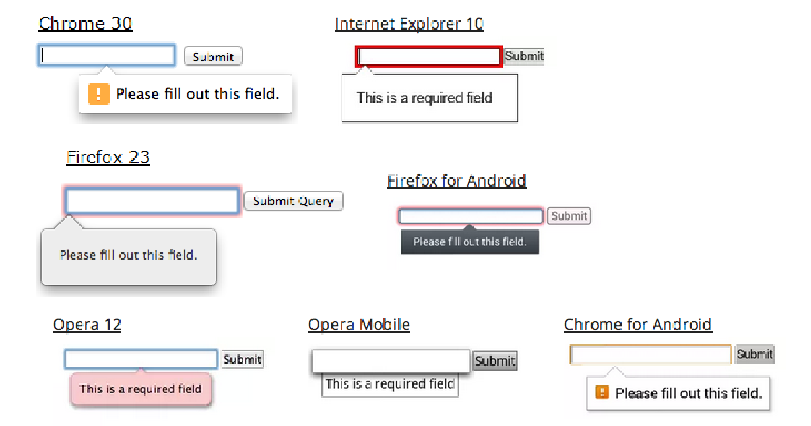<input type="number" min="1" max="10" step="1">

# HTML hyperlinks

HTML hyperlinks, or **links**, allow users to navigate between different web pages, sections within a page, or to external resources. Links are created using the <a> (anchor) element, which defines a clickable area that directs the browser to another location.

* Navigation between pages by the <a> tag
  + <a href="[http://www.aut.bme.hu](http://www.aut.bme.hu/)">AUT portal</a>
* Open link in new tab
  + <a href="[http://www.aut.bme.hu](http://www.aut.bme.hu/)" **target="_blank"**>AUT portál</a>
* Open mail client from browser
  + <a href="[mailto:xy@example.com?Subject=Hello](mailto:xy@example.com)">Send mail!</a>

HTML hyperlinks (<a> tags) are essential for creating navigable, connected web pages. Whether linking to external sites, internal pages, specific sections, or creating email and phone links, the <a> element is the cornerstone of web navigation. The combination of attributes like href, target, rel, and title enhances both functionality and security, ensuring a better user experience.

# HTML5 audio and video

HTML5 introduced native support for embedding **audio** and **video** content without requiring third-party plugins like Flash. This made media integration more seamless, accessible, and responsive across different devices and browsers.

The <video> element allows embedding of video files into a webpage. It supports various features like playback controls, autoplay, and captions.

The <audio> element is used for embedding sound files into a webpage, and just like <video>, it offers native controls and can handle different audio formats.

* Embed audio in an HTML page
  + <audio controls>
    - <source src="horse.ogg" type="audio/ogg">
    - <source src="horse.mp3" type="audio/mpeg">  
      Audio tag is not supported by the browser.  
      </audio>
* Supported formats
  + mp3
  + wav (except IE)
  + Ogg (except IE and Safari)
* Embed video in an HTML page

<video width="320" height="240" controls autoplay>

Video tag is not supported by the browser.  
</video>

* Supported formats
  + mp4
  + webM (Chrome, FF, Opera)
  + Ogg (Chrome, FF, Opera)

**Scroll down for a full html example demonstrating the key elements of HTML**

# Useful links and references:

# Here’s an HTML code that demonstrates many of the key HTML elements and functionalities, with comments explaining each part:

<!DOCTYPE html>

<!-- Defines the document type and version of HTML (HTML5) -->

<html lang="en">

<head>

  <!-- Metadata and the document's header information -->

  <meta charset="UTF-8">

  <!-- Ensures proper rendering and touch zooming on mobile devices -->

  <meta name="viewport" content="width=device-width, initial-scale=1.0">

  <meta name="description" content="This is a demo page showing various HTML elements.">

  <title>HTML Elements Demo</title>

  <!-- Links to an external CSS file for styling -->

  <link rel="stylesheet" href="styles.css">

</head>

<body>

  <!-- Heading level 1: Page title -->

  <h1>HTML Elements Demonstration</h1>

  <!-- Paragraph of text -->

  <p>This is an example paragraph showcasing basic text elements like <strong>bold</strong> and <em>italic</em> text.</p>

  <!-- Hyperlink to an external site -->

  <a href="https://www.example.com" target="_blank" title="Visit Example website">Visit Example.com</a>

  <!-- Image with alternative text -->

  <img src="image.jpg" alt="A descriptive image" width="300" height="200">

  <!-- Unordered list -->

  <h2>Unordered List</h2>

  <ul>

    <li>Item One</li>

    <li>Item Two</li>

    <li>Item Three</li>

  </ul>

  <!-- Ordered list -->

  <h2>Ordered List</h2>

  <ol>

    <li>First item</li>

    <li>Second item</li>

    <li>Third item</li>

  </ol>

  <!-- Table demonstrating tabular data -->

  <h2>Table</h2>

  <table border="1">

    <thead>

      <tr>

        <th>Header 1</th>

        <th>Header 2</th>

      </tr>

    </thead>

    <tbody>

      <tr>

        <td>Row 1, Cell 1</td>

        <td>Row 1, Cell 2</td>

      </tr>

      <tr>

        <td>Row 2, Cell 1</td>

        <td>Row 2, Cell 2</td>

      </tr>

    </tbody>

  </table>

  <!-- Form with various input fields -->

  <h2>Form</h2>

  <form action="/submit-form" method="POST">

    <!-- Text input -->

    <label for="name">Name:</label>

    <input type="text" id="name" name="name" placeholder="Enter your name" required>

    <!-- Email input -->

    <label for="email">Email:</label>

    <input type="email" id="email" name="email" placeholder="Enter your email" required>

    <!-- Number input -->

    <label for="age">Age:</label>

    <input type="number" id="age" name="age" min="18" max="100">

    <!-- Radio buttons -->

    <label for="gender">Gender:</label>

    <input type="radio" id="male" name="gender" value="male"> Male

    <input type="radio" id="female" name="gender" value="female"> Female

    <!-- Checkbox -->

    <label for="newsletter">Subscribe to Newsletter:</label>

    <input type="checkbox" id="newsletter" name="subscribe">

    <!-- Dropdown list -->

    <label for="country">Country:</label>

    <select id="country" name="country">

      <option value="usa">United States</option>

      <option value="canada">Canada</option>

      <option value="uk">United Kingdom</option>

    </select>

    <!-- Text area -->

    <label for="comments">Comments:</label>

    <textarea id="comments" name="comments" rows="4" cols="50"></textarea>

    <!-- Submit button -->

    <input type="submit" value="Submit">

  </form>

  <!-- HTML5 Video Element -->

  <h2>Video</h2>

  <video controls width="500" poster="poster.jpg">

    <source src="video.mp4" type="video/mp4">

    <source src="video.webm" type="video/webm">

    Your browser does not support the video element.

  </video>

  <!-- HTML5 Audio Element -->

  <h2>Audio</h2>

  <audio controls>

    <source src="audio.mp3" type="audio/mpeg">

    <source src="audio.ogg" type="audio/ogg">

    Your browser does not support the audio element.

  </audio>

  <!-- Blockquote: Used to indicate a long quote -->

  <h2>Blockquote</h2>

  <blockquote cite="https://www.example.com">

    "This is a famous quote that is important for context and citation."

  </blockquote>

  <!-- Embedded iframe (e.g., YouTube video) -->

  <h2>Iframe</h2>

  <iframe width="560" height="315" src="https://www.youtube.com/embed/dQw4w9WgXcQ"

    title="YouTube video player" frameborder="0" allow="accelerometer; autoplay; clipboard-write;

    encrypted-media; gyroscope; picture-in-picture" allowfullscreen>

  </iframe>

  <!-- Horizontal rule for dividing sections -->

  <hr>

  <!-- Footer -->

  <footer>

    <p>© 2024 Your Website Name. All rights reserved.</p>

  </footer>

</body>

</html>