Enhanced 5G Handover Prediction over Real-Network RSRP Traces Using Lightweight Temporal Neural Representations
Mohammadali Mousavireineh and Astra Mousavireineh
Independent Researchers
Corresponding author: mousavireineh@gmail.com
Abstract—Reliable handover prediction is a key requirement for dense 5G and beyond networks. This paper compares LSTM, GRU, and TCN temporal feature representations for RSRP-based handover prediction using processed ANATEL-derived real-network feature bases. Four downstream classifiers are optimized using F1-oriented grid search. Under a stratified held-out test protocol, TCN+SVM achieves the best F1-score (0.4274) and balanced accuracy (0.6540), while LSTM+SVM remains close and achieves the highest ROC-AUC (0.7050). The results indicate that lightweight temporal alternatives can improve or match LSTM-derived representations under stricter evaluation, while minority handover-event detection remains challenging.
Index Terms—5G, 6G, handover prediction, LSTM, GRU, TCN, RSRP, imbalanced classification.

I. INTRODUCTION
Handover transfers a user equipment connection from one serving cell to another while maintaining service continuity. In dense 5G and beyond deployments, smaller cells and more frequent coverage boundaries make mobility management more difficult. Incorrect handover timing can cause radio link failure, ping-pong effects, unnecessary signaling, interruption time, and degraded quality of experience.
This paper revisits an LSTM-based RSRP forecasting pipeline and strengthens it by evaluating GRU and TCN alternatives. The motivation is not only to improve nominal accuracy, but to test whether lighter or parallelizable temporal representations can improve minority handover-trigger detection under a held-out protocol.

II. PREVIOUS WORK
Machine learning-based handover management has been surveyed for 5G and beyond systems. Prior studies identify data availability, generalization, deployment constraints, and adaptive trigger optimization as major issues. The closest baseline is the LSTM-based work of Lima et al., which forecasts future RSRP samples and then classifies handover triggers.
LSTM is effective for long-term dependencies but can be heavy. GRU simplifies LSTM by using fewer gates while retaining memory. TCN uses causal and dilated convolutions, allowing temporal receptive fields to grow without recurrent updates. These properties motivate testing GRU and TCN as alternative RSRP representations.

III. MATERIALS AND METHODS
This work uses processed feature bases derived from ANATEL real-network measurements. Each sample is a 50-value temporal window of predicted RSRP values, and the label indicates handover trigger or no handover trigger. The dataset contains 840 samples: 675 non-handover and 165 handover-trigger samples, giving a positive ratio of 19.64%.
Problem formulation: x_t = [r_hat_(t-49), ..., r_hat_t] in R^50 and y_t in {0,1}, where y_t=1 denotes a handover trigger. The task is imbalanced binary classification.

IV. TEMPORAL REPRESENTATIONS AND CLASSIFIERS
The LSTM baseline uses input, forget, and output gates to control the memory cell and hidden state. GRU replaces this structure with update and reset gates, reducing architectural complexity. TCN replaces recurrence with causal dilated convolution.
LSTM: c_t = f_t ⊙ c_(t-1) + i_t ⊙ c~_t, h_t = o_t ⊙ tanh(c_t)
GRU: h_t = (1 - z_t) ⊙ h_(t-1) + z_t ⊙ h~_t
TCN: y_t = Σ_(k=0)^(K-1) w_k x_(t-dk)
The RBF-SVM uses K(x_i,x_j)=exp(-γ||x_i-x_j||^2) to form nonlinear decision boundaries. Random Forest combines many decision trees by voting. KNN predicts from neighboring training samples. Logistic regression provides a linear probabilistic baseline P(y=1|x)=σ(w^T x+b).

V. EVALUATION METRICS
Let TP, TN, FP, and FN denote true positives, true negatives, false positives, and false negatives. Accuracy is reported for comparison with prior work, but F1-score and recall are emphasized because handover triggers are the minority class.
Accuracy = (TP + TN) / (TP + TN + FP + FN)
Precision = TP / (TP + FP), Recall = TP / (TP + FN)
F1 = 2 · Precision · Recall / (Precision + Recall)
Balanced accuracy = 1/2 [ TP/(TP+FN) + TN/(TN+FP) ]
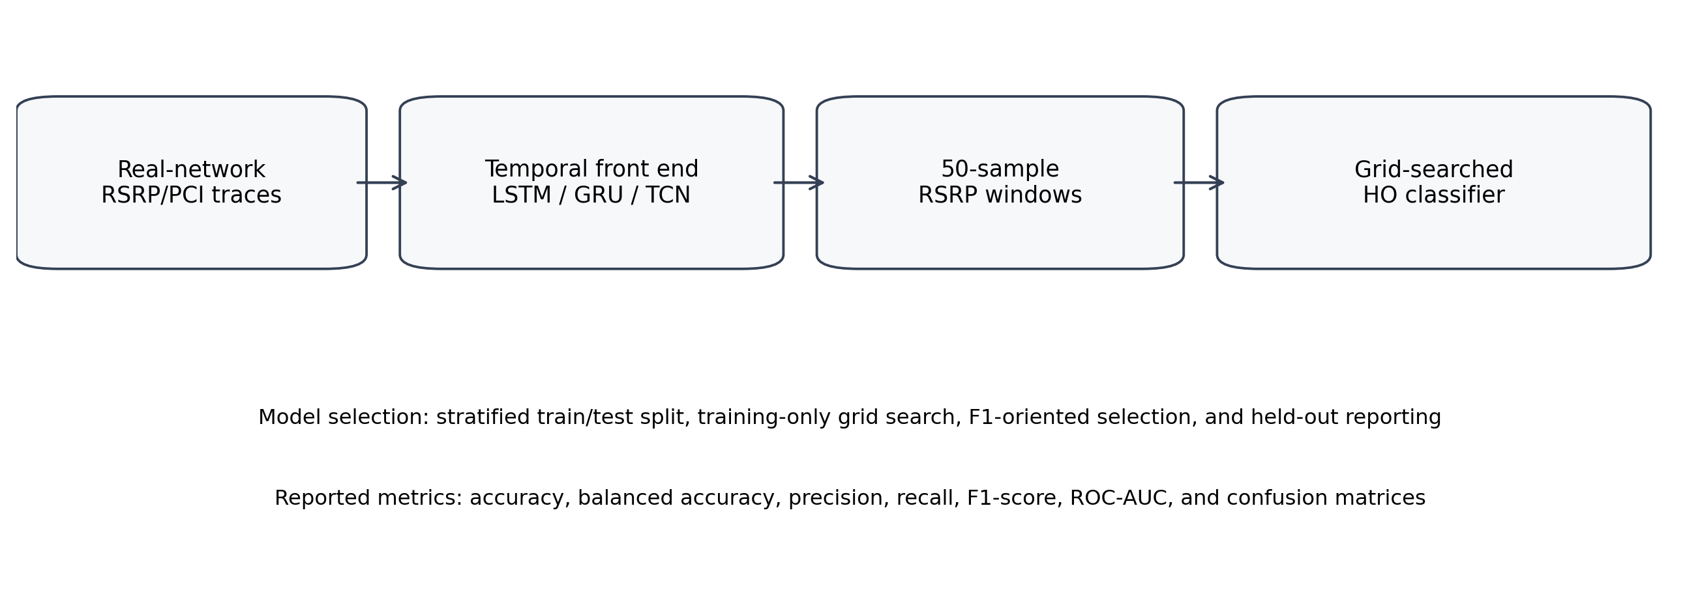
Fig. 1. Unified evaluation pipeline.
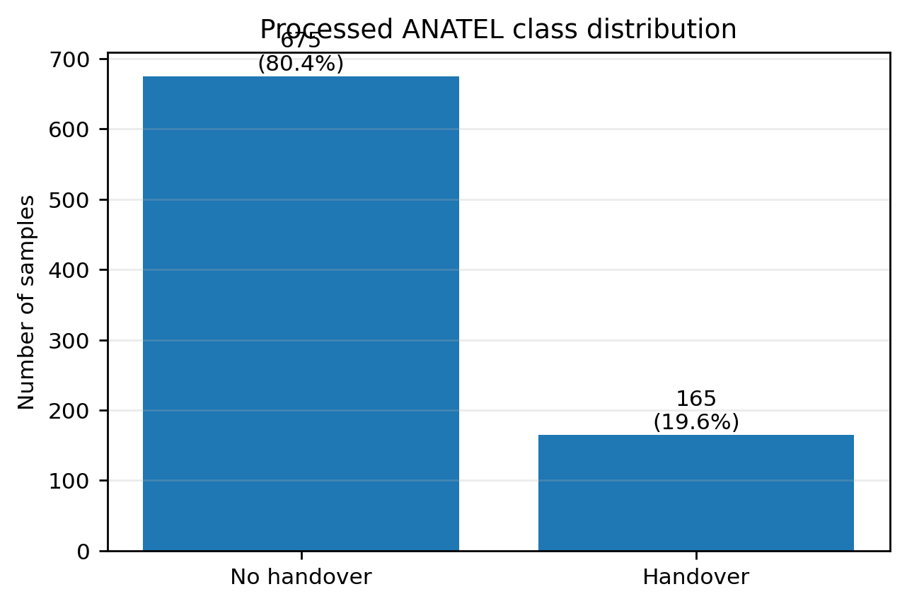
Fig. 2. Processed class distribution.

VI. RESULTS
Table I shows the best classifier selected for each temporal feature base. TCN+SVM obtains the highest F1-score and balanced accuracy. LSTM+SVM remains very close in F1-score and achieves the highest ROC-AUC.
TABLE I. BEST HELD-OUT TEST RESULTS
Base | Clf. | Acc. | Bal. | Rec. | F1 | AUC
LSTM | SVM-RBF | 0.676 | 0.651 | 0.610 | 0.424 | 0.705
GRU | SVM-RBF | 0.671 | 0.630 | 0.561 | 0.400 | 0.700
TCN | SVM-RBF | 0.681 | 0.654 | 0.610 | 0.427 | 0.694
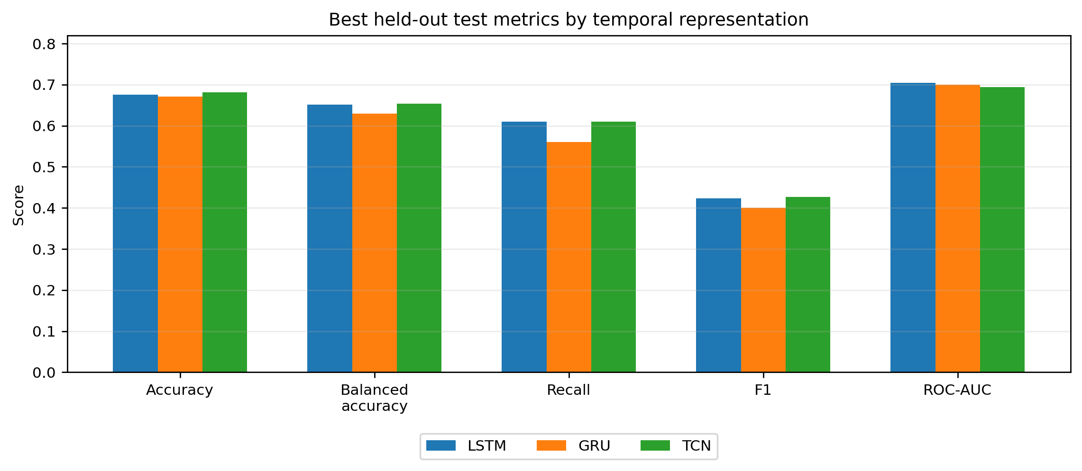
Fig. 3. Best metrics by temporal representation.
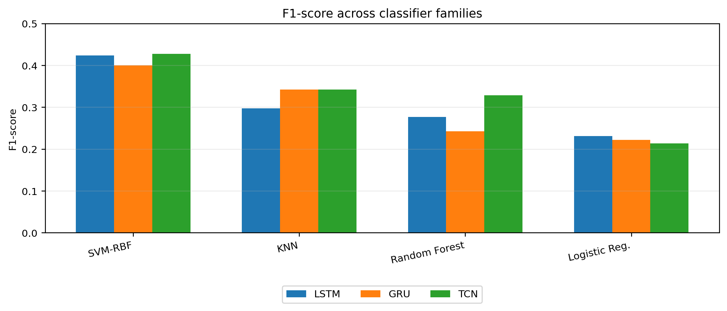
Fig. 4. F1-score by classifier family.
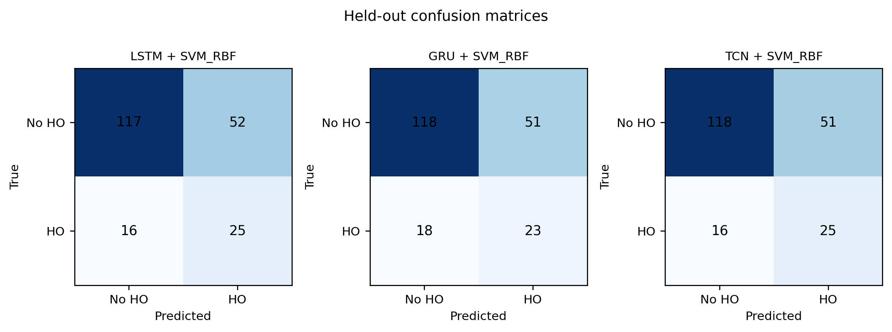
Fig. 5. Confusion matrices for selected models.

VII. DISCUSSION
TCN provides a small F1-score advantage over LSTM, but the margin is modest. The result should therefore be interpreted as evidence that TCN is competitive and slightly better under this held-out protocol, not as a decisive replacement for LSTM.
GRU is included because it is lighter than LSTM, but its lower F1-score suggests that reduced recurrent complexity alone does not guarantee better handover detection. SVM improves recall but increases false positives, showing the operational trade-off between missing handovers and triggering unnecessary actions.

VIII. LIMITATIONS
This study uses processed feature bases rather than a full raw-data reimplementation. The dataset has only 840 samples and 165 positive events. Future work should include chronological splits, larger multi-cell datasets, cost-sensitive thresholds, and end-to-end neural classifiers.

IX. CONCLUSION
This paper enhanced and re-evaluated a reproducible handover prediction pipeline using LSTM, GRU, and TCN-derived RSRP feature bases. TCN+SVM achieved the best F1-score of 0.4274 and balanced accuracy of 0.6540, while LSTM+SVM remained close and achieved the highest ROC-AUC. The findings support lightweight temporal representations as competitive alternatives while showing that minority-event detection in real-network handover data remains challenging.

REFERENCES
[1] Lima et al., “Deep Learning-Based Handover Prediction for 5G and Beyond Networks,” IEEE ICC, 2023.
[2] Mollel et al., “A Survey of Machine Learning Applications to Handover Management in 5G and Beyond,” IEEE Access, 2021.
[3] Cho et al., “Learning Phrase Representations using RNN Encoder-Decoder,” EMNLP, 2014.
[4] Bai, Kolter, and Koltun, “An Empirical Evaluation of Generic Convolutional and Recurrent Networks for Sequence Modeling,” arXiv:1803.01271, 2018.
[5] Chawla et al., “SMOTE: Synthetic Minority Over-sampling Technique,” JAIR, 2002.
[6] Breiman, “Random Forests,” Machine Learning, 2001.
[7] Cortes and Vapnik, “Support-vector networks,” Machine Learning, 1995.

