In-Silico Prediction of Eukaryotic Secretory Signal Peptides and Cleavage Sites: A Comparative Evaluation of Weight Matrices, Support Vector Machines, and Protein Language Models
Mohammadamin Roshan¹*, Mohibuddin Ahmed Umer¹, Ahmed Abdelhafize¹, Berkay Oktay Demir¹, and Rida Niaz¹
¹Department of Pharmacy and Biotechnology (FaBiT), Alma Mater Studiorum – Università di Bologna, Bologna 40126, Italy
*To whom correspondence should be addressed.

Abstract
Motivation: Secretory signal peptides (SPs) are short N-terminal targeting motifs that direct nascent polypeptides into the endoplasmic reticulum. Accurate computational detection of SPs is essential for functional annotation; however, prediction is heavily hindered by transmembrane (TM) mimicry—the physicochemical similarity between SP hydrophobic cores and N-terminal TM a-helices—and sequence divergence across eukaryotic kingdoms. Results: With reference to the DOME recommendations for supervised machine-learning validation, we curated a non-redundant eukaryotic dataset from UniProtKB/Swiss-Prot (10,182 proteins after MMseqs2 clustering at 30% sequence identity and 40% alignment coverage). The dataset was partitioned into a 5-fold cross-validation training set (N=8,145) and a held-out blind benchmarking set (N=2,037). We systematically evaluated three paradigms: (i) the classic von Heijne position-specific weight matrix (PSWM), (ii) a feature-engineered Support Vector Machine (SVM) utilizing nested cross-validation, and (iii) deep learning architectures leveraging pretrained ESM-2 protein language model (PLM) embeddings. On the blind benchmarking set, performance progressed systematically from the von Heijne baseline (MCC = 0.655) to the feature-engineered SVM (MCC = 0.859), the ESM-2 Deep MLP (MCC = 0.935), and the Hybrid ESM-2 PCA-SVM architecture (MCC = 0.943, ROC-AUC = 99.37%). Error diagnostics using Fisher’s exact tests revealed that ESM-2 representations reduced the proportion of N-terminal TM-helix false positives from 60.6% (PSWM) down to 25.0%. Furthermore, applying grammar-constrained Viterbi decoding reduced the mean absolute cleavage-site localization error from 1.94 to 1.55 residues, although exact localization accuracy decreased slightly from 65.91% to 64.09%. Probabilities were calibrated using isotonic regression. On the held-out benchmark, 99.3% of samples had a Reliability Index (RI) of at least 6. Within this confident subset, accuracy reached 99.16% and MCC reached 0.955. Availability: All Python notebooks, curated datasets, trained models, and extracted matrices required to reproduce this study are freely available under the MIT License at [Insert GitHub URL here].
________________________________________________________________________________

1 Introduction
Subcellular localization defines the biochemical environment in which a protein operates and is inextricably linked to its physiological function. In eukaryotes, proteins destined for the endoplasmic reticulum (ER), Golgi apparatus, plasma membrane, or extracellular space typically carry an N-terminal secretory signal peptide (SP). Upon recognition by the signal recognition particle (SRP) and subsequent translocation, this SP is cleaved by Signal Peptidase I (Sec/SPI).
Canonical eukaryotic secretory signal peptides commonly contain an N-terminal region, a hydrophobic core, and a more polar C-terminal region that contributes to cleavage-site recognition. The positively charged n-region (1-5 residues) facilitates initial membrane interaction, the hydrophobic h-region (7-15 residues) forms an alpha-helical structure assisting SRP interaction, and the polar c-region terminates with the A-x-A cleavage motif. However, their lengths and sequence characteristics vary across proteins and taxa; therefore, the structural ranges and cleavage-site motifs described here should be interpreted as common patterns rather than universal rules.
In-silico SP detection faces two major computational challenges. First, transmembrane (TM) mimicry: N-terminal TM a-helices share strong physicochemical similarities with the SP hydrophobic core. This mimicry causes classical prediction algorithms to generate a substantial number of false positives when encountering membrane proteins. Second, sequence divergence makes cleavage-site identification highly variable across eukaryotic kingdoms. Historically, SP prediction evolved from heuristic and motif-based strategies, such as the von Heijne Position-Specific Weight Matrix (PSWM), to machine learning approaches. Support Vector Machines (SVMs) and Neural Networks have been widely employed to integrate handcrafted physicochemical features. Recently, large-scale protein language models (PLMs) such as ESM-2 have emerged as powerful sequence encoders that capture complex evolutionary and structural syntax directly from primary sequences.
In this study, we present a supervised machine-learning pipeline dedicated to the classification of eukaryotic secretory proteins and the precise localization of their cleavage sites. We systematically compare motif-driven (von Heijne), handcrafted feature-based (SVM), and pretrained transformer-based (ESM-2) predictors. We frame N-terminal transmembrane mimicry as a challenge to be evaluated through benchmark error analysis. The study was designed with reference to the DOME (Data, Optimization, Model, Evaluation) recommendations for transparent reporting and validation of supervised machine-learning analyses in biology. The implementation details and remaining limitations of the data, optimization, model, and evaluation procedures are thoroughly documented below.

2 Materials and Methods

2.1 Dataset Collection and Redundancy Reduction
Positive examples were selected from reviewed UniProtKB/Swiss-Prot entries satisfying experimental-evidence (ECO:0000269), sequence-length (>= 40 residues), and signal-peptide annotation filters (length >= 14 residues). Negative examples were selected from reviewed entries lacking an annotated signal peptide and carrying experimental subcellular-localization annotations included in a predefined non-secretory category list (e.g., cytosol, nucleus, mitochondrion). Because the absence of an annotated signal peptide does not necessarily establish the biological absence of a signal peptide, negative-set construction relied on the specified annotation and localization criteria. Importantly, we specifically tracked whether negative proteins possessed an N-terminal TM helix within the first 90 residues to enable targeted false-positive analysis later in the pipeline.
Sequence redundancy was reduced by clustering the positive and negative sets separately with MMseqs2 using a minimum sequence-identity threshold of 30% and an alignment coverage threshold of 40%. This yielded a dataset of 1,100 positive and 9,082 negative sequences (10,182 total). The retained representatives were subsequently partitioned into an 80% Training set (N=8,145; 880 SP+, 7,265 SP-) for 5-fold cross-validation, and a 20% held-out Blind Benchmarking set (N=2,037; 220 SP+, 1,817 SP-) using stratified sampling. Because clustering was performed separately by class, cross-class sequence similarity and residual homology between the resulting splits require separate verification; the clustering procedure alone is not taken as proof that all potential leakage has been eliminated.

2.2 Exploratory Data Analysis (EDA)
Prior to modeling, Exploratory Data Analysis (EDA) was conducted to evaluate the dataset's characteristics. Analysis of the overall protein length distribution (Figure 1) indicated that secretory proteins (SP+) present a more compact length distribution in this dataset.
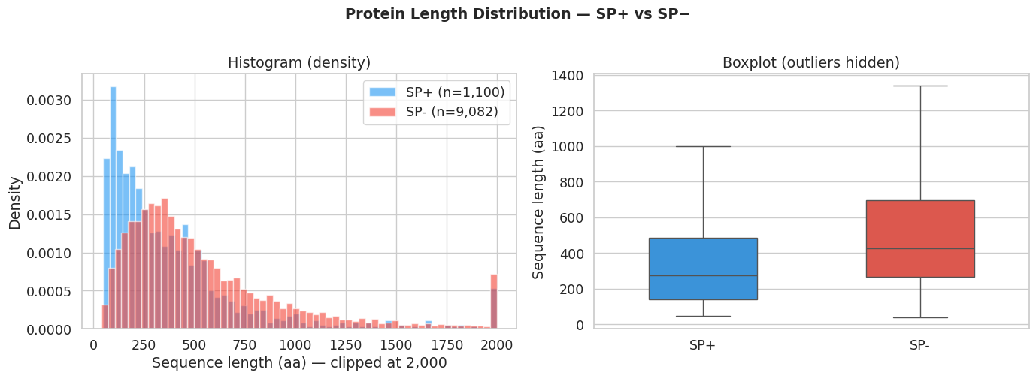
Fig. 1. Distribution of full protein lengths. The sequence length is clipped at 2,000 for visualization.
Among the retained positive examples, the signal-peptide length distribution had a mean of 23.0 residues and a median of 22 residues (Figure 2). The distribution was characterized descriptively rather than assumed to be normally distributed.
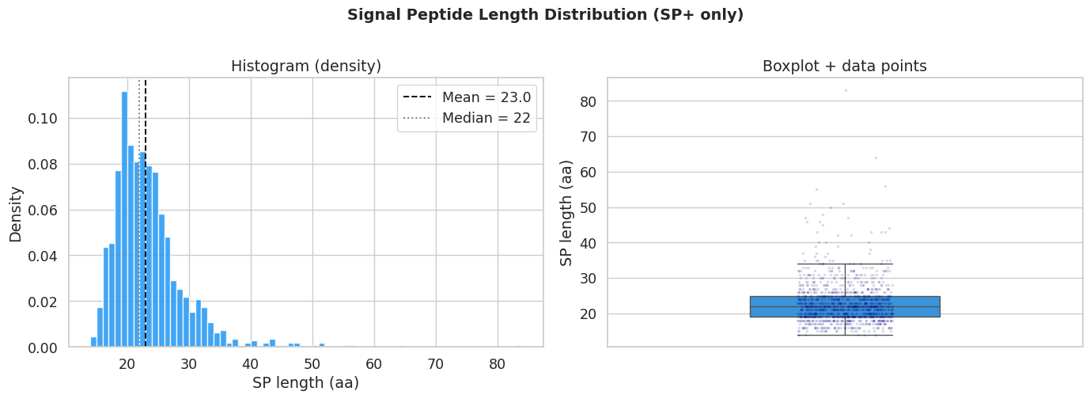
Fig. 2. Signal Peptide length distribution within the positive class (mean = 23.0, median = 22).
Furthermore, comparative amino-acid composition analysis revealed an enrichment of Leucine (L) and Alanine (A) in SP sequences relative to the SwissProt background, reflecting the presence of the dense hydrophobic h-region.
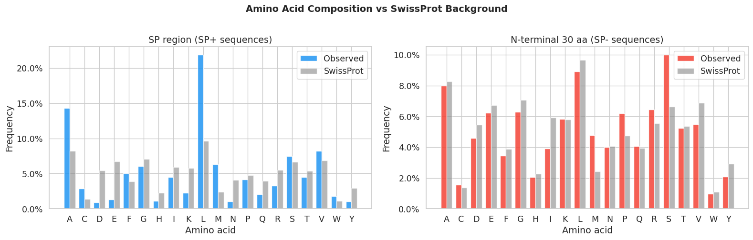
Fig. 3. Amino-acid composition of annotated signal-peptide regions in positive examples and the first 30 residues of negative examples, compared with reference Swiss-Prot frequencies. The plot provides a descriptive comparison of residue composition; statistical significance and causal interpretations are not inferred from the frequency differences alone.
Although 880 positive sequences were included in the training set, one sequence was excluded from sequence-logo construction because a complete 15-residue cleavage-site window could not be extracted (due to the presence of ambiguous amino acids). Therefore, the expected cleavage-site sequence logo was generated from the remaining 879 sequences.
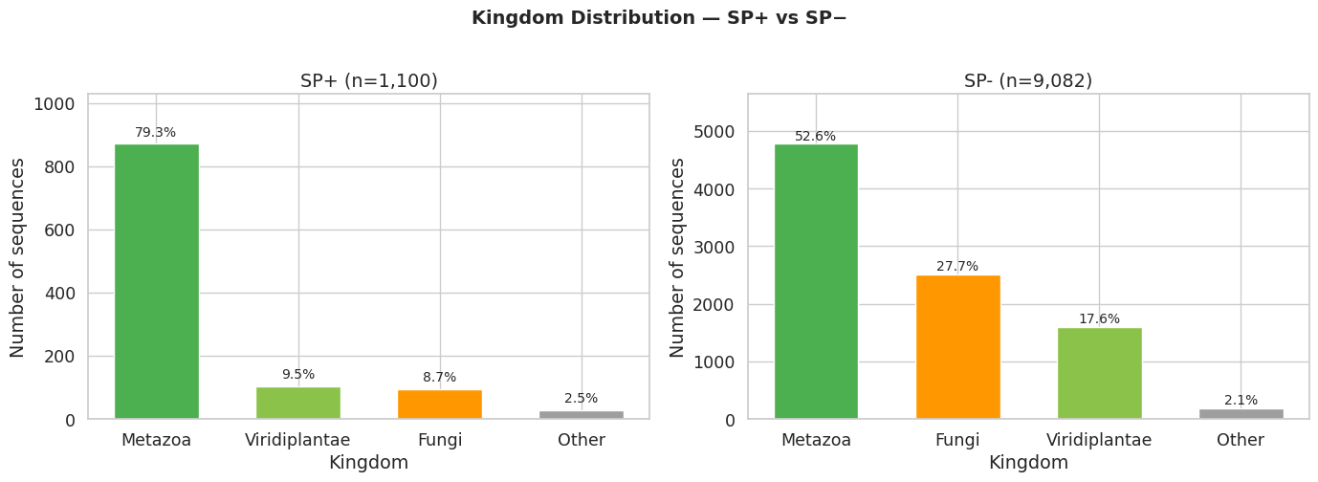
Fig. 4. Taxonomic Kingdom distribution of the dataset, illustrating Metazoan representation within this specific dataset.
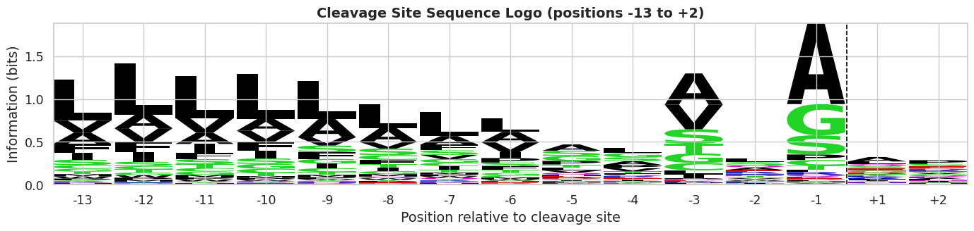
Fig. 5. Sequence Logo of the [-13, +2] cleavage site showing conserved sequence patterns at positions -1 and -3, constructed from training positive sequences (n=879).

2.3 The von Heijne Position-Specific Weight Matrix
As a rule-based baseline, we implemented the classical von Heijne method. Aligned 15-residue windows spanning positions [-13, +2] relative to the annotated cleavage site were extracted from the training positives. To account for unobserved amino acids and prevent undefined logarithms, a pseudocount of 1.0 was applied. The Position-Specific Probability Matrix (PSPM) was calculated and converted into a log-odds Weight Matrix (PSWM) by normalizing against the empirical SwissProt background frequencies.
During 5-fold cross-validation, an internal 3-1-1 split protocol was employed: in each iteration, 3 folds were used to compute the PSWM, 1 validation fold determined the optimal decision threshold (by maximizing the F1-score), and 1 test fold was used for independent evaluation. For the final production model, the decision threshold was optimized strictly on Fold 4 (used as a validation set) after training the matrix on Folds 0 to 3. To maximize information retention, the final PSWM was then retrained on all 5 training folds (the entire training set) and evaluated exactly once on the blind benchmark set using the pre-fixed threshold.

2.4 Feature Extraction and Nested Cross-Validation
The initial feature set comprised 35 physicochemical descriptors. These included 20 amino-acid composition frequencies computed over the first 30 residues. The remaining 15 features were extracted using sliding-window aggregations over the first 40 residues, leveraging AAindex scales such as Kyte-Doolittle hydropathy, Zimmerman bulkiness, Chou-Fasman alpha-helix propensity, Zhao-London TM tendency, and net charge calculations in the n-region.
To rigorously select the optimal subset of features without introducing selection bias, feature-selection strategies were compared within a nested cross-validation procedure (5 outer test folds x 4 inner validation folds). We evaluated families including Filter (Variance + Correlation |r| > 0.9, Mutual Information), Wrapper (Recursive Feature Elimination), and Embedded (L1 Logistic Regression, Random Forest Gini Importance). The final feature subset and its size (30 features) were determined from the training data only and then fixed before evaluation on the held-out benchmark using an RBF-SVM.

2.5 Protein Language Models and Hybrid Architecture
To evaluate large protein language models, we utilized the pretrained ESM-2 transformer model (esm2_t6_8M_UR50D). We extracted 640-dimensional contextual embeddings from the 6th layer of the model, applying mean pooling over the first 90 N-terminal residues. We evaluated two architectures: (i) a Multi-Layer Perceptron (Deep MLP) acting directly on the 640-d embeddings, and (ii) a Hybrid fusion model concatenating the ESM-2 dimensions with the handcrafted physicochemical features. For the Hybrid model, the concatenated features were reduced via Principal Component Analysis (PCA) fitted strictly on the training folds, and subsequently classified by an RBF-SVM.

2.6 Probability Calibration and Reliability Index
Raw SVM decision functions are uncalibrated distances from a hyperplane. To provide calibrated probabilities, we applied Isotonic Regression (fitted strictly out-of-fold). The calibrated probabilities (P) were then mapped to a Reliability Index (RI) ranging from 0 to 10 using the formula: RI = round(20 * |P - 0.5|). To resolve the exact cleavage site, we implemented a Viterbi-style decoding algorithm. Instead of relying solely on the unconstrained PSWM maximum score, this algorithm enforces a biological grammar (n-h-c) constraint, rewarding n-region positive charges, h-region hydrophobicity, and penalizing statistically unlikely SP lengths using an empirical log-prior distribution.

3 Results and Discussion

3.1 Nested Cross-Validation and Feature Stability
The Nested Cross-Validation results (Figure 6) revealed that utilizing all 35 features (Baseline) yielded excellent performance with non-linear RBF-SVMs. Embedded methods, particularly Random Forest Gini Importance, demonstrated high stability and selected core features (e.g., tm_peak_pos, max_hydrophobicity) across the nested iterations. Ultimately, a 30-feature RF selection was deemed optimal and was fixed prior to evaluation on the benchmark set.
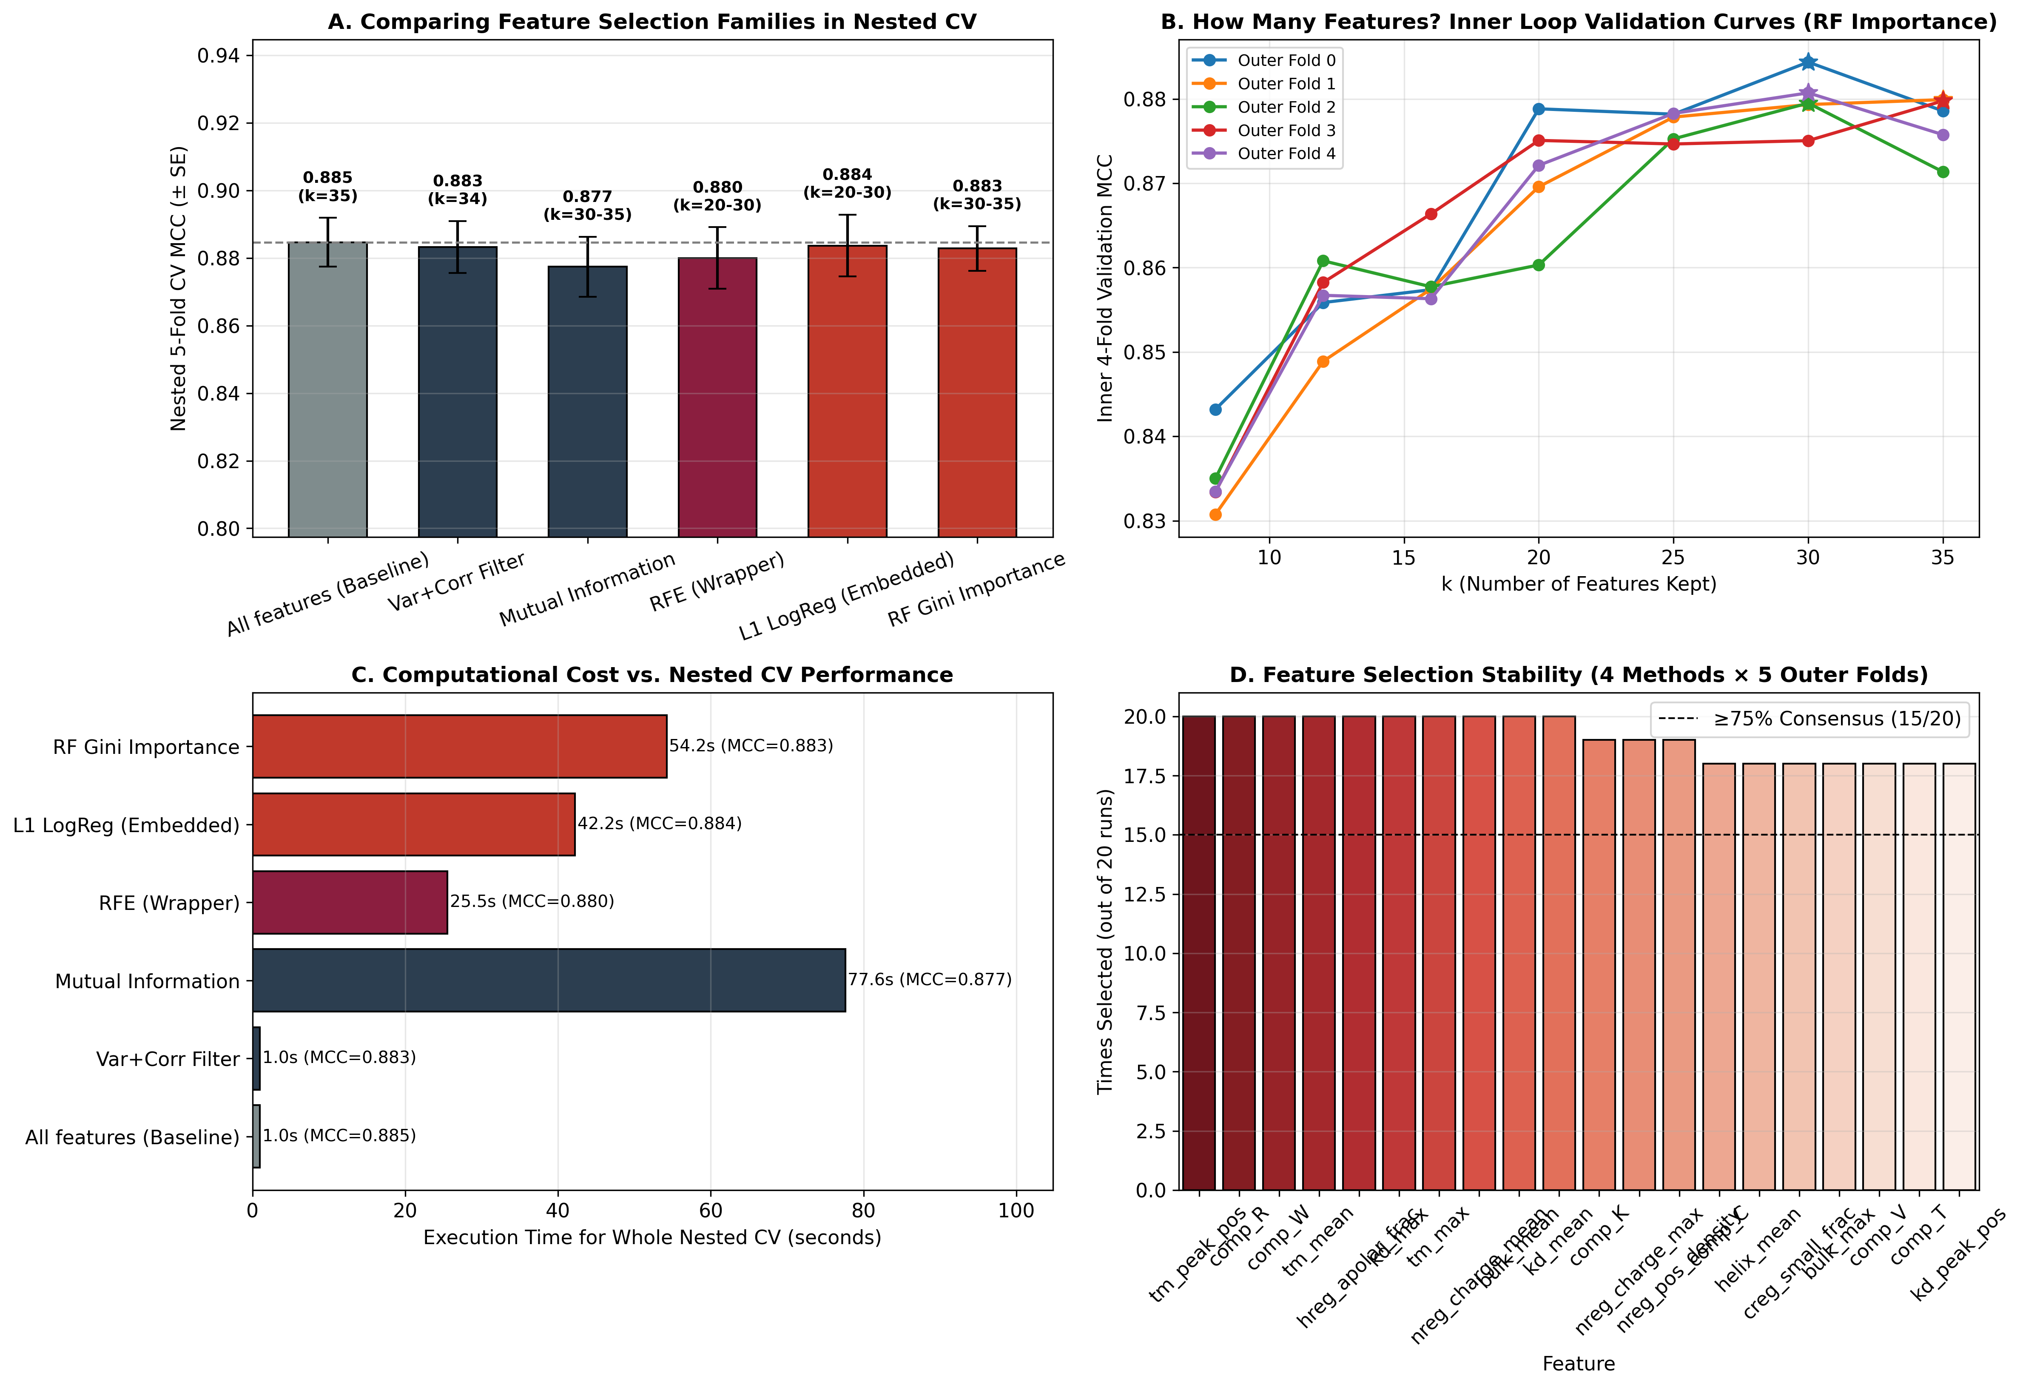
Fig. 6. Nested Cross-Validation Diagnostics. (A) MCC comparison of feature selection families, (B) Inner loop K-selection curves, (C) Computational cost, and (D) Feature stability demonstrating consensus for top physicochemical drivers.

3.2 Master Benchmark Comparison
Evaluation on the strictly held-out blind benchmark set (N=2,037) demonstrated a progression in modeling capabilities on this dataset. To provide a clear, comprehensive comparison, the performance of all evaluated models on the blind benchmarking set is summarized in Table 1.
Table 1. Comparative performance of all evaluated models on the held-out benchmark dataset.
Model | Accuracy (%) | Precision (%) | Recall (%) | F1-score (%) | MCC | ROC-AUC (%)
von Heijne PSWM | 92.64 | 63.06 | 76.82 | 69.26 | 0.655 | 94.80
SVM (RF-30) | 97.35 | 90.29 | 84.55 | 87.32 | 0.859 | 99.06
ESM-2 MLP | 98.77 | 96.21 | 92.27 | 94.20 | 0.935 | 99.60
Hybrid PCA-SVM | 98.92 | 96.70 | 93.18 | 94.91 | 0.943 | 99.37
Note: Accuracy, Precision, Recall, and F1-score are calculated at the pre-fixed cross-validated thresholds. AUC represents the ROC Area Under the Curve. All models were evaluated strictly on the same N=2,037 benchmark set. For the Hybrid model, the 640d ESM-2 embeddings were concatenated with the 35d handcrafted features before PCA dimensionality reduction.
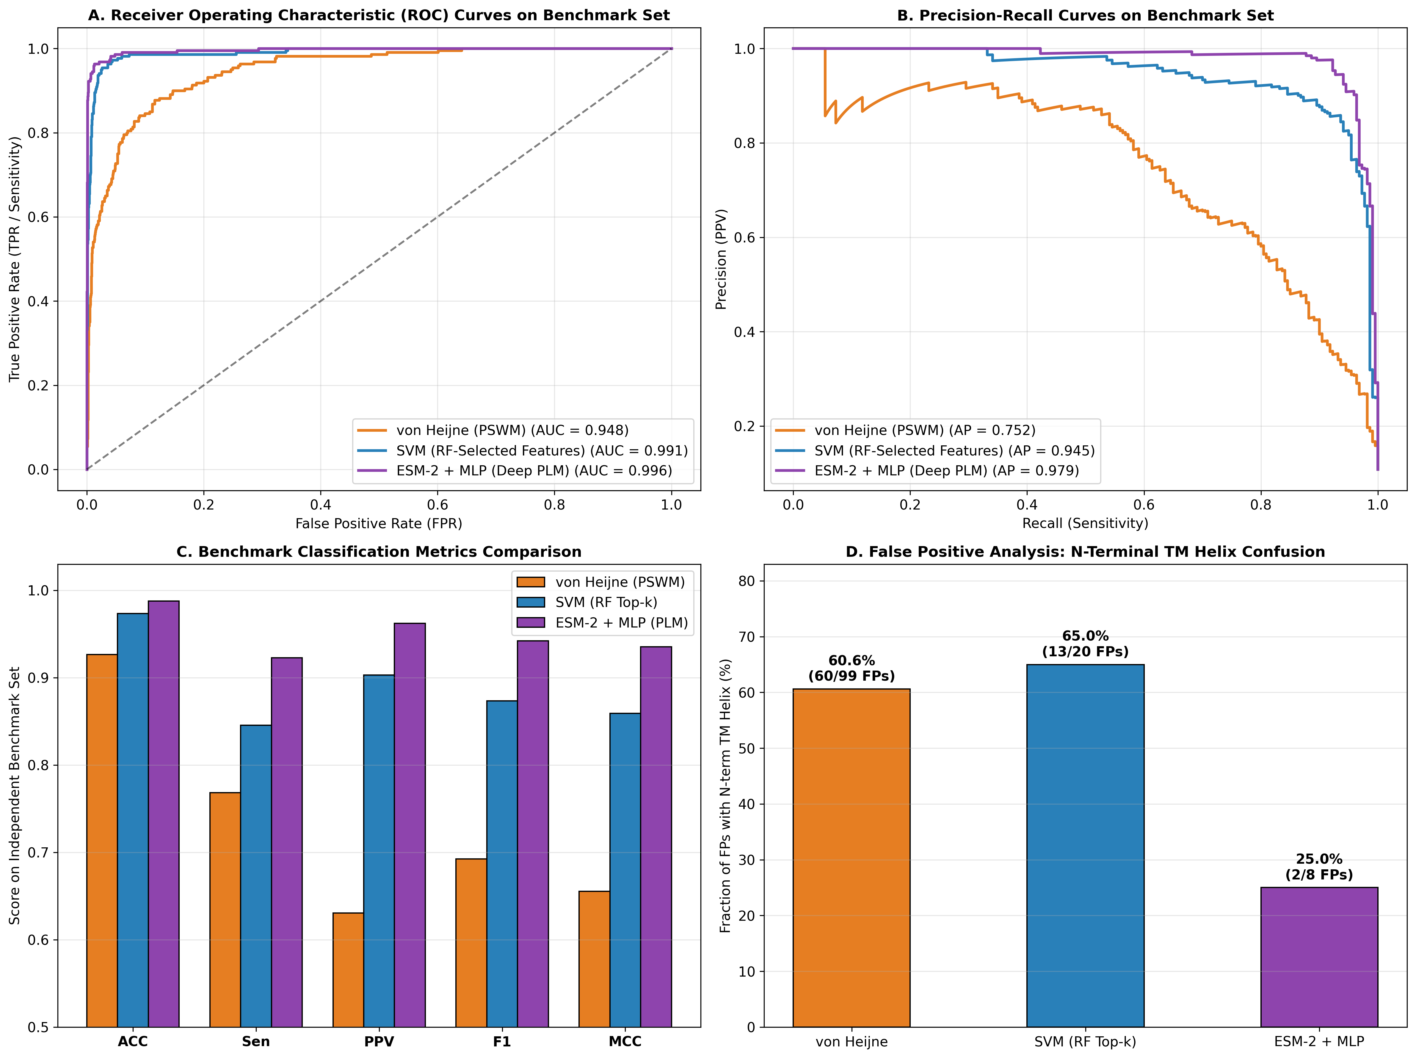
Fig. 7. Master Model Benchmark Comparison on the held-out dataset. Demonstrates the progression from von Heijne to SVM and ESM-2 PLM. Panel D highlights the proportion of False Positives annotated with an N-terminal TM helix.

3.3 Error Analysis I: Resolving Transmembrane Mimicry
The Hybrid ESM-2 model produced fewer false-positive predictions on the held-out benchmark than the PSWM and feature-engineered SVM models. We examined the proportion of false positives (FPs) that possessed an annotated N-terminal TM helix compared to true negatives (TNs). In the von Heijne baseline, 60 out of 99 FPs (60.6%) possessed an N-terminal TM helix, compared to 136 out of 1,718 TNs (7.9%). A Fisher's exact test on this 2x2 contingency table yielded an Odds Ratio of 17.90 (p = 2.47e-36). The physicochemical SVM reduced total FPs to 20, with 13 containing TM helices (65.0%), compared to 183 of 1,797 TNs (10.2%) (Odds Ratio = 16.38, p = 7.22e-09). For the ESM-2 MLP, total FPs dropped to 8, with only 2 (25.0%) containing TM helices. The observed false-positive rates among the TM-annotated subsets differed across models. However, the denominators were small and differed between the reported model-specific subsets; these estimates should therefore be interpreted cautiously. These observations are consistent with improved discrimination in this benchmark, and suggest that contextual embeddings may capture evolutionary distinctions between secretion and membrane-anchoring signals that physicochemical metrics miss, though this does not by itself establish a causal biological mechanism.

3.4 Error Analysis II: Diagnosing False Negatives
Diagnostic analysis of False Negatives (FNs) was performed separately for the PSWM and SVM models. Sequence logo analysis of the 51 missed SPs (FNs) produced by the von Heijne model revealed a weakened A-x-A consensus at positions -1 and -3 (Figure 8). For the SVM model, which produced 34 FNs, a comparison revealed that these missed sequences had a higher median annotated signal-peptide length (24.5 aa) than the 186 true-positive examples (22.0 aa, Mann-Whitney p = 2.14e-03), and the distributions of peak hydropathy also differed between the groups (p = 2.80e-07) (Figure 9). These associations suggest that signal-peptide length and hydrophobicity may contribute to classification errors. However, the observational error analysis does not establish that the fixed-length feature window (K=30) caused the errors; this hypothesis requires targeted ablation analyses.
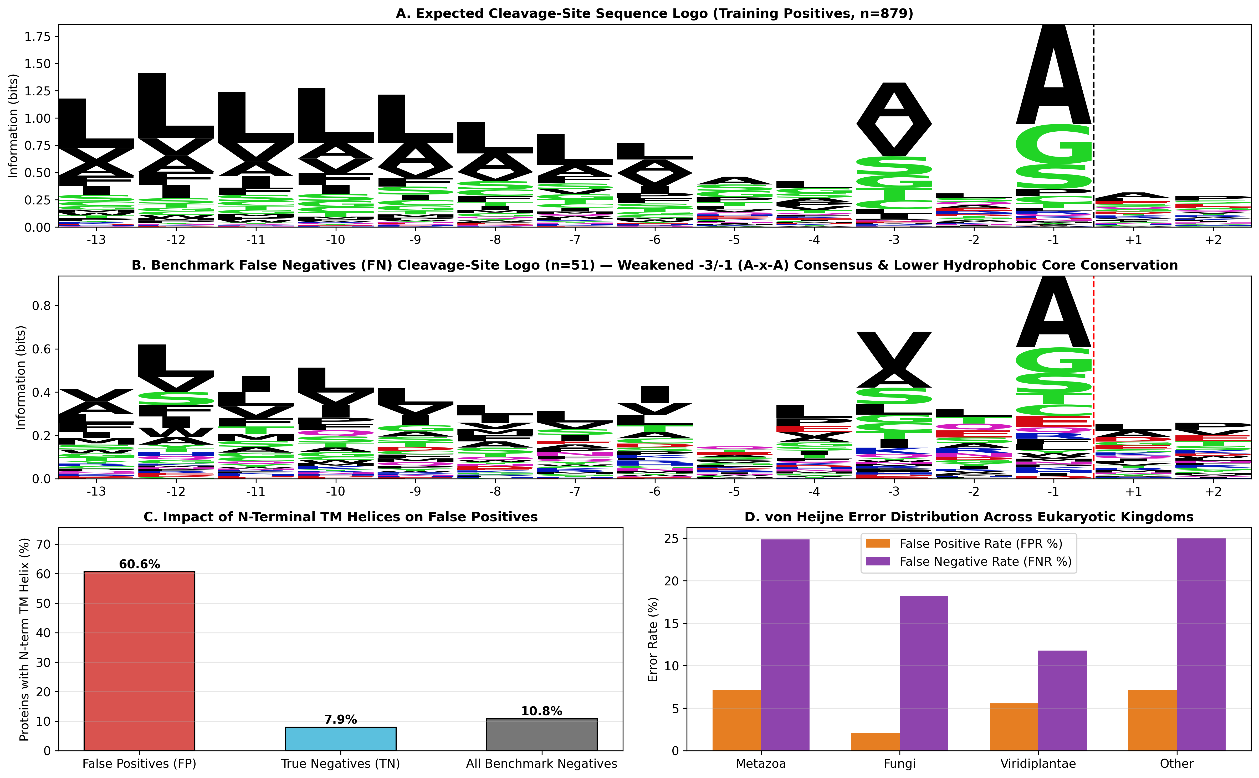
Fig. 8. Sequence Logo Analysis of PSWM False Negatives. The benchmark FNs (Panel B, n=51) display a weakened A-x-A motif compared to the expected training distribution (Panel A, n=879).
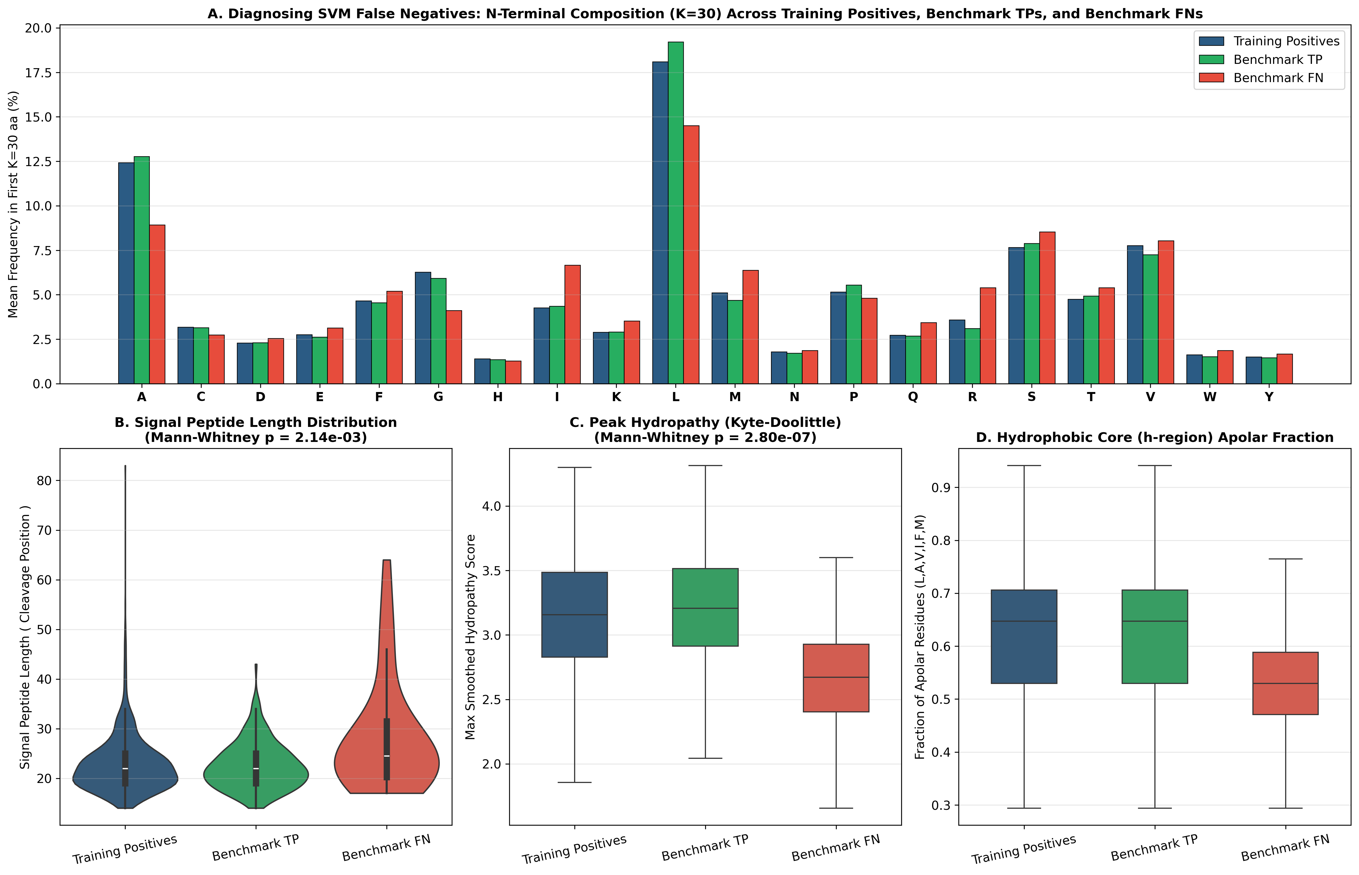
Fig. 9. SVM Error Diagnostics. Violin and box plots demonstrating that SVM False Negatives (n=34) show elongated SP lengths and reduced peak hydropathy compared to correctly identified Benchmark Positives (n=186).

3.5 Calibration, Reliability Index, and Grammar Decoding
Probabilities were calibrated using isotonic regression (fitted strictly out-of-fold), yielding a calibrated Brier score of 0.0094 on the benchmark dataset. On the held-out benchmark, 99.3% of samples had a Reliability Index (RI) of at least 6. Within this specific subset, the reported accuracy was 99.16% and the MCC was 0.955 (Figure 10). These subset-specific results should be interpreted in conjunction with the subset size and class distribution.
For Cleavage-Site Identification, grammar-constrained decoding reduced the mean absolute localization error from 1.94 to 1.55 residues, while exact-residue accuracy decreased slightly from 65.91% to 64.09%. The constraint may discourage predictions inconsistent with the predefined n–h–c architecture, effectively improving average localization proximity, but its effect on biologically implausible cleavage sites should be quantified using an explicit criterion and the observed benchmark predictions. Within a ±3 residue tolerance window, accuracy reached 80.45%.
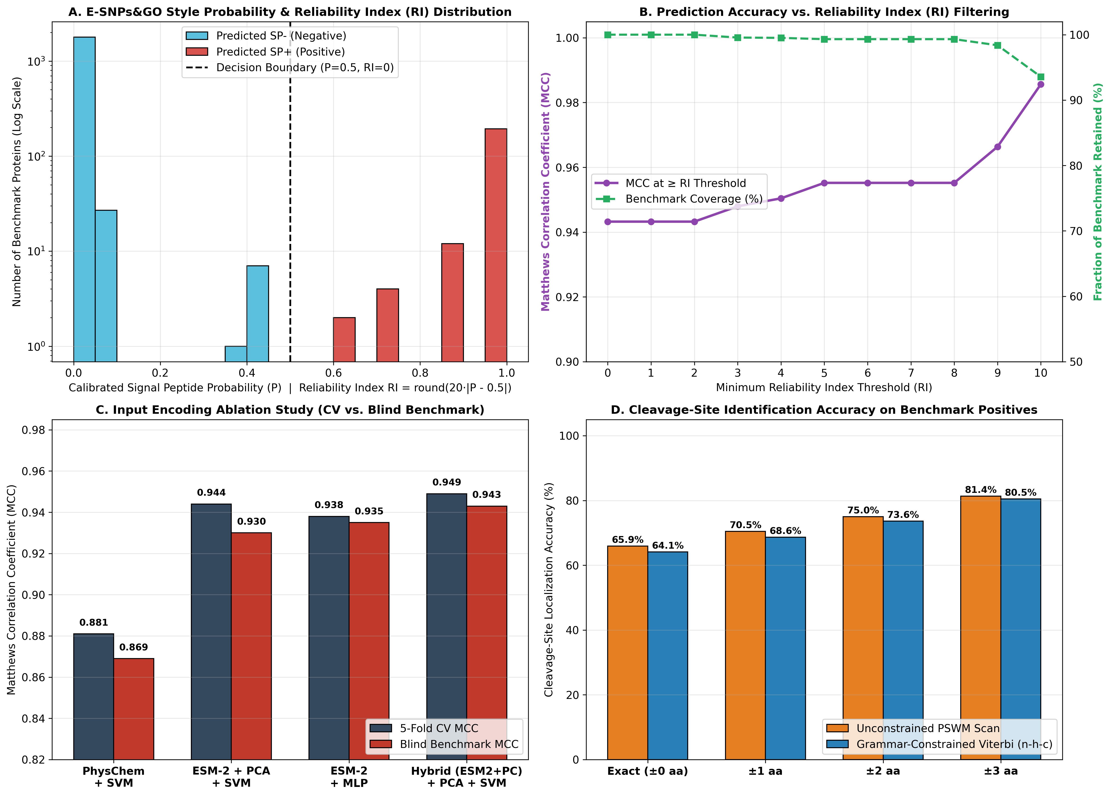
Fig. 10. Advanced Biocomputing Analysis. (A) RI distribution, (B) MCC improvements at higher RI thresholds, (C) Encoding ablation, (D) Grammar-constrained cleavage localization accuracy.

4 DOME Recommendations Compliance and Statistical Significance
The study was designed with reference to the DOME (Data, Optimization, Model, Evaluation) guidelines (Walsh et al., 2021). Optimization integrity was maintained by performing all scaling, nested feature selection, PCA fitting, and isotonic calibration exclusively within the boundaries of the training folds. The Hybrid model achieved an MCC of 0.949 during cross-validation and 0.943 on the held-out benchmark. The close agreement between cross-validation and held-out benchmark MCC values is consistent with relatively stable performance under the evaluated data-splitting protocol. However, this agreement alone does not rule out overfitting or potential sources of data leakage, and the interpretation depends on the independence of the training and benchmark sequences.
To explore threshold sensitivity, we reported metrics at the standard decision boundary and at an exploratory threshold where FP=FN on the benchmark set, though this constitutes a post-hoc analysis. Finally, an exact McNemar's paired comparison between the Hybrid ESM-2 model and the SVM on the held-out benchmark resulted in 42 discordant pairs where Hybrid was correct and SVM was wrong, versus 10 pairs where SVM was correct and Hybrid was wrong (p = 9.06e-06). This describes evidence of a difference in paired classification errors in this specific benchmark.

5 Limitations
This study is based on computational evaluation of annotated protein sequences. Its results should therefore be interpreted in the context of dataset construction, annotation quality, sequence redundancy, and the chosen evaluation protocol. Because the absence of an annotated signal peptide does not necessarily establish the biological absence of a signal peptide, residual label uncertainty may affect the estimated classification performance. Furthermore, clustering the positive and negative sets separately leaves the possibility of cross-class sequence similarity, which remains a limitation of this methodology. Experimental validation would be required to establish the biological accuracy of individual cleavage-site predictions.

References
Casadio, R., Martelli, P.L., Savojardo, C. (2022) Machine learning solutions for predicting protein-protein interactions. WIREs Comput Mol Sci. 12, e1618.
Lin, Z. et al. (2023) Evolutionary-scale prediction of atomic-level protein structure with a language model. Science, 379(6637), 1123-1130.
Madeo, G., Savojardo, C., Manfredi, M., Martelli, P.L., Casadio, R. (2023) CoCoNat: a novel method based on deep-learning for coiled-coil prediction. Bioinformatics.
Manfredi, M., Savojardo, C., Martelli, P.L., Casadio, R. (2022) E-SNPs&GO: embedding of protein sequence and function improves the annotation of human pathogenic variants. Bioinformatics, 38(23), 5168-5174.
Manfredi, M., Savojardo, C., Martelli, P.L., Casadio, R. (2023) ISPRED-SEQ: Deep neural networks and embeddings for predicting interaction sites in protein sequences. Bioinformatics.
Petersen, T. N. et al. (2011) SignalP 4.0: discriminating signal peptides from transmembrane regions. Nat Methods 8, 785–786.
Savojardo, C., Martelli, P.L., Fariselli, P., Casadio, R. (2018) DeepSig: deep learning improves signal peptide detection in proteins. Bioinformatics 34, 1690–1696.
Steinegger, M., Söding, J. (2017) MMseqs2 enables sensitive protein sequence searching for the analysis of massive data sets. Nature Biotechnology 35, 1026–1028.
The UniProt Consortium (2023) UniProt: the Universal Protein Knowledgebase in 2023. Nucleic Acids Research 51(D1), D523–D531.
von Heijne, G. (1990) The signal peptide. J Membr Biol. 115(3), 195-201.
Walsh, I., Fishman, D., Garcia-Gasulla, D. et al. (2021) DOME: recommendations for supervised machine learning validation in biology. Nat Methods 18, 1122–1127.

