**Pizza Hut Sales Analysis – SQL Project**

# Pizza Hut Sales Analysis

**Project Overview:**

Analysed Pizza Hut sales data using MySQL to uncover trends in orders, revenue, and popular pizzas. Includes category-wise insights, peak order hours, and revenue analysis to support data-driven business decisions.

## Q1: Retrieve the total number of orders placed

**SQL Query:**

SELECT COUNT(order_id) AS total_number  
FROM orders;

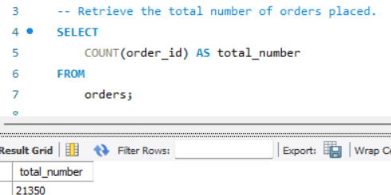

**Insight:** The total number of orders reflects overall customer engagement. High order volume suggests strong demand and potential for upselling or promotions.

## Q2: Calculate the total revenue generated from pizza sales

**SQL Query:**

SELECT ROUND(SUM(o.quantity * p.price), 2) AS total_sales  
FROM pizzas AS p  
JOIN order_details AS o ON p.pizza_id = o.pizza_id;

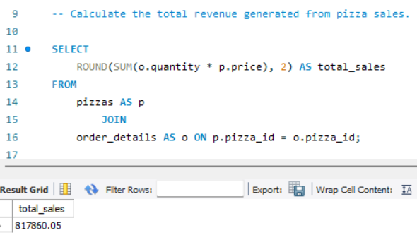

**Insight:** Total revenue indicates store financial performance. This metric serves as a benchmark for growth tracking and profitability evaluation.

## Q3: Identify the highest-priced pizza

**SQL Query:**

SELECT pt.name, p.price  
FROM pizza_types AS pt  
INNER JOIN pizzas AS p ON pt.pizza_type_id = p.pizza_type_id  
ORDER BY p.price DESC  
LIMIT 1;

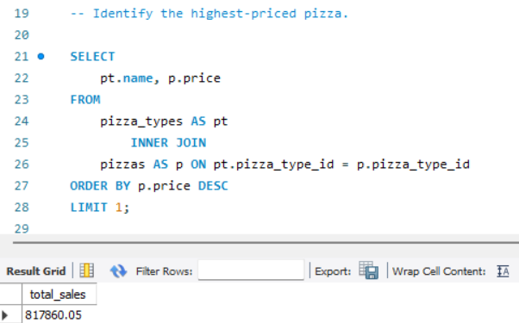

**Insight:** The highest-priced pizza represents the premium segment. Insights here guide marketing, pricing strategies, and promotions targeting high-value customers.

## Q4: Identify the most common pizza size ordered

**SQL Query:**

SELECT p.size, SUM(od.quantity) AS total_quantity  
FROM pizzas AS p  
INNER JOIN order_details AS od ON p.pizza_id = od.pizza_id  
GROUP BY p.size  
ORDER BY total_quantity DESC;

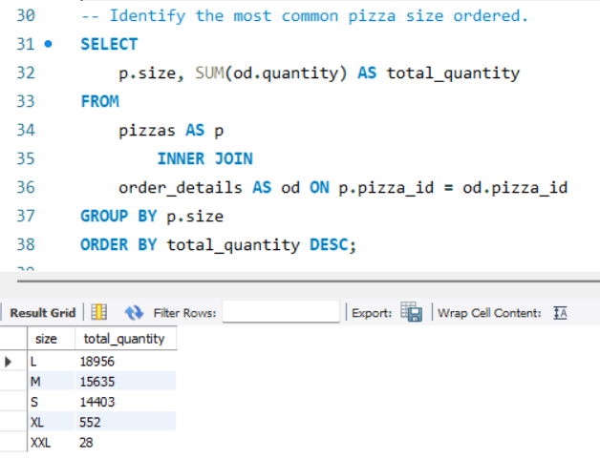

**Insight:** Shows customer preference for pizza size. Dominance of a particular size, e.g., “Large”, informs inventory planning and marketing focus.

## Q5: List the top 5 most ordered pizza types along with their quantities

**SQL Query:**

SELECT pt.name, SUM(od.quantity) AS total_qty_ordered  
FROM pizza_types AS pt  
INNER JOIN pizzas AS pz ON pt.pizza_type_id = pz.pizza_type_id  
INNER JOIN order_details AS od ON pz.pizza_id = od.pizza_id  
GROUP BY pt.name  
ORDER BY total_qty_ordered DESC  
LIMIT 5;

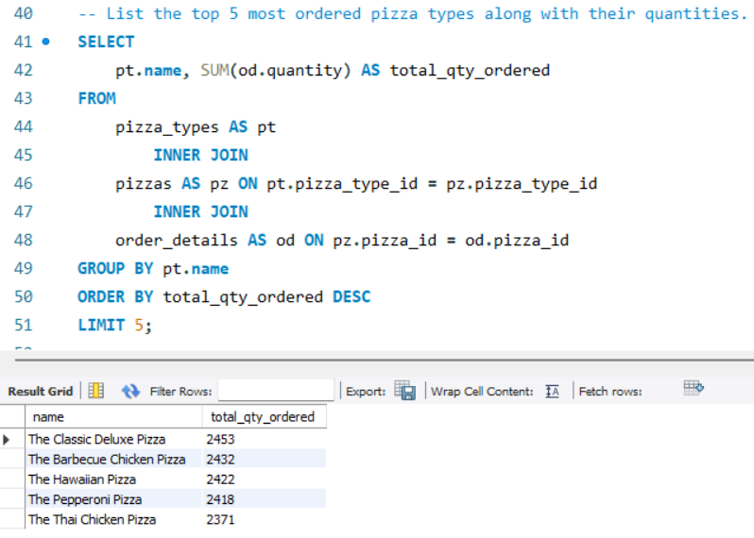 **Insight:** Identifies best-selling pizzas driving sales. Key for stock planning, promotional campaigns, and menu optimization.

## Q6: Total quantity of each pizza category ordered

**SQL Query:**

SELECT pt.category, SUM(od.quantity) AS total_quantity  
FROM pizza_types AS pt  
INNER JOIN pizzas AS pz ON pt.pizza_type_id = pz.pizza_type_id  
INNER JOIN order_details AS od ON pz.pizza_id = od.pizza_id  
GROUP BY pt.category  
ORDER BY total_quantity DESC;

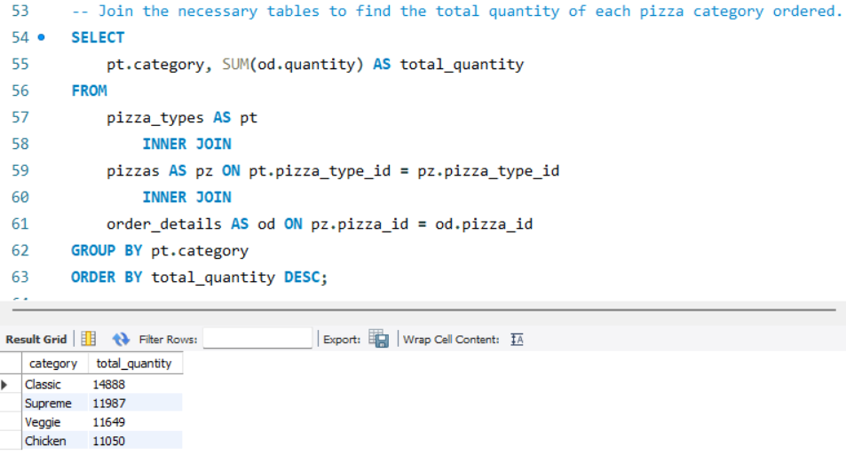 **Insight:** Category-wise orders highlight the popularity of each pizza category. This supports inventory allocation and category-focused marketing.

## Q7: Distribution of orders by hour of the day

**SQL Query:**

SELECT HOUR(order_time) as Order_Hour, COUNT(order_id) AS Order_Count  
FROM orders  
GROUP BY HOUR(order_time)  
ORDER BY Order_Count DESC;

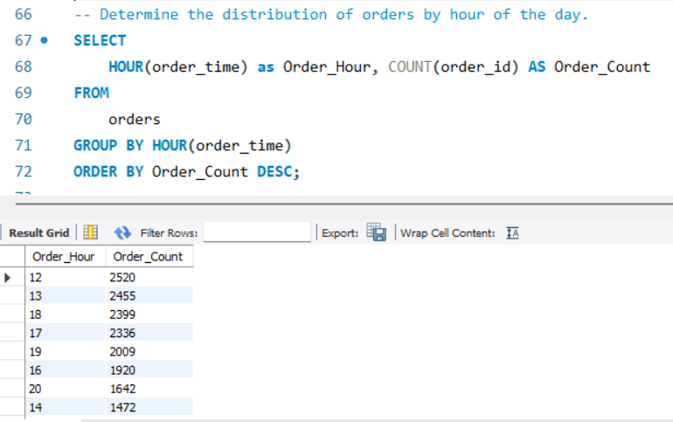 **Insight:** Peak ordering hours indicate when customers are most active. Useful for staffing, delivery scheduling, and time-based promotions.

## Q8: Category-wise distribution of pizzas

**SQL Query:**

SELECT pt.category, COUNT(p.pizza_id) AS total_count  
FROM pizza_types AS pt  
JOIN pizzas AS p ON pt.pizza_type_id = p.pizza_type_id  
GROUP BY pt.category;

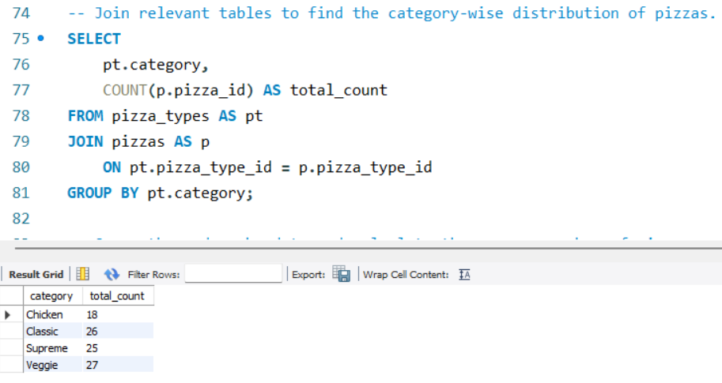 **Insight:** Shows the total number of pizzas in each category, reflecting menu composition and variety.

## Q9: Average number of pizzas ordered per day

**SQL Query:**

SELECT ROUND(AVG(daily_quantity), 0) AS avg_pizzas_per_day  
FROM (  
 SELECT o.order_date, SUM(od.quantity) AS daily_quantity  
 FROM orders AS o  
 INNER JOIN order_details AS od ON o.order_id = od.order_id  
 WHERE od.quantity IS NOT NULL  
 GROUP BY o.order_date  
) AS daily_totals;

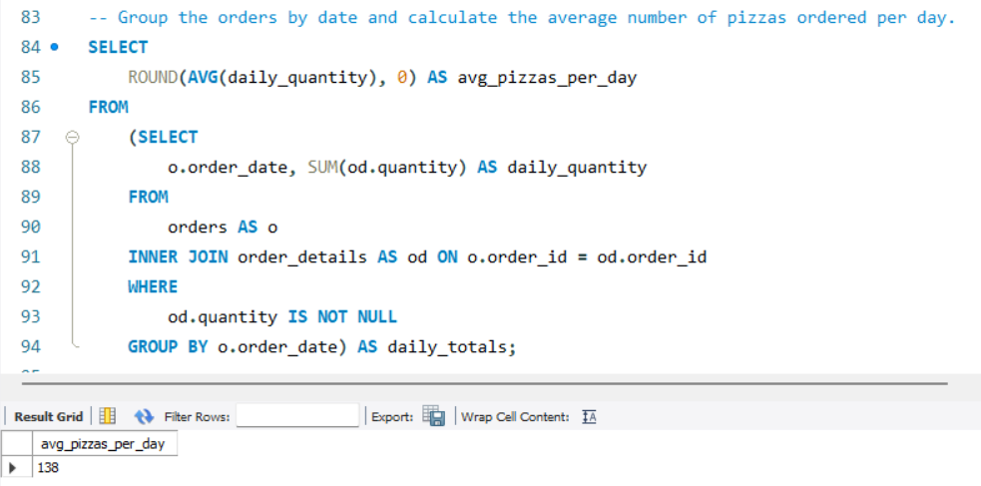 **Insight:** Provides a baseline daily demand for inventory and forecasting. Useful for detecting seasonal trends.

## Q10: Top 3 most ordered pizza types based on revenue

**SQL Query:**

SELECT pt.name AS pizza_name, ROUND(SUM(od.quantity * p.price), 2) AS total_revenue  
FROM orders AS o  
INNER JOIN order_details AS od ON o.order_id = od.order_id  
INNER JOIN pizzas AS p ON od.pizza_id = p.pizza_id  
INNER JOIN pizza_types AS pt ON p.pizza_type_id = pt.pizza_type_id  
GROUP BY pt.name  
ORDER BY total_revenue DESC  
LIMIT 3;

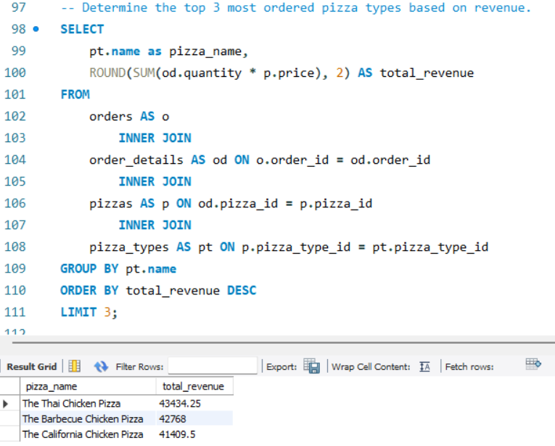 **Insight:** Identifies revenue-driving pizzas. These items are crucial for profitability and marketing focus.

## Q11: Percentage contribution of each pizza type to total revenue

**SQL Query:**

SELECT pt.category, ROUND(  
 SUM(od.quantity * p.price) / (  
 SELECT SUM(od.quantity * p.price)  
 FROM order_details AS od  
 JOIN pizzas AS p ON od.pizza_id = p.pizza_id  
 ) * 100, 2) AS pct_of_total  
FROM pizza_types AS pt  
JOIN pizzas AS p ON pt.pizza_type_id = p.pizza_type_id  
JOIN order_details AS od ON od.pizza_id = p.pizza_id  
GROUP BY pt.category  
ORDER BY pct_of_total DESC;

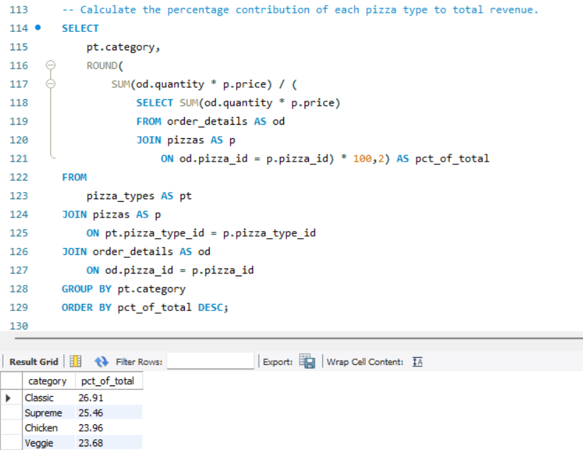**Insight:** Shows revenue concentration by category. High-percentage categories can be prioritized for promotions and inventory management.

## Q12: Analyze cumulative revenue over time (Subquery)

**SQL Query:**

SELECT order_date, SUM(revenue) OVER(ORDER BY order_date) AS total  
FROM (  
 SELECT o.order_date, SUM(od.quantity * p.price) AS revenue  
 FROM order_details AS od  
 JOIN pizzas AS p ON od.pizza_id = p.pizza_id  
 JOIN orders AS o ON o.order_id = od.order_id  
 GROUP BY o.order_date  
) AS Sales;

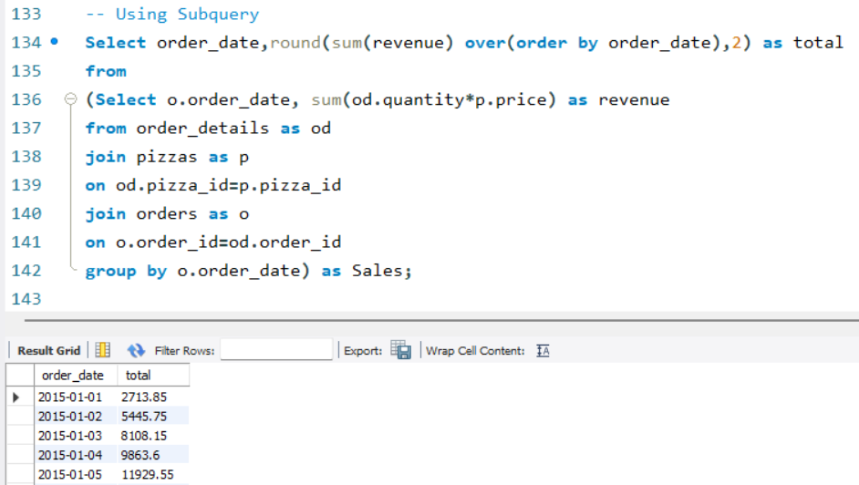 **Insight:** Tracks growth of revenue cumulatively. Helps monitor trends and measure the impact of campaigns or promotions over time.

## Q13: Analyze cumulative revenue over time (CTE)

**SQL Query:**

WITH daily_revenue AS (  
 SELECT o.order_date, ROUND(SUM(od.quantity * p.price), 2) AS revenue  
 FROM order_details AS od  
 JOIN pizzas AS p ON od.pizza_id = p.pizza_id  
 JOIN orders AS o ON o.order_id = od.order_id  
 GROUP BY o.order_date  
)  
SELECT order_date, revenue, SUM(revenue) OVER(ORDER BY order_date) AS cumulative_revenue  
FROM daily_revenue;

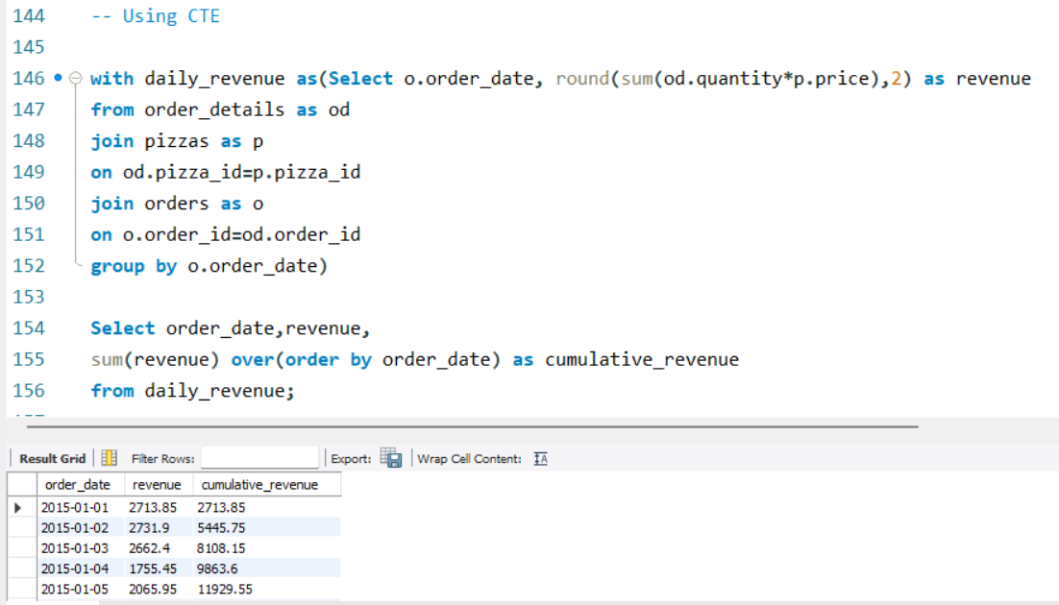**Insight:** Same as above, but modular using CTEs. Cleaner structure for reporting cumulative revenue trends.

## Q14: Top 3 most ordered pizza types based on revenue for each pizza category

**SQL Query:**

WITH pizza_revenue AS (  
 SELECT pt.name, pt.category, SUM(od.quantity * p.price) AS revenue  
 FROM pizzas AS p  
 JOIN pizza_types AS pt ON p.pizza_type_id = pt.pizza_type_id  
 JOIN order_details AS od ON od.pizza_id = p.pizza_id  
 GROUP BY pt.name, pt.category  
),  
ranked_pizzas AS (  
 SELECT name, category, revenue,  
 RANK() OVER(PARTITION BY category ORDER BY revenue DESC) AS rn  
 FROM pizza_revenue  
)  
SELECT category, name, ROUND(revenue, 2) AS total_revenue  
FROM ranked_pizzas  
WHERE rn <= 3  
ORDER BY category, revenue DESC;

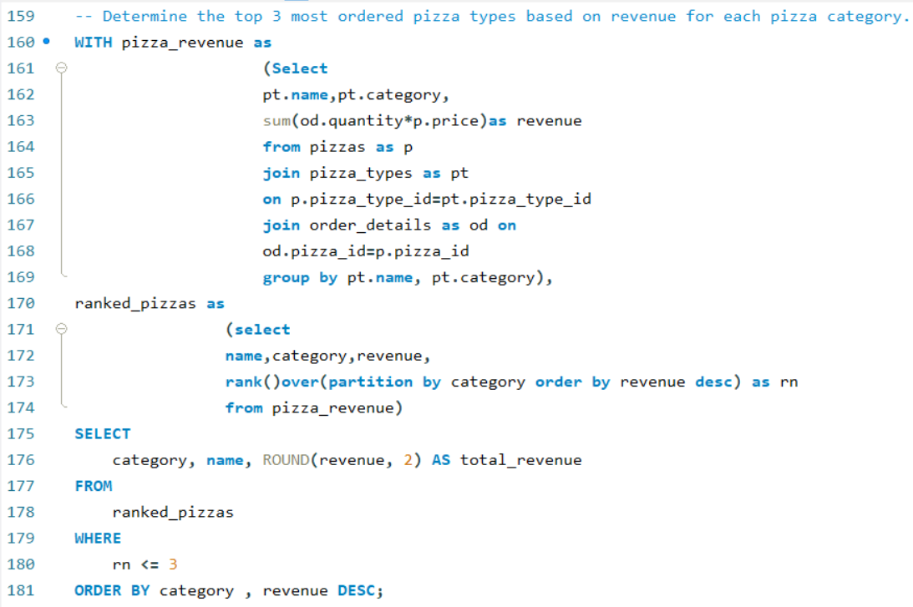 **Insight:** Provides category-specific top performers. Useful for targeted marketing and inventory optimization per pizza category.