UI Design for Web based Platform

# CRUD

|  |  |  |
| --- | --- | --- |
| **Operation** | **SQL** | **HTTP** |
| Create | [INSERT](https://en.wikipedia.org/wiki/Insert_(SQL)) | [PUT](https://en.wikipedia.org/wiki/PUT_(HTTP)) / [POST](https://en.wikipedia.org/wiki/POST_(HTTP)) |
| Read (Retrieve) | [SELECT](https://en.wikipedia.org/wiki/Select_(SQL)) | [GET](https://en.wikipedia.org/wiki/GET_(HTTP)) |
| Update (Modify) | [UPDATE](https://en.wikipedia.org/wiki/Update_(SQL)) | [PUT](https://en.wikipedia.org/wiki/PUT_(HTTP)) / [POST](https://en.wikipedia.org/wiki/POST_(HTTP)) / [PATCH](https://en.wikipedia.org/wiki/PATCH_(HTTP)) |
| Delete (Destroy) | [DELETE](https://en.wikipedia.org/wiki/Delete_(SQL)) | [DELETE](https://en.wikipedia.org/wiki/DELETE_(HTTP)) |

Ref: <https://en.wikipedia.org/wiki/Create,_read,_update_and_delete>

# Code Setup

XAMPP: [Download](https://www.apachefriends.org/download.html) and install

Run in PHPMyAdmin, the script: _create_db.txt

Copy the “crud” folder in “htdocs” folder of XAMPP

Visit <http://localhost/crud>

# Screen Shots

## Web Page # 1

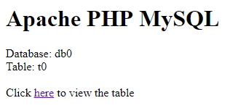

## Web Page # 2

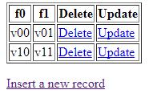

## Web Page # 3

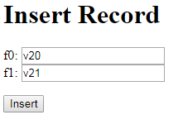

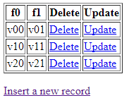

## Web Page # 4

[http://localhost/crud/update_input.php?**id=3**&f0=v20&f1=v21](http://localhost/crud/update_input.php?id=3&f0=v20&f1=v21)

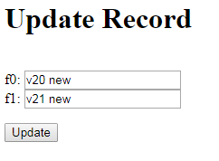

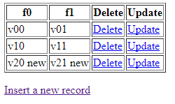

# Source Code

## Home page

<h1>Apache PHP MySQL</h1>

Database: db0<br>

Table: t0<br><br>

Click <a href=select.php>here</a> to view the table

## CRUD: Create (INSERT_input.php)

<h1>Insert Record</h1>

<form method=get action=insert_result.php>

f0: <input type=text name=f0> <br>

f1: <input type=text name=f1> <br>

<p>

<input type=submit value=Insert>

</form>

## CRUD: Create (INSERT_RESULT.php)

<?

$f0 = $_GET[f0];

$f1 = $_GET[f1];

$connect = mysql_connect("localhost", "root", "" )

or die("Can not connect");

mysql_select_db("db0")

or die("Can not select database");

mysql_query( "INSERT INTO t0 VALUES ( '', '$f0', '$f1' )" )

or die("Can not execute query");

echo "Record inserted:<br> f0 = $f0 <br> f1 = $f1";

echo "<p><a href=select.php>View all records</a>";

?>

## CRUD: Read (SELECT.php)

<?

$connect = mysql_connect("localhost", "root", "" )

or die("Can not connect");

mysql_select_db("db0")

or die("Can not select database");

$results = mysql_query( "SELECT * FROM t0" )

or die("Can not execute query");

echo "<table border> \n";

echo "<th>f0</th> <th>f1</th> <th>Delete</th> <th>Update</th> \n";

while( $rows = mysql_fetch_array( $results ) ) {

extract( $rows );

echo "<tr>";

echo "<td> $f0 </td>";

echo "<td> $f1 </td>";

echo "<td> <a href = 'delete.php?id=$id'> Delete </a> </td>";

echo "<td> <a href = 'update_input.php?id=$id&f0=$f0&f1=$f1'> Update </a> </td>";

echo "</tr> \n";

}

echo "</table> \n";

echo "<p><a href=insert_input.php>Insert a new record</a>";

?>

## CRUD: Update (UPDATE_INPUT.php)

<?

$id = $_GET[id];

$f0 = $_GET[f0];

$f1 = $_GET[f1];

?>

<h1>Update Record</h1>

<form method=get action=update_result.php>

<input type=hidden name=id value='<? echo $id; ?>'> <br>

f0: <input type=text name=f0 value='<? echo $f0; ?>'> <br>

f1: <input type=text name=f1 value='<? echo $f1; ?>'> <br>

<p>

<input type=submit value=Update>

</form>

## CRUD: Update (UPDATE_RESULT.php)

<?

$id = $_GET[id];

$f0 = $_GET[f0];

$f1 = $_GET[f1];

$connect = mysql_connect("localhost", "root", "" )

or die("Can not connect");

mysql_select_db("db0")

or die("Can not select database");

$query = "UPDATE t0 SET f0='$f0', f1='$f1' WHERE id = $id";

echo $query;

mysql_query( $query )

or die("Can not execute query");

echo "<p>Record updated:<br> f0 = $f0 <br> f1 = $f1";

echo "<p><a href=select.php>View all records</a>";

?>

## CRUD: Delete (DELETE.php)

<?

$id = $_GET[id];

$connect = mysql_connect("localhost", "root", "" )

or die("Can not connect");

mysql_select_db("db0")

or die("Can not select database");

mysql_query( "DELETE FROM t0 WHERE id=$id" )

or die("Can not execute query");

echo "Record deleted<br>";

echo "<p><a href=select.php>View all records</a>";

?>