- 
- MALAYSIAN INSTITUTE OF INFORMATION TECHNOLOGY
- UNIVERSITI KUALA LUMPUR

- BACHELOR OF INFORMATION TECHNOLOGY (HONS) IN COMPUTER SYSTEM SECURITY
FINAL YEAR PROJECT (FYP) PROPOSAL
TITLE: Spectra Chat: Forward-Secrecy Messaging with Blockchain Authentication and ZKP

- PREPARED BY:

- NAME : MOHAMMAD AZRI BIN AZIZ
- ID. NUMBER : 52215123264

For Office Use Only

 | Evaluator’s Comment: | Accept  Reject
 | Comments/ Remarks
 | Checked & Verified by:  ........................................  Name:  Designation:  Date: | Approved/Not Approved by:  ........................................  Name:  Designation:  Date:

- DETAILS OF THE STUDENT

Name
ID. Number
Semester
CGPA
Handphone Number
Email Address
Potential Supervisor
Signature & Stamped

Table of Contents

Page No.
1. Background of Study 3
2. Problem Statement 5
3. Objective 6
4. Scope 7
5. Significance of the Project 8
6. Literature Review 0
7. Methodology 0
Conclusion 3
References 4

Background of Study

Secure internal communication is critical for modern organisations, where sensitive business data, legal discussions, and regulated information are exchanged daily. Current enterprise messaging systems often depend on personal identifiers such as phone numbers or email addresses for authentication and rely on traditional encryption methods. These practices introduce two main risks:
- Privacy and compliance exposure — storing personal identifiers and metadata (such as contact graphs, timestamps, and communication patterns) can compromise user privacy and enable profiling.
- Key compromise risk — if long-term encryption keys are leaked or stolen, all past communications encrypted with those keys may be exposed.

This project proposes a privacy-first corporate messaging platform that addresses these risks. Authentication will be performed using Zero-Knowledge Proofs (ZKPs), allowing employees to prove their membership without revealing personal identifiers. To provide verifiable, tamper-evident registration and authentication records for audit and Single Sign-On (SSO) workflows, compact attestations (cryptographic commitments or transaction identifiers) of ZKP registrations will be stored on a permissioned blockchain, strictly limited to registration and authentication purposes.

For message protection, the system will implement Forward Secrecy (FS). Each communication session will generate unique, short-lived encryption keys that are securely discarded after use, ensuring that even if long-term keys are compromised, past messages remain confidential. All message exchanges will remain off-chain, preventing sensitive content or metadata from being written to the ledger.

By combining blockchain attestations (for verifiable membership), ZKPs (for privacy-preserving authentication), and Forward Secrecy (for long-term confidentiality), this project seeks to balance security, privacy, and auditability. The prototype will include client-side ZKP generation, a permissioned blockchain attestation service for registration/authentication, and an FS-enabled off-chain messaging module.

This work fills a practical gap in current literature and practice: while ZKPs, blockchain identity, and FS are studied separately, few implementations integrate them into a cohesive secure corporate messaging solution. The project will design, implement, and evaluate a prototype, measuring aspects such as authentication latency, proof sizes, client resource usage, and communication security, providing evidence for its feasibility and real-world adoption.

Problem Statement

- Reliance on personal identifiers and metadata leakage
Many modern messaging services require phone numbers, emails or other persistent identifiers for onboarding and account recovery. Even when message content is end-to-end encrypted, these identifiers plus associated metadata (who talks to whom, timestamps, contact graphs) enable profiling and can be as privacy sensitive as message content itself a serious issue for corporate internal communications.
Evidence: a formal analysis of WhatsApp shows that E2EE protects content, but that metadata can reveal social graphs and behavioural patterns; the authors conclude that encrypting payloads alone does not ensure privacy. Recent product changes that expand metadata use (e.g., new ad features tied to user activity) have renewed concerns about metadata handling.

- Risk of compromised encryption keys and lack of forward secrecy

Traditional messaging systems often rely on long-term encryption keys. If these keys are leaked, stolen, or exposed through insider threats, all past communications encrypted with the same key can be decrypted. This poses a severe risk to organisations handling sensitive business information, as a single compromise could expose entire archives of confidential communication.

Evidence: Studies on secure communication protocols emphasise that forward secrecy (FS) is essential for mitigating this risk. FS ensures that even if long-term keys are compromised, past sessions remain secure because each communication session generates short-lived, disposable keys that are discarded after use. This approach has been widely recommended in modern cryptographic protocol design (e.g., TLS 1.3).

Objective

- To study the current landscape of secure messaging and authentication
- Analyse commercial and academic messaging systems, identity providers, and federated architecture; review peer-reviewed literature and industry standards (e.g., NIST guidance). Particular attention will be given to confidentiality risks from personal identifiers and metadata, the role and trade-offs of forward secrecy in messaging, and design options for on-chain registration/authentication attestations (full proof vs commitment/hash vs tx ID), including privacy and legal/retention implications.

- To develop a confidentiality-focused messaging platform using ZKP, FS and blockchain attestations (registration/auth only)
- Design and implement a prototype in which user registration and ZKP-based membership attestations are recorded on a permissioned blockchain as compact, non-identifying commitments or transaction references; authentication validates clients against these attestations and issues short-lived JWTs for SSO. All message payloads remain off-chain and are protected by forward secrecy protocols (or hybrid classical schemes) to ensure confidentiality even if long-term keys are compromised.

- To test and evaluate the developed prototype
- Validate functional correctness of the ZKP registration/auth flow and FS-based messaging; perform security assessments (threat modelling, linkability/privacy analysis, cryptographic misuse checks, and penetration testing); and benchmark key performance metrics (authentication latency — proof generation + on-chain commit/confirmation, FS handshake latency, CPU/memory usage, message size overhead, and ledger storage growth) against a traditional E2EE baseline to quantify trade-offs and guide optimisation.

Scope

- Target Users: Employees and IT/security staff in corporate organisations

- System Functions
- Registration: ZKP-based registration where compact attestations (commitments/hashes or tx IDs) are recorded on a permissioned blockchain.
- Authentication: Membership verification at login by validating client proofs against on-chain attestations; issuance of short-lived JWTs referencing attestation tx IDs.
- Messaging: One-to-one and group messaging performed off-chain, protected by end-to-end encryption with forward secrecy (e.g., ephemeral key exchanges). No message content or message metadata is written to the ledger.

- Platform Used
- Programming Languages & Frameworks: JavaScript (Node.js, React.js), Python (for cryptographic modules)
- Blockchain Framework: Hyperledger Fabric (for ZKP-based registration & authentication)
- Cryptography Libraries: libsodium / OpenSSL (for Forward Secrecy and standard E2EE), snarkjs (ZKP)
- Database: MongoDB (distributed deployment)
- Server Infrastructure: Docker containers on distributed/fault-tolerant cloud instances
- Frontend: React.js web application
- Backend: Node.js with Express
- Development Tools: Visual Studio Code, Postman, Git

Significance of the Project

- This project equips corporate organisations with a privacy-centric internal messaging solution that registers and verifies membership via Zero-Knowledge Proofs anchored as compact attestations on a permissioned blockchain (registration/auth only). All message content remains off-chain and is protected using Forward Secrecy, thereby reducing identity exposure, strengthening long-term message confidentiality, enabling auditable SSO and compliance evidence, and providing empirical data to guide secure deployment choices.

Literature Review

No. | Citation | CIA Triad | Focus / Approach | Tools / Methods | Relevance / Key Findings
1 | Revathi, A. (2023). Enhancing Cloud Communication Security through Forward Secrecy Algorithms. | Confidentiality, Integrity | Proposed forward secrecy algorithms to secure cloud communication sessions against retrospective decryption. | Hybrid AES–RSA encryption; CloudSim simulation (encryption/decryption time, throughput). | Demonstrates how FS protects past communications even if long-term keys are leaked. Provides benchmarks useful for off-chain secure corporate messaging.
2 | Bhattacharya, S., et al. (2024). Enhancing Digital Privacy: The Application of Zero-Knowledge Proofs in Authentication Systems. | Confidentiality, Integrity | Explored how Zero-Knowledge Proofs can strengthen authentication by avoiding persistent identifiers. | Comparative study of zk-SNARKs, zk-STARKs, and Bulletproofs; theoretical and experimental analysis. | Shows ZKPs can improve privacy in user authentication, directly supporting identifier-free login in proposed system.
3 | Xiang, Z., et al. (2020). Secure Blockchain-based Single Sign-On with Zero-Knowledge Proof Authentication. | Confidentiality, Integrity, Availability | Developed a blockchain-based SSO framework that integrates ZKP for secure authentication and blockchain for tamper-proof records. | Prototype on Hyperledger Fabric; NIZKP authentication; empirical performance evaluation. | Confirms the feasibility of using blockchain + ZKP for enterprise authentication. Supports architecture of blockchain attestations for membership verification.
4 | Silonosov, A., & Henesey, L. (2025). Towards Cryptographic Agility Manifesto in End-to-End Encrypted Systems. | Confidentiality, Availability | Discussed the need for adaptable cryptographic mechanisms to sustain security in evolving environments. | Conceptual manifesto; maturity model for secure systems. | Stresses modular and flexible cryptographic design. Relevant for ensuring system can adapt FS and ZKP modules without major redesign.
5 | Rastogi, V., & Hendler, J. (2019). WhatsApp Security and Role of Metadata in Preserving Privacy. | Confidentiality | Investigated how metadata in WhatsApp communications undermines privacy despite end-to-end encryption. | Protocol analysis; traffic and metadata study. | Highlights the need to minimize metadata exposure. Supports your decision to keep messages and metadata off-chain in the proposed system.

Methodology
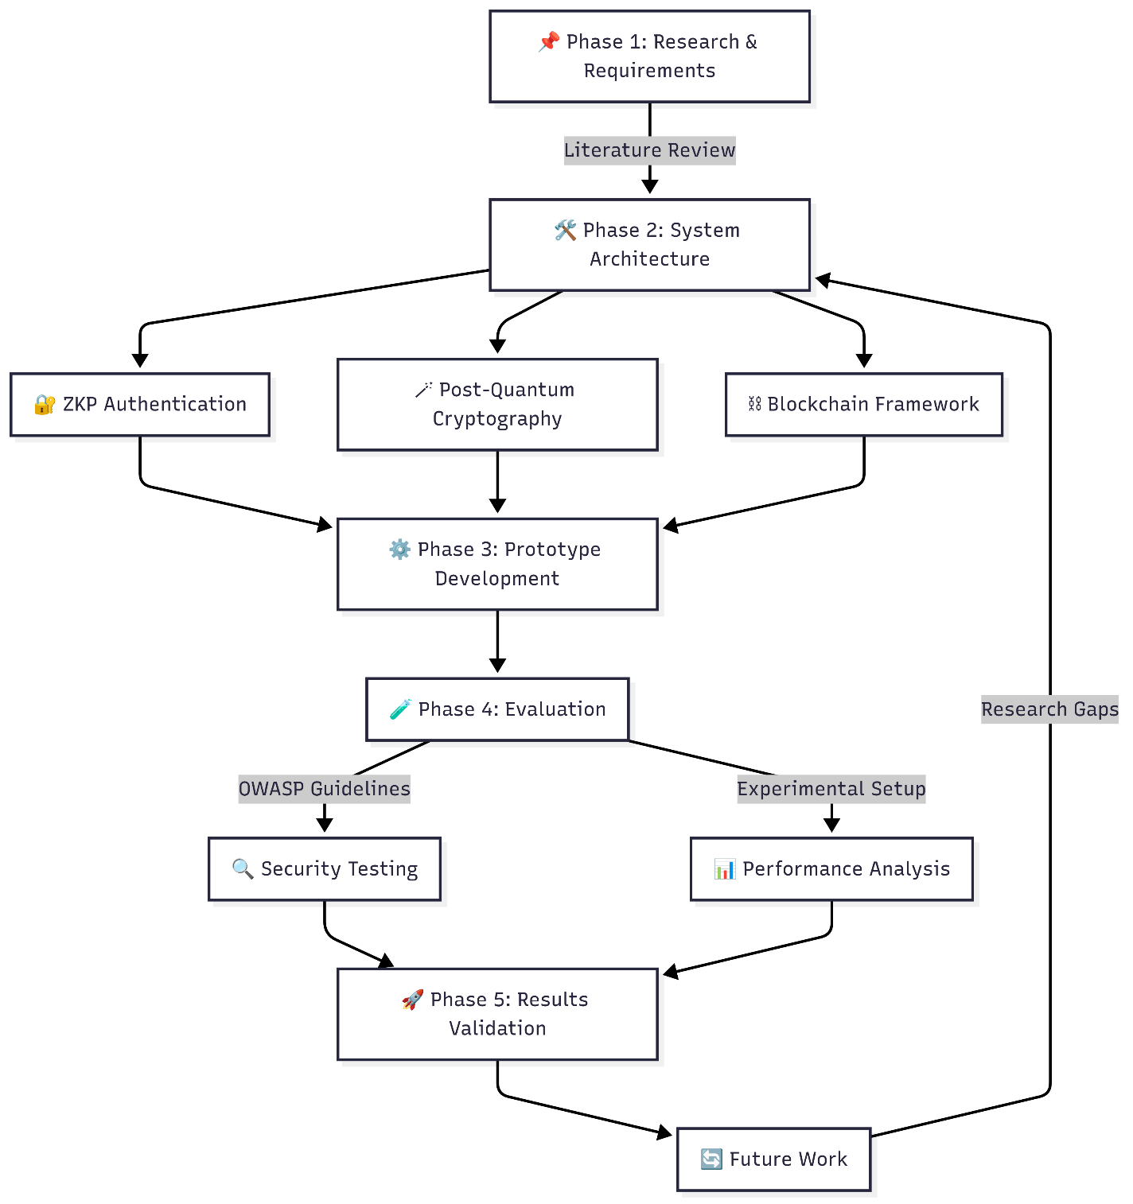

7.1 Development Model
This project adopts the Agile Software Development Model with iterative sprints. Agile is chosen due to its flexibility, adaptability to requirement changes, and suitability for research-driven prototypes involving advanced cryptographic techniques.
Phases:
- Planning & Requirement Analysis
  - Define functional and non-functional requirements based on literature review and industry needs.
  - Identify ZKP authentication methods, PQC algorithms, and blockchain integration scope.
- System Design
  - Create high-level architecture diagrams for client, backend, blockchain, and database components.
  - Select cryptographic libraries (e.g., liboqs, snarkjs) and blockchain framework (Hyperledger Fabric).
- Implementation
  - Develop the frontend (React.js) and backend (Node.js + Express).
  - Implement ZKP-based authentication on blockchain and PQC-based E2EE messaging.
- Testing & Evaluation
  - Perform unit, integration, and functional testing.
  - Conduct performance benchmarking and security testing (threat modelling, penetration testing).
- Deployment & Review
  - Deploy prototype on distributed cloud infrastructure.
  - Gather feedback from simulated organisational use cases.

7.2 Estimated Budget
Item | Specification / License Type | Estimated Cost (MYR)
Laptop (development) | Intel i7, 16GB RAM, 512GB SSD | 3,800 (Freeware)
Cloud VM instances (3 months) | 3 nodes, 4 vCPU, 8GB RAM each | 1,200
Domain & SSL Certificate | 1 year | 200
Development Tools & IDEs | Open-source (VS Code, Docker) | 0
Blockchain Framework | Hyperledger Fabric (open-source) | 0
Cryptography Libraries | Open-source (liboqs, snarkjs) | 0
Testing Tools | OWASP ZAP, JMeter (open-source) | 0
Total |  | 1400

- .

Conclusion
This project aims to develop a secure corporate communication platform that integrates Zero-Knowledge Proof (ZKP) authentication, Forward Secrecy (FS) encryption, and blockchain-based registration to protect user privacy, maintain long-term data confidentiality, and eliminate single points of failure. By addressing critical challenges such as reliance on personal identifiers, metadata leakage, and centralised system vulnerabilities, the proposed solution will enable organisations to adopt a privacy-first, resilient, and future-ready messaging system tailored for sensitive internal communications.

References
[1] M. K. Gajula and A. Akuthota, "Algorithms Built to Prevent Future Quantum Attacks: Post-Quantum Cryptography in Preparation for Quantum Computing Threats," 2023 IEEE International Conference on Quantum Computing and Engineering (QCE), Bellevue, WA, USA, 2023, pp. 256-263.
[2] A. Aydeger, J. M. Walker, and L. E. Oliveira, "Towards a Quantum-Resilient Future: Strategies for Transitioning to Post-Quantum Cryptography," IEEE Access, vol. 10, pp. 60123–60136, 2022.
[3] S. Bhattacharya, J. Jedlicka, and E. S. Grant, "Enhancing Digital Privacy: The Application of Zero-Knowledge Proofs in Authentication Systems," in Proceedings of the 2022 International Conference on Privacy, Security, and Trust (PST), Copenhagen, Denmark, Aug. 2022, pp. 45–54.
[4] A. Silonosov and L. Henesey, "Towards cryptographic agility manifesto in end-to-end encryption systems: a position paper from the perspective of crypto-consumers," in Proceedings of the 2021 International Conference on Information Security and Privacy (ICISP), Dec. 2021, pp. 11–20.
[5] N. Rastogi and J. Hendler, "WhatsApp security and role of metadata in preserving privacy," Journal of Cybersecurity and Privacy, vol. 1, no. 1, pp. 79–99, Mar. 2021.

