MALAYSIAN INSTITUTE OF
INFORMATION TECHNOLOGY
UNIVERSITI KUALA LUMPUR
MARCH 2026
2026
MOHAMMAD AZRI BIN AZIZ
52215123264
SECURE MESSAGING WITH ZERO KNOWLEDGE PROOF
AND INTELLIGENT THREAT DETECTION
BACHELOR OF INFORMATION TECHNOLOGY
(HONS.) IN COMPUTER SYSTEM SECURITY

SECURE MESSAGING WITH ZERO KNOWLEDGE PROOF
AND INTELLIGENT THREAT DETECTION

Dissertation Submitted in Fulfilment of Requirements
For Bachelor in Information Technology (Hons.)
Computer System Security
Malaysian Institute of Information Technology
University Kuala Lumpur

MARCH 2026
MOHAMMAD AZRI BIN AZIZ
52215123264

DECLARATION

I hereby declare that I carried out the work reported in this report in the Computer System security Section, Malaysian Institute of Information Technology, University Kuala Lumpur, under the supervision of Dr. Delina Beh Mei Yin. I solemnly declare that to the best of my knowledge; no part of this report has been submitted here or elsewhere in a previous application for the award of a degree. All sources of knowledge used have been duly acknowledged,


Signature: ......................................
Name: MOHAMMAD AZRI BIN AZIZ
STUDENT ID: 52215123264
DATE: 20/06/2026

DATE:

SIGNATURE: ………………………………….
SUPERVISOR: PROF. DR. MEGAT FAREEZ AZRIL ZUHAIRI
OFFICIAL STAMP:
DATE:

SIGNATURE: ………………………………….
SUPERVISOR: Dr. Delina Beh Mei Yin
OFFICIAL STAMP:
APPROVAL PAGE

We have supervised and examined this report and verified that it meets the program and University’s requirements for the Bachelor of Information Technology (Computer System Security) Honours.

DEDICATION

For my parents, your prayers and sacrifices are the reason I am here.
To my family, who never stopped believing in me,
Dr Delina Beh Mei Yin, who pushed me to be better and guided the way,
Friends since the glory days of MJII who became my foundation,
Lecturers, friends, to all the things in the world that I loved dearly.
And me. Always me..

Contents
CHAPTER 1: INTRODUCTION 1
1.1 Introduction 1
1.2 Background 1
1.3 Problem Statement 3
1.4 Objectives 3
1.5 Scope 4
1.5.1 Extent of Study and Measurements 4
1.5.2 Target Users 4
1.5.3 Project Features 4
1.5.4 Platform & Implementation 5
1.6 Significance of Study 5
1.7 Summary 5
CHAPTER 2: LITERATURE REVIEW 6
2.1 Introduction 6
2.2 Secure Internal Messaging and Insider Threats 6
2.2.1 Definition 6
2.2.2 Category 6
2.2.3 Common Features of Secure Messaging 6
2.2.4 Existing Secure Messaging and Threat Detection Methods 6
2.3 Zero-Knowledge Proofs (Authentication) 8
2.3.1 Definition 8
2.3.2 Category 8
2.3.3 Common Features of ZKP Authentication 8
2.3.4 Existing ZKP Authentication Methods 8
2.4 AI Anomaly Detection (On-Device) 10
2.4.1 Definition 10
2.4.2 Category 10
2.4.3 Common Features of On-Device AI 10
2.4.4 Existing AI Detection Methods 10
2.5 Summary 11
CHAPTER 3: METHODOLOGY 12
3.1 Introduction 12
3.2 Project Development 12
3.3 System Design 13
3.3.1 Misuse Case 13
3.3.2 Flowchart 15
3.3.3 Architecture Diagram 17
3.4 Phases of Development 18
3.5 Budget & Resources 18
3.6 Project Planning 19
3.7 Summary 20
CHAPTER 4: SYSTEM DEVELOPMENT 21
4.1 Introduction 21
4.2 Development Environment and Tools 21
4.2.1 Hardware and Operating System 22
4.2.4 Software Dependencies 23
4.3 System Architecture 25
4.4 Installation, Setup and Configuration 27
4.4.1 Backend Server Setup 28
4.4.2 Zero-Knowledge Circuit Compilation and Trusted Setup 28
4.4.3 Web Portal Setup 28
4.4.4 Mobile Application Setup 29
4.4.5 Machine-Learning Pipeline Setup 29
4.5 Implementation of the Core Security Modules 29
4.5.1 Module A: Zero-Knowledge Proof Authentication 29
4.5.2 Module B: End-to-End Encrypted Messaging 32
4.5.3 Module C: On-Device AI Threat Detection 33
4.6 User Interface and Experience Design 37
4.7 System Integration 39
4.8 Source Code Management and Version Evolution 41
4.9 Deployment Environment 41
4.10 Chapter Summary 42
CHAPTER 5: RESULT AND DISCUSSION 43
5.1 Introduction 43
5.2 Functionality Testing 43
5.2.1 Zero-Knowledge Authentication 44
5.2.2 End-to-End Encrypted Messaging 44
5.2.3 On-Device Threat Detection 44
5.2.4 Admin Controls and Alerts 44
5.2.5 Results 44
5.3 Vulnerability and Static Scanning 45
5.4 Penetration and Security Testing 46
5.4.1 Confidentiality Testing 46
5.4.2 Integrity Testing 47
5.4.3 Availability and AAA Testing 47
5.5 Machine-Learning Detection Performance 48
5.6 Performance and Latency 52
5.7 User Acceptance Testing 52
5.8 Discussion 54
5.9 Summary 54
CHAPTER 6: CONCLUSION 55
6.1 Introduction 55
6.2 Project Conclusion 55
6.3 Discussion of Findings 55
6.4 Achievement of Objectives 56
6.4.1 Objective 1 56
6.4.2 Objective 2 57
6.4.3 Objective 3 57
6.5 Limitations 57
6.6 Future Recommendations 58
6.7 Commercialization 59
6.8 Summary 59
REFERENCES 60
APPENDICES A 62
APPENDICES B 64

LIST OF FIGURES

Figure 3.1: RAD Project Development Model 14
Figure 3.2: Misuse Case of SentriZK 15
Figure 3.3: Flowchart of project 17
Figure 3.4: Architecture diagram of project 18
Figure 3.6: Project Gantt Chart Summary 21
Figure 4.1: SentriZK Full System Architecture 26
Figure 4.2: Component Diagram of the Flutter Mobile Application 28
Figure 4.3: Zero-Knowledge Registration Flow 31
Figure 4.4: Zero-Knowledge Login Flow with Nonce-Bound Session 31
Figure 4.5: Signal Protocol End-to-End Encrypted Messaging 33
Figure 4.6: On-Device TensorFlow Lite Threat-Detection Pipeline 35
Figure 4.7: URL Phishing-Detection Architecture 35
Figure 4.8: Mobile Application User Interface (representative screens) 37
Figure 4.9: Web-Based Administrator Panel 38
Figure 4.10: SentriZK Web Administrator Panel — (a) Secure Login Screen (b) Command-Centre Dashboard 39
Figure 4.11: Session Lifecycle and Security 40
Figure 4.12: Deployment and Infrastructure Architecture 41
Figure 5.1: Per-Class Classification Metrics (Bi-LSTM vs Conv1D) 48
Figure 5.2: Confusion Matrices on the 1,148-Message Validation Set 48
Figure 5.3: Model Performance Comparison Against the 90% Target 48
Figure 5.4: Predicted Threat-Score Distribution by True Class (Conv1D) 50
Figure 5.5: Receiver Operating Characteristic (ROC) Curves 51
Figure 5.6: User Acceptance Testing — Mean Score per Question (n = 5) 53
LIST OF TABLES

Table 2.1: A comparison of existing secure messaging and threat detection studies 7
Table 2.2: A comparison of existing ZKP authentication methods 9
Table 2.3: A comparison of existing AI anomaly detection methods 11
Table 3.1: Project architecture with layer classifications 18
Table 3.2: Budget for Hardware 20
Table 3.3: Software and price 20
Table 4.1: Development and Test Hardware 23
Table 4.2: Core Framework of Each System Tier 23
Table 4.3: Principal Backend Dependencies 24
Table 4.4: Principal Web Portal Dependencies 24
Table 4.5: Principal Mobile Application Dependencies 25
Table 4.6: Backend Environment Configuration 29
Table 4.7: Zero-Knowledge Circuit Parameters 30
Table 4.8: On-Device Threat-Detection Model 34
Table 4.9: Iterative Version Evolution of the Prototype 41
Table 5.1: Overview of Testing Types 43
Table 5.2: Functional Test Cases and Results 44
Table 5.3: Dependency Vulnerability Scan (npm audit) 45
Table 5.4: Confidentiality Test Results 46
Table 5.5: Integrity Test Results 47
Table 5.6: Availability Test Results 47
Table 5.7: AAA Model Mapped to Implemented Controls 47
Table 5.8: Model Performance Comparison 48
Table 5.9: Machine-Learning Detection Functional Tests 51
Table 5.10: Indicative Performance Measurements 52
Table 5.11: User Acceptance Questionnaire and Mean Results 52
Table 5.12: Individual Participant Responses (n = 5) 53
Table 6.1: Achievement of the Project Objectives 56
Table 6.2: Limitations and Corresponding Recommendations 57
LIST OF ABBREVIATIONS

AI Artificial Intelligence 1
E2EE End-to-End Encryption 1
MFA Multi-Factor Authentication 1
ZKP Zero-Knowledge Proof 1
RAD Rapid Application Development 2
zk-SNARK Zero-Knowledge Succinct Non-Interactive Argument of Knowledge 4
PDPA Personal Data Protection Act 6
ML Machine Learning 8
SLR Systematic Literature Review 8
SoK Systematization of Knowledge 8
NI-ZKP Non-Interactive Zero-Knowledge Proof 9
IoT Internet of Things 10
CNN Convolutional Neural Network 11
AES Advanced Encryption Standard 18
MAT Mobile Access Token 19
SME Small and Medium Enterprise 19
UAT User Acceptance Testing 19
RM Ringgit Malaysia 20
API Application Programming Interface 22
IDE Integrated Development Environment 23
JWT JSON Web Token 24
DTLS Datagram Transport Layer Security 25
Conv1D One-Dimensional Convolutional Neural Network 34
UI User Interface 41
AAA Authentication, Authorisation and Accounting 43
CIA Confidentiality, Integrity and Availability 43
SSE Server-Sent Events 44
APK Android Package Kit 46
AUC Area Under the Curve 48
Bi-LSTM Bidirectional Long Short-Term Memory 48
ROC Receiver Operating Characteristic 48
TFLite TensorFlow Lite 48
IETF Internet Engineering Task Force 60
MLS Messaging Layer Security 60
LOA Letter of Acceptance 62

ABSTRACT

This project addresses the ongoing challenge of securing internal messaging for small and medium enterprises (SMEs). Currently, many firms make use of collaboration platforms that keep the user credentials stored at a central server; thus, making it impossible for such tools to identify any threat after messages have been encrypted. Though these traditional systems help users communicate, there are certain security flaws in them, and thus, user information becomes vulnerable to attacks like credential theft and social engineering attacks. It is important to take preventive measures in order to protect internal corporate communications. Therefore, 'SentriZK', a secure internal chat application, is the proposed research topic to settle the conflict between privacy and security. This system integrates Zero-Knowledge Proof (ZKP) authentication, end-to-end encryption (E2EE), and on-device artificial intelligence (AI) threat detection to provide a safe, self-hosted messaging environment.

CHAPTER 1: INTRODUCTION

Introduction
This project’s accomplishments are driven by a sole topic of internal communication security, a digital challenge that is normal to occur across small and medium enterprises (SMEs). As compromised messaging has numerous side effects towards the company, its employees and the private data, domain authorities have developed multiple solutions. In terms of workplace collaboration domain, organizations have taken multiple initiatives to provide a solution that aligns with the current technological advancement.
This initiative includes utilizing centralized platforms and end-to-end encryption (E2EE) that provides data protection while it travels across the network. While one side recognizes the pros of implementation, the opposite side discovers the opportunity to channel a radical influence on the system. Seeing the potential threats such as credential theft on shared hubs and the spread of malicious anomalies through encrypted blind spots, it is wise to plan and develop methods to protect the confidentiality, integrity and availability of the system. Therefore, ’SentriZK’, a framework integrating Zero-Knowledge Proof (ZKP) and on-device Artificial Intelligence (AI), is the current proposed topic for research to guard against internal and external malicious threat.

Background
Teams rely on messaging apps to communicate at work. Most of these apps use standard login methods that come with built-in risks. Usually, companies store passwords in a single central database. Even if these passwords are hashed and salted, having them all in one place creates a huge target. If a hacker breaches that main database, the entire system is compromised. Because of this setup, credential theft continues to be a massive problem for businesses every year.
Beyond just passwords, stolen session tokens create another major headache. When attackers hijack these tokens, they can bypass extra security steps like Multi-Factor Authentication (MFA) entirely. This gives them direct access to read private company chats. Recent studies on enterprise messaging (2025) point out that relying on a central trust system is just too risky. A breach here doesn't just expose messages; it can completely disrupt a company's daily operations and cause serious financial damage.
Security experts have looked at a few ways to fix these login flaws. Zero-Knowledge Proofs (ZKP) take a completely different approach. Research from 2024 shows that protocols like zk-SNARKs let a system verify who someone is without sending any actual personal data over the internet. Instead of typing out a password and sending it to the server, the user's device proves they know the password using math. The server never sees, receives, or stores the actual secret.
Logging in safely is only half the battle. Companies still have to deal with insider threats spreading through their own networks. End-to-end encryption (E2EE) does a great job keeping outside snoops away, but it also blindfolds the company's own security team. Traditional server-side scanners cannot read encrypted messages. Because the server cannot see the chat content, a malicious employee could easily send phishing links or malware directly to coworkers without triggering any alarms.
Catching these hidden threats inside encrypted chats is a growing research area. A 2022 review on anomaly detection found that Deep Learning handles complex chat data much better than standard Machine Learning. The catch is that Deep Learning requires heavy processing power. Normally, you would run this on a big cloud server. However, you cannot do that if the messages are end-to-end encrypted, since the cloud server cannot read them anyway.
To get around the cloud problem, some researchers suggest moving the threat detection directly onto the user's phone. Recent studies from 2025 looking at AI tools like Tiny BERT and the PHILDER framework prove that small AI models work great on mobile devices. Running directly on an Android phone, these models can hit an accuracy of 96% or higher. Processing the data locally means zero network delay and absolute privacy, since the data never leaves the device. Still, most of the tools available today just look for spam SMS texts or isolated bad links. They don't actively monitor behavior inside a secure corporate chat app.
While ZKP and Edge AI are both incredibly powerful, developers rarely combine them into a single messaging tool for small and medium enterprises (SMEs). Most existing platforms force a trade-off. They either lock everything down with encryption and lose threat visibility, or they scan everything centrally and destroy user privacy. This project aims to build a better alternative using the Rapid Application Development (RAD) method. By putting the Groth16 ZKP protocol and on-device TensorFlow Lite AI together, this application stops credential theft and catches internal threats—all while keeping the user's private data strictly on their phone.

Problem Statement
Let's look at the first major issue: how workplace chat apps manage user logins. Right now, most systems store everyone's credentials in one central spot. For a small or medium-sized business, this is a huge risk because it creates a single point of failure. Even if companies hash their passwords and store them locally, a single database breach puts the whole network in danger. Just look at the Slack hack in 2023. Attackers managed to steal session tokens, completely sidestepped multi-factor authentication, and got straight into private company chats. Storing secrets on a server is just too dangerous once a hacker gets inside. That is why we need to drop traditional passwords and switch to Zero-Knowledge Proof (ZKP) authentication. ZKP changes the game because the server only keeps mathematical commitments. If a hacker breaches the system, they walk away with nothing useful.
The second big problem comes from End-to-End Encryption (E2EE). E2EE is great for keeping outsiders from snooping on company data. But it also blocks the company's own security software from scanning the chats. Because the main server literally cannot read the messages, hackers or rogue employees can easily share malware or phishing links right in the middle of normal work conversations. We have seen this happen a lot recently with malicious Discord invites. This blind spot is a serious threat because it allows hidden risks to spread across the network unchecked. To fix this, we need to run threat detection directly on the user's phone or computer using local AI. This approach catches threats exactly where the data lives. It monitors behavior offline and keeps everything completely private, meaning user data never gets exposed to a central server.

Objectives
This project focuses on building a secure internal chat application specifically for small and medium enterprises (SMEs). By combining Zero-Knowledge Proof (ZKP) authentication with on device AI, the system handles workplace messaging safely. The main goal is to completely remove the risk of stolen passwords, catch internal threats, and keep user data private. To reach this goal, the project breaks down into three specific objectives:.
- To study the security vulnerabilities in current internal messaging platforms and analyse the limitations of centralised logins and threat detection.
- To develop a secure chat application that can prevent credential theft using ZKP authentication and spot anomalies directly on the user's device.
- To test the system functionality, perform security vulnerability assessments, and evaluate the AI detection accuracy of the newly implemented application.

Scope
Setting clear boundaries keeps the research focused. This section breaks down what the application actually does, who it is built for, and how the team put it together.

1.5.1 Extent of Study and Measurements
The main goal here is to build a working, secure chat application for small and medium enterprises (SMEs). It needs to stop credential theft and catch malicious links. Most importantly, it has to do all this without overloading standard phone hardware.

1.5.2 Target Users
This app is built for SME staff and managers. People in finance, human resources, and IT handle sensitive business data every single day. They need tight data protection, but they shouldn't need a computer science degree just to send a message. The design ensures that employees with any tech skill level can use it easily, so the added security never slows down their actual work.

1.5.3 Project Features
The app mixes normal messaging tools with heavy security features.
- Zero-Knowledge Proof (ZKP) Authentication
We use the Groth16 zk-SNARK protocol so users can prove who they are without sending passwords over the internet. The phone does the math offline, meaning the server never sees or holds the actual login data.
- On-Device AI Threat Detection
The app uses TensorFlow Lite to run AI checks right on the phone. It scans messages and typing patterns instantly to spot phishing links or risky behavior. The private chat data never goes to a remote cloud server.
- Mobile Application Interface
Built with Flutter, the app is simple to navigate. If the AI spots danger, a red warning banner pops up immediately, giving the user a clear visual warning before they click a bad link.
- Cryptographic Circuit Integration
Custom math circuits built with Circom run the heavy security tasks directly on the user's device. This guarantees that even if a hacker breaches the main server, they get absolutely nothing.

1.5.4 Platform & Implementation
The final product is an Android mobile application. The team used Visual Studio Code and Android Studio to write the code, and a Node.js backend handles the ZKP proofs. Everything is fine-tuned to make sure standard mobile phones can handle the math-heavy security tasks smoothly without draining the battery.

1.6 Significance of Study
This project matters a lot to SMEs because they usually have to make a tough choice: keep chats completely private, or scan them to catch security threats. This app gives them a third option: using math and local AI to do both at the same time.
First, it completely removes the risk of stolen passwords. Hackers constantly target central corporate databases. By using ZKP authentication, the server holds zero actual credentials. If a breach happens, the attacker leaves totally empty handed.
Second, running the AI threat checks directly on the phone is a game changer for privacy. Normally, security tools have to read decrypted chats on a central server, which causes massive privacy and legal headaches under laws like the PDPA. Doing this right on the device catches phishing links without spying on staff.
Finally, this project proves that regular Android phones can actually handle heavy encryption and AI models. People often assume these technologies are just too slow for mobile. This app shows business owners that they can get enterprise-level security on consumer-grade phones without ruining the daily chat experience.

1.7 Summary
This chapter laid out the current problems with workplace chats and introduced the SentriZK solution. By identifying the main privacy risks transparently, we have a clear and practical path forward. The next chapter moves into the Literature Review, where we compare existing communication platforms and security setups before diving into the actual coding and final testing results.

CHAPTER 2: LITERATURE REVIEW

2.1 Introduction
A literature review simply gathers and summarizes the existing research on a specific topic. It helps figure out what experts already know, what is actually new, and what ideas are widely accepted. A solid review looks at past projects and compares them to guide new work. By looking at what others have already done, we can push the technology forward without repeating the same old mistakes..

2.2 Secure Internal Messaging and Insider Threats
This section briefly explains what secure workplace messaging and insider threat detection actually mean, how they are grouped, and their main features.

2.2.1 Definition
Secure internal messaging simply means using encrypted company chat systems so outsiders cannot intercept data as it travels. Insider threat detection means watching this chat environment to spot rogue employees or hacked accounts. The trick is doing this without letting the central server read the actual private messages.

2.2.2 Category
Security methods for messaging usually drop into three buckets. First is opportunistic encryption, which just blocks basic snooping by default. Second involves manual checks, like having users scan a QR code to prove their encryption keys match. Third is behavioral analysis, which looks for weird user actions to catch internal threats.

2.2.3 Common Features of Secure Messaging
Common features include End-to-End Encryption (E2EE) to shield data as it travels, endpoint security protocols, metadata protection, and continuous threat modeling to identify vulnerabilities in file sharing and chat architecture.

2.2.4 Existing Secure Messaging and Threat Detection Methods
In Table 2.1, there is a comparison of existing secure messaging studies that specify the method, strengths, and weaknesses.
Table 2.1: A comparison of existing secure messaging and threat detection studies.

Author / Year | Focus | Method / Technology | Strength | Weakness
Alatawi & Saxena, 2023 | Analysis of E2EE and Authentication Ceremonies | Systematization of Knowledge (SoK) analyzing 17 E2EE apps. | Extremely comprehensive scope. Clearly identifies human error as the weak link in E2EE. | Diagnoses the problem effectively but suggests recommendations rather than building a novel solution.
Srinivasan et al., 2025 | Insider Threat Detection Leverging Bi-LSTM | Bidirectional LSTM (Deep Learning) for time-series data. | High detection accuracy for understanding the context of user actions over time. | Computationally heavy models that usually require a central server, making it hard for mobile edge computing.
Alzaabi & Mehmood, 2024 | Review of ML Methods for Insider Threats | Systematic Literature Review (SLR) of Supervised, Unsupervised, and DL. | Excellent overview of the current state of the art in machine learning. | Does not propose a new tool, and notes that AI models often lack explainability.
Ilesanmi , 2025 | Threat Modeling for Enterprise Messaging | Threat Modeling mapping architecture diagrams for enterprise apps. | Very specific to chat app vulnerabilities, highlighting endpoint security gaps. | Focuses heavily on finding architectural problems rather than building a software solution.

2.3 Zero-Knowledge Proofs (Authentication)
The section below contains a brief definition, type, and generic features of Zero-Knowledge Proof authentication.

2.3.1 Definition
Zero-Knowledge Proof (ZKP) is a cryptographic technique that allows a user to prove their identity or knowledge of a password to a server without ever revealing the actual password. It ensures data privacy because the server only receives and verifies a mathematical commitment.

2.3.2 Category
ZKP algorithms are commonly categorized into zk-SNARKs (efficient, small proof sizes), zk-STARKs (transparent, no trusted setup, quantum resistant), and general Non-Interactive Zero-Knowledge Proofs (NI-ZKP) tailored for environments with unstable connections.

2.3.3 Common Features of ZKP Authentication
ZKP systems eliminate the need for centralized credential storage. The most important aspects include auditability without visibility, high computational math on the client side, and the prevention of credential theft even if the server is fully breached.

2.3.4 Existing ZKP Authentication Methods
In Table 2.2, there is a comparison of existing ZKP authentication frameworks that specify the method, strengths, and weaknesses.
Table 2.2: A comparison of existing ZKP authentication methods.
Author / Year | Focus | Method / Technology | Strength | Weakness
Bhattacharya et al., 2024 | Application of ZKP in Authentication Systems | Comparative Analysis of zk-SNARKs and zk-STARKs. | Distinguishes protocols clearly and shows ZKP offers superior privacy over hashed passwords. | Acknowledges that high computational complexity acts as a major barrier to adoption.
Chen et al, 2023 | Zero-Knowledge Authentication for IoT | Survey comparing NI-ZKP and Sigma protocols for weak devices. | Directly validates the use of lightweight ZKP (Groth16) on restricted, low-battery hardware. | Focuses on IoT sensors rather than smartphone applications.
Luong & Park , 2023 | Privacy Identity on Blockchain using zk-SNARK | System implementation using Ethereum and ZoKrates/Circom. | Provides practical implementation details for absolute privacy preservation. | Blockchain architecture creates high gas costs and might be overkill for a simple chat app.
Mishra & Gupta, 2025 | Privacy-Preserving Analytics in Healthcare | Framework design for checking sensitive data validity. | Demonstrates high-stakes trust, achieving auditability without data leakage. | Requires a highly complex setup for multiple organizations to use together.

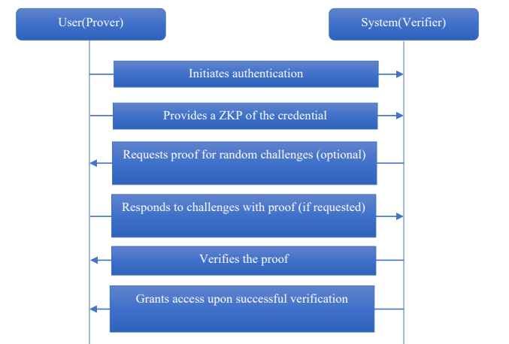
Fig. 2.3.1.1 Zero-Knowledge Proof Sequence Diagram

2.4 AI Anomaly Detection (On-Device)
The section below contains a brief definition, type, and generic features of local AI anomaly detection.

2.4.1 Definition
On-device AI anomaly detection, also known as Edge AI, pushes machine learning tasks directly to the user's hardware (like a smartphone) to monitor for suspicious activities. It analyzes behavioral patterns or malicious links locally without sending private user data to a centralized cloud.

2.4.2 Category
These threat detection setups generally fall into a few technical groups. Some rely on standard Machine Learning models like SVM or Random Forest. Others use heavier Deep Learning networks, such as CNNs and LSTMs. Recently, developers have also started using hybrid models like TinyBERT. They specifically shrink and compress these hybrid models so they can run smoothly on standard mobile phone chips.

2.4.3 Common Features of On-Device AI
The main draw of running AI directly on the device is that it processes data almost instantly. It handles risk checks completely offline. The system pulls contextual clues, like scanning the structure of a weird URL or analyzing how a person types. Above all else, it guarantees strict data privacy because the information never leaves the phone.

2.4.4 Existing AI Detection Methods
In Table 2.3, there is a comparison of existing anomaly detection studies that specify the method, strengths, and weaknesses.
Table 2.3: A comparison of existing AI anomaly detection methods.
Author / Year | Focus | Method / Technology | Strength | Weakness
Natha et al., 2022 | Review of ML/DL for Anomaly Detection | Systematic Review of SVM, k-NN, CNN, and Autoencoders. | Highlights how Deep Learning outperforms traditional ML on complex, noisy data. | High accuracy in DL usually demands heavy bandwidth and high computational power.
Gaurav et al., 2025 | Smishing Detection in Android Devices | Hybrid Deep Learning using TinyBERT and Aquila Optimization. | Achieved 96.81% accuracy, tailored specifically for Android platforms. | Transformer models can still cause battery drain if optimization is not handled perfectly.
Bispo et al ,2025 | PHILDER Phishing Detection | Experimental implementation of a compressed DL model on ARM. | Achieved high accuracy with very low latency (<100ms) and minimal privacy risks. | The framework is strictly limited to URL detection and ignores file attachments.
Karim et..., 2023 | Hybrid ML Phishing Detection based on URL | Hybrid model combining shallow learning and deep features. | Extracts lexical features effectively and performs better than any single model alone. | Hybrid models are often larger and slower, which is tricky to implement on mobile.

2.5 Summary
This chapter explores the insights of secure messaging, insider threats, Zero-Knowledge Proof authentication, and on-device AI anomaly detection that are fairly important to take note of in order to develop a privacy-compliance internal chat application. Existing studies are pivotal for this project to ensure that current project development achieves its objectives while also reflecting on previous experiments and avoiding known computational bottlenecks.

CHAPTER 3: METHODOLOGY

3.1 Introduction
Methodology is the underlying approach and justification for a research effort. It entails researching the methods utilized, as well as the theories or principles that are behind them, in order to create a strategy that is appropriate for current goals. This chapter will extend the study in terms of project development, software implementation, system process, system design, architecture, flowcharts, misuse cases, and the final budget needed to bring the secure messaging tool to life.

3.2 Project Development
Rapid Application Development (RAD) is a flexible approach to project management that emphasizes the speedy delivery of software. RAD comes with the concept of breaking a project down into small, manageable components, building them quickly, and testing them as they are developed. This will allow them to concentrate on the top priority features and adjust if needs change.
This methodology is well suited for the SentriZK project. Building this application required working on three complicated security elements at the exact same time: Zero-Knowledge logins, end-to-end encryption (E2EE), and a local AI threat scanner. RAD enabled rapid prototyping and facilitated showing the stakeholders working models for feedback. Cryptographic requirements are hard to get right on paper, and fast prototypes served to test the UI and security features early on in the process. Smaller, isolated pieces also allowed the team to identify and address security vulnerabilities in a timely manner without having to pause development of other parts of the app.
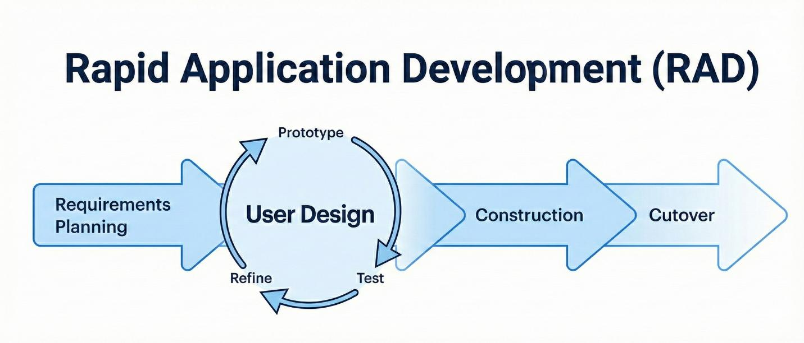
Figure 3.1: RAD Project Development Model

3.3 System Design
System design maps out the backend models, user flows, and behavioral processes that make the application fully functional and secure.

3.3.1 Misuse Case
While a standard use case shows how a normal user interacts with software, a misuse case maps out how an attacker could intentionally harm the system. Modeling threats like database breaches or replay attacks helps design better defenses to protect user privacy and data integrity.
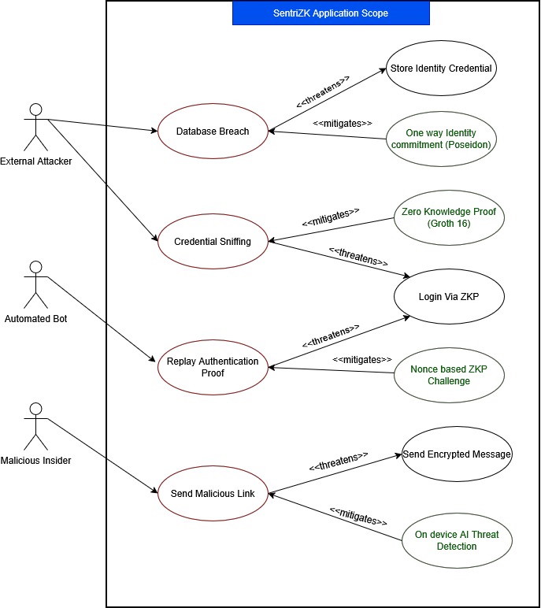
Figure 3.2: Misuse Case of SentriZK
SentriZK is designed to mitigate potential attacks in the client app, network and on the server. Any network traffic can be sniffed, credentials can be lifted from session tokens, or credentials can be stolen from the database. To mitigate such attacks, the system uses Zero-Knowledge Proofs (ZKP) and End-to-End Encryption. As a result of all the tools, if an attacker has a complete server breach, he or she will only find mathematical commitments, not actual employee passwords.

3.3.2 Flowchart
The system's operational flow starts the moment a user authenticates their device. If the mathematical ZKP check fails, the server instantly drops the connection. If it succeeds, the user gets access to the chat interface.

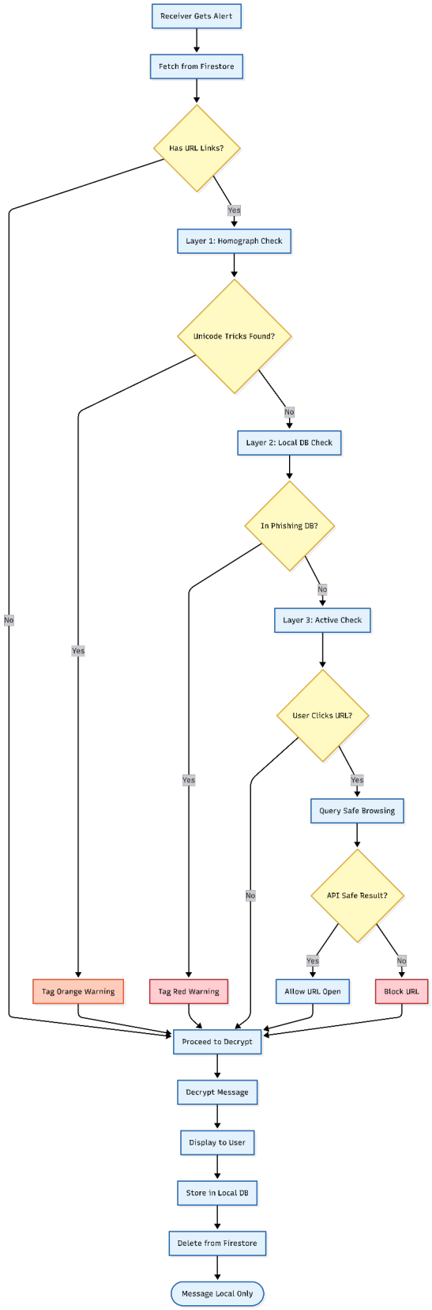
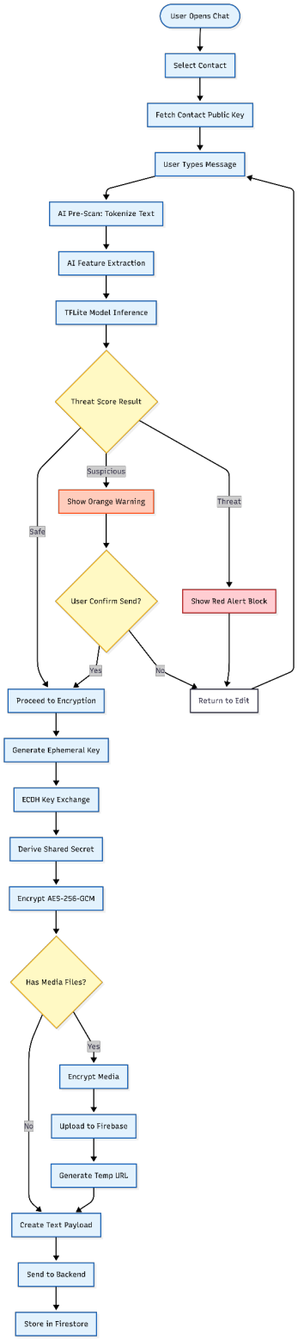
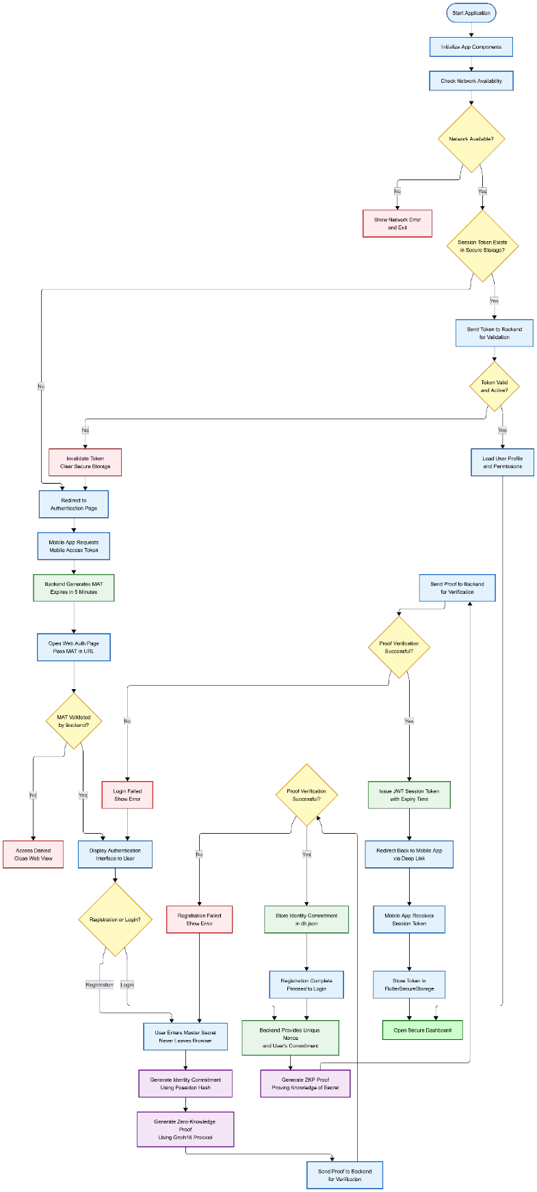
Figure 3.3: Flowchart of project.

As the user types a message, the built-in TensorFlow Lite AI model scans the text locally. The model checks for common phishing and social engineering patterns. If it flags a critical threat, a warning banner flashes on the screen before the message can even be sent. If the user decides to proceed, the phone encrypts the message payload using AES-256 and sends it over the network to the database, keeping the data secure and tamper-proof.

3.3.3 Architecture Diagram
The system structure divides into three core layers: the client device, the network tunnel, and the backend server application. Table 3.1 details exactly what happens at each stage of the process to keep company data safe.
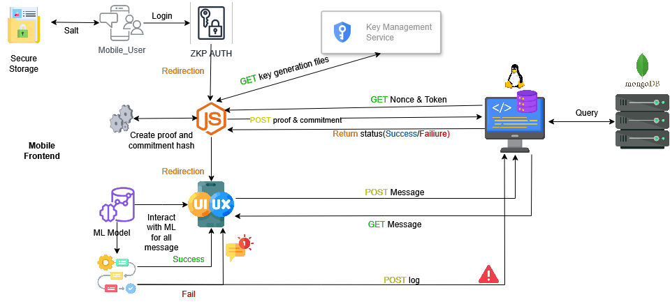
Figure 3.4: Architecture diagram of project.
As shown in Table 3.1, the layers classify each process that occurs to keep the data secure.

Table 3.1: Project architecture with layer classifications.
Layer | Process
Client Device Layer | User inputs message into the Flutter application.  TensorFlow Lite AI model scans text for anomalies locally.  App encrypts payload using AES-256 (E2EE).  App generates ZKP mathematical proof for secure login.
Network Layer | Transmits encrypted ciphertexts and mathematical proofs.  Operates purely as a tunnel, unable to read message content.
Server Application Layer | Server receives login request.  Node.js backend verifies the ZKP proof using a Verification Key.  Match grants user access and stores encrypted blob in DB.  Mismatch rejects data and drops connection.

3.4 Phases of Development
Based on the RAD framework, the development of SentriZK was divided into four phases to ensure seamless integration among all the security modules.
Phase 1: Requirements Planning: Collected open source phishing datasets for training a text classification model. Consulted the official Signal Protocol standards to confirm the minimum encryption standard is acceptable in the industry.
Phase 2: User Design: Created sequence diagrams to represent the design of how the Mobile Access Token (MAT) processes ZKP registration and how ephemeral cryptographic keys can be exchanged securely without revealing information to the server.
Phase 3: Construction: Emphasis on a lot of code. Created custom cryptographic circuits using Circom for logins, coded the AES-256 encryption protocol and trained the machine learning model before optimizing it to a TensorFlow Lite file to run on mobile devices.
Phase 4: Cutover: Took part in full integration testing for checking the mobile UI lag. Prototyped real database hacks to verify that there was no readable plain text data remaining on the server and conducted Hands On User Acceptance Testing (UAT) with normal SME staff.

3.5 Budget & Resources
Hardware and software implementation is crucial to demonstrate a fully functioning process to achieve a proven enhanced defense system. The components include development workstations, a mobile testing device, and a self-hosted Raspberry Pi server to eliminate cloud hosting fees for SMEs. The approximate cash expenditure of this project is RM 80.00.
Table 3.2: Budget for Hardware
Hardware | Category | Price (RM) | Quantity | Total (RM)
Lenovo Legion Laptop | Asset (Existing) | 4,500.00 | 1 | 0.00
Android Test Phone | Asset (Existing) | 800.00 | 1 | 0.00
Raspberry Pi 5 (8GB) | Asset (Existing) | 400.00 | 1 | 0.00
Domain Name (.com) | Cash Expenditure | 80.00 | 1 | 80.00
Grand Amount (MYR) |  |  |  | 80.00

Table 3.3 displays the list of software utilized and the price of the chosen software.
Table 3.3: Software and price.
Software | Price
Flutter / Dart | Open-source
Node.js & Next.js | Open-source
TensorFlow Lite | Open-source
SnarkJS & Circom | Open-source
Firebase & Cloudflare Tunnel | Free Tier / Open-source

3.6 Project Planning
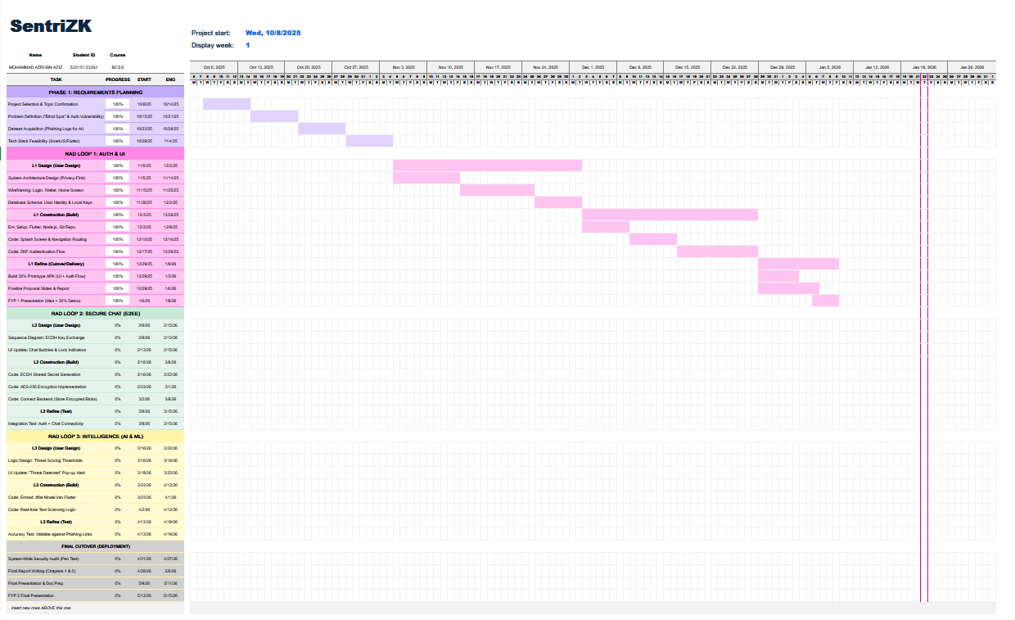
Figure 3.6: Project Gantt Chart Summary

3.7 Summary
To conclude, proper planning of the project plays a crucial role in developing a fully functional and secure system. Aligning with RAD methodology, every stage can be carried out progressively while also identifying minor issues that arise early on. This a gave permission to the team to decide. What additions can be made to the system in order to make it work and private? project. In the next chapter, further discussion will be made on the actual development of the system and coding. be discussed thoroughly..

CHAPTER 4: SYSTEM DEVELOPMENT

4.1 Introduction
This chapter explains how the SentriZK secure messaging system was actually developed.It brings the ideas and concepts of architecture and design (Chapter 3) to life. software product. The previous chapter was about the methodology and overarching plans, this chapter is about how to make the plans a reality.
In this, the emphasis is on the practical engineering. It includes the tools and frameworks that are used, as well as, the choices of technical solutions during the coding stage The three core security principles that are the foundation of the Rapid Application Development (RAD) lifecycle are:
A Zero-Knowledge Authentication (ZKP) module and an end-to-end encrypted (E2EE) module have been developed.Two modules have been developed, a Zero-Knowledge Authentication (ZKP) module and an end-to-end encrypted (E2EE) module.
Developer tools and on-device Artificial Intelligence (AI) threat detection were created and enhanced in overlapping stages. This chapter begins by describing the development environment and software,dependencies. Then it explains how you can configure the backend server, the cryptographic circuits,The web portal, the mobile app and the machine-learning pipeline. After detailing the core security
Finally, the user interface, system integration, version control, and user interface for modules are discussed.deployment. A few implementation decisions became more complex with the development of the prototype.original proposal. These changes are emphasized and explained as practical engineering choices They will be displayed in their own sections.

4.2 Development Environment and Tools
This course covers the use of a development environment and tools for the creation of software.The SentriZK project is part of a single Git monorepository. It is made up of four cooperating A node.js backend, a Next.js web portal, a Flutter mobile app, and a Python backend application. machine-learning pipeline. This section breaks down the hardware, operating systems, Development environments, and third party dependencies needed to build the system.

4.2.1 Hardware and Operating System
The majority of development was done on a Windows 11 workstation, a Lenovo. Legion laptop with its own graphics processor and built-in memory of 16Gb. The GPU was crucial for speeding up the training of the neural network models. Having 16 GB of memory was able to have the Android emulator, backend (Node.js) and server (Next.js) all operate at the same time without crashing. For final testing, however, a mobile Android device (minimally) is required. It was a must have for Android 10 (API level 29). Such as camera access, biometric You can't just judge prompts, deep link routing and real world AI inference speeds. Guaranteeing that it will run successfully on an emulator. The hardware setup is summarized in Table 4.1.
Table 4.1: Development and Test Hardware
Unit | Role | Key Specification
Lenovo Legion laptop | Primary development & ML training | Windows 11, dedicated GPU, 16 GB RAM
Physical Android phone | On-device verification | Android 10+ (API 29+), real sensors
Server node | Backend / database host | Self-hosted Linux node, 8 GB RAM

4.2.2 Integrated Development Environments and Tooling
The main IDE used for the backend, web and machine-learning was Visual Studio Code. The Android SDK, the emulator, and the Gradle were provided by Android Studio. To build the toolchain that Flutter uses. It was able to utilize version control throughout the entire project with Git. The process is remote, on GitHub. To help the audience, several tools were developed for the command line were supported. The Node.js package manager (npm), Flutter and Dart CLI tools, and workflow, Circumstances server to a web browser. In testing this local backend is connected to mobile devices.
4.2.3 Frameworks, Languages and Runtimes
As each tier has its own performance requirements, the system incorporates several Because of this necessity, programming languages are being used. The server is programmed in JavaScript using the It's a node runtime that supports the Express 5 web framework. TypeScript is the choice for development of the web portal. All of the above are built with primary language, Next.js 15.5.6 and React 19. The app uses the following mobile technologies: The Dart (SDK 3.8) is a framework that is used to build apps with. The zero-knowledge circuits are programmed in This is a domain specific language, the Circom 2.0.0, and proved with Groth16 zk-SNARKs. On the BN128 elliptic curve. Finally, the machine-learning pipeline is put into code in. Python 3.9 and TensorFlow 2.20 with Keras 3.13. These are the core frameworks listed in Table 4.2.
Table 4.2: Core Framework of Each System Tier
Tier | Language | Framework / Runtime
Backend API | JavaScript | Node.js 18+, Express 5.1
Web portal | TypeScript 5 | Next.js 15.5.6, React 19.1
Mobile app | Dart 3.8 | Flutter 3.8
ZK circuits | Circom 2.0.0 | Groth16 / BN128 (snarkjs 0.7.5)
ML pipeline | Python | TensorFlow 2.20, Keras 3.13

4.2.4 Software Dependencies
A collection of open source libraries are utilized for each sub-project. Back end properties are those that: Install snarkjs, circomlibjs for Groth16 proof verification and Poseidon hash function respectively. the Supabase client to access the database, and the Firebase Admin SDK to push. notifications. Available standard security middleware such as express rate limit and bcryptjs are also used. The primary backend dependencies are given in Table 4.3.
Table 4.3: Principal Backend Dependencies
Package | Version | Purpose
express | 5.1.0 | HTTP/REST framework (port 6000)
snarkjs | 0.7.5 | Groth16 zk-SNARK proof verification
circomlibjs | 0.1.7 | Poseidon hash / BN128 field arithmetic
@supabase/supabase-js | 2.101.1 | Supabase PostgreSQL client
firebase-admin | 13.0.0 | FCM push, Firestore admin, custom tokens
express-rate-limit | 8.1.0 | Brute-force / rate-limit protection
jsonwebtoken | 9.0.3 | Admin session JWT (HS256)
bcryptjs | 3.0.3 | Admin password hashing

To generate zero-knowledge proofs inside the browser, the web portal also depends on snarkjs and circomlibjs. It utilizes bip39 for recovery-phrase generation, js-sha3 for hashing, and crypto-js for client-side encryption. The web dependencies appear in Table 4.4.
Table 4.4: Principal Web Portal Dependencies
Package | Version | Purpose
next / react | 15.5.6 / 19.1.0 | Web application framework
snarkjs | 0.7.5 | In-browser Groth16 proof generation
circomlibjs | 0.1.7 | Poseidon / field arithmetic
bip39 | 3.1.0 | 24-word recovery mnemonic
js-sha3 | 0.9.3 | SHA3-256 username / address hashing
crypto-js | 4.2.0 | AES salt-envelope encryption (browser)
axios | 1.12.2 | REST calls to the backend

Out of all the tiers, the mobile application has the largest dependency surface since it Supports messaging, encryption, on-device AI inference, calling and push notifications. Two choices here are rather different from the original one: message encryption uses the Instead of a custom implementation, the official Signal Protocol implementation (libsignal_protocol_dart) is used. The Isar embedded database is now used instead of Hive in local storage and scheme. For state The light provider package was selected over GetX due to its better performance..
Table 4.5: Principal Mobile Application Dependencies
Package | Version | Purpose
libsignal_protocol_dart | 0.7.2 | Signal Protocol (X3DH + Double Ratchet) E2EE
tflite_flutter | 0.12.0 | On-device TensorFlow Lite inference
isar / isar_flutter_libs | 3.1.0 | Embedded reactive NoSQL database
flutter_secure_storage | 10.0.0 | Android Keystore / iOS Keychain storage
provider | 6.1.5 | State management (ChangeNotifier)
app_links / url_launcher | 7.0.0 / 6.3.2 | Deep-link bridge to the web portal
cloud_firestore / firebase_messaging | latest | Ciphertext relay and FCM push
flutter_webrtc | 0.12.1 | Audio / video calling (DTLS-SRTP)
cryptography | 2.5.0 | AES-256-GCM recovery-salt envelope

The machine learning pipeline uses TensorFlow and Keras for modeling the machine. and TensorFlow Lite conversion. pandas and numpy are used for data handling, and matplotlib was used to create evaluation charts. A version of PyTorch with CUDA acceleration was Also applied in the early experiments of training..

4.3 System Architecture
The system as built has been divided into four levels of operation. A flutter mobile application is the main tool they use to access their work. app as their main client. However, phones are not capable of running the heavy zero-knowledge proof. generation efficiently, that task is offloaded to a Next.js web portal which acts as a dedicated cryptographic surface. There is proof verification and session management in the Node.js backend. The data is stored in two places: a Supabase PostgreSQL database (authentication state) and Firebase Firestore (To send encrypted messages). The architecture that is implemented is as follows: Figure 4.1.
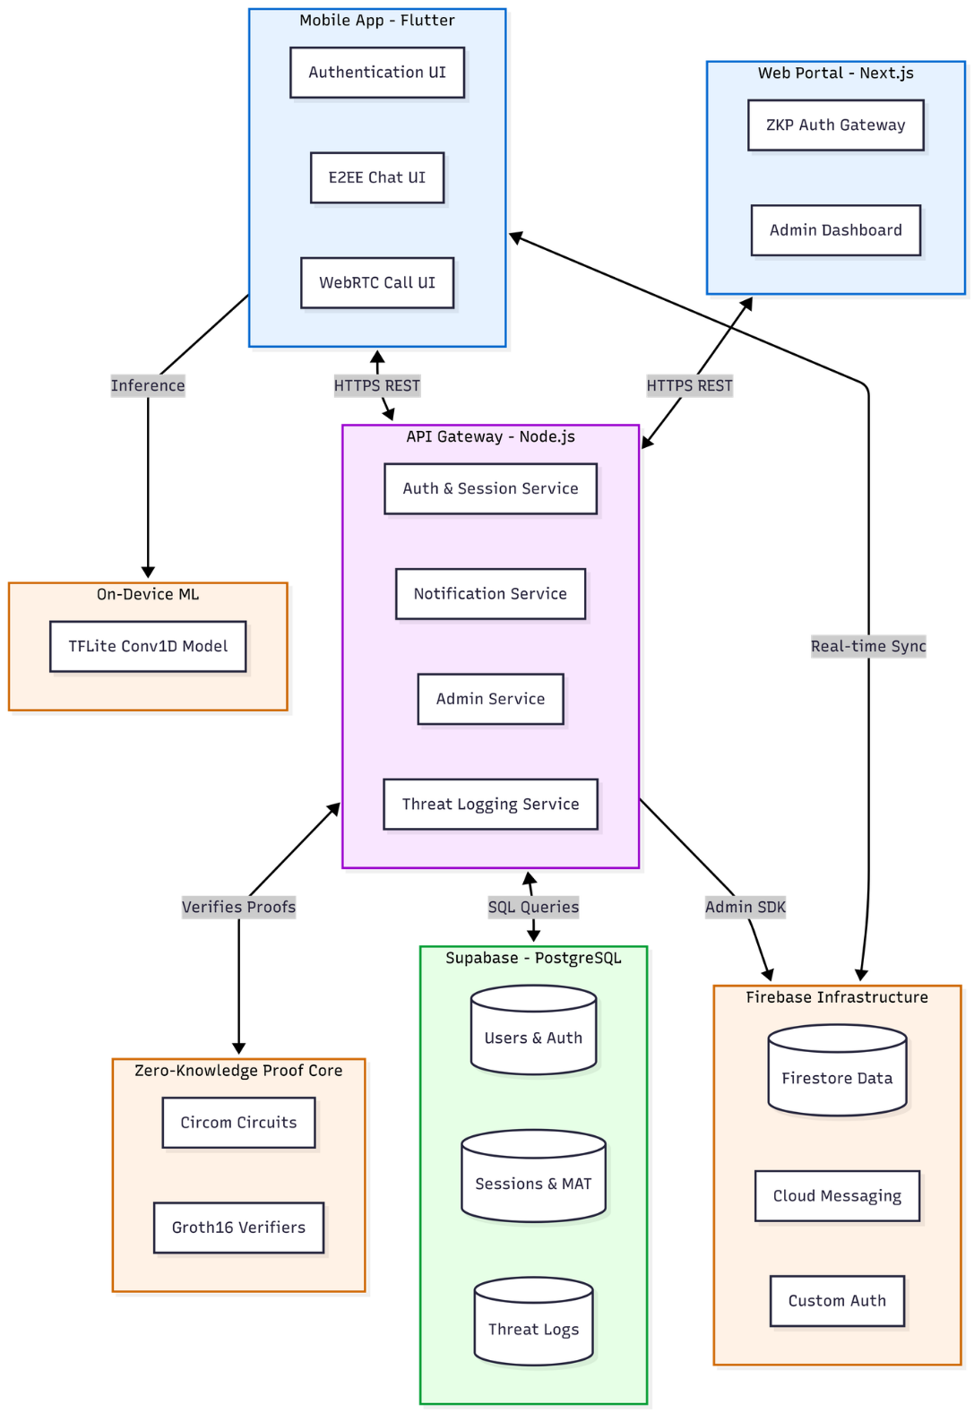
Figure 4.1: SentriZK Full System Architecture
The whole design is built around one simple rule: the server never stores anything an attacker would actually want to steal. The backend keeps mathematical Poseidon commitments instead of real passwords. The messaging layer only holds Signal Protocol ciphertext and never touches plaintext. Figure 4.2 shows the internal layout of the mobile app, covering exactly how it handles authentication, messaging, encryption, and threat scanning.
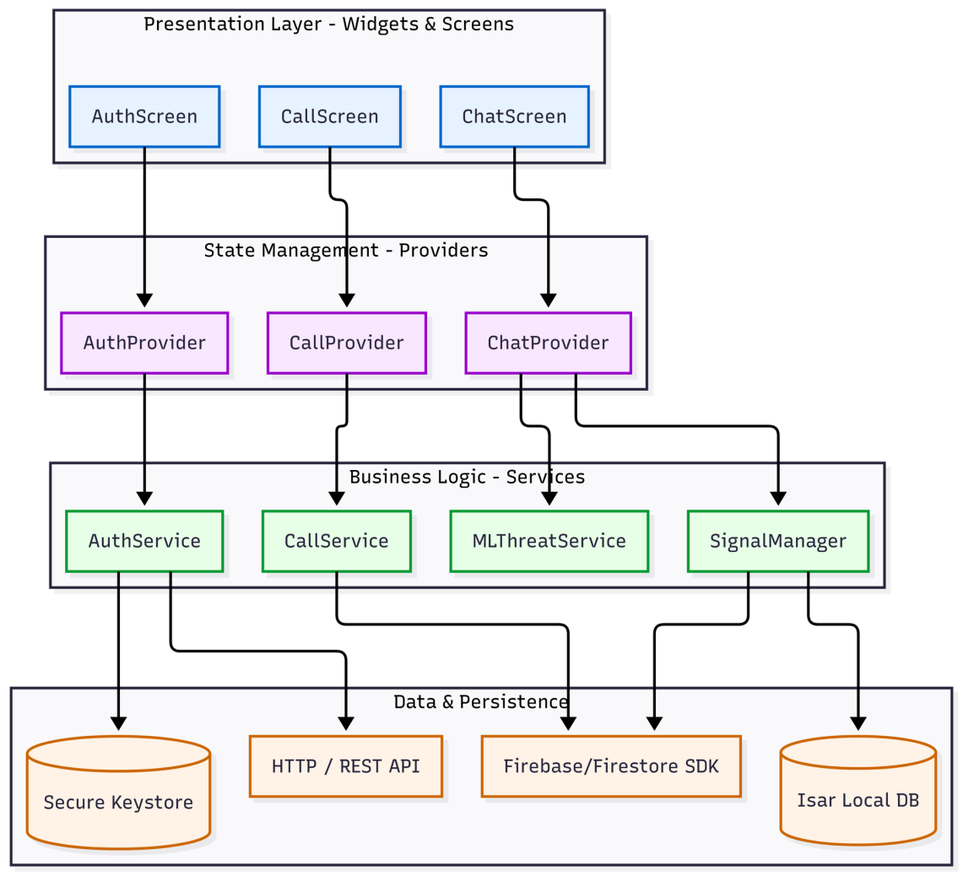
Figure 4.2: Component Diagram of the Flutter Mobile Application

4.4 Installation, Setup and Configuration
Each of these components is described in terms of its installation and configuration. Configuration is kept URLs) are not hardcoded into the application code.Centralized to avoid hard-coding of environment-specific values (such as service URLs and database URLs). (credentials) remain outside the source code. The web portal is based on .env files, and the backend is based on .env files. All of the app's configuration is provided in the text file located in the NEXT_PUBLIC_ environment variables and the mobile app retrieves it from a single app_config.dart. file.

4.4.1 Backend Server Setup
The backend is installed by executing npm install from the Backend folder and the node server.js is running on port 6000. A .env file needs to provide the following: Admin credentials, JWT signing secret, and Supabase URL. If any of these are not present, the server refuses to start to dissuade insecure deployments. A Firebase You also need to have a service account JSON file to use for creating custom tokens with the Admin SDK Lastly, the Supabase schema script is used to create the five tables required for the database..
Table 4.6: Backend Environment Configuration
Variable | Purpose
SUPABASE_URL / SUPABASE_SERVICE_ROLE_KEY | PostgreSQL connection (required)
ADMIN_USERNAME / ADMIN_PASSWORD | Admin dashboard credentials
JWT_SECRET / JWT_TTL | Admin JWT signing key and lifetime (default 1h)
PORT | Listening port (default 6000)
serviceAccountKey.json | Firebase Admin SDK private key (file)

4.4.2 Zero-Knowledge Circuit Compilation and Trusted Setup
The Circom 2.0.0 compiler turns the two Circom circuits into a WebAssembly witness generator and an R1CS constraint system. A Groth16 trusted setup follows, carried out with snarkjs. A Powers-of-Tau phase produces the universal parameters, and a circuit-specific phase-two contribution produces the proving key (stored as a .zkey file) and the verification key. The proving keys and WebAssembly files are copied into the web portal so proofs can be generated in the browser. These compiled artifacts stay incredibly compact; the registration witness generator is only about 1.84 MB.

4.4.3 Web Portal Setup
For the web portal, npm install is run inside the Frontend/web directory. Development uses npm run dev, while production is built with npm run build. The configuration just comes down to the backend API URL and the paths to the circuit artifacts. Importantly, no secret values live in the web tier. All sensitive cryptographic material is derived on the client side and is never saved.

4.4.4 Mobile Application Setup
The mobile application is installed from flutter pub get inside Frontend/mobile directory. It has its endpoints stored in a single app_config. dart that directs the app to the backend. The API and web portal. This same file is used to specify the custom deep link scheme and the machine learning thresholds. firebase is configured the same way as google services.json file.

4.4.5 Machine-Learning Pipeline Setup
The machine-learning pipeline is a self-contained Python project. The course curriculum consists of a single training script. Converts the mobile model to perform inference on the mobile device. Export the vocabulary file, and then use TensorFlow Lite. The two output artifacts (the quantized The subsets (model and its vocabulary) are then just copied into the mobile app's asset bundle. To be loaded at run time..

4.5 Implementation of the Core Security Modules
Construction focused heavily on three modules that meet the project's main objectives: zero-knowledge authentication, end-to-end encrypted messaging, and on-device AI threat detection.

4.5.1 Module A: Zero-Knowledge Proof Authentication
This module is a replacement for regular password transmission using a zero knowledge proof. Two For this, Circuits were written using Circumstance. The single Poseidon is calculated in the registration circuit. from a secret kept by the user, a salt, and a hash of the username. The login circuit Returns that same commitment with the same inputs, claims that it is the same as the server's. Record, and produce a session value which is used to attach the proof to a new server issued nonce.
Table 4.7: Zero-Knowledge Circuit Parameters
Property | Registration circuit | Login circuit
Commitment | Poseidon(secret, salt, unameHash) | recomputed and asserted equal
Private inputs | secret (256-bit), salt (128-bit) | secret, salt
Public inputs | unameHash | unameHash, storedCommitment, nonce (64-bit)
Outputs | commitment | pubCommitment, pubSession
R1CS constraints | 991 | 1,573
Proving system | Groth16 / BN128 | Groth16 / BN128

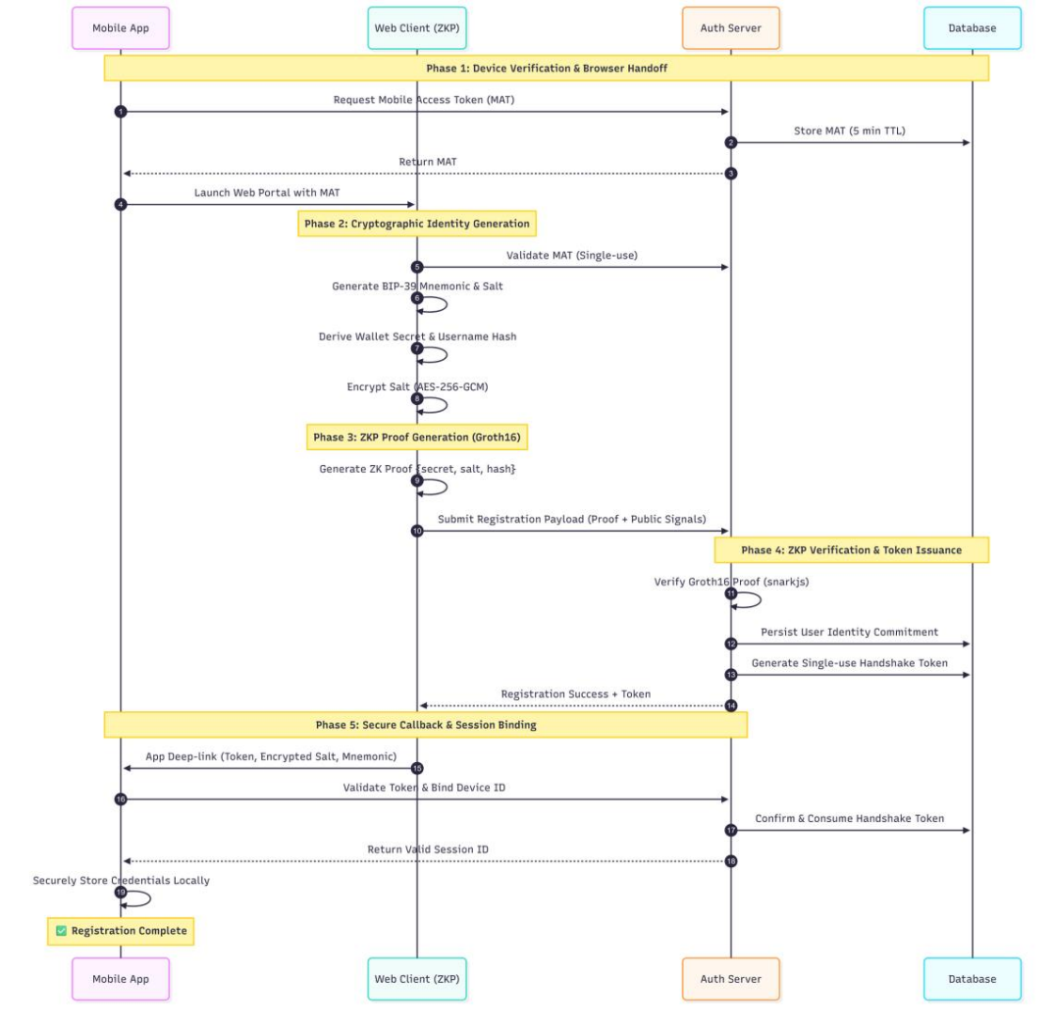
A significant design decision had to be made due to a practical constraint. Since a Flutter app cannot run the snarkjs WebAssembly prover to the app, which is efficient on-device. To send data to the Next.js web portal with a Mobile Access Token (MAT). The mobile app asks for the following: Issues a single-use token for 5 minutes, after which it launches the internet browser. The browser processes the heavy proof generation and returns the proof to the app via a custom sentriapp:// deep link. This bridge conveys all the secrets on the user's device while transferring the A high amount of computational load on the browser. Figure 4.3 and Figure 4.4 show these sequences.

Figure 4.3: Zero-Knowledge Registration Flow
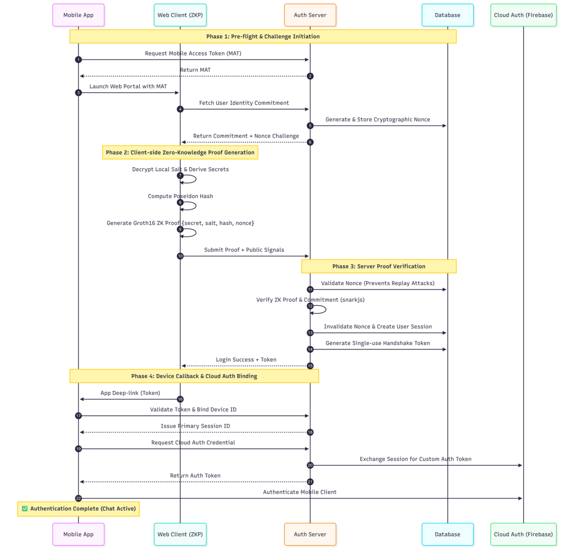
Figure 4.4: Zero-Knowledge Login Flow with Nonce-Bound Session
Replay protection is inbuilt in the login circuit. Every time you log in to the server Generates a new 60 second 64-bit nonce. This nonce is now encrypted into the circuit by the circuit binding. A key feature of the protocol is that an output (or captured proof) may not be replayed against a different nonce at a later time.

4.5.2 Module B: End-to-End Encrypted Messaging
The system uses the standard Signal Protocol with the help of the The sketched in AES scheme was not used, instead, libsignal_protocol_dart library was used. It was a deliberate choice as hand-rolled cryptographic protocols were not possible. are notoriously error-prone. The Signal Protocol is a peer-reviewed standard to provide Built-in forward security.
In this protocol every device will produce its own long-term identity key pair, a signed One hundred one-time pre-keys for the Curve25519 elliptic curve and pre-key. Only the The public half is saved to Firestore. When you send a message, the app sets up a shared Secretly sends the message using the X3DH handshake and encrypts the message using the Double Ratchet algorithm. This changes the message key for each individual message. The resulting ciphertext The plaintext is never sent to the server, it is stored in Firestore. Figure 4.5 maps out this flow
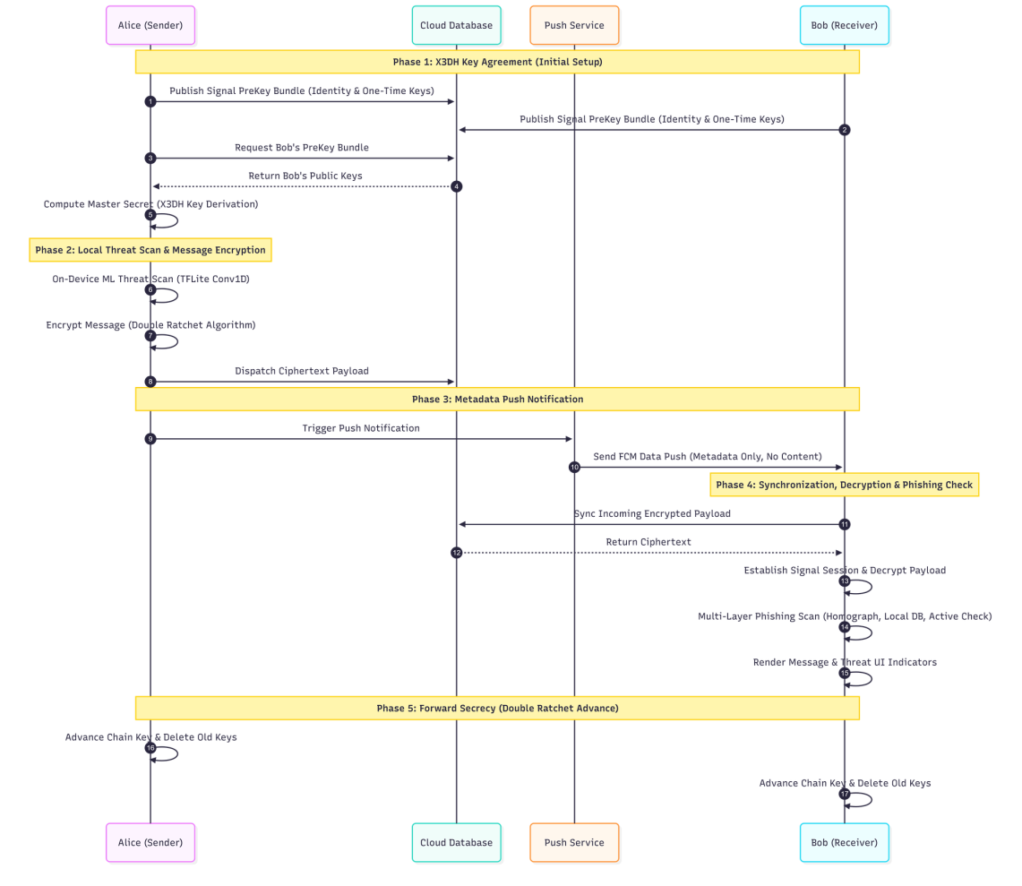
Figure 4.5: Signal Protocol End-to-End Encrypted Messaging
The app also uses an offline-first storage model. Incoming ciphertext is decrypted, written to a local Isar database, and then deleted from Firestore. This makes the physical phone the durable source of truth for conversation history.

4.5.3 Module C: On-Device AI Threat Detection
The threat-detection module conducts content analysis of messages for social engineering threats. phishing page indicators as a whole on the user's device. In development, the originally The proposed unsupervised Isolation Forest approach was not suitable for the task. A corpus of safe/unsafe messages was labeled and the module was then implemented. Reconstructed around a supervised one dimensional Convolutional Neural Network (Conv1D).
This model was selected because all its operations are natively supported in this model. Let it run smoothly on the phone hardware, with TensorFlow Lite. The model was trained with a balanced dataset of 5,740 labeled messages (2,890) from which the training set consisted. safe and 2,850 threat). A 10,000-word vocabulary is used for each message. Dynamic-range quantization was used to convert the trained model to TensorFlow Lite, Which comes out to be a tiny file around 681 KB. Table 4.8 is a summary of production model..
Table 4.8: On-Device Threat-Detection Model
Property | Value
Task | Supervised binary text classification (safe / threat)
Architecture | Embedding(64) → Conv1D(128, k=5) → GlobalMaxPool → Dense(64) → Sigmoid
Vocabulary / seq length | 10,000 words / 120 tokens
Training data | 5,740 labelled messages (2,890 safe, 2,850 threat)
Optimiser / loss | Adam / binary cross-entropy, threat-weighted
Deployed format / size | TensorFlow Lite, dynamic-range quantised, ~681 KB
Decision threshold | 0.65 (messages under 4 words are skipped)

Every outgoing message is tokenized and scored on a scale from 0 to 1 on the device. one. When it's above 0.65, the message will be reported to a backend threat-log. A destination that a user could send their data to be reviewed by the administrator. When flagged, messages on the receiving end cause a red Alert icon on the display. The inference pipeline is shown in Figure 4.6. Message text is also equipped with a unique URL inspection layer to ward off malicious links, shown in Figure 4.7.
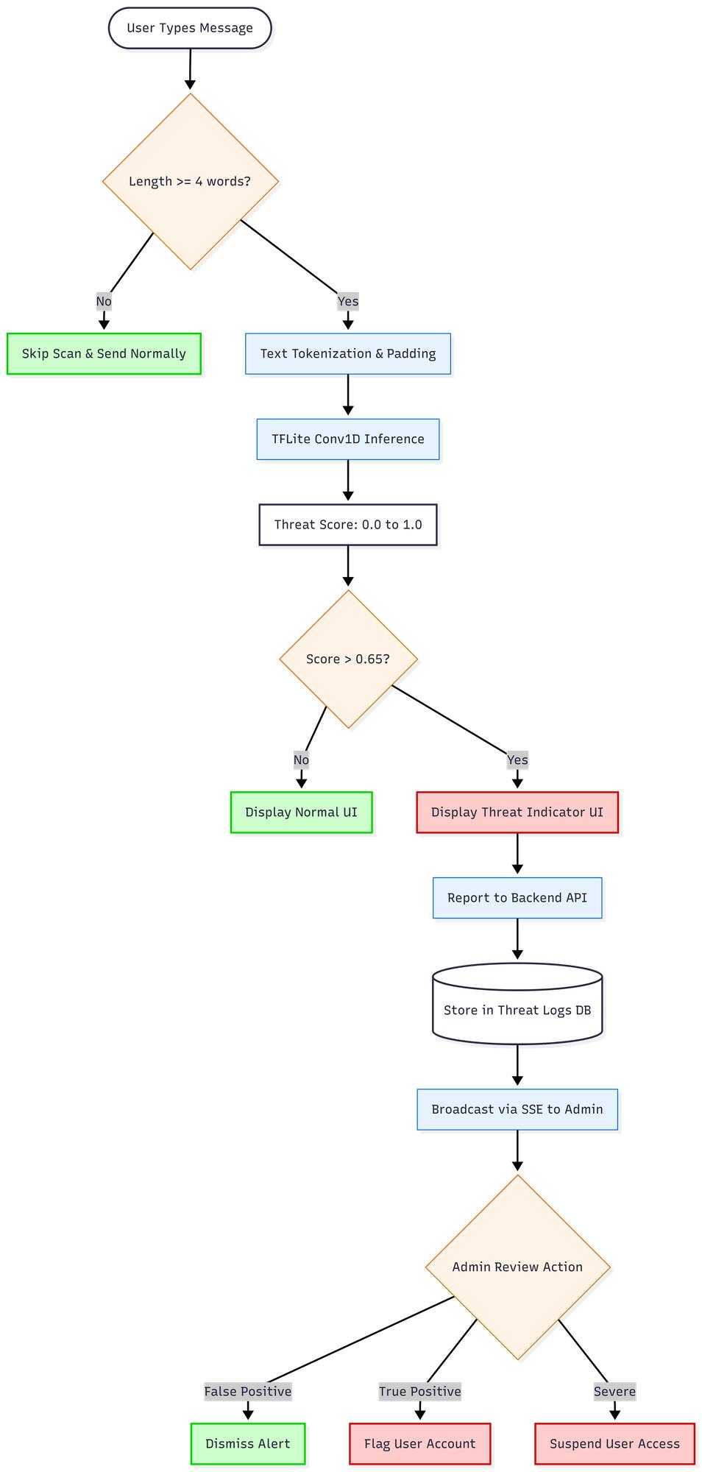
Figure 4.6: On-Device TensorFlow Lite Threat-Detection Pipeline

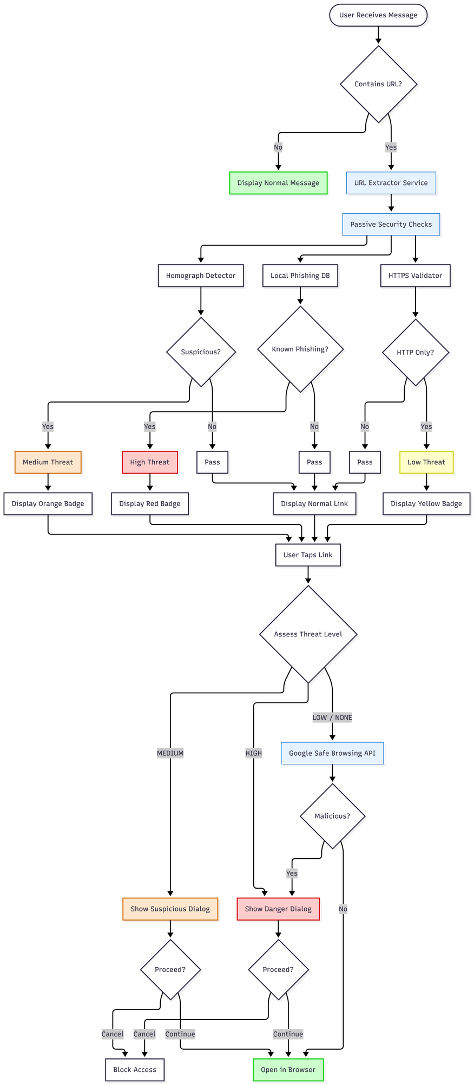
Figure 4.7: URL Phishing-Detection Architecture

4.6 User Interface and Experience Design
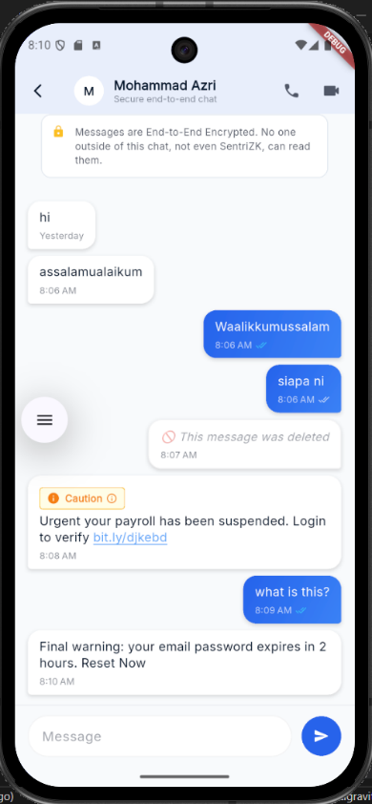
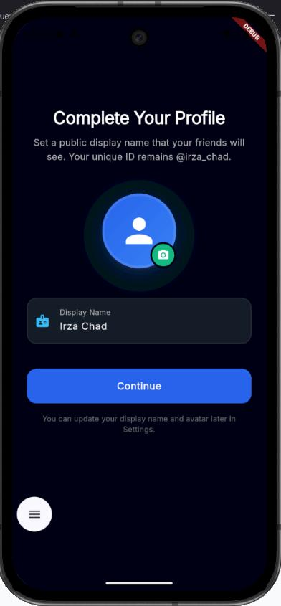
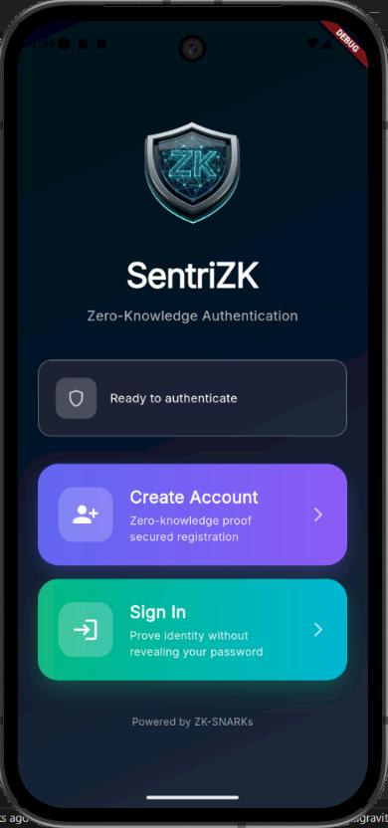
Non geoblocked users, while the desktop version is crafted in a manner that is suitable for both players.The mobile interface has been developed using Flutter to ensure the strong security functions run seamlessly in all the environments aside from non geoblocked. technical staff. The navigation is screen based, with typical screens such as the chat screen and call, etc. screen, and settings. The security feedback is displayed in the conversation itself. When the on A device AI scores a message higher than the threshold, a tinted warning badge appears with the message Suspicious The message "message detected" is shown. Are marked with the appropriate colour coding for risk and dangerous links are marked. Pop up a confirmation dialog when opened. Figure 4.8 shows representative screenshot.

Figure 4.8: Mobile Application User Interface (representative screens)
The web portal serves two different groups. Regular users just get a simple screen to log in securely. For the company management, the Next.js app features a complete admin dashboard. This panel tracks the user list and streams flagged threats live as they happen. Figure 4.9 and Figure 4.10 show the layout of this admin panel.
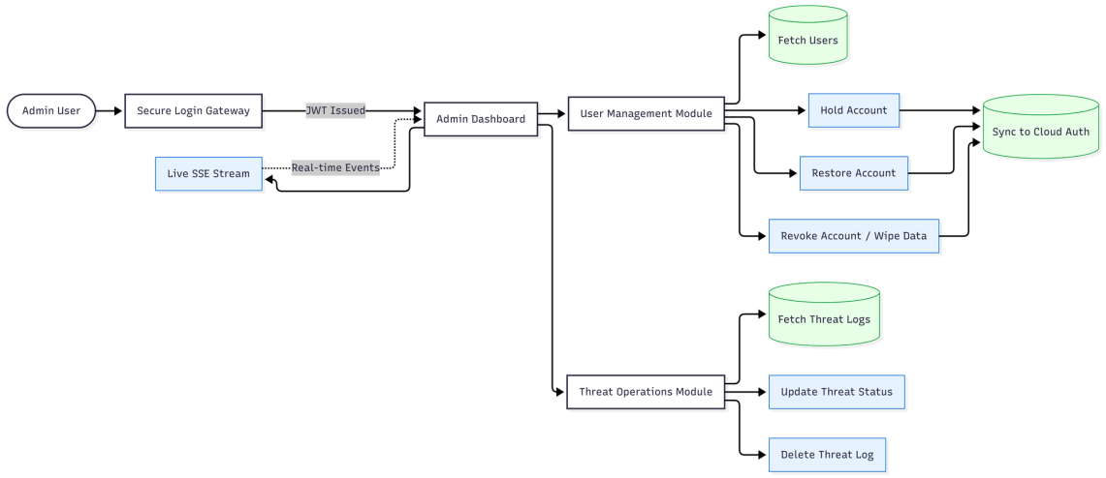
Figure 4.9: Web-Based Administrator Panel
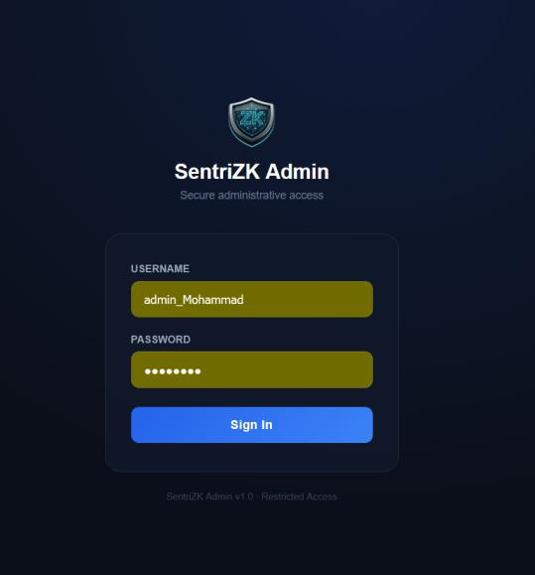
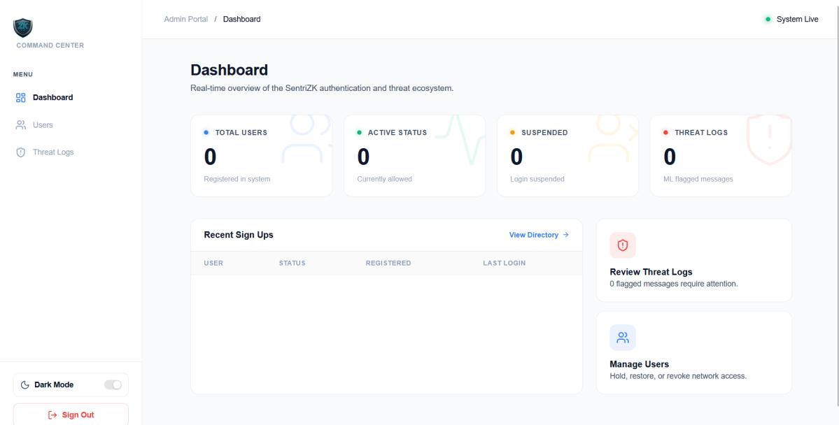
Figure 4.10: SentriZK Web Administrator Panel — (a) Secure Login Screen (b) Command-Centre Dashboard

4.7 System Integration
It was a significant engineering challenge to combine 4 different layers into a single product. The Mobile Access Token (MAT) bridge between the mobile app and web portal is the most critical integration point. The app launches the browser, the browser then does the cryptographic work, and then It provides the result via a validated sentriapp:// deep link.
The other points of integration are more common. After successful login in ZKP, the backend issues a Firebase custom token. This enables the client to sign in to Firestore, The ability to connect the password-less identity to the real-time messaging tier. When a client writes From the client, they send the ciphertext to Firestore, then the client calls a backend notify endpoint that will wake the recipient's device via a push message to enable it to decrypt on the device. This session is described in the map (Figure 4.11). lifecycle.
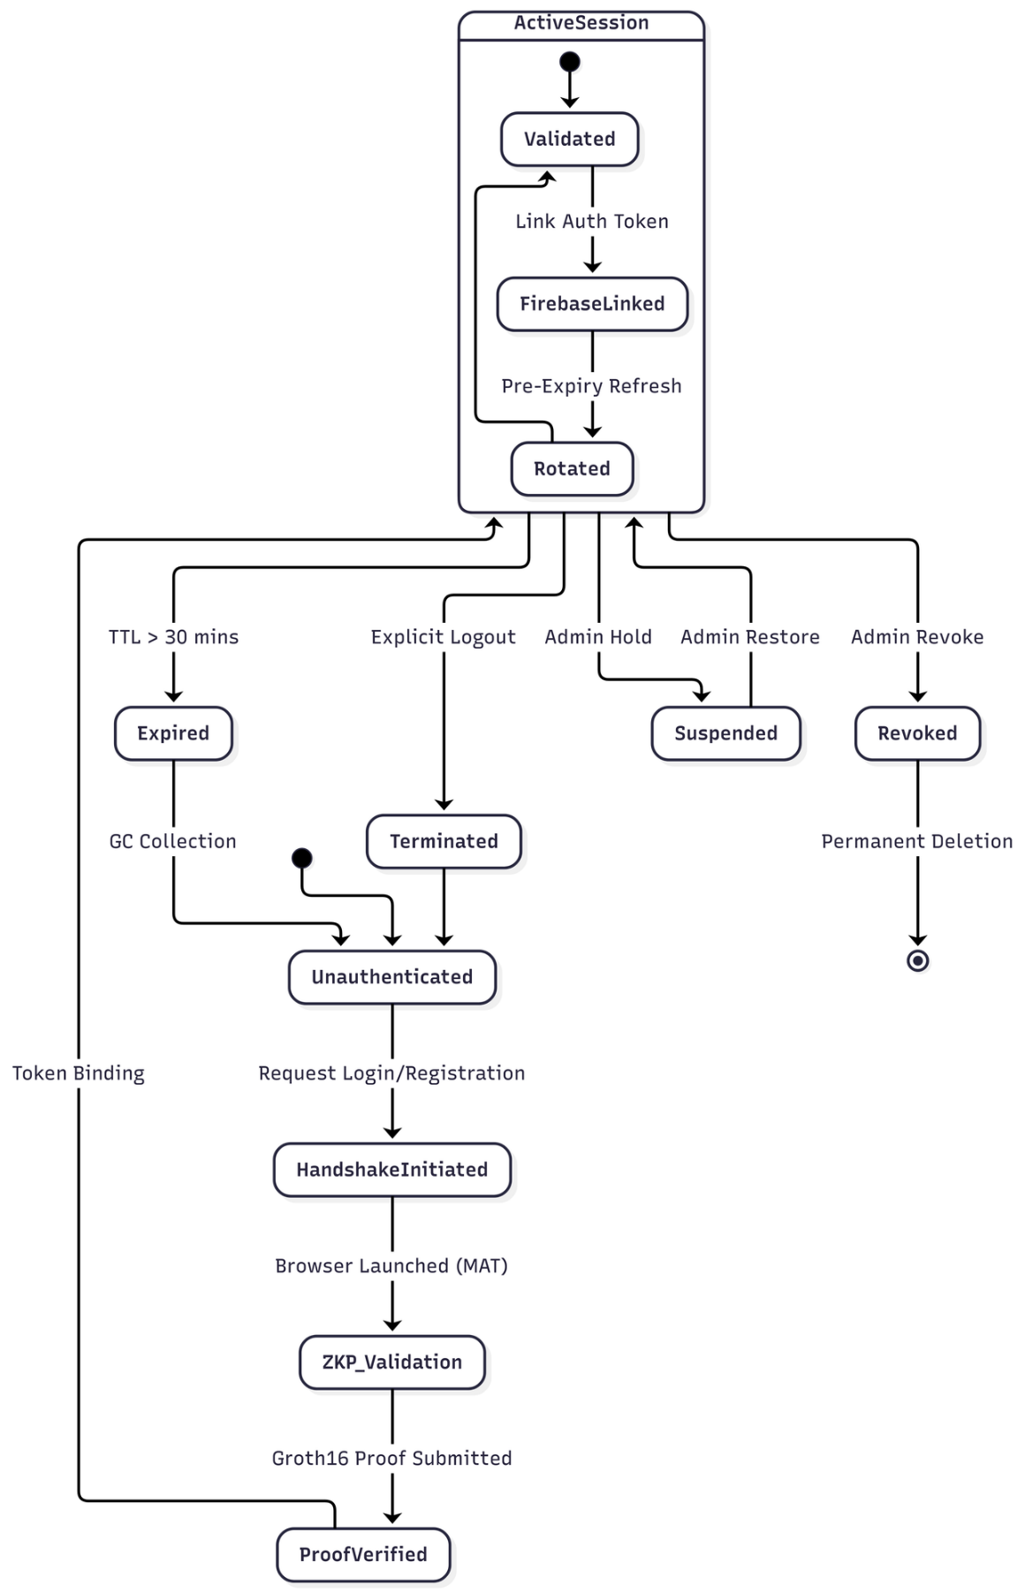
Figure 4.11: Session Lifecycle and Security

4.8 Source Code Management and Version Evolution
The project was kept as a single repository in GitHub. Development followed a feature-branch workflow. The list includes about thirty branches, covering E2EE messaging, calling, the admin, and others. Over 296 commits in seven months later, panel, and the machine learning model were merged. period. The system was delivered in a series of increments in line with the RAD methodology. The first increment was the base platform (ZKP auth, Signal messaging, base UI). The anti-virus protection).Anti-virus protection, on-device ML model, URL inspection and intelligence features added 2nd increment. audio/video calling). Table 4.9 provides an abbreviated version of this history.
Table 4.9: Iterative Version Evolution of the Prototype
Increment / Release | Focus | Representative changes
v1.0.1 (Increment 1) | Core platform | ZKP auth, Signal messaging, base UI
v1.0.5+6 | Stabilisation | Bug fixes, Supabase migration
v1.0.6+7 (Increment 2) | Intelligence | On-device ML model, threat logging
v1.0.8+9 | Hardening | Calling, admin panel, recovery, fixes

4.9 Deployment Environment
The deployment strategy is designed to take enterprise grade security to SMEs at a minimal cost. The backend was developed locally and available to the test devices. By using an ngrok tunnel. Production, the components are located behind an individual domain. The backend The self-hosted node can host an and web portal. The managed services on which the system is dependent The only true cost is domain registration, and for both (Supabase and Firebase), it remains accessible in their free tiers. recurring cost. This deployment topology is shown in figure 4.12.
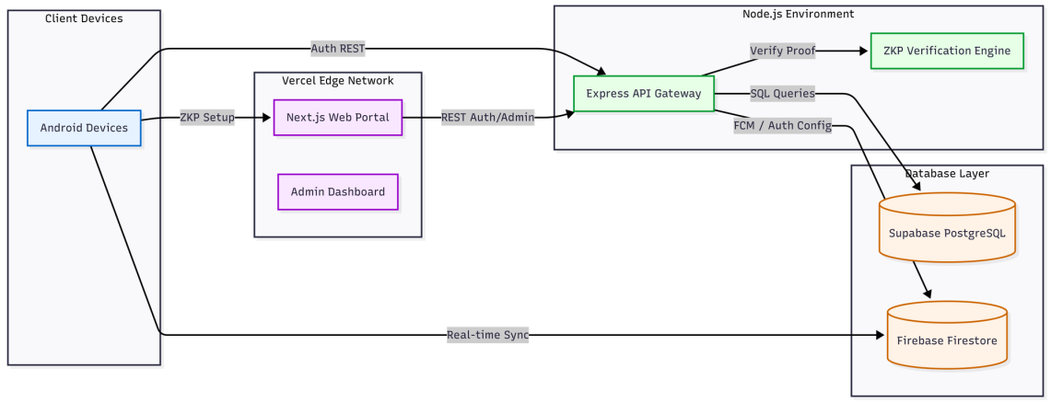
Figure 4.12: Deployment and Infrastructure Architecture
Production data is segregated based on the best practice of each service. The authentication state (users, sessions, single-use tokens, and the threat log) is stored in Supabase PostgreSQL. The real-time message relay and push notifications are provided by Firebase. This separation ensures that the security critical auth data remains in a relational store, under the tight control of the project; while delivering high volume real-time message delivery to a managed platform.

4.10 Chapter Summary
This chapter captured the journey of this SentriZK system, from development to deployment. It described the concept of four collaborating tiers, and how to configure them. The chapter explained the three fundamental security modules: the zero-knowledge authentication based on Circom circuits and a Mobile Access Token bridge; the end-to-end encrypted messaging based on a quantized neural network; and on-device threat detection based on a Signal Protocol. Also, the user interface design, system integration, version control and deployment were described. The initial proposal has since been expanded in several ways, including the adoption of the Signal Protocol and the modification of the architecture of the AI. The original proposal was subsequently expanded in a number of ways, including the adoption of the Signal Protocol, and the change in the architecture of the AI, which were both practical engineering decisions designed to enhance the system's performance. The system is now complete, and this chapter details the testing undertaken with the prototype and the results in comparison to the project goals.

CHAPTER 5: RESULT AND DISCUSSION

5.1 Introduction
In this chapter, we will see the actual testing with the final SentriZK prototype. After building the In Chapter 4, the main concern is whether the system actually functions, but here it is more about determining if the system really works, If it really provides the protection and privacy assurances it guarantees. Testing was done with four different forms: Functionality, Security, Performance, and User Acceptance testing To create security.To secure. The tests were competitive, as they could be made as realistic as possible. This is because we employed the exact not only simulate but use the same tools that a real cyber attacker would use against the live app. perfect scenario.
Table 5.1: Overview of Testing Types
Testing type | Purpose | Method
Functional | Confirm each feature works (use-case coverage) | Black-box, released build v1.0.8
Security (CIA / AAA) | Resist realistic attacks | 19 automated + 16 manual adversarial tests
Vulnerability / static scan | Find code & dependency weaknesses | npm audit, code & binary secret scans
Performance | Latency & detection accuracy | Proof timing, on-device inference, ML evaluation
User acceptance | Confirm usability for SME staff | Task-based evaluation + questionnaire

5.2 Functionality Testing
Functionality testing determines whether all the different components of the secure messaging all system functions as intended. This includes checking the zero-knowledge logins, encrypted messaging, the AI threat warnings, and the database updates. It ensures that the user data is managed without error in system and alerts are triggered without error.

5.2.1 Zero-Knowledge Authentication
The system is based on Groth16 protocol, which authenticates users without transmitting password information. To test this feature, a new account must be signed up through the web portal, and the feature will be tried. To log in via the Deep-link bridge - Mobile Access Token (MAT). The system should Successfully prove and provide a 30 minute session.

5.2.2 End-to-End Encrypted Messaging
The Signal Protocol is used for the messaging layer. For this, messages are sent between two devices. The system needs to pass the ciphertext data through Firestore, decrypt the data and show the result, and finally, delete the original data. Send messages locally via the Double Ratchet algorithm and securely save it offline. While eradicating this Isar database from the cloud.

5.2.3 On-Device Threat Detection
The local AI is trained on all messages. This test is used to determine if a known phishing attempt was successful. If the message score is above 0.65, the score is considered to be high and the appropriate UI warning is triggered. It also tests is used to make sure malicious links are properly flagged and detected before a user clicks on them in the URL inspection layer. click them.

5.2.4 Admin Controls and Alerts
The administration's controls are crucial to the organization. This feature is tested by checking if an administrator can be able to suspend or cancel an employee's account. It also queries whether the real time threat log correctly flags and displays messages via Server-Sent Events (SSE).

5.2.5 Results
Table 5.2 below shows the functionality testing where test cases, expected results, and actual verdicts are analyzed. As presented below, all 12 key project outputs presented in the table below features function perfectly.
Table 5.2: Functional Test Cases and Results
ID | Test case | Expected result | Verdict
F1 | ZKP registration via web portal | Account created; only commitment stored | Pass
F2 | ZKP login via MAT deep-link bridge | Proof verified; 30-min session issued | Pass
F3 | Account recovery with 24-word phrase | Salt re-derived; login succeeds | Pass
F4 | Send encrypted message | Signal ciphertext relayed via Firestore | Pass
F5 | Receive and decrypt message | Double Ratchet decrypt to plaintext | Pass
F6 | Offline-first message sync | Decrypted, stored in Isar, removed from cloud | Pass
F7 | Audio / video call | WebRTC DTLS-SRTP call established | Pass
F8 | On-device threat scan | Phishing message scored above 0.65 | Pass
F9 | Malicious URL warning | Homograph / HTTP / Safe-Browsing flagged | Pass
F10 | Push notification | Metadata-only FCM wakes recipient | Pass
F11 | Admin hold / revoke account | Suspended user blocked with HTTP 403 | Pass
F12 | Real-time admin threat log | Flagged message appears live via SSE | Pass

5.3 Vulnerability and Static Scanning
Prior to conducting live assaults, static assessments were conducted to identify any common programming mistakes. During the Search for hard-coded secrets in the Back End Source Code Resulted in a negative result, indicating that every sensitive piece of information is being securely stored and retrieved at runtime from environment-based file systems.
A dependency based Vulnerability audit was performed on both the Back End and Web Portal Using node package auditor, as illustrated in Table 5.3. The result of this assessment indicates that while a number of advisories were noted, most of those advisories display transitive characteristics. A transitive advisory indicates that the Advisory is based deep within a sub-dependency of a large Library or SDK like the Firebase SDK and/ or the snarkjs toolkit rather than based upon actual code within this project. It is difficult for an Attacker to obtain access to any of these transitive vulnerabilities; therefore, they are provided as a report of system limitations of Integrity.
Table 5.3: Dependency Vulnerability Scan (npm audit)
Component | Total | Critical | High | Moderate | Low
Backend (Node/Express) | 39 | 1 | 7 | 18 | 13
Web portal (Next.js) | 30 | 1 | 7 | 9 | 13

5.4 Penetration and Security Testing
The core of this assessment is to perform security tests, which are developed based on the confidentiality, integrity and availability (CIA) triad. Each of the tests work to exploit the system using actual tools such as: jadx, mitmproxy, Wireshark, and Burp Suite.

5.4.1 Confidentiality Testing
Confidentiality tests are designed to try and steal data that is intended to remain confidential. For example, passwords and message body content are considered confidential. In one example of confidentiality testing, a simulated database breach retrieved records directly from the Supabase table. The information retrieved only showed math-based Poseidon commitments; no passwords or salts are in the database. In another example of confidentiality testing, a live man-in-the-middle attack using Burp Suite completely failed at the TLS layer because the mobile application ignores custom certificates. Finally, a reverse engineering attempt of the compiled Android application using jadx showed that there is no confidential logic that could be retrieved from the compiled (.dex) file of the application.
Table 5.4: Confidentiality Test Results
ID | Attack | Tool | Expected | Verdict
C1 | Database breach: read credentials | Supabase service key | Only commitments stored | Pass
C2 | Static secret analysis of source | Code audit | No hardcoded secrets | Pass
C3a | APK full decompilation | jadx | No Dart logic / secrets | Pass
C3c | Native binary secret scan | strings on libapp.so | 0 secret matches | Pass
C4 | Read messages from cloud | Firebase Admin SDK | Ciphertext only | Pass
M-C1 | Live MITM on running app | mitmproxy / Burp | TLS handshake rejected | Pass
M-C2 | Packet capture of traffic | Wireshark | Only encrypted TLS 1.3 | Pass

5.4.2 Integrity Testing
The goal of performing integrity tests is to test the ability of your server to detect and prevent logins from being forged, replayed, or tampered with. For example, a fake Groth16 proof was sent to the server and was rejected at that time as an HTTP 400 Error. After that, they used a real, valid proof and attempted to replay it. This retry did not work because the single-use nonce had already been used. Other attempts to spoof admin JWT tokens and hijack sessions were also successfully blocked.
Table 5.5: Integrity Test Results
ID | Attack | Expected | Verdict
I1 | ZKP proof forgery | HTTP 400 rejected | Pass
I2 | Nonce replay (real proof reused) | Second attempt rejected | Pass
I3 | Commitment substitution | Mismatch detected | Pass
I4 | MAT single-use reuse | HTTP 403 on reuse | Pass
I5 | Admin JWT forgery (4 vectors) | HTTP 401 on all | Pass
I6 | Session rotation anti-replay | Old session invalidated | Pass
I7 | Device-binding session hijack | HTTP 403 device mismatch | Pass
I8 | Input injection (XSS / SQLi) | Rejected / sanitised | Pass

5.4.3 Availability and AAA Testing
The purpose of doing availability tests is to see if a system can handle attempts to crash by attempting to deplete the resource pools of the application. The login endpoints appear to do an excellent job of blocking users after too many rapid requests are made, as this appears to be strictly rate-limited.
Table 5.6: Availability Test Results
ID | Attack | Expected | Verdict
A1 | Login flood (15 rapid requests) | HTTP 429 after 10th | Pass
A2 | Admin login flood (8 requests) | HTTP 429 after 5th | Pass
A3 | Oversized payload (200 KB body) | HTTP 413 rejected | Pass

The results above can easily be mapped to the AAA (Authentication, Authorization, Accounting) Security Model Summary below.
Table 5.7: AAA Model Mapped to Implemented Controls
AAA pillar | Control | Validated by
Authentication | Groth16 ZKP, single-use nonce, MAT | C1, I1, I2, I3, I4
Authorisation | Admin JWT role check, session device binding, hold/revoke | I5, I7, M-A1
Accounting | Threat log, request logging, admin SSE event stream | F12, M-A2

5.5 Machine-Learning Detection Performance
The on-device AI model was evaluated using a validation set of 1,148 messages that were new to the AI model. One model was a weighty Bidirectional LSTM (Long Short Term Memory) and the other one was a lightweight Conv1D (1-Dimensional Convolutional neural Network). The Conv1D is the model that is applied to the phone.
The Conv1D model's final overall accuracy was 89.20%, and it was able to outperform the heavier Bidirectional LSTM model while only utilizing about 0.68MB of space. The comparison between the two models is illustrated in Figure 5.1 and summarized in Table 5.8..
Figure 5.1: Per-Class Classification Metrics (Bi-LSTM vs Conv1D)
Table 5.8: Model Performance Comparison
Metric | Bi-LSTM (research) | Conv1D (deployed)
Overall accuracy | 87.20% | 89.20%
Precision (threat) | 82.07% | 88.69%
Recall (threat) | 94.48% | 89.32%
F1-score (threat) | 87.84% | 89.01%
AUC-ROC | 96.40% | 96.21%
Model size | 7.68 MB (.keras) | 0.68 MB (TFLite)
The confusion matrix depicted in Figure 5.2 provides a straightforward presentation of the results. Of the 562 actual threats identified in the message set, 502 of them were successfully captured by the model and only 60 were not captured by the model. The performance of the model is specifically identified in Figure 5.3. There was very little overlap between the two groups of messages based on the 0.65 threshold used to differentiate the two groups (safe threats and unsafe threats) illustrated in Figure 5.4. The results of the ROC (Receiver Operating Characteristic) curves presented in Figure 5.5 summarizes the results of the analysis..
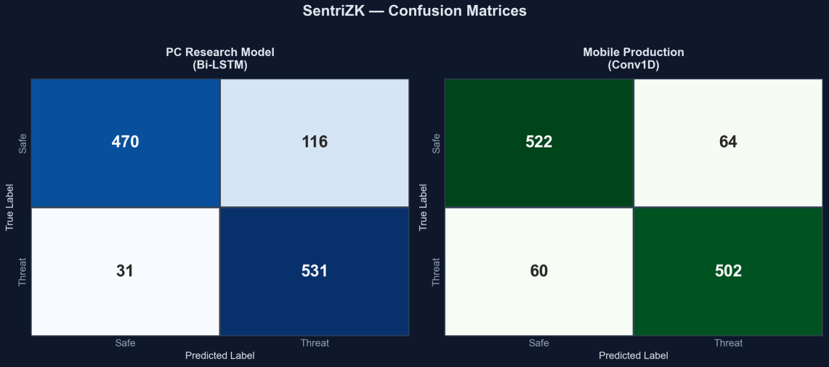
Figure 5.2: Confusion Matrices on the 1,148-Message Validation Set
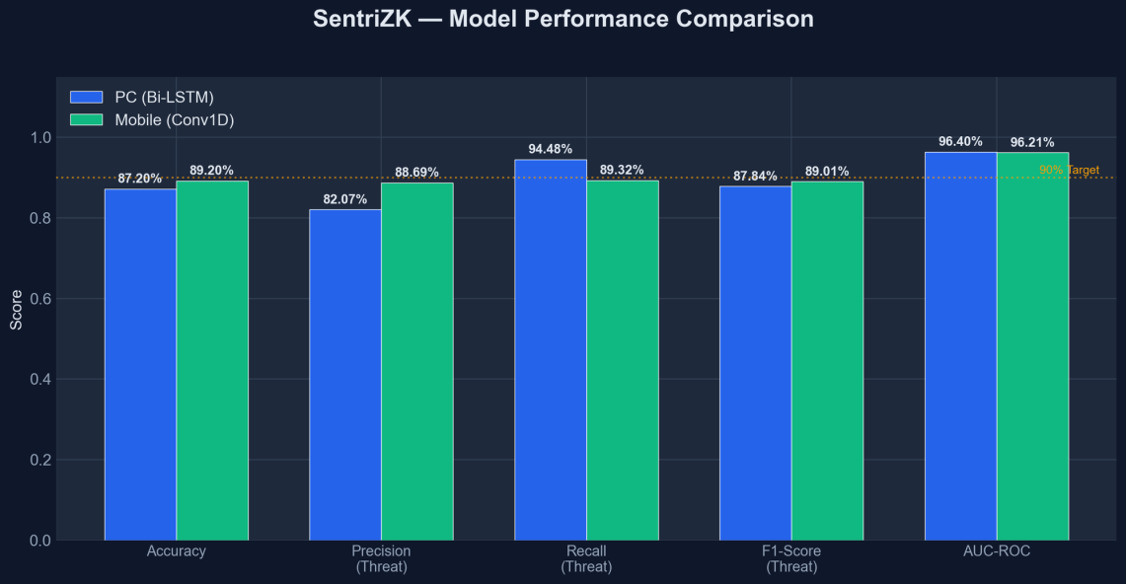
Figure 5.3: Model Performance Comparison Against the 90% Target
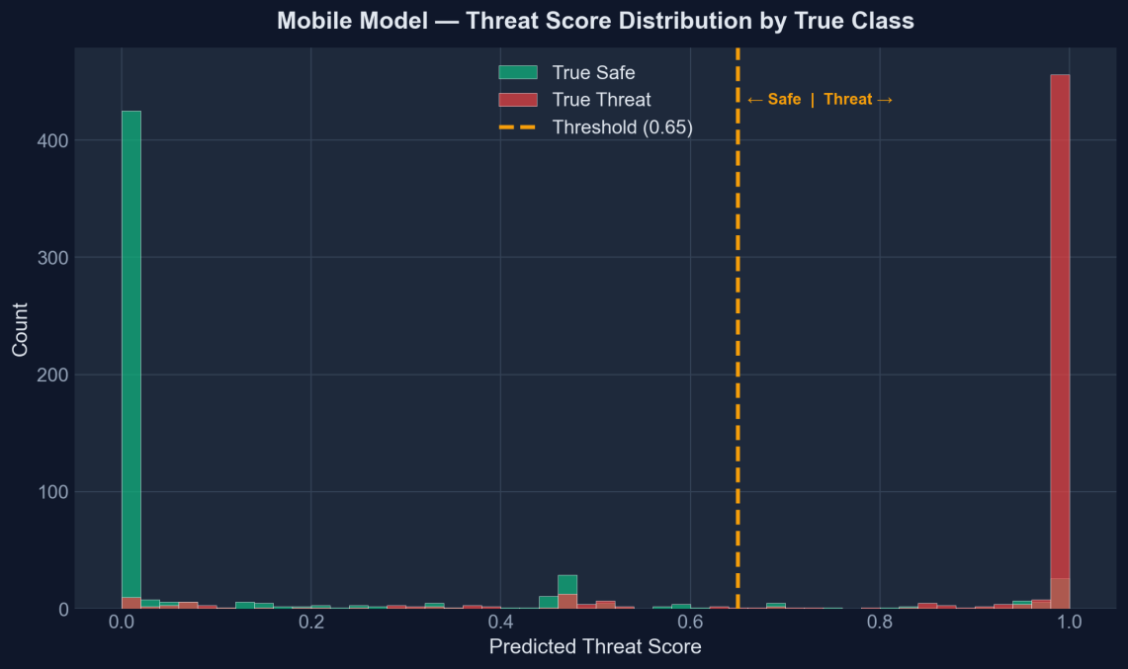
Figure 5.4: Predicted Threat-Score Distribution by True Class (Conv1D)
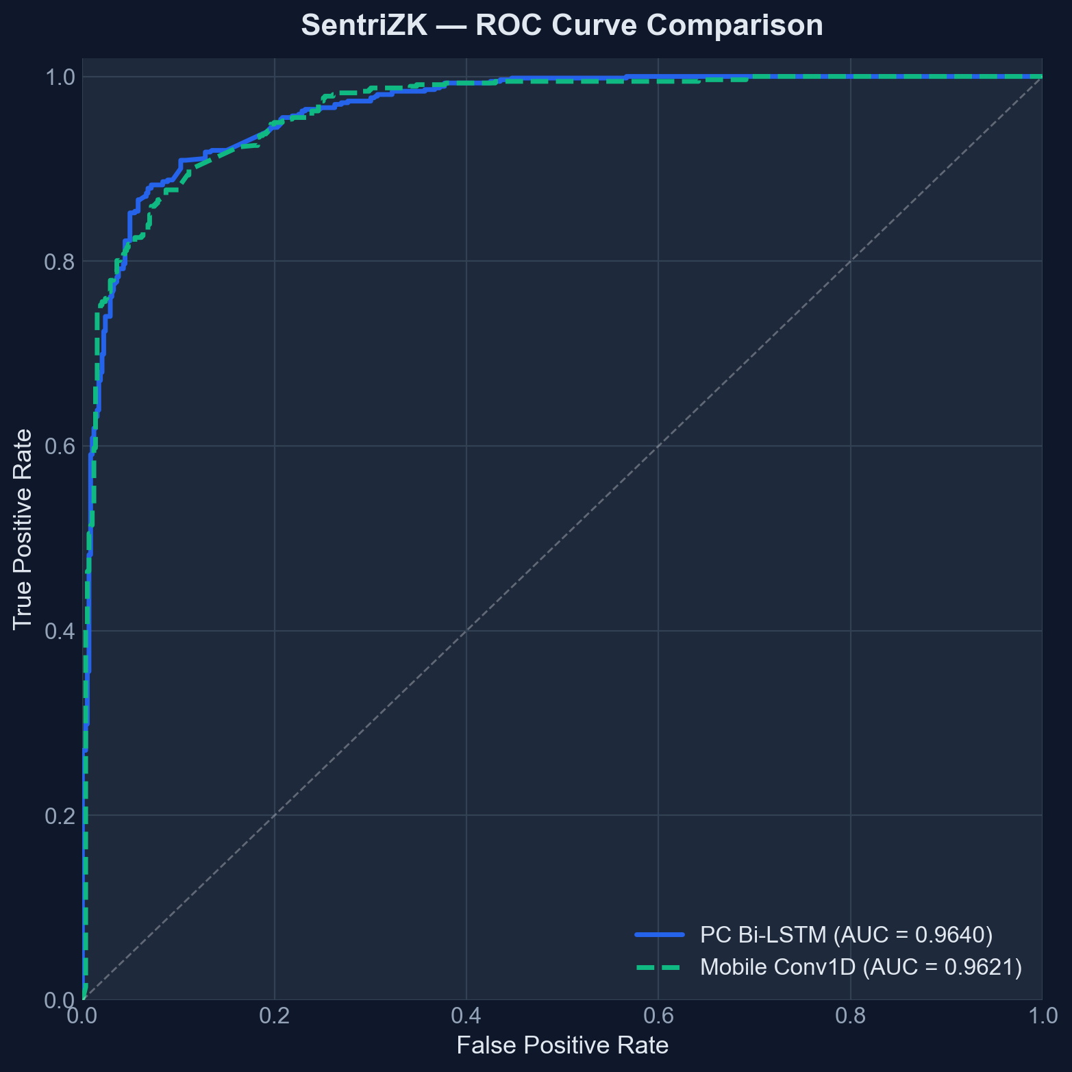
Figure 5.5: Receiver Operating Characteristic (ROC) Curves
The ML model’s ability to deal with actual text messages is established by three specific functional tests that indicated that the ML model appropriately ignored messages that contained a length below the minimum threshold for containing a threat.
Table 5.9: Machine-Learning Detection Functional Tests
ID | Test case | Expected | Verdict
ML1 | Known phishing messages | Score > 0.65 | Pass
ML2 | Benign messages | Score < 0.5 | Pass
ML3 | Messages under 4 words | Skipped, score 0.0 | Pass

5.6 Performance and Latency
We had to ensure the additional load of heavy cryptographic processing and AI wouldn't make the application feel sluggish for users. The heaviest processing load for our application occurs when generating the Groth16 proof, which takes approximately two to three seconds to generate within the users browser. Once a proof has been created, verifying it with the server takes less than 50 milliseconds. The AI Threat Scanner completes processing on the mobile device in under 100 milliseconds. Table 5.10 illustrates how well consumer grade hardware performs all of these computational tasks without degrading the user's chat experience.
Table 5.10: Indicative Performance Measurements
Operation | Approx. latency | Where
Groth16 proof generation | 2–3 s | Web portal (browser)
Groth16 proof verification | < 50 ms | Backend server
On-device threat inference | < 100 ms | Mobile device
Passive URL inspection | < 10 ms | Mobile device
Google Safe Browsing lookup | 100–300 ms | On link tap

5.7 User Acceptance Testing
User Acceptance Testing (UAT) evaluates whether non-tech-savvy 'everyday' employees are able to successfully use our application. Five individuals from NISHA SUTERA PRIMA were engaged to test the app. Each person registered for an account, sent/received messages, and received simulated threat alerts/alerts while testing the functionalities of our app. After completing testing, each participant rated the experience they had using our app on a scale from one to five. The purpose of UAT was to identify if increased security features would interfere with a user's daily workflow.
Table 5.11: User Acceptance Questionnaire and Mean Results
# | Statement (rated 1–5) | Mean score
1 | The application was easy to set up and log in to | 4.0
2 | Sending and receiving messages felt natural | 4.6
3 | The threat / link warnings were clear and helpful | 4.4
4 | Security did not slow down my daily tasks | 4.0
5 | I would trust this app for confidential work chat | 4.6

Overall User Satisfaction Ratings averaged at 4.32 (86.41%). The slightly lower average rating for the log-in process at 4.0 is expected due to the fact that it is unique from the use of other applications where the user generally has not previously waited approximately two seconds for the generation of web-assisted proof. Overall users rated the chat experience and their level of trust in the chat application very positively.
Table 5.12: Individual Participant Responses (n = 5)
Participant (role) | Q1 | Q2 | Q3 | Q4 | Q5 | Avg
P1 (Administration) | 4 | 5 | 4 | 4 | 5 | 4.4
P2 (Finance) | 4 | 4 | 5 | 3 | 4 | 4.0
P3 (Operations) | 3 | 5 | 4 | 4 | 5 | 4.2
P4 (Human Resource) | 5 | 5 | 5 | 4 | 5 | 4.8
P5 (Management) | 4 | 4 | 4 | 5 | 4 | 4.2
Mean | 4.0 | 4.6 | 4.4 | 4.0 | 4.6 | 4.32
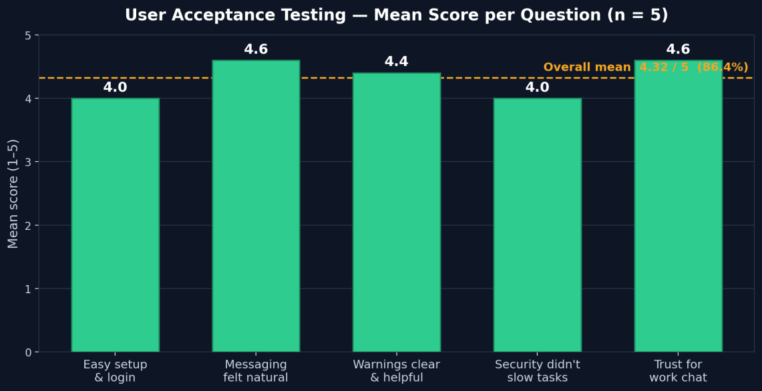

Figure 5.6: User Acceptance Testing — Mean Score per Question (n = 5)

5.8 Discussion
The outcome of the database breach test demonstrated that there were no passwords able to be stolen from the database, further validating the primary purpose of this project: to provide a means to authenticate a user while their credentials are held solely on their device. Additionally, tests performed indicate that a 0.68 MB machine learning model can identify 89% of threat types without text leaving the user's device.
While the program has proven itself functional and secure, the testing further identified a few constraints caused by limitations. For example, the dependency scan found several vulnerabilities not caused by malicious actions, and no confirmed method exists for alerting an individual using the sender-side checks if they are attempting to send a malicious message. While these limitations do not negate the overall integrity of the system; they do offer valuable insight as to what improvements can be completed in the future.

5.9 Summary
This chapter concludes with a summary of the extensive testing performed on the SentriZK prototype, which included functional testing, security testing, performance testing, and user acceptance testing, with the expectation that all functional test cases will be passed successfully. In terms of security testing, the system was able to successfully defend against credential theft, session hijacking, replay attacks, and reverse engineering. The AI local detection model was very successful in that it was able to achieve a high level of accuracy (89.2%) while also remaining small enough and fast enough to run on a standard mobile device. Finally, participants in the user acceptance testing agreed that the application is both reliable and natural to use. The next chapter will summarize the conclusions of this dissertation, offer reflections on the journey, and provide recommendations for future enhancements.

CHAPTER 6: CONCLUSION

6.1 Introduction
The final chapter summarizes the entire SentriZK project by covering the overall conclusion, main results from testing phase, and whether the original project objectives were accomplished. Further sections will include a discussion of limitations or honest shortcomings of the system itself as well as suggestions for future improvements, potential commercial benefitsof the application, and a final summary that wraps up the dissertation.

6.2 Project Conclusion
The purpose of this project is to assist in helping SMEs (Small and Medium Enterprises) with one of their biggest challenges: how to protect employee communications within the company while still retaining their privacy. SentriZK accomplishes this task by combining three key technologies: Zero-Knowledge Proof (ZKP) based authentication, End-To-End (E2E) encrypted communications, and an AI-based threat detection app running directly on the user’s phone. By making this technology available to users, it mitigates the risk of password theft and helps identify insider threats via the phone in real time.
SentriZK was thoroughly tested through rigorous functional, security, performance and end-user acceptance tests in an effort to demonstrate that it demonstrates true resiliency to cyber security vulnerability exploit onboarding methods while attempting implementation

6.3 Discussion of Findings
This section provides an overview of the results found during the testing and evaluating phase. The testing showed that the historical trade-off between privacy and security is not a forced choice. The simulated database breaches and live traffic interception testing demonstrated that no credentials are kept on the server, and no messages are stored in the clear. The local AI still picked up on malicious links.

The results confirmed the literature but also had some surprises. Generating Groth16 proof of concept in only two to three seconds proved that heavy math can be done on mobile devices. Additionally, the lightweight Convolutional Neural Network (Conv1D) model surpassed the more substantial research models with an accuracy of 89.2% and only taking 0.68 MB of storage. This demonstrates that significant cloud storage is unnecessary for quality threat detection.

6.4 Achievement of Objectives
This section illustrates how the project reached the intended objectives through continuous research, coding, and testing. As outlined in Chapter 1, the three main research objectives were:
- To study existing authentication and anomaly-detection methods in internal messaging systems and identify their security limitations.
- To develop a secure internal chat application integrating Zero-Knowledge Proof authentication and on-device AI anomaly detection.
- To test the functionality and security effectiveness of the newly implemented system.
Table 6.1 below summarizes the achievement of these objectives.
Table 6.1: Achievement of the Project Objectives
Objective | Evidence of achievement | Status
1. Study existing methods and identify limitations | Literature review and research gap (Chapter 2, Section 2.6) | Achieved
2. Develop the integrated secure chat application | Working prototype v1.0.8 (Chapter 4); 12/12 functional tests pass (Section 5.3) | Achieved
3. Test functionality and security effectiveness | 19 automated + 16 manual tests pass; 89.2% accuracy; UAT 4.32/5 (Chapter 5) | Achieved

6.4.1 Objective 1
Through an extensive literature review in Chapter 2, this objective was accomplished; the analysis showed that there are numerous flaws in how traditional messaging systems handle message encryption, and that companies typically encrypt everything to maintain privacy while sacrificing visibility into threats, or monitor everything by sacrificing user privacy for the ability to see potential threats. As a result of this analysis, there was clear evidence indicating a need for an update of the architecture of SentriZK to fill the market gap.

6.4.2 Objective 2
The development of a secure chat application has been successfully completed (see Chapter 4) by leveraging Circom circuits for ZeroKnowledge Proof (ZKP) login credentials, the Signal Protocol for End-to-End Encryption (E2EE) of messages between users, and a quantized TensorFlow Lite trained AI model for real-time detection of potential threats; thus creating an operational solution.

6.4.3 Objective 3
The third and final objective was achieved as outlined in Chapter 5 after extensive testing. All twelve core functionalities were confirmed to be operating correctly following extensive functional testing and security testing. Nineteen automated and 16 manual simulation attacks were executed using various known techniques (SQL injection, replay attack, token forgery) by invoking the attacking agent upon the SentriZK system; every attack was successfully blocked by the SentriZK system in every instance providing evidence that SentriZK has an exceptionally secure system and has successfully met its intended functionality..

6.5 Limitations
There are some inherent limitations of the SentriZK System that should be acknowledged. These limitations must be understood in order to properly direct any future development before deploying SentriZK on a large enterprise scale.
The first limitation involves silent sender side detection, i.e. the AI scans outgoing messages silently; the user can still send a risky message without being blocked and the only notification made to the user is when the future message arrives at its destination. Although this feature will still give the user the benefit of being able to prevent risky action on their behalf, this feature reduces the security value provided by the scanner.
The second limitation is regarding plaintext fallback; the SentriZK System will revert to plaintext to allow communication to occur in the event that the user attempts to send a message to another user who has not yet completed the process of obtaining the encryption key. This means that there are gaps in the integrity of encryption that occurs between users who do not fully complete this process before sending and/or receiving messages.
The app will trust a contact's encryption key automatically the first time they communicate with each other in order to make it more user-friendly at the expense of a the ability to secure against an attacker using MITM (man-in-the-middle) attacks. Also, the messages stored on the phone can be found in the local Isar database and are not encrypted. This means that the Android OSs can only provide a protection mechanism for these messages via the built-in sandbox created with the Android OS. Finally, the library scan found numerous underlying vulnerabilities within the 3rd-party libraries being used (such as the Firebase SDK). Although these vulnerabilities are not easily accessible for an attacker, they do exist in the background and therefore pose a risk to the application.

6.6 Future Recommendations
The testing identified limitations which are addressed with a series of recommendations made to improve the system's performance and security. All of these recommendations are designed to enhance the project's usefulness in the real world and allow it to qualify as production-ready. A summary of the specific limitations and related recommendations is found in Table 6.2.
Table 6.2: Limitations and Corresponding Recommendations
Limitation | Recommended improvement
Transitive dependency vulnerabilities | Apply audit fixes, pin versions, and add automated dependency scanning to a CI pipeline
Silent sender-side detection | Add a configurable pre-send warning or block for high-risk messages, with admin-tunable sensitivity
Plaintext fallback | Enforce ciphertext-only delivery by queuing messages until a recipient bundle is available
Trust-on-first-use key model | Add an optional key-verification ceremony (safety numbers / QR codes) to authenticate contacts
Unencrypted local storage | Encrypt the local database at rest with a key held in the hardware-backed keystore
Web-assisted authentication | Investigate a native on-device prover to remove the browser hand-off
Android-only / small UAT | Complete iOS support and conduct a larger, multi-organisation usability study

Additionally, the capabilities of the AI model can be extended to include the detection of unusual patterns of behaviour over time, such as odd login activity or extremely high message frequency. Finally, the addition of post-quantum cryptography will safeguard the system against threats to future computational capabilities.

6.7 Commercialization
SentriZK is responding to a market opportunity that is growing exponentially every year. Many small - to medium-sized businesses (SMBs) are forced to manage highly sensitive information; however, these companies cannot justify the high price tag of enterprise-level, customizable, configurable, integrated enterprise security solutions used by the larger corporations with significantly larger budgets. Therefore, SentriZK is the best fit to solve this problem because it combines passwordless log-in with in-city (local) artificial intelligence (AI) based cybersecurity threat detection.
Cost structure is by far the most compelling feature. Because SentriZK uses self-hosted infrastructure and self-managed services at no charge, initial implementation costs are approximately RM 80, with ongoing expense of zero after the installation of the system. The best business plan would be to provide cost-conscious SMBs with a free self-hosted version of SentriZK, and charge customers that do not want to host their own system a managed service subscription based on tiered pricing. The primary message is ‘security without surveillance;’ detection of computer or technical crimes and harmful behaviours without monitoring or surveillance of employees’ communications.

6.8 Summary
The research concludes that organisations do not need to decide between protecting the privacy of their employees and protecting themselves against cybercriminals. The research provides some recommendations for the future duration of the application, the need for modifications to enhance the security of the system, and clearly lays out a strategy for commercialising the application. SentriZK proves that privacy preserving, intelligent, and affordable secure messaging is an achievable reality.

REFERENCES

Alatawi, M., & Saxena, N. (2023). SoK: An Analysis of End-to-End Encryption and Authentication Ceremonies in Secure Messaging Systems. 2023 IEEE Symposium on Security and Privacy (SP), 2816–2833.
https://doi.org/10.1109/SP46215.2023.00158
Barnes, R., Beurdouche, B., Robert, R., Millican, J., Omara, E., & Cohn-Gordon, K. (2023). The Messaging Layer Security (MLS) Protocol (RFC 9420). Internet Engineering Task Force (IETF). https://www.rfc-editor.org/rfc/rfc9420.html
Bhattacharya, S., Seth, D., Panyam, S., & Gangrade, P. (2024).1 Enhancing Digital Privacy: The Application of Zero-Knowledge Proofs in Authentication Systems. International Journal of Computer Trends and Technology, 72(4), 34- 41.
Bispo, G. D., Silva, L., & Souza, A. (2025). PHILDER: Lightweight Framework for Intelligent Phishing Detection on Resource-Limited Devices.2 IEEE Internet of Things Journal, 12(4), 3421-3435.
Chen, Z., Liu, Y., & Wang, H. (2023). A Survey on Zero-Knowledge Authentication for Internet of Things. Electronics, 12(9), 2098.
Gaurav, A., Gupta, B. B., & Panigrahi, P. K. (2025). AI-Driven Smishing Detection in Android Devices Using TinyBERT and Aquila Optimization. Neural Computing and Applications, 37, 1245–1258.
Hussain, S., & Ali, M. (2023). Phishing Detection System Through Hybrid Machine Learning Based on URL. 2023 International Conference on Computing, Electronics & Communications Engineering (iCCECE), 112-117.
Ilesanmi, M. (2025). Threat Modeling for Enterprise Secure Messaging Applications. Journal of Cybersecurity, 9(1), tyad004.
Luong, D. A., & Park, J. H. (2023). Privacy-Preserving Identity Management System on Blockchain Using zk-SNARK. IEEE Access, 11, 1840-1853.3
11310. Mishra, P., & Gupta, A. (2025). A Secure Framework for Privacy-Preserving Analytics in Healthcare Records Using Zero-Knowledge Proofs. Future Generation Computer Systems, 158, 201-214.
Natha, S., Al-Zahrani, A., & Al-Ghamdi, A. (2022). A Systematic Review of Anomaly Detection Using Machine and Deep Learning Techniques. Journal of King Saud University - Computer and Information Sciences, 34(9), 7483-7498.
Patel, R., & Singh, V. (2025). Implementation of Secure E2EE Chat Application in Microservice Architecture. MDPI Applied Sciences, 15(3), 1204.
Rahman, F., & Lee, K. (2024). A Review of Recent Advances, Challenges, and Opportunities in Malicious Insider Threat Detection Using Machine Learning Methods. IEEE Access, 12, 15432-15455.
Srinivasan, K., Chauhan, G. S., & Almahdi, M. (2025).4 Insider Threat Detection and Secure Data Transfer Leveraging Bidirectional LSTM. International Journal of Digital Innovation and Discoveries, 1(1), 15-21.5

APPENDICES A

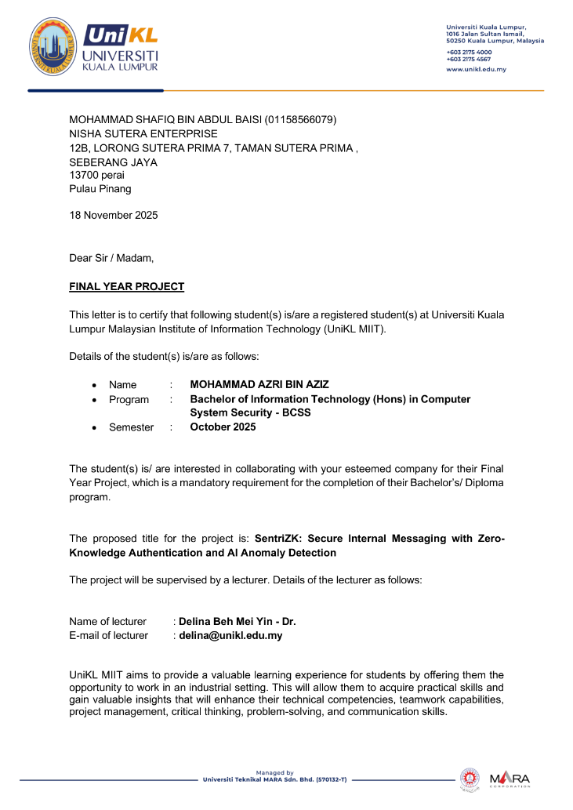
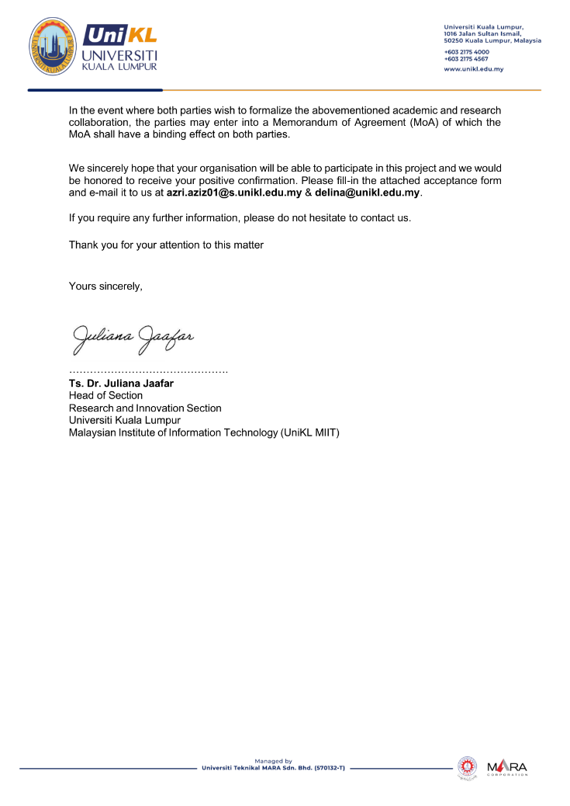
Letter of Acknowledgement (LOA)
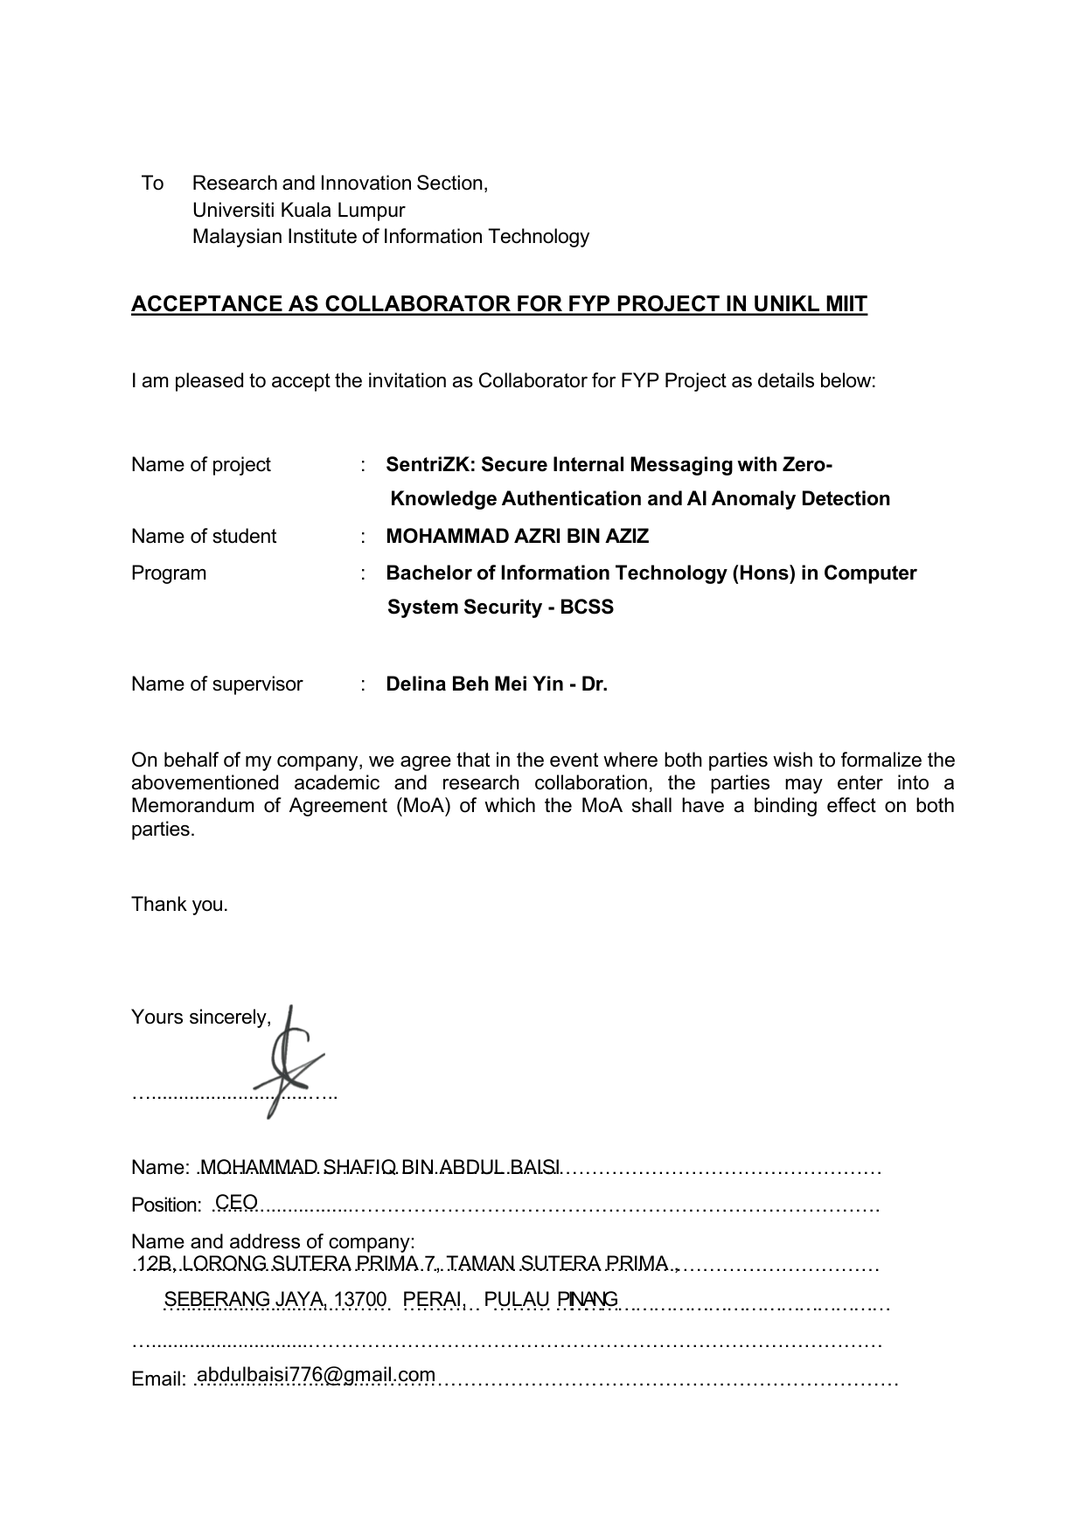

APPENDICES B

Gantt Chart: Link
The complete source code for the SentriZK secure messaging system including the Flutter mobile application, the Next.js web portal, the Node.js backend, and the Python machine-learning pipeline is publicly available in the following Git repository:
https://github.com/mohammadazri/SentriZK-InternalChat

