List of Component:

Component – Description Qty

**LED** – IR LED(5mm) , used to as a light source for tracking 4

**Resistor** – 100 ohm, used to limit the current of LEDs 4

**opt101**  – photo diode, used to as a receiver for for projection 2

**Header** – to connect board with arduino 28-30 pins

**Arduino** – for serial communication and powering up the board 1

**Bread Board Version:**

**Project Steps:**

* **Place all resistors on the breadboard according to Figure. All resistor are 100 ohm and one end is connected to (–) slot and other connected to small leg(-ve) of LED.**
* **Place all LEDs according to Figure. The long leg(+ve) is connector to arduino pin through a jumper wire(yellow wire) and second is connector to resistor.**
* **Place both ICs(opt101) according to Figure, make sure that the orientation of ICs is correct.**
* **Place all the jumper wires on the bread board according to Figure.**
* **Connect the arduino 5v pin and Gnd pin to (+) and (-) slot respectively.**
* **Connect four digital pins(8,9,10,11) of arduino to LEDs through jumper wires(yellow).**
* **Connect two analog pins(A0,A1) to ICs through jumper wires(orange wire).**

**Note:**

**Make sure that the (-) and (+) slots of the board are same as in Figure**

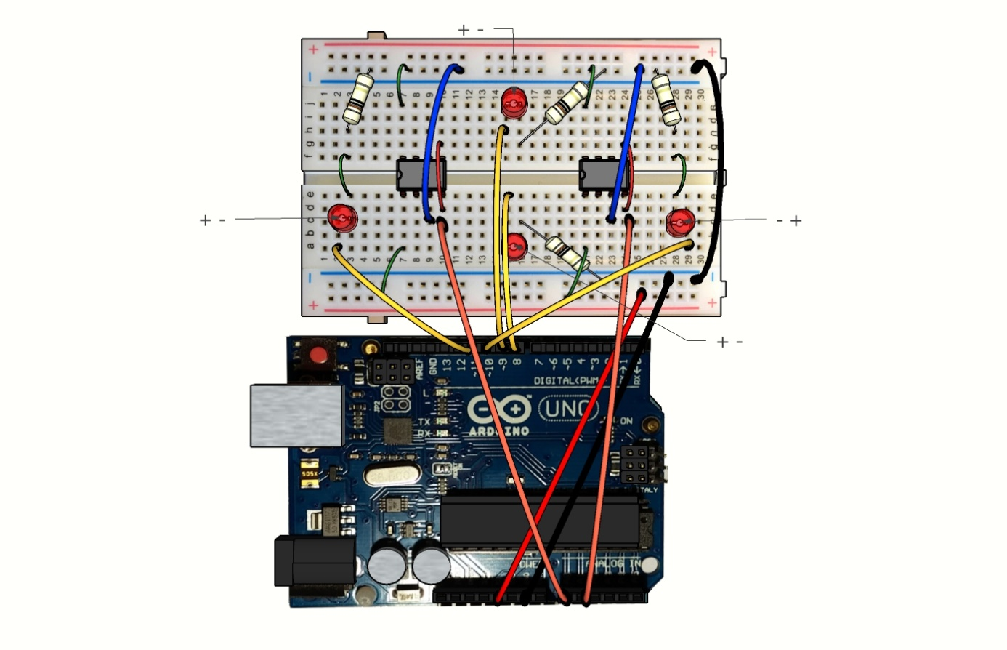

Figure 1 : Bread Board Version

**PCB Version:**

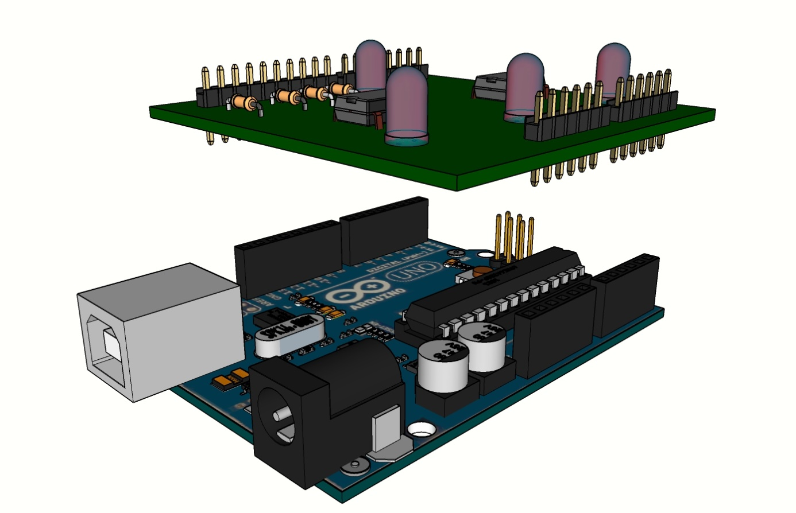 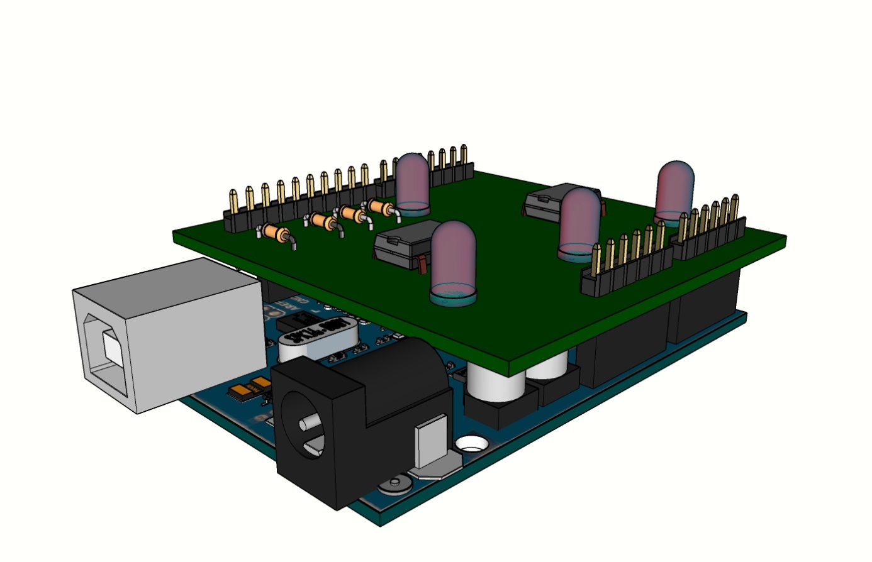

Figure : PCB Version

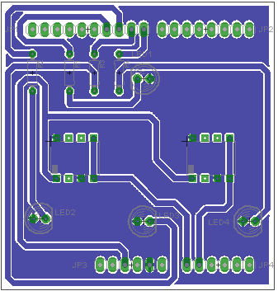

Figure : PCB LAYOUT

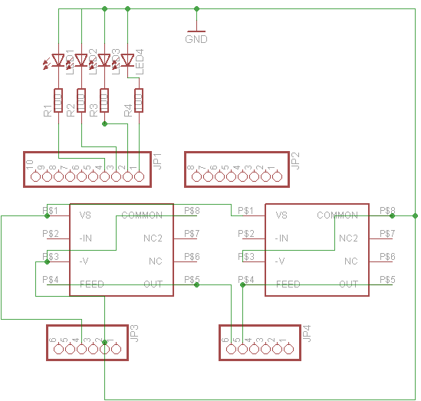

Figure : PCB Schematic