Index
Lab No | Experiment Name | page
01 | Basic String Operations in C
02 | Lexical Analysis (Whitespace Identification, Removal & Tokenization)
03 | Lexical Analysis(identifying tokens such as keywords, identifiers, operators, and constants.)
04 | Regular Expressions

Experiment No. 01: Basic String Operations in C

1. Objective
The objectives of this experiment are:
- To understand the concept of strings in C programming
- To find the length of a string
- To copy one string into another string
- To concatenate two strings
- To compare two strings
- To reverse a given string

2. Pre-requisites
- Basic knowledge of C programming language
- Understanding of arrays and loops
- Familiarity with stdio.h and string.h libraries

3. Required Tools
- C Compiler (GCC / Dev-C++ / CodeBlocks / Turbo C)
- Any C IDE or text editor

4. Theory
In C programming, a string is a sequence of characters stored in a character array and terminated by a null character (\0).
The standard header file <string.h> provides several built-in functions for efficient string manipulation:
- strlen() – finds the length of a string
- strcpy() – copies one string to another
- strcat() – concatenates two strings
- strcmp() – compares two strings
String operations are widely used in system software, compilers, database systems, and general-purpose applications.

5. Programs
Note: Each operation is implemented using both built-in functions and manual logic (without built-in functions) to better understand internal string handling.

Program 1: Finding the Length of a String (Using strlen()) & without Built-in function.
Code Without Built-in Function:  #include <stdio.h>  #include <string.h>  int main() {  char str[100];  int length = 0;  printf("Enter a string: ");  fgets(str, sizeof(str), stdin);  str[strcspn(str, "\n")] = '\0';  for (int i = 0; str[i] != '\0'; i++) {  length++;  }  printf("Length of the string: %d\n", length);  return 0; } | Code (Using strlen()):  #include <stdio.h>  #include <string.h>  int main() {  char str[100];  printf("Enter a string: ");  fgets(str, sizeof(str), stdin);  str[strcspn(str, "\n")] = '\0';  printf("Length of the string: %lu\n", strlen(str));  return 0;  }

Input & Output:
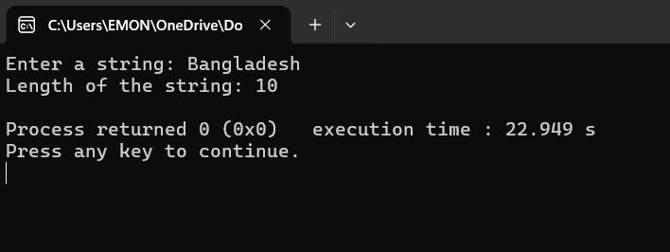
Program 2: Copying One String to Another (Using strcpy()) & without Built-in function.

Without Built-in Function:  #include <stdio.h>  int main() {  char str1[100], str2[100];  printf("Enter a string: ");  fgets(str1, sizeof(str1), stdin);  for (int i = 0; str1[i] != '\0'; i++) {  str2[i] = str1[i];  }  str2[i] = '\0'; // Null-terminate the copied string  printf("Copied string without using built-in function: %s\n", str2);  return 0;  } | Code(Using strcpy()):  #include <stdio.h>  #include <string.h>  int main() {  char str1[100], str2[100];  printf("Enter a string: ");  fgets(str1, sizeof(str1), stdin);  str1[strcspn(str1, "\n")] = '\0';  strcpy(str2, str1);  printf("Copied string: %s\n", str2);  return 0;  }

Input & Output:

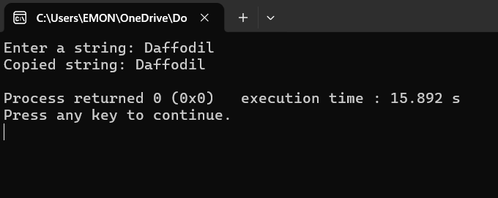

Program 3: Concatenating Two Strings (Using strcat()) & without Built-in function.
Without Built-in Function:  #include <stdio.h>  #include <string.h>  int main() {  char str1[100], str2[100];  int i, j;  printf("Enter first string: ");  fgets(str1, sizeof(str1), stdin);  str1[strcspn(str1, "\n")] = '\0';  printf("Enter second string: ");  fgets(str2, sizeof(str2), stdin);  str2[strcspn(str2, "\n")] = '\0';  // Check buffer overflow  if (strlen(str1) + strlen(str2) >= sizeof(str1)) {  printf("Error: Concatenation exceeds buffer size.\n");  return 1;  }  // Move i to the end of str1  i = strlen(str1);  // Append str2 to str1  for (j = 0; str2[j] != '\0'; j++) {  str1[i] = str2[j];  i++;  }  // Null terminate the final string  str1[i] = '\0';  printf("Concatenated string: %s\n", str1);  return 0;  } | Code(Using strcat()):  #include <stdio.h>  #include <string.h>  int main() {  char str1[100], str2[100];  printf("Enter first string: ");  fgets(str1, sizeof(str1), stdin);  str1[strcspn(str1, "\n")] = '\0';  printf("Enter second string: ");  fgets(str2, sizeof(str2), stdin);  str2[strcspn(str2, "\n")] = '\0';  strcat(str1, str2);  printf("Concatenated string: %s\n", str1);  return 0;  }
Input & Output:
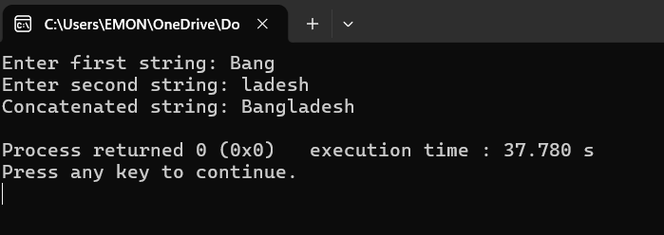

Program 4: Comparing Two Strings (Using strcmp()) & without Built-in function.
Without Built-in Function:  #include <stdio.h>  #include <string.h>  int main() {  char str1[100], str2[100];  int i = 0;  printf("Enter first string: ");  fgets(str1, sizeof(str1), stdin);  printf("Enter second string: ");  fgets(str2, sizeof(str2), stdin);  while (str1[i] != '\0' && str2[i] != '\0') {  if (str1[i] != str2[i]) break;  i++;  }  if (str1[i] == str2[i])  printf("Strings are equal.\n");  else  printf("Strings are not equal.\n");  return 0;  } | Code(Using strcmp()):  #include <stdio.h>  #include <string.h>  int main() {  char str1[100], str2[100];  printf("Enter first string: ");  fgets(str1, sizeof(str1), stdin);  str1[strcspn(str1, "\n")] = '\0';  printf("Enter second string: ");  fgets(str2, sizeof(str2), stdin);  str2[strcspn(str2, "\n")] = '\0';  if (strcmp(str1, str2) == 0)  printf("Strings are equal.\n");  else  printf("Strings are not equal.\n");  return 0;}

Alternative Solution:  #include <stdio.h>  #include <string.h>  int main(){  char str1[100], str2[100];  printf("Enter first string: ");  fgets(str1, sizeof(str1), stdin);  str1[strcspn(str1, "\n")] = '\0';  printf("Enter second string: ");  fgets(str2, sizeof(str2), stdin);  str2[strcspn(str2, "\n")] = '\0';  int result = strcmp(str1, str2);  if (result == 0)  printf("Strings are equal.\n");  else if (result < 0)  printf("First string is less than second.\n");  else  printf("First string is greater than second.\n");  return 0;  } | Input & Output:  Test Case-01:  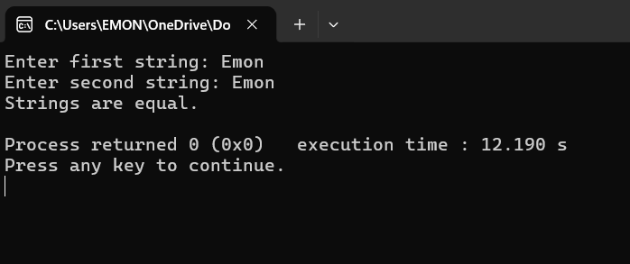  Test Case-02:  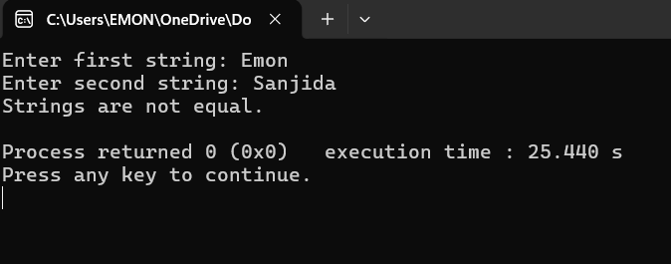

Program 5: Reverse a string without using library functions & without using a second string.
Code Using Two strings and string length given by user:  #include <stdio.h>  #include <string.h>  int main() {  int len;  printf("Enter the max length of the string: ");  scanf("%d", &len);  getchar(); // clear newline  char str1[len + 1];  char str2[len + 1];  printf("Enter a string: ");  fgets(str1, sizeof(str1), stdin);  str1[strcspn(str1, "\n")] = '\0';  int actual_len = strlen(str1);  int j = 0;  for (int i = actual_len - 1; i >= 0; i--) {  str2[j] = str1[i];  j++;  }  str2[j] = '\0';  printf("Reversed string: %s\n", str2);  return 0;  } | Code Without using a second string:  #include <stdio.h>  #include <string.h>  int main() {  char str[100];  int len, i;  printf("Enter a string: ");  fgets(str, sizeof(str), stdin);  str[strcspn(str, "\n")] = '\0';  len = strlen(str);  for (i = 0; i < len / 2; i++) {  char temp = str[i];  str[i] = str[len - i - 1];  str[len - i - 1] = temp;  }  printf("Reversed string: %s\n", str);  return 0;  }
Input & Output:

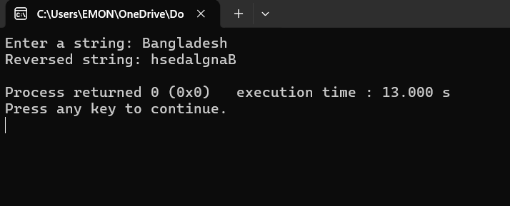

6. Comparison: Built-in vs Without Built-in
Operation | Built-in Functions | Without Built-in
Length | Simple and fast | Logical and educational
Copy | Reliable and short | Manual memory handling
Concatenation | Clean syntax | Improves index control
Comparison | Accurate ASCII result | Easy exam logic
Reverse | Less code | Strengthens algorithm skills

7. Observations
- Built-in string functions reduce coding effort
- String comparison is case-sensitive
- Correct handling of the null character is essential

8. Result
All the objectives of this experiment were successfully achieved. The programs compiled and executed correctly, producing the expected outputs for each string operation such as length calculation, copying, concatenation, comparison, and reversal. Both built-in and manual implementations worked as intended, confirming a clear understanding of string manipulation concepts in C programming.

9. Conclusion
This experiment successfully demonstrated fundamental string operations in C programming. Understanding both built-in and manual implementations enhances problem-solving ability and prepares students for examinations and real-world programming tasks.

Experiment No. 02: Lexical Analysis (Whitespace Identification, Removal & Tokenization)

1. Objective
The objectives of this experiment are:
- To identify whitespace characters (space, tab, newline).
- To count whitespace characters in a given input.
- To remove whitespace from a string (using different methods).
- To tokenize input strings using the strtok() function.
- To understand the role of whitespace in lexical analysis.

2. Software Requirement
- C Compiler (GCC / MinGW / Turbo C)
- Any C IDE (VS Code / Dev C++ / CodeBlocks)
- Operating System: Windows / Linux

3. Theory
In compiler design, lexical analysis is the first phase of compilation. It scans the source code character by character and groups them into tokens.

Whitespace Characters
Whitespace characters include:
- Space ' '
- Tab '\t'
- Newline '\n'
These characters are used to separate tokens but usually have no semantic meaning, except inside string or character literals.

isspace() Function
The isspace() function (from <ctype.h>) checks whether a character is a whitespace character.
- Returns non-zero if true
- Returns 0 if false

strtok() Function
The strtok() function is used to split a string into tokens based on delimiters.
char *strtok(char *str, const char *delim);
It is commonly used in lexical analysis to separate identifiers, keywords, and symbols.

4. Algorithm

A. Whitespace Identification
- Read a character.
- Check if it is space, tab, or newline.
- Display whether it is a whitespace character.

B. Whitespace Counting
- Read a string.
- Initialize a counter.
- Traverse the string.
- If isspace() is true, increment counter.
- Print total count.

C. Whitespace Removal
- Read input string.
- Copy only non-whitespace characters to another string or same string.
- Display the modified string.

D. Tokenization
- Read input string.
- Use strtok() with space as delimiter.
- Print each token separately.
5. Program Implementation
Program 1: Identification of Whitespace (Without Library Function)  Code:  #include <stdio.h>  int main() {  char a;  printf("Enter a character: ");  scanf("%c", &a);  if (a == ' ' || a == '\t' || a == '\n') {  printf("Whitespace character\n");  }  else {  printf("Not a whitespace character\n");  }  return 0;  } | Program 2: Identification of Whitespace (Using isspace())  Code:  #include <stdio.h>  #include <ctype.h>  int main() {  char a;  scanf("%c", &a);  if (isspace(a))  printf("Whitespace character\n");  else  printf("Not a whitespace character\n");  return 0;  }
Input & Output:
Test Case–1 (Space character)
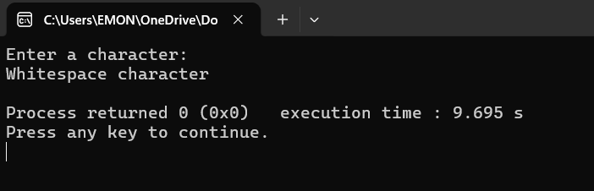
Test Case–5 (Digit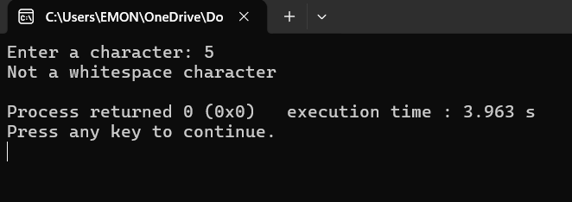
Comparison:
- Manual checking is basic and limited.
- isspace() is cleaner, readable, and handles all whitespace types.

Program 3: Count Whitespace in a String

Code:
#include <stdio.h>
#include <string.h>
#include <ctype.h>

int main() {
char str[100];
int count = 0;

printf("Enter a string: ");
fgets(str, sizeof(str), stdin);
str[strcspn(str, "\n")] = '\0';

for (int i = 0; i < strlen (str); i++) {
if (isspace(str[i]))
count++;
}
printf ("Number of whitespace characters: %d\n", count);
return 0;
}

Input & Output:

Test Case–1 (Sentence with spaces)

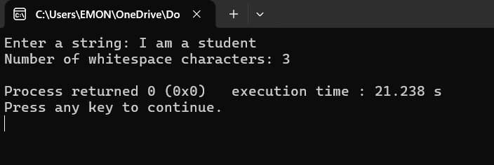
Program 4: Remove Whitespace Using Another String  Code:  #include <stdio.h>  #include <string.h>  #include <ctype.h>  int main(){  char str[100], result[100];  printf("Enter a string: ");  fgets(str, sizeof(str), stdin);  str[strcspn(str, "\n")] = '\0';  int j = 0;  // for (int i = 0; i < strlen(str); i++)  for (int i = 0; str[i] != '\0'; i++)  {  if (!isspace(str[i]))  {  result[j] = str[i];  j++;  }  }  result[j] = '\0';// Null-terminate the result string  printf("String without whitespace: %s\n", result);  return 0;  } | Program 5: Remove Whitespace In-Place  Code:  #include <stdio.h>  #include <string.h>  #include <ctype.h>  int main() {  int size;  printf("Enter the size of string: ");  scanf("%d", &size);  getchar();  char str[size];  printf("Enter a string: ");  fgets(str, sizeof(str), stdin);  str[strcspn(str, "\n")] = '\0';  int j = 0;  /*  for (int i = 0; str[i] != '\0'; i++) {  if (!isspace(str[i])) {  str[j] = str[i];  j++;  }  }  */  for (int i = 0; str[i] != '\0'; i++){  if(isspace(str[i])){  continue;  }  str[j++] = str[i];  }  str[j] = '\0';  printf("String without whitespace: %s\n", str);  return 0;  }

Comparison:
- Using a new string is safer and clearer.
- In-place modification is memory efficient.

Input & Output:

Test Case–1

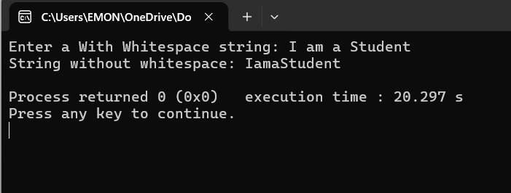

Program 6: Tokenization Using strtok()
Code:
#include <stdio.h>
#include <string.h>
int main(){
char str[100];

printf("Enter a string: ");
fgets(str, sizeof(str), stdin);
str[strcspn(str, "\n")] = '\0';

char *token;
token = strtok(str, " ");

//printf("first token: %s\n", token);//print first token

while (token != NULL)
{
printf("%s\n", token);
token = strtok(NULL, " ");
}

return 0;

}
Input & Output:

Test Case–1

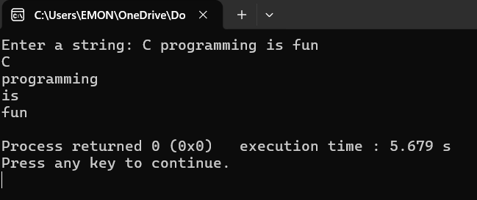

6. Comparison: Built-in Functions vs Without Built-in Functions
In lexical analysis, whitespace handling can be implemented either by manual checking or by using built-in library functions. Both approaches were explored in this experiment.

A. Whitespace Identification
Aspect | Without Built-in | Using Built-in (isspace())
Method | Manual comparison (' ', '\t', '\n') | Standard library function
Coverage | Limited to specified characters | Covers all standard whitespace
Readability | Less readable for large cases | More readable and clean
Reliability | Error-prone if cases are missed | More reliable
Using isspace() is preferable because it handles all whitespace characters and improves code clarity.

B. Whitespace Counting & Removal
Aspect | Without Built-in | Using Built-in
Logic Complexity | Higher | Lower
Code Length | Longer | Shorter
Maintenance | Difficult | Easy
Standard Compliance | Low | High
Built-in functions reduce complexity and follow standard C practices, making programs easier to debug and maintain.

C. Tokenization
Aspect | Manual Tokenization | Using strtok()
Implementation | Complex logic needed | Simple and efficient
Code Size | Large | Small
Error Possibility | High | Low
Performance | Moderate | Optimized

strtok() is highly efficient for lexical analysis and widely used in compiler design for token
separation.

7. Result
All objectives of the experiment were successfully achieved. Different methods of identifying, counting, and removing whitespace were implemented and compared.

8. Conclusion
This experiment helped in understanding the practical implementation of lexical analysis concepts such as whitespace handling and tokenization, which are essential parts of compiler design.

Experiment No. 03: Lexical Analysis

Objective: To write a program that performs lexical analysis — identifying tokens such as keywords, identifiers, operators, and constants.

Experiment No. 04: Regular Expressions

Objective: To understand and implement Regular Expressions for pattern matching.

