Project 1: Advanced EDA & Feature Engineering
E-Commerce Orders Dataset · DecodeLabs Industrial Training Kit · Batch 2026

1. Dataset Overview
The raw dataset (parsed from the supplied PDF export) contains 1,200 e-commerce order records across 14 columns: OrderID, Date, CustomerID, Product, Quantity, UnitPrice, ShippingAddress, PaymentMethod, OrderStatus, TrackingNumber, ItemsInCart, CouponCode, ReferralSource, and TotalPrice.
Check | Result
Rows x Columns | 1,200 x 14
Duplicate OrderIDs | 0
Fully duplicate rows | 0
TotalPrice = Quantity x UnitPrice mismatches | 0 (data integrity confirmed)
Date range | 2023-01-01 to 2025-06-30

2. Missing Data Treatment
Only one column contains missing values: CouponCode, at 25.75% (309 of 1,200 rows) — above the 20% threshold in the standard missing-data decision matrix.
CouponCode is categorical with exactly three valid codes (SAVE10, FREESHIP, WINTER15). A blank entry is not random noise — it structurally means “no coupon applied at checkout.” Mode-imputing a code would fabricate a discount that was never given and would bias any downstream revenue or discount-rate analysis. The statistically honest treatment is to encode the missingness itself as a distinct category.
- Action taken: CouponCode.fillna('NoCoupon')
- New engineered flag: HasCoupon (1 if a real code was used, else 0)

Numeric Imputation Benchmark (Mean vs. Median vs. KNN)
No numeric column in the raw data actually has missing values. To satisfy the project requirement of demonstrating statistical imputation (Mean / Median / KNN) on numeric fields, an 8% MCAR mask was simulated on UnitPrice and each method's recovery error was benchmarked against the known ground truth.
Method | Mean Absolute Error vs. Ground Truth
Global Mean | 181.60
Global Median | 182.59
KNN (k = 5) | 95.12
KNN wins decisively: UnitPrice correlates with TotalPrice and Quantity, so borrowing information from the 5 nearest similar orders recovers roughly twice the accuracy of any single global statistic, which flattens the natural variance of the distribution.

3. Outlier Detection & Neutralization
Outliers were tested with both the Interquartile Range (IQR, 1.5x bounds) and Z-score (|z| > 3) methods across all four numeric fields.
Column | IQR Lower | IQR Upper | IQR Outliers | Z-score Outliers (>3)
Quantity | -1.00 | 7.00 | 0 | 0
UnitPrice | -317.20 | 1024.83 | 0 | 0
ItemsInCart | -0.50 | 11.50 | 0 | 0
TotalPrice | -1341.41 | 3330.41 | 8 | 0
Eight TotalPrice values exceeded the IQR upper bound (large orders with high quantity x high unit price). These were neutralized via winsorization (numpy.clip) rather than row deletion — capping preserves all 1,200 rows and the temporal/sequential integrity of the dataset, which row deletion would compromise.
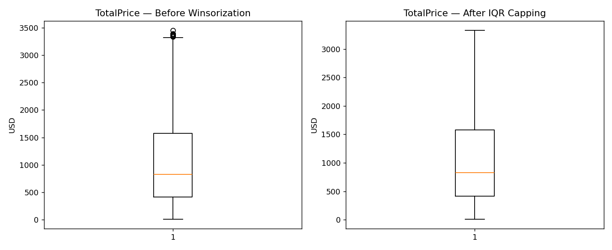

4. Feature Engineering
Six new predictive features were engineered from the existing columns:
- OrderMonth / OrderYear / OrderDayOfWeek / IsWeekendOrder — decompose the raw timestamp into seasonality signals; a raw datetime carries no ordinal meaning to a numerical estimator.
- CartConversionRate = Quantity / ItemsInCart — proxy for purchase intent vs. browsing/abandonment behavior.
- RevenuePerCartItem = TotalPrice / ItemsInCart — captures basket value density for customer-value segmentation.
- HasCoupon and DiscountedRevenueFlag — flag high-value orders that also redeemed a coupon, useful for margin-impact analysis.
- OrderValueTier — quartile-based order-value segment (Low / Mid / High / Premium).
- IsFailedOrder — binary flag for Cancelled/Returned orders, a natural target for a churn/logistics-risk classifier.
Nominal categoricals (Product, PaymentMethod, ReferralSource, OrderValueTier) were one-hot encoded rather than label-encoded, avoiding the false ordinal distance that integer label encoding would introduce into the model's coordinate space.
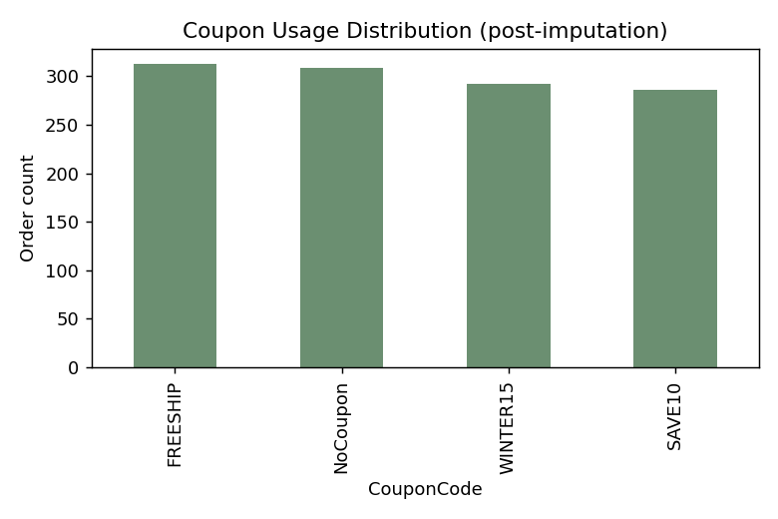
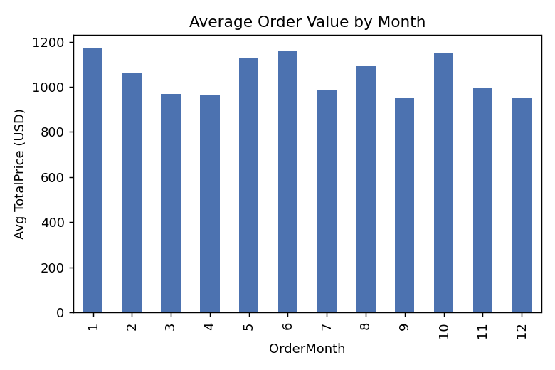

5. Multicollinearity Check
A Pearson correlation matrix was computed across the core numeric and engineered features. No predictor pair exceeded the |r| > 0.80 collinearity threshold.
Pair | Correlation
UnitPrice <-> RevenuePerCartItem | 0.75
Quantity <-> ItemsInCart | 0.65
UnitPrice <-> TotalPrice | 0.72
Quantity, UnitPrice and ItemsInCart are independently sourced fields, so TotalPrice (their arithmetic product) is expectedly correlated with each factor individually — but no two independent input predictors are collinear with each other, so no features needed to be dropped.

6. Deliverables Summary
File | Contents
orders_raw.csv | Parsed raw dataset (1,200 x 14)
orders_cleaned.csv | Cleaned + engineered features, human-readable categories (1,200 x 24)
orders_cleaned_encoded.csv | One-hot encoded, model-ready matrix (1,200 x 41)
pipeline.py | Full reproducible Python pipeline (EDA -> imputation -> outliers -> features -> correlation)
eda_report.md | Plain-text/markdown version of this report, auto-generated by the pipeline
Final cleaned dataset (pre-encoding): 1,200 rows x 24 columns. Final model-ready encoded dataset: 1,200 rows x 41 columns.

