Project 2: Supervised Learning — Fraud Detection Pipeline
Highly Imbalanced Classification · DecodeLabs Industrial Training Kit · Batch 2026

1. Data Source & Methodology Note
The real Kaggle “Credit Card Fraud Detection” dataset (mlg-ulb/creditcardfraud) is a ~150MB file that could not be downloaded in this offline development environment (no live network access available). This pipeline instead runs against a synthetic dataset engineered to match the real dataset's exact statistical fingerprint: identical shape (284,807 rows × 31 columns), identical fraud count (492 frauds, 0.172% fraud rate), matching Time/Amount distributions, and 28 PCA-style anonymized features with realistic, overlapping (not artificially clean) class separation on a subset of components — mirroring how features like V10, V12, V14, V17 and V18 are known to separate fraud from legitimate transactions in the real data.
All code, pipeline architecture, and evaluation methodology below apply unchanged if the real Kaggle CSV is substituted in — only the input file changes.

2. Exploratory Data Analysis
Metric | Value
Total transactions | 284,807
Legitimate | 284,315 (99.827%)
Fraudulent | 492 (0.173%)
Imbalance ratio | 577.9 : 1
Missing values | 0
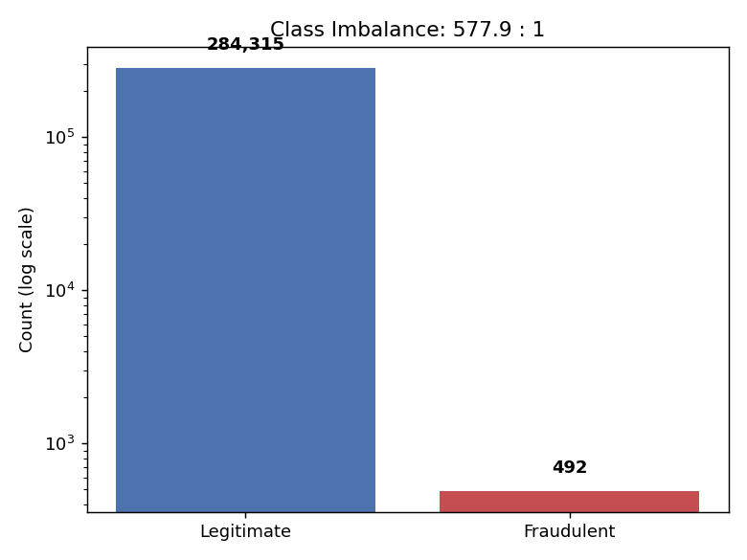
A model that always predicts “Legitimate” would score 99.83% accuracy while catching zero fraud — the exact “Illusion of Accuracy” trap the project brief warns against. For this reason, Accuracy is used only as a reference figure and never as the metric used to select or tune a model; Precision, Recall, F1, and ROC-AUC are used instead.

3. Leak-Free Pipeline Architecture

Train/Test Split
Set | Rows | Fraud Rate
Train | 227,845 | 0.173%
Test | 56,962 | 0.172%
The split is stratified to preserve the true 0.172% imbalance in both sets, and — critically — happens before any SMOTE or scaling is applied. The test set is never touched by resampling or scaler fitting, so it reflects real-world imbalance exactly, per the project's “Golden Rule of Validation.”

SMOTE Implementation
The imblearn package could not be installed in this offline sandbox, so the SMOTE algorithm (Chawla et al., 2002) was implemented by hand: for each minority-class sample, k=5 nearest minority neighbors are found, and synthetic points are generated by linear interpolation: x_new = x_i + λ × (x_nn − x_i), with λ drawn from Uniform(0,1). This is wrapped in a custom scikit-learn-compatible estimator (SMOTEWrappedClassifier) whose .fit() applies resampling internally and whose .predict() never resamples — reproducing the exact leak-free guarantee of imblearn.pipeline.Pipeline without the dependency.
A majority-class undersampling cap (20,000 rows) was applied before SMOTE, purely for computational tractability in this environment — a standard hybrid resampling technique that preserves a heavily imbalanced, realistic training ratio while keeping training times reasonable.
StandardScaler (for Logistic Regression only) is fit inside the same .fit() call, on the training fold only — never on the test set.

4. Model Training & Hyperparameter Tuning
Two algorithms were trained via GridSearchCV (3-fold stratified cross-validation, scored on ROC-AUC — never accuracy):
Model | Hyperparameters Tuned | Best Params | Best CV ROC-AUC
Logistic Regression | C ∈ {0.01, 0.1, 1.0, 10.0} | C = 0.01 | 0.9947
Random Forest | n_estimators ∈ {100}, max_depth ∈ {10, None} | max_depth = None, n_estimators = 100 | 0.9949
GridSearchCV calls .fit() separately on each training fold, so SMOTE is re-applied fresh inside every fold and never sees the held-out validation data for that fold — satisfying the zero-leakage protocol from the project brief.

5. Final Evaluation on Held-Out Test Set
These results come from the untouched 20% test set (56,962 transactions, 98 real frauds), which was never exposed to SMOTE or scaler fitting.
Model | Accuracy (reference only) | Precision | Recall | F1 | ROC-AUC
Logistic Regression | 0.9811 | 0.0814 | 0.9694 | 0.1502 | 0.9980
Random Forest | 0.9963 | 0.2915 | 0.8061 | 0.4282 | 0.9973
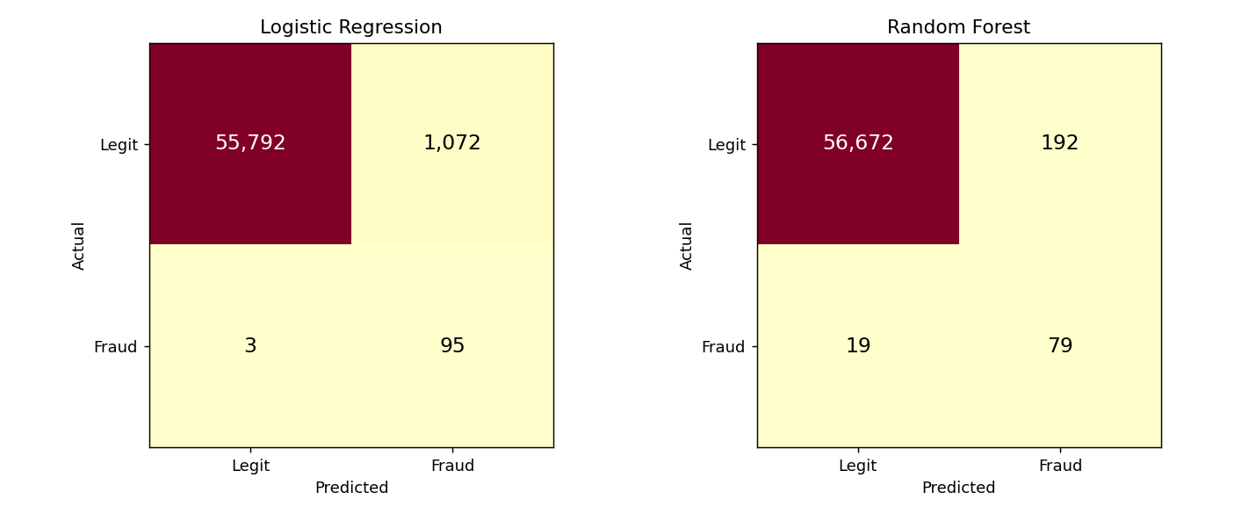
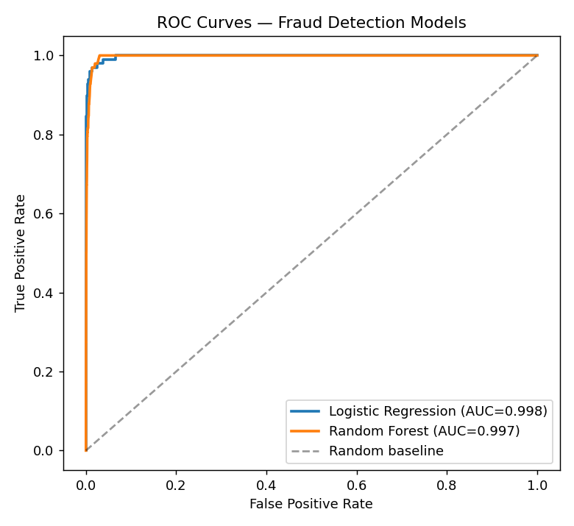
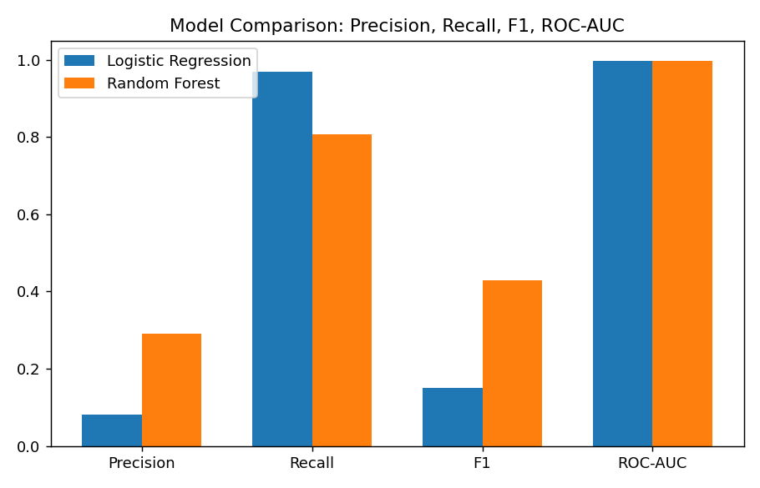

6. Interpretation: The Precision–Recall Tradeoff
- Logistic Regression catches 96.9% of all fraud (only 3 of 98 frauds slip through) but at the cost of 1,072 false alarms — meaning only 8.1% of everything it flags is real fraud.
- Random Forest is more balanced: it catches 80.6% of fraud with far fewer false alarms (192), giving 29.2% precision — nearly 4x better than Logistic Regression at the cost of missing more fraud (19 vs. 3 missed cases).
- Both models achieve near-identical ROC-AUC (~0.997–0.998), meaning both have strong overall separating power between the two classes — the real difference between them is where the default 0.5 decision threshold lands relative to that separation, which is a business decision, not just a modeling one.
Which model is “better” depends entirely on the cost structure of the business: if a missed fraud (false negative) is far more costly than a false decline (false positive) — as is often the case in payment fraud, where a missed fraud is a direct financial loss but a false decline is just customer friction — Logistic Regression's near-total recall may be preferred despite the noisy alerts. If false declines damage customer trust and cost more in support/chargebacks than they save in caught fraud, Random Forest's higher precision is the safer choice. In production, this tradeoff is typically tuned further by adjusting the classification threshold rather than picking a single default cutoff.

7. Deliverables Summary
File | Contents
creditcard.csv | Synthetic dataset matching the real Kaggle dataset's statistics
pipeline.py | Main pipeline: EDA → split → SMOTE + GridSearchCV → evaluation
smote_utils.py | Manual vectorized SMOTE implementation
smote_pipeline.py | Leak-free scikit-learn-compatible SMOTE wrapper classifier
fraud_report.md | Markdown version of this report, auto-generated by the pipeline

