System Design

RetailEase Store

1. Architecture Diagram: Client–Server–Database
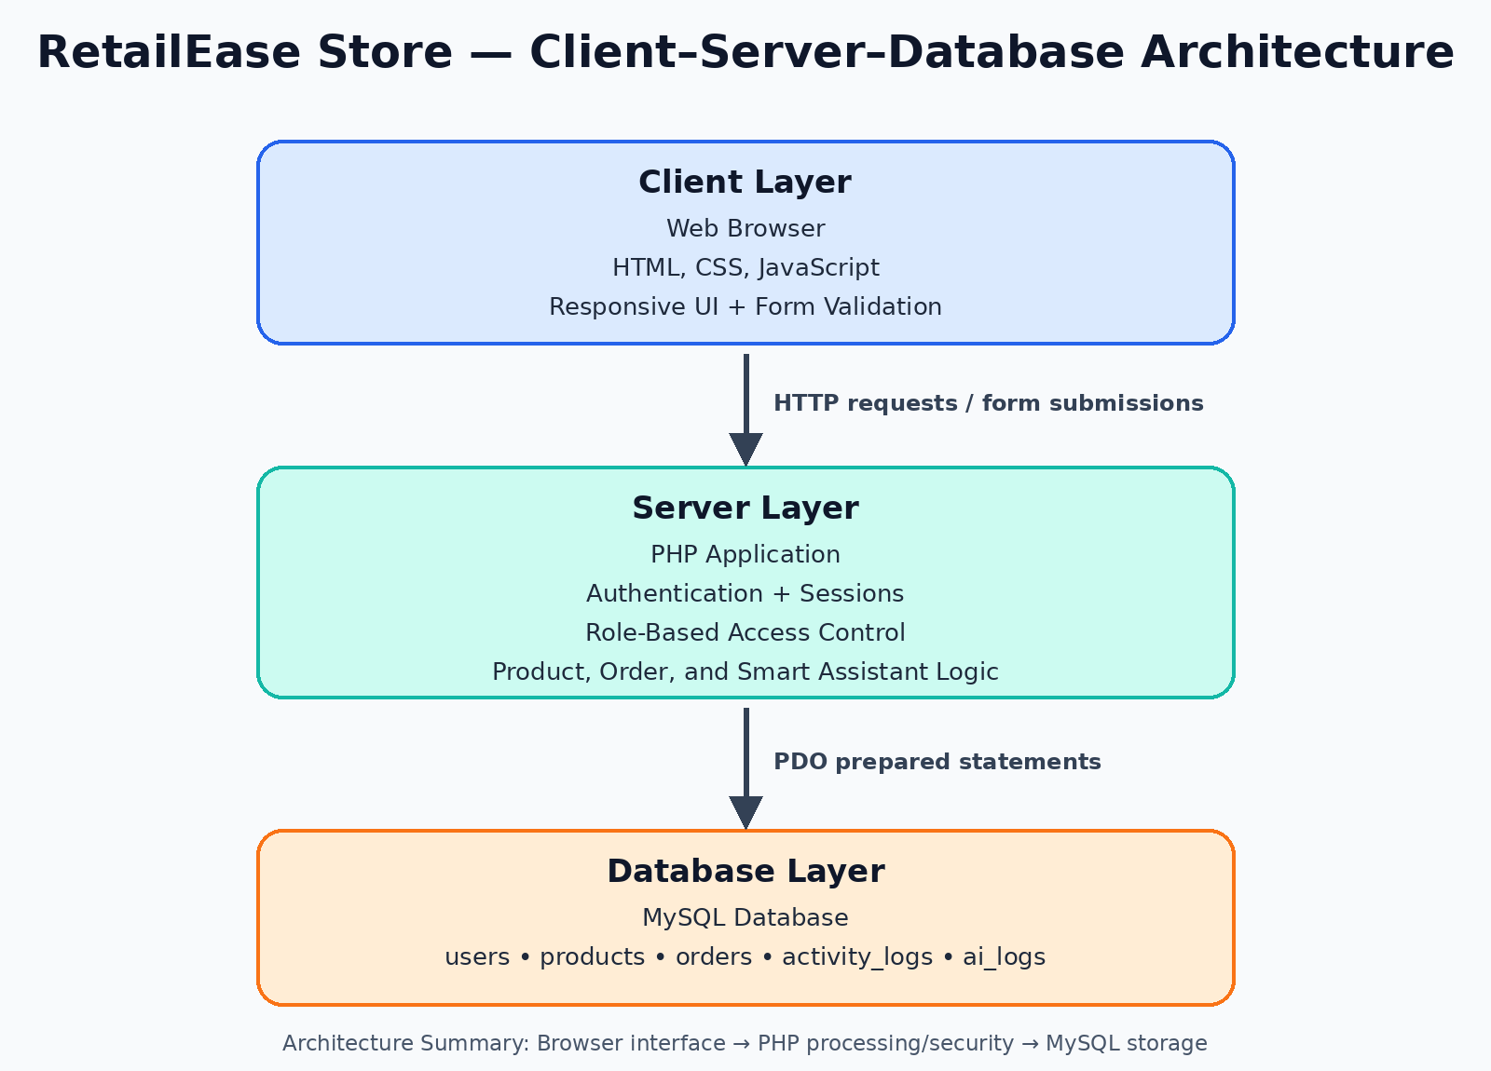

RetailEase Store uses a simple three-layer web architecture. The user interacts with the application through a browser. The PHP server processes requests, validates input, checks login sessions and user roles, and communicates with the MySQL database using PDO prepared statements.

Architecture Summary
Layer | Description
Client Layer | Browser interface using HTML, CSS, and JavaScript
Server Layer | PHP application handling authentication, validation, role-based access, product/order logic, and Smart Assistant logic
Database Layer | MySQL database storing users, products, orders, activity logs, and AI logs

- ERD: Database Schema

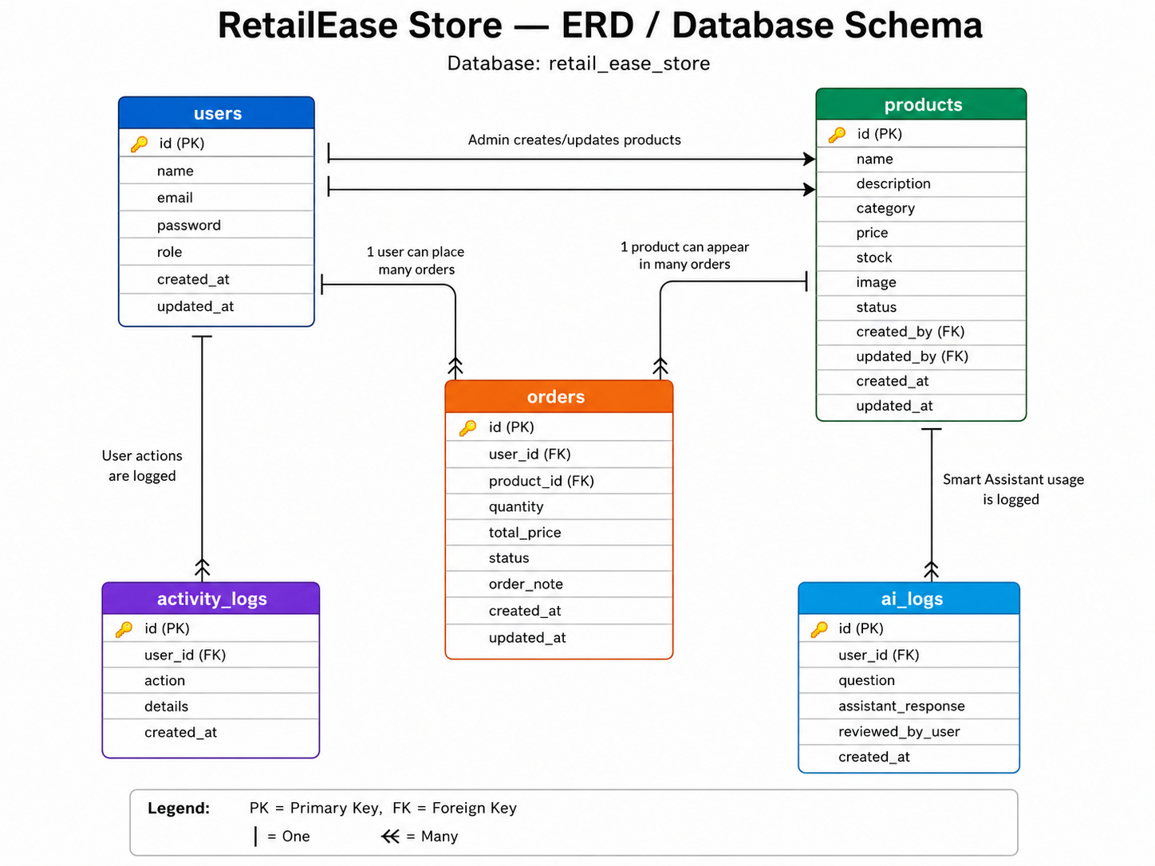

Table Summary

Table | Purpose
users | Stores admin and customer accounts
products | Stores product catalogue data
orders | Stores customer product orders
activity_logs | Stores important user/admin actions
ai_logs | Stores reviewed Smart Assistant responses

Key Relationships

Relationship | Meaning
users → orders | One user can place many orders
products → orders | One product can appear in many orders
users → products | Admin users can create and update products
users → activity_logs | Users can have many activity log entries
users → ai_logs | Users can have many AI assistant log entries

3. API Endpoints / Page Routes
This project is built using PHP pages rather than a separate REST API. Therefore, the system uses page routes instead of API endpoints.
Page | Purpose | Access
index.php | Homepage | Public
register.php | Customer registration | Public
login.php | User/admin login | Public
logout.php | Ends session and logs out user | Logged-in users

Customer Routes

Page | Purpose | Access
user/dashboard.php | Customer dashboard | Customer only
user/products.php | Product catalogue with search/filter | Customer only
user/product_details.php | Product details and order form | Customer only
user/my_orders.php | Customer order history | Customer only
user/cancel_order.php | Cancel pending order | Customer only
user/smart_assistant.php | Smart Assistant feature | Customer only

Admin Routes

Page | Purpose | Access
admin/dashboard.php | Admin dashboard | Admin only
admin/products.php | Product CRUD management | Admin only
admin/orders.php | View and update customer orders | Admin only
admin/users.php | View registered users | Admin only
admin/activity_logs.php | View system activity logs | Admin only
admin/ai_logs.php | View Smart Assistant logs | Admin only

4. Brief Design Summary
RetailEase Store uses a clear client–server–database structure. The PHP backend manages authentication, role-based access, product CRUD, order handling, search/filtering, activity logs, and Smart Assistant logic. The MySQL database stores all persistent records. The route structure separates public, customer, and admin pages to support security, usability, and maintainability.

