**DOCUMENTATION**

**1.DOBOX**

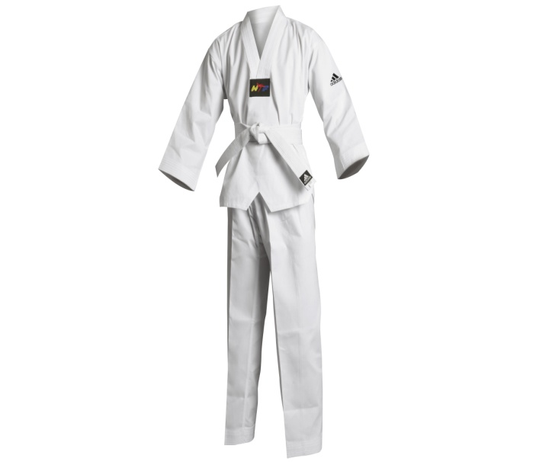

[**http://www.dragonsports.eu/312711-verylarge_default/taekwondo-dobok-initiation-adidas-adits01.jpg**](http://www.dragonsports.eu/312711-verylarge_default/taekwondo-dobok-initiation-adidas-adits01.jpg)

**2.HEADGEAR**

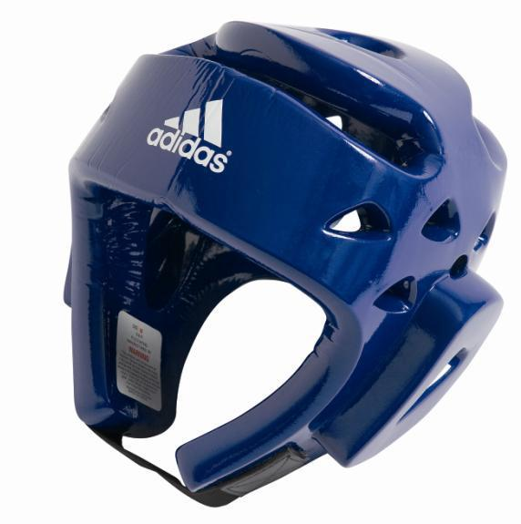

[**http://ep.yimg.com/ay/yhst-36451256984760/adidas-deluxe-head-gear-94.gif**](http://ep.yimg.com/ay/yhst-36451256984760/adidas-deluxe-head-gear-94.gif)

**3.SULING**

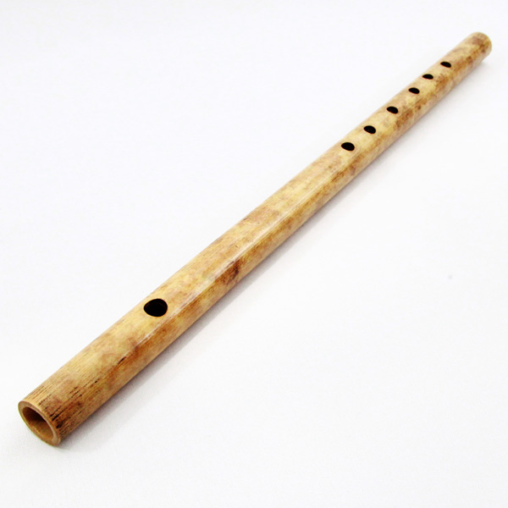

[**http://www.kadaiku.com/wp-content/uploads/2013/08/Suling-1.jpg**](http://www.kadaiku.com/wp-content/uploads/2013/08/Suling-1.jpg)

**SCREEN SHOOT DOCUMENTATION**

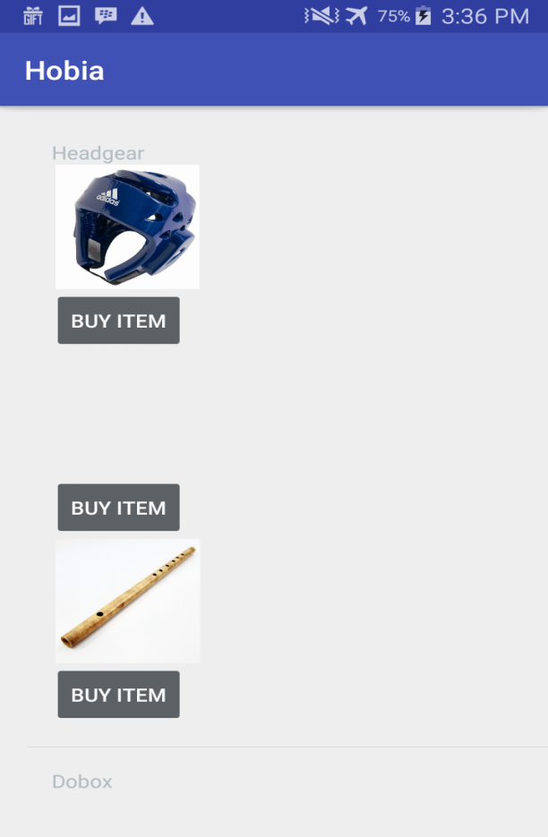

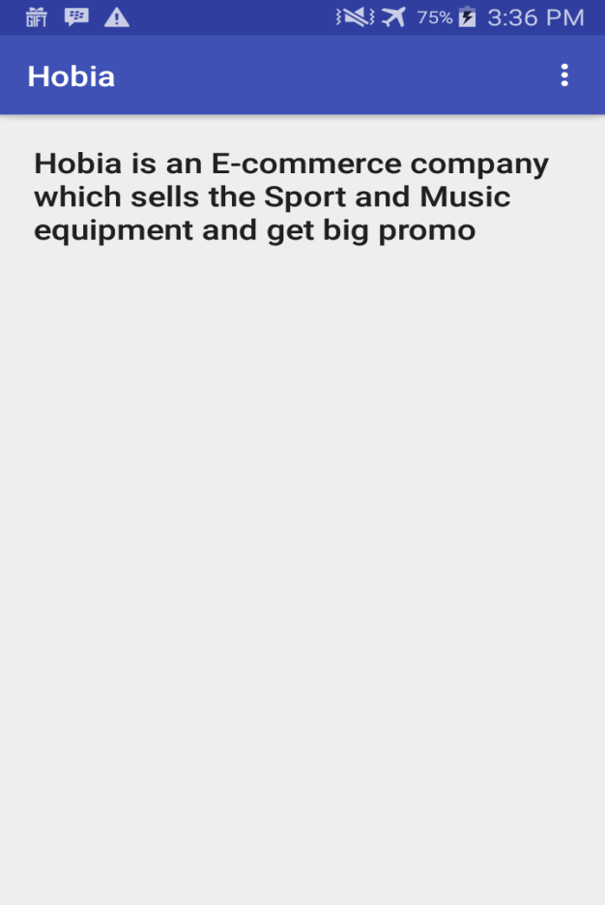

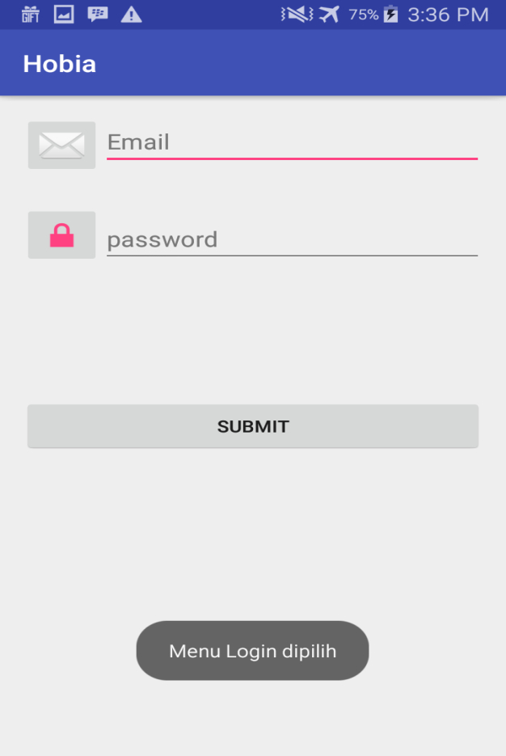

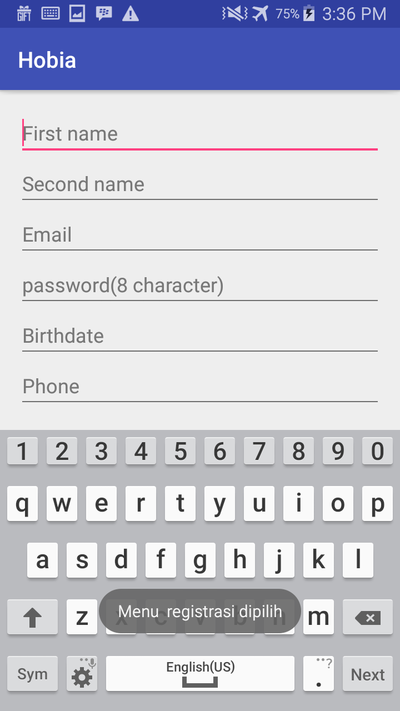

**Hobia**

**Hobia** is an E-commerce company which sells the **Sport** and **Music** equipment. **Hobia** wants to expand its service by providing a mobile based application on **Android operating System** which will be used by their **customers** to order their product. As an Android Mobile Application Developer, You are asked by the CTO of **Hobia** to develop this application based on some conditions below. You can buy taekwondo, sport equipment and music sport equipment speciality for taekwondo atribute **.**