Special Topics

# **Monitoring photovoltaic converters using Wireless Sensor Networks**

Student: Vítor Filipe Alves Morais [v.morais@fe.p.pt](mailto:v.morais@fe.p.pt)

Supervisor: António Pina Martins [ajm@fe.u.pt](mailto:ajm@fe.u.pt)

# **Background**

This proposal is inserted in the scope of a microgeneration project of the SYSTEC Research Unit. Figure 1 in attachment presents the main architecture of this project. Currently, several work has been done in this project to implement a monitoring subsystem. This work focuses on data collection from each power converter and also on its control by sending references and actions. At the moment of this proposal, no work has been done to implement the monitoring feature in the PV converters. This way, a wireless network implementation is proposed to monitor the PV power converters.

The PV converter uses a non-isolated high gain DC/DC topology and has a PIC32 microcontroller which implements a MPPT algorithm in the control loop. It is currently possible to connect a device with wireless capabilities to the PV power converter. The converter is able to provide power and data. The data collected from the monitoring device is sent to an aggregator node for post processing and data storage. Currently, several work has already been done to have a reliable wired data aggregator/concentrator (figure 2). This subsystem is also responsible for sending user commands to the power converters and presenting the user interface in a webpage remotely accessed via a web browser.

# **Proposal**

In the scope of Special Topics course is proposed to implement a wireless sensor network that monitors each PV converter. The methodology to be followed within the abovementioned scope is the following:

* System Requirement Specification (SRS) of the monitoring wireless system
* Market survey in wireless technologies for monitoring/supervision
* Study on the appropriate protocols/standards for this communication
* Study and selection of Key Performance Indicators to evaluate the wireless communication
* Selection of one wireless technology that fulfills the requirements
* Software/Hardware architecture design – UML detailed diagram
* Implementation and testing of wireless communication in PV power converters:
  + With small number of nodes
  + With a star-type architecture

# **Outcomes:**

At the end of this course it is expected to deliver one report with two main sections**.** The first one will be focused on: 1) Overview of the existing communication system; 2) SRS; 3) Market survey of wireless technologies; 4) Protocols and standards; 5) Communication KPI’s. The second section will cover the following subjects: 1) Description of the selected wireless technology; 2) Hardware and software architecture; 3) Communication results and KPI metrics. 4) Discussion of the results.

A second outcome will be the submission of a paper to a conference in related fields.

Attachments

* Website platform - work under construction - <http://microgen.fe.up.pt>
* Development repository for this course: <https://github.com/vitormorais/specialTopics>
* Main architecture of power system:

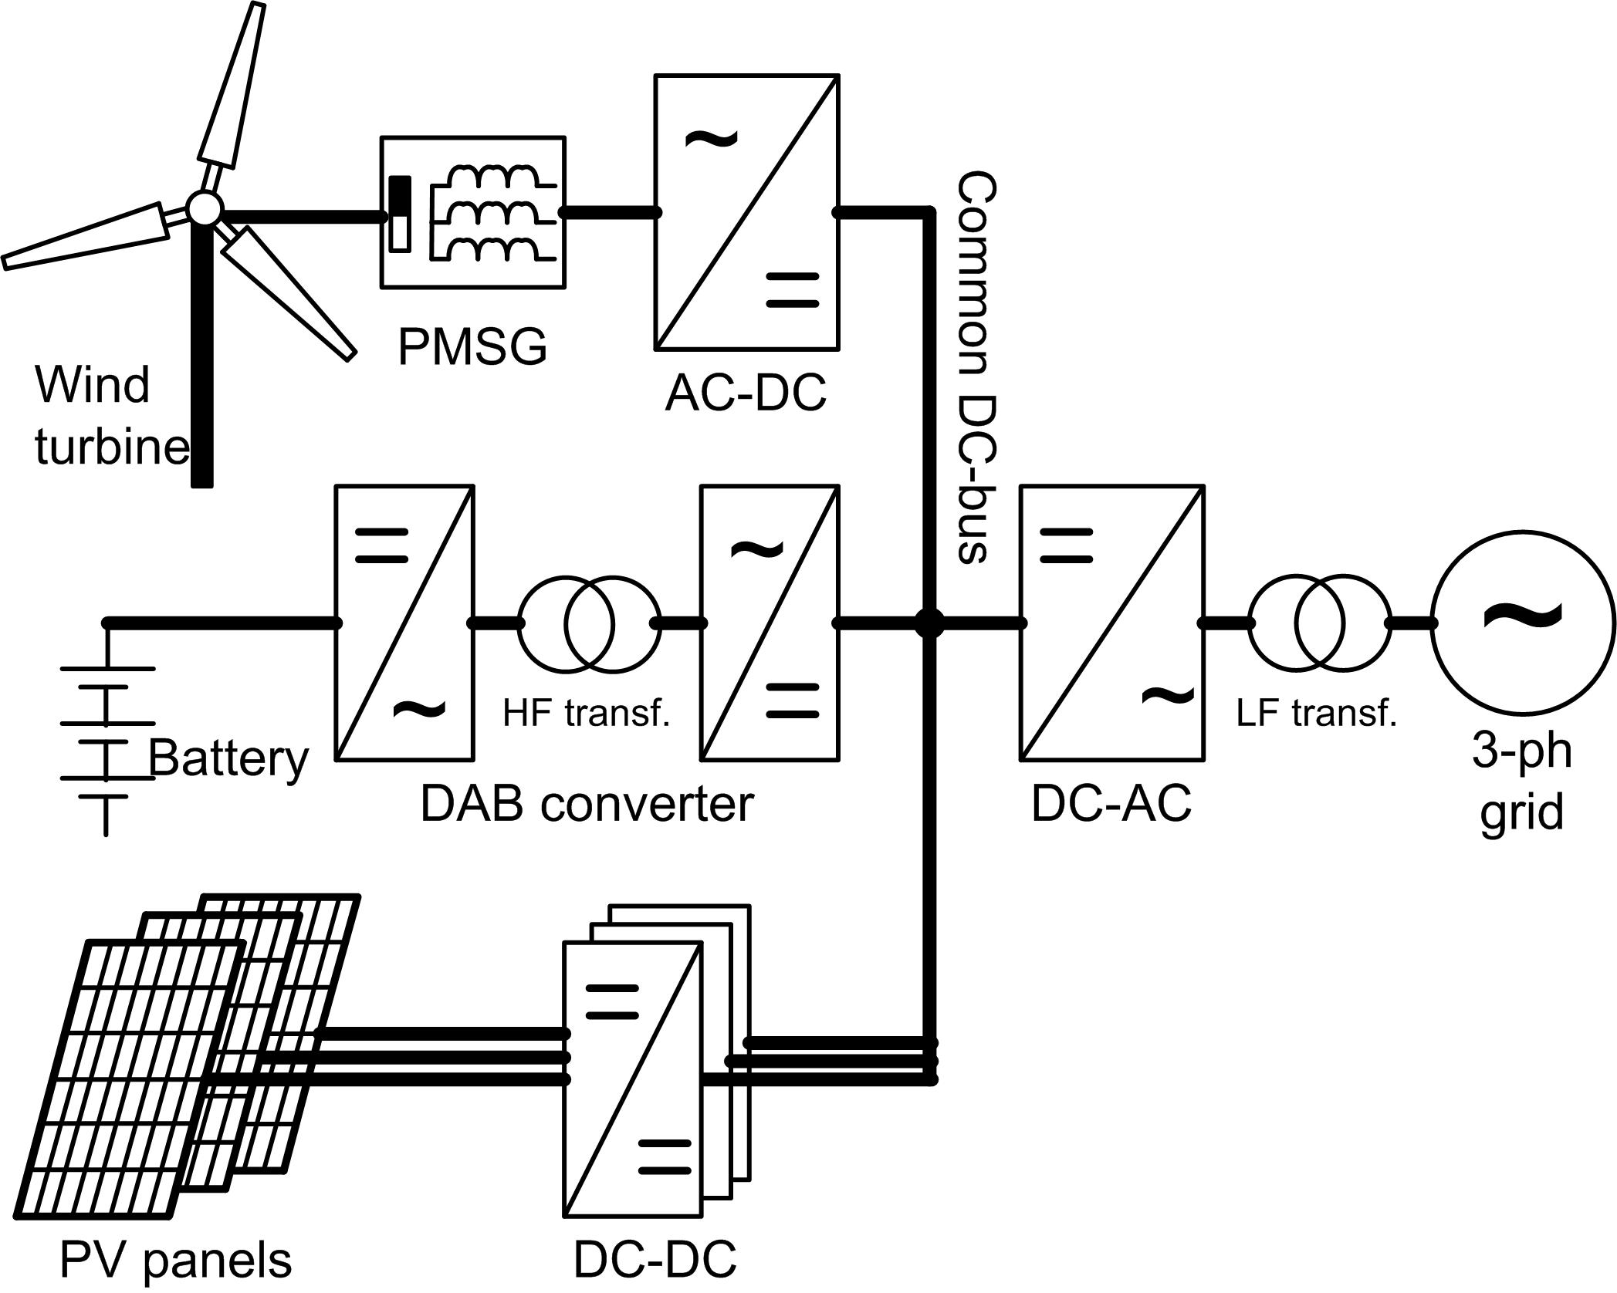

Figure 1 - Main architecture of microgeneration project.

* Communications architecture:

http://simpleicon.com/wp-content/uploads/antenna-3.pnghttp://simpleicon.com/wp-content/uploads/antenna-3.pnghttp://simpleicon.com/wp-content/uploads/antenna-3.pnghttp://simpleicon.com/wp-content/uploads/antenna-3.pnghttp://simpleicon.com/wp-content/uploads/antenna-3.png

Planned data concentrator

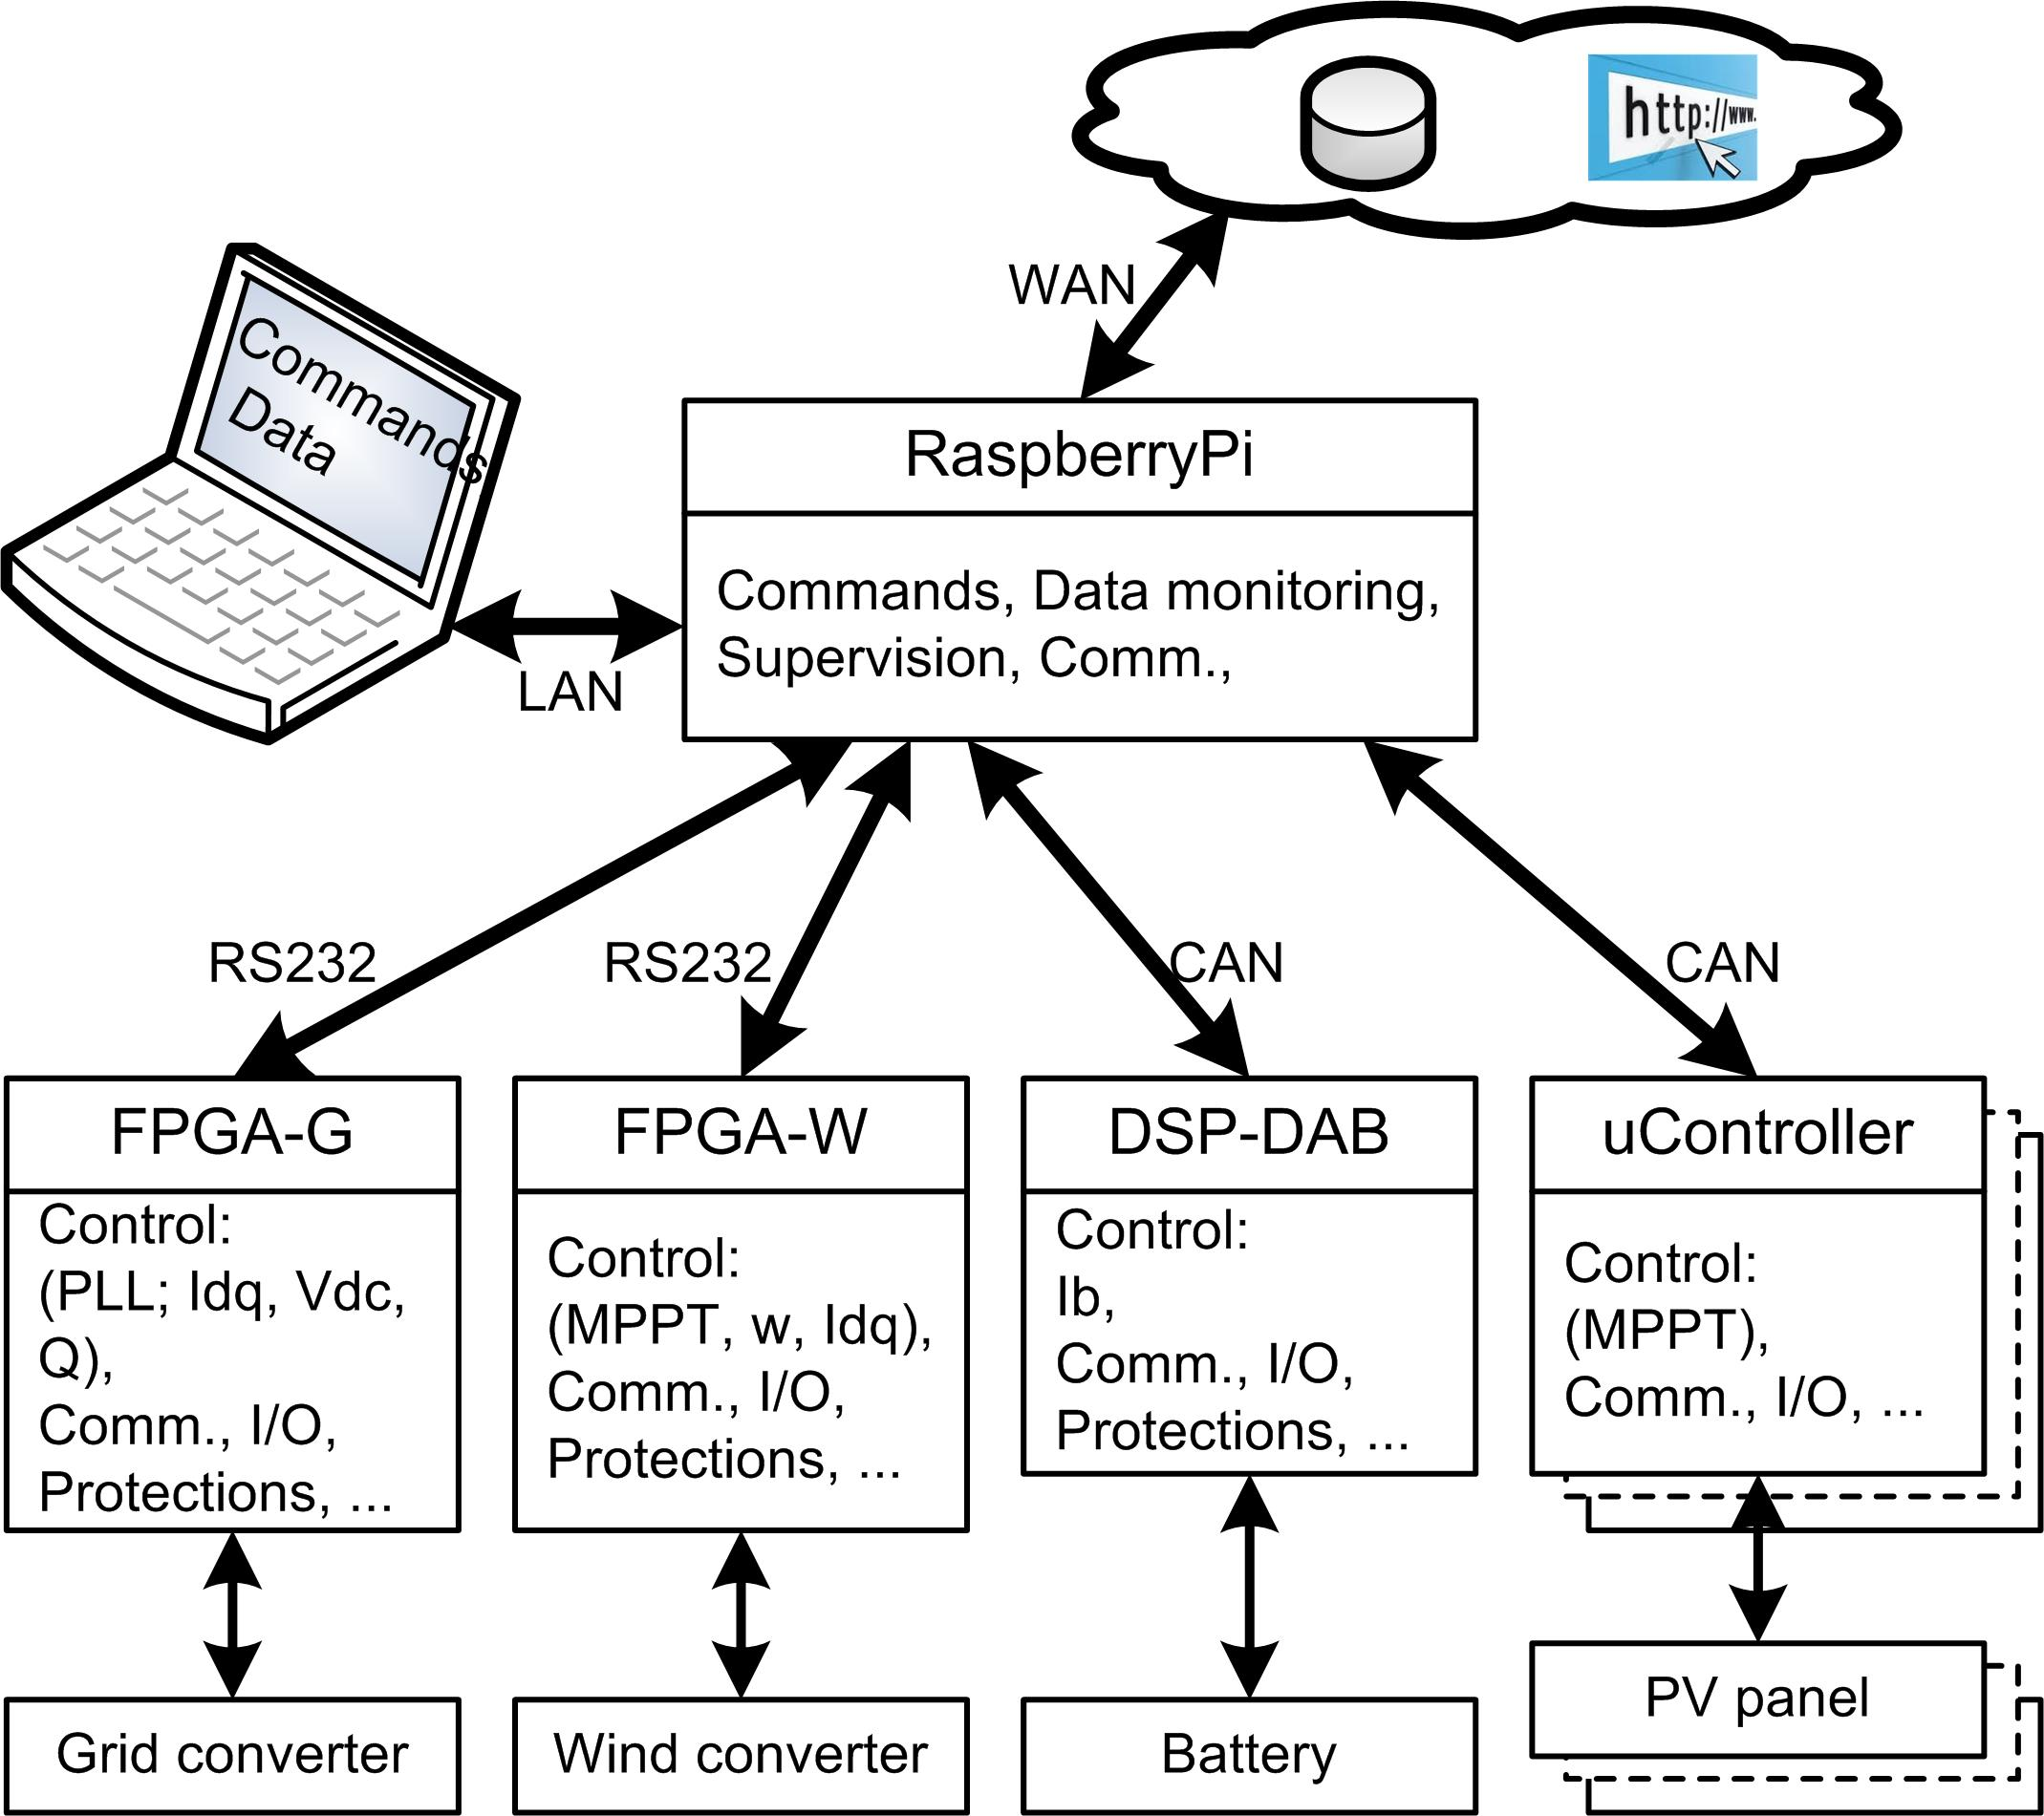

Figure 2 - Communications architecture in microgeneration project.