Software Requirements Specification
for
Police Inquiry and Record System for Vehicle Information
Version 2.1 approved
Prepared by Mohamad Gorji, Ali Eftekhar, Mohammad Hassan Khanipour
USC Department of Computer Science

July 02, 2020
Table of Contents
Table of Contents ii
Revision History ii
1. Introduction 1
1.1 Purpose 1
1.2 Intended Audience 1
1.3 Product Scope 1
1.4 References 1
2. Overall Description 2
2.1 Product Perspective 2
2.2 Product Functions 2
2.3 User Classes and Characteristics 3
2.4 Operating Environment 3
2.5 Design and Implementation Constraints 3
2.6 User Documentation 3
2.7 Assumptions and Dependencies 4
3. External Interface Requirements 5
3.1 User Interfaces 5
3.2 Hardware Interfaces 6
3.3 Software Interfaces 6
3.4 Communications Interfaces 6
4. System Features 7
4.1 Record Accident 8
4.2 Record Fine 8
4.3 License Inquiry 9
4.4 Car Card Inquiry 9
5. Other Nonfunctional Requirements 10
5.1 Performance Requirements 10
5.2 Safety Requirements 10
5.3 Security Requirements 10
5.4 Software Quality Attributes 10
Appendix A: Glossary 11
Appendix B: Analysis Models 12

Revision History
Name | Date | Reason For Changes | Version
Mohamad Gorji | 07-02-2020 | Creation | 1.0
Mohammad Hassan Khanipour | 07-14-2020 | Partial Completion – Functional Requirements | 1.2
Ali Eftekhar | 07-19-2020 | Partial Completion – Non Functional Requirements | 1.3
Mohamad Gorji | 07-21-2020 | Adding Diagrams and Completion | 2.0
Mohammad Hassan Khanipour | 07-25-2020 | Completion and Final Touches | 2.1

Introduction
This section gives a scope description and overview of everything included in this SRS document. Also, the purpose for this document is described and a list of suggestions is provided.

Purpose
The purpose of this document is to give a detailed description of the requirements of the “Police Inquiry and Record System for Vehicle Information” (PIRS) software. It will illustrate the purpose and complete declaration for the development of system. This document will also explain system constraints, interface and interactions with other external software and systems.

Intended Audience
This document is intended to be purposed to “Iran’s Traffic Police Department” for its approval and for the development team as a reference for developing the first version of the system, as well as the system’s admin to be able to manage the system properly.

Product Scope
The “Police Inquiry and Record System for Vehicle Information” is a software for police department system and police officers’ handheld devices so they can easily manage accidents, fines, car and license authenticity, etc. and get reports. The devices will be provided by the police department for all of officers who roam in the city or are present in gates between cities for road safety.

System managers can also have access to the system to manage and administrate it, and make sure the information entered the system are accurate and there’s nothing wrong.
The software needs both Internet and GPS connections to connect to the server and, fetch and display or submit the records accurate to where the incident has happened, these connections will be provided for the software via features on officers’ devices.

References
[1] IEEE Software Engineering Standards Committee.

[2] Traffic Police of NAJA, abbreviated as RAHVAR

Overall Description
This section will provide an overview of the whole system. The system will be explained in its context to show how the system interacts with other systems and introduce the basic functionality of it. It will also describe the type of users that will use the system and what functionality is available for each of them. At last, the constraints and assumptions for the system will be presented.

Product Perspective
PIRS is a part of the PDMS, and it defines a crucial component of PDMS. Since this is a data-centric system it uses PDMS databases that has access to which to store data.

The system would connect to the database via Internet connection and it can retrieve data, submit data or edit data, GPS connection would let the system to submit the location that the incident has taken place or retrieve data based on where some incident has happened.

Figure 1 shows a simple diagram of the system for a better vision.
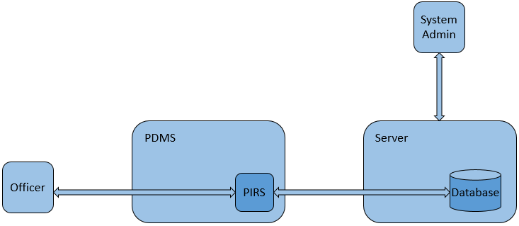

Figure 1 – Simple Diagram for the System

Product Functions
The application must be able to perform the following actions:
- Submit records in their related tables
- Provide a report on vehicle, vehicle card or license at any time
- It must establish secure connections and avoid untrusted and unsecure networks

Figure 2 shows Data Flow Diagram Context of the system.
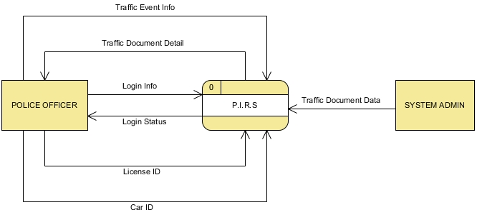

Figure 2 – Data Flow Diagram Context

User Classes and Characteristics
Police officers are the major users of this system, and they use their devices constantly. On the other hand system managers who use the system as frequent as the officers and they mainly use the system to maintain it and make sure nothing is wrong with the system.

Police officers don’t need to be experts and know exactly how the system is working but the system managers need to know how operations are taking place and how different situations are controlled.

With their handheld devices police officers will be able to do the following:
- Record Fines
- Record Car Accidents
- Car Card Inquiry
- License Inquiry

System managers will be able to do the following while logged in:
- Check system stats
- Check records to look for potential errors and security issues
- Enter primitive traffic documents into databases

Operating Environment
The software must be totally compatible with the police officers’ handheld devices and be able to take advantage of the device’s features such as internet and GPS connections.

This software runs on a customized operating system which has been developed for officers’ handheld devices and is powered by a version 5 Linux kernel.

The system is also can be accessed through a website as a web application, both of which allow access to the officers and system managers and provides relevant reports and functions.

Design and Implementation Constraints
The software is constrained by the performance of processing power of the servers, database design, and DBMS software. Since the number of I/O requests are pretty high, an efficient way of doing the CRUD (Create, Read, Update, and Delete) operation is necessary.

Since this is a national project, databases should be able to store a very large amount of data. Servers should be capable of storing several petabytes of data and fetching the desired data should be as fast as possible.

The Internet connection is also a constraint for the application. Since the application fetches data from the database over the Internet, it is crucial that there is an Internet connection for the application to function.

User Documentation
An online help system containing tutorials will be provided for police officers to show how to use the system correctly and efficiently.

Assumptions and Dependencies
One assumption about the product is that it will always have access to the Internet. Since all of the operations take place over a wireless connection, there always should be a reliable and fast internet connection. Also, the hardware resources used in the servers ought to sustain over a long period of time.
Speed is one of the main concerns of this system and that can be achieved by utilizing the 5G technology.
One of the main dependencies of the system is the capability to print files. So that, printing the documents like fine can be possible.
Another assumption is that the GPS components in all devices work in the same way. If the devices have different interfaces to the GPS, the application need to be specifically adjusted to each interface and that would mean the integration with the GPS would have different requirements than what is stated in this specification.

External Interface Requirements
This section provides a detailed description of all inputs into and outputs from the system. It also gives a description of the hardware, software and communication interfaces and provides basic prototypes of the user interface.

User Interfaces
The first time user opens the app they should log in to the system to be able to use the features.
Users log in using the log in part of the page which is shown as figure 3.
After logging in they can use the features for instance as a police officer they can see their profiles which contains their name, rank, and the city in which they are currently active. This is shown as figure 4.
Users can access different features of the application via menu, menu is shown as figure 5.
Officers can submit new records of fines or accidents, using the menu they can have access to related pages, Record Fine page is shown as Figure 6 and Record Accident page is shown as Figure 7.

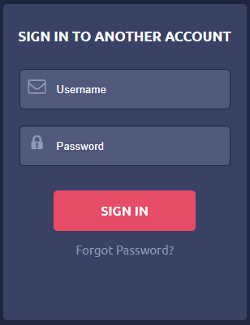
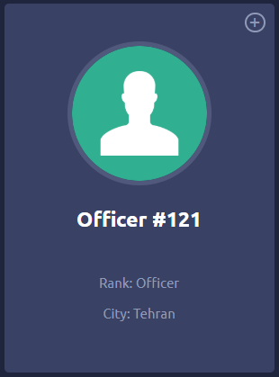
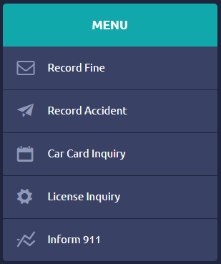

Figure 3 – Log in Figure 4 – Profile Figure 5 – Menu

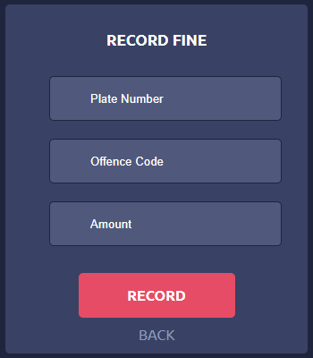
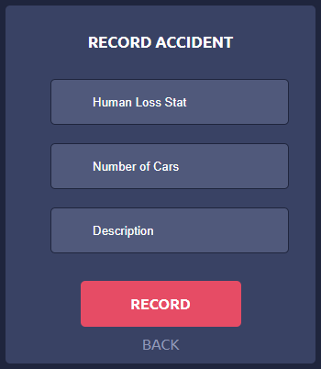

Figure 6 – Record Fine Page Figure 7 – Record Accident Page

Hardware Interfaces
Since neither the application nor the officers’ devices have any designated hardware, it does not have any direct hardware interfaces. The GPS connection for the software will be provided by GPS feature of the handheld devices or computers and the connection to the database server is managed by the underlying operating system on the devices, computers and the web server.

Software Interfaces
The application communicates with the GPS application in order to get geographical information about where the traffic events are being occurred. Also, the application communicates with the database to create, read, update, and delete the information about vehicles and their owners.
In order to manage and optimize the use of data in the application, a DBMS software is used to ensure the ACID properties of the database.

Communications Interfaces
The front-end and back-end of the application are connected by using the HTTPS protocol and REST architectural style is used to provide a fast and reliable connection to the servers.
To record traffic events, police officers need to know the exact date and time and the application uses the NTP protocol to achieve this necessity.

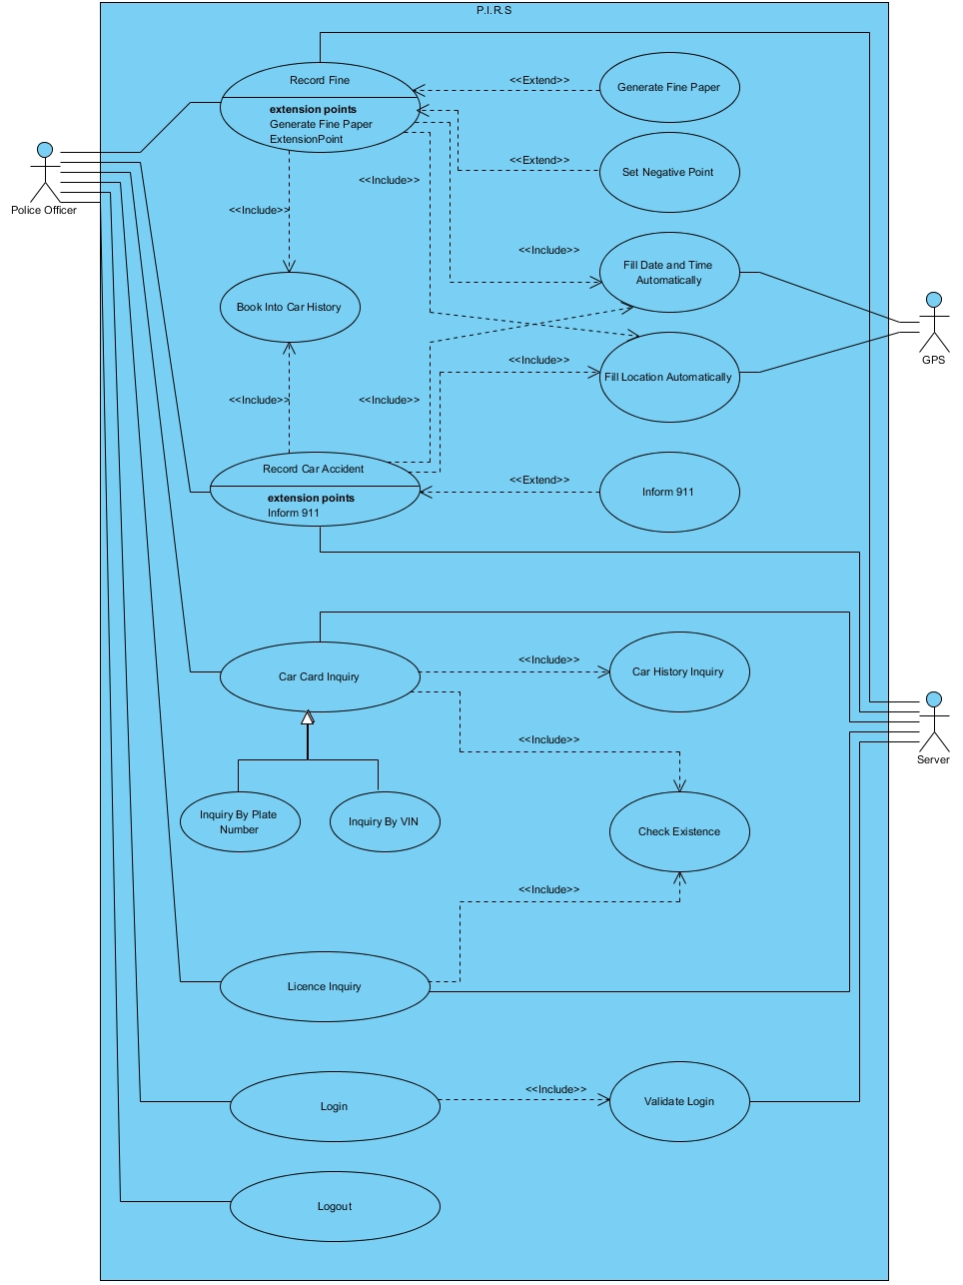
System Features
In this section we will take a look at PIRS features one by one to know exactly what we are facing and what this system is capable of.

Figure 8 shows the Use Case Diagram of the system for a better understanding of how things work.

Figure 8 – Use Case Diagram

Record Accident
4.1.1 Description and Priority
At any time officers can submit a new record of an accident using their handheld devices. This component is crucial and it has a priority level of 10/10. This feature must be available 100% of the time. If the accident is intense and emergency service is needed 911 will be informed.
4.1.2 Stimulus/Response Sequence
When the officer attempts to submit a new record the system checks to see if he is logged in or not, then it gets the required information such as car(s) model, license plate, VIN number, estimated damage, and owner’s information after the officer fills the field of info system will get location using GPS then it establishes a connection with the database, gets time using NTP, creates a new record and submits these information and finally it will show a massage demonstrating that the records are submitted with no problem.
4.1.3 Functional Requirements
REQ-1: Secure internet connection via Wi-Fi or cellular connection provided by the Police Department for officers.
REQ-2: GPS connection which will be provided by handheld devices for the system.

Record Fine
4.2.1 Description and Priority
At any time officers can submit a new record of a fine using their handheld devices. This feature must be available 100% of the time. If this is a high-risk offence then this record will be submitted to driver’s log.
4.2.2 Stimulus/Response Sequence
When the officer attempts to submit a new record the system checks to see if he is logged in or not, then it gets the required information such as car(s) model, license plate, fine amount, and owner’s information after the officer fills the field of info system will get location using GPS then it establishes a connection with the database, gets time using NTP, creates a new record and submits these information and finally it will show a massage demonstrating that the records are submitted with no problem.
4.2.3 Functional Requirements
REQ-1: Secure internet connection via Wi-Fi or cellular connection provided by the Police Department for officers.
REQ-2: GPS connection which will be provided by handheld devices for the system.

License Inquiry
4.3.1 Description and Priority

Officers can check driver’s license inquiry at any time. This is also a crucial component of the system and have a priority level of 8/10.

4.3.2 Stimulus/Response Sequence

After making sure the user is logged in correctly the system will fetch previous data in the server and the data will be shown to the officer so the officer knows whether they match or not.

4.3.3 Functional Requirements

REQ: Secure internet connection

Car Card Inquiry
4.4.1 Description and Priority

Officers can check car card inquiry at any time, car card inquiry can be done by either VIN or license plate number. This is also a crucial component of the system and have a priority level of 8/10. If the inquiry fails then

4.4.2 Stimulus/Response Sequence

After making sure the user is logged in correctly the system will get VIN or license plate number and fetch previous data in the server and compare them with the current data. The result of this comparison will be shown to the officer so the officer knows whether they match or not.

4.4.3 Functional Requirements

REQ: Secure internet connection

Other Nonfunctional Requirements
This section contains all nonfunctional and non-technical requirements for PIRS.

Performance Requirements
Since this system could be used in special conditions it must be able to communicate via weak internet and GPS connections as well, so data size is to be kept minimum. Keeping data size minimum helps with faster response times as well, since it makes calculations faster and easier. Also, considering the various possibilities during rush hours, the availability of the system should be at the maximum and that would be possible by using powerful hardware resources for the back-end of the product.

Safety Requirements
Stored data in the central database of this system is what makes it operative. So, all of the hardware resources must be in a secure place away from any possible physical dangers. Access to the servers and the handheld devices in which the application is installed should be very strict.

Security Requirements
Since this is a national project, all the information used by this product is crucial and needs to be severely protected. This product can only be used by authenticated users and the available operations for each user may be different based on the authorization level.

Software resources used by this product should be impenetrable and hardware resources must be secure against any physical damage.

Software Quality Attributes
Since this system is data-oriented the calculations must be flawless and any type of error is not acceptable. There is a lot of calculations and fetches happening, so in order to keep everything in good shape application’s response time should be kept minimum, this is a crucial aspect of the program.

This system requires a high level of testability to keep everything functioning at their best. Due to the continuous nature of the system, total uptime of the system should be close to 99.9% of the time. Since, traffic events can occur at any time of the day, MTTF should be more than 1000hrs.

Appendix A: Glossary
ACID | Automaticity, Consistency, Isolation, Durability
DBMS | Database Management System
CRUD | Create, Read, Update, Delete
GPS | Global Positioning System
HTTPS | Hypertext Transfer Protocol Secure
MTTF | Mean Time To Failure
NTP | Network Time Protocol
PDMS | Police Department Management System
PIRS | Police Inquiry and Record System
REST | Representational State Transfer
SRS | Software Requirement Specification
VIN | Vehicle Identification Number

Appendix B: Analysis Models
In this sections diagrams including Use Case Diagram, Class Diagram, Sequence Diagram, Activity Diagram, Data Flow Diagram Context, and Data Flow Diagram will be presented.

Figure 9 – Use Case Diagram

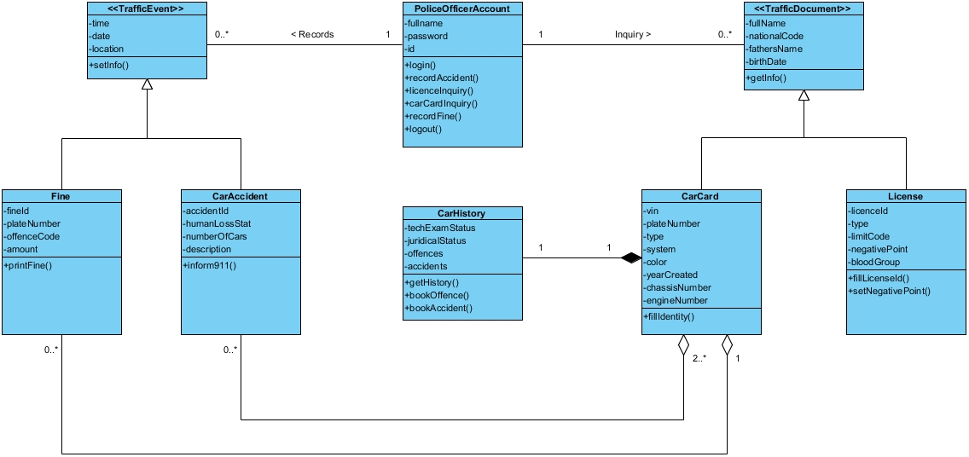

Figure 10 – Class Diagram

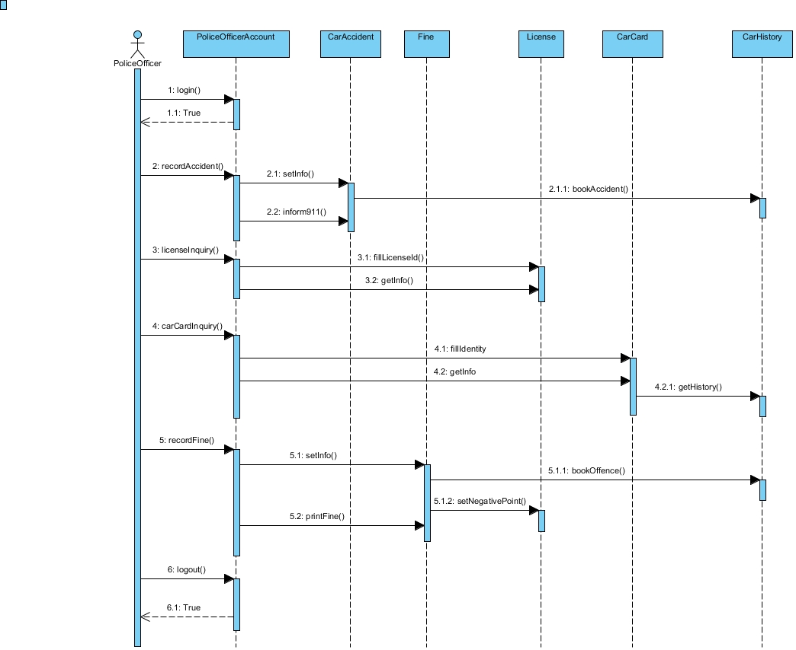

Figure 11 – Sequence Diagram
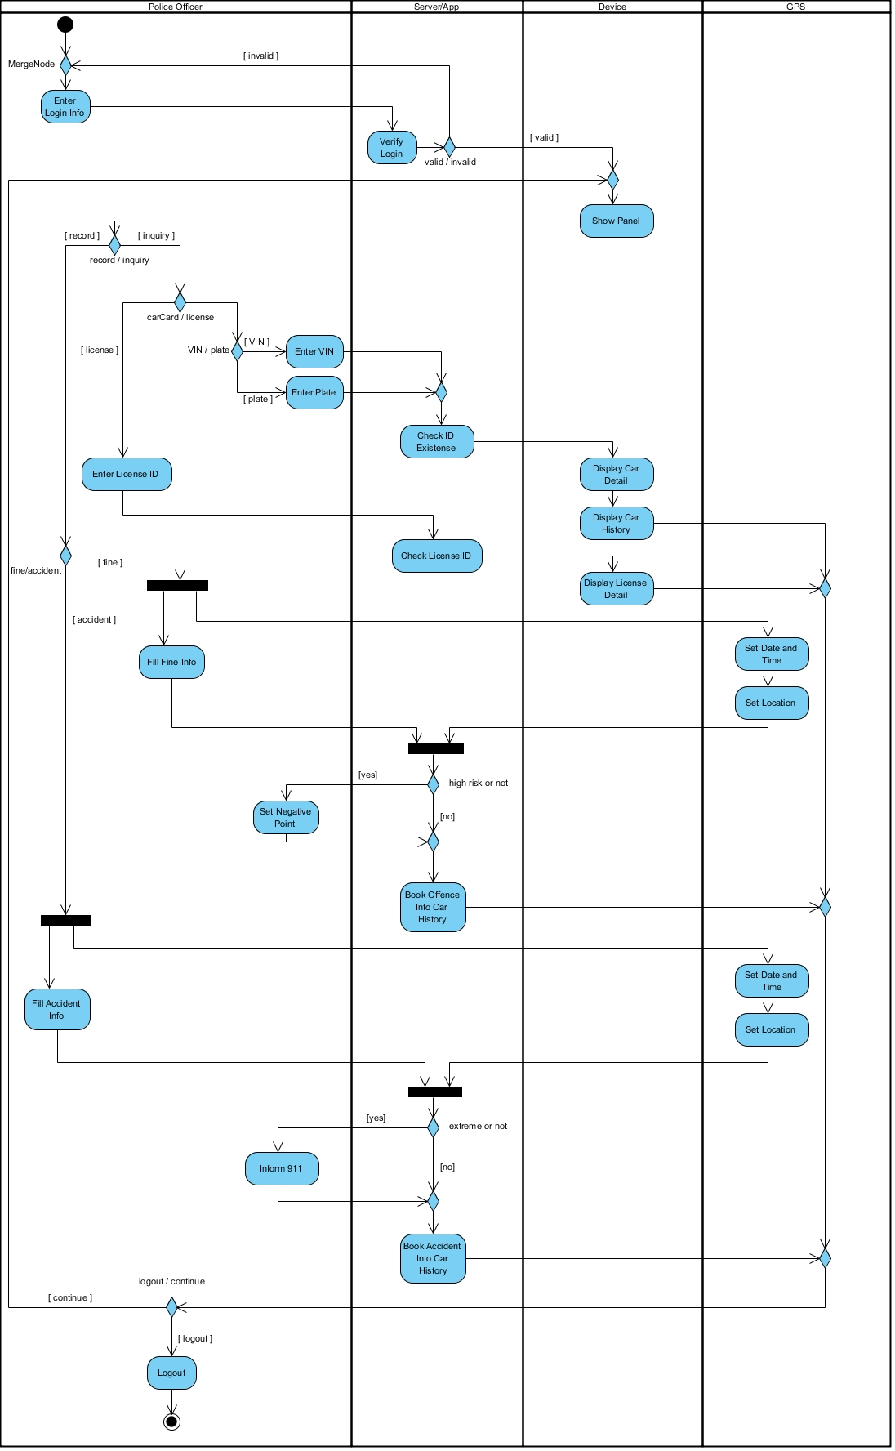

Figure 12 – Activity Diagram

Figure 13 – Data Flow Diagram Context

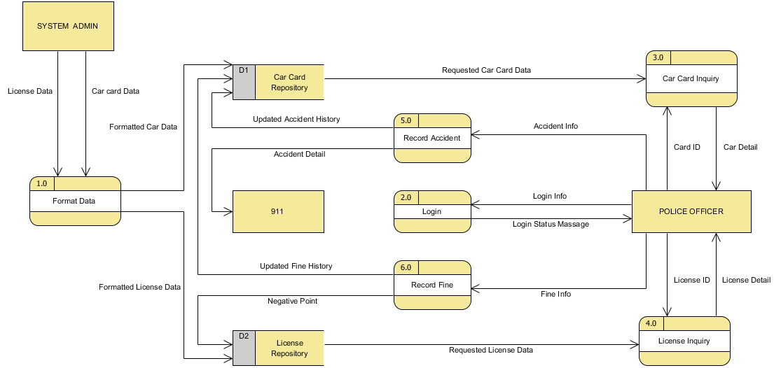

Figure 14 – Data Flow Diagram

