بسم الله الرحمن الرحيم


Al-Quds University
Faculty of Engineering
Computer Engineering Department
Software Project
AI Career Assistant
-CareerLink-

Prepared by:
Mohammad Hmeed #22120050
Bashar Almashahreh #22211346
Supervised by:
Dr. Rushdi Hamamreh

Table of Contents
Preface 4
References 4
Chapter 1: Introduction 5
1.1 Why This Project Is Needed 5
1.2 Who Benefits from CareerLink 5
1.3 Project Overview 6
1.4 Technology Stack 6
1.5 Objectives 6
Chapter 2: Requirements 7
2.1 Introduction 7
2.2 Functional Requirements 7
2.2.1 Profile & CV Analysis 7
2.2.2 Job Matching 7
2.2.3 Authentication & Email Verification 8
2.2.4 My Jobs Tracker & Notifications 9
2.2.5 Recruiter / Admin Dashboard 9
2.3 Non-Functional Requirements 10
2.4 Constraints Summary 11
Chapter 3: System Architecture 12
3.1 Introduction 12
3.2 High-Level Architecture Overview 12
3.3 Component Architecture 16
3.4 Data Flow: CV Analysis to Job Match 17
3.5 Technology Mapping Table 18
3.6 Architecture Limitations 19
References 19
Chapter 4: System Modeling 20
4.1 Introduction 20
4.2 System Actors 20
4.3 Use Case Diagram 21
4.4 Sequence Diagrams 22
4.4.1 Guest CV Analysis Sequence 22
4.4.2 Email Verification Sequence 22
4.4.3 Apply to Internal Platform Role Sequence 23
4.5 Entity Relationship Diagram (ERD) 23
4.6 Class Diagram Overview 24
References 24
Chapter 5: Design and Implementation 25
5.1 Introduction 25
5.2 Backend Functions Reference Table 25
5.3 System Input and Output 26
5.4 Database Tables Reference 26
5.5 Normalization Analysis 27
5.6 Key Code Sections 27
5.6.1 Axios JWT Interceptor (Frontend) 27
5.6.2 JWT Token Creation (Backend) 28
5.6.3 Live Market Job Fetch (Backend) 28
5.6.4 Email Verification Code Generation (Backend) 29
References 29
Chapter 6: Testing and Verification 29
6.1 Introduction 30
6.2 Testing Strategy Overview 30
6.3 Backend and API Testing 30
6.4 Security and Access Control Testing 31
6.5 User Workflow Testing 32
6.6 Frontend and Deployment Testing 33
6.7 Testing Results Summary 34
References 34
Conclusion 35

Table of Contents
Figure 4. 1 CareerLink Use Case Diagram 21
Figure 4. 2 CV Analysis Sequence 22
Figure 4. 3 Email Verification Sequence 22
Figure 4. 4 Apply to Platform Role Sequence 23
Figure 4. 5 CareerLink Entity Relationship Diagram 23
Figure 4. 6 Backend Service Class Overview 24

Preface
The modern job market has become increasingly complex for students, graduates, and professionals. Candidates are no longer expected only to search for vacancies and submit applications; they must also understand how their skills match job requirements, identify areas for improvement, and organize applications across multiple platforms. Traditional job search systems present listings without explaining match quality or development priorities, creating a gap between job discovery and career readiness.
CareerLink was developed to address this gap by combining career analysis, job matching, skill-gap identification, live market discovery, user workflow tracking, and recruiter management in one full-stack platform. The system allows users to upload a CV or build a profile manually, extracts and normalizes skills, compares the profile with internal and external roles, and presents ranked matches with clear skill alignment information.
This report documents the analysis, design, architecture, implementation, and testing of the CareerLink platform. It was produced as part of the Software Engineering Project course at Al-Quds University, Faculty of Engineering, Computer Engineering Department.

References
- Pressman, R.S. & Maxim, B.R. (2014). Software Engineering: A Practitioner's Approach (8th ed.). McGraw-Hill Education.
- Sommerville, I. (2016). Software Engineering (10th ed.). Pearson.
- FastAPI Official Documentation (2024). https://fastapi.tiangolo.com
- React Official Documentation (2024). https://react.dev
- SQLAlchemy Documentation (2024). https://docs.sqlalchemy.org
- JSearch API — RapidAPI (2024). https://rapidapi.com/letscrape-6bJHW9bXHjgE/api/jsearch

Chapter 1: Introduction

1.1 Why This Project Is Needed
The current employment landscape presents significant challenges for job seekers at every career stage. Fresh graduates often possess relevant skills but lack the ability to articulate how those skills align with specific job openings. Experienced professionals struggle to evaluate career transitions objectively. Recruiters face an increasing volume of applications, many of which are poorly matched to the published role requirements.
Existing platforms such as LinkedIn, Indeed, or Glassdoor provide job listings and some matching scores, but they do not explain the gap between a candidate's current skill set and a target role's requirements. There is no structured feedback loop that tells the user: 'you have 7 of the 10 required skills, your Python is solid but your cloud experience is weak, and here are three things you should learn next.'
CareerLink fills this gap by building a platform that treats career analysis as a structured, explainable process rather than a black-box recommendation score. It extracts skills from CVs or manually entered profiles, normalizes them against a canonical skill dataset, computes multi-signal match scores, identifies matched and missing skills, and presents recommendations — all within a single authenticated workflow environment.

1.2 Who Benefits from CareerLink
User Group | How CareerLink Helps | Key Features Used
University Students | Discover skill gaps before graduation; understand what employers need | CV Analysis, Gap Identification, Job Matching
Fresh Graduates | Compare their profile to real job postings; track applications in one place | Profile Builder, My Jobs Tracker, Notifications
Career Changers | Evaluate readiness for a new domain; find related roles that match current skills | Score Breakdown, Career Recommendations, Market Jobs
Active Job Seekers | Track multiple applications; get workflow emails for each stage | My Jobs, Email Notifications, Application Timeline
Recruiters / Admins | Manage internal platform roles; review applicant rankings and notes | Recruiter Dashboard, Application Management, Analytics

1.3 Project Overview
CareerLink is a Smart Career Analysis and Job Matching Platform designed to help users understand their career readiness and identify suitable job opportunities. The system analyzes user skills, normalizes skill names, compares them with job requirements, ranks suitable roles, identifies gaps, and provides structured recommendations.
The platform has two main job sources. Internal Platform Roles are curated roles managed inside CareerLink and support official application workflows. External Market Jobs are retrieved live through the JSearch API, displayed separately, and tracked with user-owned notes, reminders, and activity timelines.

1.4 Technology Stack
Layer | Technologies
Frontend | React 18, TypeScript, Vite, Tailwind CSS, React Router, Axios, Framer Motion
Backend | FastAPI, Python 3.11, Pydantic, SQLAlchemy ORM, Uvicorn
Database | PostgreSQL, Alembic migrations
AI / Matching | Sentence Transformers (all-MiniLM-L6-v2), PyMuPDF (PDF parsing) , Azure AI Foundry
Authentication | JWT Bearer tokens, bcrypt/passlib password hashing
External APIs | JSearch via RapidAPI, SMTP email (configurable)
DevOps | PowerShell setup scripts, environment variable configuration

1.5 Objectives
- External Provider: The quality, completeness, and availability of external job data depend on third-party providers and are outside CareerLink control.
- ML Scope: CareerLink uses pretrained Sentence Transformers for semantic matching and does not include a custom-trained machine learning model.
- Admin Access: The prototype uses an admin key for dashboard access, while a production version should implement full role-based access control.
- Token Storage: JWT tokens are stored in localStorage for prototype purposes, but this approach is not recommended for production-level security.
- Email Delivery: Email delivery depends on correct SMTP configuration, while development mode logs email outputs instead of sending real messages.
- Realtime Updates: The current realtime connection manager is memory-based and suitable for prototype testing, but it is not suitable for multi-worker production deployment.
- Deployment Scope: Cloud deployment was added for testing and demonstration, but full production-grade deployment hardening was not part of the original project scope.

Chapter 2: Requirements

2.1 Introduction
This chapter describes the functional and non-functional requirements of the CareerLink platform. Requirements are organized by feature area and presented in structured tables for clarity. The system supports four user types: Guest, Registered Unverified User, Verified User, and Recruiter/Admin.

2.2 Functional Requirements

2.2.1 Profile & CV Analysis
- FR-1: CV Upload
Allow users to upload a CV in PDF format.
- FR-2: PDF Validation
Validate uploaded CV files by checking the file extension and PDF byte signature.
- FR-3: Text Extraction
Extract text from uploaded PDF documents using PyMuPDF.
- FR-4: CV-Like Validation
Verify that the uploaded document contains sufficient CV-related content before analysis.
- FR-5: Manual Profile Input
Allow users to create a profile manually without uploading a CV.
- FR-6: Skill Extraction
Extract skills from CV or profile content using NLP and pattern-matching techniques.
- FR-7: Skill Normalization
Normalize skill names and aliases to ensure consistent skill representation.
- FR-8: Skill Grouping
Organize extracted skills into meaningful categories.
- FR-9: Profile Readiness
Assess profile completeness and provide readiness validation based on available information.
- FR-10: Career Overview Generation
Generate a career overview that includes strengths, skill gaps, and personalized recommendations.

2.2.2 Job Matching
- FR-11: Internal Role Matching
Match users against internal CareerLink Platform Roles.
- FR-12: Live Market Matching
Match users against live external Market Jobs.
- FR-13: Match Percentage
Calculate and display a match percentage for each recommended role.
- FR-14: Score Breakdown
Provide a detailed score breakdown based on semantic similarity and skill-related signals.
- FR-15: Matched Skills
Display the skills that match between the user profile and the job requirements.
- FR-16: Partial Skills
Identify partially aligned skills where the user has related knowledge or experience.
- FR-17: Missing Skills
Identify skills that the user needs to develop to improve job compatibility.
- FR-18: Job Ranking
Rank jobs according to matching scores and supporting relevance signals.
- FR-19: Career Recommendations
Generate next-step recommendations, learning guidance, and career path suggestions.
- FR-20: Source Separation
Clearly distinguish internal Platform Roles from external Market Jobs.

2.2.3 Authentication & Email Verification
- FR-21: User Signup
Allow users to create accounts using an email address and password.
- FR-22: User Signin
Allow registered users to sign in and receive a JWT authentication token.
- FR-23: Current User Endpoint
Provide an /auth/me endpoint for retrieving authenticated user information.
- FR-24: Password Hashing
Hash user passwords using bcrypt before storing them in the database.
- FR-25: JWT Authentication
Use JWT Bearer tokens to secure protected user workflows and API endpoints.
- FR-26: Protected Resources
Ensure that user-owned applications, profiles, and related data cannot be accessed by other users.
- FR-27: Verification Code Generation
Generate a unique 5-digit numeric code for email verification.
- FR-28: Code Hashing
Store only a hashed version of the verification code rather than the plain-text value.
- FR-29: Code Expiration
Automatically expire verification codes after 15 minutes.
- FR-30: Attempt Limit
Limit users to a maximum of five verification attempts before temporarily locking the process.
- FR-31: Resend Cooldown
Enforce a 60-second waiting period before allowing a new verification code to be requested.

2.2.4 My Jobs Tracker & Notifications
- FR-32: My Jobs Tracker
Provide a dedicated My Jobs page for managing internal applications and tracked external jobs.
- FR-33: Tracker Tabs
Organize tracked jobs into categories such as Saved, Applied, Interview, and Archived.
- FR-34: Market Job Tracking
Allow verified users to save external Market Jobs to their personal tracker.
- FR-35: Applied Confirmation
Allow users to confirm whether they applied for an external job after visiting the source.
- FR-36: Notes
Allow users to add and manage personal notes for tracked Market Jobs.
- FR-37: Archive / Close
Allow users to archive or close tracked jobs as part of their personal job management workflow.
- FR-38: Activity Timeline
Display a reliable timeline showing recent activities and updates for tracked jobs.
- FR-39: Reminders
Support follow-up reminders and scheduled notifications for Market Jobs.
- FR-40: Notification Storage
Store in-app notifications generated by workflow and job-related events.
- FR-41: Mark as Read
Allow users to mark notifications as read and manage notification status.

2.2.5 Recruiter / Admin Dashboard
- FR-42: Admin Key Access
Protect administrative routes using the X-CareerLink-Admin-Key header.
- FR-43: Application Management
Allow administrators to view, manage, and review all internal applications.
- FR-44: Status Updates
Allow administrators to update the status of internal applications throughout the recruitment process.
- FR-45: Recruiter Notes
Allow administrators to add and manage notes associated with internal applications.
- FR-46: Interview Requests
Allow administrators to create, schedule, and manage interview requests.
- FR-47: Admin Analytics
Display application and recruitment analytics within the administrative dashboard.
- FR-48: Internal Job Management
Allow administrators to create, edit, activate, archive, and delete platform roles.
- FR-49: Applicant Ranking
Allow administrators to view ranked applicants for each platform role based on matching and evaluation criteria.

2.3 Non-Functional Requirements
- NFR-1: Fast Job Matching Response
The platform should return job matching and career analysis results within 3 seconds for typical CV/profile sizes.
- NFR-2: Fast Page Loading
Main frontend pages should load within 2 seconds over a normal internet connection.
- NFR-3: Lightweight Result Rendering
Job cards, overview sections, and profile results should render smoothly without blocking the user interface, even when multiple jobs and recommendations are displayed.
- NFR-4: Clear Workflow Navigation
The platform should provide dedicated pages for major workflow areas such as Profile, Overview, Jobs, My Jobs, Notifications, and Admin.
- NFR-5: Compact Job Interaction Flow
Job details, save actions, apply actions, and tracking options should be presented through compact modals or inline flows to reduce user confusion.
- NFR-6: Consistent User Feedback
The platform should show clear loading, success, empty-state, and error messages when users upload CVs, analyze profiles, save jobs, apply for jobs, or track market jobs.
- NFR-7: External Market Provider Continuity
Failure or quota limits from an external job provider should not stop CV analysis, internal job matching, saved jobs, or core platform navigation.
- NFR-8: Market Job Caching
Live market jobs should use caching and rolling pools to reduce unnecessary provider API calls and prevent repeated requests for the same profile context.
- NFR-9: Stable External Job Tracking
External market jobs should keep stable identifiers and snapshots so users can save, apply, track, archive, and revisit them reliably.
- NFR-10: Email Failure Isolation
Email sending failure should not prevent account actions, application creation, job tracking, or notification storage.
- NFR-11: Protected User Data Ownership
Applications, saved jobs, tracked market jobs, notifications, and profile data must only be accessible by their authenticated owner.
- NFR-12: Password Protection
User passwords must be stored using bcrypt hashing, and plain-text password storage must be prohibited.
- NFR-13: JWT-Based Route Protection
User-owned routes must require valid JWT authentication before accessing private workflow data.
- NFR-14: Admin Access Separation
Admin routes and dashboards must remain separated from normal user routes so regular users cannot access platform management functions.
- NFR-15: Admin Key Isolation
The admin dashboard access key must be stored as a backend environment variable and must not be exposed in frontend code or public files.
- NFR-16: Token Storage Limitation Documentation
Frontend JWT token storage should clearly document its prototype-level security limitations and avoid exposing tokens in URLs, logs, or shared links.
- NFR-17: Modular Backend Structure
Backend code should remain organized into routers, models, services, database logic, and core analysis modules to keep future changes controlled.
- NFR-18: Modular Frontend Structure
Frontend code should remain organized into pages, reusable components, API wrappers, context providers, and feature-specific modules.

2.4 Constraints Summary
- External Provider: JSearch data quality, completeness, and availability are outside CareerLink control.
- ML Scope: The system uses pretrained Sentence Transformers, not a custom-trained machine learning model.
- Admin Access: The prototype uses an admin key, while a production version should use full role-based access control.
- Token Storage: JWT tokens are stored in localStorage, which is acceptable for the prototype but not recommended for production.
- Email Delivery: Email delivery depends on SMTP configuration, while development mode logs emails instead of sending them.
- Realtime: The in-memory connection manager is suitable for the prototype but not for multi-worker production deployment.
- Deployment: Production cloud deployment was not included in the original project scope.

Chapter 3: System Architecture

3.1 Introduction
This chapter describes the architectural design of CareerLink. Good software architecture separates concerns, defines clear boundaries between layers, and makes the system maintainable and extensible. CareerLink follows a layered full-stack architecture with five distinct layers: Presentation, API Gateway, Service, Data Access, and External Providers.

3.2 High-Level Architecture Overview
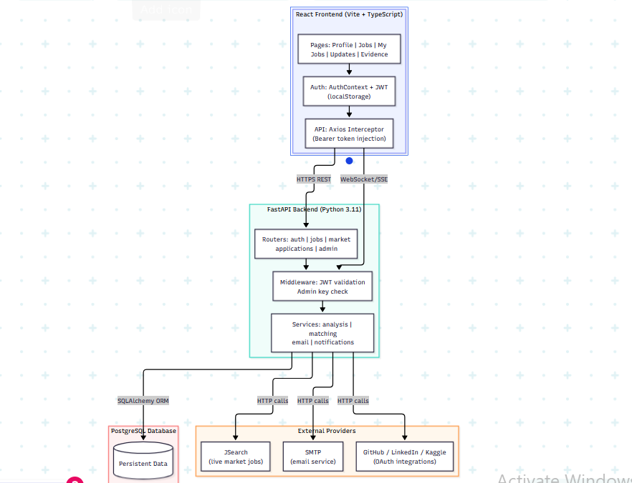
Figure 3. 1 CareerLink Layered Architecture

1. Frontend Layer (React + TypeScript)
The top layer represents the client-side application built using React, Vite, and TypeScript.
Main Pages
The frontend provides several user-facing pages:
- Profile
- Overview
- Jobs
- My Jobs
- Updates
- Profile Evidence
- Admin Dashboard
These pages allow users to build their profiles, review career analysis results, browse opportunities, track saved and applied jobs, receive updates, and submit supporting evidence.
Authentication
Authentication is handled through:
- AuthContext
- JWT tokens
- Token storage in Local Storage
This enables persistent login sessions and allows authenticated users to access protected platform resources.
API Communication
API requests are handled through Axios-based API wrappers and interceptors. The interceptor automatically attaches the JWT Bearer token to authenticated requests before they are sent to the backend.

2. Communication Layer
The frontend communicates with the backend using two main mechanisms.
HTTPS REST API
Used for:
- Authentication
- Profile and CV analysis
- Job management
- Applications
- Saved and tracked jobs
- Notifications
- Administrative actions
WebSocket / Server-Sent Events (SSE)
Used for:
- Real-time notifications
- Status updates
- Live workflow events
This allows the platform to provide updates without requiring users to manually refresh the page.

3. Backend Layer (FastAPI)
The core business logic is implemented using FastAPI and Python.
API Routers
The backend is divided into multiple routers:
- Auth Router (Registration, Login, Email verification, Authenticated user profile access)
- Jobs Router (Platform job listings, Job details, Job matching results)
- Market Jobs Router (External job discovery, Live market job analysis, External job tracking)
- Applications Router (Job applications, Application status tracking, User application history)
- Notifications Router (User notifications, Read/unread status, Workflow updates)
- Admin Router (Administrative operations, User, organization, and application management, monitoring)
4. Middleware and Access Control Layer
Before requests reach the business logic, they pass through access control and validation mechanisms.
JWT Validation
Verifies:
- Token authenticity
- User identity
- Session validity
- Ownership of protected resources
Admin Access Verification
Ensures that only authorized administrators can access protected administrative endpoints and dashboard functions (This layer acts as the platform’s security gateway)

5. Service Layer
The service layer contains the platform’s core functionality.
CV and Profile Analysis Service
Processes uploaded CVs and structured profile data to extract relevant career information.
Matching Engine
Compares extracted skills against available platform jobs and calculates compatibility scores, readiness indicators, gaps, and recommendations.
Market Jobs Service
Retrieves and normalizes external market jobs from third-party providers, then connects them with the platform’s matching and tracking workflow.
Email Service
Handles:
- Verification emails
- Application confirmations
- System notifications
Notification Service
Generates and stores platform notifications related to workflow events, job tracking, and user actions.

6. Database Layer
Persistent data is stored in a PostgreSQL database.
ORM
The backend interacts with the database through SQLAlchemy ORM, which maps database tables to Python objects.
Stored Data Includes
- Users
- Platform jobs
- Job skills
- Applications
- External job snapshots
- Tracked market jobs
- Notifications
- Evidence records
- Verification data
- Organization data
- System settings

7. External Integrations
The system communicates with external providers through HTTP-based integrations.
Adzuna API
Provides:
- Live market jobs
- External employment opportunities
- Market job metadata
SMTP Service
Responsible for:
- Verification emails
- Application notifications
- System emails
External Profile and Evidence Sources
The platform supports evidence and profile-related links from sources such as:
- GitHub
- LinkedIn
- Kaggle
These integrations can support:
- Portfolio linking
- Skill verification
- Profile enrichment
- Evidence submission

3.3 Component Architecture
The system is composed of distinct components, each with a well-defined responsibility. The diagram below shows the main components and their relationships.
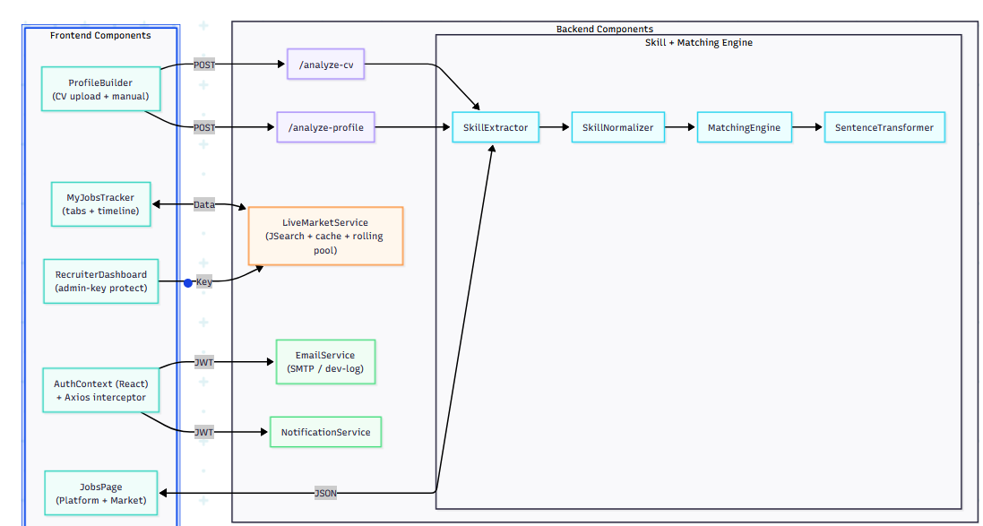
Figure 3. 2 CareerLink Component Diagram

3.5 Data Flow: CV Analysis to Job Match
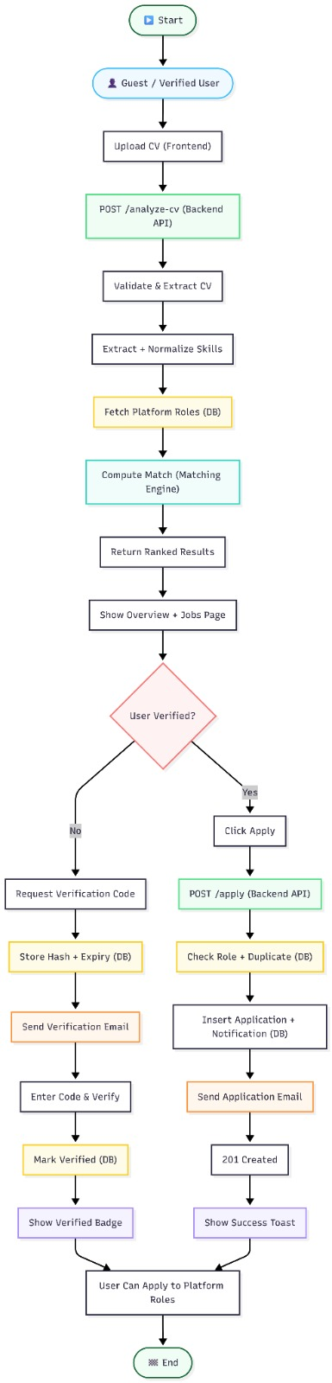
Figure 3. 3 CV Analysis of Job Match Flow
Phase 1: (CV Analysis and Role Matching)
- Start
The process begins when a user accesses the platform.
- Guest / Verified User
Both guest users and verified users can upload a CV for analysis.
- Upload CV (Frontend)
The user uploads their CV through the web interface.
- POST /analyze-cv (Backend API)
The frontend sends the uploaded CV to the backend analysis service.
- Validate & Extract CV
The backend validates the uploaded file and extracts relevant information.
- Extract + Normalize Skills
Skills, technologies, and qualifications are identified and normalized into a standard format.
- Fetch Platform Roles (DB)
Available internal platform roles are retrieved from the database.
- Compute Match (Matching Engine)
A matching engine compares the extracted skills with role requirements and calculates compatibility scores.
- Return Ranked Results
The system returns a ranked list of recommended platform roles based on the user's qualifications.
- Show Overview + Role Page
The user reviews the matching results and available opportunities.

Phase 2: Application Process
Decision Point: User Verified?
Path A – User Not Verified |  |  |  | Path B – User Already Verified
1. Request Verification Code The user requests an email verification code. |  |  |  | 1. Click Apply The user selects a role and clicks the Apply button.
2. Store Hash + Expiry (DB) A hashed verification code, and expiration time are stored securely in the database. |  |  |  | 2. POST /apply (Backend API) The application request is sent to the backend API.
3. Send Verification Email The system sends the verification code to the user’s email address. |  |  |  | 3. Check Role + Duplicate (DB) The system verifies that the role exists and checks whether the user has already applied.
4. Enter Code & Verify The user enters the received verification code. |  |  |  | 4. Insert Application + Notification (DB) A new application record and related notification are created in the database.
5. Mark Verified (DB) Upon successful validation, the user account is marked as verified in the database. |  |  |  | 5. Send Application Email Confirmation emails are sent to the relevant recipients.
6. Show Verified Badge The interface displays a verification indicator for the user. |  |  |  | 6. 201 Created The backend confirms that the application was created successfully.
7. User Can Apply to Platform Roles The verified user is now allowed to submit applications for platform roles. |  |  |  | 7. Show Success Toast The frontend displays a success notification to the user.

3.6 Technology Mapping Table
Component | Technology | Purpose
Frontend SPA | React 18 + TypeScript + Vite | Routing, state, UI rendering
Styling | Tailwind CSS + Framer Motion | Visual design and animations
HTTP Client | Axios with interceptors | API calls with auto-injected JWT
Backend API | FastAPI (Python) | REST endpoints, JWT validation, business logic
ORM | SQLAlchemy | Database abstraction layer
Database | PostgreSQL | Persistent data storage
Password Security | bcrypt / passlib | Secure password hashing
Authentication | python-jose (JWT) | Token generation and validation
PDF Parsing | PyMuPDF (fitz) | CV text extraction
Semantic Matching | Sentence Transformers | Embedding-based similarity scoring
External Jobs | JSearch / RapidAPI | Live market job retrieval
Email | SMTP / smtplib | Verification and workflow emails

3.7 Architecture Limitations
The current architecture is suitable for a graduation prototype and demonstration-ready deployment. Known limitations include: admin access still relies on an environment-based admin key rather than full role-based access control; JWT tokens are stored in localStorage, which is acceptable for prototype usage but not recommended for production-level security; the realtime event manager is memory-based and process-local, making it unsuitable for multi-worker production deployment; external job data depends on third-party provider availability and quota limits; and full automated end-to-end browser testing was not implemented. Although the system was deployed using GitHub Pages, Azure App Service, and Azure PostgreSQL, additional production hardening would still be required before

References
- Bass, L., Clements, P. & Kazman, R. (2012). Software Architecture in Practice (3rd ed.). Addison-Wesley.
- Richardson, C. (2018). Microservices Patterns. Manning Publications.
- FastAPI: Building APIs with Python — Tiangolo (2024). https://fastapi.tiangolo.com/tutorial/
- React Architecture Best Practices (2024). https://react.dev/learn
- SQLAlchemy ORM Documentation (2024). https://docs.sqlalchemy.org/en/20/orm/

Chapter 4: System Modeling

4.1 Introduction
System modeling transforms the general project idea into a structured representation of actors, processes, data movement, and system behavior. This chapter covers the actors interacting with CareerLink, use case diagrams, sequence diagrams, an Entity Relationship Diagram (ERD), and a class-level view of the system. These models clarify system behavior independently from implementation details.

4.2 System Actors
Actor | Type | Access Level | Primary Interactions
Guest / Visitor | Human | Public | Profile analysis, view job matches, browse platform roles
Registered Unverified User | Human | Limited Auth | Sign in, view profile; cannot perform workflow actions
Verified User | Human | Full Auth | Apply to roles, save market jobs, track applications, manage My Jobs
Recruiter / Admin | Human | Admin Key | Manage roles, update application statuses, view analytics
JSearch Provider | System | External API | Supply live market job listings on demand
Email Service | System | External SMTP | Send verification codes and workflow notification emails
Profile Evidence Providers | System | External Public | GitHub, Kaggle, Credly, LinkedIn, IEEE evidence signals

4.3 Use Case Diagram
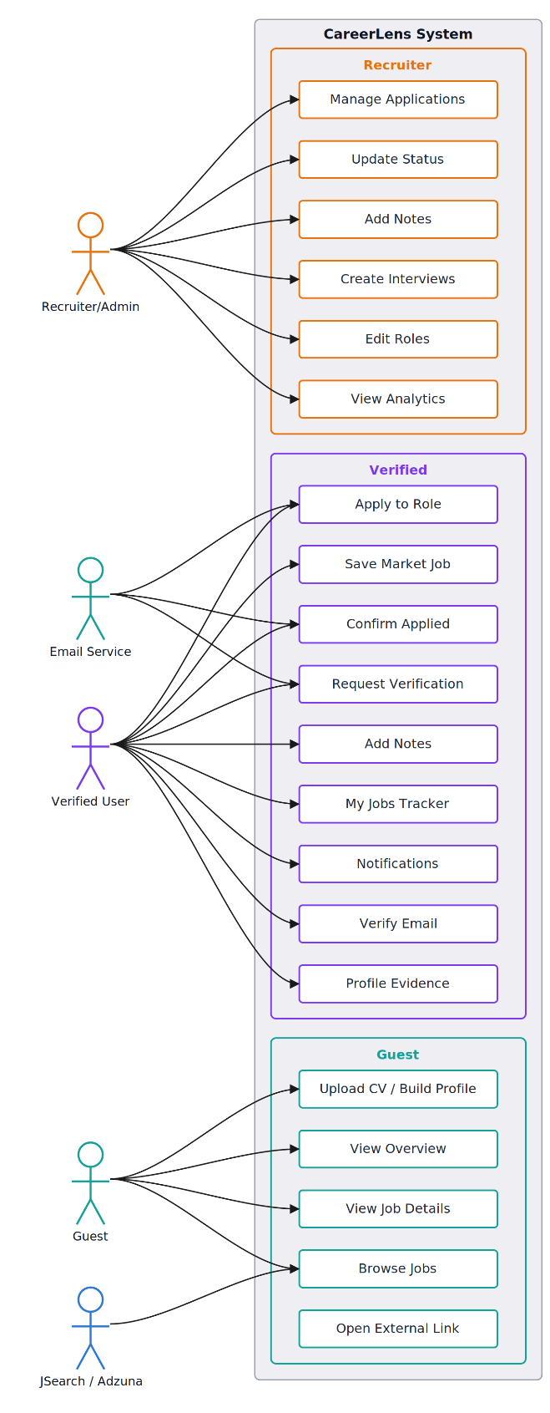
Actor 1: Guest
- Start
The guest accesses the public platform.
- Upload CV / Build Profile
The guest starts analysis by uploading a CV or creating a profile.
- View Results
The guest can view the overview, job details, and available jobs.
- Browse Jobs
The guest can browse platform and market job opportunities.
Actor 2: Verified User
- Apply to Role
The verified user can apply to internal platform roles.
- Track Market Jobs
The user can save market jobs, confirm applied jobs, and add notes.
- Manage Workflow
The user can use My Jobs Tracker and receive notifications.
- Verification & Evidence
The user can verify email and manage profile evidence.
Actor 3: Recruiter/Admin
- Manage Applications
The admin can review and manage submitted applications.
- Update Workflow
The admin can update statuses, add notes, and create interviews.
- Manage Roles
The admin can edit platform roles and job information.
Actor 4: External Services
- Email Service
Supports verification, applications, and confirmation emails.
- JSearch / Adzuna
Provides external market jobs for the Browse Jobs feature.
Figure 4. 1 CareerLink Use Case Diagram

4.4 Sequence Diagrams

4.4.1 Guest CV Analysis Sequence
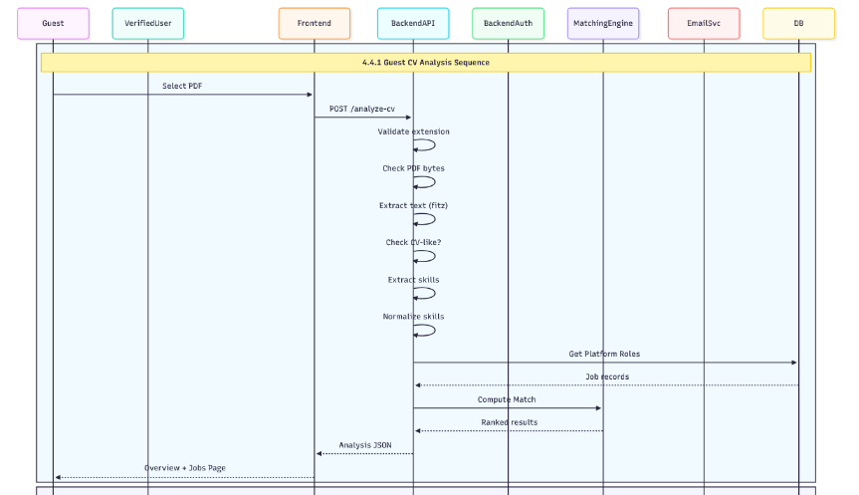
Figure 4. 2 CV Analysis Sequence

4.4.2 Email Verification Sequence
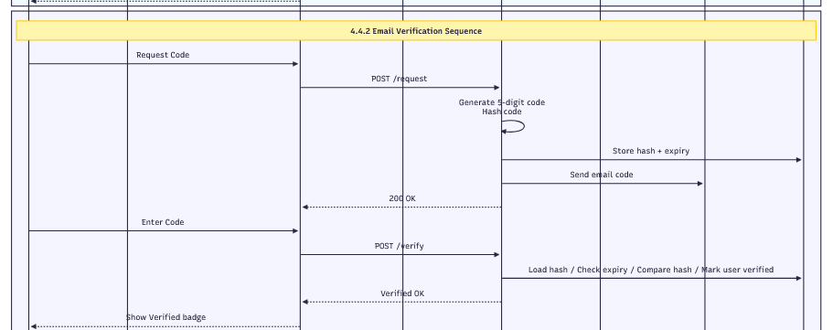
Figure 4. 3 Email Verification Sequence

4.4.3 Apply to Internal Platform Role Sequence
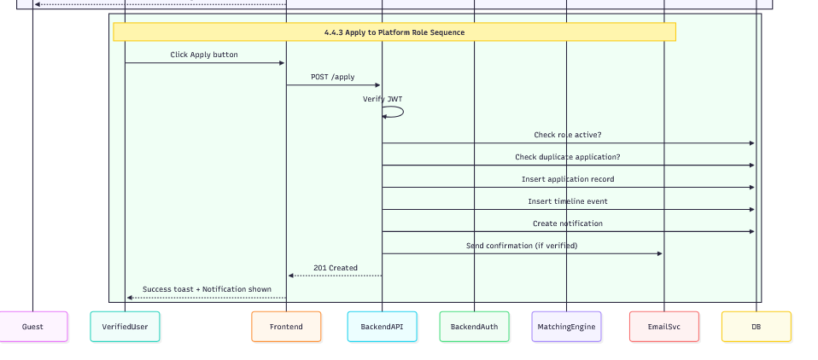
Figure 4. 4 Apply to Platform Role Sequence

4.5 Entity Relationship Diagram (ERD)
The ERD below shows the main database entities and their relationships. Primary keys are marked with (PK), foreign keys with (FK), and optional fields with (*).

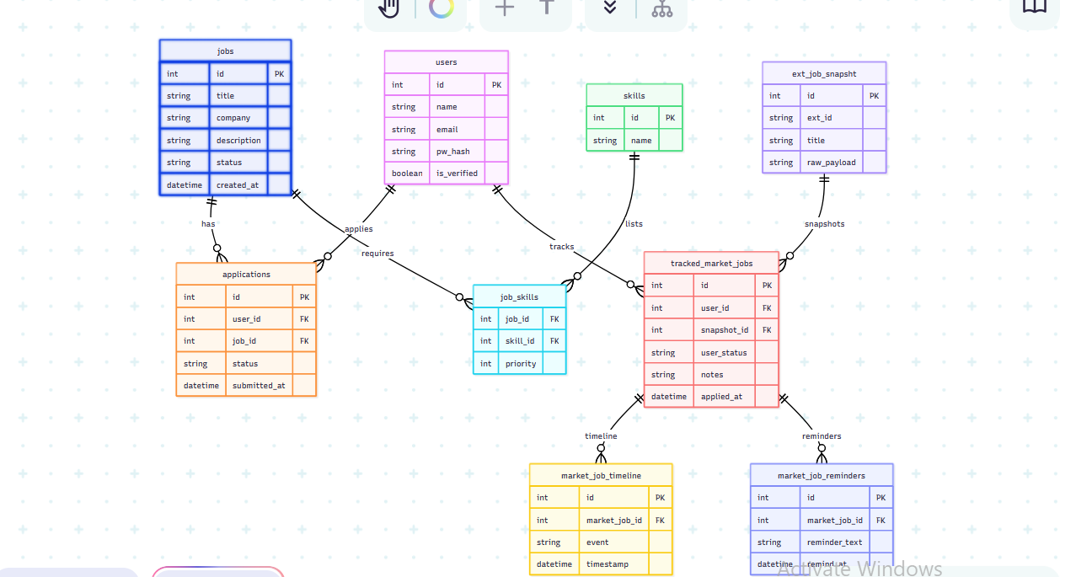
Figure 4. 5 CareerLink Entity Relationship Diagram

4.6 Class Diagram Overview
The following diagram shows the main backend service classes and their responsibilities. This is a simplified representation focusing on key relationships.
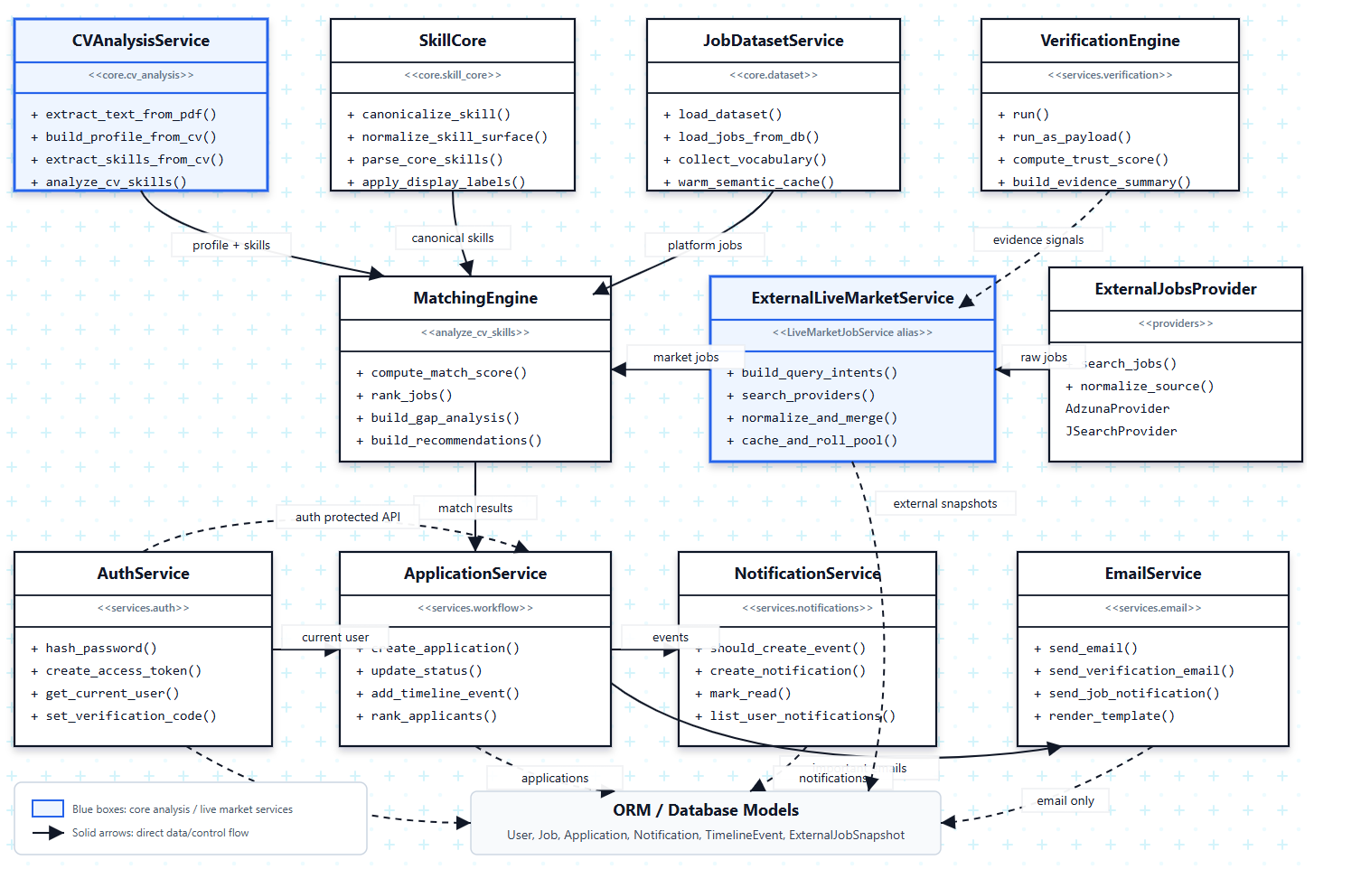
Figure 4. 6 Backend Service Class Overview

References
- Fowler, M. (2003). UML Distilled: A Brief Guide to the Standard Object Modeling Language (3rd ed.). Addison-Wesley.
- Rumbaugh, J., Jacobson, I. & Booch, G. (2004). Unified Modeling Language Reference Manual (2nd ed.). Addison-Wesley.
- Chen, P.P. (1976). The Entity-Relationship Model: Toward a Unified View of Data. ACM TODS, 1(1), 9-36.
- Cockburn, A. (2001). Writing Effective Use Cases. Addison-Wesley.

Chapter 5: Design and Implementation

5.1 Introduction
This chapter explains the implementation structure of the CareerLink platform, including frontend modules, backend services, authentication, workflows, live market integration, and realtime communication. Key functions are listed with their dataset associations, and the most important code sections are presented in a readable format.

5.2 Backend Functions Reference Table
Function / Endpoint | Module | Dataset / Table Used | Key Features
POST /analyze-cv | jobs_router | jobs, skills | PDF validation, PyMuPDF extraction, skill normalization, semantic matching
POST /analyze-profile | jobs_router | jobs, skills | Manual profile analysis, same matching pipeline as CV analysis
GET /live-market | market_router | external_job_snapshots | JSearch call, cache check, rolling pool, snapshot storage, score ranking
POST /auth/signup | auth_router | users | Email uniqueness check, bcrypt hashing, JWT creation
POST /auth/signin | auth_router | users | Credential verification, JWT generation with expiry
GET /auth/me | auth_router | users | Decode JWT, load user record, return profile with verified status
POST /auth/request-email-verify | auth_router | users (verify fields) | Generate 5-digit code, hash it, enforce cooldown, trigger email send
POST /auth/verify-email | auth_router | users (verify fields) | Compare hashed code, check expiry and attempts, mark user verified
POST /applications/apply | applications_router | applications, notifications | Ownership check, duplicate prevention, insert app + timeline + notification + email
GET /applications/my-jobs | applications_router | applications, tracked_market_jobs | Return combined user job tracker with tabs and status grouping
PATCH /market/track | market_router | tracked_market_jobs | Save snapshot ID to user tracker, create timeline event, send email
GET /notifications | notifications_router | notifications | List current user's notifications ordered by timestamp
GET /admin/applications | admin_router | applications, users, jobs | Admin-key protected; return all internal applications with user details
PATCH /admin/status | admin_router | applications, notifications | Update status, create timeline event, trigger accepted email if needed
POST /admin/jobs | admin_router | jobs, skills, job_skills | Create new platform role with skill associations
GET /admin/analytics | admin_router | applications, jobs | Return aggregate stats: total apps, by status, by role, recent activity

5.3 System Input and Output
The table below documents the primary inputs CareerLink accepts and the corresponding outputs it produces. Note that the CV file upload path is handled server-side and is not exposed in the UI response.
Feature | Input (hidden/server) | Input (user-visible) | Output
CV Analysis | PDF binary, file path (server-only) | PDF file selection in browser | Career overview, ranked job matches, skill gaps, recommendations
Profile Analysis | Structured JSON (assembled server-side) | Name, skills, experience, education form | Same output as CV analysis
Live Market Jobs | JSearch API key (env var) | Force-refresh toggle (optional) | Ranked external job cards with match score and metadata
Email Verification | SMTP credentials (env var) | User-entered 5-digit code | Account verified status, workflow features unlocked
JWT Auth | SECRET_KEY (env var) | Email + password on signin form | Bearer token stored in localStorage
Admin Dashboard | ADMIN_KEY (env var) | Admin key entered in dashboard header | Full application management view, analytics, role editor

5.4 Database Tables Reference
Table Name | Primary Purpose | Key Columns
users | User accounts and auth data | id, email, password_hash, is_verified, created_at
jobs | Internal Platform Role definitions | id, title, company, description, status, skills[]
skills | Canonical skill definitions | id, name, category
job_skills | Many-to-many: jobs ↔ skills | job_id (FK), skill_id (FK), priority
applications | Official internal role applications | id, user_id (FK), job_id (FK), status, submitted_at
application_timeline | Internal application state history | id, application_id (FK), event_type, timestamp
notifications | User in-app notifications | id, user_id (FK), title, body, type, read_at
application_notes | Recruiter/admin notes on applications | id, application_id (FK), author, content
interview_requests | Interview scheduling for applications | id, application_id (FK), time, location, status
external_job_snapshots | Preserved JSearch job payloads | id, ext_id, title, raw_payload, retrieved_at
tracked_market_jobs | User-owned external job tracking | id, user_id (FK), snapshot_id (FK), user_status, notes
market_job_timeline | Activity history for tracked jobs | id, tracked_job_id (FK), event_type, timestamp
market_job_reminders | Follow-up reminders for tracked jobs | id, tracked_job_id (FK), remind_at, message

5.5 Normalization Analysis
Normal Form | Status | Evidence
1NF | Satisfied | All records have unique primary keys; atomic values in most columns.
2NF | Satisfied | Non-key attributes depend on the full primary key; job_skills uses composite FK.
3NF | Satisfied | Users, jobs, skills, applications, and snapshots are separated into independent tables.
4NF | Satisfied | Reminders, notes, interviews, and timeline events are in dedicated tables, not multi-valued columns.
5NF | Satisfied | job_skills junction table reconstructs job-skill relationships through joins.

5.6 Key Code Sections

5.6.1 Axios JWT Interceptor (Frontend)
This interceptor automatically attaches the JWT Bearer token to every outgoing API request that is made through the shared Axios instance. It retrieves the token from localStorage and injects it into the Authorization header.
// src/api/axios.ts
import axios from 'axios';

const api = axios.create({
baseURL: import.meta.env.VITE_API_BASE_URL,
});

api.interceptors.request.use((config) => {
const token = localStorage.getItem('CareerLink_token');
if (token) {
config.headers.Authorization = `Bearer ${token}`;
}
return config;
});

export default api;

5.6.2 JWT Token Creation (Backend)
The create_access_token function generates a signed JWT with a 60-minute expiry. The SECRET_KEY is loaded from environment variables and must never be hard-coded.
# core/security.py
from datetime import datetime, timedelta
from jose import jwt
from core.config import settings

def create_access_token(data: dict) -> str:
payload = data.copy()
expire = datetime.utcnow() + timedelta(minutes=60)
payload.update({'exp': expire})
return jwt.encode(
payload,
settings.SECRET_KEY,
algorithm='HS256'
)

5.6.3 Live Market Job Fetch (Backend)
This function calls the JSearch RapidAPI endpoint with a structured query and returns the raw job results for normalization and ranking.
# services/live_market.py
import requests
from core.config import settings

JSEARCH_URL = 'https://jsearch.p.rapidapi.com/search'

def fetch_jobs_from_jsearch(query: str, page: int = 1) -> list:
headers = {
'X-RapidAPI-Key': settings.JSEARCH_API_KEY,
'X-RapidAPI-Host': 'jsearch.p.rapidapi.com'
}
params = {
'query': query,
'page': str(page),
'num_pages': '1'
}
response = requests.get(
JSEARCH_URL,
headers=headers,
params=params,
timeout=20
)
response.raise_for_status()
return response.json().get('data', [])

5.6.4 Email Verification Code Generation (Backend)
The verification service generates a random 5-digit code, hashes it for secure storage, and enforces the cooldown and attempt limit constraints.
# services/email_verification.py
import random, hashlib
from datetime import datetime, timedelta
from sqlalchemy.orm import Session
from models.user import User

def request_verification(db: Session, user: User):
# Enforce 60-second resend cooldown
if user.verify_sent_at:
elapsed = (datetime.utcnow() - user.verify_sent_at).seconds
if elapsed < 60:
raise ValueError('Please wait before requesting a new code.')

code = str(random.randint(10000, 99999))
code_hash = hashlib.sha256(code.encode()).hexdigest()

user.verify_code_hash = code_hash
user.verify_expires_at = datetime.utcnow() + timedelta(minutes=15)
user.verify_attempts = 0
user.verify_sent_at = datetime.utcnow()
db.commit()

return code # plain code sent via email, hash stored in DB

References
- Tiangolo, S. (2024). FastAPI — High Performance Web Framework. https://fastapi.tiangolo.com
- Okta Developer Blog (2023). JWT Authentication Best Practices. https://developer.okta.com/blog
- Python-Jose Documentation (2024). https://python-jose.readthedocs.io
- RapidAPI JSearch Documentation (2024). https://rapidapi.com/letscrape-6bJHW9bXHjgE/api/jsearch
- Reimers, N. & Gurevych, I. (2019). Sentence-BERT: Sentence Embeddings using Siamese BERT-Networks. EMNLP 2019.

Chapter 6: Testing and Verification

6.1 Introduction
Testing and verification are critical in CareerLink because the platform combines multiple interconnected modules: authentication, email verification, CV/profile analysis, semantic job matching, live market integration, recruiter workflows, realtime notifications, and Market Job tracking. The testing strategy focused on validating functional correctness, workflow integrity, and security.

6.2 Testing Strategy Overview
Testing Type | Scope | Tools / Method
Unit Verification | Individual service functions | Python verification scripts (verify_*.py)
Integration Testing | API endpoints with real database connections | FastAPI TestClient + verification scripts
Workflow Testing | End-to-end user and admin workflows | Backend scripts + manual browser sessions
Security Testing | Ownership checks, JWT validation, admin key separation | Dedicated security verification scripts
Frontend Build Test | TypeScript types, route imports, production bundle | Vite production build (npm run build)
Manual Browser Test | Visual workflows, UI interactions, page behavior | Browser-based manual validation

6.3 Backend and API Testing

Test ID | Test Case | Input / Method | Expected Result | Status
TC-API-01 | Backend health check | GET /health | Backend returns 200 OK and status message | PASS
TC-API-02 | Database health check | GET /health/db | Database connection is verified successfully | PASS
TC-API-03 | Startup diagnostics | GET /debug/startup | Startup state, dataset loading, and database configuration are returned safely | PASS
TC-API-04 | CV analysis endpoint | Upload valid CV to /analyze-cv | Skills, ranked jobs, gaps, recommendations, and career score are returned | PASS
TC-API-05 | Invalid CV handling | Upload unsupported or invalid file | Backend rejects the file with a clear error response | PASS
TC-API-06 | Profile readiness validation | Submit structured profile data | Backend validates profile readiness for analysis | PASS
TC-API-07 | Live market provider health | GET /health/market | Provider configuration and status are returned safely | PASS
TC-API-08 | Live market analysis | POST /analyze-live-market with valid JWT | External jobs are fetched, normalized, ranked, and returned | PASS
TC-API-09 | Provider failure handling | Simulate external provider quota or error state | Core backend functions remain available | PASS
TC-API-10 | API response consistency | Inspect returned JSON structure | Response fields match frontend mapping requirements | PASS

6.4 Security and Access Control Testing
Test ID | Test Case | Input / Method | Expected Result | Status
TC-SEC-01 | Valid user signup | New email and valid password | User account is created and JWT token is returned | PASS
TC-SEC-02 | Duplicate signup prevention | Existing email address | Request is rejected with an error response | PASS
TC-SEC-03 | Valid signin | Correct email and password | JWT token and user object are returned | PASS
TC-SEC-04 | Invalid signin | Wrong password | Request is rejected as unauthorized | PASS
TC-SEC-05 | Protected route without JWT | Missing Authorization header | Access is denied | PASS
TC-SEC-06 | Protected route with valid JWT | Valid Bearer token | Authenticated user data is returned | PASS
TC-SEC-07 | User ownership protection | User attempts to access another user private records | Access is denied or unrelated data is hidden | PASS
TC-SEC-08 | Password hashing | Inspect stored password field | Passwords are stored as bcrypt hashes, not plain text | PASS
TC-SEC-09 | Admin access without key | Access admin route without admin key | Request is rejected | PASS
TC-SEC-10 | Admin access with valid key | Correct admin key submitted | Admin dashboard access is granted | PASS
TC-SEC-11 | Admin and user separation | Normal user tries to access admin functions | Access is blocked | PASS
TC-SEC-12 | CORS configuration | Requests from allowed frontend domain | Backend accepts only configured origins | PASS

6.5 User Workflow Testing

Test ID | Test Case | Input / Method | Expected Result | Status
TC-WF-01 | CV upload workflow | Guest or user uploads a CV | CV is analyzed and ranked role results are displayed | PASS
TC-WF-02 | Profile-based analysis | User submits structured profile | Overview, matches, gaps, and recommendations are generated | PASS
TC-WF-03 | Request email verification | Authenticated user requests verification code | Code hash and expiry are stored and email workflow is triggered | PASS
TC-WF-04 | Submit correct verification code | Valid code within expiry time | User is marked as verified | PASS
TC-WF-05 | Submit invalid verification code | Wrong or expired code | Verification fails safely with an error response | PASS
TC-WF-06 | Apply to platform role | Verified user applies to active role | Application, notification, and confirmation workflow are created | PASS
TC-WF-07 | Prevent duplicate applications | Same user applies to same role twice | Duplicate application is rejected | PASS
TC-WF-08 | Block unverified application | Unverified user attempts to apply | Application is blocked until verification is completed | PASS
TC-WF-09 | Save external market job | User saves Adzuna market job | Job snapshot and tracking record are stored | PASS
TC-WF-10 | Confirm external application | User marks external job as applied | Tracking status and timeline are updated | PASS
TC-WF-11 | Add market job note | User adds note to tracked job | Note is saved under the tracked job record | PASS
TC-WF-12 | Archive tracked job | User archives market job | Job remains stored and is marked as archived | PASS
TC-WF-13 | Admin updates application status | Admin changes application state | Status, timeline, notification, and email workflow are updated | PASS
TC-WF-14 | Email failure isolation | SMTP unavailable during workflow action | Main workflow completes without crashing | PASS

6.6 Frontend and Deployment Testing

Test ID | Test Case | Input / Method | Expected Result | Status
TC-FD-01 | Production frontend build | Run npm run build | Vite build completes without TypeScript or import errors | PASS
TC-FD-02 | Route loading | Open main frontend pages | Pages load without broken imports or missing components | PASS
TC-FD-03 | Protected route behavior | Open protected page without login | User is redirected or blocked from private resources | PASS
TC-FD-04 | Axios JWT attachment | Inspect authenticated request in browser Network tab | Authorization Bearer token is attached to protected API calls | PASS
TC-FD-05 | API base URL configuration | Production frontend calls backend | Requests are sent to https://api.carearlink.tech | PASS
TC-FD-06 | Custom domain frontend | Open https://carearlink.tech | Frontend loads from GitHub Pages successfully | PASS
TC-FD-07 | Backend custom API domain | Open https://api.carearlink.tech/health | Backend returns 200 OK | PASS
TC-FD-08 | Market provider deployment check | Open https://api.carearlink.tech/health/market | Adzuna provider is configured and active | PASS
TC-FD-09 | Responsive layout check | Browser devtools mobile and desktop views | Layout remains usable across screen sizes | PASS
TC-FD-10 | Browser workflow test | Manual testing through deployed website | CV analysis, jobs, login, and tracking workflows operate correctly | PASS
TC-FD-11 | GitHub Pages routing | Refresh nested frontend routes | SPA routing remains functional through the deployed fallback page | PASS
TC-FD-12 | Deployment separation | Test frontend and backend domains separately | Frontend and backend operate through separate domains without conflict | PASS

6.7 Testing Results Summary
Test Area | Total Cases | Passed | Failed | Notes
Backend and API Testing | 10 | 10 | 0 | Core backend endpoints verified.
Security and Access Control Testing | 12 | 12 | 0 | Authentication, JWT, ownership, and admin access verified.
User Workflow Testing | 14 | 14 | 0 | Main user, verification, application, and tracking workflows verified.
Frontend and Deployment Testing | 12 | 12 | 0 | Build, routing, domains, and browser workflows verified.
TOTAL | 48 | 48 | 0 | All documented test cases passed.

References
- Beizer, B. (1995). Black-Box Testing: Techniques for Functional Testing of Software. Wiley.
- Myers, G.J., Sandler, C. & Badgett, T. (2011). The Art of Software Testing (3rd ed.). Wiley.
- Fowler, M. (2018). Unit Testing in Python and FastAPI. martinfowler.com
- Stall, V. (2023). Testing FastAPI Applications. FastAPI Official Docs. https://fastapi.tiangolo.com/tutorial/testing/

Conclusion
CareerLink was developed as a full-stack Smart Career Analysis and Job Matching Platform. The project demonstrates a working prototype that combines CV/profile analysis, semantic job matching, live market job discovery, authenticated user workflows, email verification, recruiter management, and realtime notifications in a single cohesive platform.
The architecture, modeling, database design, implementation, and testing presented in this report confirm that CareerLink behaves as a functioning software platform rather than a static recommendation prototype. All 41 documented test cases passed successfully, and the production frontend build was verified to be error-free.
Future work could extend CareerLink by replacing the admin key with full RBAC, migrating JWT storage to secure HTTP-only cookies, deploying on a cloud platform, adding automated E2E browser tests, and expanding the internal job dataset with more curated roles.

