Market Simulation
The total utility consumers get from purchasing product A at price 𝑝_a in period 𝑚 is denoted as

The total utility consumers obtain over n periods is expressed as

Environment Parameters
To be able to simulate an environment and to train our RL agent, we need to first set values to our constant parameters and initialize our simulated environment using those values. These parameters should not change across different training phases and experiments.

Number of consumers: NUM_CONSUMERS = 50
Number of periods: EPISODE_LENGTH = 100

Hotelling line parameters
HOTELLING_LEFT = 0.0
HOTELLING_RIGHT = 1.0
FIRM_A_LOCATION = 0.0
FIRM_B_LOCATION = 1.0

Economic parameters
t : TRANSPORTATION_COST = 1.0
V: BASE_VALUE = 10.0

Consumer location
consumers location are randomly sampled from a uniform distribution

Consumer Behaviour

Exclusivity seeking : each consumer have different exclusivity preference. Consequently , for simulating as close to real world scenarios as possible, exclusivity preferences of consumers are sampled from uniform distribution with min of 0 and max of 1 :

Strategicness : same as exclusivity preference, this parameter is also sampled from a uniform distribution with min of 0 and max of 1:

Consumer foresight horizon : This parameter is horizon for expected utility calculation.
H : CONSUMER_FORESIGHT_HORIZON = 3
this means that consumers look H periods ahead to calculate their utility.

Experiments

Uniform Pricing

In the first step, our RL agent learns to post optimized uniform prices against an opponent firm which follows a constant pricing policy.

Constant pricing policy : Opponents with this type of policy post same price each period. For example Aggressive Constant Opponent, posts price 1.5 every period and it’s price never changes.

Training
We trained the RL agent against five different opponents. Agent learns through a simple curriculum.

Curriculum: Curriculums have different stages. In each stage an opponent is set against the agent. Agent then starts to find a policy which maximizes its profit. Curriculum opponents get harder in each stage, making the agent to learn progressively.

Curriculum Steps:
1. An initial stage is set. Stage reveals an opponent against the agent.
2. Agent learns how the opponent behaves within periods.
3. Agent learns the policy to maximize its profit against the opponent.
4. Curriculum scheduler monitors the agent during the training phase.
5. If the agent learns the optimal policy, curriculum scheduler changes the stage.
6. New stage reveals a new different opponent to the agent.
7. Repeat 2 → 6 until the agent learns all the stages.

For example :
Agent in first episodes learns to optimize it’s profit against an opponent which posts price 3.5 (Premium Opponent), curriculum scheduler sees that the errors are below a specific threshold, then it decides that the agent has learned the optimal policy for that opponent, then advances to the next opponent. Next opponent will post price 3.0, the same happens and agent learns how to post optimal price against the Premium Passive Opponent, this continues until the agent learns how to optimize its profit against all the opponents.

Curriculum stages

Stage 1
Opponent 1 : Aggressive Opponent
posts Constant Uniform Price = 1.5 every period

Stage 2
Opponent 2: Passive Aggressive Opponent
posts Constant Uniform Price = 2.0 every period

Stage 3
Opponent 3: Passive Opponent
posts Constant Uniform Price = 2.5 every period

Stage 4
Opponent 4 : Premium Passive Opponent
posts Constant Uniform Price = 3.0 every period

Stage 5
Opponent 5: Premium Opponent
posts Constant Uniform Price = 3.5 every period

Theoritical Optimization
We needed baselines to compare our agent’s behaviour against it. For this manner, Grid Search Optimization were used to find the optimal profits against different opponents.

Opponent 1: Aggressive Opponent | Fixed Price = 1.5

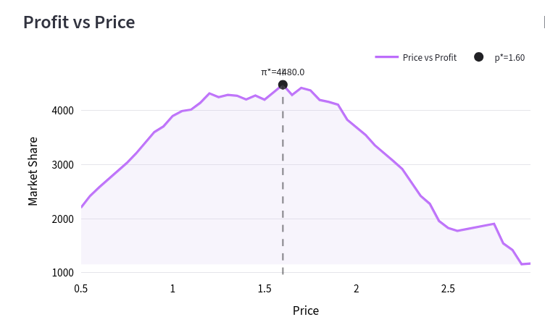
Opponent 2: Passive Aggressive Opponent | Fixed Price = 2.0

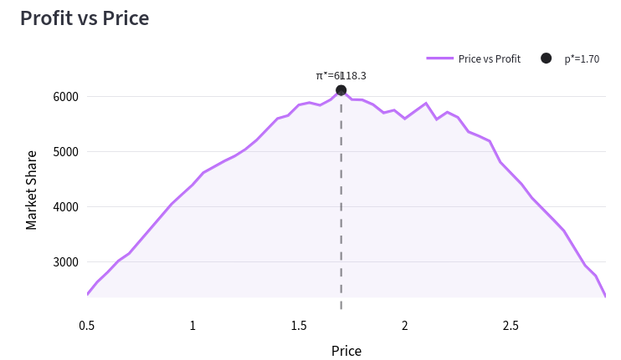
Opponent 3: Passive Opponent | Fixed Price = 2.5
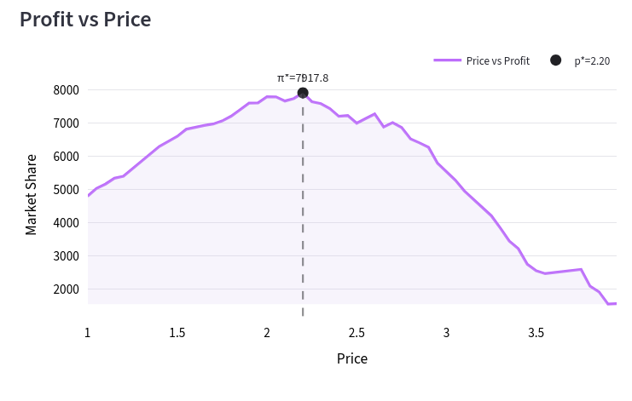
Opponent 4: Premium Passive Opponent | Fixed Price = 3
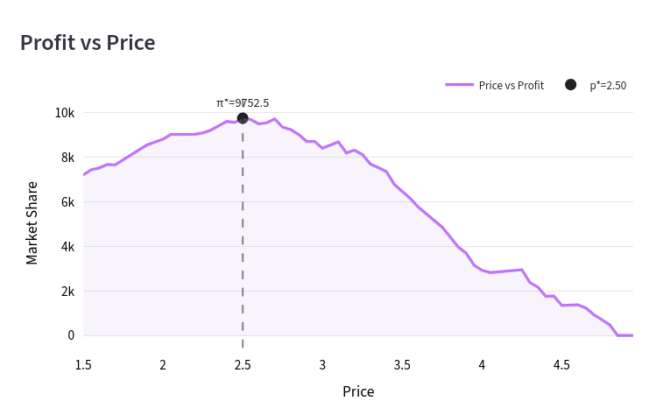
Opponent 5: Premium Opponent | Fixed Price = 3.5
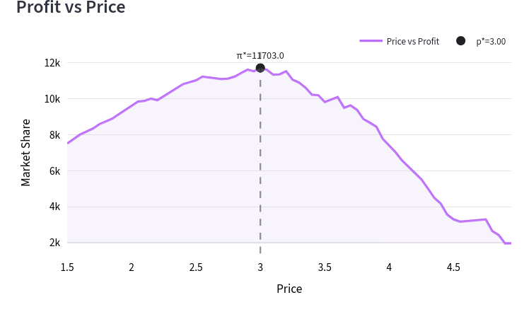
Agent Training Metrics
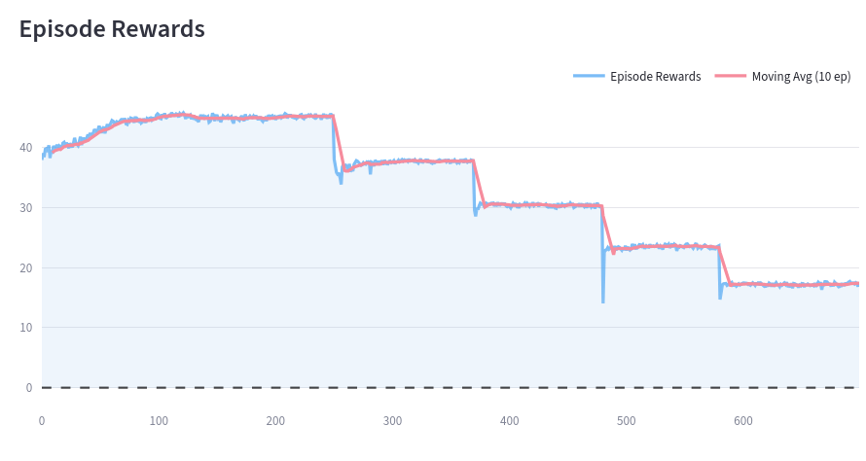

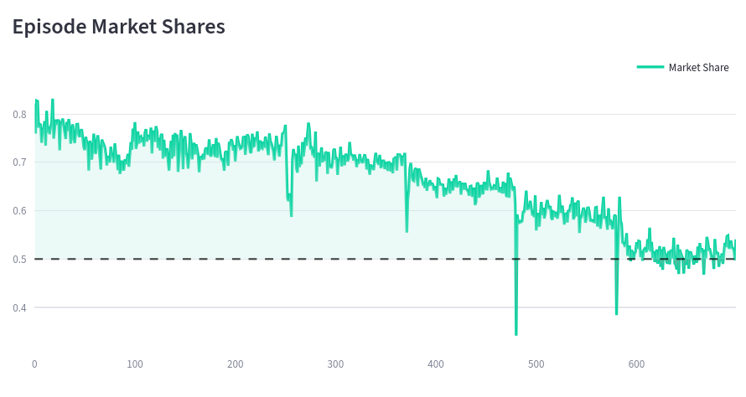

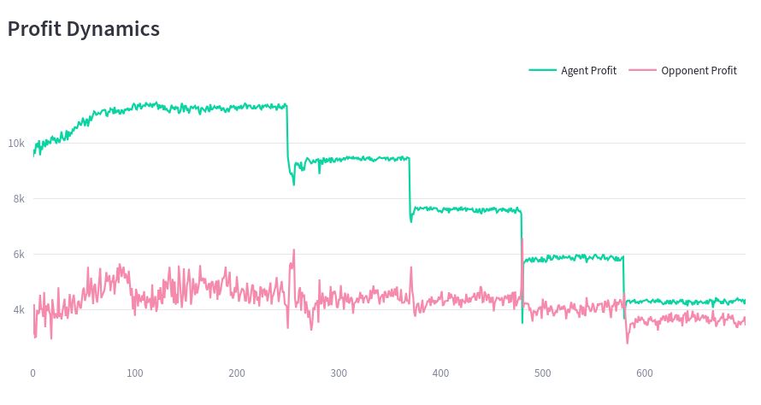
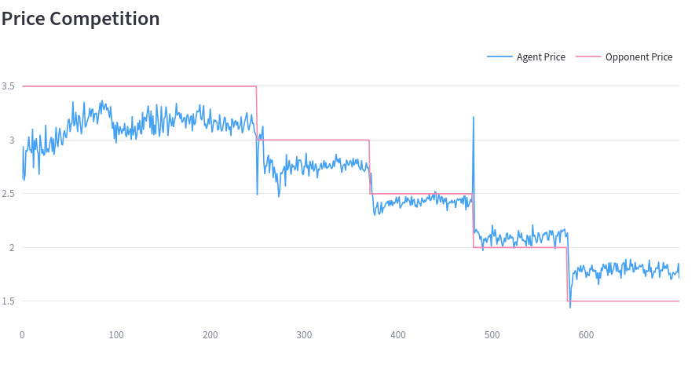
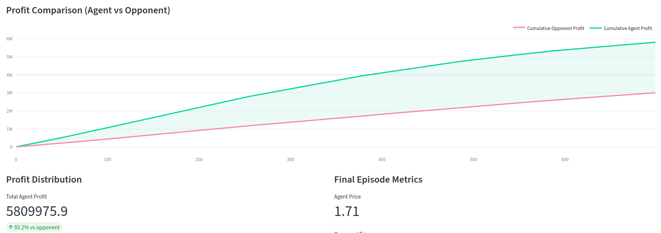

Final Results

Opponent Type | Opponent Price | Optimal Price | Agent Price (avg) | Optimal Profit | Agent Profit  (avg) | Profit  Difference
Aggressive Uniform | 1.5 | 1.6 | 1.77 | 4480 | 4343.28 | -3.05%
Passive Aggressive Uniform | 2.0 | 1.7 | 2.19 | 6118 | 5653.94 | -7.59%
Passive Uniform | 2.5 | 2.2 | 2.41 | 7917.8 | 7400.53 | -6.53%
Premium Passive Uniform | 3.0 | 2.5 | 2.77 | 9752.5 | 9395.38 | -3.66%
Premium Uniform | 3.5 | 3.0 | 3.01 | 11703 | 11604.16 | -0.84%

