Create a tables Employees and Departments with structure as given below along with constriants

CREATE TABLE dept
(
department_id NUMBER(12) PRIMARY KEY,
department_name VARCHAR2(30) NOT NULL,
manager_id NUMBER(6),
location_id NUMBER(4)
);
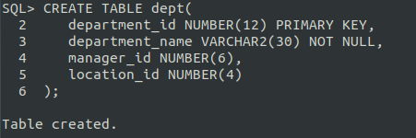

DESCRIBE dept;

Name Null? Type
----------------------------------------- -------- ----------------------------
DEPARTMENT_ID NOT NULL NUMBER(12)
DEPARTMENT_NAME NOT NULL VARCHAR2(30)
MANAGER_ID NUMBER(6)
LOCATION_ID NUMBER(4)

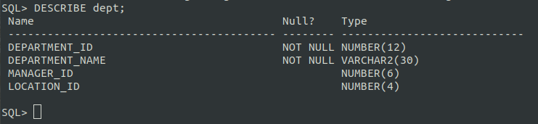

INSERT INTO dept(department_id,department_name,manager_id,location_id) VALUES('10', 'Administration', '100', '1000');
INSERT INTO dept(department_id,department_name,manager_id,location_id) VALUES('20', 'Marketing', '200', '2000');
INSERT INTO dept(department_id,department_name,manager_id,location_id) VALUES('30', 'Shipping', '300', '3000');
INSERT INTO dept(department_id,department_name,manager_id,location_id) VALUES('40', 'IT', '400', '4000');
INSERT INTO dept(department_id,department_name,manager_id,location_id) VALUES('50', 'Sales', '500', '5000');
INSERT INTO dept(department_id,department_name,manager_id,location_id) VALUES('60', 'Accounting', '600', '6000');
INSERT INTO dept(department_id,department_name,manager_id,location_id) VALUES('70', 'Contracting', '700', '7000');
INSERT INTO dept(department_id,department_name,manager_id,location_id) VALUES('80', 'Executive', '800', '8000');

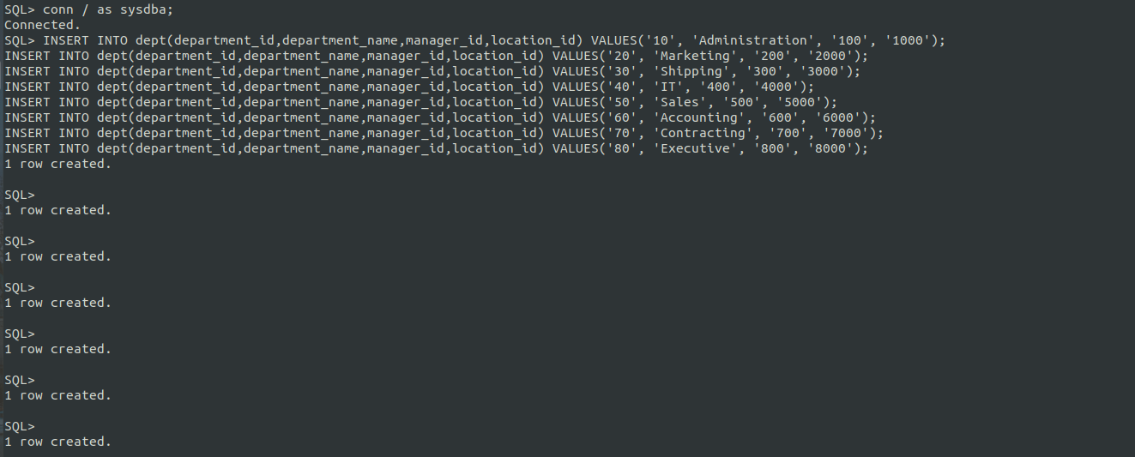
SELECT * FROM dept;

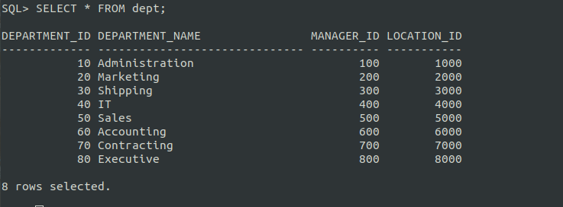

CREATE TABLE emp
( employee_id NUMBER(6) PRIMARY KEY,
first_name VARCHAR2(64),
last_name VARCHAR2(64) NOT NULL,
email VARCHAR2(320) NOT NULL,
phone_number NUMBER(15),
hire_date DATE NOT NULL,
job_id VARCHAR2(10),
salary NUMBER(8,2),
commissoion_pct NUMBER(2,2),
manager_id NUMBER(6),
department_id NUMBER(6),
FOREIGN KEY(department_id) REFERENCES dept(department_id)
);

SQL> DESCRIBE emp;
Name Null? Type
----------------------------------------- -------- ----------------------------
EMPLOYEE_ID NOT NULL NUMBER(6)
FIRST_NAME VARCHAR2(64)
LAST_NAME NOT NULL VARCHAR2(64)
EMAIL NOT NULL VARCHAR2(320)
PHONE_NUMBER NUMBER(15)
HIRE_DATE NOT NULL DATE
JOB_ID VARCHAR2(10)
SALARY NUMBER(8,2)
COMMISSION_PCT NUMBER(2,2)
MANAGER_ID NUMBER(6)
DEPARTMENT_ID NUMBER(6)

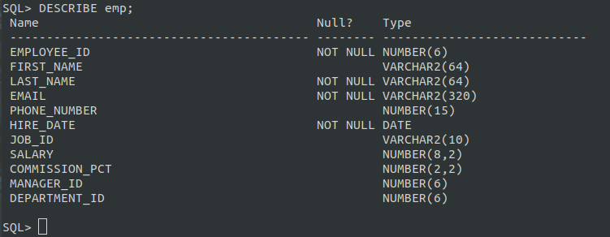

INSERT INTO emp
VALUES(100, 'Mike', 'Waren', 'mikewaren@gmail.com', 1254875545, TO_DATE('12/01/2020', 'DD/MM/YYYY'), 'AD_SALES', 15000, 5, 200, 10);
INSERT INTO emp
VALUES(200, 'Niel', 'Waren', 'neilwaren@gmail.com', 1285458454, TO_DATE('12/05/2020', 'DD/MM/YYYY'), 'IT_PROG', 18000, 8, 400, 40);
INSERT INTO emp
VALUES(300, 'John', 'Waren', 'john@gmail.com', 1289458454, TO_DATE('30/01/2020', 'DD/MM/YYYY'), 'AD_EXE', 17000, 5, 800, 80);
INSERT INTO emp
VALUES(400, 'Jonthan', 'odhams', 'jonathanodhams@gmail.com', 1845455455, TO_DATE('15/01/2020', 'DD/MM/YYYY'), 'AD_MKT', 11000, 4, 400, 20);
INSERT INTO emp
VALUES(500, 'William', 'odhams', 'williamodhams@gmail.com', 1254587545, TO_DATE('11/06/2020', 'DD/MM/YYYY'), 'AD_SHIP', 15000, 8, 400, 20);

INSERT INTO emp
VALUES(600, 'Wesh', 'Waren', 'mikewaren@gmail.com', 1254875545, TO_DATE('12/01/2010', 'DD/MM/YYYY'), 'AD_SALES', 15000, 5, 200, 10);
INSERT INTO emp
VALUES(700, 'Houl', 'Waren', 'neilwaren@gmail.com', 1285458454, TO_DATE('12/05/2017', 'DD/MM/YYYY'), 'IT_PROG', 18000, 8, 400, 40);
INSERT INTO emp
VALUES(800, 'Kitee', 'Waren', 'john@gmail.com', 1289458454, TO_DATE('30/01/2005', 'DD/MM/YYYY'), 'AD_EXE', 17000, 5, 800, 80);
INSERT INTO emp
VALUES(900, 'Will', 'odhams', 'jonathanodhams@gmail.com', 1845455455, TO_DATE('15/01/2006', 'DD/MM/YYYY'), 'AD_MKT', 11000, 4, 400, 20);
INSERT INTO emp
VALUES(110, 'Niccke', 'odhams', 'williamodhams@gmail.com', 1254587545, TO_DATE('11/06/2005', 'DD/MM/YYYY'), 'AD_SHIP', 25000, 8, 400, 20);

INSERT INTO emp
VALUES(120, 'Mike', 'Waren', 'mikewaren@gmail.com', 1254875545, TO_DATE('12/01/2020', 'DD/MM/YYYY'), 'AD_SALES', 19000, 5, 200, 10);
INSERT INTO emp
VALUES(220, 'Niel', 'Waren', 'neilwaren@gmail.com', 1285458454, TO_DATE('12/05/2020', 'DD/MM/YYYY'), 'IT_PROG', 35000, 8, 400, 40);
INSERT INTO emp
VALUES(300, 'John', 'Waren', 'john@gmail.com', 1289458454, TO_DATE('30/01/2020', 'DD/MM/YYYY'), 'AD_EXE', 17000, 5, 800, 80);
INSERT INTO emp
VALUES(430, 'Jonthan', 'odhams', 'jonathanodhams@gmail.com', 1845455455, TO_DATE('15/01/2020', 'DD/MM/YYYY'), 'AD_MKT', 5000, 4, 400, 20);
INSERT INTO emp
VALUES(500, 'William', 'odhams', 'williamodhams@gmail.com', 1254587545, TO_DATE('11/06/2020', 'DD/MM/YYYY'), 'AD_SHIP', 80000, 8, 400, 20);

INSERT INTO emp
VALUES(180, 'Mike', 'Waren', 'mikewaren@gmail.com', 1254875545, TO_DATE('12/01/2020', 'DD/MM/YYYY'), 'AD_SALES', 85000, 5, 200, 10);
INSERT INTO emp
VALUES(250, 'Niel', 'Waren', 'neilwaren@gmail.com', 1285458454, TO_DATE('12/05/2020', 'DD/MM/YYYY'), 'IT_PROG', 75000, 8, 400, 40);
INSERT INTO emp
VALUES(380, 'John', 'Waren', 'john@gmail.com', 1289458454, TO_DATE('30/01/2020', 'DD/MM/YYYY'), 'AD_EXE', 15000, 5, 800, 80);
INSERT INTO emp
VALUES(490, 'Jonthan', 'odhams', 'jonathanodhams@gmail.com', 1845455455, TO_DATE('15/01/2020', 'DD/MM/YYYY'), 'AD_MKT', 8500, 4, 400, 20);
INSERT INTO emp
VALUES(510, 'William', 'odhams', 'williamodhams@gmail.com', 1254587545, TO_DATE('11/06/2020', 'DD/MM/YYYY'), 'AD_SHIP', 75000, 8, 400, 20);

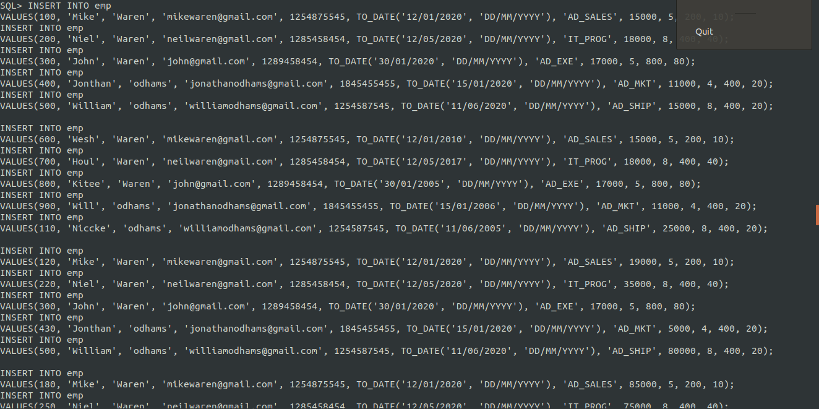

Write a query to display the last name and salary of employees earning more than 12,000
SELECT last_name, salary FROM emp WHERE salary > 12000;
LAST_NAME SALARY
---------------------------------------------------------------- ----------
Waren 15000
Waren 18000
Waren 17000
odhams 15000
Waren 15000
Waren 18000
Waren 17000
odhams 25000
Waren 19000
Waren 35000
Waren 85000

LAST_NAME SALARY
---------------------------------------------------------------- ----------
Waren 75000
Waren 15000

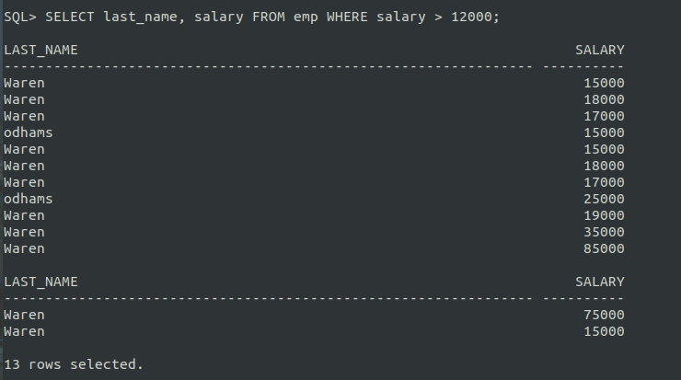
Write a query to display the employee last name and department name for given employee number
Assume Employee Number is 430, 300, 180

SQL> SELECT e.last_name, d.department_name FROM emp e, dept d WHERE e.department_id = d.department_id AND employee_id IN(430,300,180);

LAST_NAME DEPARTMENT_NAME
---------------------------------------------------------------- ------------------------------
Waren Administration
odhams Marketing
Waren Executive

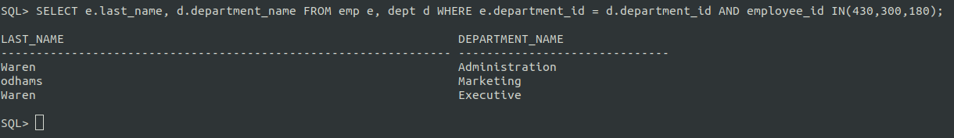
Write a query to display the last name and salary for all employees whose salary is not in the range of 5,000 and 12,000
SQL> SELECT last_name, salary FROM emp WHERE salary NOT BETWEEN 5000 AND 12000;

LAST_NAME SALARY
---------------------------------------------------------------- ----------
Waren 15000
Waren 18000
Waren 17000
odhams 15000
Waren 15000
Waren 18000
Waren 17000
odhams 25000
Waren 19000
Waren 35000
Waren 85000

LAST_NAME SALARY
---------------------------------------------------------------- ----------
Waren 75000
Waren 15000

13 rows selected.
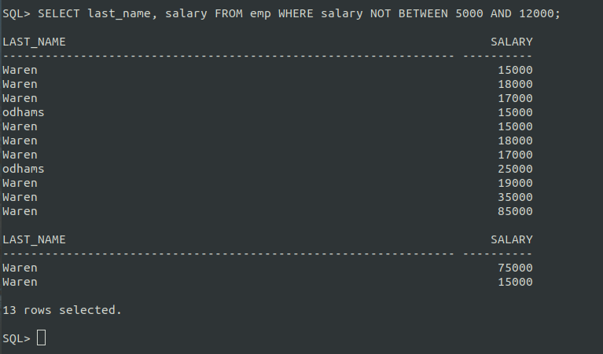
Display the employee last name, job ID, and start date of employees hired between two given dates
SQL> SELECT last_name, job_id , hire_date FROM emp WHERE hire_date > TO_DATE('10/01/2000', 'DD/MM/YYYY') AND hire_date < TO_DATE('20/12/2020', 'DD/MM/YYYY');

LAST_NAME JOB_ID HIRE_DATE
---------------------------------------------------------------- ---------- ---------
Waren AD_SALES 12-JAN-20
Waren IT_PROG 12-MAY-20
Waren AD_EXE 30-JAN-20
odhams AD_MKT 15-JAN-20
odhams AD_SHIP 11-JUN-20
Waren AD_SALES 12-JAN-10
Waren IT_PROG 12-MAY-17
Waren AD_EXE 30-JAN-05
odhams AD_MKT 15-JAN-06
odhams AD_SHIP 11-JUN-05
Waren AD_SALES 12-JAN-20

LAST_NAME JOB_ID HIRE_DATE
---------------------------------------------------------------- ---------- ---------
Waren IT_PROG 12-MAY-20
odhams AD_MKT 15-JAN-20
Waren AD_SALES 12-JAN-20
Waren IT_PROG 12-MAY-20
Waren AD_EXE 30-JAN-20
odhams AD_MKT 15-JAN-20

17 rows selected.

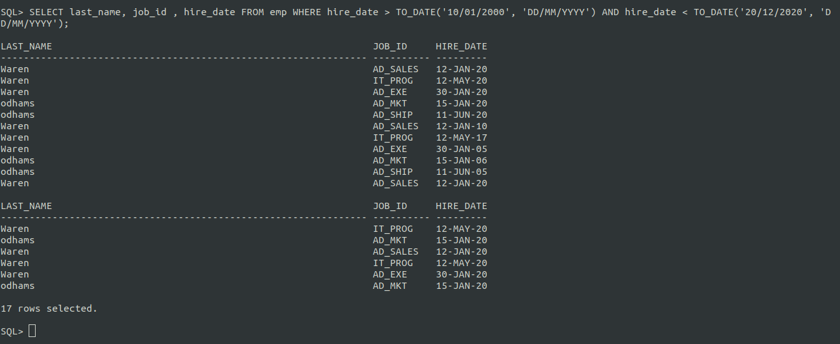
Display the last name and department number of all employees in departments 20 and 50 in alphabetical order by name
SQL> SELECT last_name, department_id FROM emp WHERE department_id IN(20,50) ORDER BY last_name;

LAST_NAME DEPARTMENT_ID
---------------------------------------------------------------- -------------
odhams 20
odhams 20
odhams 20
odhams 20
odhams 20
odhams 20

6 rows selected.

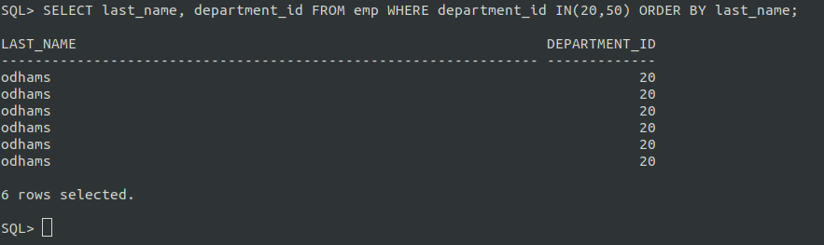

https://github.com/mohammadimranora/dd-lab.git

