Git & GitHub
DevOps Assignment
Student: Mohammad Imrose
Repository: https://github.com/mohammadimrose123/Git_and_GitHub

Important evidence and accuracy note
This ZIP contains the Flask project, a local Git demonstration repository, example screenshots of actual local Git command output, and an illustrative UI preview. These screenshots do NOT prove that SSH authentication, GitHub branch pushes, or remote merges succeeded. Complete the workflow on your own PC and replace/add screenshots that show your actual terminal and GitHub results before submission. The repository URL is included as requested, but no remote push was performed from this package.

Project overview
Flask application with GET /api returning data.json, a To-Do form, and POST /submittodoitem. The backend validates itemName and itemDescription, generates Item ID/UUID when omitted, computes a SHA-256 hash, and stores the document in MongoDB when MONGODB_URI is configured.

Setup and run on Windows
- 1. Install Python 3.10+ and Git.
- 2. Open Command Prompt in the project folder.
- 3. Run: py -m venv .venv
- 4. Run: .venv\Scripts\activate
- 5. Run: pip install -r requirements.txt
- 6. Copy .env.example to .env and set MONGODB_URI to your MongoDB URI.
- 7. Run: python app.py
- 8. Open http://127.0.0.1:5000 and http://127.0.0.1:5000/api.

Task 1 — Repository setup, SSH and first branch
Repository URL: https://github.com/mohammadimrose123/Git_and_GitHub
SSH setup: ssh-keygen -t ed25519 -C "your-email@example.com"; add the contents of %USERPROFILE%\.ssh\id_ed25519.pub in GitHub Settings → SSH and GPG keys; test with ssh -T git@github.com.
Clone and branch commands:
git clone git@github.com:mohammadimrose123/Git_and_GitHub.git
git switch -c MohammadImrose
git add .
git commit -m "Add initial Flask project"
git push -u origin MohammadImrose
git switch main
git merge MohammadImrose
git push origin main
Screenshot to capture: SSH success greeting, branch list, commit, merge output and repository page.

Task 2 — JSON update and merge conflict
Create MohammadImrose_new, edit data.json, commit and push it. To demonstrate conflict resolution, make a different committed edit to data.json on main, then merge the _new branch. If the intended resolution is to accept the incoming _new branch's data.json, use git checkout --theirs data.json during that merge, then git add data.json, commit and push. Confirm the final JSON content before committing.
Commands: git switch -c MohammadImrose_new; git add data.json; git commit -m "Update API JSON data"; git push -u origin MohammadImrose_new; git switch main; git merge MohammadImrose_new.
Screenshot to capture: conflict markers, resolution, git status and the final merge commit.

Task 3 — Parallel frontend/backend branches
Create master_1 from main and commit the frontend form. Create master_2 from main and commit the Flask /submittodoitem route and MongoDB integration. Merge both branches into main, resolving conflicts if necessary, then run and test the application.
Commands: git switch main; git switch -c master_1; git add templates/index.html static/style.css; git commit -m "Add To-Do form frontend"; git switch main; git switch -c master_2; git add app.py requirements.txt; git commit -m "Add MongoDB To-Do submission API"; git switch main; git merge master_1; git merge master_2; git push origin main.
Screenshot to capture: both feature branch commits, successful POST request, and MongoDB document.

Task 4 — Sequential commits, reset and rebase
On master_1, add Item ID, Item UUID, and Item Hash in separate commits. Verify with git log --oneline --graph --all. Use the actual commit hash for the Item ID-only state.
Reset caution: git reset --soft <ITEM_ID_COMMIT_HASH> moves the current branch pointer and keeps changes staged. It rewrites local history. Confirm you are on main and have a clean working tree first. Recommit the staged state only if that matches the instructor's intended history. Do not force-push without understanding the consequences.
Rebase command required by the assignment: git rebase main master_1. This rebases master_1 onto main; it does not merge master_1 into main. Resolve any conflicts, git add the resolved files, then git rebase --continue. Do not squash commits.
Screenshot to capture: three separate commits, staged status after soft reset, successful rebase and final commit graph.

Evidence screenshots included
The included local Git screenshots are actual output from a local demo repository created in this package. They are not evidence of remote GitHub actions. The UI preview is illustrative, not a browser capture.
Local Git history demo (not remote GitHub proof)
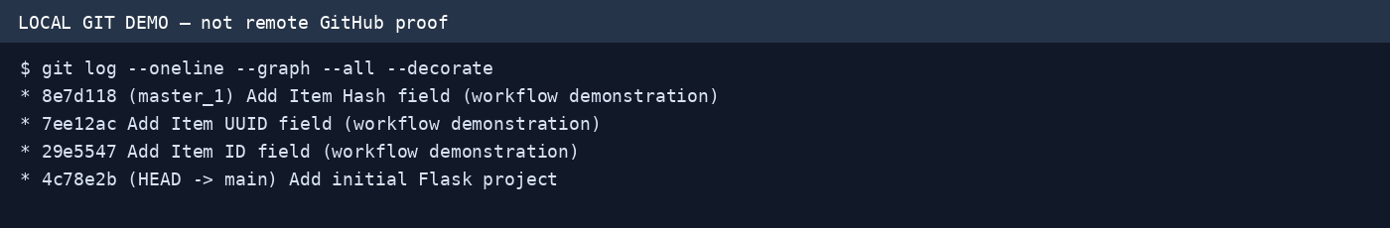
Local branch list demo
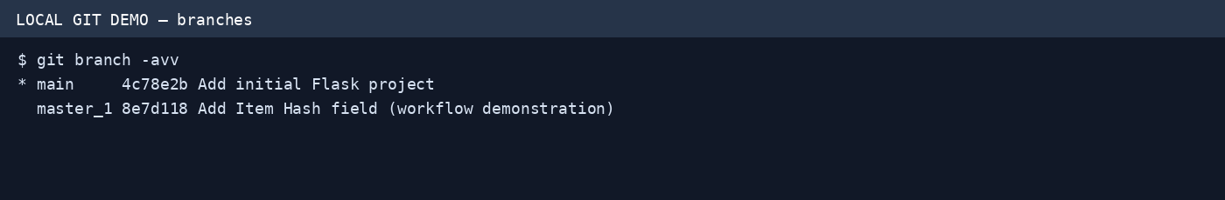
Local working tree status demo
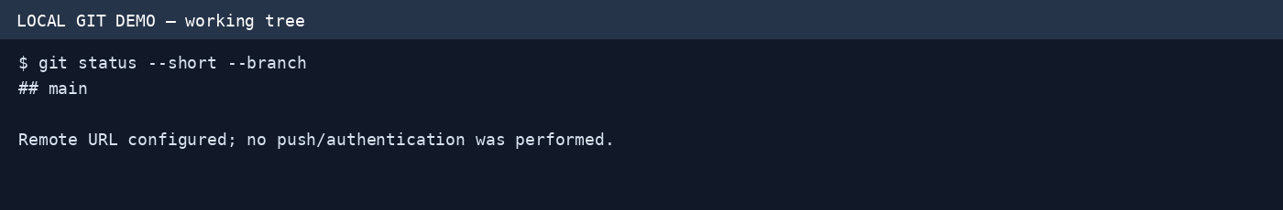
Illustrative To-Do UI preview
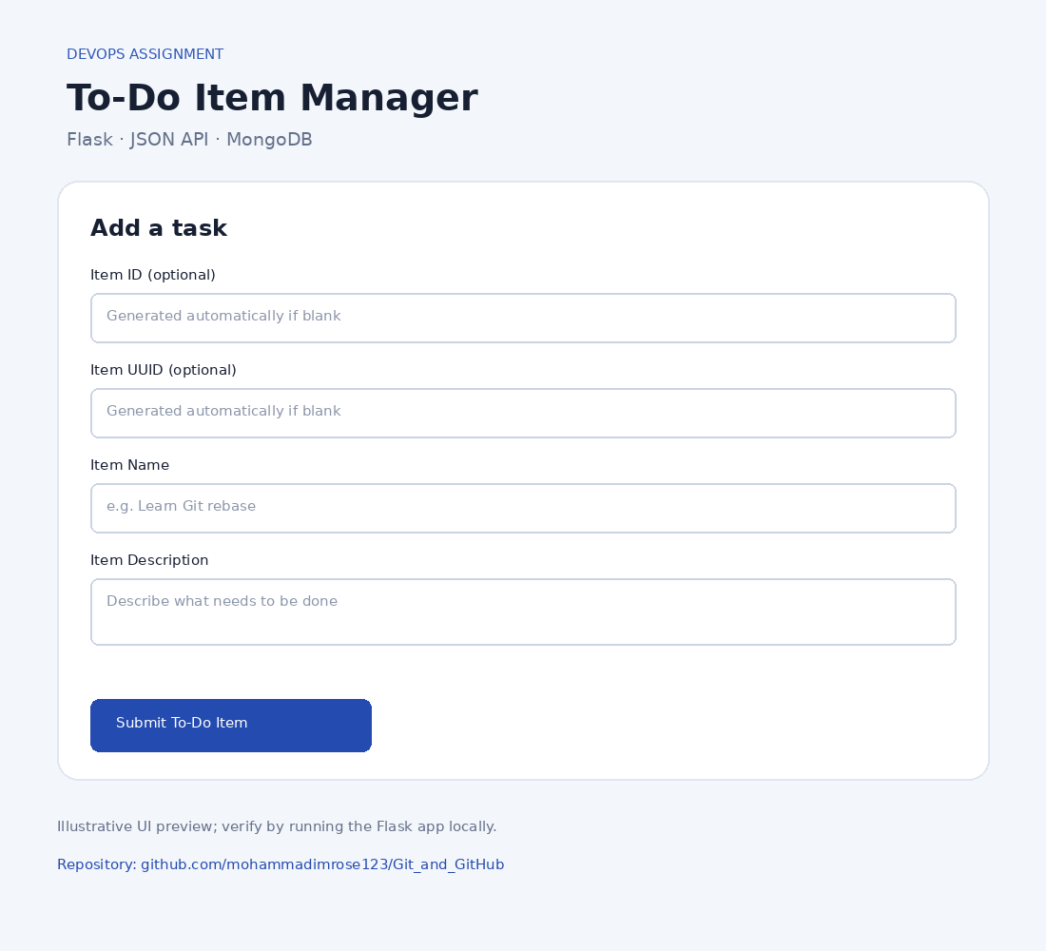

Final submission checklist
- Run the Flask app and test GET /api.
- Configure MongoDB and test POST /submittodoitem.
- Complete SSH authentication with your own GitHub account.
- Perform each required branch/merge/reset/rebase workflow and capture actual screenshots.
- Confirm repository URL is https://github.com/mohammadimrose123/Git_and_GitHub.
- Remove secrets and virtual environments.
- Compress the complete Git_and_GitHub_MohammadImrose folder into Git_and_GitHub_MohammadImrose.zip.

