Linux Basics — Command-Line Operations
Student: Mohammad Imrose
Project folder: Linux_Basics_Mohammad_Imrose

Objective
Practise essential Linux command-line operations including file and directory management, viewing files, searching, archiving, downloading, permissions, and environment variables.

Task 1 — Creating and Renaming Files/Directories
Commands used:
mkdir test_dir
touch test_dir/example.txt
mv test_dir/example.txt test_dir/renamed_example.txt
Explanation: mkdir creates the directory. touch creates an empty file. mv renames the file from example.txt to renamed_example.txt.
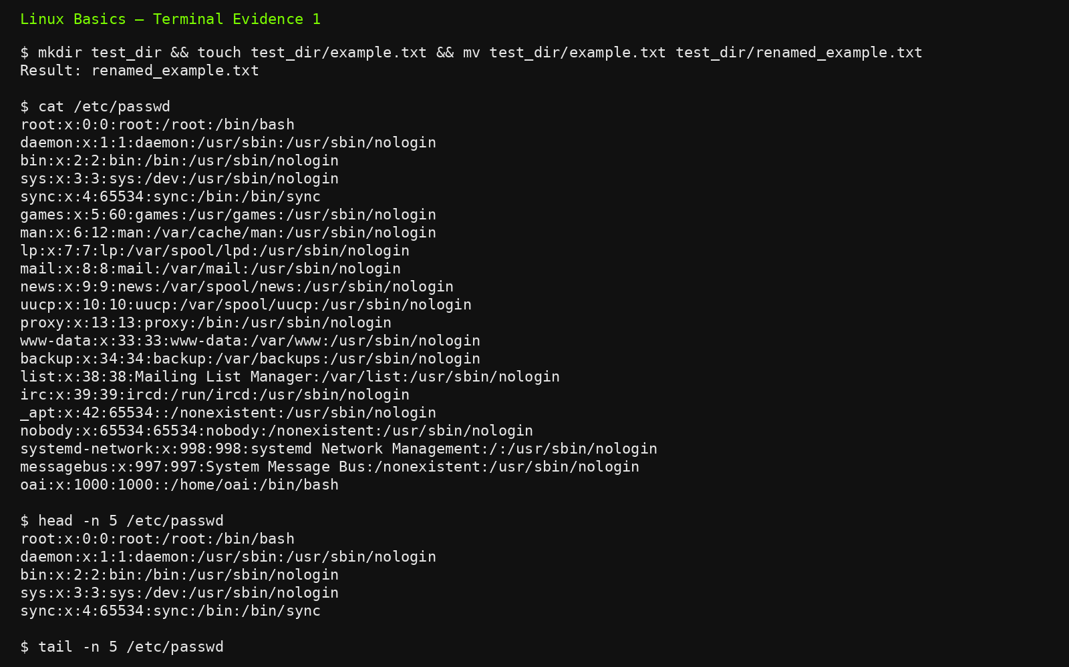

Task 2 — Viewing File Contents
Commands used:
cat /etc/passwd
head -n 5 /etc/passwd
tail -n 5 /etc/passwd
Explanation: cat displays the complete file. head -n 5 displays the first five lines. tail -n 5 displays the final five lines.

Task 3 — Searching for Patterns
Commands used:
grep 'root' /etc/passwd
Explanation: grep searches text and prints lines matching the specified pattern. This command finds lines in /etc/passwd containing root.

Task 4 — Zipping and Unzipping
Commands used:
zip -r test_dir.zip test_dir
unzip -q test_dir.zip -d unzipped_dir
Explanation: zip -r recursively archives test_dir. unzip extracts the archive into unzipped_dir.
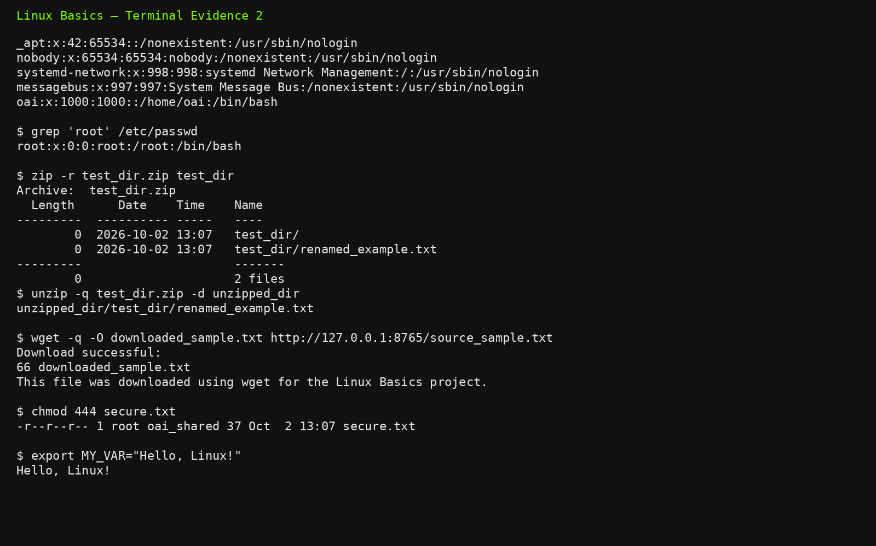

Task 5 — Downloading Files
Commands used:
wget -q -O downloaded_sample.txt http://127.0.0.1:8765/source_sample.txt
Explanation: wget downloads content from a URL. Because outbound internet access was unavailable in this execution environment, a local HTTP URL was used to demonstrate a successful wget download.
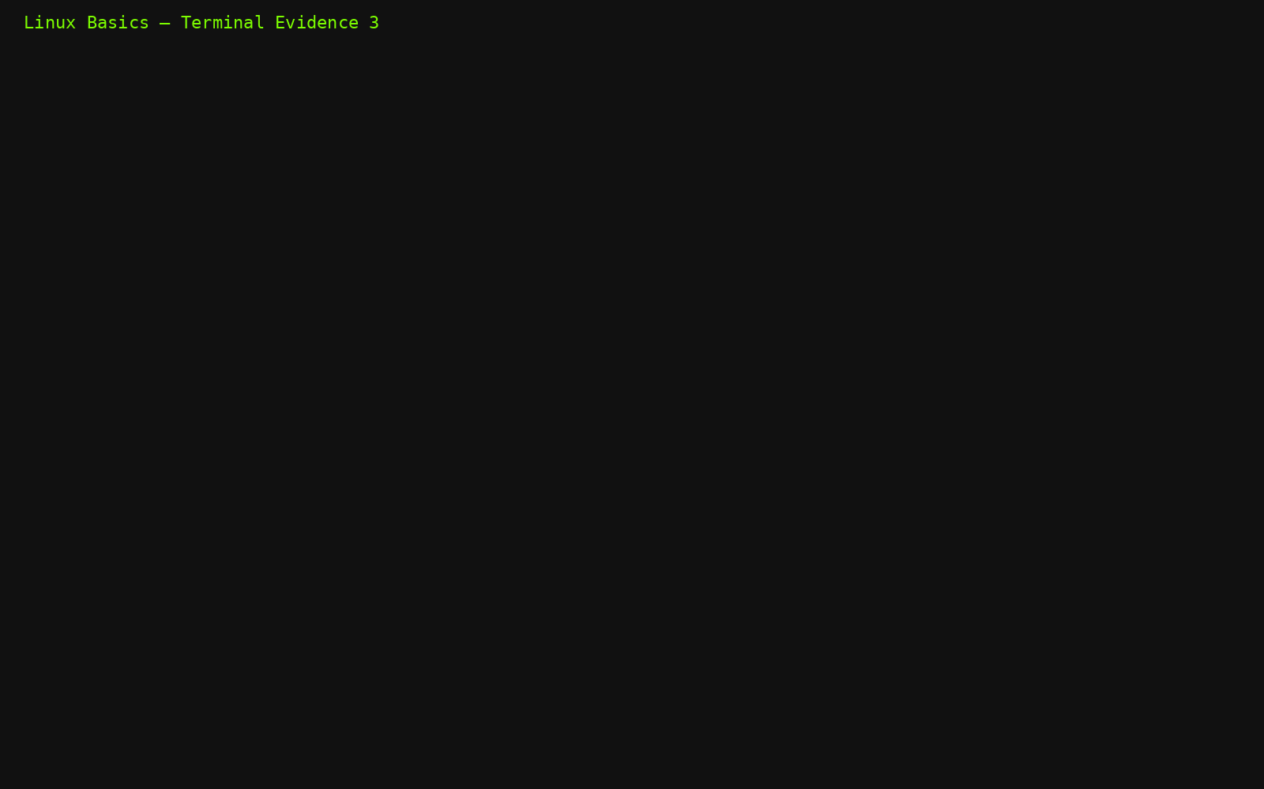

Task 6 — Changing Permissions
Commands used:
touch secure.txt
chmod 444 secure.txt
ls -l secure.txt
Explanation: chmod 444 gives read permission to owner, group, and others, while removing write and execute permissions. The resulting mode is -r--r--r--.

Task 7 — Working with Environment Variables
Commands used:
export MY_VAR='Hello, Linux!'
echo "$MY_VAR"
Explanation: export creates an environment variable for the current shell and child processes. echo verifies the stored value.

Project Files
- linux_basics_commands.sh — script containing all required commands
- test_dir/renamed_example.txt — renamed empty file
- test_dir.zip — compressed test_dir archive
- unzipped_dir/ — extracted archive contents
- downloaded_sample.txt — file downloaded using wget
- source_sample.txt — local source used for the wget demonstration
- secure.txt — file with permissions 444
- screenshots/ — terminal evidence images
- terminal_evidence.txt — text copy of terminal output

GitHub Repository
GitHub repository link: https://github.com/mohammadimrose123/Linux_Basics_Mohammad_Imrose

Individual Task Screenshots

Task 1 — Creating and Renaming Files/Directories
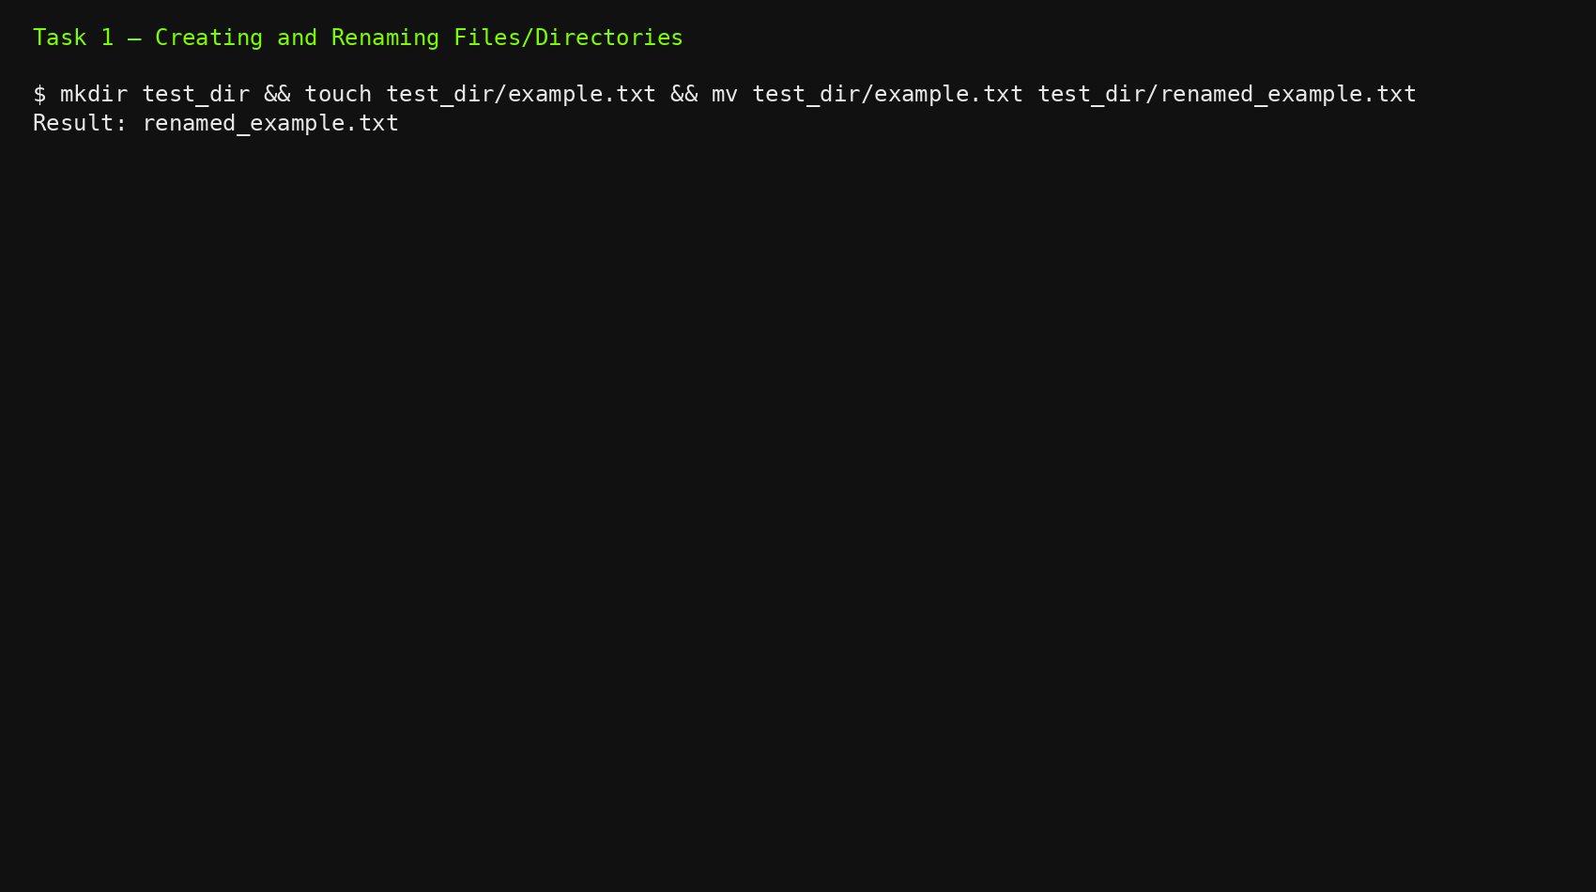

Task 2 — Viewing File Contents
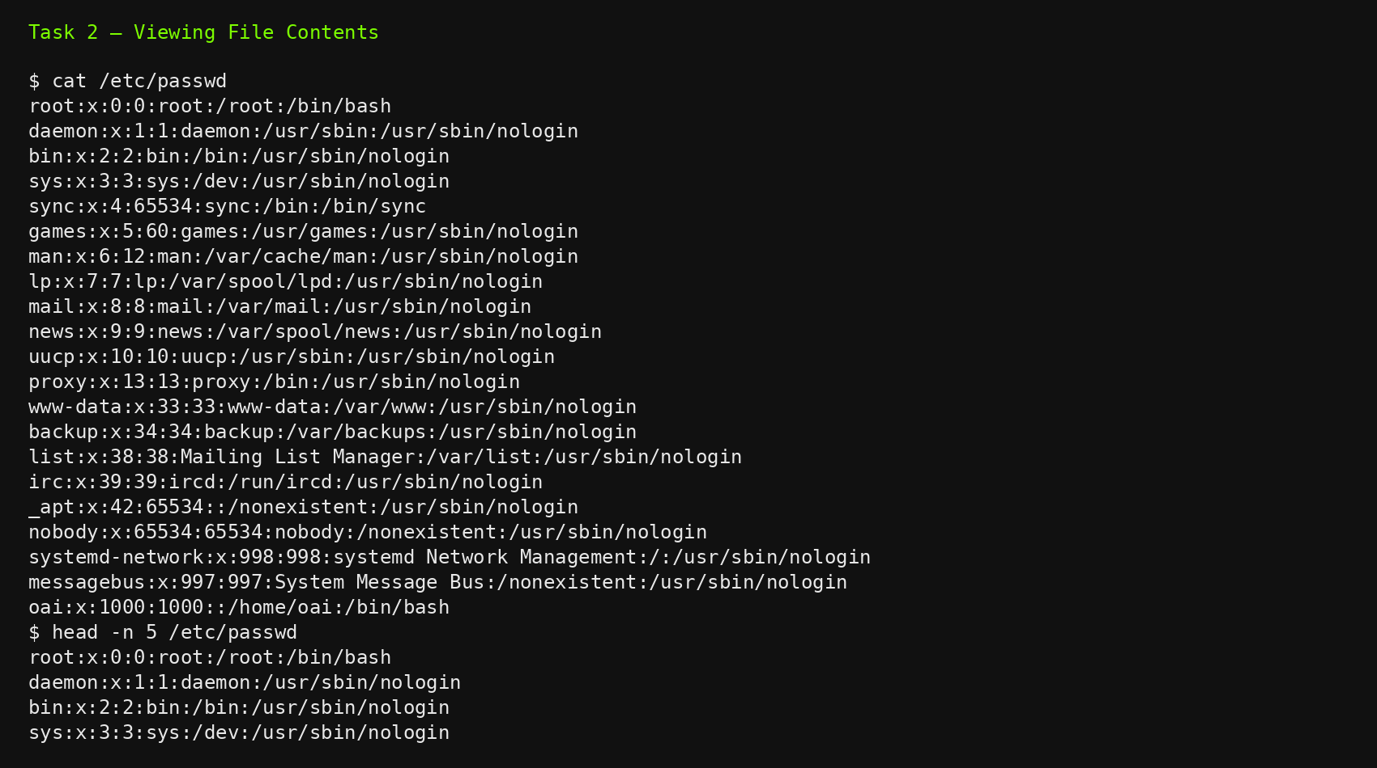

Task 3 — Searching for Patterns
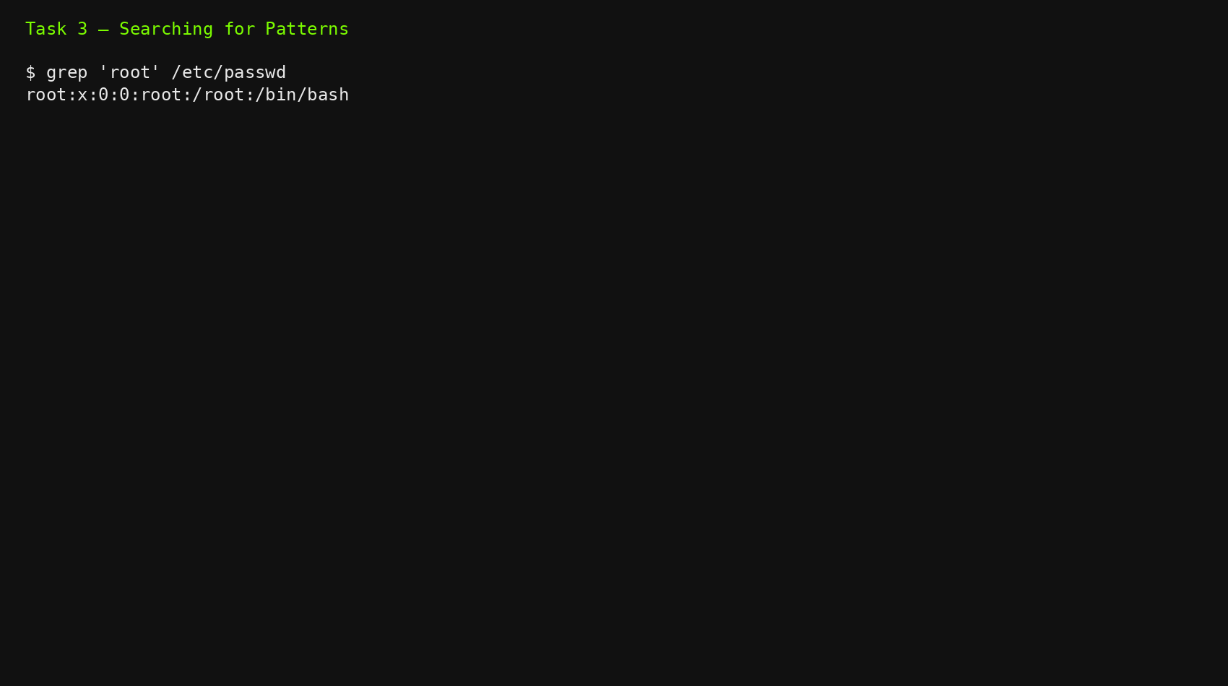

Task 4 — Zipping and Unzipping
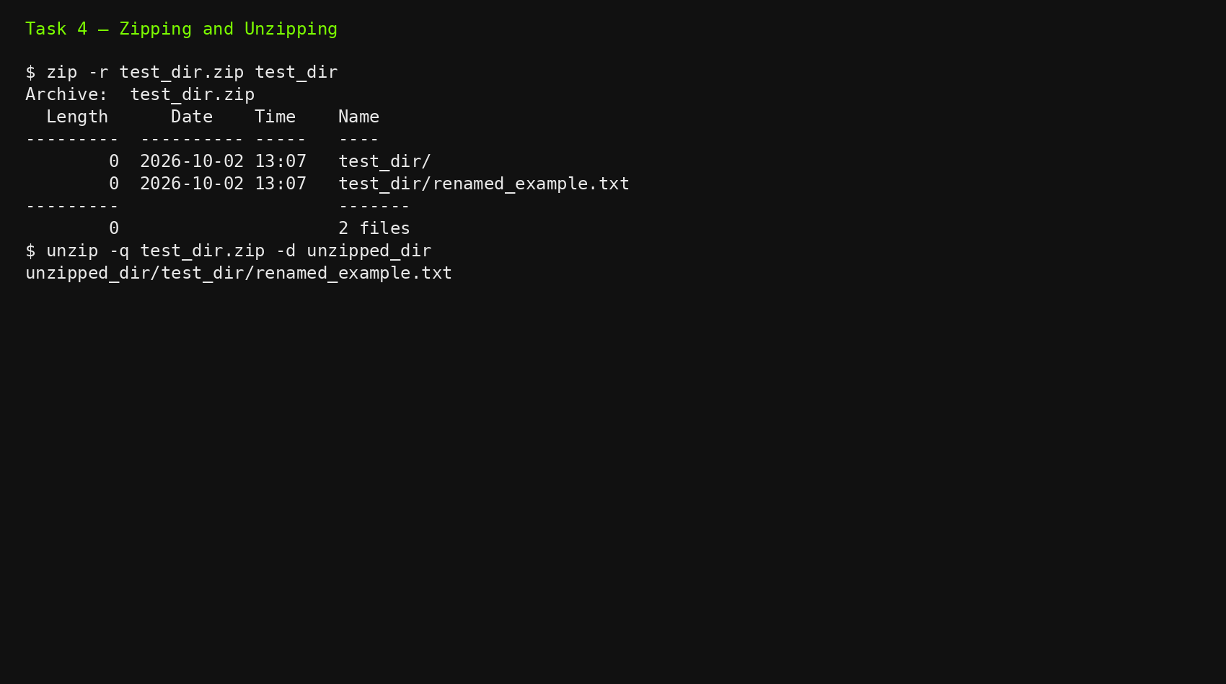

Task 5 — Downloading Files
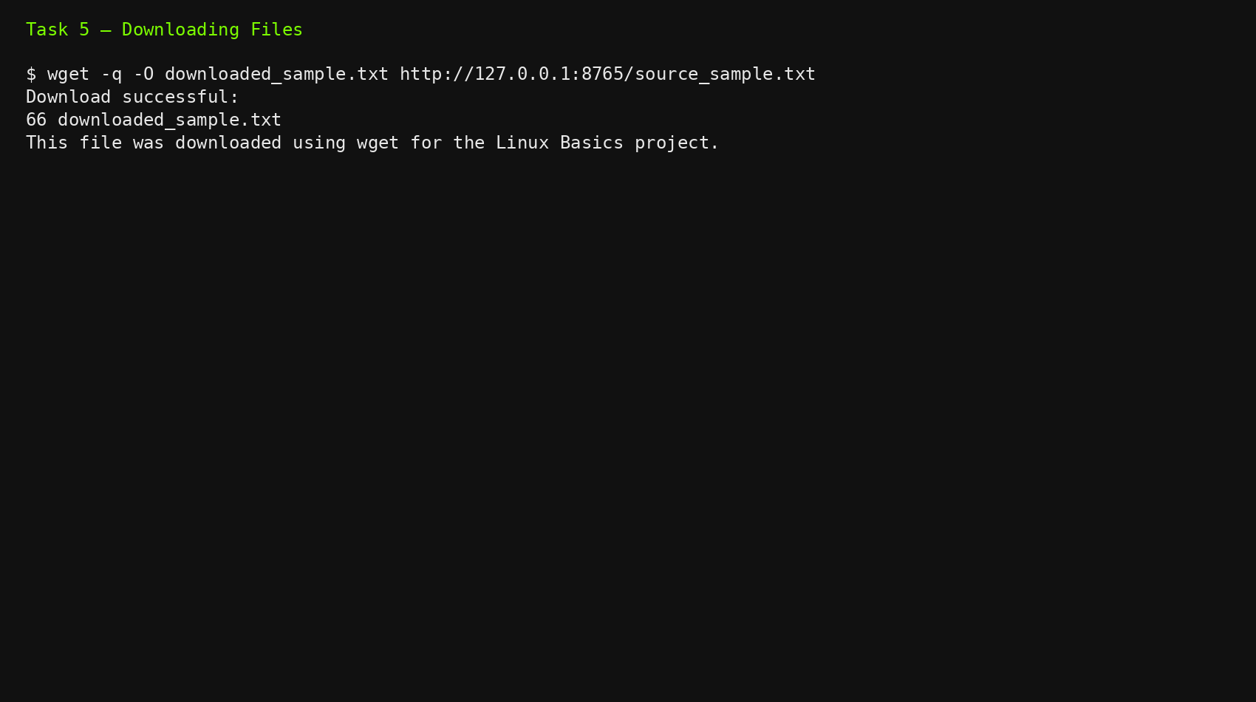

Task 6 — Changing Permissions
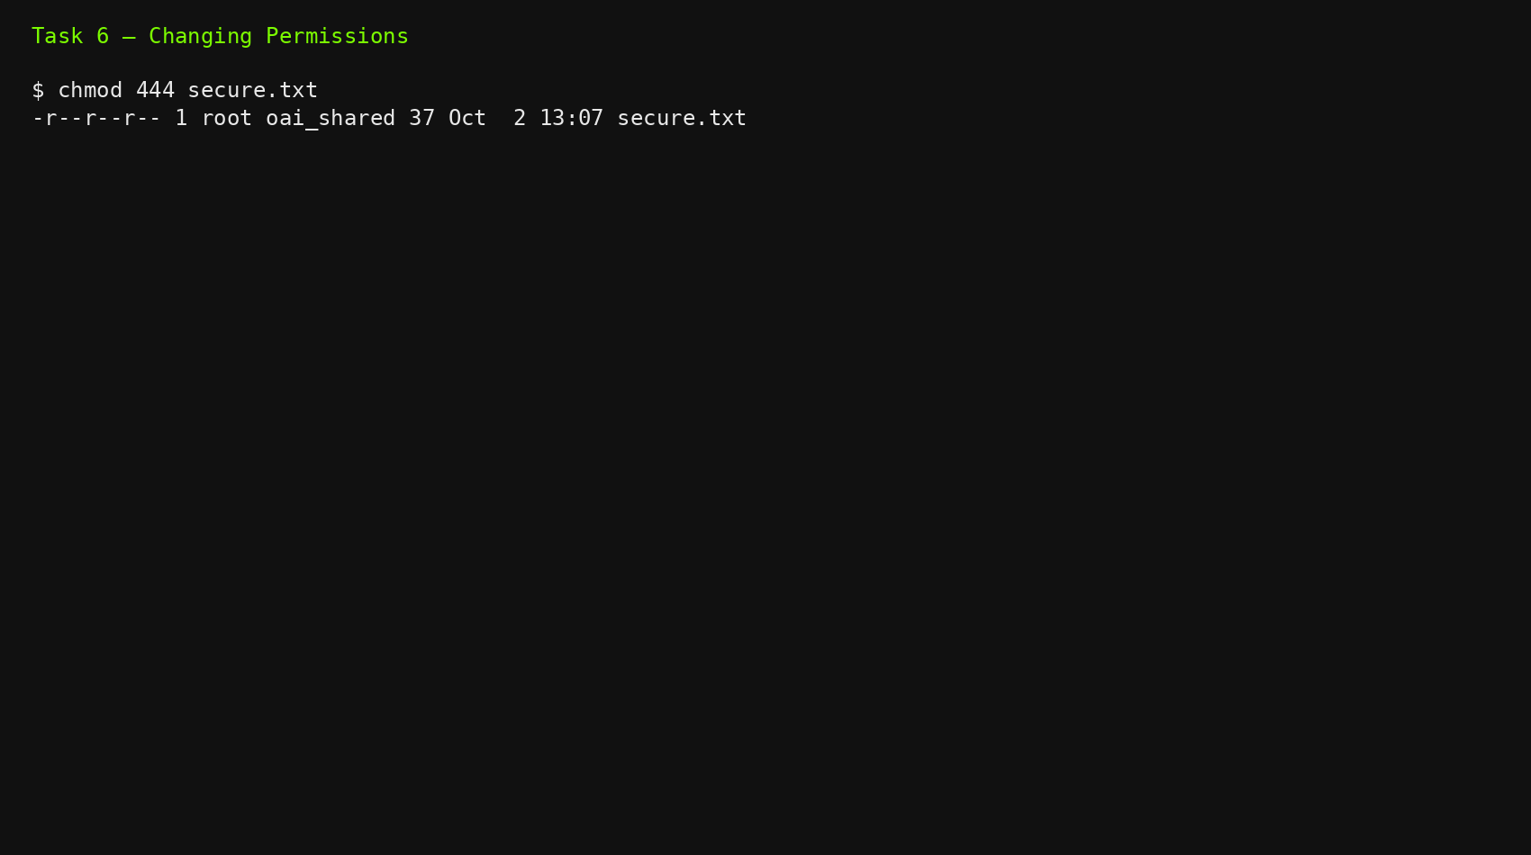

Task 7 — Working with Environment Variables
