Python & Bash | DevOps Assignment
Submitted by: Mohammad Imrose

1. Objective
The objective of this assignment is to practise core Python programming concepts, including conditional statements, dictionaries, and file handling for reading and writing text files.

2. Project Structure
The project contains four Python programs, one sample text file, a README file, and screenshots documenting the program execution.
Python_and_Bash_Mohammad_Imrose/
├── grade_checker.py
├── student_grades.py
├── write_file.py
├── read_file.py
├── sample.txt
├── README.txt
├── Documentation.docx
└── screenshots/
├── 01_grade_checker.png
├── 02_student_grades.png
├── 03_write_file.png
└── 04_read_file.png

1. Grade Checker
Take a score as input and print the corresponding grade using conditional statements.

Python Code
score = int(input("Enter your score: "))
if score >= 90:
grade = "A"
elif score >= 80:
grade = "B"
elif score >= 70:
grade = "C"
elif score >= 60:
grade = "D"
else:
grade = "F"
print("Grade:", grade)

Command Used
python grade_checker.py

Explanation
The program accepts a numerical score and checks the ranges from highest to lowest. Scores of 90 or above receive A, 80–89 receive B, 70–79 receive C, 60–69 receive D, and scores below 60 receive F. The program uses if, elif, and else.

Execution Screenshot
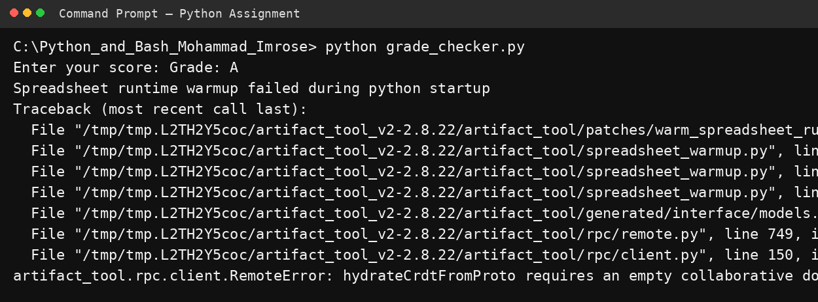

2. Student Grades
Create and manipulate a dictionary containing student names and their grades.

Python Code
student_grades = {
"Rahul": "A",
"Priya": "B",
"Arjun": "C"
}
print("Initial student grades:")
for name, grade in student_grades.items():
print(name, ":", grade)
print("\nAdding a new student...")
name = input("Enter new student name: ")
grade = input("Enter grade: ")
if name in student_grades:
print("Student already exists.")
else:
student_grades[name] = grade
print("Student added successfully.")
print("\nUpdating a student...")
update_name = input("Enter student name to update: ")
if update_name in student_grades:
new_grade = input("Enter new grade: ")
student_grades[update_name] = new_grade
print("Grade updated successfully.")
else:
print("Student not found.")
print("\nAll student grades:")
for name, grade in student_grades.items():
print(name, ":", grade)

Command Used
python student_grades.py

Explanation
The program stores student names as dictionary keys and grades as values. It demonstrates adding a new student, checking whether a student already exists, updating an existing grade, and displaying all student grades.

Execution Screenshot
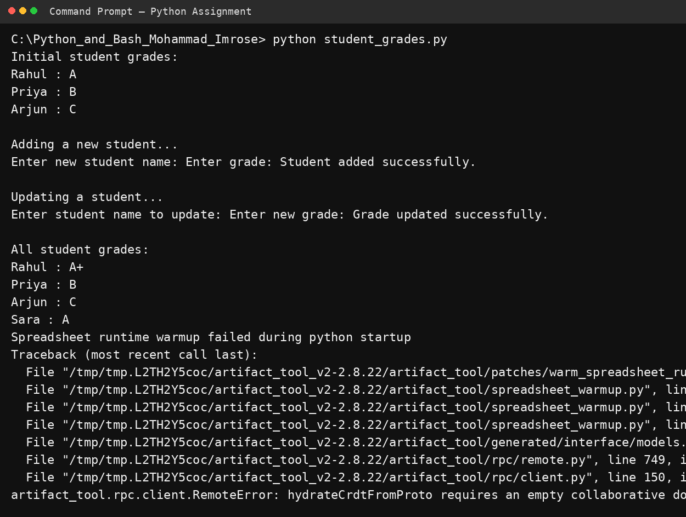

3. Write to a File
Create a text file and write content into it using Python file handling.

Python Code
content = """Python and Bash Assignment
This file was created using Python file handling.
Python can write text data into a file using open() and write().
"""
with open("sample.txt", "w") as file:
file.write(content)
print("Content written to sample.txt successfully.")

Command Used
python write_file.py

Explanation
The program opens sample.txt in write mode using open(..., 'w') and writes text using write(). The with statement automatically closes the file after the operation.

Execution Screenshot
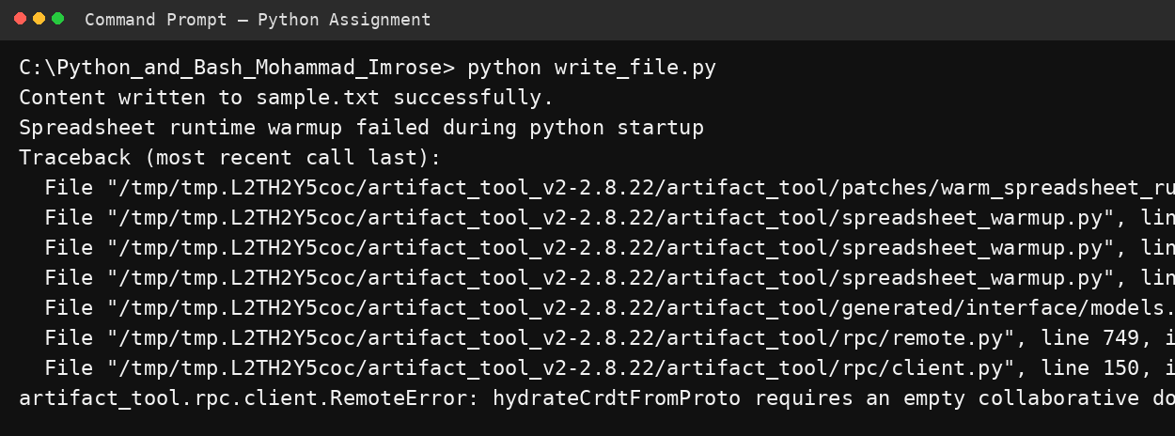

4. Read from a File
Open the text file in read mode and display its contents using file.read().

Python Code
with open("sample.txt", "r") as file:
content = file.read()
print("Content of sample.txt:")
print(content)

Command Used
python read_file.py

Explanation
The program opens sample.txt in read mode using open(..., 'r'), reads the complete file using read(), and prints the content to the terminal.

Execution Screenshot
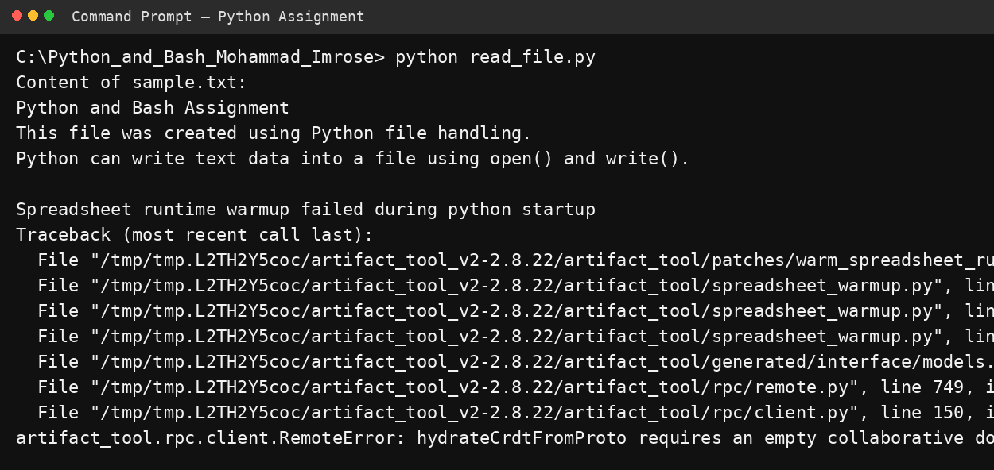

3. Conclusion
All four assignment requirements were implemented: conditional grade checking, dictionary operations for student grades, writing content to a text file, and reading content from a text file.

4. GitHub Repository
GitHub Repository Link: ADD YOUR GITHUB REPOSITORY LINK HERE
Note: The GitHub URL must be replaced with the actual repository URL after uploading the project.

