Python & Bash | DevOps Assignment
Resubmission - Menu-Driven Calculator
Submitted by: Mohammad Imrose

1. Objective
This assignment implements a menu-driven Python calculator demonstrating separate mathematical functions, a continuous menu loop, division-by-zero error handling, and inline comments explaining the calculator logic.

2. Requirements Implemented
- Menu-driven Python calculator program.
- Separate functions for addition, subtraction, multiplication and division.
- Continuous menu loop allowing repeated calculator execution.
- Division-by-zero error handling.
- Screenshots of calculator execution and division-by-zero handling.
- Inline comments explaining calculator logic.

3. Project Structure
Python_and_Bash_Mohammad_Imrose_Resubmission/
├── calculator.py
├── README.txt
├── Documentation.docx
└── screenshots/
├── 01_calculator_operations.png
├── 02_division_by_zero.png
└── 03_invalid_choice_and_exit.png

4. Python Code
# Menu-driven calculator for basic arithmetic operations
# Function to add two numbers
def add(a, b):
return a + b
# Function to subtract the second number from the first
def subtract(a, b):
return a - b
# Function to multiply two numbers
def multiply(a, b):
return a * b
# Function to divide two numbers with division-by-zero handling
def divide(a, b):
if b == 0:
return "Error: Cannot divide by zero."
return a / b
# Keep showing the calculator menu until the user chooses Exit
while True:
print("\n===== MENU-DRIVEN CALCULATOR =====")
print("1. Addition")
print("2. Subtraction")
print("3. Multiplication")
print("4. Division")
print("5. Exit")
choice = input("Enter your choice (1-5): ")
# Exit the calculator when the user selects option 5
if choice == "5":
print("Calculator closed.")
break
# Validate the menu choice before asking for numbers
if choice not in ("1", "2", "3", "4"):
print("Invalid choice. Please select 1-5.")
continue
try:
num1 = float(input("Enter first number: "))
num2 = float(input("Enter second number: "))
except ValueError:
print("Invalid input. Please enter numeric values.")
continue
# Call the appropriate function based on the selected operation
if choice == "1":
print("Result:", add(num1, num2))
elif choice == "2":
print("Result:", subtract(num1, num2))
elif choice == "3":
print("Result:", multiply(num1, num2))
elif choice == "4":
print("Result:", divide(num1, num2))

5. How to Run
python calculator.py

6. Explanation
The calculator defines four separate functions: add(), subtract(), multiply(), and divide(). The divide() function checks whether the second number is zero before performing division. The main program uses a while True loop to keep displaying the menu. The loop ends only when the user selects option 5. The selected menu option determines which mathematical function is called.

7. Execution Screenshots

7.1 Arithmetic Operations and Continuous Menu
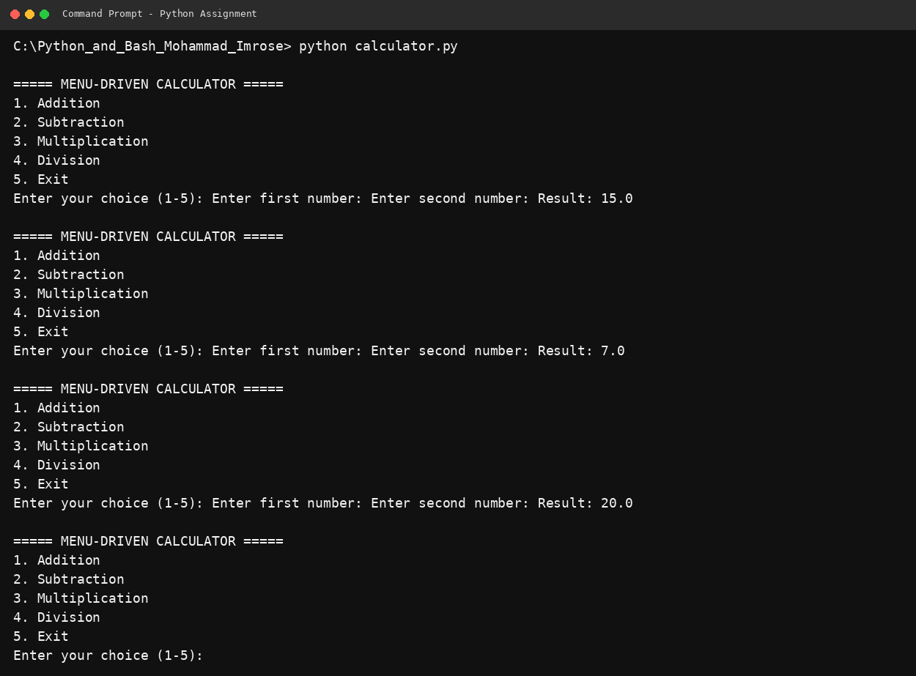

7.2 Division by Zero Handling
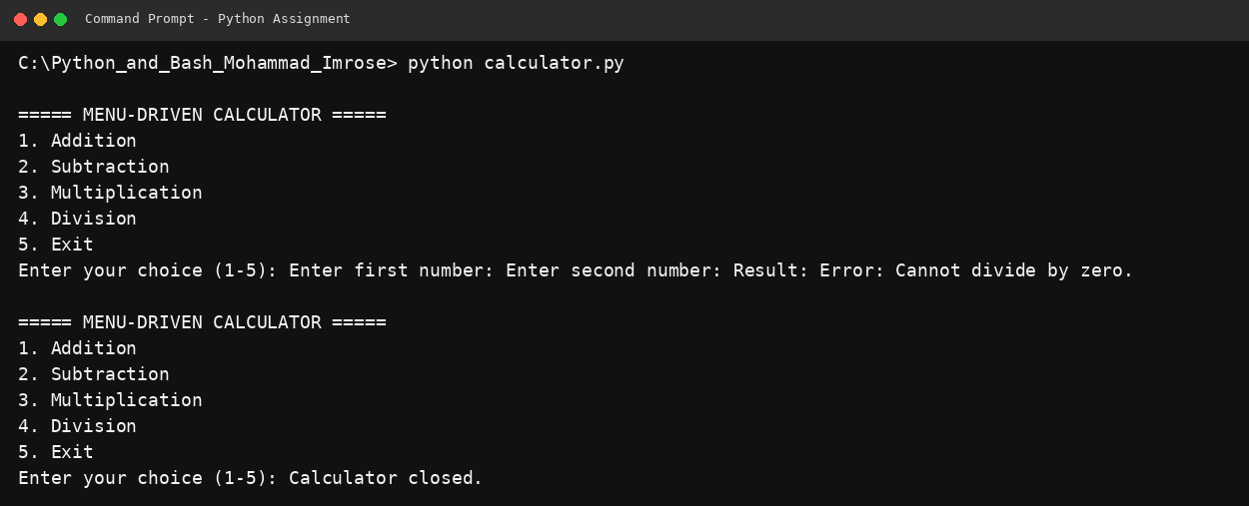

7.3 Invalid Choice and Exit Handling
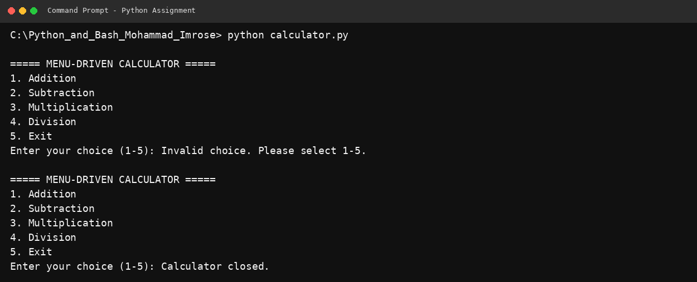

8. GitHub Repository
GitHub Repository Link: https://github.com/mohammadimrose123/python-menu-driven-calculator

9. Conclusion
The menu-driven calculator demonstrates the requested Python concepts through reusable functions, repeated menu execution, input validation, and explicit division-by-zero handling.

